Marketing plan written for

Marriott International

Student Name

Kristine Holtere
__________________________________________________

Student ID number
2235440
___________________

Marketing Essentials BMIH4005

Lecturer

Luciana Suardi
________________________________
Word count
1272

Table of Contents
Component A: Marketing Plan 3
Introduction 3
Situational Analysis 3
Objectives 6
Strategy 6
Tactics 6
Action 7
Control 8
Conclusion 8
Component B: Presentation 9
References 13

Component A: Marketing Plan

Introduction
Marketing Plan is the strategic pro-planning approach that contemplates the marketing and promotional strategy of the organisation to achieve its goals and objectives (Assaad, 2021). Moreover, the marketing plan includes a list of action that helps to attain the desired marketing objectives. The marketing plan is prepared based on situational analysis like PESTLE along with the Marketing mix elements (Kerzner, 2019). The report will design a marketing plan for Marriott International by identifying its target market, value proposition, and required campaigns and determination of the metrics to control and evaluate the action plan. Marriott International is a global hospitality organisation that is operating in 130 countries with its 30+ brand portfolio.

Situational Analysis
Situational Analysis reflects the assessment of the external and internal business environment to analyse the determining factors which influence business decisions (Barker, 2019). The COVID-19 pandemic has reduced the economic output by 42% in the year 2020 along with the decline in the share of the hospitality industry to the UK economy by 3% can be observed. However, the withdrawal of the travel restrictions by the UK Government, increase in the traveller’s spending, technological developments, sustainable tourism, etc. have increased the business opportunities of the hospitality organisations.
5C Analysis is a strategic marketing framework that analyses the business environment in which the organisation is operating (Blythe, 2019).
- Company: SWOT Analysis is a strategic assessment technique that addresses the key strengths, weaknesses, threats, and opportunities of the company.
Strengths  Marriott International is a global hospitality organisation that is operating in 130 countries with its 30+ brand portfolio. In the year 2022, Marriot International reported an increase in revenue of around $5.923B which is approximately 33% (Marriot, 2022). The Annual gross profit reached $2.801B at the end of the year 2022. | Weaknesses  The privacy of the customers has been breached due to the lack of data security. Moreover, the directionless positioning strategy has failed to attract Generation Z and millennial customers.
Opportunities  The increase in international visitors and market assessment report has predicted that the UK will expect 36 million visits within the year 2023. | Threats  The economic fluctuation across the world has restricted people to opt for luxury accommodation services. Furthermore, Russia’s invasion of Ukraine has increased the raw materials shortages.

- Customers: Marriott International has segmented its accommodation service into two forms that are Classic and Distinctive (De Chernatony, 2019). The classic form of accommodation supports the aspirations and desires of modern travellers and guests. On the contrary, a distinctive form of accommodation provides a memorable and lifetime experience to the guests.
- Competitors: Marriott International has positioned its brands like W hotels and Courtyard into the high-price and low-price categories (Brassington, 2019). Moreover, the brands of Marriott International are aligned in the business categories.
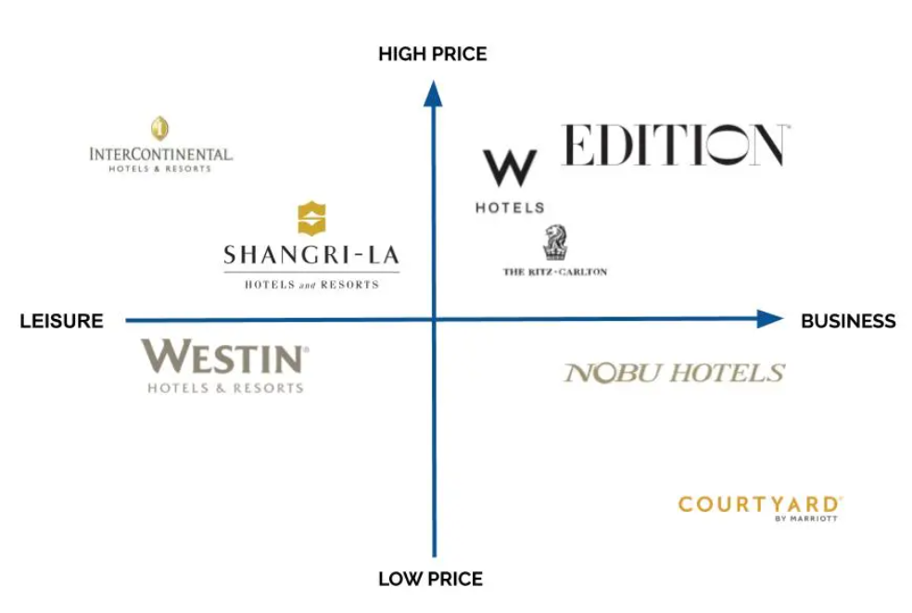
Source: Author
- Collaborators: Marriott International has formed a partnership with multiple suppliers and associations to meet the service benchmark (Freytag, 2020). Moreover, Marriott International has 5,500 franchisees that are operating in over 130 countries (marriott, 2023). The strategic acquisition of Marriott International like Ritz Carlton, Starwood, Bulgari hotel, and Gaylord has enhanced the business turnover.
- Climate: PEST analysis is the strategic assessment of the external business factors that influence the business decision making process of the organisation (Kotler, 2019).
PEST analysis | Impact
Political factor | The Brexit formation has created complexity in the immigration process. Moreover, hospitality organisations are encountering issues in recruiting EU workers due to the change in immigration policy (Freytag, 2020). Hence, a negative impact can be identified on the hospitality business operations in the UK.
Economic factor | The rise in the inflation rate in the UK up to 10.4% has affected consumer spending power. Moreover, 35% of the adult British population has curtailed their annual budget to non-essential items.
Socio-cultural factor | The ongoing change in the taste and preferences of the people has influenced hospitality businesses to innovate and reposition their strategy (Rafiq, 2019).
Technological factor | Digitalisation in the hospitality business has increased operational efficiency. Smartphone penetration and high internet usage have raised the digital culture across the world (Payne, 2019). In consideration of technological upgradation, hospitality organisations are in the continuous process to implement innovation in the service portfolio.

Objectives
Marriott International will consider three aspects of our guests, employees, and hotel management to reposition their marketing strategy. The SMART objectives of Marriott International in the UK hospitality market are as follows:
- To increase the average occupancy of the hotel up to 2% in the upcoming financial year
- To drive the possibility of repeat purchases of the guests up to 10%
- To reduce the check-in and check-out time by focusing on the guest’s convenience
- To reposition the customer segmentation strategy by fulfilling the requirements of Generation Z and millennials
- To enhance brand awareness by embedding the customer engagement strategy in the social media networks

Strategy
Marketing strategy is part of a long-term plan that supports the organisation in understanding the needs of the customers and creating a sustainable competitive advantage (Walsh, 2019). Marriott International has positioned its brands like W hotels and Courtyard into the high-price and low-price categories for catering the budget-conscious and premium guests. However, the hospitality sector of the UK will be dominated by millennials and Generation Z customers. Therefore, the repositioning strategy of Marriott International is needed. In consideration of Bowman’s Strategy Clock, the strategic positioning of the company can be formulated based on price and value. The position 3 ‘hybrid’ option will be effective for Marriott International to attract the new target segment. The competitive price and focused differentiation can influence the new target segment of Marriott International (Leek, 2019). Moreover, a balance between differentiation and cost can be beneficial for Marriott International to maintain good profit margins.

Tactics
Marketing Mix elements are formulated to deliver superior value propositions to the customers (Louro, 2019). Furthermore, the marketing mix elements are composed of the aspects like product, price, place, and promotion.
- Product: Marriott International is dedicated and committed to offering quality accommodation, attractive transport packages, timeshare vacations for the guests. Furthermore, Marriott International will emphasis on the ‘sustainable accommodation service’ to the new customer segment for attaining sustainable business targets.
- Price: Marriott International will position its brands like W hotels and Courtyard into the high-price and low-price categories to attract the customer groups like Generation Z and millennials (De Chernatony, 2019). An aggressive competitor’s pricing strategy for the customers will be effective for Marriott International to create acceptance in the market. Furthermore, the competitive pricing strategy supports the organisation to maintain an advantage by strategically setting the lower price in consideration to close rivals.
- Promotion: Marriott International will have to redesign the loyalty programmes as a part of the sales promotion strategy to create a hedonic effect on the mind of the customers. Furthermore, social media engagement strategies need to be executed efficiently to attract the new customer segment.
- Place: Marriott International can opt for the ‘omni-channel distribution’ strategy to accelerate the reach and availability of the services. The 24*7 customer service support, easy reservation, and proactive customer service will be beneficial for Marriott International to meet the demand of the guests (Assaad, 2021).

Action
Gantt chart is a project management tool that describes the key activities to be completed within a specific period of time (Kerzner, 2019). Moreover, the milestones and task dependencies can be spotted from the Gantt chart.
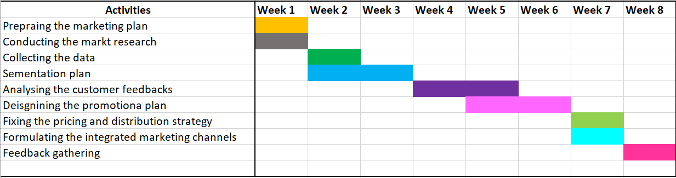
Source: Author

Control
Marriott International will segment its accommodation service into two forms that are Classic and Distinctive (Pagani, 2019). The classic form of accommodation will support the aspirations and desires of modern travellers and guests. On the contrary, a distinctive form of accommodation will provide memorable and lifetime experiences to the guests. Moreover, the customer groups like Generation Z and Millennials will be targeted in consideration of the affordable price and premium quality. Hence, the desires of the new customer groups can be fulfilled with the new offers of Marriott International.

Conclusion
To conclude, the marketing report has considered a strategic pro-planning approach that contemplates the marketing and promotional strategy of the organisation to achieve its goals and objectives. The marketing plan is prepared based on situational analysis like PESTLE along with the Marketing mix elements. The marketing plan of Marriott International has considered the identification of the target market, value proposition, required campaigns, and determination of the metrics to control and evaluate the action plan.

Component B: Presentation
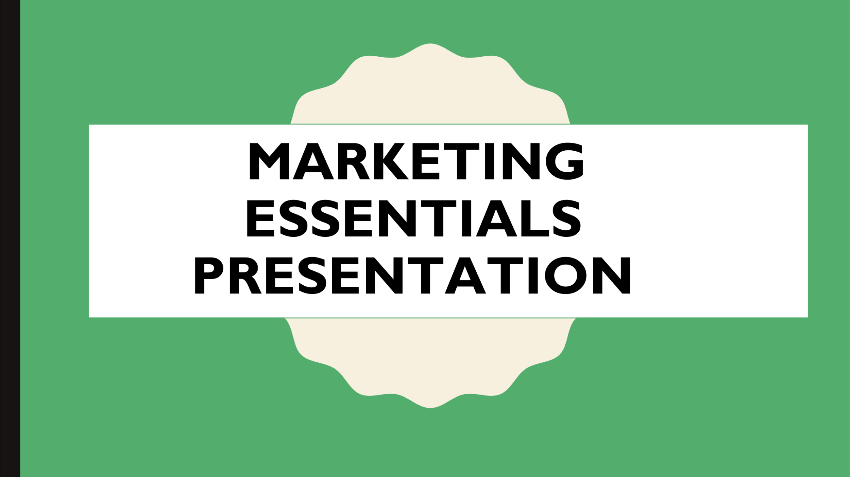

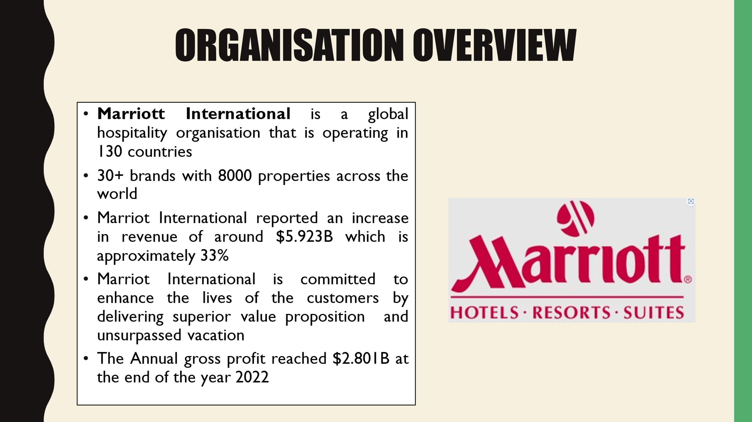
Marriott International is a global hospitality organisation that is operating in 130 countries with its 30+ brand portfolio. In the year 2022, Marriot International reported an increase in revenue of around $5.923B which is approximately 33% (Marriot, 2022). Moreover, the Annual gross profit reached $2.801B at the end of the year 2022. The increase in international visitors and market assessment report has predicted that the UK will expect 36 million visits within the year 2023. Hence, Marriott International will focus on new customer segments in the upcoming year.
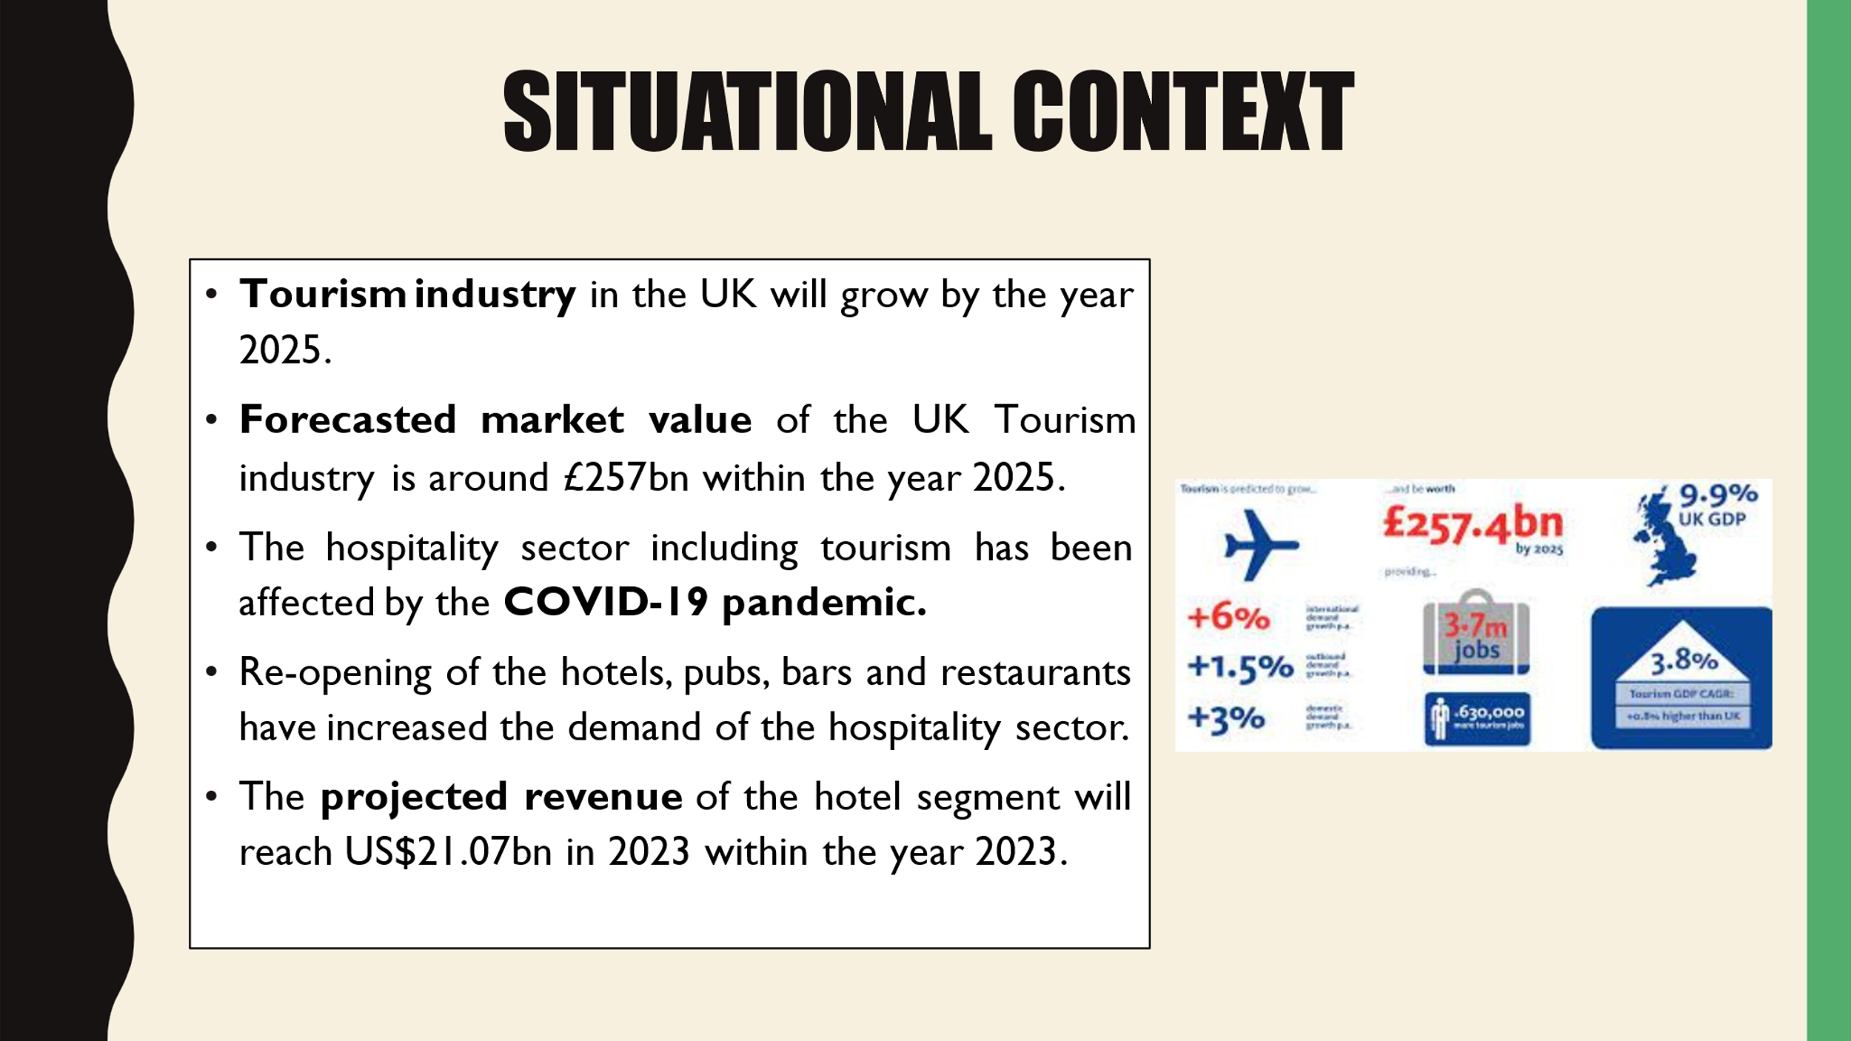
The increase in international visitors and market assessment report has predicted that the UK will expect 36 million visits within the year 2023. The hospitality sector including tourism has been affected by the COVID-19 pandemic. Moreover, the opening of hotels, pubs, bars, and restaurants has increased the demand in the hospitality sector. In consideration of the forecasted revenue, Marriott International will capture a new market segment.
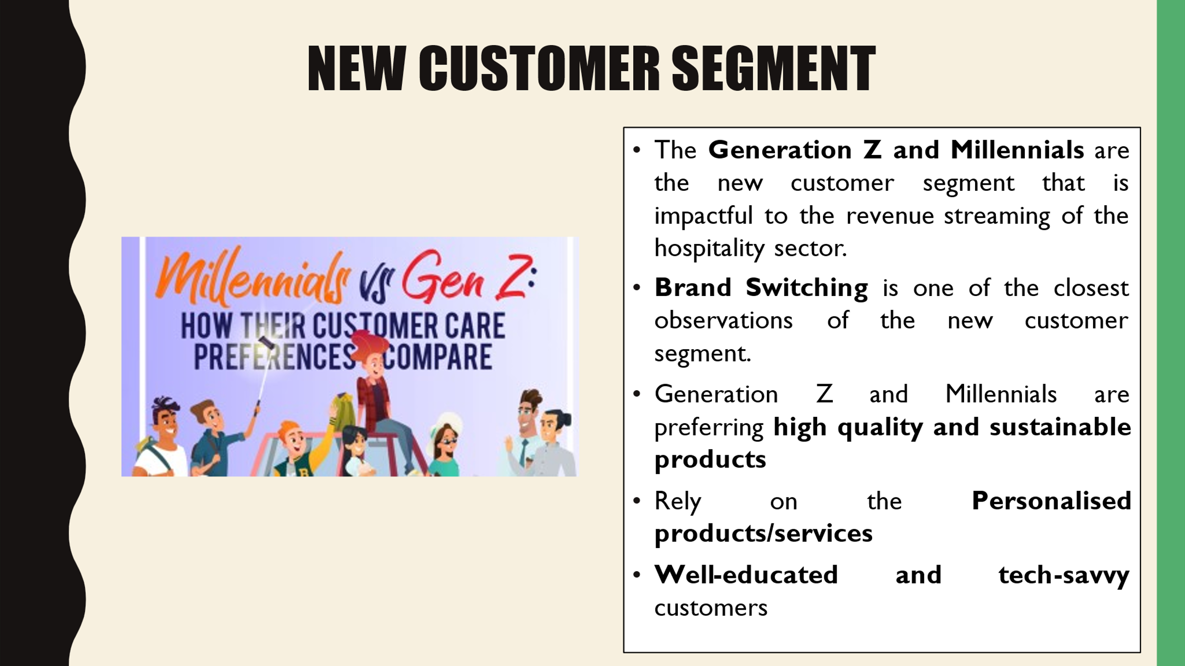
Customer Segmentation underlines the process of classifying the customer group by focusing on the key characteristics. Generation Z and Millennials are the new customer segment that is impactful to the revenue streaming of the hospitality sector. Moreover, Generation Z and Millennials used to rely on sustainable products/services. However, Brand Switching is one of the closest observations of the new customer segment.
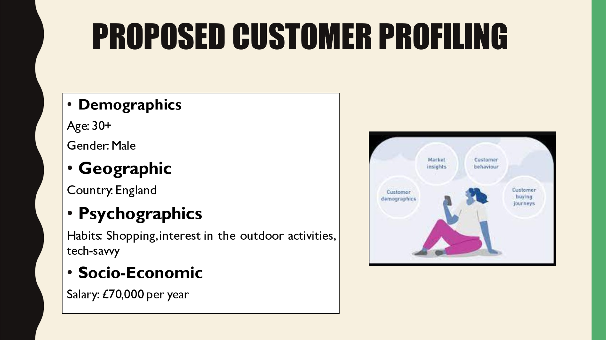
Customer Profiling is a focused marketing strategy that creates a profile of the customers based on anticipated consumer behaviour.
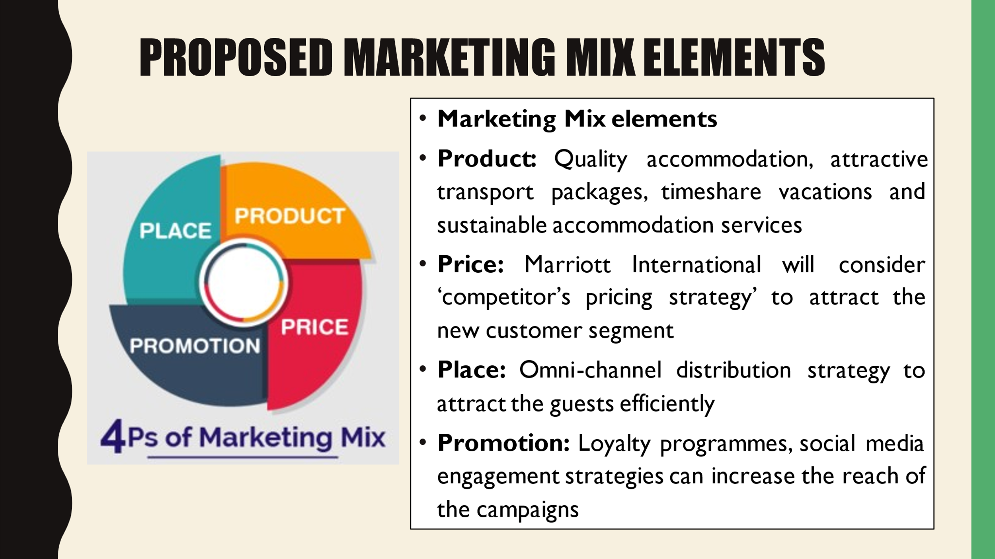
Marriott International will offer quality accommodation, attractive transport packages, timeshare vacations for the guests. Furthermore, Marriott International will emphasis on the ‘sustainable accommodation service’ to the new customer segment. Marriott International will position its brands into the high-price and low-price categories to attract the customer groups like Generation Z and millennials. Moreover, Marriott International will redesign the loyalty programmes as a part of the sales promotion strategy to create a hedonic effect on the mind of the customers. Lastly, Marriott International will rely on ‘omni-channel distribution’ strategy to accelerate the reach and availability of the services.
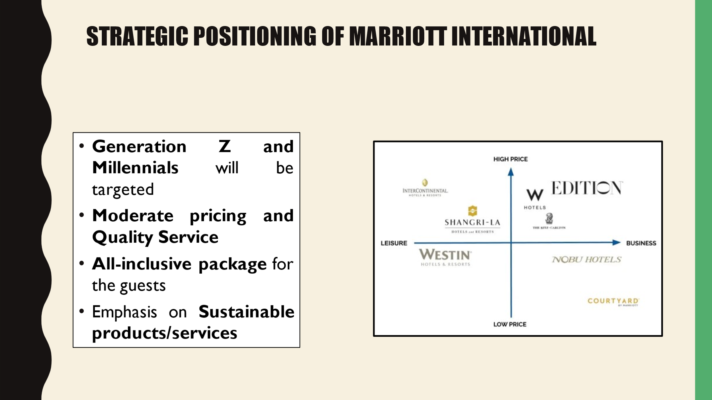
The strategic positioning of the company can be formulated based on price and value. The position 3 ‘hybrid’ option will be effective for Marriott International to attract the new target segment. The competitive price and focused differentiation can influence the new target segment of Marriott International (Leek, 2019). Moreover, a balance between differentiation and cost can be beneficial for Marriott International to maintain good profit margins.

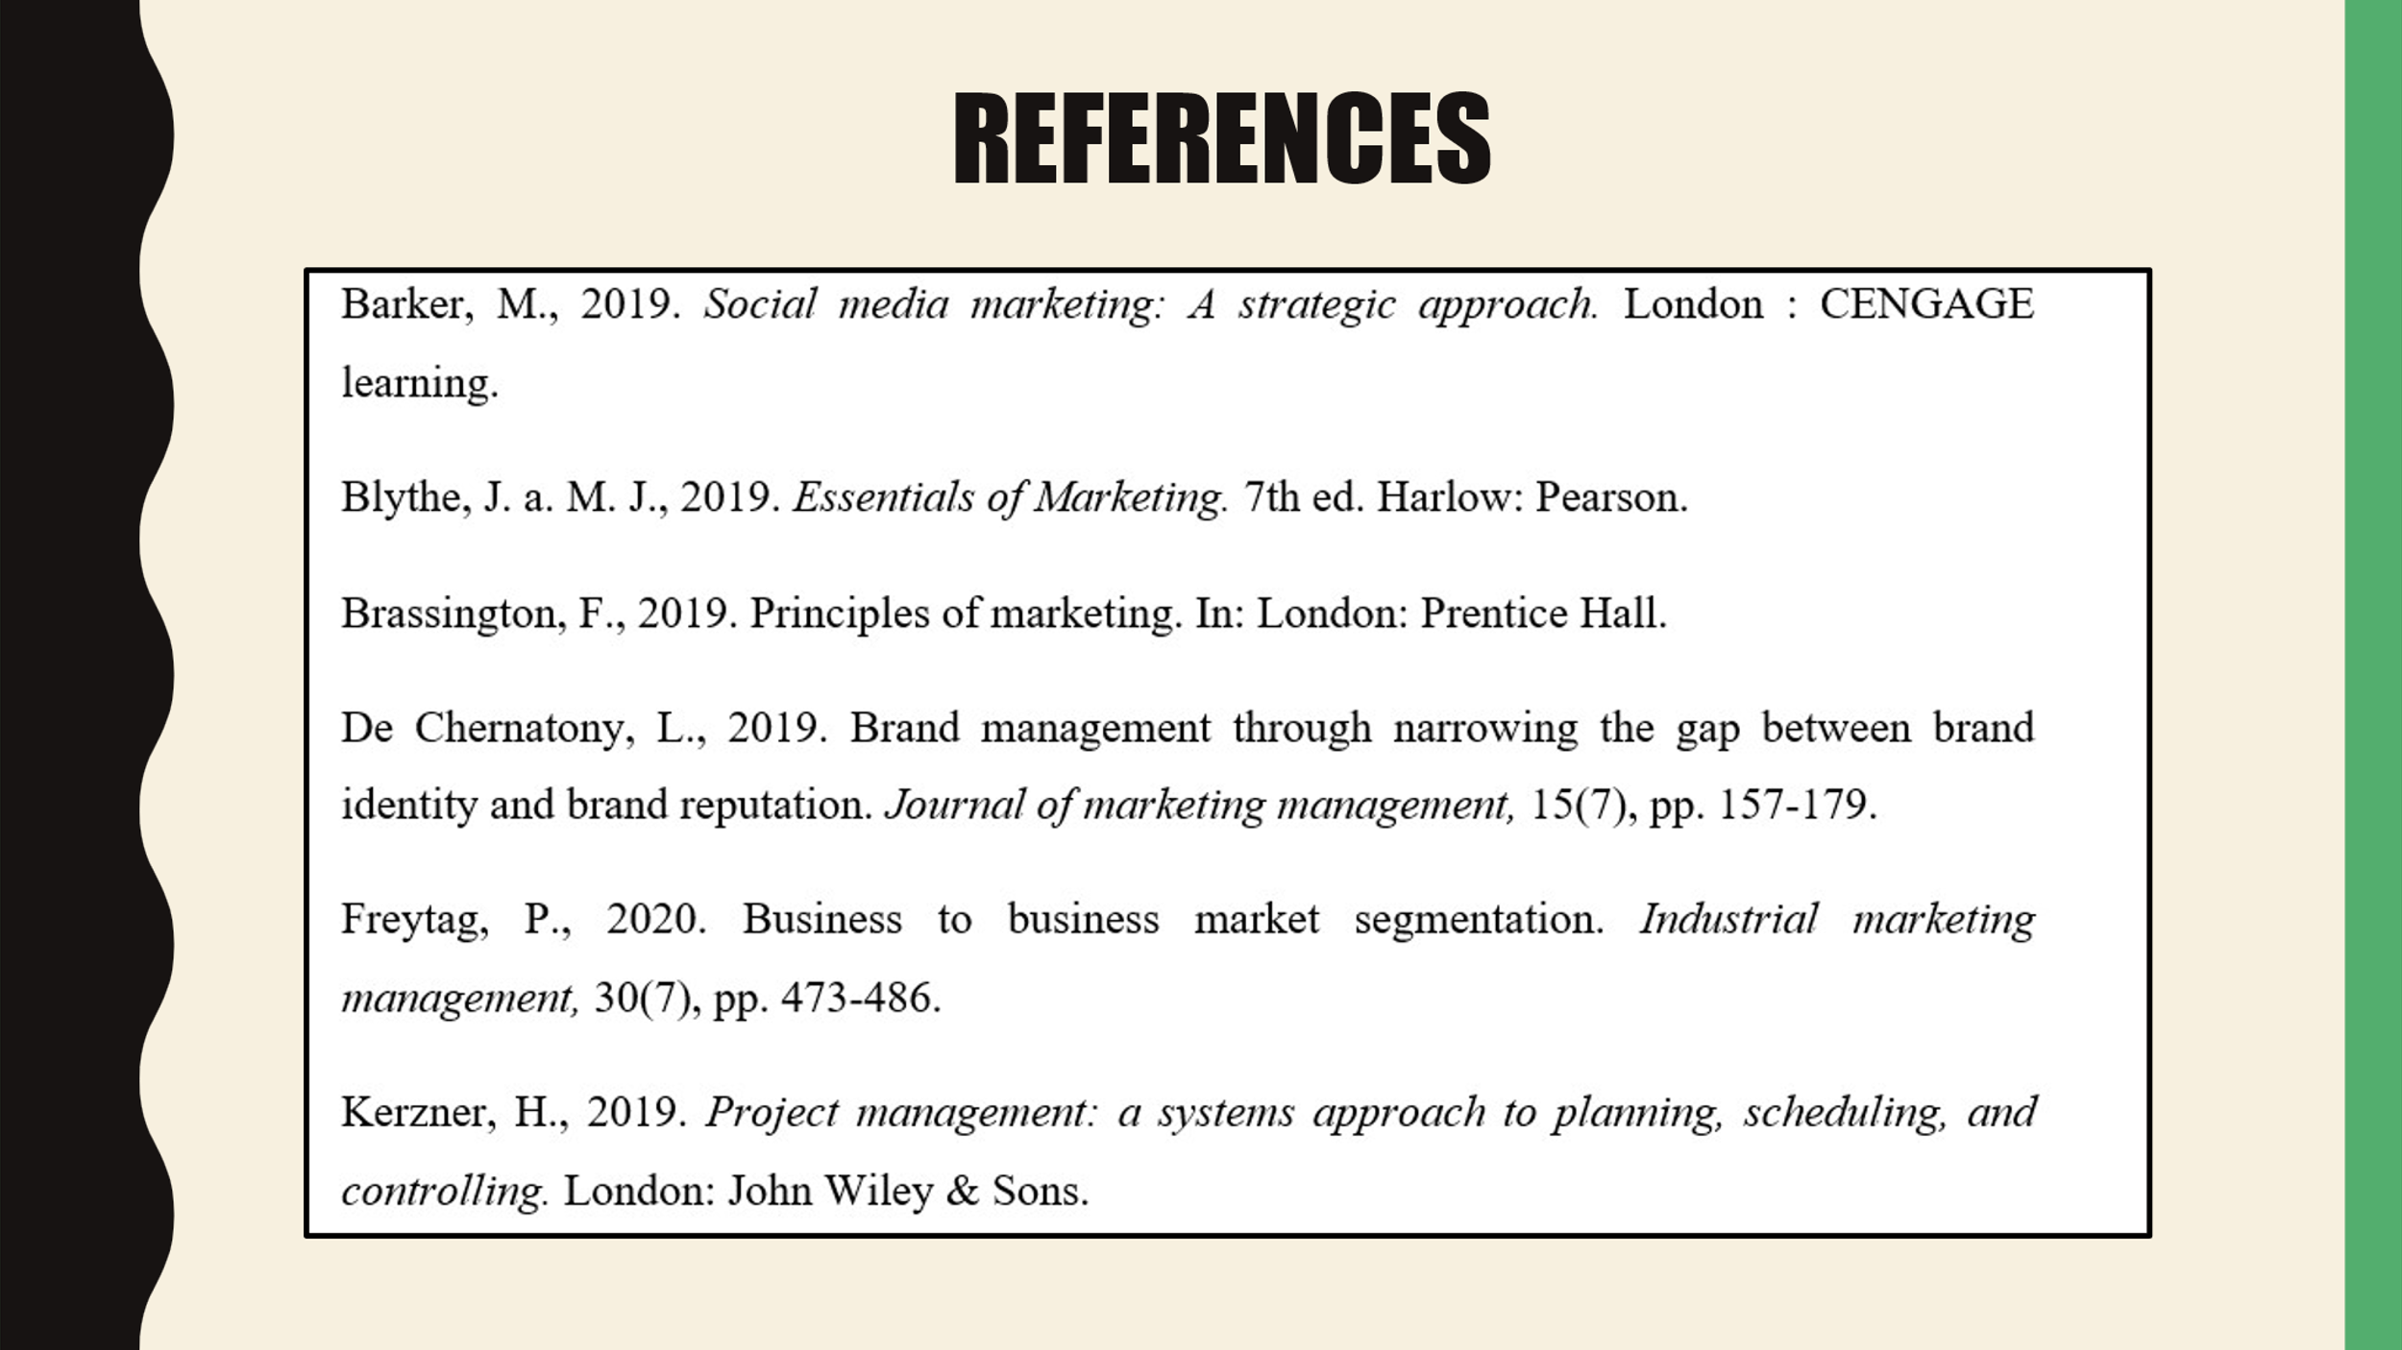

References
Assaad, W. a. G. J., 2021. Social network in marketing (social media marketing) opportunities and risks. International Journal of Managing Public Sector Information , 15(3), pp. 120-129.
Barker, M., 2019. Social media marketing: A strategic approach. London : CENGAGE learning.
Blythe, J. a. M. J., 2019. Essentials of Marketing. 7th ed. Harlow: Pearson.
Brassington, F., 2019. Principles of marketing. In: London: Prentice Hall.
De Chernatony, L., 2019. Brand management through narrowing the gap between brand identity and brand reputation. Journal of marketing management, 15(7), pp. 157-179.
Freytag, P., 2020. Business to business market segmentation. Industrial marketing management, 30(7), pp. 473-486.
Kerzner, H., 2019. Project management: a systems approach to planning, scheduling, and controlling. London: John Wiley & Sons.
Kotler, P., 2019. Marketing Management. London: Pearson.
Leek, S. T. P. a. N. P., 2019. How is information technology affecting business relationships? Results from a UK survey. Industrial marketing management, 34(4), pp. 119-126.
Louro, M. a. C. P., 2019. Brand management paradigms. Journal of marketing management, 17(5), pp. 849-875.
Marriot, J., 2022. Offers. [Online]
Available at: https://www.marriott.com/hotels/hotel-deals/mlejs-jw-marriott-maldives-resort-and-spa/
[Accessed 08 06 2022].
Pagani, M., 2019. The impact of digital technology on relationships in a business network. Industrial Marketing Management, 67(2), pp. 185-192.
Payne, A. a. F. P., 2019. Customer relationship management: from strategy to implementation. Journal of marketing management, 13(4), pp. 135-168.
Rafiq, M., 2019. The scope of internal marketing: defining the boundary between marketing and human resource management. Journal of marketing management, 9(5), pp. 219-232.
Walsh, G., 2019. Disadvantaged consumers' experiences of marketplace discrimination in customer services. Journal of Marketing Management, 15(8), pp. 143-169.

