Knowledge Acquisition at NHS Wales:
Knowledge is closely linked to doing and implies know-how and understanding (Davenport & Prusak, 2000).

Knowledge acquisition also refers to the knowledge that a firm can try to obtain from external sources (Gamble & Blackwell, 2001).

The pyramid below gives a clear meaning to knowledge, information and data; although in an everyday language we seem to understand that the three mean the same thing.
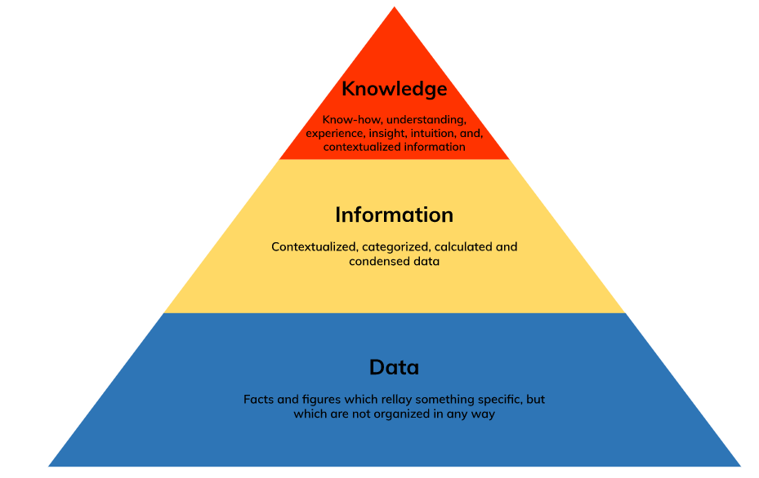

Knowledge acquisition is a crucial stage in the development of an expert system (Alison, 1987).

At NHS, knowledge acquisition follows the process of information processing, collection and analysis following the stages of:
- Input, storage and provision of information;
- Modification, structure and maintenance of information.
In order to acquire knowledge, NHS Wales develops the acquisition protocol to allow a better acquisition, provision and use of knowledge and/or information.
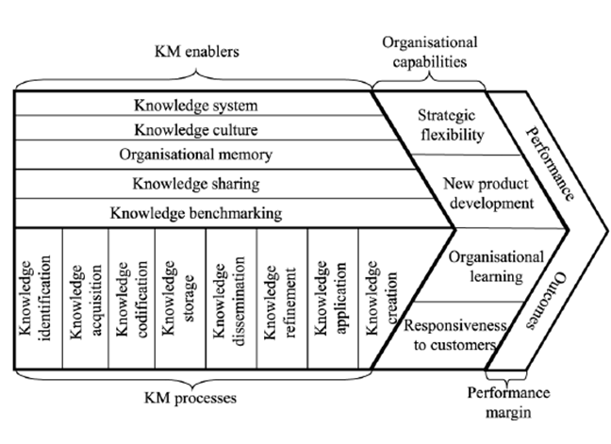
Knowledge acquirers need to gather and evaluate knowledge or information on the organisation’s use of and need for, and identify any current or potential future issues and opportunities including the extent to which they support legislation (GDPR), policies and procedures. They also acquire additional knowledge resources and technologies and integrate them appropriately into the overall system.

Where does NHS Wales get data/information/knowledge from?
The Welsh Health Survey is a major source of information about the health of people in Wales, the way they use health services, and the things that can affect people's health. The survey is a key source of information about the health of the general population in Wales. Data on health and healthcare in Wales is produced by many different bodies. Further data analysis tools such as specialist applications used by the NHS and Welsh Assembly Government relating to data quality and performance management; along with further resources on other NHS datasets are available to NHS staff via the All Wales intranet service (Wales.Nhs.Uk, 2012).

What sort of knowledge does NHS Wales acquire?
As well as data collected from health services and sources such as birth and death registrations, the Assembly produces information from specific surveys. The Welsh Health Survey is a major source of information about the health of people in Wales, the way they use health services, and the things that can affect people's health.

How does NHS Wales ensure this is accurate/up-to-date/reliable?
The NHS dataset is across the social spectrum, from birth to death. While other datasets are more fragmented, the NHS Wales database has comprehensive patient records that go back decades. From smaller healthcare firms, which are vying to develop health mobile phone apps to higher technology tools, NHS Wales uses developed comparison tools to keep data accurate and reliable thanks to annual reviews of data register (Julia Kollewe, 2019).

Does NHS Wales use internal or external sources, or both?
In accordance with the National Information Security Policy, NHS Wales uses external sources of data/information (Information Governance Management, 2019).

According to Wales.Nhs.Uk (2022), NHS Wales only acquires and process the personal data that is necessary for the particular task that it is carrying out. Data is acquired through:
- Information provided directly by the individual,
- Information provided by other NHS organisations (e.g. Health Boards)
- Surveys and research

If NHS Wales uses manuals as a knowledge source, does it use other explicit knowledge (combination) or tacit knowledge (externalisation) to develop this?
NHS Wales does not use manuals as a knowledge source, but uses KP’s information systems as an electronic health record. KP’s information systems are centred on the detailed patient record, known as the electronic health record (EHR) which contains the full patient clinical record (NHS Alliance, 2008).

Does NHS Wales have scheduled meetings for knowledge sharing (socialisation -tacit to tacit)?
Yes, information about people’s health and care helps NHS Wales to improve individual care, speed up diagnosis, plan their local services and research new treatments. As the NHS Wales cannot analyse all information on its own, so it safely and securely share some with researchers, analysts and organisations who are experts in making sense of complex information (Nhs.Uk, 2021).

During the COVID-19 crisis, Zoe Covid launched a tool to collect information via an app, which information was shared with the NHS.

Is knowledge valued/given high currency in the organisation?
Applying the 5 C’s process during the knowledge acquisition, NHS Wales insures that information is contextualised, categorised, calculated, corrected and condensed to make information be accurate, relevant, complete and available. At NHS Wales, data is acquired and stored to help easy access and use in time of need. NHS Wales also plans and reviews the acquisition of knowledge to allow development and organisation of the acquired knowledge for a safe use.

Comparative element:
NHS Wales is different from NHS England in terms of data acquisition. In Wales, data is acquired from the patient, while in England; data is acquired from General Practice Data for Planning and research (GPDPR), which is sometimes out of date.

A written statement made on June 2021 by the Welch Minister for Health and Social Services says: “NHS Digital does not have any authority or responsibility in Wales. However, Welsh residents who are registered with GPs in England will need to opt out by 1 September if they do not want their data to be included.”

References
Health in Wales (2012). Sources of Data. Online article available at : http://www.wales.nhs.uk/statisticsanddata/sourcesofdata#:~:text=Welsh%20Government,-The%20Statistics%20Directorate&text=The%20Welsh%20Health%20Survey%20is,that%20can%20affect%20people's%20healthh [Accessed 04 June 2022].

Allison, L. K. (1987). Knowledge Acquisition for Expert Systems, p.1, Plenum Press N.Y.

Julia Kollewe (2019). NHS Data. Online article available at: https://www.theguardian.com/society/2019/jun/10/nhs-data-google-alphabet-tech-drug-firms [Accessed 03 June 2022].

NHS WALES UK (2019). NHS Wales Information Governance Policy. Online article available at: http://www.wales.nhs.uk/sites3/Documents/950/All%20Wales%20Information%20Governance%20Policy%20v1.pdff [Accessed 07 June 2022].

WALES.NHS.UK (2022). Privacy Statement. Online article available at: https://www.wales.nhs.uk/privacystatementt [Accessed 03 June 2022].

NHS ALLIANCE (2008). Integrated Care Organisations: the importance of integrated information systems. Online article available at: https://www.networks.nhs.uk/nhs-networks/nhs-alliance-specialists-network/documents/Information%20systems%20in%20ICOs.pdf
[Accessed 03 June 2022].

NHS.UK (2021). Sharing your Health Records. Online article available at: https://www.nhs.uk/using-the-nhs/about-the-nhs/sharing-your-health-records/ [Accessed 02 June 2022].

Beth Kurtz-Costes (2015) Knowledge Acquisition. Online article available at: https://www.sciencedirect.com/topics/social-sciences/knowledge-acquisition [Accessed: 02 June 2022].

Morgan, E. (2021). Written Statement: Sharing Patients Details in Wales. Online article available at: https://gov.wales/written-statement-sharing-patient-records-wales [Accessed 07 June 2022].

