

UNIVERSITY OF WALES TRINITY SAINT DAVID
School of Engineering
E-Business Development and Impact
Student: GEORGIANA FLORINA CUNE
1805121
Logistics and Supply Chain Management
5 November 2018
MANAGEMENT & e-BUSINESS (M4X01274)

Abstract
Companies are implementing warehouse management systems (WMS) as part of e-Business strategies and solutions. Warehouses are essential in the operations of retailers and manufactures and developing the most efficient systems leads to increased productivity and accuracy, together with real-time stock and inventory updates. Organizations are using ‘On-premises’ or on ‘the Cloud’ WMS software, to help the company’s need and requirements, as integrated part of ERP or as individual system.

Table of Contents

1. Introduction 1
2. Overview 1
2.1. Supply chain execution – Warehouse Management Systems (WMS) 1
2.2. WMS in ‘the Cloud’ or ‘on premises’ 2
2.3. Software-as-a-Service (SaaS) and Cloud WMS 3
2.4. Case study 4
3. Discussion 5
4. Conclusion 6

Introduction
Technology advanced world of today has led many organizations to apply e-Business strategies and solutions to their businesses development in order to satisfy customer demands and enhance production processes, internal management operations, marketing and customer service. The efficiency of supply chain operations, as exchange of information, workflow and transaction costs was significantly achieved by implementing e-Business strategies (Linton, 2017). This paper describes and evaluates the developments and applications in e-Business that are impacting the logistical supply chain solutions and strategies.
The supply chain management (SCM) software is segmented between applications focused on supply chain planning (SCP) designed to provide managers a long-term time vision and those focused on supply chain execution (SCE) which is more operational and allows tasks to be completed even in minutes. SCP software includes mainly tasks related to network and capacity planning, real-time demands and manufacturing planning, whereas SCE software usually includes inventory management systems, warehouse management systems (WMS) and transport management systems (TMS) (Manners-Bell, 2017). Computer-based information and communication technology (ICT) is an essential element for the management of logistical activities in transportation and within warehouses.

Overview

Supply chain execution – Warehouse Management Systems (WMS)
The warehouse management system is largely implemented by companies, such as retailers and manufacturers, as usually an integrated part of ‘…broader enterprise resource planning (ERP) system’ (Manners-Bell, 2017, p.225) and has become fundamental in managing various operations in the warehouses. This software system, according to Rushton et al. (2017) is used to control and manage with accuracy al the activities in warehouses, as follows:
- receiving (usually the initial phase in WMS): scanning the weight and dimensions of the items into the system, checking quality by sampling;
- put-away: algorithms to decide the best storage location;
- picking optimization of the most efficient picking route;
- value added services: labelling, kitting and final assembly (bills of materials);
- packing: identification of SKUs dimension by database and choosing the right packaging;
- cross-docking: planning and sortation;
- sortation by categories;
- dispatching: load planning, documentation and ASNs transmission;
- yard management: truck parking control and dock door allocation;
- stock counting: full counting and constant inventory;
- lot management: all management features regarding the planning of work, measure of performance, productivity scheme etc;
- multiple language capability: implementation of voice technology system used to recognise and understand sounds and foreign languages.
All this information processes are conducted by operatives using barcode or RFID (radio frequency identification) readers – fully automated, computers, tablets, smartphones, label printers and voice technologies through which the time, costs and errors in information managing is reduced. (Mangan et al., 2012).

WMS in ‘the Cloud’ or ‘on premises’
In recent years warehouse management software solutions are being accessed via ‘the Cloud’ rather than ‘on premises’. Although some companies still provide warehouse solutions using ‘on premises’ servers that can sustain more on-site fulfilments and offer more system backup security (Avectuos, 2016), the costs will frequently be higher because it involves the acquisition of licenses and hardware, investments in infrastructure and permanent maintenance costs (Răfoi, 2017).
‘The Cloud’ computing services are Internet based supported on secure servers by a third-party software company supplier and can have many users at different locations efficiently controlling information tasks. The Cloud software is provided as a Software-as-a-Service (SaaS) product and the applications include ERP systems used within the companies by employees with a ‘permanent desk location’ (Avectuos, 2016). As listed in Table 2.2. below and noted by Santagate (2017), IDC (International Data Corporation) anticipates that in 2019 cloud-based supply chain applications will grow compared with the on-premise setups, due to today’s improved speed, good performance and reliability of the Internet.

Table 2.2. Forecasts of Supply Chain Management Growth Rate partition in 2019 (%) (IDC 2016, source in Santagate, 2017)
 | Cloud | On-Premise
Logistics (transportation management systems and global trade management) | 19.8 | 4.8
Production planning (supply planning, demand planning, and sales and operation planning) | 16.4 | 6.3
Inventory management (warehouse management systems, inventory management and optimization, and supply chain optimization | 26.5 | 4.2

Software-as-a-Service (SaaS) and Cloud WMS
According to the IDC report research (Stangate, 2017) on Cloud WMS applications and as it seen in Figure 2.3.1., it is estimated that in 2019 the WMS applications in retail and manufacturing will grow at a Compound Annual Growth Rate (CAGR) of 6.47% and reach an excess value of global market of $1.32 billion with approximately 38% of the retail global market and 62% in manufacturing global market.
Figure 2.3.1. WMS revenue across the world by retail and manufacturing segment from 2015 to 2019 (IDC 2016, source in Santagate, 2017).
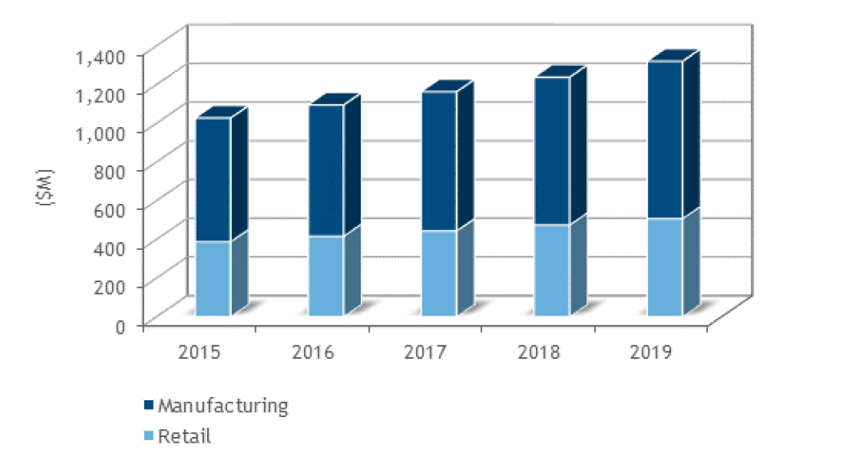

Figure 2.3.2. Global market for WMS revenue division by area, 2015 (IDC 2016, source in Santagate, 2017).
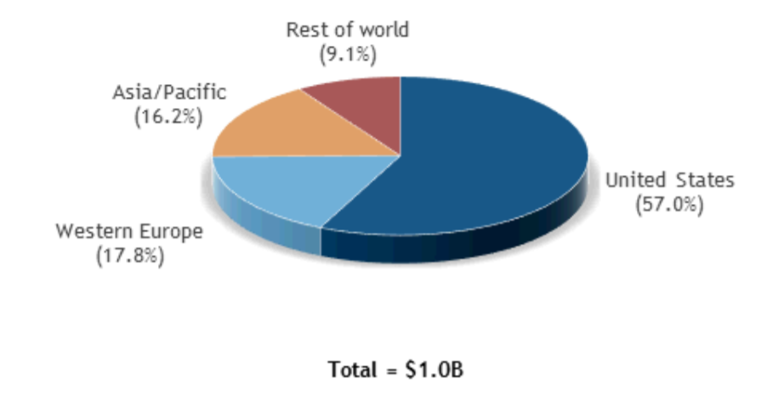
In Figure 2.3.2 it is represented the global market for WMS revenue distribution by area, showing that in 2015, United States had the highest concentration of WMS in the retail and manufacturing market at a share of 57%, followed by Western Europe – 17,8% and Asia/Pacific – 16,2% (Santagate, 2017). Therefore, the adoption of WMS in ‘the Cloud’ will be influenced by the share of global market for WMS, where the Internet connection is strongly reliable and constantly available.

Case study
In Sanpfulfill (2018) and Richards (2018) it is presented the case of a company’s decision to implement a cloud-based WMS. The Costwold is an online retailer company which sells accessories and wood furniture for house decoration and whose warehousing operation is situated in West Midlands, UK since 2013. The company’s growth in 2015 has led to the opening of another 55,000 sq. ft facility along its main 90,000 sq. ft warehouse, which both manage approximately 1,200 SKUs and 1,800 orders every week, increasing to 3,000 during the peak seasons.
The Costwold Company decided to implement Snapfulfil Cloud WMS software, a cost-effective and innovative technology solution, in order to improve the accuracy and productivity in the warehouse. Prior the implantation of the Cloud system, the company was using SAGE accounting system to run the warehouses. The paper-based processes had no real-time stock visibility and, picking and inventory was not accurate due to human errors.
As a result of Snapfulfil application, The Costwold Company has significantly improved accuracy and productivity by running simultaneously goods in replenishment and picks. The counting functionality of Snapfulfil’s structured cycle has considerably increased the receiving capacity, from 3 to 8 containers per day, while eliminating the requirement of an annual stock take and the related loss of revenue. Another efficient functionality of the Cloud system is the returns management task which supports customer service and supplier performance, as well as optimised integration and real-time stock visibility and detectability.
According to Paul Wilson, the Costwold’s warehouse manager, the company is 30% leaner because it operates with less people to control and allocate resources within the warehouses, improving the operational efficiency and reducing the overtime bill.
Richards (2018) notes that, although SaaS offers numerous advantages as entry lower costs, scalability and minimum software maintenance or instant upgrades, it is possible that the security of the data to be affected and constant upgrades can have consequences on the running processes. Another aspect to be emphasized is that some providers are particularly producing cloud-based software whereas some are just moving the ‘on-premises’ to ‘the Cloud’.

Discussion
The introduction of ERP systems has been an important expansion within the e-Business companie allowing to store data from each sector into a single computer system, ‘which then gives a single source for all key business information activities, such as customer orders, inventory and financials’ (Rushton, 2018).
The increasing number of e-commerce orders is leading companies to adapt new strategies and solutions into their logistical and supply chains in order to satisfy the customers increasing demands and to adapt to the competitive market. As Manners-Bell notes: ‘The higher volume of e-commerce orders is affecting this need for speed to fulfil, and the layout of the warehouses is becoming of great importance (Manners-Bell, 2017).
In the modern warehouses, the implementation of Warehouse Management Systems is becoming a major factor for companies to efficiently improve accuracy and productivity. Many WMS packages have complex functionalities for processes that can be switched on and off for certain applications (Rushton, 2018) and are able to store and process quickly data for each phase of the warehousing operation.
As it can be noted from the Costwold Company case study, adopting a Cloud management system to coordinate the operations within the warehouse, has been an efficient progress for the company’s development. It is important that when deciding for a right WMS, according to Richards (2018) to understand the present and future needs or requirements of the company. He also notes that the interference with other operation systems, such as ERP and TMS is critical, as well with accessibility to stored data and operation with the highest number of users. Other essential factors are that a WMS should calculate the return on investment (ROI) and work in real time, offering constant inventory updates.
Thus, the system is seamlessly adopted by some companies, others are experiencing problems with its implementation within the company, due to security and data loss concern, still operating the ‘on premise’ systems.

Conclusion
The integration of management systems with e-Business has been made to meet customer demands and fulfil orders, as well with improving the efficiency of logistic activities and supply chain operations in retailing and manufacturing. As part of the of the supply chain execution (SCE), warehouse management systems (WMS) are integrated to enhance productivity, to provide accuracy and real-time visibility in the stock records, to optimize the picking process and customer service. WMS are offered integrated as part of ERP operated through computers, automated systems or RFID or some providers offer the system on its own. In the last years, companies have started using software on ‘the Cloud’ or software-as-a-service (SaaS), over the ‘on premise’ WMS.

References
- Avectuos (2016) ‘Cloud-Based or On-Premises? Choosing a Warehouse Management Software Solution’, Avectous Integrated Software [blog]. 12th September. Available at: http://avectous.com/blog/cloud-based-premises-choosing-warehouse-management-software-solution/ (Accessed at 31 October 2018).
- Linton, I. (2017) The Impact of E-Business. Available at: https://bizfluent.com/info-8270572-impact-ebusiness.html (Accessed: 29 October 2018).
- Mangan, J. et al. (2012) Global Logistics and Supply Chain Management. 2nd Ed. West Sussex: John Wiley & Sons, Ltd
- Manners – Bell, J. (2017) Introduction to Global Logistics. 2nd Ed. London: Kogan Page.
- Răfoi, A. (2017) An objective comparison between cloud and on-premise WMS solutions. Available at: https://www.linkedin.com/pulse/objective-comparison-between-cloud-on-premise-wms-solutions-rafoi (Accessed at: 30 October 2018).
- Richards, G. (2018) Warehouse management. 3rd Ed. Hampshire: Kogan Page.
- Rushton, A. et al. (2017) The Handbook of Logistics and Distribution Management. 6th Ed. London: Kogan Page.
- Santagate, J. (2017) IDC Perspective - WMS in the Cloud. Available at: https://www.oracle.com/webfolder/s/delivery_production/docs/FY16h1/doc36/WMSinthecloud.pdf (Accessed at: 31 October 2018).

