Francesca Giannattasio 1814533
Francesca Giannattasio
[Company name] [Company address]
marketing research
Lecturer Joy Botu
Module BMSK4003_Digital skills and Research Methods

Contents
Introduction 2
Marketing research 3
the DIKW model for Knowledge Management 4
Aim and Objectives 5
Method 6
Result 7
Discussion 10
Conclusion 11

Introduction
In opening a new business, entrepreneurs have to deal with a myriad of unanswered and uncertain questions in regards what the future holds such as: what are the potential of success, how customers would judge the new services provided and the most haunting ones, the location to open the activity. To have a vision of these possibilities, marketing research becomes a crucial constituent to have a view of the Global market. Essential in the creation of a blueprint of the business where it is used to gather information in the prediction of important business goals and become aware of profit opportunities or risk factors in a given market to develop qualified marketing strategies. The most functional and most used methodology for the execution of market analysis involves the integration between the quantitative method and the qualitative method; A market survey is a clear example of effective collaboration between data and info breakdown gathered from the targeted customers. A collection of secondary data has been collected to provide a generalised view of the targeted demographic. A primary data from an online survey collected to evaluate the feelings of the targeted customers in regard of the new services provided by the opening of this premises and the possible impact on the existing market, and so foresee its competitiveness position among competitors. Therefore, the following research is conducted to highlight the steps taken to collect this information. Further evaluation of the advantages and disadvantages of using these research methods have been analysed to have an empirical understanding of the objectives questioned above. The conclusion should marvellously lead to an interpretation of the insignificant amount of data collected into information, bringing knowledgeable input to the equation which if correctly resolved would open the mind to answer these questions wisely and confidently.

Marketing Research

Many entrepreneurs in the foundation of small businesses take into account only the skills and the needed financial capital, but to predict how successful or not it might be, should not be unknowingly left to Fate According to Covello & Hazelgren (1995), the omission of business the plan is the reason behind the numerous bankruptcies in the first five years of opening. A successful entrepreneur should instead consider several factors
before launching a new product/enterprise; Therefore, he would have sought a
unique selling point and also an action plan in the event of unforeseen circumstances. Through self-study the marketing strategies and financial economies of the industry he would carefully organise and oversee the aspects of the present and updated image of the business as a critical factor to evaluate the opportunity and risk at stake when validating project objectives.
However, to gain control over the multitude of data available nowadays, it is essential to understand how finding, evaluations and analyses data correctly to extricate the information sought and how Critical thinking is required to succeed. According to Morgan, P.(2017) in quoting Bloom Taxonomy, (Bloom et al. 1956 p81) and its hierarchical set of skills with its associated verbs, suggested people who reached knowledge thanks to an excellent memory they may lack evaluation or analyse skills. In this case, the DIKW model for Knowledge Management (Clark2004) “Data-Information-Knowledge-Wisdom-Data” is key to enhance these critical thinking skills and consequentially be able to conduct researches; here, a brief explanation of the model regarding this study:

DATA & INFORMATION

Since the invention of computers, the word Data is being
used to identify stored information of facts which left on their own have
meaningless use. This passage is important to capture relevant data in a precise context so that it can be processed into information.
Divide into two categories primary and secondary data, in marketing research, primary data define either a recollection of personal experience related to a fact or having collected these information first hand from the use of a survey, questionnaire, face to face interview or by phone and it usually offers a qualitative response.
Secondary data instead define what others have researched regarding a topic as an example in Statistic Celsius and is mostly used for quantitative
When finally, able to process the collected data in a meaningful context, this becomes information. At this stage, evaluation and analysis of the info gathered should follow to check its composition, reliability and stored in an email, document, spreadsheet etc. for future references.

KNOWLEDGE & WISDOM

In marketing research for information to become knowledge, the person should have familiarity with the topic. Furthermore, personal experiences, the perception of reality and emotional intelligence would play a major role in how information enables to comprehend the fact. The fusion of knowledge with critical thinking skills will not just show the expected result but would enable wisdom to make the right choice for the future or the business.

Advantages and Disadvantages of marketing research before the opening of a business

Advantages | Disadvantages
- Grater profitability for a company  - Mitigates Risks  - Improve sales  - Measure Brand Reputation | - It could be pricey  - takes time  - Can only target a small population

Aims and Objectives

The collection of secondary data through demographic research is to establish where to base “Kids Lounge” venue and from an online survey find out the likeliness of the unique selling point Creche and Restaurant service from the targeted customers.
- Secondary data from Census have been collected to see target customer density population between Croydon and Bromley Boroughs.
- Secondary data from Zoopla website have been analysed to compare the commercial properties prices
- Primary data has been collected from an online survey.

Methods

Firstly, a few reading of the meaning of marketing strategies and acknowledge how to conduct marketing research should be researched on the web, as many suggestion and directives are shared from the wisdom of the marketing community. QuestionPro an online survey software was suggested for the creation of a survey and after an easy free subscription of the basic services, lead to a platform where create the questionnaire which can be easily shared on platforms such as Facebook, Messenger, Outlook. The receivers will answer the questions, and after the survey, the answers are collected and analysed by the software and elaborate in tabular form. Quantitative research of secondary data has been conducted by visiting the website of Bromley and Croydon council to collect and compare data of the targeted customer, which range comprehend children between the age of two to ten years old and carers and investigate the percentage of families in a financial difficulty living the boroughs.
Same steps have been followed to collect information by visiting the website Zoopla where it's been investigated the price of the property to evaluate from a costly by choosing as a possible location for the business Bromley, Croydon and Cristal Palace,
Result
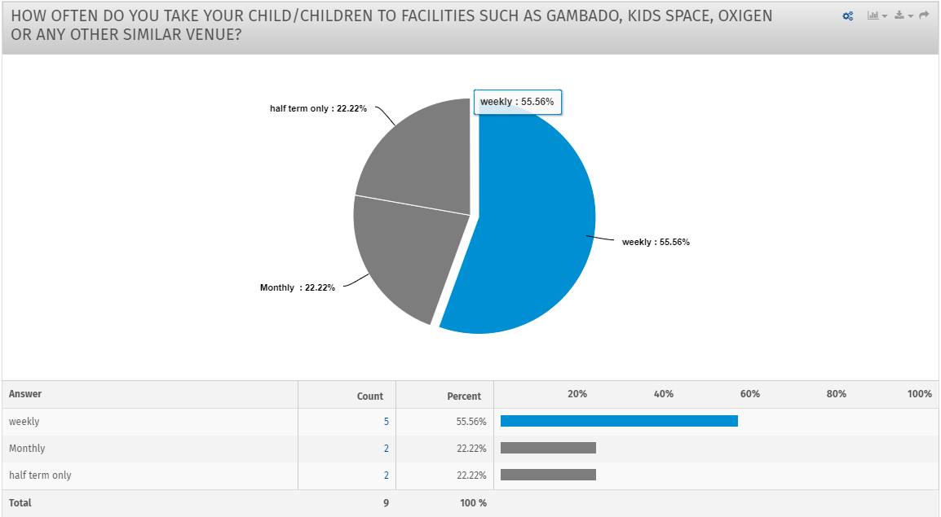
From the first question of the survey, 55% of the participant use the competitor's children sites leaving the remaining 45% visiting the venues maybe monthly or and occasionally during the half-term

In the second question, the response for the likeliness of the services offered from Kids-Lounge had reached the unanimity of loving the idea.

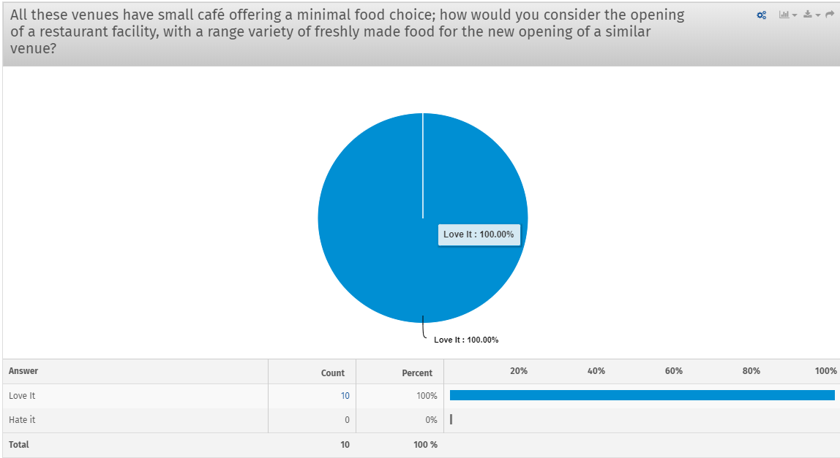

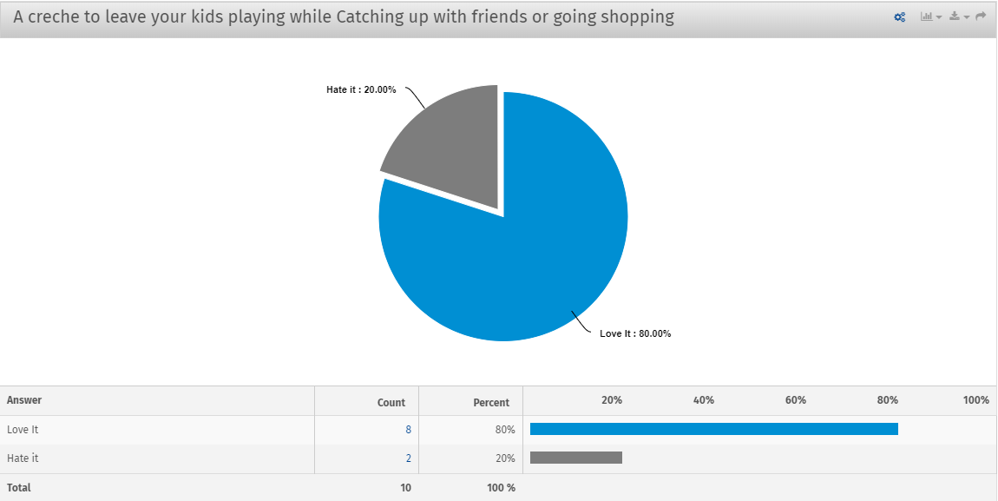
The unique selling point as creche service reached 80% of likeliness and 20% disregarded the idea.

At the question of many children under the age of twelve in the household shows that the 50% of the people have only one child, 20% have two children, and 30% have three children falling under the category which are the potential customer.

At the question where do you live 70% of customers live in Croydon against the 30% living in Bromley

Secondary data graphic results
Commercial properties in Croydon annually cost half price of the rent in Bromley, where Cristal Palace is instead twice expensive than Croydon and a once than Bromley.

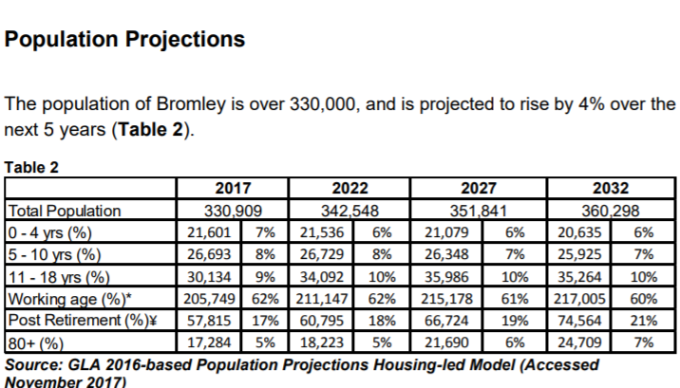

Croydon’s Population disaggregated by five years age band and gender
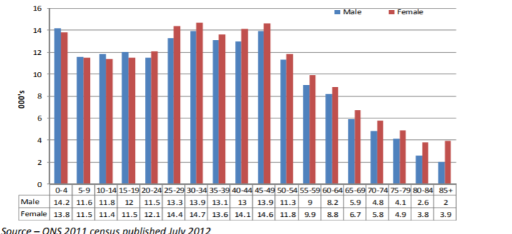

Discussion
The Survey we generated to ask parents and carers five questions to understand the
effectiveness of the new services offered from kids-lounge compared the
services offered from the established competitors and from quantitative research of
secondary data to evaluate where to open the business. The results of the survey were
unsatisfactory if we want to consider the time consumed in the elaboration and preparation
of the questionnaire classifying the right audience. On 100 invitation sent through the various platform, only the 10% have replayed, compromising the attainability of the response. To improve the future experience, it may better option a face to face or phone interview to reach the number of response desired. Regardless, from the few feedbacks is possible to establish that all the participant use the competitor's services.
In the second question regarding the likeliness of the unique selling point and restaurant facilities provided by the new business reveals a poor collection of data making the result vague and irrelevant, it would have been better if the participant had expressed their opinion by scaling from one to ten their appreciation of the services. In the evaluation of the third question, the response has a valuable piece of information, considering that the targeted customers are families. All the participants who have taken part in the survey have children below the age 12 if we multiply by 100 empirical responses, it is already possible to quantify a hypothetical total of 150 possible customers for the creche service and 200 customers being the parents using the restaurant facilities. In support of this finding, secondary data of the demographic area of Bromley and Croydon have been collected from Census Information. Both boroughs have a high birth rate counting 15% of the population of Bromley in preschool age and counting of an increase for the next few years. Croydon reaches the winning spot by having 28% of the population being in preschool-age although 16% of the families in Croydon experience financial distress, where Bromley shows only 2.3% of unemployment.
In regard of how pricey can be an area compared to another, I was aware that Bromley and Crystal Palace are quite sophisticated where Croydon since 2008 has slowly declined, and its shopping centre is falling below the standard expectation, never less it is the only location that offers the annual rent as budgeted in the business plan.
Conclusion
Trough, an attentive evaluation and analysis of all the data collected, have concluded that even though the population is well off in Bromley, Croydon can offer a vast property to rent for a reasonable price and a high density of population of target customers. Taking a relatively amount of time to conduct this research and being a first attempt in elaborating such a difficult task in the light of this investigation and findings I believe that I can be satisfied with the result. Afterall in marketing strategies, there is always something to research for, and the opening of a new business would lead to many other questions that are suggested to seek expert advice.
References
Covello & Hazelgren (1995) cited by Haag, A.B (2013 p482) “writing a successful business plan” certificate in higher education Sage London Sage
.
Morgan, P.(2017 p81) The business student guide “theoretical frameworks for critical thinking
Sage Publication Ltd London Sage.

Clark (2004) the DIKW model for Knowledge Management available at
http://www.theitsmreview.com/2016/04/dikw-model-knowledge-management/ (accessed on 30
August 2019)

