Marketing Plan - Premier Inn Hotel

Student Name
Lucian Mihaita Stefan

Student ID number
2234126

Marketing Essentials BMIH4005

Assessment 2

Lecturer
Ruth Taylor Davies

Table of Contents
Component 1 Presentation 3
Summary of the Marketing Plan 3
Introduction 3
Conclusion 4
Component 2-Marketing Plan 5
Introduction 5
Situation Analysis 6
Customers: Segmentation and Targeting/ Customer profile 7
Porter's five forces 7
Collaborators 8
PESTLE Analysis 8
Smart Objectives 9
Strategy 9
Tactics 10
Action 10
Conclusion 11
References 13
Appendices…………………………………………………………………………………………………………………………………….15

Component 1 Presentation

Summary of the Marketing Plan

Introduction
The marketing plan proposed by the report has aimed at improving the awareness of the brand in the new locations of Ireland and the UK where the Premier Inn is opening its new hotels. A proper systematic approach for creating the marketing plan was used. To conduct the situational analysis for the hotel use of following strategic framework such as:
- SWOT Analysis
- PESTLE Analysis
- Porter’s Five Forces
In addition to the macro environment analysis, the use of the SMART framework was done for highlighting the setting of specific goals that would help marketers effectively align their marketing strategy.
The report has also provided a comprehensive understanding of the use of specific value propositions for attracting the potential customers that the brand attempts to attract. Various channels of digital marketing strategy were used for promotional purposes to increase the reach and leverage the growing trend of online use by customers. Premier Inn has focused to improve the engagement rates and website reach that would help the brand in achieving greater visibility in the new cities (Jobber and Ellis-Chadwick, 2020).
The process of creating a marketing plan goes through a number of stages that includes the following stages
- Identification of the marketing goals and objectives
- Use of situational analysis for strategic development
- Use of STP (“Segmentation, Targeting Positioning”)
- 4P’s of Marketing mix Model
- Action plan
- Setting of key performance indicators for evaluating the performance and monitoring the marketing plan

Conclusion
The marketing plan that has been designed for Premier Inn has been curated by following a systematic process of marketing designing.

Component 2 - Marketing Plan

Introduction
The chosen brand Premier Inn is one of the largest hotel brands in the UK that provides full hotel and resort services. The hotel has more than 72,000 rooms and 800 hotels that are located in different locations of the country. Premier Inn is opening new hotels in the locations of UK and Ireland for which the marketing plan will be curated in the given report. The use of a marketing mix model of 4ps and proper customer segmentation will be carried out in the report to effectively reach the target audience that the brand aims to reach through the help of the marketing plan.

Situation Analysis
SWOT Analysis
SWOT Analysis of Premier Inn
Strengths  - Large hotel chain and strong position in the UK  - Good brand image and positive reputation | Weakness  - Very limited presence at a global level  - Issues of refunding
Opportunities  - Newer marketplace and growth in Germany  - Investments on digital marketing | Threats  - High competition  - High inflation rate at UK
Table No1: SWOT Analysis of Premier Inn
(Source: Self-Created)
Analysis
Premier Inn has a very high occupancy rate of 76.3% that helps the brand to hold a good position in the hospitality sector of the UK. The brand has hotels in different locations of the country which provides hotels with the opportunity of working in a larger market. However, with a limited global presence, the brand has been facing difficulty while competing in the global market.
In addition, the brand faced issues in the refunding of bookings during the covid times which has impacted the perception of the customer towards the brand. The growth of the country in Germany and higher investments in digital marketing have created opportunities for the brand to increase its customer base. The presence of many competitors like ACCOR, Days Inn Worldwide Inc. and Travelodge Hotels Ltd. and an inflation rate of 11% in the UK has been posing threats to the survival of the business as it has reduced the spending power of the customer in travel and leisure related activities (Gowrea, 2023).

Customers

Segmentation and Targeting - Customer profile
Segmentation
Customer segmentation is done on the basis of two categories, one for business and other for leisure. Four key variables that can be included in the process are price sensitivity, use of additional products or services that are preferred, demography and geographical dividend.
Targeting
The target customer group of the Premier Inn includes business travellers, tour groups and individual tourists. In addition, the brand will also focus on travelling families who are in search of a hotel for spending quality vacation time with their families.
Customer Profile  Name: David Smith | 
About
Like to spend quality time with family members by travelling into novel places and aims to follow sustainable approaches wherever possible.
Demography  - Age:39  Gender: Male  - Occupation: Software Engineer  - Annual Income: £39190  - Education Level: M.Tech | Motivations  - Adventure and Travelling  - Reading books  - Moto Ride
Table No2: Customer Personal
(Source: Self-Created)

Porter's five forces
Forces | Discussions
Bargaining power of the suppliers | Since the industry is overcrowded with lots of market players, getting reliable suppliers is difficult for hoteliers. Hence suppliers enjoy High power.
Power of customers | With many service providers for hotel services, customers enjoy high bargaining power.
The potential of new entrants into the industry | The initial investment that is required to enter the hospitality industry is high. However, technology has made it possible for new players to get access to potential customers and resources. Hence, the power of this force is said to be moderate (mordorintelligence.com, 2022).
The threat of substitute services | Differentiation of services in hospitality is very difficult because which threat of new service substitution is low.
Competition in the industry | Since there are many competitors who offer similar services, the competition is high.
Table No3: Porter’s Five Forces
(Source: Self-Created)

Collaborators

There exists a strategic partnership between Premium Inn and Emirates Group which has helped the brand to improve its brand awareness in the middle east region. The hotel has also partnered with Clean Linen services to improve the quality of room services.

PESTLE Analysis
Factors | Discussion
Political | The onset of the Brexit regime has led to the implementation of an immigration policy in the UK which has created a shortage of staff in the sector.
Economical | Premier Inn is largely dependent on the UK economy for its revenue earning. The economic recession and high inflation rate of 11% have impacted the operations of the hoteliers as well as reduced consumer spending power.
Social | The UK has an internet penetration rate of 98% which facilitates online services for bookings and other services related to hotels (Neves, 2022).
Technological | The UK stands in fifth position on the “Global Innovation Index” of 2019 among G20 countries where the development of technology has facilitated the creation of websites and technological integration, helping hotels to improve their services.
Legal | Premier Inn has been facing legal issues in relation to new “. The brand has not been able to comply with the norms of new rules “Point Based Immigration System” which is causing a shortage of workforce.
Environmental | The challenges in relation to the reduction of carbon emission and compliance with sustainability commitments as well as guidelines of the “Environmental Protection Act 1990” is what the hospitality industry like Premier Inn has been facing in the sector (Wang et al., 2019).
Table No4: PESTLE Analysis
(Source: Self-Created)

Smart Objectives
Specific | Measurable | Achievable | Relevant | Time Specific
Increase customer awareness | Increase the website traffic rate by 50% | Make use of digital market strategy | Reach targeted customers in areas where new hotels are being opened. | 6 months
Increase sales | Improve services sales figure by 20% | Penetrate into new marketplace and create more hotels | Improve investments in newer markets | 5 months
Table No4:Smart Objectives
(Source: Self-Created)

Strategy
Value Proposition
Premier Inn is known for their lucrative and attractive room feature that includes en-suite bathrooms, super comfy bed with duvet and quality services. All the Premier Inn hotels make use of an online booking system called Bart that helps customers to book their services easily (Smith, 2020). It also facilitates the payment of services, providing enhanced customer experience and convenience.
Being the UK’s biggest hotel brand, Premier Inn offers quality accommodation in some of the great locations of the country at affordable prices. Affordability and greater reach have been important elements that have helped the brand in gaining a competitive advantage over other brands (Twin, 2023). All the Premier rooms provide a convenient mini-fridge and the hotel also has a food service facility that is reputed for its delicacy and variety.
Premier Inn, through the help of its marketing strategy, would try to impart its value propositions to the targeted audience through the help of digital marketing campaigns. Following an omnichannel strategy where social media channels, SEO strategies, influencing marketing and content marketing would be used to impart knowledge about the unique features of their services (Jobber and Ellis-Chadwick, 2020).
The targeted audience of Premier Inn consists of audiences who belong to the middle-income range and for whom affordability is an important factor. Most tourists prefer hotel services where food and accommodation are provided at an affordable rate. The marketing plan would portray the unique features of the services provided by the brand and attract customers to enjoy their leisure time with ease.

Tactics
Marketing mix:
Product: Premier Inn will focus on introducing its hotel services in the new cities of the UK and Ireland.
Place: The brand would partner with local distributors and suppliers for introducing its service and make use of an official website for promoting its services online.
Price: The brand will make use of a competitive pricing strategy to gain a competitive advantage.
Promotion: Most of the promotions would be done through social media campaigns and television advertisements. All the new customers would be provided with a 50% discount on their first room bookings in addition to free dinner service (thatagency.com, 2019).

Action
Gantt chart
Activities | Start Date | End Date | Duration
Preparation and Planning | 02/03/2023 | 10/03/2023 | 8
Market research | 11/03/2023 | 20/03/2023 | 9
Marketing channels schedule | 21/03/2023 | 31/03/2023 | 10
Gathering feedback | 1/04/2023 | 10/04/2023 | 9
Table No5: Work Breakdown Structure
(Source: Self Created)
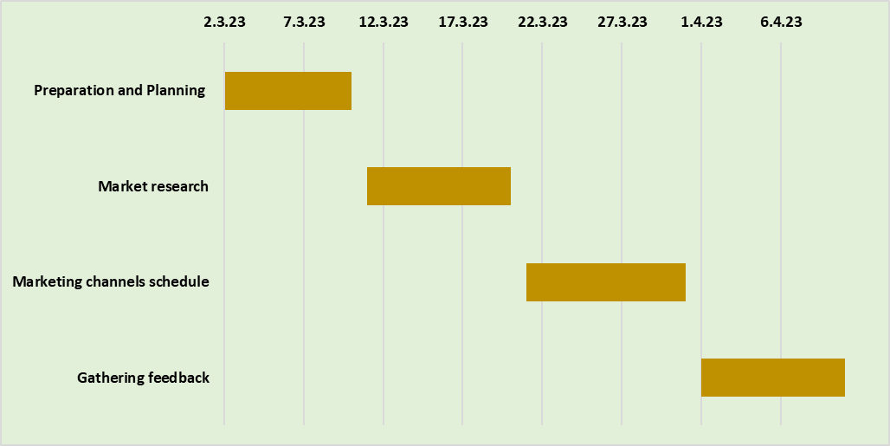
Figure No1: Gantt Chart
(Source: Self-Created)

Control

To monitor and evaluate the performance of the marketing campaign, the following KPIs (“Key Performance Indicator”) would be used:
- Conversion Rates
- Number of new customers acquired
- Revenue rates (Golightly, 2023)

Conclusion

The marketing plan has provided a comprehensive idea about the prospects of the marketing process. A few of the recommendations are provided below:
- Use of Data mining for analysing the customer trend
- Use of augmented reality for improving the engagement rates
References

Gowrea, V. (2023) SWOT analysis of Premier Inn (premier inn swot), www.howandwhat.net. Available at: https://www.howandwhat.net/swot-analysis-premier-inn-premier-inn-swot-analysis/ (Accessed: March 1, 2023).
mordorintelligence.com (2022) UK hospitality market analysis - industry report - trends, Size &amp; Share, UK Hospitality Market Analysis - Industry Report - Trends, Size &amp; Share. Available at: https://www.mordorintelligence.com/industry-reports/hospitality-industry-in-the-united-kingdom (Accessed: March 1, 2023).
Neves, D.L.M., 2022. Macau-s hospitality sector: planning a response to a pandemic (Doctoral dissertation).
Wang, S., Hung, K. and Huang, W.J., 2019. Motivations for entrepreneurship in the tourism and hospitality sector: A social cognitive theory perspective. International Journal of Hospitality Management, 78, pp.78-88.
Twin, A. (2023) Value proposition: How to write it with examples, Investopedia. Investopedia. Available at: https://www.investopedia.com/terms/v/valueproposition.asp (Accessed: March 1, 2023).
thatagency.com (2019) What is your hotel marketing mix?, What Is Your Hotel Marketing Mix? THAT Agency. Available at: https://blog.thatagency.com/hotel-marketing-mix-hotel-marketing-plan (Accessed: March 1, 2023).
Golightly, E. (2023) 20 marketing KPI examples in 2023: Track Kpis with Clickup, ClickUp. Available at: https://clickup.com/blog/marketing-kpis/ (Accessed: March 1, 2023).
Jobber, D. and Ellis-Chadwick, F (2020), Principles and practice of marketing. 9th ed. London:
Bowie,D. Buttle,F. Brookes,M &amp; Mariussen,A (2017), Hospitality Marketing. 3 rd ed, Routledge, London Smith PR &amp; Zook ZE (2020) Marketing Communications. 7 th ed, Kogan Page, London
Kotler, P., Armstrong, G., Harris, L. and He, H., 2020. Principles of marketing. 8 th European ed, London: Pearson Education Limited.
Clow, K &amp; Baack, D (2013), Integrated Advertising, Promotion and Marketing Communications. 6 thed, Pearson, London Chaffey, D and Ellis- Chadwick, F. (2019) Digital Marketing. 7 th ed, Pearsons, London.
Ghauri, P N (2014) International Marketing, 4 th Ed, McGraw Hill, London
Housden M (2008), Marketing Research &amp; Information, Butterworth Heinemann, Oxford.
Kotler,P and Kartajaya, H. Marketing 4.0 Moving from Traditional to Digital (2017) Wiley. New York.
Ryan, D. (2012) Understanding Digital marketing: Marketing Strategies for Engaging The Digital Generation. Kogan Page, London.

Appendices
Slide 1
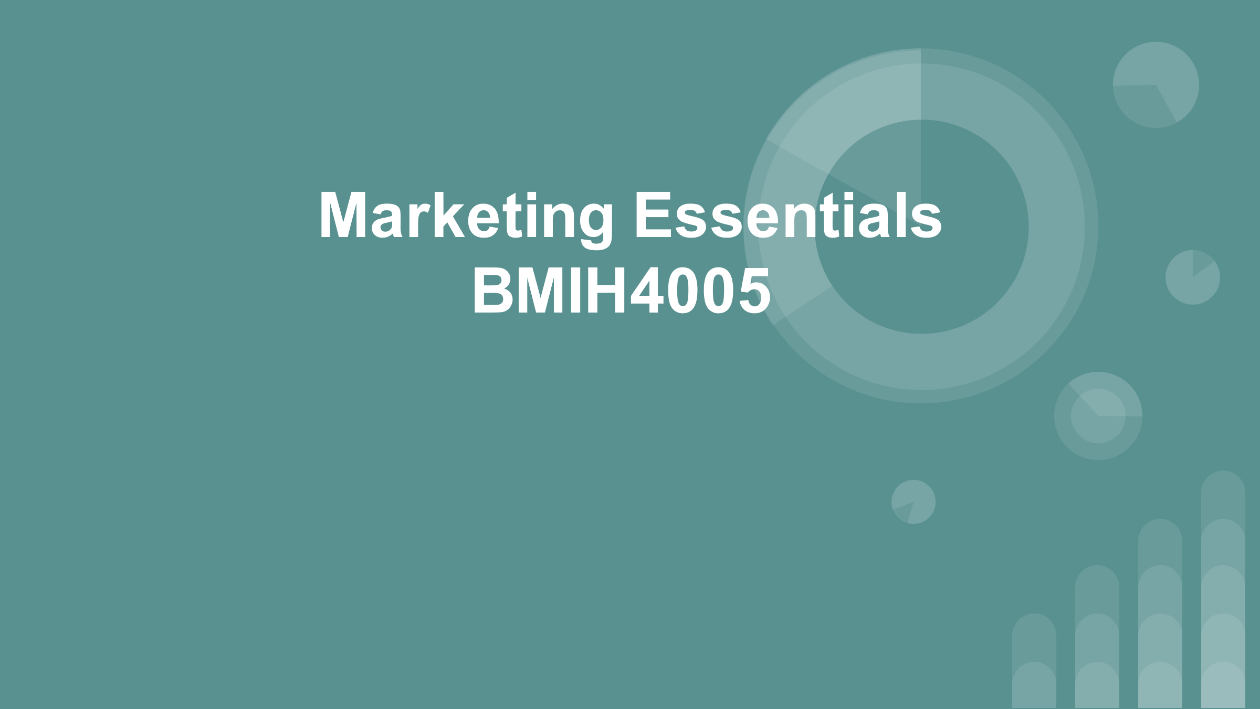
Slide 2
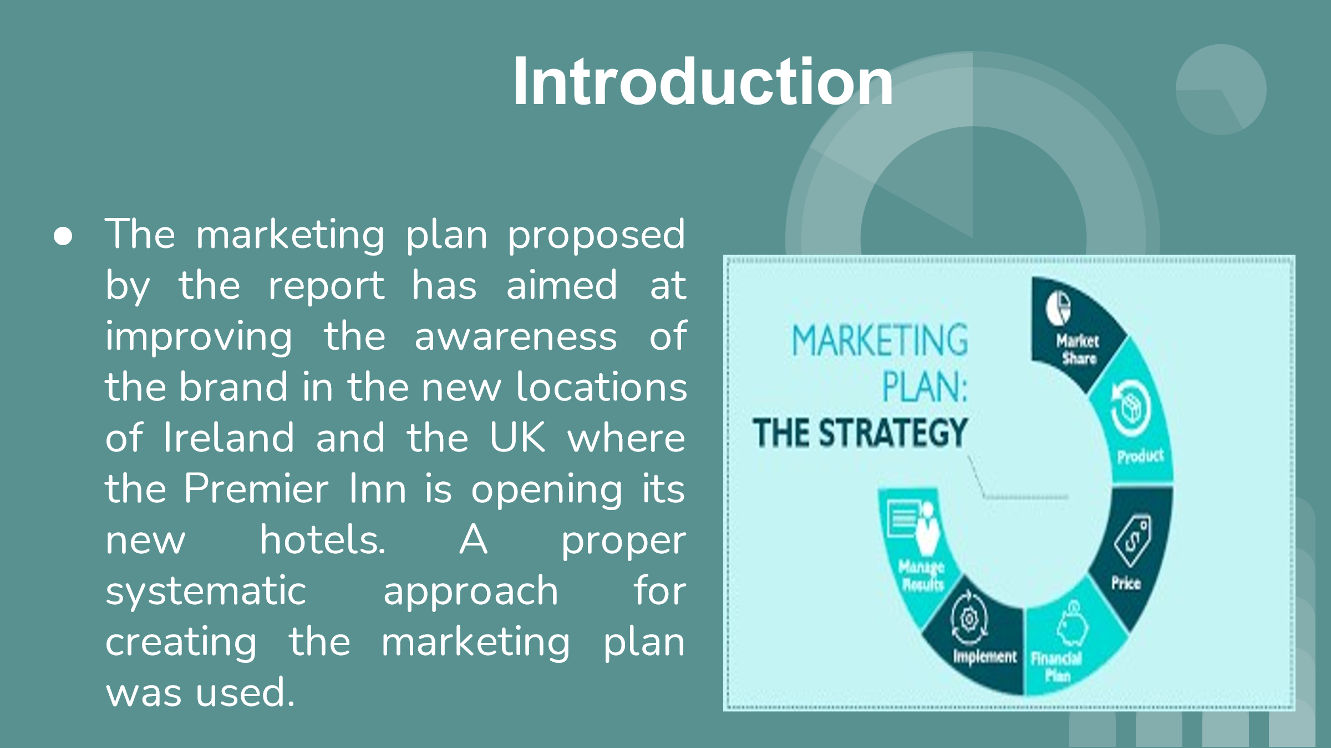

Slide 3
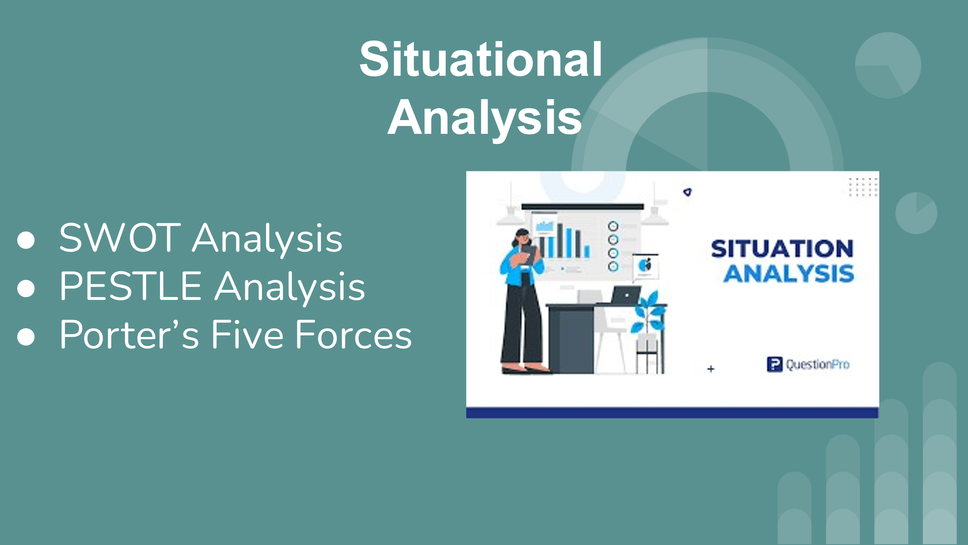
Slide 4
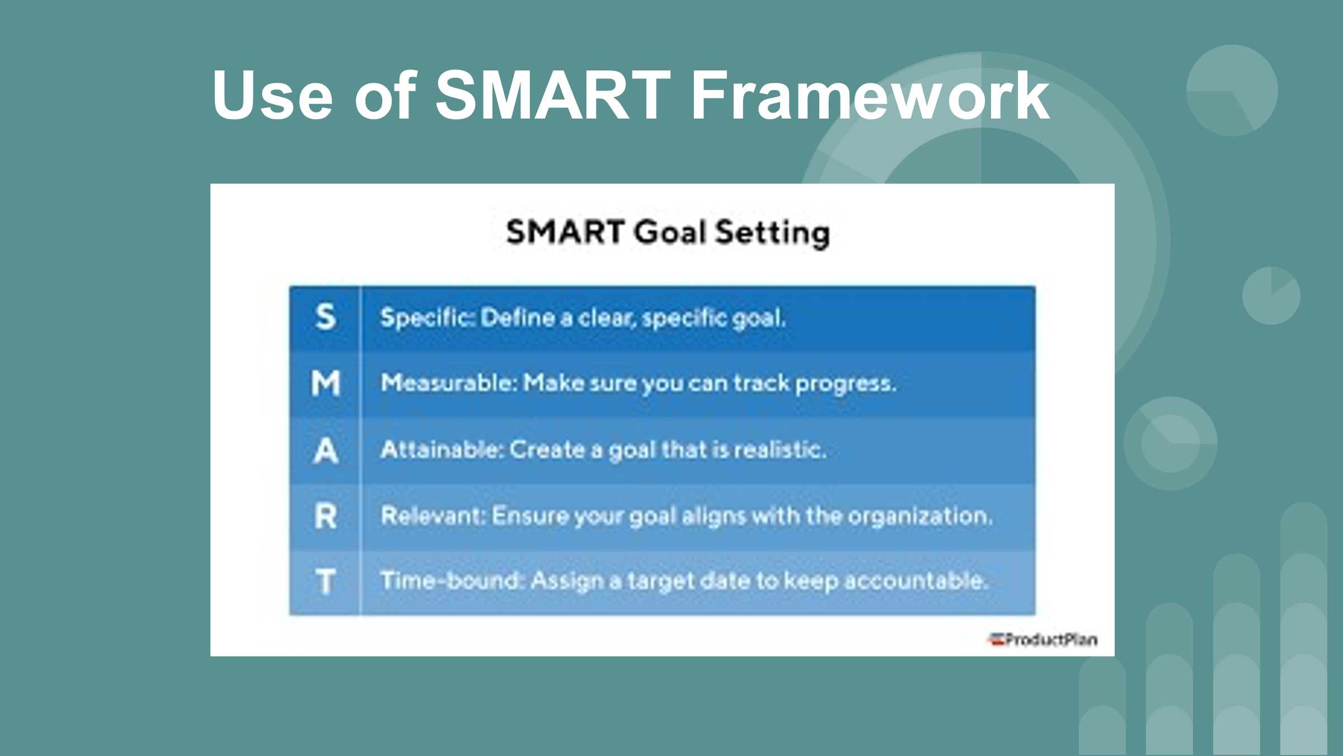

Slide 5
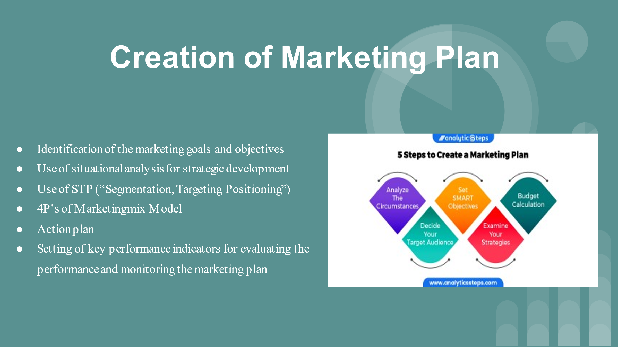
Slide 6
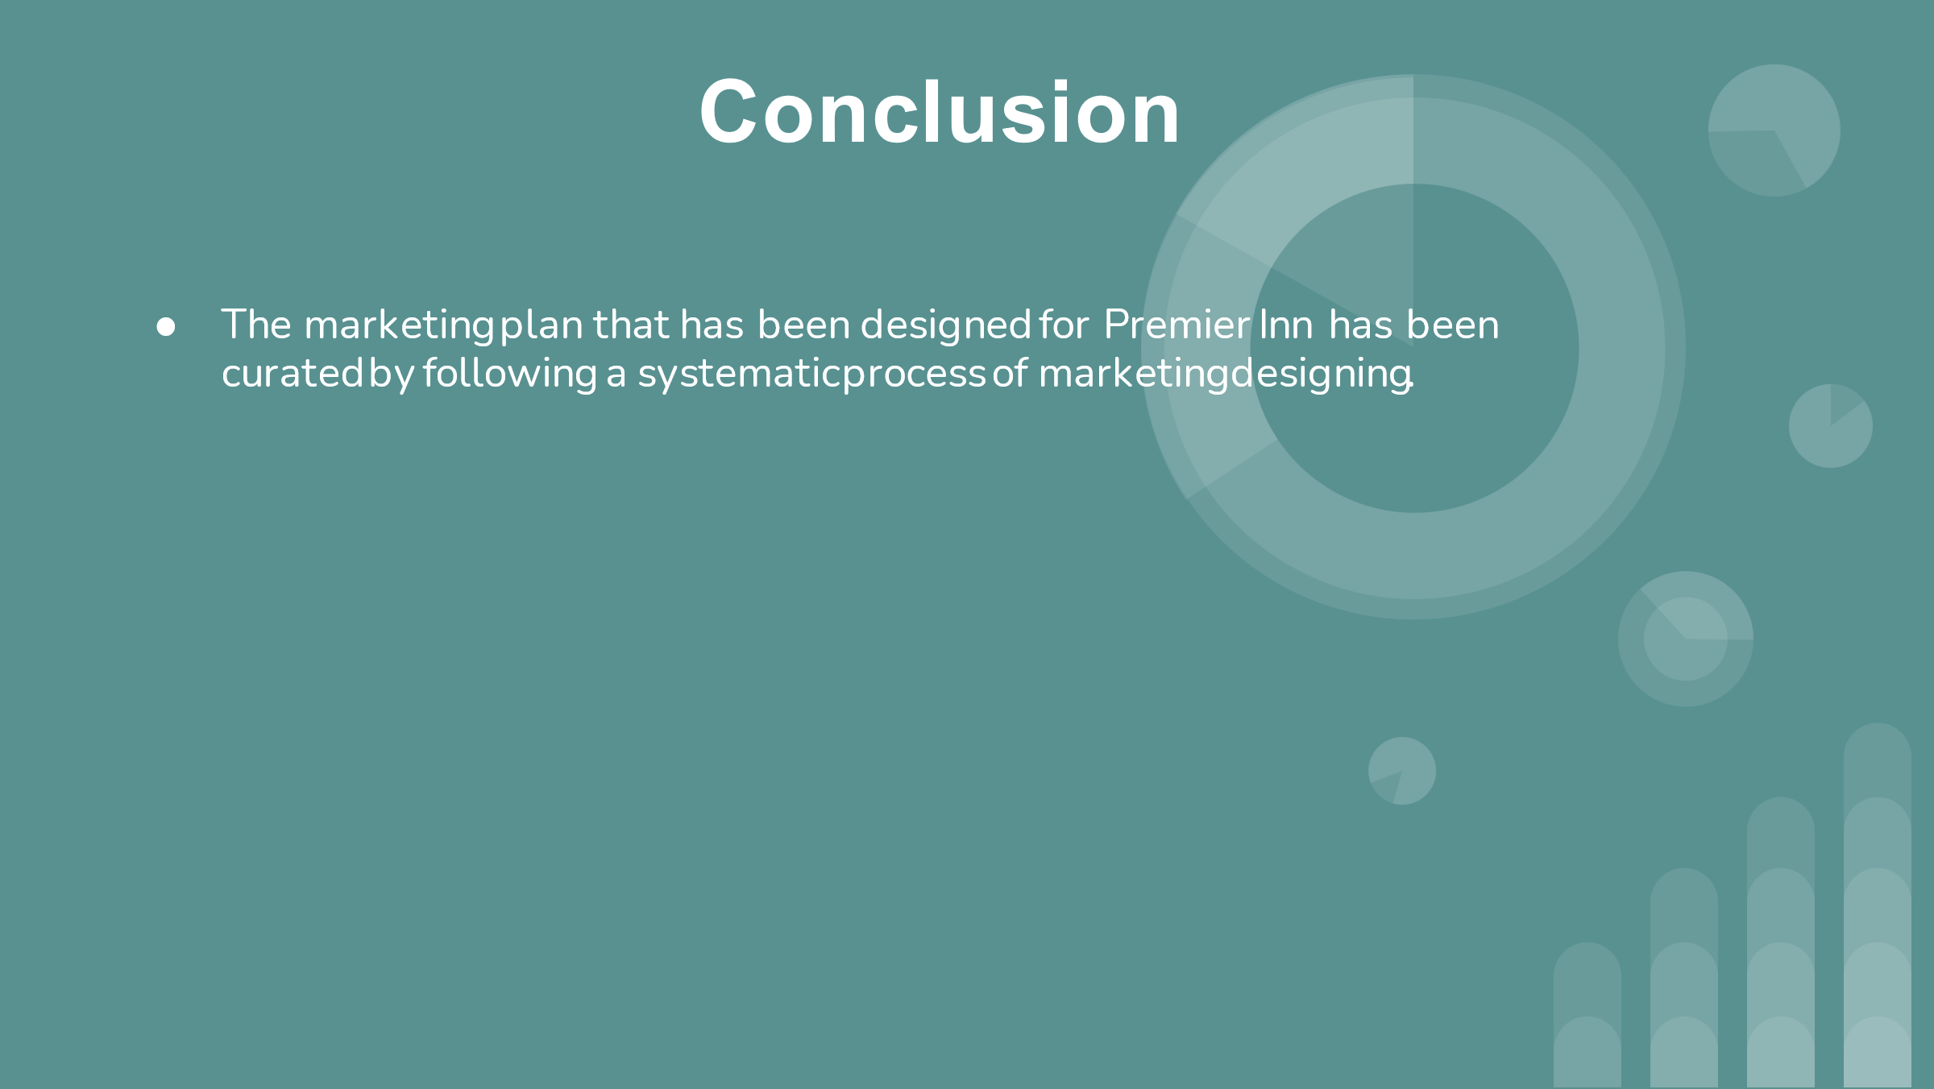

Slide 7
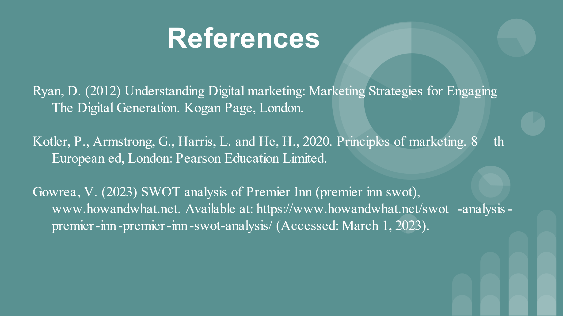
Slide 8


