Outline of the presentation

Define culture and its various elementsThe UK retail organisation is emphasising a strategic alliance with a Chinese e-commerce firm as a way of opening up more business opportunities in the international market. It will also cover the major cultural issues that will be observed during negotiations, the methods by which a successful agreement will be achieved and the role of cultural awareness and adaptability in cross-cultural business negotiations.

Define culture and its various elements
Culture in international business determines how decisions are made, leadership styles, communication styles and the negotiation styles. Geert Hofstede claims that culture is the collective programming of the mind that can be said to be the difference between members of one group and another.
Understanding the culture is especially valuable in international relationships since the difference in expectations, communications and business patterns may influence negotiations and cooperation. The understanding of these cultural differences assists organisations in decreasing misunderstanding, enhancing collaboration, and building better international relationships.
Chinese business culture, on the other hand, tends to embrace indirect communication and values politeness and harmony. Therefore, it is possible that disagreements can be articulated in a less overbearing Chinese negotiation.
The other major cultural element is relationship orientation. Chinese business culture is highly valued on long-term associations and trust, commonly known as guanxi. The business contracts are built on top of interactions and respect. In comparison, contractual agreements and task-centred negotiations are quite common in UK organisations.
Effective cross-cultural negotiations require cultural sensitivity, awareness and adaptability. Knowledge of other cultural values, styles of communication, and expectations enables the managers to change their negotiation techniques as well. Cultural adaptability is one of the means of establishing long-term cooperation in negotiations between the UK and Chinese partners to promote mutual respect.
Cultural awareness then becomes essential in ensuring the attainment of effective communication and the establishment of sustainable international business relationships. Cultural awareness and adaptability will provide the opportunity to develop effective negotiating behaviours towards achieving valuable international decision-making and desired outcomes.

Theoretical underpinning about impact of culture

The theory describes the role played by cultural values in organisational behaviour, communication styles, leadership practice, and negotiation style in different countries. Hofstede was able to determine six major dimensions of culture that could be used to compare the cultures of the countries, and these dimensions include: power distance, individualism, masculinity, uncertainty avoidance, long-term orientation and indulgence.
The figure outlines the comparative view between the two countries, the UK and China. It will provide the beneficial aspects to enhance cross-cultural communication strategies, negotiation and market entry strategic approaches. As the comparison between China and the United Kingdom shows, a number of cultural differences may affect business negotiations. One of them is power distance, with China at 80 and the United Kingdom at 35. It means that Chinese organisations are more accepting of hierarchical structure and respect authority more strongly. On the contrary, the organisations in the United Kingdom tend to use participative decision-making.

Cultural differences are also pointed out by the dimension of long-term orientation. China has a score of 77, and the United Kingdom has a score of 60, which means that Chinese organisations tend to put more emphasis on long-term planning, perseverance and building of relations in business relationships.
These cultural differences are the key valuable aspects which should be evaluated by a UK company when it comes to international negotiations.
This theoretical knowledge helps managers to change their tactics in negotiation, consider cultural expectations, and build sustainable cross-cultural business relations. This Cultural Dimensions Theory argues that the United Kingdom has a higher individualism and a lower power distance, which will affect the business communication with China because the culture of the country is hierarchical and relationship-driven, thus promoting undirected communication, consultative decision-making, and quicker negotiations.

The cultural elements based on the Chinese to overcome
The negotiator should be aware of certain cultural elements which could affect business dealings when negotiating with Chinese organisations. The cultural differences may influence the process of communication, leadership expectations and negotiation.
Employees usually have a high level of respect for senior leadership, and they may not openly disagree with decisions. Conversely, the United Kingdom has organisations that tend to permit employees to have their say and be involved at various levels.
The Chinese business culture regards building trust and long-term relationships as a prerequisite to the finalisation of formal agreements. This will increase the time of negotiations since credibility and mutual understanding are important for the Chinese to overcome. Nevertheless, the UK organisations tend to focus on efficiency and quicker contract deals.
The only way through such cultural differences is to be patient, respectful and culturally sensitive as an international manager during negotiations. Recognising hierarchy, spending time on establishing relationships and paying attention to business communication cues will enable organisations to address the challenge of cultural differences and enhance the efficacy of the cross-cultural business negotiations.

Negotiation Strategies for a successful deal.
In order to enter an international business, for a successful deal, the agreement will demand negotiation strategies taking into account the cultural variations between the United Kingdom and China.
Chinese business culture tends to form trust and personal relations before formal agreements. It is therefore the role of the managers to take time in meetings, discussions and networking opportunities to build credibility and mutual understanding.
As Chinese organisations tend to practice hierarchical forms of management, the decisions are typically made by the senior leaders. It will be necessary that the teams in negotiation make communication clearly respectful and aimed at the top representatives.
Managers need not be impatient in seeking fast outcomes, and they need to be patient and tolerant of slow developments.
Listening and cultural sensitivity will be required to be implemented to prevent misunderstandings and build stronger professional relationships. Organisations will have the opportunity to enhance trust and chances of success in the cross-cultural business deals by integrating the aspects of relationship building, the respect of the hierarchy, patience, and with the help of the effective communication.

Conclusion
Cultural awareness will enable managers to identify various expectations and behaviours in negotiations. The organisations will have the opportunity to interpret the cross-cultural dynamics through the application of theoretical frameworks like the Cultural Dimensions Theory by Geert Hofstede. This knowledge will assist managers in changing their leadership styles, communication and negotiation procedures. Consequently, the organisation will be able to establish better trust, reduce misunderstanding, and establish long-term and mutually beneficial international business relationships.

References
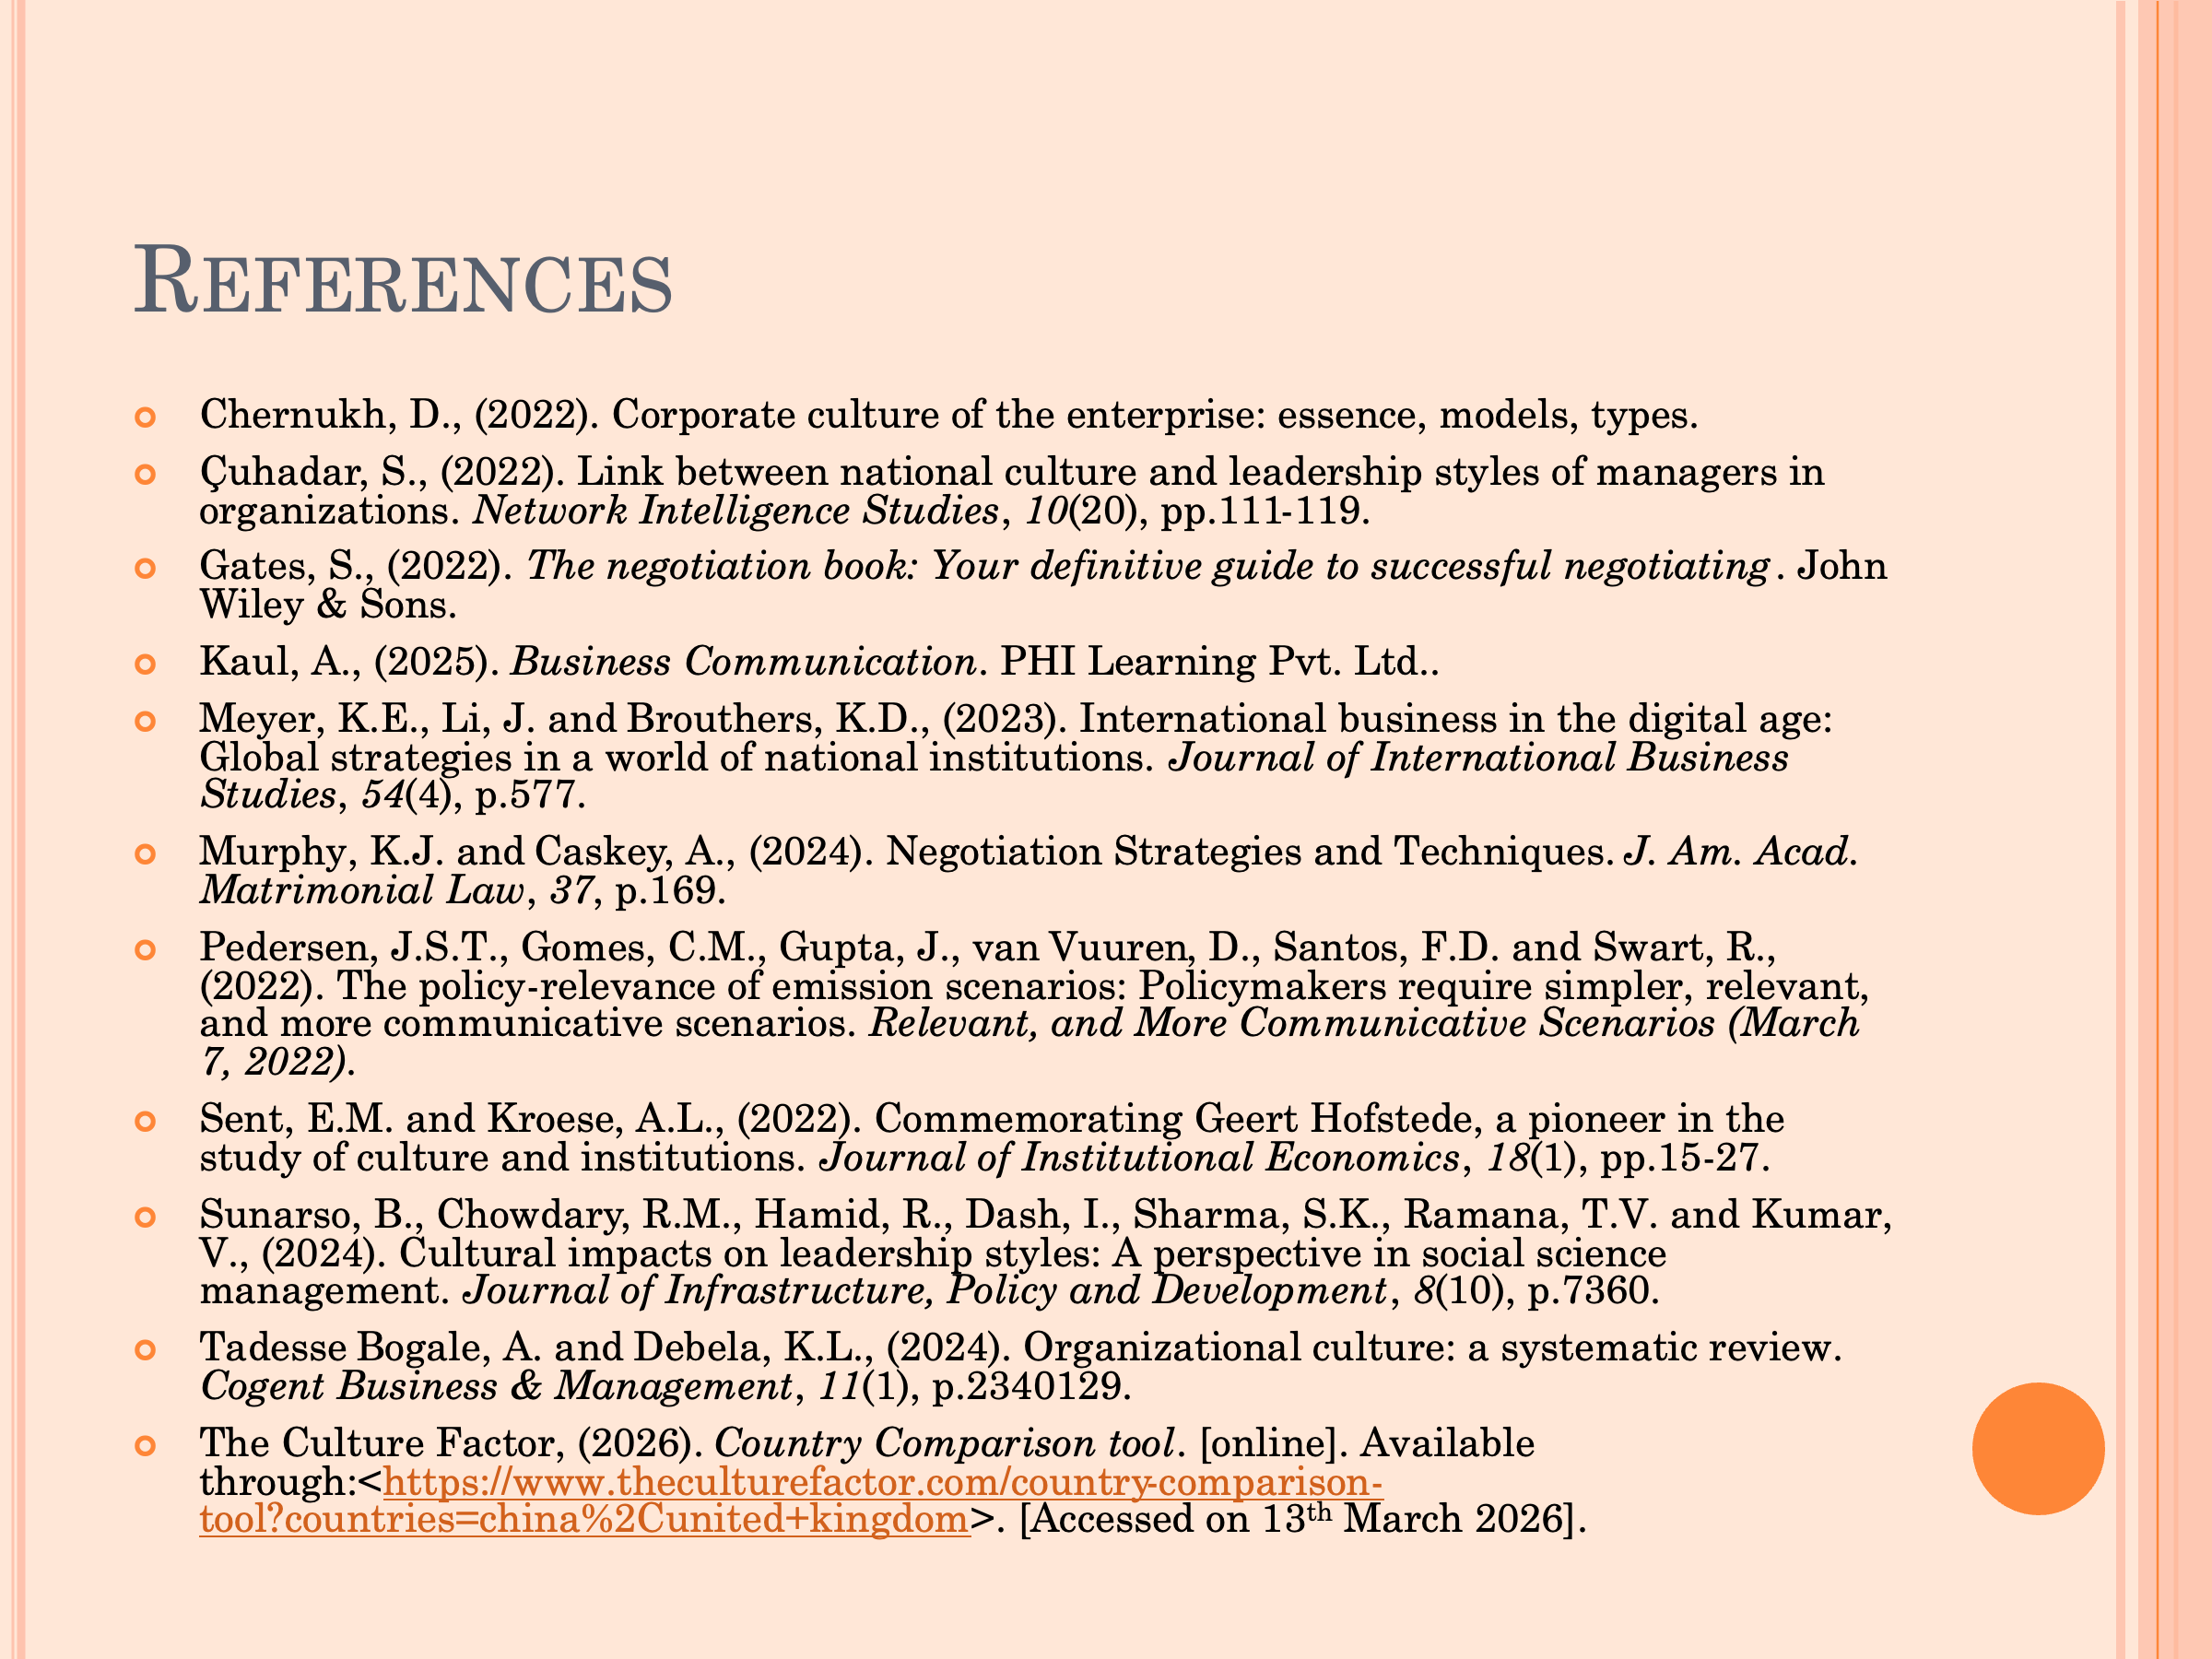
- Chernukh, D., (2022). Corporate culture of the enterprise: essence, models, types.
- Çuhadar, S., (2022). Link between national culture and leadership styles of managers in organizations. Network Intelligence Studies, 10(20), pp.111-119.
- Gates, S., (2022). The negotiation book: Your definitive guide to successful negotiating. John Wiley & Sons.
- Kaul, A., (2025). Business Communication. PHI Learning Pvt. Ltd..
- Meyer, K.E., Li, J. and Brouthers, K.D., (2023). International business in the digital age: Global strategies in a world of national institutions. Journal of International Business Studies, 54(4), p.577.
- Murphy, K.J. and Caskey, A., (2024). Negotiation Strategies and Techniques. J. Am. Acad. Matrimonial Law, 37, p.169.
- Pedersen, J.S.T., Gomes, C.M., Gupta, J., van Vuuren, D., Santos, F.D. and Swart, R., (2022). The policy-relevance of emission scenarios: Policymakers require simpler, relevant, and more communicative scenarios. Relevant, and More Communicative Scenarios (March 7, 2022).
- Sent, E.M. and Kroese, A.L., (2022). Commemorating Geert Hofstede, a pioneer in the study of culture and institutions. Journal of Institutional Economics, 18(1), pp.15-27.
- Sunarso, B., Chowdary, R.M., Hamid, R., Dash, I., Sharma, S.K., Ramana, T.V. and Kumar, V., (2024). Cultural impacts on leadership styles: A perspective in social science management. Journal of Infrastructure, Policy and Development, 8(10), p.7360.
- Tadesse Bogale, A. and Debela, K.L., (2024). Organizational culture: a systematic review. Cogent Business & Management, 11(1), p.2340129.
- The Culture Factor, (2026). Country Comparison tool. [online]. Available through:<https://www.theculturefactor.com/country-comparison-tool?countries=china%2Cunited+kingdom>. [Accessed on 13th March 2026].

