February 26, 2021
alina culea
University of Wales Trinity Saint David
1918156
problem solving & decision making
bmsw4004_card
an analysis into the decline of royal mail

Abstract

The current report was focused on identifying the reason behind Royal Mail’s decline. It was identified that the biggest problem faced by Royal Mail is the declining of letters, which made the company vulnerable because this was the main source of income. The company is substantially affected by this issue, mostly financially, resulting in the loss of staff. At the same time, it was discovered that the cause of the letters’ decline is the online communication, which made the customer prefer a faster, more secure way of exchanging information. But, on the other side, Royal Mail started to gain more profit from parcel deliveries, which is a perfect opportunity for them to regain their strength and to recover financially.
The Action Plan is focused on how to invest smart into Royal Mail to change its identity from a letter-delivery company into a parcel-delivery company, and increase the profit, decrease the customers’ complaints and modernise its entire infrastructure.
Contents
Abstract 1
Table of Figures 2
Introduction 3
Main Findings 3
Nature 3
Scope 4
Impact 4
SWOT analysis 5
PESTLE analysis 8
Conclusion 9
Options/Recommendations 9
Action Plan 9
Monitored 9
Reviewed/ Evaluated 10
Communicated 10
Appendices 11
SWOT analysis 11
PESTLE analysis 12
Reference List 14

Table of Figures
SWOT analysis of Royal Mail 5
PESTLE analysis of Royal Mail 6
Monitoring & Evaluation template 8

Introduction

This analysis was requested by the lecturer Christian Felices on 25th of January 2021, as a rework for the Problem Solving and Decision-Making module, at the University of Wales Trinity Saint David. The report was compiled by Alina Culea, student number 1918156 on 26th of February 2021, being submitted at the same date.
The purpose of the report is that the lecturer can evaluate the student’s skills and understanding regarding the module and its ability to analyse a problem and find proper solutions. In this case, the main problem of Royal Mail must be identified and analysed using tools such as SWOT and PESTLE, followed by the proposition of various solutions.
The main findings of the report are sustained by official Royal Mail reports and communications, articles, and journals, all from reliable sources.

Main Findings

Royal Mail has 500 years of history behind their back, with ups and down, but definitely interesting. The company was founded back in 1516, but it became available to the public a century later, in 1635 (Blake, 2010). The company started to operate in foreign countries such as Egypt in 1941 (JustShipIt, 2021) and continued to expand its service all around the globe. There are a few interesting facts about Royal Mail that many people forget to mention when they talk about their current problems, but that are definitely important in understanding the main problem faced by Royal Mail – the decline in letter volume. According to the same source, JustShipIt (2021), which is a history blog, before the apparition of the e-mail, Royal Mail used to deliver the mail around 7 times a day, which translates into almost 2 million postcards delivered daily, and it also had its own train in London from 1927 to 2003, which carried around 4 million letters per day. This is important because it directly affects the branding of the company and the way it operates daily.

Nature
In November 2020, a few months after the COVID-19 pandemic exploded all around the world, Joanne Partridge, journalist at The Guardian, wrote a captivating article regarding the current problems faced by Royal Mail, the most important being the decline of the letters volume in front of parcels volume. She argued that the main cause of the lower use of letter is the technology which allows people to communicate and exchange information a lot faster, and also due to the fact that people are keener to order things online, especially during lockdowns. On the other side, she argued that decline in letter volumes has a bright side as well, because the company earns more through parcels than through letters. An example was in regard to the annual costs of handling the parcels and the letter, with additional costs this year to make the workplace COVID-safe couldn’t be covered with only letters sending, and the parcels delivered last year helped the company have a better revenue.
In addition to the discoveries made by Partridge, Mark Sweney argued at the same time that cutting the Sunday deliveries impacted the letter volume as well, as people need a service that will deliver 7 days per week.
It is worth mentioning that both reporters predicted that the decline of the letter volume will never stop, as long as we live in a digital world, and that Royal Mail must start preparing and investing in become more digitalized and, at the same time, must start rebranding itself.

Scope
There are many parts affected by the decline of letters, but Royal Mail is affected the most. The reason behind this is that Royal Mail is not only losing its identity, being at core a letter delivery company, but it is also losing money (Pratley, 2020). The revenue from letters was lower with 9% than usual by the end of 2020 (Royal Mail, 2020), and with the cost’s growth, that meant a deeper loss for Royal Mail. At the same time, the company is forced to grow from what once was – a letter delivery company – into a parcel delivery company so that it can keep its position on the market. This loss also affected the shareholders, because Royal Mail started its privatisation back in 2010 (Vincent, 2018).

Impact
As mentioned above, Royal Mail was affected the most by losing profit, but that is not all, due to the fact that losing money affect the employees, as well as their families. It was said that at the middle of 2020, after the pandemic hit, Royal Mail must let go around 2000 employees, because they need to cut costs in the management are and put those money into infrastructure (O’Connell, 2020). This translates into many people losing their income in a difficult global situation during the pandemic, which affected them the most, especially because the pandemic created an unemployment crisis all around United Kingdom (Partington, 2021). If it was to continue on this journey, the impact was bigger than that, because with families losing their income, the situation became more difficult in regard to food, rents, bills or utilities, because this situation is similar to a domino game, and if one piece falls, the others will fall too.

SWOT analysis
The SWOT analysis that can be found in the appendices shows that, like any other company, Royal Mail has its ups and down, but the company also has the possibility to overcome the challenges due to their strengths and their opportunities. This possibility will be later analysed and proposed in the Action Plan, after the micro and the macro analyses of Royal Mail will be conducted, for a better understanding.
Among other, the most important strengths of Royal Mail are:
- Worldwide recognised brand – according to Forbes (2021), Royal Mail is one of the most recognised brands in the world, and it is often associated with United Kingdom, as a symbol. This is a strength because every brand with a strong identity is seen as trustful between the companies, creates a strong relationship with its customers and directly impacts the sales and the profit (Cantor, 2020).

- Largest post operator in UK – this is connected with the strong brand identity stat Royal Mail has, because it is a brand with a history for over 500 years, it is considered to be a symbol the United Kingdom and it is the main operator of the Royal Post as well, which helps the citizens communicate with the Royal Family as well (Royal, 2021).
- Multiple delivery options – according to the Royal Mail website (2021), there are multiple delivery options, which include Tracked Delivery, 48H Delivery, International Delivery, Business Delivery as well as letters and parcels delivery. This is a strength because they can offer customers a wide range of services, which will attract them more, especially if they can find all the options that they want in the same place.
- Has its own courier network – Royal Mail is able to cut costs, have more control over the deliveries, prices and personnel because the company owns its own courier network, which helps having the entire business in one place, without other company in between. This also helps the communication between customers and company, due to the internal handling of the information (Royal Mail, 2021).
- Numerous investors – the privatisation of Royal Mail has the benefit that all the numerous investors can help the business expand and invest in new technology which will help save time and make the work more efficient, increasing the productivity (Independent Voices, 2013).
The most noticeable weaknesses of Royal Mail are:
- The obligation to deliver in all areas – Royal Mail must deliver to all the areas in the United Kingdom, no matter the package, quantity or price. Sometimes, they lose money if they send a courier to an address which is isolated, due to the cost of gas, the time that takes to arrive at the location, even for a single letter (Neate, Farrell, 2014). This is a weakness for Royal Mail because its competitors are allowed to choose in which areas they want to operate so that they can have the profit at maximum, while Royal Mail must deliver everywhere, no matter if the gain or lose profit.
- The universal service obligation – Ofcom made Royal Mail to deliver to 31 million addresses in 6 days per week, at the same price. This is a weakness because due to that, the company has financial loss and no control about when and where to deliver first (Ralph, 2020).
- The loss of 12000 jobs since privatisation – this is a weakness because with all the investors and the possibility to better sustain the company financially, the costs were cut and more than 12000 people lost their job (Furniss, 2018). At the same time, this is also a weakness because this is a trend of letting people with permanent contracts go, while they prefer to invest only in temporary staff (BBC, 2021), which can also mean that their quality of service will lack.
- The growing number of customer complaints – there is a trend between Royal Mail’s customers to log a complaint, mostly due to the late arrival of the post (Gray, 2021). The trend can be seen on the website Down Detector, which monitors all the daily complaints of the customers in real time. Unfortunately, it seems that the service is getting poorer, one of the causes being the temporary staff that is not so engaged in deliver a better quality of work.
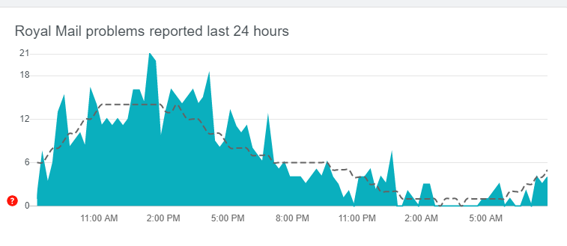
- Low Liquidity – this means that even though the Royal Mail makes profit, it doesn’t have the capital to further invest in the company (Sweney, 2020).
The most important Royal Mail opportunities are:
- Privatisation – because they can use this to change the company from a letter-led company to a parcel-led company and invest in new equipment to increase the productivity.
- Growth opportunities – Royal Mail has the possibility to expand its business and to become more focused on the parcels than letters, which will help the company in the long term by increasing the profit.
- Parcel delivery company – this should be the next step for Royal Mail, but for this the company must invest in technology and staff.
The threats faced by Royal Mail are:
- Constant letter decline – result in financial loss, staff loss, and if the company will fail to adapt to the new world this will become a bigger threat every year.
- Competitors – because they have a few privileges that Royal Mail doesn’t have, for example they can chose the area of operating and they can establish their own prices, which represent a profit for them.
- Loss in direct mail – people are no longer using letter, which means that the equipment for letter is not useful anymore.
- Customer complaints – if Royal Mail will continue to offer poor customer service the customers will go with the company’s competitors, and Royal Mail will face more loss and fines from Ofcom.
- Ofcom regulations – Ofcom fined Royal Mail multiple times for not meeting their expectations, resulting into a financial loss for the company (Ofcom, 2010).

PESTLE analysis
There are a few factors that have an increased level of influence of Royal Mail and the way they conduct the business all over the world.
Political – From this point of view, Royal Mail is affected by two factors: the privatisation and Brexit. The privatisation affects Royal Mail by the fact that a few years ago the company was under valuated, with massive loss. On the other hand, Brexit might force the company to close its business from other countries or increase the taxes.
Economical – The three factors that affects Royal Mail are: privatisation, Brexit and the pandemic. The privatisation brought more competition to Royal Mail, but also the opportunity of an investment from the shareholders. The Brexit might have something to say in the investors’ decision to keep their business into UK or to move it in another country. The pandemic come at great cost for Royal Mail as they had to invest in the employees’ safety at the workplace, but it also created an economical crisis, and Royal Mail was forced to let go of 2000 employees.
Social – There are two important factors in this category: the pandemic and the evolution of the online shopping. The pandemic forced people to stay at their home in lockdown, while the evolution of online shopping made the people in lockdown to start ordering more online.
Technological – The mail factors are the online communication and the updated technology. The online communication such as E-Mail and the social platform created a decreased need to send letters, and the updated technology is created to better handle the parcels, in which Royal Mail must invest.
Environmental – the biggest factor is pollution, and Royal Mail has successfully adapted to the new recycling requirement by created the SmartStamp, Sustainable Mail and Click&Drop (Royal Mail, 2019), which help recycle more, save more paper and gas.
Legal – From this point of view there are 4 factors that Royal Mail must take into consideration: GDPR, Brexit, Change of regulator and Pandemic. The GDPR created an even noticeable decline in letter delivery due to the new rules of confidentiality and people more aware of their personal data. The Brexit came with bigger taxes for deliveries. The change of regulator meant that Royal Mail has a new set of rules for being regulated by Ofcom and the pandemic came with new safety measures that are forced to be introduced by law.

Conclusion
Royal Mail was and will remain a symbol of the United Kingdom, but if the company wants to survive and strive in profits like old times, it must accept that the world has changed, along with the people necessities, and it must try to adapt according to the macro factors. Where there are opportunities, like growing into a parcel led company, Royal Mail must use all their strengths to make this happen. If not, the company will constantly have to face the threats, until there will be no other solution than to close its doors to the world.

Options/Recommendations
Based on the micro and the macro analysis, it was concluded that the best way for Royal Mail to overcome its own decline is to change its identity and focus more on delivering the parcel, and not making a priority from the letter.

Action Plan
The action plan proposed is to focus on changing the company from a letter-led one into a parcel-led one, with the scope of increasing the profit, modernising the workplaces and decreasing the customers’ complaints.

Monitored
The resources needed to apply the action plan to Royal Mail are:
- Investors – because they will have the final word in agreeing to the change or not.
- Money – because there will be a few costs, and there must be a budget allocated for that.
- Equipment – because it is essential to invest in new equipment suitable for parcel delivery which will increase the productivity.
- People – because the staff must learn and adapt to the new changes.
The Key Indicators that will show if the Action Plan has succeeded are:
- Increased number of parcels delivered
- Decreased number of customers’ complaints
- Increased profit
The Targets set for this Action Plan are:
- Modernise all the hubs in the next 2 years
- Increase productivity by 20% in the next year, and by 40% in the next two years
- Constant decreasing in the number of complaints
- Constant profit increase.
The Data sources that will confirm if the Action Plan was successful are the reports that are issued at the end of every financial year.

Reviewed/ Evaluated
The following questions must be asked to check the progress of the Action Plan:
- How many hubs still need modernisation?
- Has the productivity increased?
- The customers are still not satisfied?
- What is the profit?

Communicated
Internally, the decision will be communicated with the employees and management to keep them updated with all the changes.
Externally, the decision will be proposed to the investors so that they can approve the investment and to the customers so that they can be aware of any changes in deliveries or quality of customer service.

Appendices

SWOT analysis
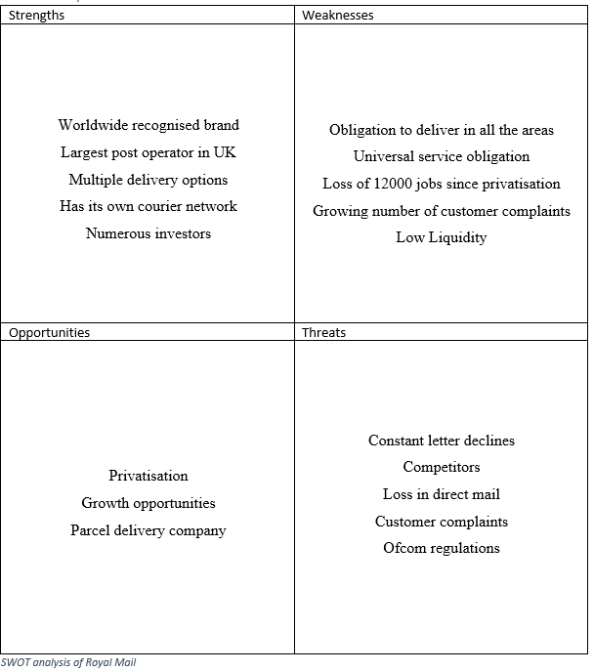

PESTLE analysis
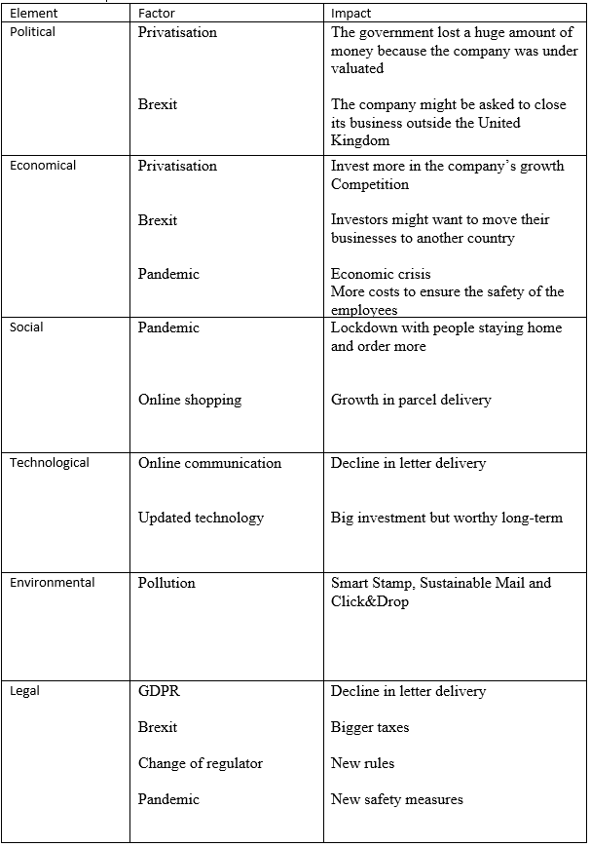
PESTLE analysis of Royal Mail
Monitoring & Evaluation template
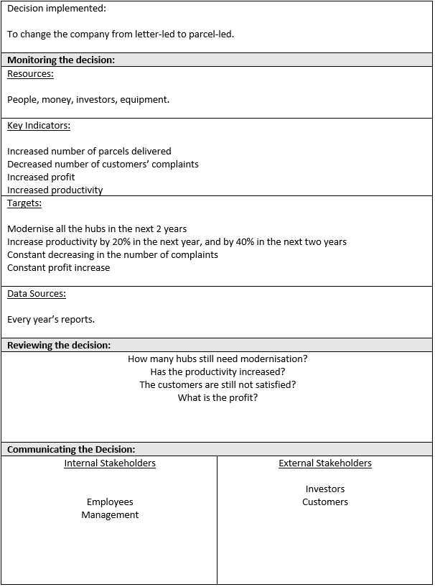
Monitoring & Evaluation template

Reference List

- BBC (2021) Royal Mail to keep on 10,000 temporary workers. Available at: https://www.bbc.co.uk/news/business-56022948 (Accessed: 21st of February 2021).
- Blake, H. (2010) The Royal Mail: A History of the British postal service. The Guardian. Available at: https://www.telegraph.co.uk/news/uknews/royal-mail/7814591/The-Royal-Mail-a-history-of-the-British-postal-service.html (Accessed: 20th of February 2021).
- Cantor, A. (2020) The importance of branding: why branding matters. Available at: https://99designs.co.uk/blog/logo-branding/importance-of-branding/ (Accessed: 20th of February 2021).
- Down Detector (2021) Royal Mail. Available at: https://downdetector.co.uk/status/royalmail/ (Accessed: 21st of February 2021).
- Forbes (2021) Royal Mail. Available at: https://www.forbes.com/companies/royal-mail/?sh=13d0585c774e (Accessed: 20th of February 2021).
- Furniss, G. (2018) Five Years Since the Privatisation of The Royal Mail, The Consequences Are Being Felt More Than Ever. Available at: https://www.huffingtonpost.co.uk/entry/five-years-on-the-consequences-of-privatisation-of_uk_5bc495ece4b0484342b6b7b4 (Accessed: 21st of February 2021).
- Gray, S. (2021) Royal Mail delays: Major COVID-19 delivery problems addressed as thousands hit - new update. Available at: https://www.express.co.uk/life-style/life/1384662/Royal-Mail-delays-coronavirus-restrictions-deliveries-latest-updat (Accessed: 21st of February 2021).
- Independent Voices (2013) Royal Mail privatisation: The Pros and Cons. Available at: https://www.independent.co.uk/voices/debate/royal-mail-privatisation-pros-and-cons-8814217.html (Accessed: 21st of February 2021).
- JustShipIt (2021) What is Royal Mail – A brief history and facts. Available at: https://www.justshipit.co.uk/what-is-royal-mail-a-brief-history-and-facts/ (Accessed: 20th of February 2021).
- Neate, R., Farrell, S. (2014) Royal Mail says postal deliveries to remote areas under threat. The Guardian. Available at: https://www.theguardian.com/uk-news/2014/may/22/royal-mail-universal-service-threat-rivals (Accessed: 21st of February 2021).
- O’Connell, D. (2020) Royal Mail to cut 2,000 jobs as virus hits business. BBC. Available at: https://www.bbc.co.uk/news/uk-53175739 (Accessed: 20th of February 2021).
- Ofcom (2010) Royal Mail fined £1.5m for missing 2018/19 delivery target. Available at: https://www.ofcom.org.uk/about-ofcom/latest/features-and-news/royal-mail-fined-for-missing-delivery-target (Accessed: 21st of February 2021).
- Partington, R. (2021) The UK's Covid-19 unemployment crisis in six charts. The Guardian. Available at: https://www.theguardian.com/business/2021/feb/03/the-uks-covid-19-unemployment-crisis-in-six-charts (Accessed: 20th of February 2021).
- Partridge, J. (2020) Royal Mail gets more revenue from parcels than letters for first time. The Guardian. Available at: https://www.theguardian.com/business/2020/nov/19/royal-mail-gets-more-income-from-parcels-than-letters-for-first-time (Accessed: 20th of February 2021).
- Pretley, N. (2020) The red-letter day for Royal Mail can't last. The Guardian. Available at: https://www.theguardian.com/business/nils-pratley-on-finance/2020/sep/08/the-red-letter-day-for-royal-mail-cant-last (Accessed: 20th of February 2021).
- Ralph, A. (2020) Royal Mail looks for new ways to deliver universal service. The Times. Available at: https://www.thetimes.co.uk/article/royal-mail-looks-for-new-ways-to-deliver-universal-service-z5bmp7w69 (Accessed: 21st of February 2021).
- Royal (2021) About. Available at: https://www.royal.uk/contact (Accessed: 20th of February 2021).
- Royal Mail (2019) A guide for letter envelope design and clear addressing. Available at: https://www.royalmail.com/sites/default/files/Guide-for-clear-addressing-Nov-2019.pdf (Accessed: 21st of February 2021).
- Royal Mail (2020) Full Year 2019-20 Results and Business Update. pp. 14-15.
- Royal Mail (2021) Same day courier services from the most trusted delivery company in the UK. Available at: https://www.royalmailsameday.com/ (Accessed: 20th of February 2021).
- Royal Mail (2021) Sending letters and parcels. Available at: https://www.royalmail.com/sending (Accessed: 20th of February 2021).
- Sweeney, M. (2020) Royal Mail closer to ending Saturday letter deliveries after Ofcom review. The Guardian. Available at: https://www.theguardian.com/business/2020/nov/26/royal-mail-closer-to-ending-saturday-letter-deliveries-after-ofcom-review (Accessed: 20th of February 2021).
- Sweney, M. (2020) Royal Mail may reduce postal services as more staff take sick leave. The Guardian. Available at: https://www.theguardian.com/business/2020/mar/27/royal-mail-may-reduce-postal-services-as-more-staff-take-sick-leave-coronavirus (Accessed: 21st of February 2021).
- Vincent, M. (2018) Royal Mail continues to show how privatisation can deliver. The Guardian. Available at: https://www.ft.com/content/fd051332-fc54-11e7-9b32-d7d59aace167 (Accessed: 20th of February 2021).

