Energy of a fly wheel
Engineering Science 1

University of Wales Trinity Saint David
School of Engineering

William Jake Taylor
1909829
06/03/2020

Contents

1.0 Introduction
1.1 Introduction - Energy of a fly wheel (Page 2)

2.0 Experimental Procedure (Page 3)
2.1 Procedure

3.0 Results (Page 4)
3.1 Raw data

4.0 Analysis (Page 5)

5.0 Conclusion & Evaluation (Page 6)
5.1 Conclusion
5.2 Evaluation

6.0 Further Work (Page 7)
6.1 Reflection

Energy of a fly Wheel
1.0 Introduction
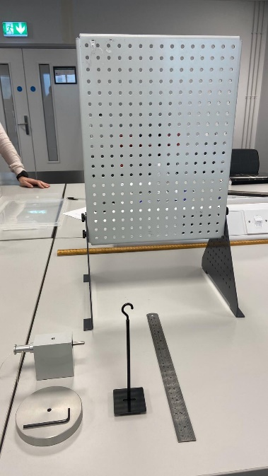
1.1 Introduction - Energy of a fly wheel
The task was to carry out an experiment using the Potential and Kinetic Energy Kit ES9. The experiment consisted of assembling the apparatus, seen in Figure 1, then preparing everything ready and task the team with specific jobs to ensure the correct readings were obtained.
The purpose of this experiment was to calculate the potential and kinetic energy generated from the fly wheel when different loads are applied, also to discover the difference between potential, kinetic energy and the transfer of energy.
This is done by retracting the fly wheel to the starting positon of the weights at 280mm, then releasing and timing how long it takes to descend and bounce to its highest peak. See Figures 2 and 3.

Figure 1- Pre-assembled apparatus

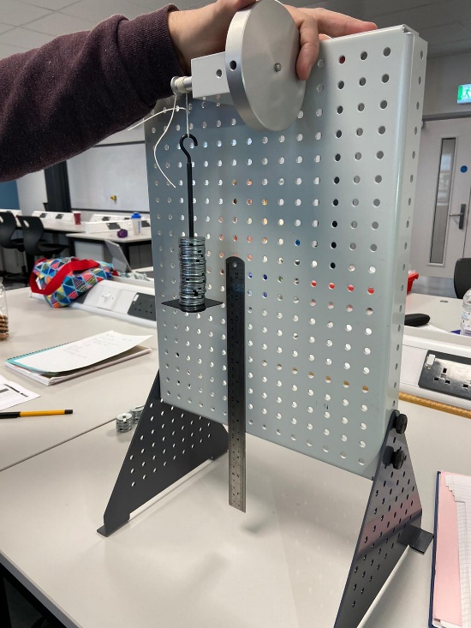
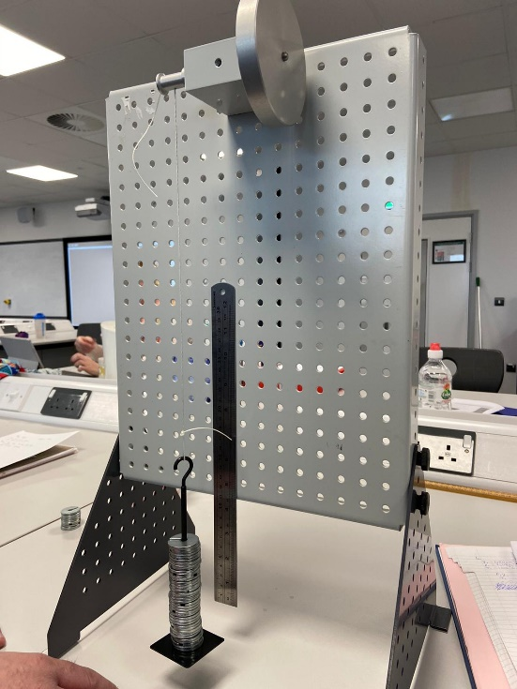

Figure 2: Retracted fly wheel at 280mm
Figure 3: Fly wheel released
2.0 Experimental Procedure
2.1 Procedure
The test began by assembling the apparatus according to the instructions given in Figure 1. First, assembling the fly wheel together and attaching it to the board, Figure 4, retracting the wheel and attaching the weight holder. A magnetic rule was attached to the board with the bottom edge being level with the weight holder.
10g of weight was added to the weight holder and the fly wheel was retracted until the holder was level with 280mm, see Figure 5.
Within the team we decided who was responsible for what reading, 3 people timing the test, one person operating the fly wheel, one person reading how high it bounced and one person taking photos and taking down the readings.
Once ready the fly wheel was released and the timers had started, the test was preformed 3 times with 10gs, so an average can be made. Tests were conducted over 100g, 200g, 300g, 400g and 500g. See Figures 7-11.

Energy of a fly Wheel
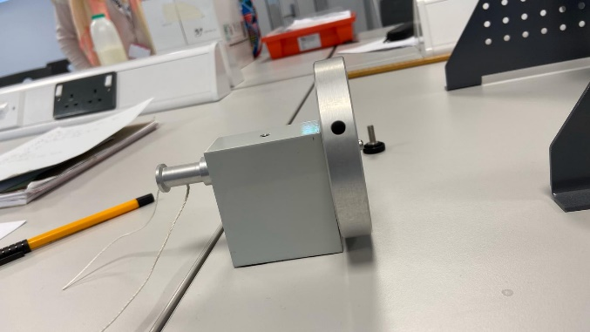

Figure 4: Fly wheel assembled

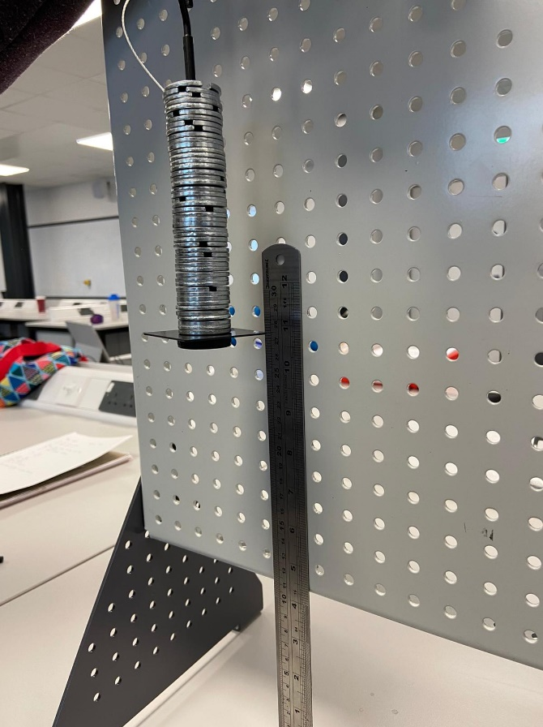

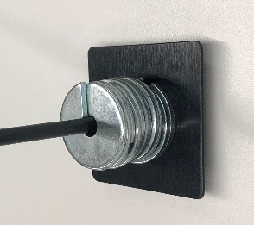
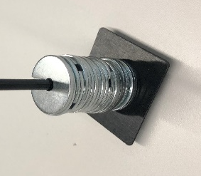
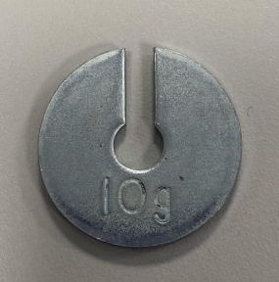

Figure 6: 10g

Figure 8: 200g

Figure 7: 100g

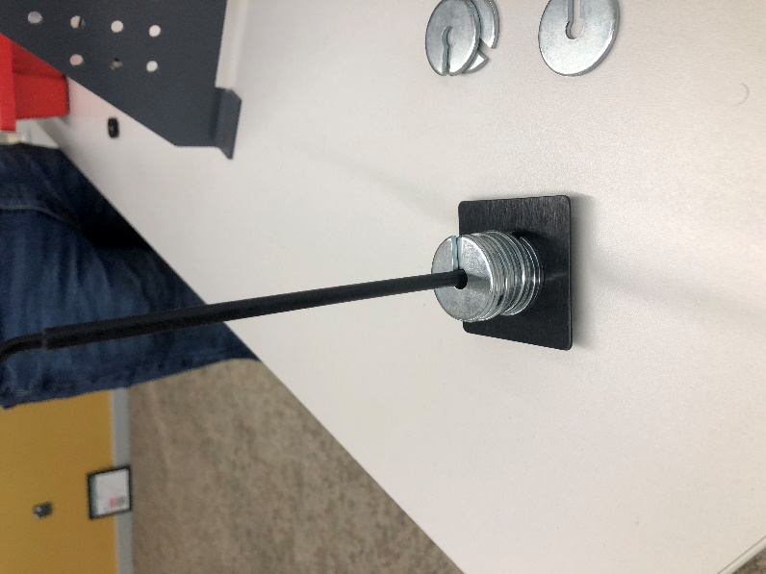

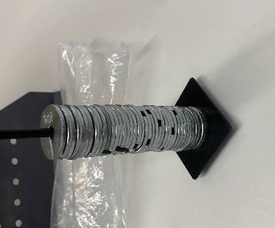
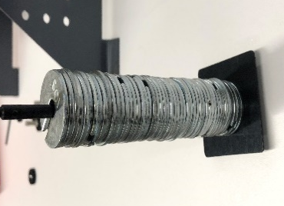
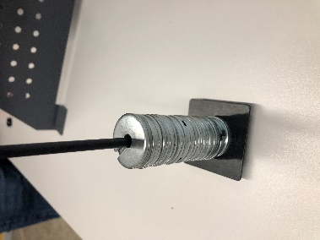
Figure 5: Fly wheel and weights retracted to 280mm

Figure 10: 400g

Figure 11: 500g

Figure 9: 300g

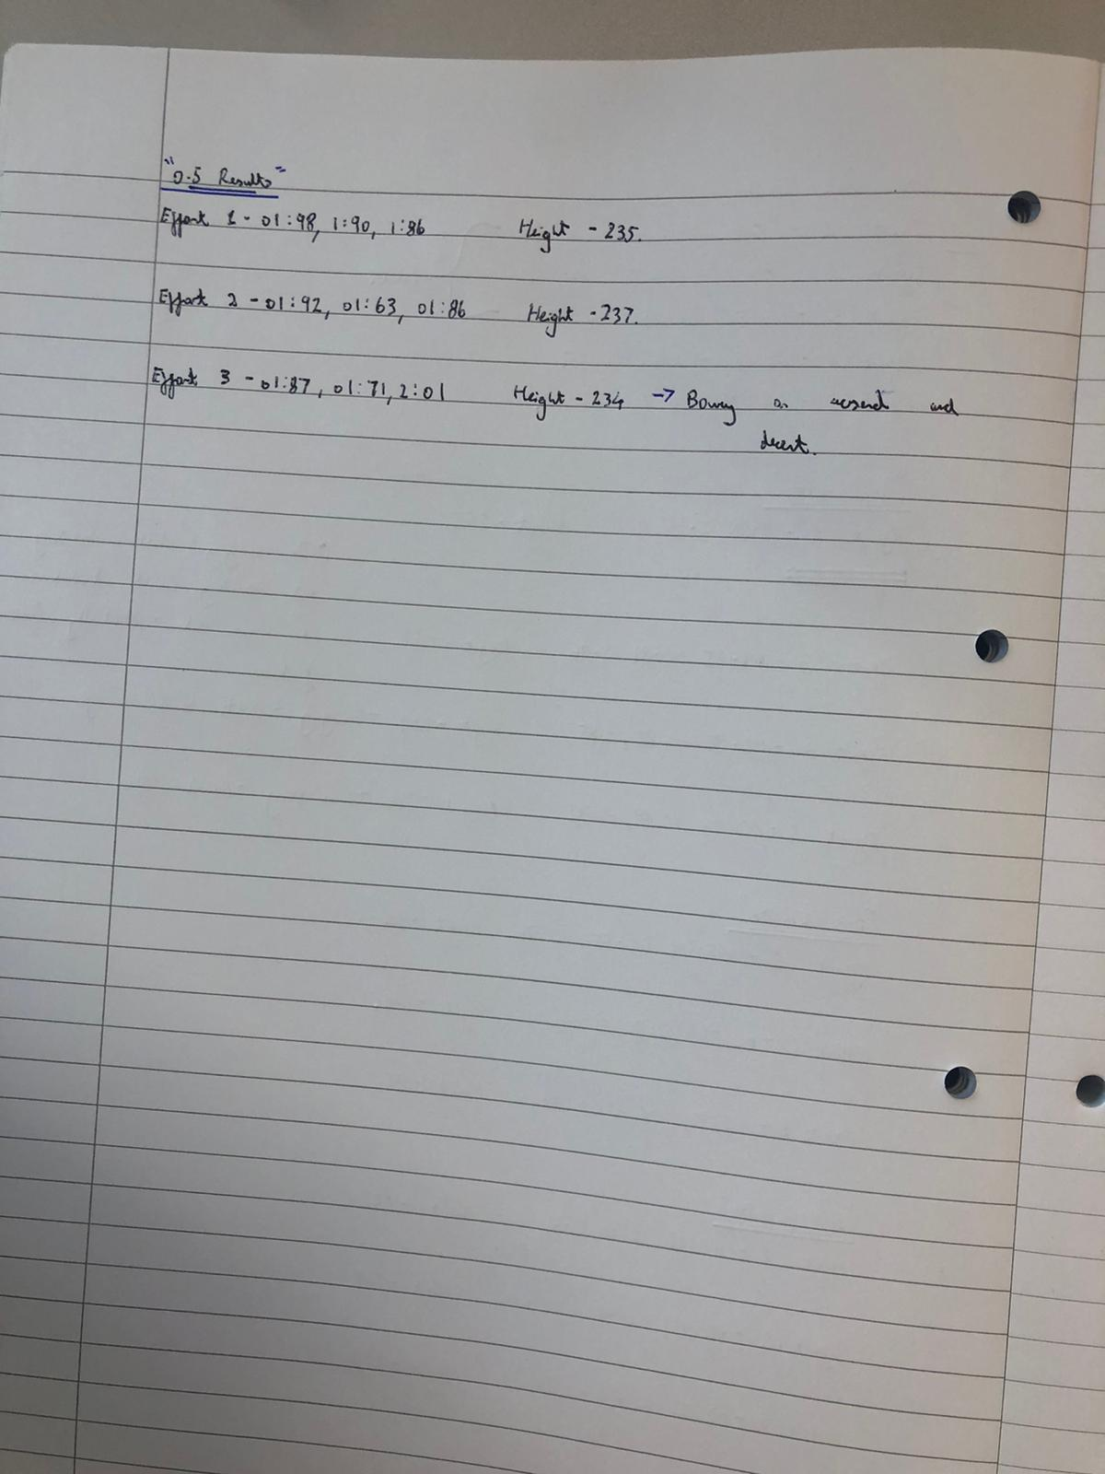
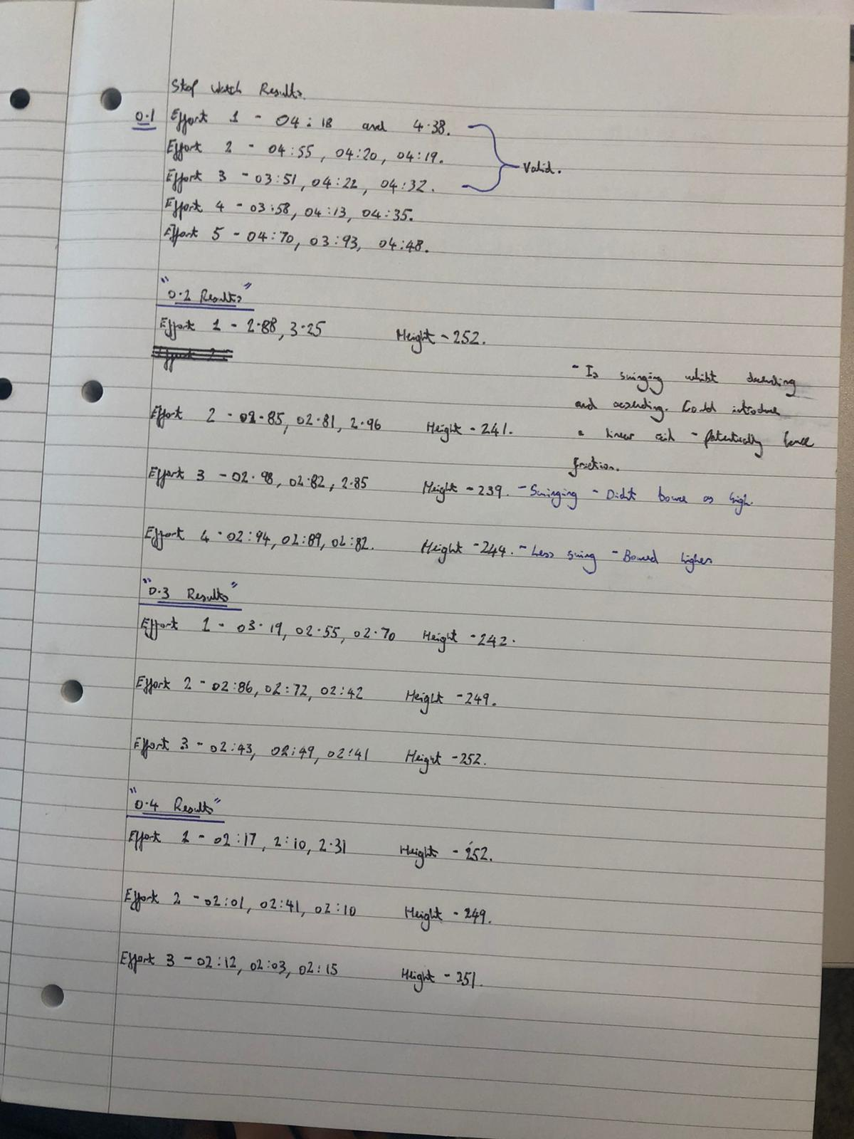
Figure 13: Data extracted from the test
Figure 12: Data extracted from the test
Data was extracted from the test by timing the test from start to finish and by an operator using a slow motion camera to establish a height measurement, each weight had 3 tests taken so a mean can be calculated to create a more accurate result.
0.1Kg Mass average of time to fall and rise was 4.19 seconds with a height measurement average of 0.247m. The test was taken more than 3 times as discrepancies were discovered in the first 2 readings.
0.2Kg Mass average of time to fall and rise was 2.92 seconds with a height measurement average of 0.245m.
0.3Kg Mass average of time to fall and rise was 2.64 seconds with a height measurement average of 0.248m. A trend of time to fall and rise was discovered as the more mass applied to the test, the less time it took to fall and rise.
0.4Kg Mass average of time to fall and rise was 2.15 seconds with a height measurement average of 0.245m. The more mass applied to the test piece, more inconsistent readings occurred. The test piece began to bounce and spin instead of a smooth decent and a smooth rise.
0.5Kg Mass average of time to fall and rise was 1.86 seconds with a height measurement average of 0.237m. 0.5Kg became increasingly difficult as it was more prone to inconsistent readings because of the bounce and twist in the rope.

3.1 Raw Data
Energy of a fly Wheel
3.0 Results
4.1 Analysis
4.0 Analysis
Energy of a fly Wheel
After the experiment a table of results was created which included, mass, time to fall and rise, initial height and max height. Based on the original readings, all other measurements was calculated, a trend was discovered during the test. The time to fall and rise got shorter and the bounce height started to rise. Given the measurements for the inertia of the fly wheel and the shaft, the total inertia involved was calculated in the experiment (4.70*10^-4 Kg/m²). After table was completed a graph was created with (MG-MA) on the Y axis and A/R on the X axis including a trend line.

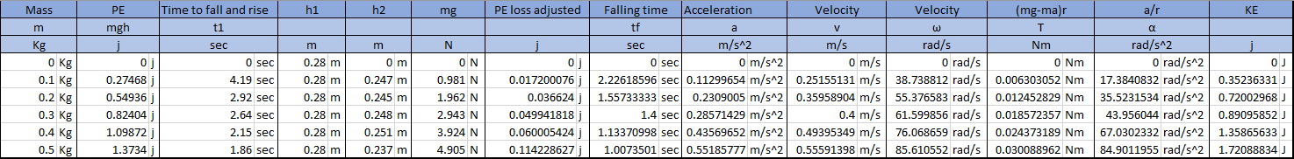

‘’The moment of inertia, 𝐼, of an object, around some given axis of rotation, is a proportionality constant between the applied torque 𝜏 and the angular acceleration 𝛼 of the object around that axis. (In a sense it is the equivalent of mass m in linear motion, which is a proportionality constant between the applied force, 𝐹and the acceleration 𝑎 of the mass, i.e., 𝐹 = 𝑚𝑎.) So, in general, 𝜏 = 𝐼𝛼.
The moment of inertia of an object, around some given axis, depends on the mass of the object, as well as the way in which that mass is arranged around the axis of rotation; more specifically, 𝐼 depends on the sum of the mass of each particle in the object, multiplied by the square of the radius of rotation of each particle around the given axis, i.e. 𝐼!"! = 𝑚!𝑟!’’¹
!
Figure 16: Graph of (MG-MA) on the Y axis and A/R on the X axis
Calculations
PE=Mass x 9.81 x initial height
Mg=Mass x 9.81
PE loss=(Mass x 9.81 x(Initial height – bounce height) x (initial height / (initial height + bounce height)))
Falling time= time to fall and rise x (initial height / (initial height + bounce height))
Acceleration=(2 x initial height) / Falling time^2
Velocity (v) = acceleration x falling time
Velocity (ω)=(2x π x velocity(v) )/ Pulley circumference)
(mg-mr)= Mg –(Mass x acceleration) x Radius of Pulley
a/r = acceleration / radius of pulley
KE=(Velocity(ω)^2) x ((I of flywheel)+(I of shaft)))/2
Figure 15: Given measurements in assignment booklet and total inertia of experiment
Figure 14: Results table with all measurements calculated
Concluding the experiment. It is to be believed that the necessary procedure was taken place and the correct preparation was conducted. The results gathered Proves that the more mass added to the test, the higher the velocity the less time the test took to complete one cycle. The test became faster with increasing Kinetic Energy. This is because kinetic energy only increases linearly with Mass, it loses Kinetic energy and velocity when it starts to rise as the acceleration of gravity is constant. The fly wheel’s velocity would increase more if there was less friction and a lower point of inertia. If the mass was increased, the Potential energy was be larger because the bigger the mass of the object, the object’s gravitational potential energy is increased. This means that mass and potential energy have a significant relation to each other.
‘’The higher up an object is the greater its gravitational potential energy. The larger the distance something falls through the greater the amount of GPE the object loses as it falls. As most of this GPE gets changed into kinetic energy, the higher up the object starts from the faster it will be falling when it hits the ground’’²
The mass 𝑚 has a certain potential energy when it is at height ℎ!, and some of that potential energy is converted as the mass moves down through distance 𝑠 to height ℎ!. The change in potential energy, 𝑈! Is converted into the kinetic energy of the falling mass, 𝐾𝐸, and the rotational kinetic energy of the flywheel, with some of the energy being dissipated through friction, producing thermal energy, 𝐸. The system is defined as the flywheel and the falling mass with the assumption that all energy is being conserved.³
5.1 Conclusion
5.0 Conclusion & Evaluation
Energy of a fly Wheel
5.2 Evaluation
After the experiment, there are variables that should have been considered when conducting this experiment, all of the variables will have affected the accuracy of our readings.
When recording our readings, considerations to the potential friction created during the test and how it could affect the fall and rise of the weights.
One person should be timing the process instead of three as problems were encountered as many discrepancies between some people missing early or late starting the time and stopping, this can affect all recordings in the table causing inaccurate results.
Inconsistent readings of how high the weight rose to as the idea of using a ‘Slow Motion’ camera but unless it was filmed at the perfect angle, it was hard to see how high it actually rose to.
Potential incorrect weights due to manufactured tolerances, weights should have been weighed accurately to ensure each weight is within tolerance to make the results more accurate.
Results show that the kinetic energy is higher than potential energy, this shouldn’t be the case and there could be some incorrect readings or formulas put into the table.
Figure 17: Measurement 0.3 mass off the trend line and units
A result became clear as the trend line show an inaccurate reading on my graph. This gives a clear indication that 0.3 mass was either inaccurate readings or a variable wasn’t considered when conducting this size weight. Figure 17.
6.1 Reflection
References
¹ PHY1025F PRACTIAL MANUAL Department of Physics, University of Cape Town (Page 13)
http://www.phy.uct.ac.za/sites/default/files/image_tool/images/281/courses/phylab1/PHY1025F_Lab_Manual.pdf
² Gravitational Potential Energy, S-cool the revision website
https://www.s-cool.co.uk/gcse/physics/energy-calculations/revise-it/gravitational-potential-energy
³ PHY1025F PRACTIAL MANUAL Department of Physics, University of Cape Town (Page 14)
http://www.phy.uct.ac.za/sites/default/files/image_tool/images/281/courses/phylab1/PHY1025F_Lab_Manual.pdf
⁴ PHY1025F PRACTIAL MANUAL Department of Physics, University of Cape Town (Page 14)
http://www.phy.uct.ac.za/sites/default/files/image_tool/images/281/courses/phylab1/PHY1025F_Lab_Manual.pdf

The experiment was a success within a good functional team, the team had a good chemistry and good communication between each other. Everyone had a basic understanding on all of the variables to consider and knowledge on the practical theory behind preforming this experiment.
If a retest was to be conducted to this experiment, more research in to all the different variables that need to be considered to make sure to create more accurate result. Before assembling the experiment, the fly wheel is to be inspected for its functionality, reliability and cleanliness. To optimize the energy-to-mass ratio the flywheel needs to spin at the maximum possible speed. The person letting go of the fly wheel should time the test as that person would be able to let go and start at more accurate time. If ‘Slow Motion’ was to be used again I would ask people to get multiple angles so we can make multiple judgements and decide on a more accurate result. After each reading I would put the results straight in to an Excel sheet instead of on Paper as I believe we could of created the table and graph and noticed any discrepancies when we were testing, we could of made a decision to retest again to provide more results.
The experiment’s accuracy could be increased if the manufacture’s tolerances was tighter and surface finish improved as it will make the fly wheel incredibly more reliable and accurate. Replace the string for a different material to avoid bounce and keep friction to a minimum. Tighter requirements of weights to ensure we have the closest accuracy to the intended weight, a sturdier unit holding the flywheel and other components and a calibrated table to ensure the weights aren’t falling at a slight angle due to table not being close enough to flat.
^{4 ‘’}For six (6) repeats, and using the Go Motion sensor provided, record and tabulate the velocity of the mass when it reaches height ℎ!, i.e., when the string is released from the axle.’’
University of Cape Town conducted this experiment by using technology like the ‘Go Motion sensor’ to be able to measure velocity and mass when it reaches its highest height, this is very useful as it can be more reliable to measure highest rather than the naked eye.

Energy of a fly Wheel
6.0 Further work

