

Applied Leadership and Management in the Workplace
Module Assignment Submission

Student Name: | Emma Davies
Student Number: | 2409780
Module No: | BMSK4013
Module Title: | Management Communication

Statement of Confirmation of Authenticity
By the act of making this submission, the student declares that this is the work of the student named above. The work has not, in whole or in part, been knowingly presented elsewhere for assessment, or where assessment has been built on a previous assessment, this has been identified. Where materials have been used from other sources it has been properly acknowledged. If this statement is untrue, the student acknowledges that an assessment offence has been committed.
Attention is drawn to the plagiarism and unfair practice policies of both the University and of ILM.

Table of Contents
Introduction 3
Communication Models: Theoretical Overview 3
Workplace Communication 5
Types and Models of Communication 5
Factors that Affect Communication in the Workplace 8
Formality, Tone, and Effective Communication in the Workplace 10
Conflict Management 11
Self-Evaluation & PDP 11
References 13
Appendix B: Questionnaire 17

Introduction
Communication is described by Spitzberg, (2023) is inherently ambiguous and ambivalent. This means that communication is a mix of being open to interpretation and can also have contradictory feelings. When describing communication is the workplace, Maund et al (2025) suggests that communicating in a team may imply hidden meanings. This can lead to misunderstandings and misinterpretations.

This report explores communication in the workplace, and how to overcome obstacles within communication. The report will also delve into the communications styles and models that are used in management communication in the workplace. It will also show the barriers to communication and how to overcome them. It will also show factors that affect performance and motivation within the workplace, self-evaluation of my own communication skills and how to deal with conflict using the CLEAR model. (Clarify, Listen, Express, Agree & Review) This technique shows how to deal with conflict in a calm and respectful manner.

The review will show models of communication cycles Basic, Shannon & Weaver, Schramm, Berlo (SMCR), the pros and cons of them all respectively and give a theoretical overview. The report will also assess the communication styles that I use in my own workplace and through research, describe what areas that I will need to focus and improve on.

This will be shown in the format of a questionnaire sent out to my peers and how the findings are processed. From this, as well as self-evaluations and quizzes, I will produce a personal development plan or (PDP). This will indicate the areas of communication that I struggle with and how to overcome them. This can be found in appendix A.

Communication Models: Theoretical Overview
Below are the 4 types of communication style models used within management communication and a brief overview of each model.

- Basic communications cycle – Circular

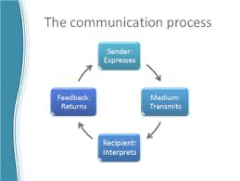

Pros: This is a simple model with many benefits. It provides feedback and is easy to understand. Diaz et al., (2012) suggests that it is useful for basic noise importance and this model is useful for describing misinterpretations.

Cons: There are, however, disadvantages of this model as describes by Diaz et al., (2012). The model doesn’t take into consideration, non-verbal or tone and can cause misunderstandings due to unclear feedback. This model doesn’t consider barriers to communication or take the receivers knowledge into account.

- Shannon & Weaver – Linear
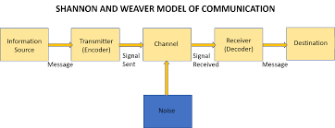

Pros: Oluga et al., (2013) states that the best use of this model would be for technical communication such as emails or WhatsApp communications. This model does take the receivers knowledge into account so can be useful if used in the correct environment.

Cons: This model can be described by Al-Fedaghi, (2012) as out-dated as it lacks a clear use of feedback. This model is complex and slightly more technical than other models. The noise importance of this style of communication is high as miscommunication during a call or interference on the line can cause misunderstandings or broken communication.
The model doesn’t consider any barriers and lacks the use of non-verbal communication.

- Schramm – Circular

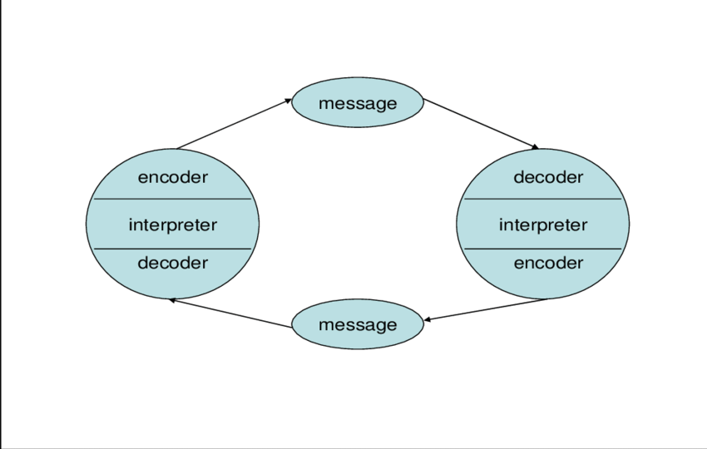

Pros: This is a simple model which is described by Huang, (2003) as being useful to those who communicate within environments of similar understanding such as team communications. The model provides feedback and takes the receivers knowledge into account. It also considers what others should already understand.

Cons: (Huang, 2003) also argues that there are issues with the lack of non-verbal communication and not taking any barriers to communication into account. The noise importance of this model is moderate as there could be misunderstanding due to a louder environment, and messages can be misread or misinterpreted

- Berlo (SMCR) – Linear

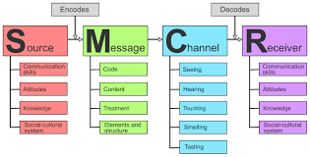

Pros: This is a complex model but offers a variety of benefits as stated by Diaz et al., (2012). It allows for noise distractions, it includes the use of non-verbal communication, it takes the receivers knowledge into account and considers the barriers to communication. This model would ideally be used for leadership or managerial roles.

Cons: Whilst this model does allow for noise or distractions, it is considered as moderate for noise importance as messages can still be misread or misinterpreted. The model doesn’t take feedback into account which can cause barriers in communication.

Workplace Communication
In my own workplace we mainly use the Schramm communication model. Whilst it lacks the use of non-verbal communication, it does offer a feedback loop which enables myself and my colleagues to clear up any misinterpretations. This works well for my job role as communication is a key part of my job and having the feedback structure enables me to determine any issues or misunderstandings.

Types and Models of Communication
There are many different types of communication. Below I will add a table with the different types of communication with the pros and cons of each as described by Foulger, (2004). I will also show the differences in formal and informal communication and the purpose of both.

Communication Type | Definition | Pros | Cons
Verbal | Spoken form of communication used face to face, over the phone or video call. | Gives immediate feedback.  Builds rapport.  Can clarify misunderstandings quickly. | Could lead to misinterpretation of unclear communication.  Depends on listening skills and ability.
Non-verbal | Conveying messages through body language, facial expressions, gestures, posture and eye contact. | Provides emotional cues.  Supports verbal communication.  Can be used when there are barriers such as language or culture. | Can be easy to misread.  Can contradict verbal messages if used incorrectly.
Written | Communicating through written words i.e. Letters, emails, reports, memos. | Provides a clear structure.  Useful for complex or detailed information.  Allows for a permanent record. | Can be time consuming.  Can be misinterpreted without clarification.  Lacks non-verbal cues i.e. tone and emotions.

Type | Definition | Purpose
Formal communication | We use formal communication to exchange information through official settings. Such as sending external emails, reports to managers and in business settings. | The purpose of using a formal tone is to clarify what is being said from sender to receiver.  To establish official records or documentation.  Used within policies and procedures.
Informal communication | Informal communication is used in a more casual settings such as general conversation between colleagues or friendship groups during breaks. | To adopt a sense of community within the team.  Allows feedback when sharing ideas.  Promotes collaboration and morale in the workplace.

In the above tables I have shown the definitions and purposes of types of communication, the importance of knowing your audience and combined with communication models, can allow for a more productive team dynamic.

In my own workplace, we use a mixture of formal and informal communication. Our monthly team meetings are formal and structured, and the agenda and minutes are recorded. We also use formal communication when liaising with social workers and finance managers on our service user’s behalf.

We also use informal communication when communication with our service users. We need to adapt our tone and formality to suit the needs of the individuals we support for them to feel safe and respected. We also use informal messages to communicate on Teams between colleagues. This is useful and beneficial for team morale.

Communication Barriers
There are many barriers to communication which can affect the communication cycle. These can include:

- Linguistic barriers
- Physical barriers
- Cultural barriers
- Emotional barriers
- Hierarchical barriers
- Phycological barriers
- Technological barriers

I will briefly describe these in the table below.

Barriers | Potential causes | Ways to overcome
Cultural | These can be caused by having different backgrounds, different languages or having different values and beliefs. This can lead to misinterpretations and misunderstandings. | Be more aware of diverse cultures and adapt communication style to suit specific audiences as stated by Khene Barieva et al., (2018)
Emotional | Emotional barriers can arise by having personality clashes, personal experiences and state of mind. | Focus on your own emotions and actively listen to others’ opinions and concerns.
Physical | Khene Barieva et al., (2018) suggests that these barriers can be caused by noise, distance and environmental distractions such as poor lighting or crowded spaces. | Prioritise messages in a clear and concise manner. Try to adapt work style to suit environment. i.e. working in a quiet space or ensuring the noise distractions are at a minimum.
Technological | These can arise from many issues, such as, faulty equipment, technical failures, technical jargon or lack of training. | Try to prioritize accessibility and user-friendly equipment. Use clear and concise communication and keep active engagement and feedback.
Physiological | These barriers can arise from many factors, such as, sensory impairments, physical ailments or illnesses. They can also include conditions like dyslexia and stutters. | Adopt clear communication like speaking clearly and using simple language. Also request feedback and check understanding to avoid misinterpretations.
Hierarchical | These can be caused by power imbalances within the workplace, fear of speaking up and having a lack of open dialogue. | Promoting collaboration is very important. Adopt an open communication structure and include active listening. Encourage direct communication and team building activities.
Semantic | These barriers can arise by misunderstanding, difference of opinions and different interpretations between the sender and receiver. | Ensure clarity, active listening and adapt communication style to suit.

The table above shows what the communication barriers are, potential causes and how to overcome them. These barriers can lead to misunderstandings and cause obstacles within communication. Erven, (2002) states that individuals can overcome these barriers by working at improving communication skills, making communication goal orientated and keeping a positive attitude about communication. Erven, (2002) goes on to say that accepting the reality of miscommunication can minimize its negative impacts.

One communication barrier I face in my workplace is semantic. For example, we use emails and Teams chat to communicate within our team and these messages can and are be misinterpreted often. This can be resolved by using clear, and concise language and requesting feedback so messaged are sent and received correctly. This can prevent confusion and improve collaboration within the team.

Factors that Affect Communication in the Workplace
Below is a table that shows the 4 theories of motivation and a brief description of each.

MOTIVATION THEORY | KEY ELEMENTS | STRENGTHS | WEAKNESSES | BEST APPLIED IN:
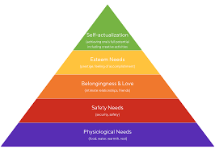  Maslow’s Hierarchy of Needs | This is a 5-tier pyramid of human needs.  - Physiological  - Safety  - Love and belonging  - Esteem  - Self-actualisation | This is a simple structure and is widely used within management training. It emphasizes growth and human potential and highlights the nature of motivation.  (Kaur, 2013) | This theory is not universally applicable and lacks variable support. This also assumes that individuals are all motivated in the same way. | PDP’s educational settings and welfare assessments for organisations.  Best used for individual’s needs.
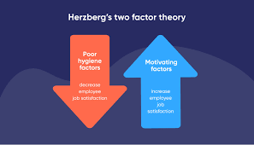  Herzberg’s Two Factor Theory | This theory indicates that motivation is influenced by two factors.  - Extrinsic-Hygiene  - Intrinsic-Motivators  Hygiene factors prevent dissatisfaction but do not motivate.  Motivators increase job satisfaction and performance. | This theory distinguishes between satisfaction and dissatisfaction.  It supports job enrichment and is practical in improving workplace environments.  (Pardee, 2025) | The classification of factors can be seen as too simplistic. It may not apply to all industries. | Motivation audits, job design and staff engagement surveys.  Best used for company policies.
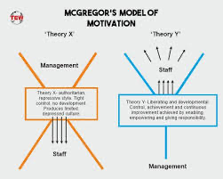  McGregor’s Theory X & Y | This theory shows the opposing views of employees.  - Theory X – dislikes work and avoids responsibility.  - Theory Y – Enjoys work and seeks responsibility. | This theory encourages leadership and management styles. It highlights the impact of managerial assumptions on motivation and supports participative management practices. | This theory can be oversimplified and exhibits traits from both theories. It also runs a risk of stereotyping staff based on limited assumptions as stated by  Markwell, (2004). | Leadership training, designing team building activities and organisational assessments.  Best used for management.
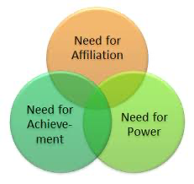  McClelland Three Needs Theory | This is a 3-factor theory that focuses on the needs for:  - Affiliation  - Power  - Achievement | This theory recognises the individuals’ differences in motivation. It is applicable to workplace training and recruitment and is practical for leadership roles. | Rybnicek et al., (2017) suggests this theory may oversimplify human motivations by excluding external factors. It only focuses on workplace contexts and can be difficult to standardise. | Leadership development, team formation and HR recruitment.  Best used for individuals.

The above table identifies the strengths and weaknesses and gives examples of where they would be best applied.

In my role supporting adults with learning disabilities, I regularly see how Maslow’s hierarchy is relevant, not only for service users but also for staff. For example: Belonging and Esteem are used through team building activities and regular supervisions. Physiological and Safety are met by ensuring staff have regular breaks and safe working conditions.

Not all staff members are motivated in the same way so they may use another motivation theory such as Herzberg. Recognition can significantly improve morale in demanding roles like ours.

Understanding these theories has improved how I support and communicate with colleagues. By recognising individual motivators, I can make a more positive, productive work environment that helps both team performance and service user outcomes.

Formality, Tone, and Effective Communication in the Workplace
Communication, especially in the workplace, the use of formality and tone is crucial for keeping team morale, clarity, and professional relationships. As Eckert et al. (2013) suggest, formality can be shaped by our manner of speaking and writing, and a lack of correct formality can lead to misunderstandings or even conflict.
Tone refers to the attitude and emotional quality conveyed in communication. According to Phelan (2014), the tone we use reflects our values and attitude, and it significantly affects how our message is received by colleagues, managers, and clients alike. Perrine (1963) further emphasises that tone can be more powerful than the actual words used, as it carries the speaker's emotional state and intent.
In my role working with adults with learning disabilities, tone and formality are especially important. As noted by Erven (2002), a calm, clear, and respectful tone makes a safe and supportive environment, something that is vital when caring for vulnerable individuals. Using overly formal language may confuse service users, while a tone that is too casual or dismissive could come across as disrespectful or patronising. Adapting communication styles to suit the audience ensures better understanding and dignity in support.
For example, formal communication is necessary when writing care plans, incident reports, or when contacting external professionals like social workers and finance managers. These situations require structured language, accuracy, and a respectful tone. Whilst informal communication helps build trust with service users. A warm, friendly tone during everyday conversations makes individuals feel comfortable, understood, and valued (Erven, 2002).
Tone also includes features such as pitch, pace, volume, and pauses. For instance, speaking in a calm and measured tone with appropriate pauses signals patience. However, a loud or rushed tone may appear impatient or intimidating, especially for service users with sensory or emotional issues.
It's also important to consider the types of tone used in the workplace, such as empathetic, assertive, or encouraging. An empathetic tone can de-escalate tension and show support, while an assertive tone may be necessary for setting boundaries or giving clear instructions. However, a passive or aggressive tone can negatively impact team dynamics and trust.
Lastly, the way we use tone is intricately linked to our emotional intelligence. Being aware of our own emotions and how they influence our voice, and delivery can help us manage stressful conversations more effectively. For example, during a crisis or conflict, maintaining a calm and composed tone can reassure others and reduce panic.
In summary, tone and formality are more than just communication tools, they are essential elements of professionalism, empathy, and inclusivity in the workplace. Being mindful of both helps ensure effective communication, positive working relationships, and a supportive care environment.

Conflict Management
The two main types of conflict at work are personal and professional.
Personal conflict as described by Verma, (1998) can involve emotions and can arise from different values, beliefs, or even personality clashes.
Verma, (1998) also suggests that professional conflicts are typically centred around work related issues. Theses can arise when there are disagreements over workload, organisational policies or mistrust.

The key to avoiding conflicts is by adopting the CLEAR model. (Clarify, Listen, Express, Agree, Review and reflect). It is important to know the tone you use and the use of “I’s” instead of “you”. By using this model, it will enable staff and colleagues to keep a clear head and focus on the matter at hand. By not using this model, tempers may fray and cause multiple issues such as lack of trust, suspicion and doubt and a negative atmosphere.

Whilst in my own workplace, I did not adopt this approach when dealing with a conflict. Emotions were involved and I questioned the intensions of my colleague.
I was a supervisor for a small team and one of my staff members came into work out of uniform and wearing provocative gym wear. I asked the individual to put on her workwear and asked why she had not worn them to work as I knew she had come straight from home. The staff member gave me attitude which led to a full-blown argument. By me not remaining calm and dealing with the situation using the CLEAR approach, the situation escalated, and we ended up in mediation.

By knowing how this approach works, it has enabled me to get a better understanding of what I need to achieve in any future situations to avoid escalation. I will undoubtedly adopt this approach in the future.

Self-Evaluation & PDP
Having distributed a survey to my friends, family, colleagues and peers (of which I asked for feedback about my communication strengths and weaknesses), I have been able to determine areas of my communication that I need to work on. I created a questionnaire on Microsoft Forms and asked my peers, colleagues and friends for their feedback.

I analysed the results from this questionnaire, and I have determined that I need to focus on my listening skills. Whilst my verbal communication came back as excellent, my attitude and tone came back as room for improvement. I have also completed a workplace self-assessment questionnaire, which also established that alike the survey, I need to focus on my listening skills. It also showed me that I need to improve my bad habits, i.e. fidgeting and my ability to speak in front of larger groups. My strengths, however, show that my written and verbal communication are excellent.

By gathering this information, I have realised that there are several areas that I need to improve and develop. I will display these key areas and how to advance them with my personal development plan using the SMART technique which can be found in appendix A.
Conclusion
In this report, I have explored communication models and their relevance in various workplace contexts, emphasizing the importance of using appropriate methods based on setting, tone, and formality. I have also examined motivational theories and their practical application within professional environments.
Each section has been linked to my own workplace experience, including a detailed account of a workplace conflict. This reflection highlighted my responses, the outcomes, and what I could have done differently to improve communication and resolution. I also identified common barriers to effective communication and determined appropriate strategies to overcome each one.
Building on this analysis, I used communication and motivation theories, along with self-assessment tools, to develop a Personal Development Plan (PDP). By applying the SMART technique, I was able to identify specific areas of my communication that require improvement and state steps for personal growth.
As Beausaert et al. (2011) suggest, supporting personal development enhances both motivation and productivity. By implementing my PDP, I aim to strengthen my communication skills, increase my professional confidence, and contribute more effectively to the workplace.

References
Ali, A., Hussain, T., Tantashutikun, N., Hussain, N., & Cocetta, G. (2023). Application of smart techniques, Internet of Things and data mining for resource use efficient and sustainable crop production. Agriculture, 13(2), 397. https://doi.org/10.3390/agriculture13020397

Beausaert, S. A. J., Segers, M. S. R., & Gijselaers, W. H. (2011). Using a personal development plan for different purposes: Its influence on undertaking learning activities and job performance. Vocations and Learning, 4(3), 231–252. https://doi.org/10.1007/s12186-011-9060-y

Diaz, I., Chiaburu, D. S., Zimmerman, R. D., & Boswell, W. R. (2012). Communication technology: Pros and cons of constant connection to work. Journal of Vocational Behavior, 80(2), 500–508. https://doi.org/10.1016/j.jvb.2011.08.007

Eckert, C., Stacey, M., & Earl, C. (2013). Formality in design communication. Artificial Intelligence for Engineering Design, Analysis and Manufacturing, 27(2), 91–103. https://doi.org/10.1017/S0890060413000073

Erven, B. L. (2002). Overcoming barriers to communication. Department of Agricultural, Environmental, and Development Economics, Ohio State University. https://aede.osu.edu/sites/aede/files/publication_files/Overcoming%20Barriers%20to%20Communication.pdf

Foulger, D. (2004). Models of the communication process. https://d1wqtxts1xzle7.cloudfront.net/45035040/comm-libre.pdf‌

Huang, C. (2003). Transitional media vs. normative theories: Schramm, Altschull, and China. Journal of Communication, 53(3), 444–459. https://doi.org/10.1111/j.1460-2466.2003.tb02601.x‌

Kaur, A. (2013). Maslow’s need hierarchy theory: Applications and criticisms. Global Journal of Management and Business Studies, 3(10), https://www.ripublication.com/gjmbs_spl/gjmbsv3n10_03.pdfSCIRP+1Studocu+1
Khene Barieva, Zarima Kireeva, Zhou, N., & Kadi, S. (2018). The overcoming of the communication barriers of students as a means of personalization of education. Journal of Social Studies Education Research, 9(3), 398–409. https://dergipark.org.tr/en/pub/jsser/issue/43625/534244

Markwell, J. (2004). The human side of science education: Using McGregor’s theory Y as a framework for improving student motivation. Biochemistry and Molecular Biology Education, 32(5), 323–325. https://doi.org/10.1002/bmb.2004.494032050393

Maund, A., Shriek, M., & Tinkler, P. K. (2025). Certificate in higher education: Skills for the workplace student yearbook (p. 46). University of Wales Trinity Saint David.
https://librarysearch.uwtsd.ac.uk/discovery/fulldisplay?context=L&docid=alma99100160460302421&vid=44WHELF_UWTSD%3A44WHELF_UWTSD_VU1‌

Muyanga, C. C., & Phiri, J. (2021). Assessment of effective communication in international schools in developing countries based on the Berlo’s SMCR model. Open Journal of Business and Management, 9(1), 448–459. https://doi.org/10.4236/ojbm.2021.91024

Oluga, S., Rahman Kampar, A., Campus, P., Halira, M., & Babalola, A. L. (2013). An exploration of the pros and cons of the text message communication system. International Journal of Asian Social Science, 3(2), 334–344. https://archive.aessweb.com/index.php/5007/article/view/2420

Pardee, R. L. (2025). Motivation theories of Maslow, Herzberg, McGregor & McClelland: A literature review of selected theories dealing with job satisfaction and motivation. ERIC. https://eric.ed.gov/?id=ED316767

‌Perrine, L. (1963). The importance of tone in the interpretation of literature. College English, 24(5), 389–395. https://doi.org/10.58680/ce196327131

Phelan, J. (2014). Voice, tone, and the rhetoric of narrative communication. Language and Literature: International Journal of Stylistics, 23(1), 49–60. https://doi.org/10.1177/0963947013511723

Ritchie, D. (1986). Shannon and Weaver. Communication Research, 13(2), 278–298. https://doi.org/10.1177/009365086013002007

Schramm, W. (1962). Mass communication. Annual Review of Psychology, 13(1), 251–284. https://doi.org/10.1146/annurev.ps.13.020162.001343

Spitzberg, B. H. (2023). What is good communication? Journal of the Association for Communication Administration, 29(1). https://stars.library.ucf.edu/jaca/vol29/iss1/7/

Verma, V. (1998). Conflict management. In Project management handbook (pp. 353–364). Project Management Institute. http://www.communicationcache.com/uploads/1/0/8/8/10887248/conflict_management.pdf

Appendix A: PDP

Goals | Actions | Resources | Measurements | Time
Improve active listening by avoiding interruptions and increasing focus during conversations. | Practice active listening during daily conversations; pause before responding to ensure understanding. | Read "Active Listening" by Carl R. Rogers (available at university library); attend university communication workshop. | Ask for feedback weekly from 2 peers. Record reflections in a communication journal. | By 30th November 2025
Reduce nervous habits (fidgeting, lack of eye contact) during social and professional interactions. | Meditate for 10 minutes daily; log anxiety triggers after interactions. | Calm app for guided meditation; Self-awareness workbook from student wellbeing services. | Maintain weekly journal entries; check meditation streaks and app usage data. | Track progress until 15th of December 2025
increase public speaking confidence by participating in group discussions at least once a week. | Volunteer to present during class/group activities; rehearse aloud in front of a mirror or friend. | Library books on public speaking (e.g. TED Talks). Join a university speaking group. | Keep a confidence rating log after each speaking event; gather peer feedback once a month. | Achieve measurable improvement within 6 months (by 17th November 2025)

Appendix B: Questionnaire

