
Module Name | Digital Skills for Personal and Professional Growth
Module Code | BMSW4008
Assignment Name | Evidence of Learning (E-Portfolio)
Student Name | Ali Ahmed Suliman
Student Number | 2326008
Lecturer | Muhammad Cassamo
Deadline | Friday 12th December 2025 23.59pm

AI Statement:

Module Name: Digital Skills for Personal and Professional Growth
Module Code: BMSW4008
Assignment Name: Evidence of Learning (E-Portfolio)
Student Name: Ali Ahmed Suliman
Student Number: 2326008
Lecturer: Muhammad Cassamo
Deadline: Friday 12th December 2025 23.59pm
Wordcount: 1752 words
AI Acknowledgement
I confirm that I have not presented any AI generated materials as my own work.
I confirm that I have copies of my drafts, notes, and other resources I used, which I may be asked to provide in evidence.
I confirm that I have use a tool like Microsoft Editor, Bing Chat or specific elements of Grammarly, to check for grammar, spelling and readability.
Contents
1
Task 1- Private Hire Market Research and Digital Strategy Report 4
1.1 Introduction 4
1.2 Data Collection and Questionnaire Design 4
1.2.1 Key Data Insights 4
1.2.2 Willingness to Use Private Hire Transport 5
1.2.3 Frequency of Use 5
1.2.4 Key Decision Drivers 6
1.2.5 Feature Preferences 6
1.3 Audience Segmentation 6
1.4 Business Strategy 7
1.5 Website and Marketing Materials 8
1.6 Website Design and SEO Integration 9
1.7 Marketing Material Development 10
1.7.1 Tone & Messaging 10
1.7.2 Campaigns 10
1.7.3 Visual Elements 10
1.8 Conclusion 10
Task 2- Integrating Excel into Strategic Growth for a Private Hire Business 11
2.1 Data Analysis and Insight Generation 11
2.2 Financial Modelling for Service Viability 11
2.3 Marketing ROI and Customer Retention Metrics 12
2.4 SEO and Content Planning 12
2.5 Operational Optimization and Driver Scheduling 12
2.6 Conclusion 12
4.1 References 14
4.1.1 Task 1 References 14
4.1.2 Task 2 References 14

Task 1- Private Hire Market Research and Digital Strategy Report

1.1 Introduction

Resourcing services like Uber are rapidly reshaping urban transport. Although in 2014 Taxi and Private Hire Vehicles (PHVs) made up just 1.3% of London’s daily trips, the number of PHVs and licensed drivers has surged by 58% and 81% respectively, indicating significant growth. This rise reflects wider adoption of app-based services, which are challenging traditional public transport and car ownership models. As part of the broader sharing economy, services like UberPOOL are changing how people access mobility, aided by advanced technologies and digital platforms. These trends raise important questions for policymakers and transport operators, especially regarding the actual impact on travel behaviour and existing public transit systems. The paper you referenced explores these disruptions through interviews and literature, using London as a case study.

With the rise of technology-driven ride-hailing services, traditional private hire transport operators must innovate to remain competitive. This project investigates how customer-centred digital design and marketing can bridge the gap between local taxi services and on-demand mobility apps. Primary data was collected through a 11-question online questionnaire distributed to a target demographic within the local community. The goal was to understand usage patterns, expectations, and trust signals that inform branding and digital strategy.

1.2 Data Collection and Questionnaire Design

The questionnaire, created using Google Forms, featured ten carefully structured questions that measured attitudes toward private hire transport. These included demographic data, usage frequency, decision-making factors (e.g., safety, price, professionalism), and feature preferences (e.g., app-based access, operating hours). Responses were gathered from 30 individuals, providing a representative snapshot of potential service users across Cardiff and the surrounding area.

1.2.1 Key Data Insights

Several questions yielded significant insights that informed the website structure, marketing tone, and overall positioning.

1.2.2 Willingness to Use Private Hire Transport

- (54.5%) of participants responded “Yes” to using private hire services, while (36.4%) selected “Maybe. This reveals high potential for conversion, particularly among hesitant users. A targeted marketing campaign that addresses concerns and communicates value could convert “maybes” into loyal customers.
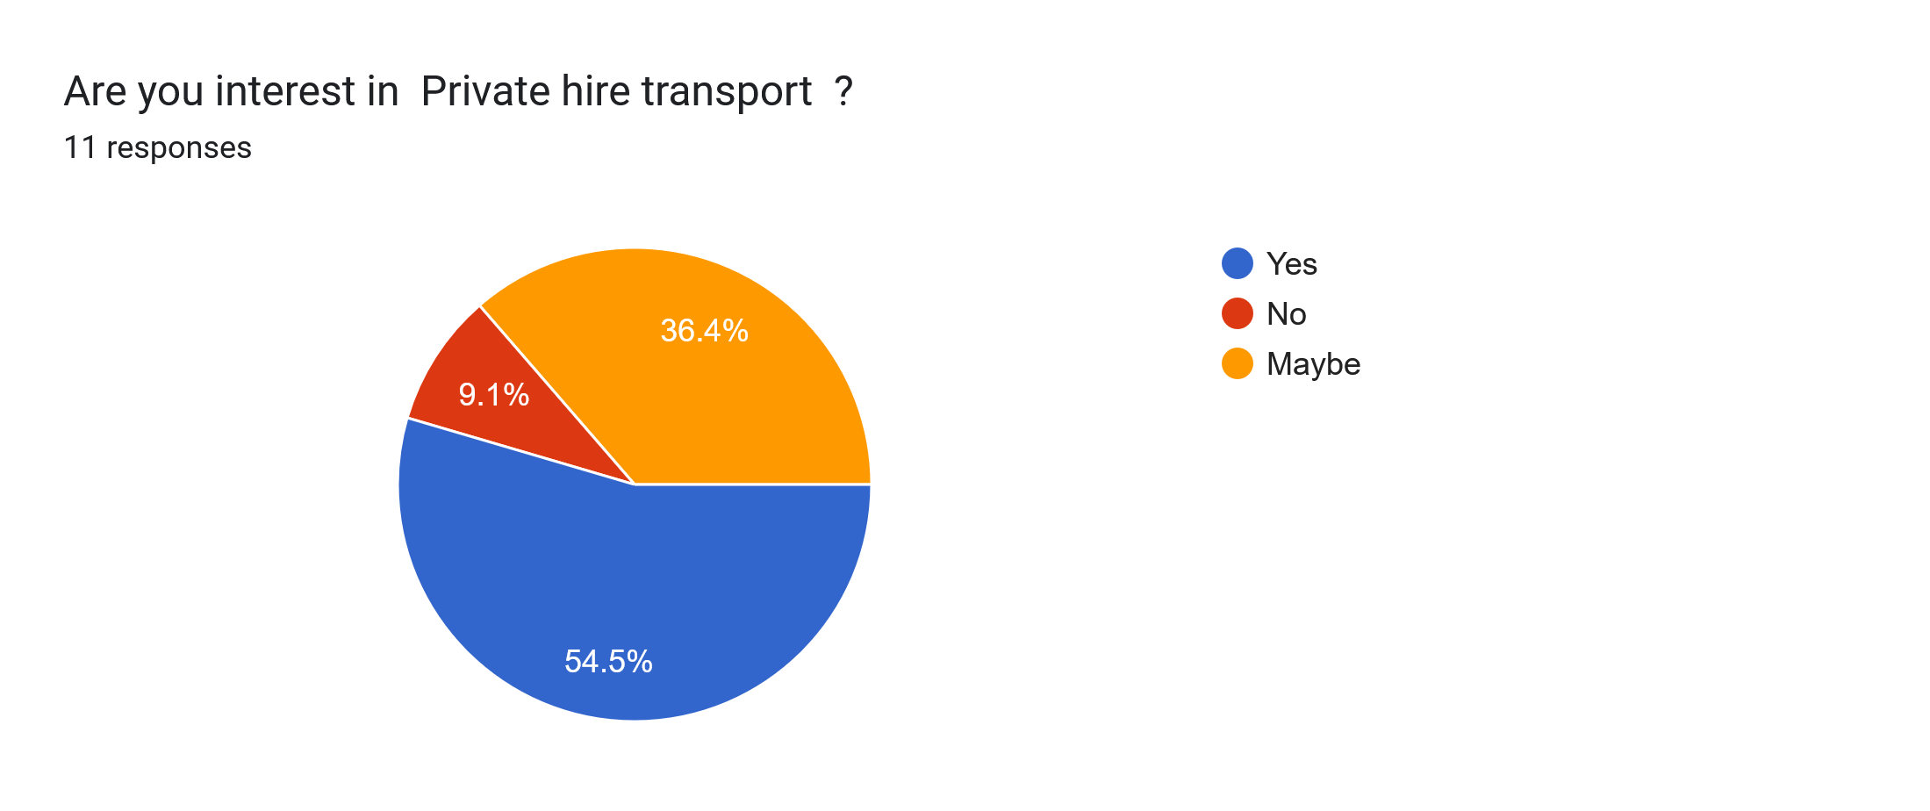
Figure 1.1: Private Hire interest

1.2.3 Frequency of Use
- (72.7%) of respondents use services occasionally, while (9.1%) are frequent users and another (9.1%) were. This supports a flexibility-focused business model, where occasional users are incentivised to increase frequency through promotions and loyalty rewards.
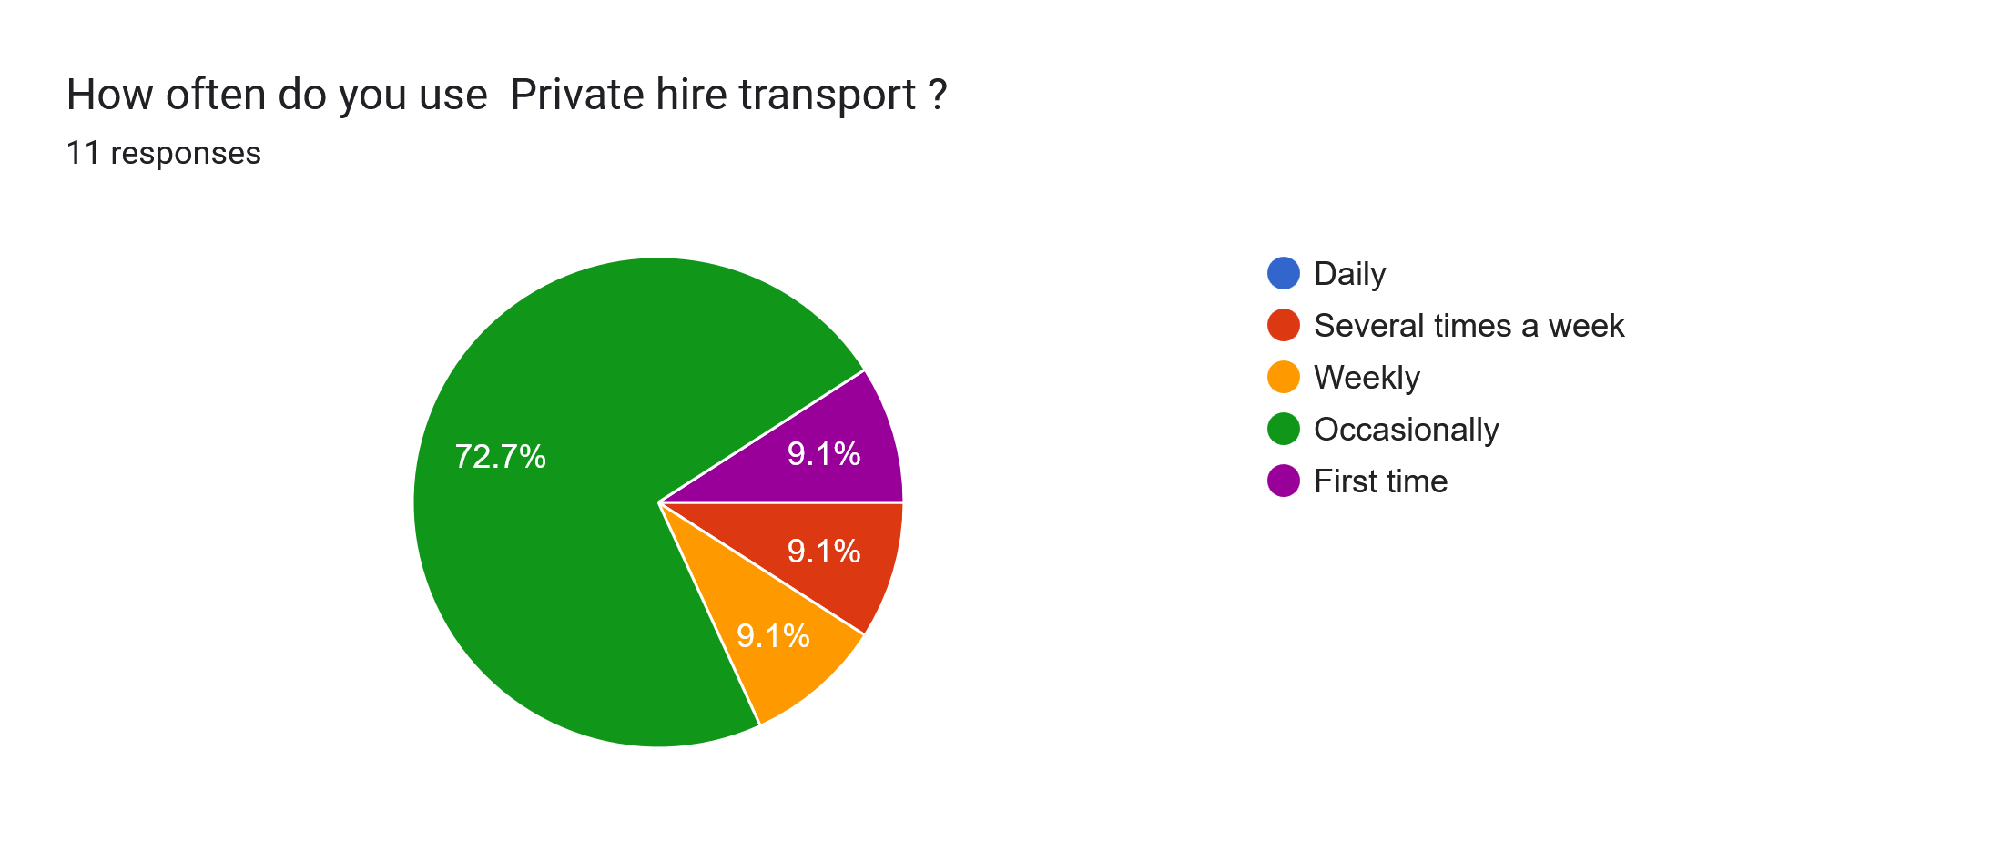
Figure 1.2: Use of Private Hire

1.2.4 Key Decision Drivers
- Price (45.5%), Safety (36.4%), and Cleanliness (36.4%) emerged as top motivators. These values formed the foundation of the branding strategy, ensuring that both the website and marketing content reinforce these priorities.
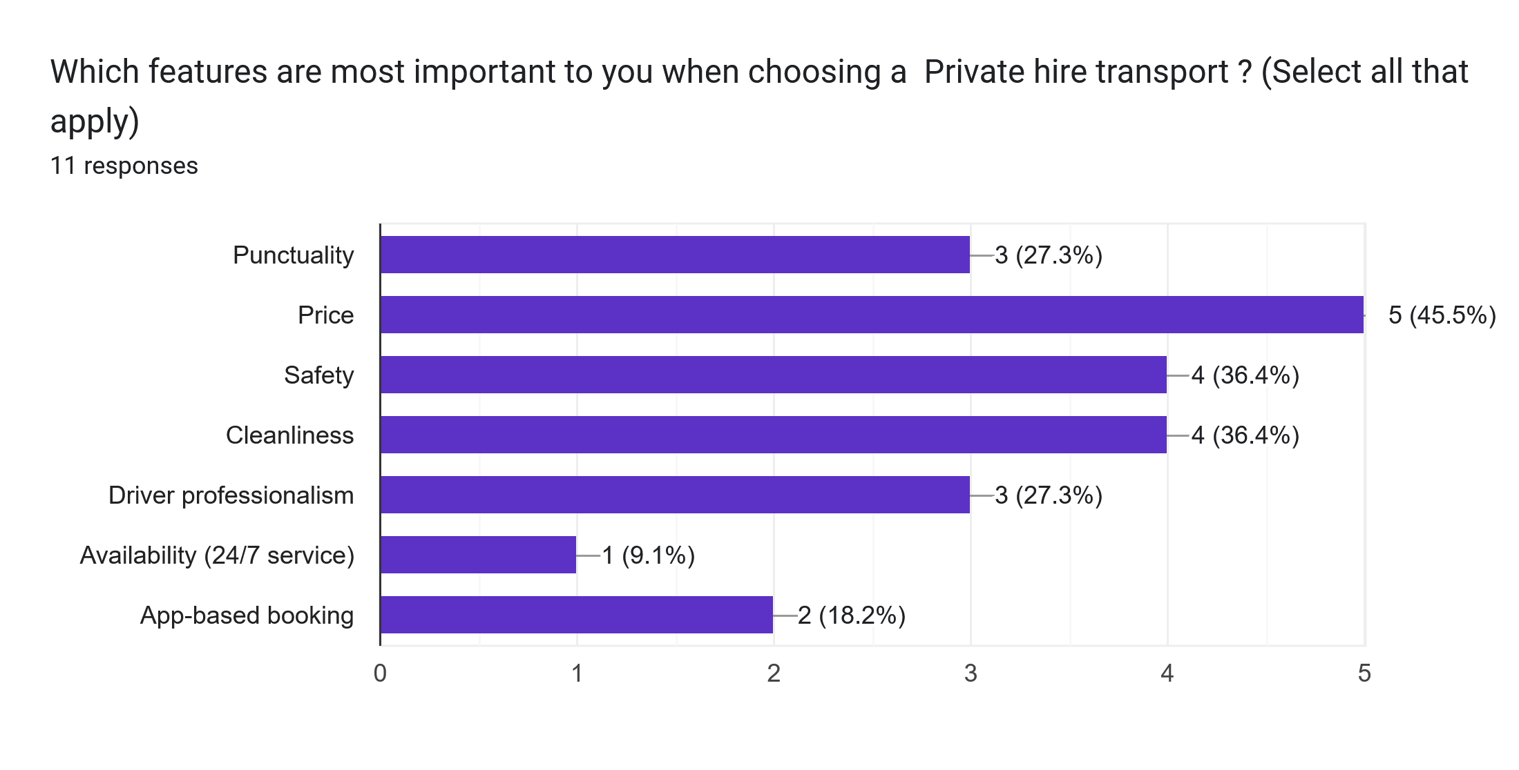
Figure 1.3: Important Feature

1.2.5 Feature Preferences

- Only (9.1%) of users viewed features like 24/7 availability or app access as essential. The human factor and reliability outweigh technical perks for most users, suggesting a strategic focus on community trust and clear value.

Graphical representations of these insights were visualised in pie charts and bar graphs (see appendix), offering a data-driven foundation for design and messaging.

1.3 Audience Segmentation
The insights allowed for the development of three core user personas:
- The Occasional Rider: (72.7%) Convenience-driven and responsive to price incentives.
- The “Maybe: (36.4%) Needs assurance about safety, trust, and value.
- The Loyal Regular: (9.1%) Likely to refer others; should be rewarded through referral schemes.
Effective segmentation enabled personalised messaging and user journey design.

1.4 Business Strategy
Using the data, the business concept was refined to offer:
- On-demand private hire with transparent pricing
- Locally trusted drivers with visible credentials and health & safety procedures
Introductory offers and loyalty rewards targeting both new and occasional users
Rather than compete solely on technology, the business’s niche lies in community integration, personalised service, and reliability.

1.5 Website and Marketing Materials
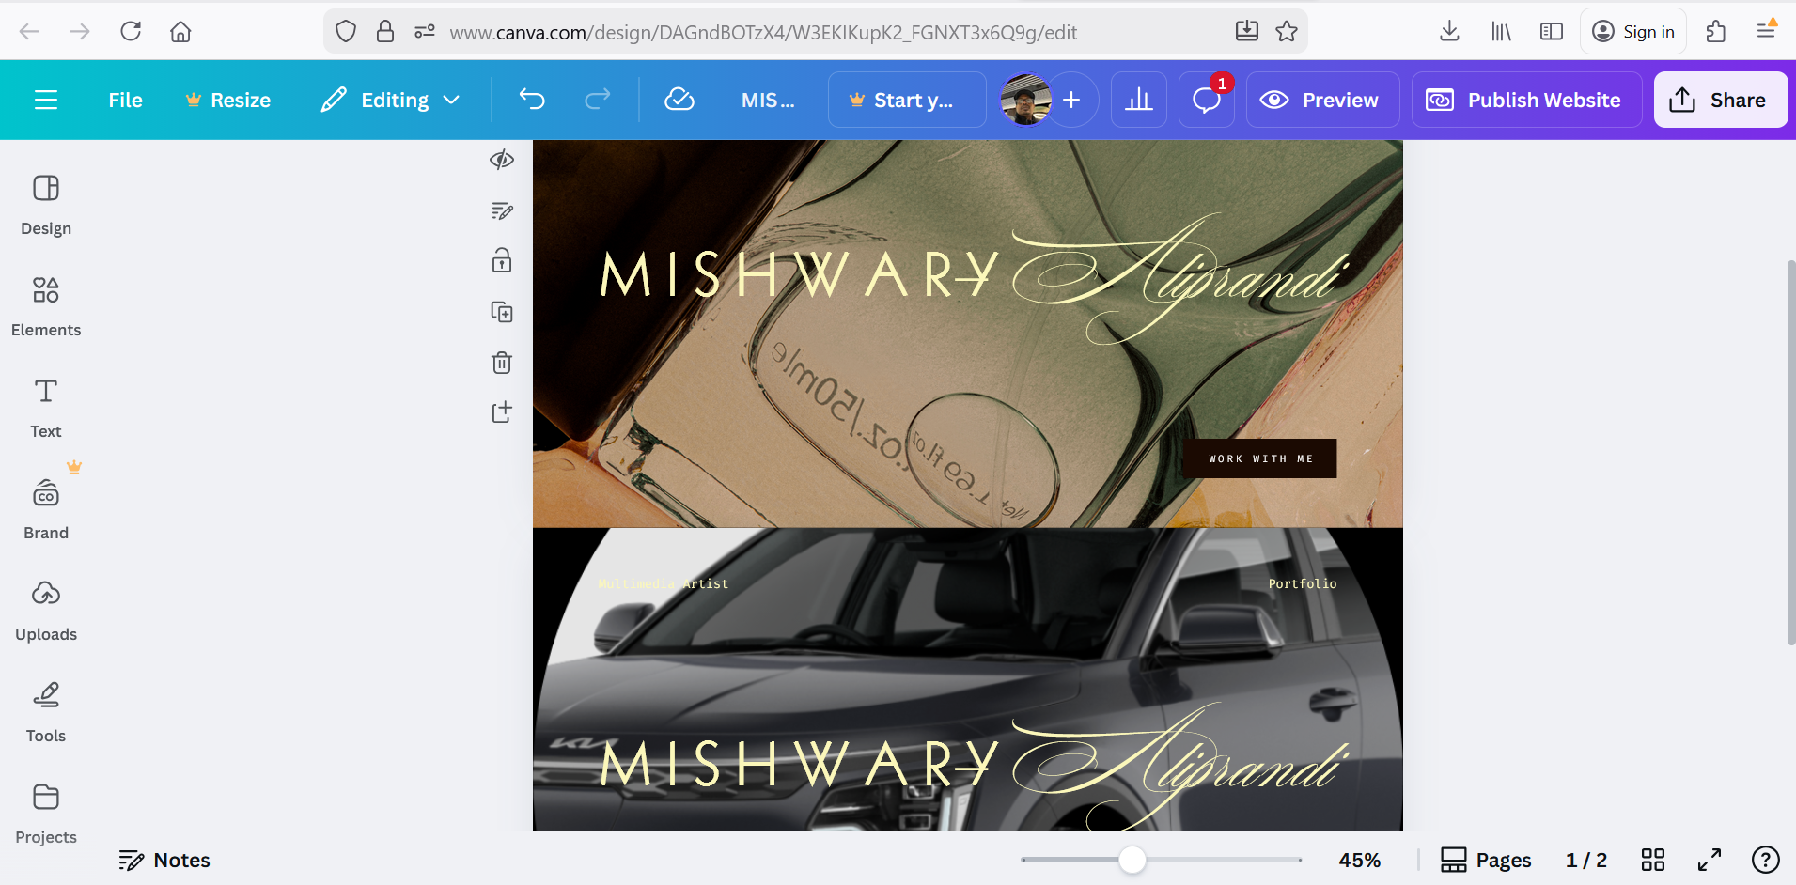
Figure 1.4

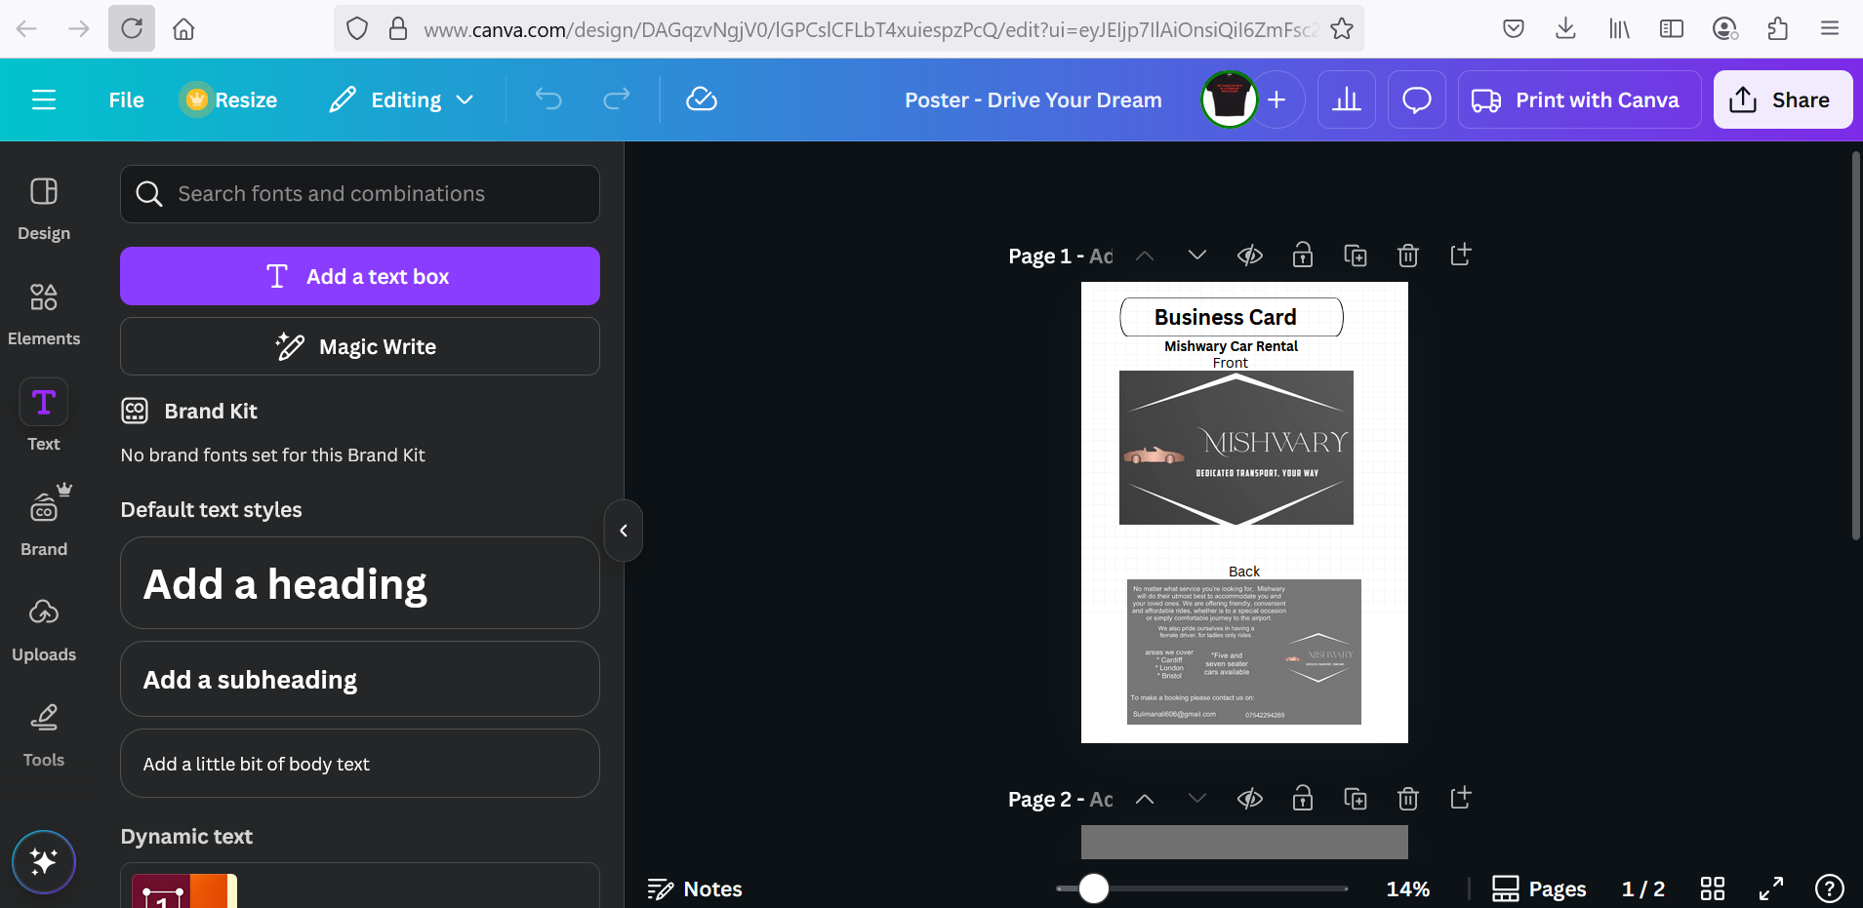
Figure 1.5:

1.6 Website Design and SEO Integration

A responsive, two-page website was created using Canva. Guided by user insights, the layout and messaging reinforce critical decision drivers: safety, cleanliness, and value.
Design Features:
- Home Page: Displays pricing options and service comparisons
- Trust Page: Highlights sanitisation practices, driver credentials, and verified reviews
- Testimonials: Showcase real customer feedback to increase credibility

SEO Strategy: To improve discoverability, key search terms such as “safe Cardiff taxi,” “affordable private hire Wales,” and “trustworthy local drivers as shown below:
Figure 1.1: (As illustrated in Figure 1.1, 54.5% of respondents expressed a clear willingness to use private hire services, while 36.4% were undecided. This indicates strong potential for customer conversion through trust-building and value-focused campaigns).
Figure 1.2: (Figure 1.2 shows that 72.7% of participants use private hire services occasionally, with only 9.1% identifying as frequent users. This supports a flexible service model that encourages repeat usage through loyalty incentives and targeted promotions).
Figure 1.3:( As shown in Figure 1.3, price (45.5%), safety (36.4%), and cleanliness (36.4%) were the most influential factors in choosing a private hire service. These insights directly shaped the branding strategy, ensuring that marketing messages reinforce affordability, trust, and hygiene).
These were selected based on Google Trends and supported by recommendations from Moz’s SEO best practices guide (Moz, 2023).

1.7 Marketing Material Development
Marketing assets were designed using Canva, aligning visual identity with audience values.

1.7.1 Tone & Messaging
- Slogan: “Clean Rides. Safe Trips. Smart Prices.”
- Emphasis on professional service, comfort, and affordability
- Inclusive language to attract hesitant or infrequent users

1.7.2 Campaigns
- “First Ride Free” promotion to reduce the barrier for new users
- Referral Program: Rewards loyal customers for introducing new riders

1.7.3 Visual Elements
- Soothing colours (e.g., light blue, green) to convey trust and calmness
- Minimalist layouts that ensure clarity and reinforce professionalism
Each design decision directly links back to user preferences as captured in the questionnaire.

1.8 Conclusion

The private hire sector presents significant growth potential—particularly when businesses align their services with customer priorities. This project illustrates how targeted market research can shape every aspect of a business strategy, from branding and service design to digital presence and promotional campaigns. The findings revealed that while over half of respondents are ready to use private hire services, a substantial portion remains undecided. This “maybe” segment represents a valuable opportunity for conversion through trust-building, transparent communication, and value-driven messaging.
The data also highlighted that most users are occasional riders, suggesting that flexible, incentive-based models—such as loyalty rewards and introductory offers—can effectively increase usage frequency. Furthermore, decision drivers like price, safety, and cleanliness emerged as more influential than technical features, reinforcing the need for a human-centric approach that prioritises reliability and community trust.
By integrating these insights, the business concept evolved to focus on local credibility, professional service, and clear value rather than competing solely on app-based convenience. The website and marketing materials were designed to reflect these values, using inclusive language, calming visuals, and SEO-optimised content to reach and reassure target audiences.

Task 2- Integrating Excel into Strategic Growth for a Private Hire Business

In the digital era, success in the private hire industry hinges not only on service quality and marketing, but on the ability to interpret, organize, and act on data. Microsoft Excel serves as a foundational tool in this process—enabling small and growing businesses to make evidence-based decisions without the need for complex or expensive software. In the context of this project, Excel plays a pivotal role in refining service delivery, marketing strategies, and financial planning.

2.1 Data Analysis and Insight Generation

The core of your business strategy rests on insights drawn from the 10-question community questionnaire. While the survey was conducted through Google Forms, Excel can significantly enhance post-collection analysis. By importing the raw data:
- You can use pivot tables to identify correlations between user demographics and service expectations (e.g., safety vs. price preferences by age group).
- Conditional formatting helps to highlight trends, such as which features are most valued among infrequent users.
- Frequency distribution tables and pie chart generation help visualize patterns for use in investor pitches or marketing reviews.
This use of Excel ensures that your digital marketing and service design remain tightly aligned with real-world customer needs.

2.2 Financial Modelling for Service Viability
Your business model includes pricing transparency, driver health & safety procedures, and loyalty campaigns. Excel enables you to:
- Build dynamic pricing models that account for fuel costs, driver pay, and promotions.
- Run what-if analysis scenarios to forecast how a “First Ride Free” campaign might affect revenue across different uptake rates.
- Track cash flow, break-even points, and profit margins crucial for keeping your business sustainable and scalable.
These capabilities are vital for creating a robust business plan and securing funding or grants.

2.3 Marketing ROI and Customer Retention Metrics
Excel makes it easy to evaluate the return on marketing campaigns:
- Use lookup functions and filters to compare pre- and post-campaign booking data.
- Maintain a customer database to monitor retention, referrals, and rebooking behaviour.
- Visualize campaign performance using bar charts or line graphs—helpful for identifying which promotions yield the highest engagement.
This data-driven approach to marketing ensures budgets are allocated effectively and strategies are continuously refined.

2.4 SEO and Content Planning
Even in SEO, Excel provides structure. As you noted, keyword phrases like “safe Cardiff taxi” were used for discoverability:
- You can create keyword tracking spreadsheets to monitor page ranking progress.
- Use Excel to audit on-page content for keyword density and identify opportunities to improve metadata.
- Organize your blog post ideas or content calendar with priority columns based on trends pulled from Google Trends or Moz data.

2.5 Operational Optimization and Driver Scheduling
As the business grows, Excel can aid in planning driver shifts, mapping high-demand time slots, and recording service feedback:
- Use spreadsheet templates to coordinate schedules, avoid overlaps, and maximize coverage during peak hours.
- Aggregate feedback ratings to improve service and monitor driver performance metrics.

2.6 Conclusion
- Microsoft Excel is far more than a spreadsheet tool it’s a strategic engine for digital transformation. In today’s competitive and fast-moving economy, success hinges on the ability to connect data with decisions, and Excel empowers you to do just that. It bridges the gap between marketing and metrics, strategy and execution, customer insight and operational delivery. Whether you're tracking budgets, forecasting demand, or analysing customer feedback, Excel provides the flexibility and analytical power to turn raw data into actionable intelligence.
- Embedding Excel into your daily operations doesn’t just streamline workflows it elevates your entire business model. It enables you to respond quickly to market changes, optimize resource allocation, and deliver services that are both efficient and customer centric. For small and medium-sized enterprises in Cardiff, this kind of agility is essential. Excel helps you build dashboards that visualize performance, automate repetitive tasks, and maintain financial clarity all while supporting collaboration across teams.

4.1 References

4.1.1 Task 1 References

    - Abdullah. (2022) Artificial intelligence in education: A bibliometric analysis (2010–2021) : Available at : [PDF] Artificial Intelligence in Education: A Bibliometric Analysis (2010–2021) | Semantic Scholar
    - Abid M (2015) The close relationship between informal economic growth and carbon emissions in Tunisia since 1980: The (ir)relevance of structural breaks. Sustain Cities Soc 15:11–21. https://doi.org/10.1016/j.scs.2014.11.001
    - Abumunshar M, Aga M, Samour A (2020) Oil price, energy consumption, and CO2emissions in Turkey. New evidence from a bootstrap. ARDL test. Energies 13:5588. https://doi.org/10.3390/en13215588
    - Comput. Hum. Behav., 129 (2022) Swift trust development and prosocial behavior in time banking: a trust transfer and social support theory perspective Available at : Swift trust development and prosocial behavior in time banking: A trust transfer and social support theory perspective - ScienceDirect
    - Energy.(2022) Policy effectiveness of market-oriented energy reform: Experience from China energy-consumption permit trading scheme: Available at : Policy effectiveness of market-oriented energy reform: Experience from China energy-consumption permit trading scheme - ScienceDirect
    - Environ. Sci., 10 (2022) Population density: an underlying mechanism between road transportation and environmental quality : Available at : Frontiers | Population Density: An Underlying Mechanism Between Road Transportation and Environmental Quality

7- Heliyon.(2023) Green road transportation management and environmental sustainability: the impact of population density : Available at : Green road transportation management and environmental sustainability: The impact of population density - ScienceDirect
8- J. Market. Manag., 38 (2021) Understanding the brand and website effects of online loyalty: a mediation perspective : Available at : Understanding the brand and website effects of online loyalty: a mediation perspective: Journal of Marketing Management: Vol 38, No 3-4

9- J.Clean.Prod.(2022) Market segmentation and urban energy consumption: An analysis of threshold effects from an agglomeration perspective: Available at: Market segmentation and urban energy consumption: An analysis of threshold effects from an agglomeration perspective - ScienceDirect

10- Technovation.(2021) Understanding managers’ attitudes and behavioural intentions towards using artificial intelligence for organizational decision-making Available at: Understanding managers’ attitudes and behavioral intentions towards using artificial intelligence for organizational decision-making - ScienceDirect

4.1.2 Task 2 References

Aya Ashraf,Christina Albert Rayed,Nancy Awadallah Awad,Heba M. Sabry . (2025) A Framework for Customer Segmentation to Improve Marketing Strategies Using Machine Learning Available at : A Framework for Customer Segmentation to Improve Marketing Strategies Using Machine Learning - ScienceDirect

B Methodol.(2021) Vehicle and reliable driver scheduling for public bus transportation systems Available at : Vehicle and reliable driver scheduling for public bus transportation systems - ScienceDirect
Financial Stability, 53 (2021), How economic policy uncertainty affects the cost of raising equity capital: Evidence from seasoned equity offerings Available at : Does annual report readability influence the design of SEOs? - ScienceDirect

11- Hossein Bonakdari,Amir Noori,Khosro Morovati.(2025) Application of Microsoft Excel in multicriteria decision-making Available at : Application of Microsoft Excel in multicriteria decision-making - ScienceDirect
12- van Laar, E., van Deursen, A.J.A.M., van Dijk, J.A.G.M. and de Haan, J.( 2024). Digital skills at work – Conceptual development and empirical evidence. International Journal of Information Management, 74, p.102675.
13- Xuefei Nancy Deng,Sheng Yi.(2025) Individual motivation and self-perception of excel skills learning: An empirical study of first-generation college students and their peers Available at: Rightslink® by Copyright Clearance Center

