MARKETING FUNDAMENTALS
ASSIGNMENT 2

Student Name: Catalina Simona Stoian
Student ID: 2119687
Contents
Introduction 3
Overview of Apple 3
Internal and external analysis of a company 4
Marketing 4
Marketing process 4
Macro environment of Apple 5
SWOT analysis of Apple 8
Segmentation, targeting and positioning of Apple 9
Segmentation of the Apple market 10
Targeting of Apple 10
Placement of Apple 10
Marketing mix of Apple 11
Recommendation 13
Conclusion 14
References 14

Introduction
Consumer items were first produced in the industrial sector a long time ago (Kotler, Armstrong Harris, Piercy, 2017). The items were designed and selected to meet the needs of a wide range of customers. Many positioning strategies were tested in the lead-up to the product's introduction. Substantial market research and analysis resulted in the segmentation of the commodities markets. This paper discusses APPLE's segmentation, messaging, and marketing mix, as well as the company's internal and external studies.

Overview of Apple
Steve Jobs, Steve Wozniak, and Ronald Wayne created Apple in 1976, and the company has since become a household name in the technology industry.
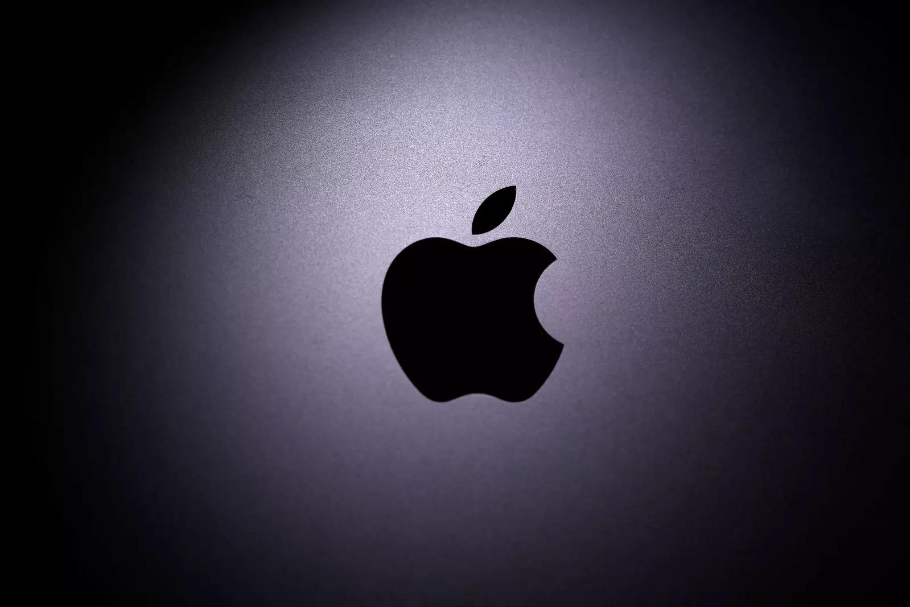
For a long period, the company's excellent sales and ROI drew investors in. Android users and music players are only two examples of Apple Inc.'s many electrical creations. Apple's business model relies heavily on the development of its own proprietary software. It has an operating system that is compatible with Apple devices. Because Apple is the leading online music and movie streaming service provider, it has had a significant influence on the information services market.

Internal and external analysis of a company

Marketing
Marketing focuses on the activities a company does to promote the sale or purchase of products or service(Blythe, 2014). Promotion, sales, and delivery are all part of the marketing process. A company's affiliates are responsible for portion of the company's marketing efforts. Advertising is a tool used by a company's marketing and public relations departments to draw in potential customers and clients. There are some groups of people that are specifically targeted for advertising, which could include celebrity endorsements, unique phrases or slogans, package designs and visual layouts as well as extensive media exposure.

Marketing process
Situational analysis
The goal of marketing in profit-driven companies is to meet consumer needs while also making a profit. Businesses must first figure out who and what needs they can fulfil before they can begin to meet those demands(Fill C., 2014).
Narrow segments of the market
Subsegments and niches are even more narrowly defined subdivisions of a segment. According to the definition of the term "niche," it is a very narrow segment of the population that has very specialised wants and demands(Baack, 2013).
Positioning
Positioning is an important part of marketing strategy that involves creating and delivering a message that clearly places the company or brand in comparison to its competitors.
Planned advertising campaigns
Choosing the most effective tactics for achieving a company's strategic goals is an important part of building a long-term plan. Strategic marketing is all about creating a marketing mix that meets the needs of the target market by using the following four elements: product, price, location, and promotion(Housden,2010).
Putting marketing plans into action
As a general rule, corporations have hired a number of agencies to aid in the development of advertising and marketing strategies. A lack of coordination between the promotion mix's components might result from this approach. An unbalanced combination might lead to a message that is difficult for consumers to understand. An automotive advertising on television may emphasise the vehicle's exclusivity and elegance, whereas an advertisement on a website may push reductions and sales, contradicting this impression of exclusivity.
A look at the management of marketing
Regardless matter how precisely planned a company's marketing strategy may be, it cannot guarantee maximum profit. Because markets are dynamic, a strategy that works now may not work in the future. For a marketing effort to be successful, it has to be evaluated on a regular basis.
Marketing management.
There are four types of marketing controls: yearly plan control, profitability control, efficiency control, and strategic controls.
Control over the annual plan
Setting monthly or quarterly management goals, like as sales and profitability targets, is essential to annual-plan control. Organizations employ a variety of technologies to track the progress of their plans. To begin with, sales analysis compares sales goals to actual results and explains or accounts for discrepancies. Second, market-share analysis compares a firm's revenues to those of its competitors.

Macro environment of Apple
As the name suggests, the PESTEL analysis is often abbreviated as "PEST". In this context, it refers to a company's interactions with the political, economic, social, technological, environmental, and legal contexts. It is a strategy for enhancing a company's professional reputation. Analyzing a company's strengths and shortcomings may be done using this kind of method.. Additionally, PESTEL study identifies the organization's undiscovered prospects and hazards. It is easy to have a thorough grasp of a company's many aspects thanks to the analytical system's architecture. Businesses need this sort of planning in order to keep track of their progress and improve it in the future. An important part of monitoring a company's development may be achieved by mapping risks in the macro-remote environment(Alam,2015).
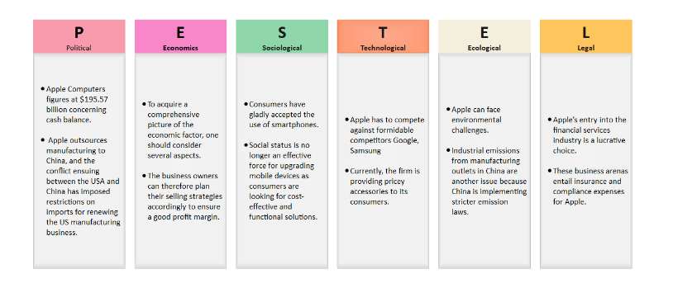
Figure 1 PESTLE of APPLE(Alam,2015)
Political Factors
State and country-level policies have a considerable influence on the development of firms. There are a number of government regulations, including taxes, labour laws, anti-corruption laws, and foreign trade rules(Alam,2015). They provide the backbone of the PESTEL analysis's political portion. Apple Computers has $195.57 billion in cash on hand. Concerns about company tax rules have been raised as a result of the publicly available cash balance in the United States. As a result of the outbreak, economic inequality has already widened. Because Apple has outsourced its manufacture to China, the United States and China have been locked in a trade spat that has stymied efforts to revive the American manufacturing economy.
Ecological Factors
The organization's overall revenue is directly related to the organization's economic component. Other aspects must be assessed in order to fully comprehend the economic component. Employment, manufacturing, raw material costs, and the interest rate are all included in this report. This component gives business owners a comprehensive picture of the purchasing power of their customers. Sales strategies may be arranged in such a way as to provide a healthy profit margin for business owners. As a result of Chinese workers' demand for higher wages, Apple's production costs may rise, reducing the company's cost advantage.
Societal factors
Customers' tastes may be better understood with the help of the sociocultural component. To accurately predict a product's demand in a certain market, you need to know these information. Legacy and culture, population density, and educational attainment are all crucial factors to take into account when using this standard. Smartphones have been widely accepted by the general public. A person's use of their smartphone may therefore be inferred.
Factors Influenced by Technology
There has been a considerable influence on the industry due to the recent advancements in information technology. Because of this, it is an essential part of the PESTEL analysis. Creating cutting-edge consumer goods and cellphones puts Apple in direct competition with Google and Samsung, two formidable competitors. Frequently, the flagship products of Apple. As a result, further creativity is required in order to provide really unique services.
Customers may now purchase pricey accessories from the brand. This, however, does not qualify as ground-breaking ingenuity.
Economic Factors
Ecological PESTEL looks at how an organisation will grow and survive in a certain environment(Alam,2015). When it comes to environmental issues, the PESTEL study does an excellent job of addressing them. It is possible that Apple may face environmental issues. Obsolete Apple products are the biggest problem to overcome in this regard. Industrial emissions from China's manufacturing outlets are now much more of a worry since the country is imposing stricter emission restrictions.
Factors in the Law
The requirements of a court of law are known as legal considerations. Businesses must adhere to industry regulations, workplace safety standards, consumer protection laws, and more in order to avoid legal ramifications. Entering the financial services business is a smart move for Apple. The area is, nevertheless, under control. Apple plans to expand its business by developing automobile manufacturing factories. Apple has to pay for insurance and regulatory compliance in these fields. Legal action is a necessary safeguard for a business that wants to keep its products safe from infringement of its intellectual property rights.
The macroenvironment's prospective opportunities and dangers are shown in this PESTEL analysis. I also explained how Apple will take advantage of these opportunities and mitigate the dangers. In order to maintain their position as a leader in their field, Apple must stay one ahead in the competition.

SWOT analysis of Apple
Strengths
- For the tenth year in a row, Interbrand values Apple's brand at $408 billion, making it the top brand in the world. With a brand value of $249 billion, Amazon comes in second place, followed by Microsoft, which has a $210 billion brand value(Jinjin,2013).
- When it comes to customising high-tech devices and goods, Apple is a name you can trust. Millions of people use it every day, and its popularity is only expected to rise.
- Apple was the first to introduce several of the most groundbreaking products in the world (iPhones, iPads, AirPods). Apple is dedicated to creating technical devices that are better and more efficient.
Weaknesses
- Apple's biggest weakness must be the exorbitant cost of its products. The company's high-priced products are a drawback since customers may easily get similar products at a lower price(Jinjin,2013).
- Apple's market share is also declining, in part due to the company's dependence on the iPhone and iPad series. This suggests that a decline in interest in these products might be harmful to Apple's business.
- For this reason, customers have had difficulty making the switch to iOS-based devices, which are less user-friendly and need some time of adjustment.
Opportunities
- As a result of Apple's substantial market dominance and brand recognition, the company's multiple products are seeing an increase in demand. By exhibiting an interest in emerging technology, users of Apple goods demonstrate their commitment to the firm(Jinjin,2013).
- Demand for communication devices has grown significantly since 2013. In this way, the company will be able to explore hitherto untapped areas like the Commonwealth of Independent States (CIS).
- Experts in consumer product branding are a core component of Apple's researchers, developers, and product professionals. Apple is able to continually develop new opportunities because of the expansion of its workforce.
Threats
The strong competition in the technology industry is fueled in part by corporate hostility(Jinjin,2013). Apple has to compete with other tech giants like Samsung, who also depend on rapid product development. To maintain a competitive edge in computer hardware and software and online services, this SWOT analysis shows that fierce competition has a restricting effect on the organisation. Apple also has to deal with the possibility of its products, such as the iPhone, being copied. Appearance and functionality of Apple products have been replicated by regional and global rivals alike. Contract manufacturers' profit margins are also being squeezed by rising labour costs in places like China.
In light of the major challenges identified by this SWOT analysis, it is recommended that Apple Inc(Jinjin,2013). maintain its aggressive and rapid product innovation strategy. Because of technological developments, imitation's detrimental impacts have decreased. Also advised is that Apple automate its manufacturing processes and help its contract manufacturers automate theirs in order to combat growing labour costs. Another option is to form alliances with other distributors in order to broaden the company's reach in the marketplace.

Segmentation, targeting and positioning of Apple
The practise of identifying different characteristics of a market in order to suit the needs of all potential clients is known as market segmentation. In order to better serve and upsell to their target audience, companies may use this technology to develop a complete and unified solution. A thorough understanding of potential clients and a desire to meet their needs are two prerequisites for effective segmentation(Ping, 2021).

Segmentation of the Apple market
For the sake of segmenting the market, Apple makes use of behavioural and psychographic elements(Ping, 2021). Depending on criteria like gender, age, and consumer preferences, an audience may be divided into smaller groups by dividing them into subgroups. For the advantage of the firm, these divisions or characteristics must be easily accessible, quantifiable, and actionable. When it comes to the demographic market segmentation of Apple's target clients, the company makes goods tailored to their age, lifestyle, and occupation. According on characteristics such as population size and age, Apple's goods are dispersed over the globe. A PC for specialists would have the most up-to-date capabilities and software, whilst a PC for children would have a greater selection of games. Besides the iPad and iPod, Apple's other devices provide a broad variety of features. The older generation will choose crystal oscillators that can measure pulse rate, while the younger generation would prefer clocks with greater visuals.

Targeting of Apple
According to the company, its methods of market segmentation include pinpointing its most coveted customer bases. This stage is all about deciding which categories of people to target with Apple's products after conducting a segmentation study. The company positions itself as a leading supplier of high-quality goods and services with cutting-edge capabilities and features. High-tech goods and services with sophisticated features, capacities, and designs are the focus of Apple's marketing strategy. Many studies of the demographics of Apple's customers have indicated that the great majority of them value product attributes like usability, dependability, and beauty more than they do cost(Ping, 2021).

Placement of Apple
The positioning strategy in any marketing plan is critical to the success of a brand's image in the eyes of customers.. Companies that use a well-thought-out positioning strategy are more likely to succeed. According to the nature of the sector as well as the size and scope of the company, corporations place focus on various aspects of their brand positioning. Product innovations are constantly being launched as a consequence of the industry's rapid expansion and consistent progress. Apple, with its cutting-edge products and creative technology, is frequently looked to as a role model by its rivals. Success is due in part to its well-rounded and effective positioning, which is the result of several variables(Ping, 2021). Apple has positioned itself as a high-end luxury brand in the marketplace. Despite the fact that Apple products aren't cheap, there are ways for those who can't afford them to receive them.

Marketing mix of Apple
The company's outputs are the focus of Apple's product marketing strategy. Technology and technology-related services and goods make up this category. In contrast, Apple's product diversification has allowed it to include non-IT-related services in its 4Ps. A look at Apple's key product lines and some explanations of their various strategies(Tasnim,2018).
Mac: In 1984, Steve Jobs introduced this device as one of Apple's first products. Personal computers with mouse and graphical user interfaces and platforms were first made available to the general public with the Macintosh. MacBook Air, MacBook Pro, and iMac remain among the most popular Mac models(Tasnim,2018).
iPhone. It's no secret that the iPhone has been nearly universally used in our day. One of the first firms to produce multitouch smartphones was Apple. It was designed with a smartphone and iPod in mind. A number of variations of the iPhone 13 have been released after its initial release in 2016.
iPod: The iPod touch, iPod nano, and iPod shuffle are among the new iPod versions that have hit the market. Digital music may be stored on the iPod's memory card.
Apple's timepieces. Users may keep track of their exercise routines using this watch.
iPhone: It's no secret that the iPhone has been nearly universally used in our day. One of the first firms to produce multitouch smartphones was Apple. It was designed with a smartphone and iPod in mind. A number of variations of the iPhone 13 have been released after its initial release in 2016.
extra applications and services Among Apple's advantages is MacOs, the brand's software and operating system.
iPad: The iPad was released as a direct sequel to the iPhone and was an immediate hit with Apple customers. With this new idea, people will be able to connect their laptops and mobile phones.
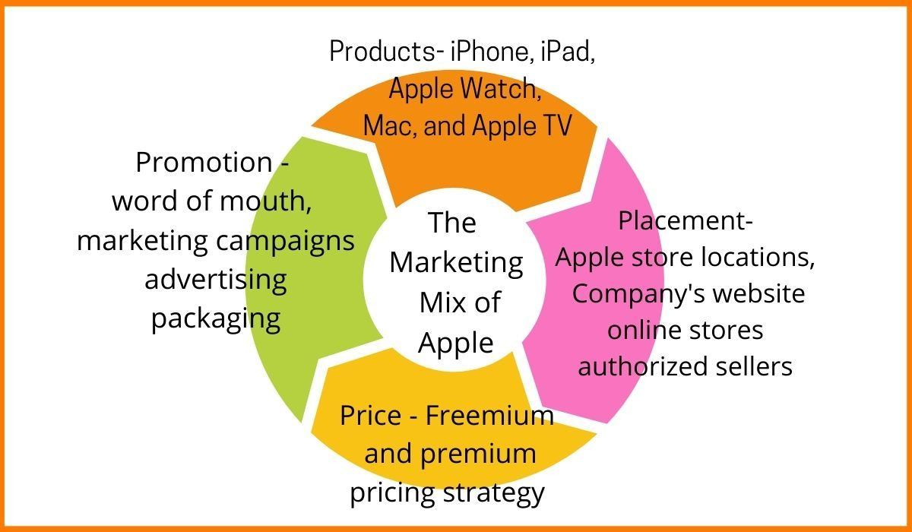
Figure 2 marketing mix of Apple (Tasnim,2018)
Products
The outputs of a company that offers technology and internet services are defined in this section of the marketing mix(Tasnim,2018). A large portion of Apple's product and service offerings fall under the category of information technology. Despite this, the company continues to broaden its product line, making it possible to add 4P things that aren't IT-related. Apple Inc.'s main product lines are as follows:
- Mac.
- iPad.
- iPhone.
- Advertising.
- AppleCare.
Price
Considering Apple's wide range of products, it is clear that the business aims to serve its customers with cutting-edge technology. There is no doubt in my mind that they are superior to the competition despite their high price. Another strong explanation for Apple's high pricing is the company's ability to manufacture products with cutting-edge technological features. Furthermore, the company does not lower its pricing in order to make them more affordable for the general public. Providing the finest possible user experience justifies Apple's hefty price tag. Using only the best materials and creating beautiful designs, Apple creates products of the highest calibre. Customers who rely on Apple products are more likely to switch to other brands(Tasnim,2018).
Place
Apple products may be found practically everywhere. Many distribution strategies are used by the company to satisfy the demands of its global customers. Online and offline distribution platforms are used by them(Tasnim,2018).
Apple has retail locations all around the world where customers may purchase its products.
Online retailers like Amazon, Flipkart, and others allow customers to purchase Apple products straight from the company's website as well as through other online shops. One of the most important distribution channels for Apple products is the web.
Approved corporate resellers are allowed to sell Apple products via Apple's partnerships as well. These stores have been hand-picked because of their high-end image, which is based on factors such as store size, monthly sales, etc. Apple's products are available in over 100 countries, making it easier for the company to expand its customer base and raise its global brand awareness.
Apple's marketing strategy emphasises aggressive advertising in a variety of media, including print, television, billboards, and the Internet. It employs a mix of classic and innovative marketing techniques. The products are also marketed on the company's website and via other online mediums, such as social media.
Features like Apple's pricing strategy and commitment to not decreasing prices in order to compete with competitors are crucial. In addition, it's worth noting that Apple's exorbitant prices are justified by its products' greater functionality and technological capabilities. No matter how long your company has been in operation or how new it is, one can learn from Apple that charging higher prices as long as your products meet or exceed customer expectations will not destroy your business. Apple's ability to continuously provide high-end features in its new product models is another critical component of the company's strategy for generating interest, anticipation, and a sense of wonder among its target audience. Non-tech enterprises and startups may benefit from some of Apple's marketing strategies(Tasnim,2018).

Recommendation
This research shows that Apple Inc. has a number of benefits when it comes to coping with organisational faults, both internally and externally. The growth of a company's retail distribution network is one such opportunity that may be taken advantage of by using these talents. A strong brand image and rapid innovation processes enable the organisation to quickly establish and sell new technological product lines.. Competition and imitation are major obstacles for Apple in the worldwide markets for consumer technology, computer hardware and software, and digital content distribution services. This paper outlines the strategic issues facing Apple Inc., and one solution is to maintain the current rate of product development. Because of technological developments, imitation's detrimental impacts have decreased. Also advised is that Apple automate its manufacturing processes and help its contract manufacturers automate theirs in order to combat growing labour costs. Another option is to form alliances with other distributors in order to broaden the company's reach in the marketplace.

Conclusion
In Principles of Marketing, we will learn the principles of marketing theory and practise. From banking to retail to public services, this textbook examines diverse marketing tactics and approaches through analysing case studies from a number of sectors. Exploring marketing ideas, this book uses real-life case studies from companies.

References
Kotler P, Armstrong G, Harris, L, Piercy, N., (2017), Principles of Marketing, 7th Edition, Pearson
Blythe, J., (2014), Principles and Practice of Marketing, 3rd edition, Sage
Khan, U.A., Alam, M.N. and Alam, S., 2015. A critical analysis of internal and external environment of Apple Inc. International Journal of Economics, Commerce and Management, 3(6), pp.955-961.
Jinjin, T.A.N., 2013. A strategic analysis of Apple computer Inc. & Recommendations for the Future direction. Management Science and Engineering, 7(2), pp.94-103.
Yie, C.E., Zhi, C.E. and Ping, N.T.S., 2021. A Critical Analysis of Internal and External Environment: Case Study of Apple Inc. Journal of International Business and Management, 4(10), pp.01-14.
Tasnim, M., 2018. An Organizational Analysis on Apple. European Journal of Business and Management, 10(11).
Baines, P., Fill C., Page, K., (2014) Marketing, Oxford, 2nd edition
Clow, K., Baack, D., (2013), Integrated Advertising, Promotion and Marketing Communications 6e, Pearson
Housden, M., (2010), Marketing Information and Research, Butterworth Heinemann
Jobber, D., (2016) Principles and Practice of Marketing, McGraw Hill 8th edition

