Module: Academic and Employability Skills
Assignment Title: Evolution of Blended learning and classroom learning on students’ attainment.
DUE: 7-12-2021
NAME: CHRISTIAN AMOAH
STUDENTS ID: 2110832
TASK 2

INTRODUCTION
We'll make use of Individually, use the formative feedback you obtained on task 1 Assignment draught and the feedback you obtained from completing the activity below to prepare a reflective report on how the learning in this module has benefited you grow a range of employable skills.

- Time Management: What exactly is it? and how do I put it to use? And examples.
- Note Taking: What exactly is it? and how do I put it to use?
- Team working skills: What exactly is it? and how do I put it to use?

Team Management
What is Time management? The skills to spend your time wisely and effectively is known as time management. You may also consider of it as the skill of having enough time to do all your tasks without feeling rushed. It appears easy, but it is far more difficult in practise. To put it another way, those who are skilled at time management are also great at getting stuff done. They are, however, better at prioritization and determining what truly must be done and then dismissing the rest.

Why Is Time Management Important?

Time management is vital because this allows you to organise your everyday life so that you may grow your business while maintaining a healthy balance between work and family. Time management improve a lot.
- It improves performance: You'll have quite a better understanding of whatever you need to achieve and how long each job should take if you learn to schedule time through your day for almost all your critical duties. When you stick to a timetable, you'll probably spend a little less time determining what else to work on or delaying and more time down to the business. Time management may assist you in focusing on only the most important activities at hand and avoiding night before going to bed distractions.

- Individuals can devote more attention and thoughtfulness to their work when they aren't constantly hurrying to complete the assignment on time. Time management enables you to prioritise your responsibilities and ensure that you have enough time to complete each job. If you're not hurrying to finish anything before an end date, the quality of work improves.

- Reduce to amount of stress you will get on the due date: Once you have a long list of duties to complete both at school and at home, it's easy to grow nervous. Proper time management may help you prioritise your lists as well as reserve the time needed some of your most critical chores, so you know precisely what you'll do and how much time you must accomplish it in. Identifying your chores and allowing adequate time to complete them will help you feel less stressed.

- It also improves career opportunities: Time management may assist you in becoming a more dependable employee who consistently provides high-quality work in a timely manner. As a result, you will be more useful as both a worker, and your future career will increase, which also will help you identify new possibilities to further your education.

- You become much more effective as an individual: When people know how to successfully manage your time, you'll become much more concentrated at school, allowing you to do more in less time. Rather than attempting to complete a huge project in 15 minutes before a presentation, you may complete a few minor things in that time and store the larger activities that demand more brain capacity for once you have a larger timeframe available. You'll be able to work effectively, allowing you to accomplish more in much less time.

I manage my time by setting a reminder on my phone, which helps me stay on top of my university tasks and other personal responsibilities. I treat myself now and again as a reward for my hard work and ability to keep track of everything. For me, modest rewards for each activity I do during the day are a fantastic motivation for excellent time management. For example, you may take a 15-minute stroll outdoors to commemorate finishing a report. Rewards help me stay motivated at work and can help me attain a better work-life balance in the future. I use this method to stay of truck.
- Plan my day in advance
- Set goals “SMARTER GOALS".
- Stop multitasking.
- 4D method “DO IT, DELEGATE IT, DUMP IT, DELAY IT”.

NOTES TAKING

Note-taking is however the process of collecting information from a wide range of sources and putting it down. By taking notes, the person catches the essence of the information and releases their mind of the pressure of remembering everything. Notes are typically the only record of an event and are collected from a transient source, including an oral conversation at a conference or a presentation. Writing notes is an example of moral. Taking notes is a crucial learning technique in both school and business. Remembering can only take in and store data until it is replaced with new data. This indicates that true, long-term information is gained outside of class, between courses, and while you study. You'll have a lasting record of a class as well as the capacity to grasp and learn how much you've heard if you take careful notes. I employ all these techniques since we now live in a digital age, and it is critical that you always have your notes at your fingertips as a student.

BENEFIT OF TAKING NOTES
- It keeps you awake: Taking notes keeps your brain active and engaged, preventing feelings of fatigue or distractions.
- It enhances your ideas by keeping your mind interested with what you're hearing by listening carefully and making judgments on what to put in notes.
- Information is emphasised and organised. You'll pick on and underline the essential concepts you understand while taking notes, determining the layout of a class presentation. You'll therefore be able to identify a presentation's supporting points, enabling studying and comprehension easier within a week of class. It is easy to connect classroom learning to textbooks studies with such well-organized notes.
- Makes a compact note that can be studied. You'll have all you really need for studying, learning, and reviewing after class if you keep a copy of short, well-organized notes from each class session, its will be beneficial to your studies.

Finally, collecting even good notes over several days and anticipating understanding them immediately even before exam is a sure-fire way to fail. Learning takes time, much like exercising for health, and it does not happen all at once! You can learn from your professors, but no one else can learn for you. This is your job, and you're the only one who can do it. Preparing for class, taking notes, and analysing them is an important aspect of becoming a great student and making use of all your time and effort in class. Make the completion of this course the start of your commitment to taking better notes. The work will be well worth it! I take notes during lectures using Reminds, Notes, and my laptop since they are all connected to one server and help me keep accurate records for my work and future responsibilities.

TEAM WORKING SKILLS

Teamwork skills are a set of interconnected qualities that enable you to engage with others in a structured and empathic manner in a variety of circumstances, meetings, and initiatives. Individuals that are educated and have strong people skills are typically successful at group work since it helps them to collaborate with others to attain the objectives. However, several studies showed that when individuals work together as a team, they may create a burst of energy that enhances creativity, productivity, enthusiasm, communication, and effectiveness.

IMPORTANCE OF TEAMWORK

Students can benefit from team projects by developing a variety of skills which have become increasingly useful in the workplace (Caruso & Woolley, 2008; Mannix & Neale, 2005). Furthermore, positive group experiences have indeed been demonstrated to aid student learning, memory, and students' overall achievement (Astin, 1997; Tinto, 1998; National Survey of Student Engagement, 2006). Team working helps the individual gain more skills to help your project or help you academically. Skills like.
- COMMUNICATION: is a key cooperation skill. It must be fair and effective. Verbal and non - verbal skills are both important. Communication abilities can be applied in person, however over cell phone, or through email. The form of communication has no bearing upon that effectiveness of communication. Communication skills enable you to successfully convey your ideas, facts, and views with co-workers and other stakeholders. An atmosphere of confidence and trust exists among teams having great communication abilities.

- PROBLEM-SOLVING: Teams are formed by the teachers to handle certain challenges. Effective cooperation necessitates problem-solving abilities, which include looking at a subject from several perspectives in order to come up with unique and innovative solutions.

- LISTENING SKILLS: When you listen to what other people have to say, it's easier to establish rapport. Listening to one another helps team members to have a better understanding of one another by encouraging the interchange of ideas, opinions, and experiences. Asking some questions, expressing worry, and using nonverbal clues to display knowledge and caring are all ways to communicate that you are paying attention.

- DECISION MAKING: When individuals differ on a task, making decisions may be difficult. Team members must set their own interests aside in order to choose what is important for the team in order to attain its objectives. By including team members into decision-making, the team can weigh the options and choose the best solution for the whole group.

- LEADING SKILLS: Group leaders must be able to motivate their teammates to reach the group's aims and outcomes. Improving various collaboration abilities will help you learn about being convincing and persuade others. To impact team members, you must first establish the team's confidence in one another and then engage with each teammate to capitalise on their individual abilities.

IN CONCLUTION

To summarise, it is critical to take notes, co - operate with others, and manage your time since doing so allows you to be more disciplined with yourself and prepare you for a future employment. Presentation skills were employed in the photographs presented, but before that, we were put in a team of three and the team sat down and selected who would be the team leader. I was finally promoted to team leader since I possessed stronger leadership qualities and had a better chance of guiding the team to reach its goals and objectives. Following that, each member of the group had to select a topic to discuss.
- TEAM LEADING: As the team leader, it was my responsibility to ensure that everyone turned in their work on time. During the study, I also had to make sure that everyone in the group was giving it their all and exchanging ideas.

- COMMUNICATION: We, the team members, needed to communicate with one another to ensure that we were sharing and combining ideas in order to create a successful presentation. During the preparation of the presentation, we also used Microsoft Teams to communicate.

- TAKING NOTES: The most significant aspect of the presentation was taking notes, because the notes we took during the study became the ultimate product of our presentation.

The final presentation resulted in a very positive outcome because our presentation had all the relevant information. The images in the presentation caught the audience's attention, which is crucial when it comes to presentations. This is because you must keep the audience's attention focused on the point, we're trying to convey to them; otherwise, they will become bored with what's going on and may even leave the premises.

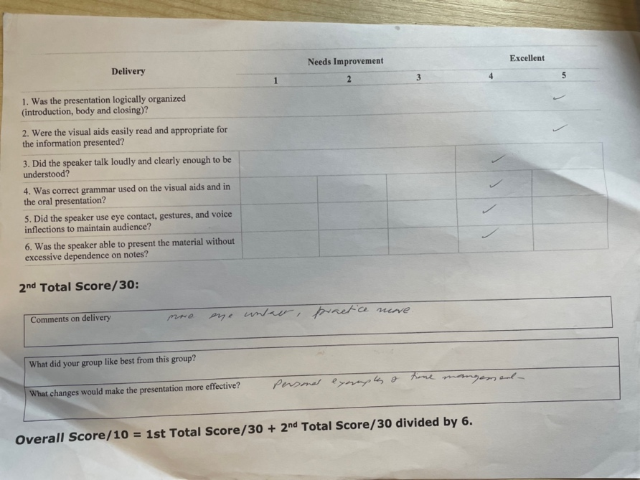
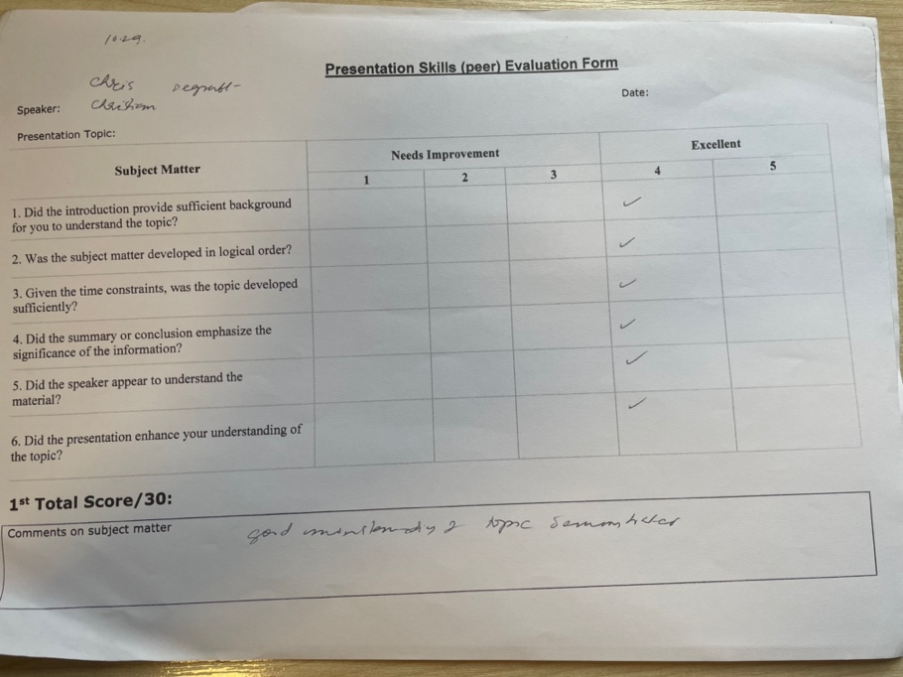

Reference

https://www.freshbooks.com/hub/productivity/importance-of-time-management

https://www.definitions.net/definition/note-taking

https://sites.austincc.edu/student-skills-workshops/taking-effective-notes/benefits-of-notetaking/

https://uk.indeed.com/career-advice/career-development/teamwork-skills

Astin, A. (1993). What matters in college? Four critical years revisited. San Francisco: Jossey-Bass.

Caruso, H.M., & Wooley, A.W. (2008). Harnessing the power of emergent interdependence to promote diverse team collaboration. Diversity and Groups. 11, 245-266.

