
Dissertation Proposal

’’To explore the impact of digital marketing on consumer behaviour and analysis of Amazon.’’

Student number: 2119164
Student Name: Olga Andronic
Module code : LCBB6000
Dissertation supervisor: Tushara Balendran

Table of Content
Contents
1.Introduction 3
Aim, objectives and research questions 3
1.1 The main aim of the research 3
1.3 The Research question 3
2.Literature review 4
2.1 Digital marketing- definition 4
2.2 Consumer behaviour- definition 4
2.3 How is my research useful for Amazon 4
2.4 The current digital marketing strategies utilised by Amazon 5
2.5 Advantages and Disadvantages of Amazon's Digital Marketing Strategies: 6
3. Research Method & Methodology 7
3.1 Research Philosophy 7
3.2 Methodological research 7
3.3 Research paradigm 8
3.3.1 Positivism 8
3.4 Research Onion- definition 8
3.5 Research Approaches 9
3.5.1 Deductive research 9
3.6 Research Strategy 10
3.6.1 Survey strategy 10
3.7 Data collection methods/tools 10
3.8 Sampling methods 11
3.8.1 Convenience Sampling 11
Time prospects of the research (Gantt chart) 11
4. Ethical considerations 12
5.Conclusion 12
6.References 13

1.Introduction
This dissertation explores the influence of social media on consumer purchasing behaviour. With the rise of innovative methods for marketing products and services, the Internet has become a crucial platform for businesses globally to attract more customers and boost profits. Statistics show that with over 5 billion Internet users worldwide, the number of individuals making online purchases continues to grow each year. In 2022, global e-commerce sales were estimated to surpass 5.7 trillion U.S. dollars, and this figure is projected to reach new heights in the years ahead (Statista, 2023).
As digital marketing increasingly surpasses traditional retail methods, numerous businesses are shifting towards online shopping channels to expand their customer base and enhance customer satisfaction.

Aim, objectives and research questions

  - The main aim of the research -’’Is to explore and analyse the impact of digital marketing on consumer behaviour of Amazon’’ . The study aims to identify how digital marketing influences consumer actions, the factors contributing to its success with a particular emphasis on online shopping.

  - Following this research, a number of Objectives will be evaluated:

- To investigate the current digital marketing strategies utilised by Amazon;
- To determine the advantages and disadvantages of digital marketing strategies for Amazon
- To analyse the impact of digital marketing strategies for Amazon successful business.
- To investigate the reasons why customers often prefer to purchase products advertised on social media platforms
- To identifying the most frequently used social media platforms for online advertising by Amazon

1.3 The Research question which will be deeply analysed in my research:

- What are the current digital marketing strategies utilised by Amazon?
- What advantages and disadvantages of digital marketing strategies for Amazon?
- What impact does digital marketing strategies for costumer behaviour?
- What are the reasons why customers often prefer to purchase products advertised on social media platforms?
- What are the most frequently used social media platforms for online advertising by Amazon?

2.Literature review

2.1 Digital marketing- definition
Digital marketing is the practice of promoting products or services online to connect with and engage potential customers. It involves utilizing various digital channels, such as search engines, social media platforms, email, and mobile devices, to reach and influence target audiences. Holiday, R., & Ferriss, T. (2024)

2.2 Consumer behaviour- definition
Consumer behaviour is the study of how people make decisions about what to buy, use, and consume. It explores the factors influencing these choices, such as psychological, social, and cultural elements. Understanding consumer behaviour helps businesses tailor their products and marketing strategies to meet customer needs and preferences effectively. (Shelly, G. L., & Cashman, T. J. 2024).
The company name which I use for my research is Amazon, was inspired by the world's largest river, symbolizing the company's desire to be the biggest retailer in the world.
Amazon is a multinational technology company that has revolutionized the way we shop and consume digital services. Founded in 1994 by Jeff Bezos, the company initially started as an online bookstore but has since expanded its reach to become a dominant force in e-commerce, cloud computing, digital streaming, and artificial intelligence. (Stone, B. 2013).
2.3 How is my research useful for Amazon:

Recognising Customer Preferences and Behaviour
Consumer Segmentation: Amazon can target these groups more successfully if my research reveals additional consumer segments or subsegments:
1. Purchase Behaviour: By comprehending how customers choose what to buy on Amazon, the platform's marketing and recommendation systems can be improved.
2. Customer satisfaction: Product selection, cost, and customer service may all be improved with knowledge of the variables that influence customer satisfaction.
Enhancing the Amazon Platform User Experience: User experience research can be used to pinpoint areas where the Amazon website or app needs to be improved.
3. Logistics & Supply Chain: Amazon's operations can benefit from research on inventory control and supply chain efficiency.
4. Technology and Innovation: Studies on new technologies that could be used in
e-commerce can offer Amazon's future development a path forward.

5. Handling Ethical and Societal Concerns Sustainability: Research on eco-friendly e-commerce techniques can assist Amazon in lessening its environmental effect.
6. Privacy and Security: Research on cybersecurity and customer data privacy can help Amazon make better decisions about its policies.
7. Ethical Considerations: Studying moral dilemmas in online shopping can assist Amazon in preserving its good reputation. (Smith, M. 2024).
Particular Indices
Amazon can improve its recommendation system with the help of my findings, leading to happier customers.
Optimisation of the supply chain can help develop cost- and delivery-cutting plans.
Amazon can enhance its recommendation engine and targeted advertising by leveraging research on the effects of personalized marketing on consumer behaviour. The findings from this study will offer valuable insights into the effectiveness of Amazon's digital marketing strategies and their influence on consumer purchase decisions, as well improve its social media approach

2.4 The current digital marketing strategies utilised by Amazon
Amazon employs a range of digital marketing strategies, including:
Search Engine Marketing (SEM): Using paid ads to appear in search engine results and attract traffic.
Social Media Marketing: Promoting products and engaging with customers on platforms like Facebook, Instagram, and Twitter.
Email Marketing: Sending personalized recommendations, promotions, and updates to customers.
Content Marketing: Leveraging blog posts, videos, and product reviews to drive engagement and inform customers.
Affiliate Marketing: Partnering with affiliates to promote products and drive traffic to Amazon's site.
Retargeting Ads: Using cookies to show targeted ads to users who have previously visited Amazon's site.
Personalized Recommendations: Utilizing data-driven algorithms to suggest products based on browsing and purchasing history. (Smith, M. 2024)

2.5 Advantages and Disadvantages of Amazon's Digital Marketing Strategies:

Advantages | Disadvantages
1. Expanded Reach | 1. Intense Competition
Enables businesses to connect with a global audience, overcoming geographic limitations. | The vast number of online businesses creates a highly competitive environment.
2. Cost-Effective | 2. Reliance on Technology
Generally more affordable than traditional marketing methods, offering better returns on investment. | Heavily dependent on technology, making it susceptible to technical issues.
3. Targeted Marketing | 3. Privacy Issues
Allows precise targeting of specific demographics and consumer groups. | The use of personal data can lead to privacy concerns and legal challenges.
4. Trackable Outcomes | 4. Constantly Evolving Trends
Analytics tools provide detailed insights into the performance of marketing campaigns. | Rapid changes in digital marketing trends and algorithms require continuous adaptation.
5. Consumer Engagement | 5. Potential for Negative Feedback
Facilitates direct interaction with consumers through social media and other platforms. | Negative reviews and feedback can quickly spread online, damaging a brand’s reputation.
6. Customization | 6. Time-Intensive
Enables the personalization of content for individual consumers. | Managing campaigns, content, and customer interactions can be time-consuming.
7. Flexibility and Agility | 7. Risk of Information Overload
Allows for easy adjustments and real-time optimization of campaigns. | The sheer volume of digital ads can overwhelm consumers, leading to ad fatigue.
8. Increased Brand Visibility | 8. Security Vulnerabilities
Boosts brand awareness and recognition across multiple platforms. | Online platforms are vulnerable to security breaches and cyberattacks.

(Stone, B. 2013).

3. Research Method & Methodology
- Research Method: the research method involves the specific techniques and processes used to gather data.
- Research Methodology: refers to the systematic plan and approach used in research to gather, analyze, and interpret data. It includes the selection of research methods (qualitative, quantitative, or mixed), data collection techniques (such as surveys, interviews, or experiments), and data analysis procedures.

Choosing a quantitative methodology is ideal for research using surveys due to its structured and systematic approach. It ensures consistent data collection through standardized surveys, enabling reliable and objective measurement. Quantitative methods allow for the use of statistical analysis to identify patterns, trends, and relationships, making it easier to generalize findings to a larger population. Overall, this methodology provides a robust framework for analyzing numerical data and making objective insights. (O’Gorman, K., 2015)

3.1 Research Philosophy

Research Philosophy: refers to the set of beliefs and assumptions that guide how knowledge is developed in a study, influencing the choice of methods and interpretation of data . According to Saunders theory, research methodology can be developed through four different types: ontological, epistemological, axiological and methodological. There are also three specific elements of paradigms: positivism, realism and interpretivism " (Saunders, Lewis, & Thornhill, 2019)
3.2 Methodological research philosophy involves the foundational principles and approaches that shape the selection and application of research methods, including beliefs about how knowledge should be collected, analyzed, and interpreted in a study.
Why methodological research ?
Selecting a methodological research approach for studying digital marketing and consumer behaviour is advantageous because it offers a structured way to systematically collect and analyze data. This approach ensures rigorous and replicable research, helping to uncover patterns, measure the effects of digital marketing strategies, and understand consumer preferences and behaviours, which are essential for making informed marketing decisions.

3.3 Research paradigm
A research paradigm refers to a fundamental set of beliefs and assumptions that shape how researchers approach and conduct their investigations. It encompasses the theoretical frameworks, methodologies, and perspectives that influence how research questions are formulated, data is collected, and results are interpreted (Guba & Lincoln, 1994).

3.3.1 Positivism is the belief that the only true knowledge comes from things we can see, hear, touch, or measure. It's about using facts and experiments to understand the world, not guessing or relying on ideas without proof.
Why I choose positivism paradigm?

Positivism is an excellent method for analysing a business because it concentrates on facts and figures and provides a clear and logical point of view.
- Make data-driven decisions: I can determine what is truly effective and ineffective by examining facts and statistics.
- Problem identification and solutions: Data can be used to identify problems and suggest workable remedies.
- Assess achievement: I can monitor the success of my company and determine whether the plans are effective with positivism.
Be impartial: Relying on the facts keeps the judgement clear of subjective feelings.

3.4 Research Onion- definition
The Research Onion is a model created by Saunders, Lewis, and Thornhill to help structure the development of research methodology. It consists of several layers, each representing a step in the research process:
- Philosophies: The overarching belief system guiding the research, like positivism or interpretivism.
- Approaches: The method of reasoning used, either deductive (testing theories) or inductive (building theories).
- Strategies: The overall plan, such as surveys, case studies, or experiments.
- Choices: The decision on using a single method, multiple methods, or mixed methods.
- Time Horizons: The timeframe of the study, either cross-sectional (one-time) or longitudinal (over time).
- Techniques and Procedures: The specific tools and methods used for collecting and analyzing data.

The Research Onion provides a clear, structured framework for developing research methodology, ensuring each decision aligns with the study's objectives and enhancing the overall coherence and rigor of the research. (Saunders, M., Lewis, P., and Thornhill, A., 2019.)

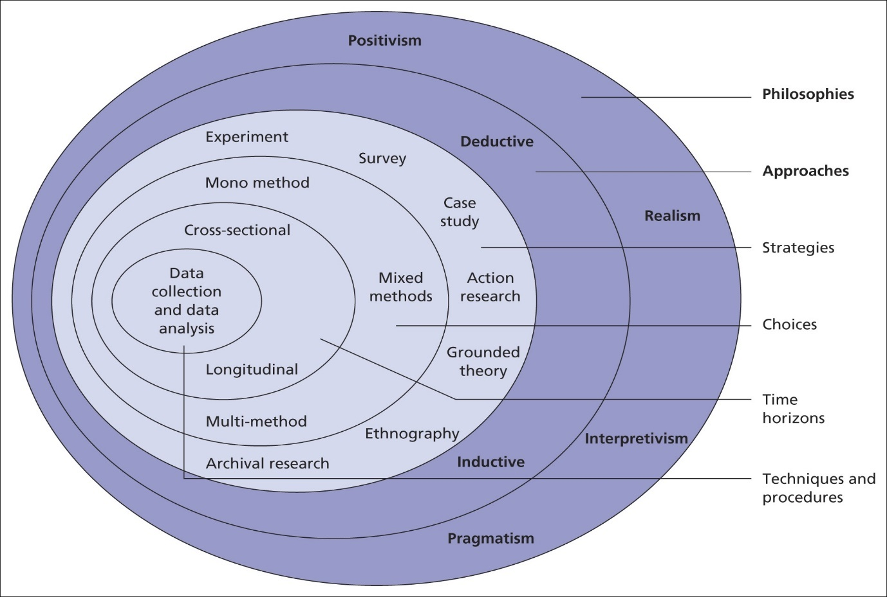

3.5 Research Approaches

Research approach is the strategic framework that directs how a study is carried out. It defines the methods for collecting, analyzing, and interpreting data, ensuring alignment with the study’s goals.

3.5.1 Deductive research starts with a general idea or theory and then looks for specific evidence to prove or disprove it. It's like working backwards from a general rule to see if it fits specific examples.

Why I choose deductive approach:
Deductive research is best when I have a clear idea or theory. I can test this idea by collecting specific data. It's like starting with a rule and checking if it works in different situations. This approach is great for getting exact answers quickly, and for making sure your findings apply to a larger group of people. (Babbie, E. R. 2023).

3.6 Research Strategy
A research strategy is a structured approach for conducting a study, detailing how data will be gathered, analyzed, and interpreted to answer research questions or test hypotheses. It involves choosing the right methods and techniques, such as surveys, case studies, or experiments, to meet the research objectives. (Acme Research Group, 2023)
3.6.1 Survey strategy is a systematic plan for gathering information from a specific group of people. It involves setting clear objectives, identifying the target audience, designing effective questions, choosing the best survey method, and analyzing the data to gain valuable insights.
Why I choose survey strategy ?

Surveys are often the best choice for collecting quantitative data because they efficiently gather standardized responses from large groups, ensuring consistency and comparability. (Babbie, E. R. 2023).

3.7 Data collection methods/tools
Data collection will be a mono-method approach, type of investigation: primary research because I will collect data directly, quantitative research.
Quantitative data will be gathered through online surveys to assess how digital marketing impacts consumer purchase decisions on the Amazon platform. Data will be collected through an online survey targeting consumers who have made purchases via digital channels. (Creswell, J. W. 2014).
In particular, information about client preferences for online purchases will be obtained through the use of a survey with roughly ten questions, with multiple choise.
The allocated time will be 10-15min per person to answer all questions. Comprising demographic and topic-related questions, the questionnaire will be created on the Google Forms platform and send the link through messaging apps to a specific community which I will select based on their activity, religion, race, sexual orientation etc.
Google Forms is a user-friendly tool for creating surveys and gathering data. Here’s a basic guide:
- Create a Survey:
  - Design the survey using Google Forms.
  - Choose question types (multiple choice, short answer, etc.)
  - Customize the appearance of the form.

- Distribute the Survey:
  - Share the survey link via email, social media, or embed it on a website.
  - Use QR codes for easy access.
- Collect and Analyze Data:
  - Responses are automatically saved in a Google Sheets spreadsheet.
  - Review and analyze the data to gain insights.

3.8 Sampling methods are strategies for taking a subset of people or things from a broader population and drawing conclusions about the population as a whole. These techniques are essential in statistics, research, and other areas where studying a whole population is impractical or not practicable. (Smith, J. A., & Johnson, R. T. 2020)
3.8.1 Convenience Sampling: The sample is taken from a group that is easiest to access, rather than being randomly selected. This method is less likely to be representative but is often used for practical reasons. (Creswell, J. W. 2014).
Why I choose convenience sampling?
Convenience sampling is often chosen for its practicality and efficiency, especially in situations where other methods are not feasible.
- Ease of Use: It’s straightforward to implement, requiring less complex procedures compared to other methods.
- Cost-Effective: It is generally cheaper because it involves fewer resources for recruitment and data collection.
- Time-Saving: It speeds up data collection, making it ideal for quick studies
- Practicality: Useful for preliminary or exploratory research where detailed precision is less critical.
- Resource Constraints: Suitable when resources are limited or when working with hard-to-reach populations. (Sekaran, U., & Bougie, R. 2016

Time prospects of the research (Gantt chart)

 | June |  |  |  | July |  |  |  | August
Task | Week 1 | Week 2 | Week 3 | Week 4 | Week 1 | Week 2 | Week 3 | Week 4 | Week 1 | Week 2
Introduction topic writing
Main body: definitions, theories, literature review etc.
Writing the methodology
Creating the questionnaire
Implementation of the survey
Analysis of data
Writing the conclusion and recommendations
Reference and bibliography editing
Checking and formatting pages

4. Ethical considerations

Ethical guidelines will determine the conduct of the research. The respondents' personal information will be kept confidential and private, and it won't be utilised for any other reason than research.
We are not going to manipulate data in any way. Additionally, if they so choose, respondents to the survey may discontinue at any moment. The study will uphold data security, encourage accurate statements, protect anonymity, and maintain integrity.

5.Conclusion

My findings indicate that digital marketing significantly influences consumer buying behaviour, as consumers use digital channels to research products, read reviews, and make purchases.
In conclusion, because it increases visibility, traffic, and revenue, digital marketing is essential for e-commerce, particularly for sites like Amazon. By targeting particular client categories, reaching a large audience, and effectively promoting products, Amazon's digital marketing methods help it keep its competitive edge. Customers can purchase more conveniently and intelligently because to digital marketing's personalised shopping experiences, simple access to product information, and customised recommendations. In the end, digital marketing is essential for establishing a connection between Amazon and its clients, which promotes client happiness and business expansion in the e-commerce industry.

6.References

Holiday, R., & Ferriss, T. (2024). Digital Marketing for Dummies. Wiley.
Shelly, G. L., & Cashman, T. J. (2024). E-Commerce: A Managerial Perspective. Wiley
Stone, B. (2013). The Everything Store: Jeff Bezos and the Age of Amazon. Simon & Schuster.
Amazon Book: The Story Behind the World's Most Powerful Company by Brian Dumaine
Smith, M. (2024). Social Media Marketing: An Integrated Approach. Wiley.
Intuit Mailchimp, 2023. Digital Marketing. What is Digital Marketing? | Mailchimp (Accessed on 4th of December 2023)
Digital Marketing for Dummies Book by Ryan Holiday and Tim Ferriss
Saunders, M., Lewis, P. and Thornhill, A., 2019. Research Methods for Business Students. 8th ed. Pearson Education Limited.
O’Gorman, K., 2015. Research methods for business and management: a guide to write your dissertation. 2nd ed., Oxford, England: Goodfellow Publishers Ltd.
Saunders, M.N.K., 2019. Research methods for business students. 8th ed., Harlow: Pearson
Babbie, E. R. (2023). The basics of social research (8th ed.). Wadsworth Publishing.
Statista, 2023. E-commerce worldwide – statistics and facts. E-commerce worldwide - statistics & facts | Statista (Accessed on 12th of December 2023)
Wolters Kluwer, 2023. Use the Internet to effectively market your business. Use the Internet to Effectively Market Your Business | Wolters Kluwer
Guba, E. G., & Lincoln, Y. S. (1994). Competing paradigms in qualitative research. Sage Publications.
Creswell, J. W. (2014). Research design: Qualitative, quantitative, and mixed methods approaches.

