

Student Name: Harsh Dhirajlal Paghdar
Student ID: 2312429
Dissertation Proposal

Dissertation Topic:
THE IMPACT OF BRAND IMAGE AND PRODUCT DESIGN ON CONSUMER BUYING BEHAVIOUR. ANALYSIS OF THE APPLE / A CASE STUDY OF APPLE
Table of Contents
Introduction 3
Aim, objectives, and research questions: 3
Background 4
Business Model 4
Motivation 5
Apple Promotions 6
Literature Review 6
Methodology 7
References 9

Introduction
This last argument is best exemplified by Apple, a company that proved that the brand image and the attractive appearance of their product can significantly help them change consumers’ behaviour. This concept is examined in this study by adopting a case study approach using Apple Inc as the area of interest, to examine how Apple’s brand image that is built over time based on aspects such as trust and innovation influences consumer behaviour. It examines how Apple’s design ethic and its principle of achieving equilibrium between form and function leads customers to become loyal and possibly impulsive. The analysis will also focus on the use of specific marketing strategies and their impact on enhancing the brand identity and guiding the consumer’s decisions. Specifically, they are the examination of brand image as part of Apple’s global marketing strategy, analyzing the influence of product design on brand recognition and on consumers’ decision-making process.

Aim, objectives, and research questions:
To investigate the impact of brand image and product design on consumer buying behavior through a case study analysis of Apple Inc.
Objectives
- To explore how the image of Apple, as a brand impacts how consumers view and choose to buy their products.
- To investigate how the design of products contributes to attracting consumers and fostering their loyalty to Apple.
- To evaluate how Apple's marketing tactics help strengthen its brand image. Shape consumer behaviours.
Research Questions
- Does Apple's design philosophy, balancing usability and aesthetics, contribute more to impulse purchases or brand loyalty among consumers?
- How do specific aspects of Apple's brand image (e.g., trust, innovation) influence consumer willingness to pay a premium for their products?
- To what extent do Apple's trendsetting design choices influence consumer desire for their products, compared to the established brand image?

Background
Apple Inc. is a recognized tech celebrated for its groundbreaking products and precise logo identification. Founded in 1976 by way of manner of Steve Jobs, Steve Wozniak, and Ronald Wayne Apple has developed from a startup, in storage to turn out to be one of the most treasured organizations worldwide (Cai et al., 2024). Its success is attributed to its combo of hardware, software programs, and services that deliver a character revel in fostering customer loyalty and sustaining a competitive facet. The belief of a brand and the design of its merchandise are elements that have an impact on how purchasers make shopping for alternatives, inside the case of a corporation, like Apple. The manufacturer's stable popularity, known for its innovation, pleasant and standing attracts a lot of customers (Cai et al., 2024). Apple's stylish and easy product designs not only improve their enchantment but also prioritize consumer first-class capabilities contributing to an upscale man or woman revel. This combination of a brand image and belief in products fuels patron hobbies, frequently resulting in repeat purchases and unwavering emblem loyalty. Consequently, Apple maintains its benefit in the evolving generation enterprise.

Business Model
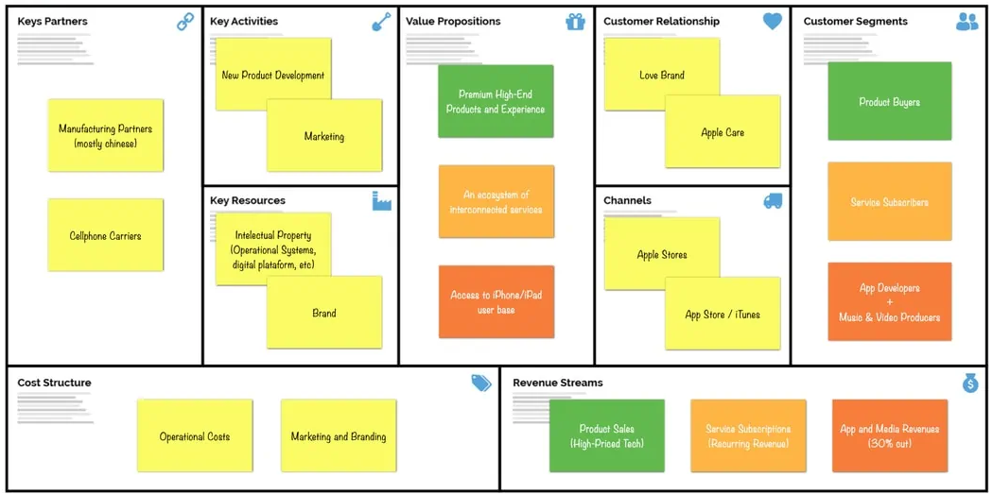
Figure: Business Model for Apple
Source: (Hacklin et al., 2018)
At the center of Apple's business enterprise technique are product offerings, surroundings, and an unwavering dedication to format and innovation (Hacklin et al., 2018). The organization typically generates revenue through the sale of hardware such as the iPhone, iPad, Mac Apple Watch, and Apple TV at the side of software programs and offerings such as the App Store, Apple Music, iCloud, and AppleCare. This atmosphere provides customers with a revel that maintains them engaged within the Apple environment.

Motivation
When humans decide to shop for Apple merchandise, they're stimulated by using the use of elements, just as the producers recognize, the layout of the products how they recognize the remarkable and their standard consumer revel in. Apple has constructed a brand picture known for being highly pleasant and prestigious. This notion of the logo motivates customers because proudly owning Apple merchandise is seen as a symbol of fame and a high-priced way of lifestyle. Furthermore, Apple's consciousness of design and superior technology appeals to those who feel every beauty and capability of their devices.

Apple Promotions
In phrases of promotions, Apple uses strategies to enhance its emblem photo and lift profits. The organization runs advertising campaigns that exhibit the capabilities and blessings of its merchandise. These advertisements often highlight innovation, layout excellence, and the manner nicely all Apple devices work together seamlessly (Mao al., 2021). In addition to advertising Apple's retail shops function as places in which customers can experience the goods firsthand with demonstrations and personalized carriers. Whenever there may be a product launch from Apple it turns into a cope with plenty of media interest and pleasure, from clients.

Literature Review
The case of Apple is therefore a very good example of how brand image and product design can positively impact the behaviour of consumers. r has been strategically associated with innovation, high quality and usability of its products and this has created trust which makes the users’ willing to be charged fairly. It is also important for Apple to portray the feeling that one gets when he hears the word creativity, or the feeling of belonging to a selected class of people, which is actually a feeling that goes beyond the product (Oyenuga, Ahungwa, and Onoja, 2021). This actually develops an enlarged consumer base and encourages the development of brand loyalist, which in turn determines the market choice. In line with this understanding, Apple’s design philosophy is characterized by placing the user at the heart of design. Easy to use software, clean looks, and compatibility with the Apple environment provide a satisfying experience to the everyday consumer (Razak et al., 2020). Concerning design, this emphasis is not only the functionality of the products themselves. Glossy and shiny products turn up into something that people crave to have, and not merely means to perform certain tasks. Innovation is a key aspect of the company that makes the consumers’ stick to the new product waiting for the next innovation.
The integration of brand image and design mostly affects consumers in the way they act. Consumer is willing to make impulse purchases for the Apple products and are also loyal customers who are prone to replace their current products with new Apple products and try other Apple products as well (Li et al., 2021). Indeed, even Apple’s choices of colours and other aesthetics dictated trends in the technology market, hence creating a demand for its gadgets. Wrapping up, it can be stated that Apple’s story is a vivid example of how crucial brand image and the conception of product design are. Through the use of brand positioning appealing to the consumers’ emotions, and delivering goods and services that are sleek and elegant in design as well as their usability, Apple has established itself at the top of the technology market.

Methodology
The entire methodology section is based on the secondary data collection processes. That upsurges the outcomes of the research. So, while undertaking this research on Apple brand image and its influence on the client’s behavioural intentions using a product design perspective, it is vital to employ sound methodological approaches that will aid the subsequent interpretation of secondary materials and qualitative data analysis. A proper methodology helps to avoid wandering and keeps a focus while selecting the data. Secondary sources such as research papers or the industry reports are relevant when evaluated critically because biases present may misrepresent the data in regard to the topic (Jain, 2021). Likewise, when dealing with qualitative variables, there is a specific methodology that explains which codes were adopted in order to categorize textual data such as interviews or customer feedbacks. Thus, the enhanced level of control over researcher influence and increased methodical clear-sightedness give the reader an idea of how data has been analysed and conclusions have been made. Finally, a robust method builds a solid foundation for the analysis of Apple’s success and enables the presentation of the results.

References
Cai, Q. and Chen, S., 2024. Analysis of the influencing factors of marketing strategy on consumer purchasing behaviour: A case study of apple. In SHS Web of Conferences (Vol. 188, p. 03005). EDP Sciences.https://www.shs-conferences.org/articles/shsconf/abs/2024/08/shsconf_icdde2024_03005/shsconf_icdde2024_03005.html
Hacklin, F., Björkdahl, J. and Wallin, M.W., 2018. Strategies for business model innovation: How firms reel in migrating value. Long range planning, 51(1), pp.82-110.https://www.sciencedirect.com/science/article/pii/S0024630117302881
Jain, N. (2021). Survey versus interviews: Comparing data collection tools for exploratory research. The Qualitative Report, 26(2), 541-554. https://search.proquest.com/openview/6bbd0e7f4fcb5c2b0b1f1a9f52506d21/1?pq-origsite=gscholar&cbl=55152
Li, Y., Teng, W., Liao, T. T., and Lin, T. M. (2021). Exploration of patriotic brand image: its antecedents and impacts on purchase intentions. Asia Pacific Journal of Marketing and Logistics, 33(6), 1455-1481. https://www.emerald.com/insight/content/doi/10.1108/APJML-11-2019-0660/full/html
Mao, J., 2021, August. An Interpretation of Semiotics in the Display Design of Apple User Experience Store. In 7th International Conference on Arts, Design and Contemporary Education (ICADCE 2021) (pp. 407-414). Atlantis Press.https://www.atlantis-press.com/proceedings/icadce-21/125960013
Oyenuga, M., Ahungwa, A., and Onoja, E. (2021). Effect of Brand Equity on Consumer Behaviour Among Students of Veritas University, Nigeria: A Study of Apple Smartphones. Marketing and Branding Research, 8(1), 48-64. https://mbr.cikd.ca/article_60544_en.html
Razak, M., Hidayat, M., Launtu, A., Kusuma Putra, A. H. P. A., and Bahasoan, S. (2020). Antecedents and consequence of brand management: empirical study of Apple’s brand product. Journal of Asia Business Studies, 14(3), 307-322. https://www.emerald.com/insight/content/doi/10.1108/JABS-01-2019-0030/full/html

