Personal actual development
Interviews write up
When partaking in any interviews or having new experiences it is important to reflect on the situation. In doing so, this can help with future improvements and give awareness to what is expected. Below is an image of Gibbs’ (Bing.com, 2019) model of reflection that I will use to reflect on this interview.
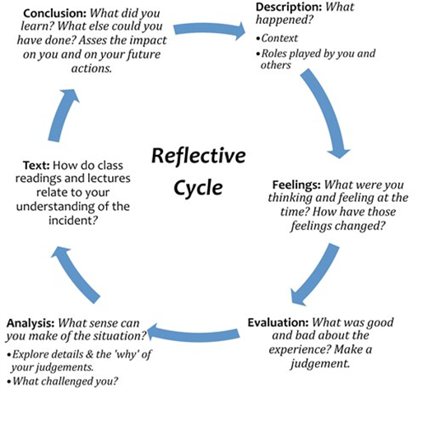

Prior to my interview, I looked into the background of midwifery and made notes on the different roles of a midwife. I also researched what skills would be essential for this course and how my work experience skills can be transferred and suit becoming a midwife. I ordered some books, one was a nursing and midwifery interview questions booklet in which I practiced repeatedly so that I felt confident in answering questions and had a rough idea of what sorts of questions to expect.
The role of a midwife is to provide antenatal care to woman during pregnancy, labour and immediately after birth (targetjobs, 2019).
Health careers NHS (2019) states that there are essential skills and characteristics needed to become a good midwife; these include excellent people and communication skills, a strong interest in the birthing process of pregnancy, have the ability to answer questions and apply knowledge, work well as part of a team and have the ability to remain professional during emotionally charged situations.
I also made effort to revise a few current issues within midwifery in case I was asked about these. I retrieved this information from the online midwifery journal. My main focus was on support for home births as these can be safer for low risk women. The culture of having hospital births is still high due to expectant mothers being worried about limited options for pain relief and reluctance to be too far from lifesaving care in case problems were to arise. NICE statement has affirmed that there is no evidence that suggests homebirths have an increased risk to the baby (Wang, 2015).
I received an e-mail from Cardiff University inviting me to an interview on March 6th at 10.30. I was sent a case study in which I had to revise for and prepare information to discuss within my group. The case study is displayed below.
I set my alarm for 8:00 AM to get myself ready and organized. I also bought a new smart outfit for the interview. I chose to wear black high waist trousers, a grey and white blouse with a black blazer and tanned leather shoes. I had my hair pinned back out of my face and aimed to look professional and suited to the course I was applying for.
I left at 8.30 to allow for any road incidents, heavy traffic or road maintenance works that may have caused me a delay. I ensured I had money set aside for parking and refreshments. I arrived at the university early and sat down with others, we were all placed into our groups and seated in a room until we were called through. We all spoke of how nervous we felt - some had been to several interviews prior to this one but this was my first university interview that I attended so I didn’t know what to expect, however I did prepare for it and was confident with my preparations. I read over some notes and practiced answering interview questions in my head. It was very warm at the university and I was nervous, felt sweaty, so I tried to control my breathing by slowing it down to try to reduce my nerves.
When we were called into the interview room we were told that we were going to have a multiple mini-interview that consisted of 6 stations where, at each station, there was someone who would give us a question in which we had a limited time to answer, from what I can remember it was 1 minute. The questions asked included the 6 c’s (CITATION) which I answered confidently as I had revised these prior to the interview. I was also asked what I would do if I was in a situation where a colleague had been out the night before and attended work still drunk and would I allow her to work or inform a member of staff or advise her to go home. I said that I would advise her to go home and sober up and if she refused, then I would report this to someone as she would be endangering the patient, which is unprofessional. I was asked how would I would apply dignity and respect and what is meant by both terms. I answered by saying I would respect a person’s feelings and beliefs. For instance, if they raised concern that they were not happy about something then I would not do that or I would find an alternative (as long as this didn’t affect their health and safety) so that they would feel satisfied and comfortable.
I doubt that the feelings I had throughout the interview would change, I feel that I will always be nervous throughout interviews and, for that reason, it is a bad experience for me. Because I am not comfortable with being nervous, being organised and prepared for interviews makes them a lot easier, and this is why lectures on interview skills and preparation is needed. What I found great about this interview was the multiple mini-interviews, it was a fun way to answer questions and less invasive in comparison to the group interview in which it was rather difficult to get my voice and opinion out to the group because others were far louder and overpowering. A minority was more concerned about getting their opinion out themselves and I, personally, did not feel like there was good communication between members of this group because not one person asked another their opinion. I will take this on board for future group discussions.
This interview experience has been relevant and I know what to expect for future interviews and how to make changes for improvement.

Reference list
Bing.com (2019) Gibbs model of reflection. Available at http://slavonic.group.shef.ac.uk/wp-content/uploads/Gibbs_reflective_cycle.jpg (Accessed on 12/04/19).
Wang, S (2015) New support for home biths; U,K. NICE, in a surprise, rules having a baby at home is safer than a hospital in some low risk pregnancies. Wall street journal [online]: New York. Available at: https://search-proquest-com.ezproxy.uwtsd.ac.uk/central/docview/1717020118/E128DFE7D6164073PQ/1?accountid=130472 (Accessed on 05/04/19).

