The relevance of ethics within marketing decisions for contemporary business

Introduction

The purpose of this essay is to look at the ethics within marketing of businesses today. By researching industry examples and academic theories, it will explore some of the different marketing approaches, trends, and tactics that companies often use. It will discuss how such marketing trends fit in to the marketing frameworks, concepts, and techniques and whether these go on to further help or actually even hinder social problems. The role of the marketing mix, the marketing environment and marketing ethics and how they impact the day to day running of a contemporary business will be considered. Also, key stakeholders will be identified and the impact they have on marketing activities of the business (and how ethical those marketing activities are) will be assessed.

What is Marketing?

Marketing is a broad term, that has had varied and evolving definitions throughout the years. The American Marketing Association currently defines marketing as “the activity, set of institutions, and processes for creating, communicating, delivering and exchanging offerings that have value for customers, clients, partners and society at large” (2022), in 2017 the same Association stated that “Marketing is the process of planning and executing the conception, pricing, promotion and distribution of ideas, goods and services to create exchanges that satisfy individual and organisational objectives” (American Marketing Association, 2017). Kotler has published many writings on Marketing and has described marketing as the “science and art of exploring, creating, and delivering value to satisfy the needs of a target market at a profit” (Kotler Marketing Group, Inc., n.d.)

The marketing concept was brought about in the 1950s. It looked at key areas such as customer orientation, integrated effort, profit direction and competitor orientation. The marketing mix was further condensed, in 1960, to the more commonly known and used 4P formula (Product, Price, Place and Promotion) (McCarthy & Perreault, 1984). In 1981 the service Marketing mix was created. It was an extension of the traditional marketing mix and increased the 4P’s to 7P’s (adding People, Process and Physical Evidence). Academics and practitioners were realising that marketing included a lot more than just advertising and selling; marketing is building a relationship between organisations and external stakeholders, regardless of if it is Business to Business or Business to Customer marketing.

Marketing Ethics

Ethics are defined as moral principles that control or influence a person's behaviour (Ethic Noun - Definition, Pictures, Pronunciation and Usage Notes | Oxford Advanced Learner’s Dictionary at OxfordLearnersDictionaries.com, n.d.)

Ethics within business can relate to all business areas and all elements of the marketing mix. When choosing ethical marketing, companies/organisations are adopting a philosophy more than a marketing strategy, as it encompasses all marketing efforts. Consumers are becoming more socially aware of good business practice and morals, and organisations must take this into consideration; from the sourcing of materials to the production, labour, advertising, employee relations and logistics (just to name a few). When discussing marketing ethics, companies must consider how their marketing practices promote fairness, social responsibility, empathy, and honesty and how their organisation also impacts the environment and sustainability.

The World Fair Trade Organisation (WFTO) is a global movement that aims to create a world where people and planet come first in business and trade. The vision has the objective to fight poverty, climate change, gender inequality and injustice. The WFTO is steered by 10 main principles, (pictured below)

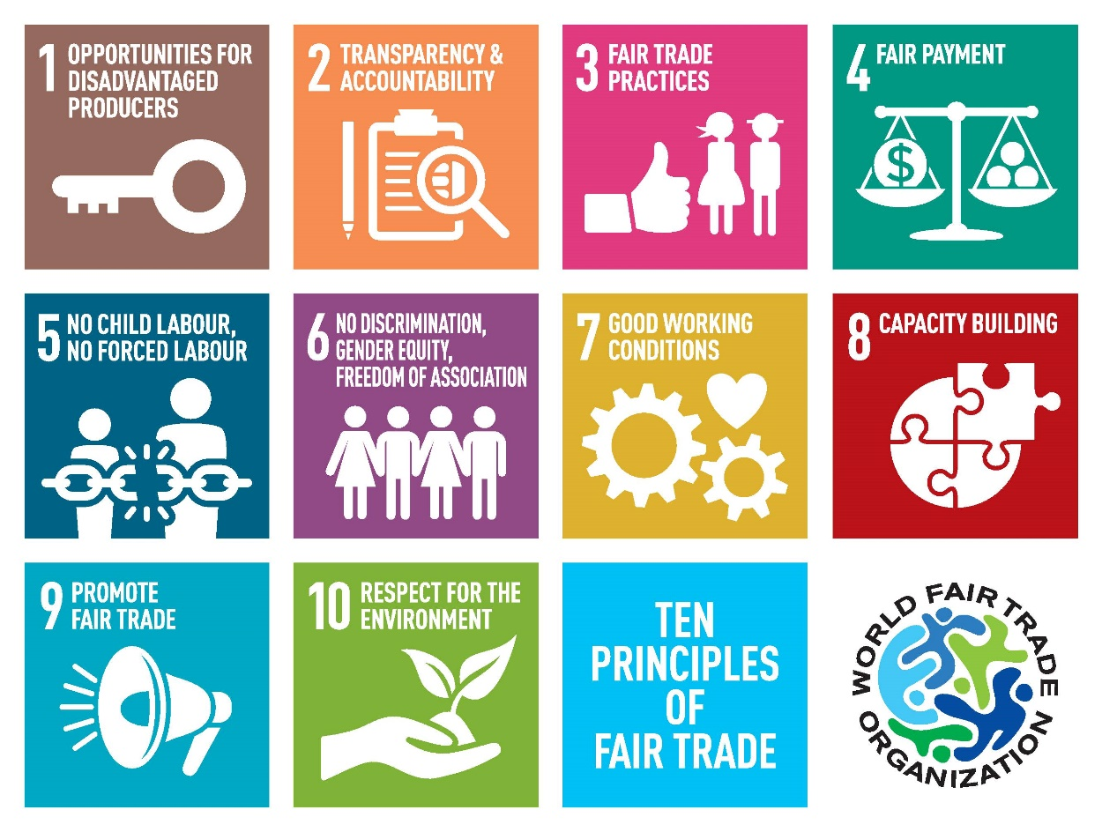
(WFTO Europe, 2016)

Marketing itself is a topic that prompts much debate. Some theorists argue that marketing is simply a form of persuasion, which can be perceived as unethical. One of the main aspects of marketing that gets scrutinised is advertising. Marketing and Advertising Law in the UK states that all marketing and advertising must be an accurate description of the product or service, legal, decent, honest, truthful and socially responsible. In addition to restricting advertising powers with regulations, there are two codes of practice in advertising. The codes of practice are enforced by the Advertising Standards Authority (ASA) and complaints can be brought to the ASA within 3 months of an advert appearing, if there is belief that rules have been broken. Repercussions could be the withdrawal of the advert, or even prosecution if the advert has actually broken the law. (Government Digital Service, 2015)

Marketing Progressions through time

Advancements in technology, changes in consumer behaviour and living in a more contemporary society have affected marketers’ choice of medium over time. Marketing has moved on from print, radio, and television formats and has evolved in to a much more sophisticated digitally based era. With today’s society relying heavily on mobile devices it was the obvious next step.

Paper-based marketing

The average British letterbox receives approximately 650 pieces of junk mail each year, resulting in around 17.5 billion pieces being produced annually in the UK, which, is using in the region of 550,000 tonnes of paper (Junk Mail, 2019). The cost to the environment is detrimental in more ways than one:
- the trees cut down to create the paper used mean that there is an increase in deforestation, which threatens the worlds biodiversity
- many households disregard junk mail and dispose of it in the waste. If not recycled properly this junk mail will end up contributing to the landfill dilemma that we face globally.

Digital Marketing

Living through the contemporary and digital era, companies are increasingly substituting paper-based marketing for digital formats. This seems a much more ethical decision in terms of sustainability and the environment. Facebook dominates the UK social network market and in 2020 the number of UK Facebook users reached fifty-one million (Zivkovic, 2022). Organisations are likely to reach a much wider audience with the use of social media (platforms and websites) as a marketing tool. For smaller organisations and community groups the move to social media marketing would be beneficial as it cuts the cost of printing and distribution, and they could opt for ‘free’ social media advertising. There is also the option to have sponsored adverts and pay a small fee to reach a certain target audience.
Advertisers use ‘apps’ such as Facebook, Instagram, Tik-Tok, You-Tube, etc as a way of getting their product or service in front of potential customers. Through cookies and data collection from sites and search engines, companies such as Facebook are able to sell advertising space, with the knowledge that the consumer already has a vested interest in the area. To some users, this type of targeted advertising is welcomed. They find it beneficial to have relevant adverts selected for them. However, many people find this method too personal and can be left feeling exploited, they would view it as unethical, not only as an invasion of privacy but also unethical in the way that the companies profit from selling such data. Facebook and its Founder Mark Zuckerburg have come under scrutiny for data breaches in the past and changes were made to the policies and procedures of data collection and sharing. In response to the Cambridge Analytica scandal (first reported in 2015) Mark Zuckerburg CEO of Facebook said "We will restrict developers' data access even further to prevent other kinds of abuse. For example, we will remove developers' access to your data if you haven't used their app in three months”. Zuckerburg also added that users will give a reduced amount of data when signing in on third party apps, if developers want further access to anyone’s data, they have to gain approval and sign a contract. (Sky, 2018)
A large part of marketing nowadays (especially within digital marketing) is evangelism. Due to the nature of social networks and the general public being able to share their thoughts and experiences at the click of a button, evangelism (word of mouth marketing) is a crucial element that companies need to consider. Customer relations are now vitally important and potential customers often turn to social networking sites to ask for others’ reviews, opinions, and recommendations. In light of this, companies must ensure that they are meeting ethical standards and are viewed as being ethical in the consumers eyes.

Marketing unhealthy drinks and snacks to children
In terms of ethical marketing, there is major public concern when it comes to advertising food. Marketeers are restricted by rules and regulations to ensure responsible advertising standards are met.
In 2010, the World Health Assembly (the main governing body of the World Health Organization) sanctioned a list of recommendations for countries to use as a guide in creating new and reinforcing existing policies on food marketing communications to children “in order to reduce the impact of marketing of unhealthy foods and drinks on their health” (WHO EMRO | Marketing of Unhealthy Foods | Nutrition Site, n.d.)
The ASA (Advertising Standards Authority) and CAP brought in further recommendations in 2017, which advised that when creating responsible adverts companies should use health and nutrition claims correctly, and with regards to unhealthy foods high in fat, sugar and salt they should not place inappropriate adverts, promote unhealthy lifestyles, use licensed characters, target to Under 12 or exploit powers of persuasion.
Reference List

- American Marketing Association. (2022, July 20). Definitions of Marketing. https://www.ama.org/the-definition-of-marketing-what-is-marketing/

- Booms, B. and Bitner, M., 1981. Marketing Strategies and Organizational Structures for Service Firms Marketing of Services. Chicago: American Marketing Association, pp.47-51.

- ethic noun - Definition, pictures, pronunciation and usage notes | Oxford Advanced Learner’s Dictionary at OxfordLearnersDictionaries.com. (n.d.). Retrieved 20 October 2022, from https://www.oxfordlearnersdictionaries.com/definition/english/ethic?q=ethics

- Government Digital Service. (2015, August 27). Marketing and advertising: the law. GOV.UK. https://www.gov.uk/marketing-advertising-law/advertising-codes-of-practice
- Junk Mail. (2019, March 19). WRWA. https://wrwa.gov.uk/materials/junk-mail/
- Kotler Marketing Group, Inc. (n.d.). Retrieved 30 October 2022, from https://kotlermarketing.com/phil_questions.shtml
- McCarthy, J. E., & Perreault, W. D., Jr. (1984). Basic Marketing: A Managerial Approach (Irwin Series in Marketing) (8th ed.). Richard D. Irwin, Inc.
- Sky. (2018, March 22). Facebook boss 'open' to testifying before Congress. Sky News. https://news.sky.com/story/facebook-boss-open-to-testifying-before-congress-11299538
- WHO EMRO | Marketing of unhealthy foods | Nutrition site. (n.d.). World Health Organization - Regional Office for the Eastern Mediterranean. Retrieved 4 November 2022, from https://www.emro.who.int/nutrition/marketing-of-unhealthy-foods/index.html
- WFTO Europe. (2016, August 4). The 10 principles of Fair Trade. https://wfto-europe.org/the-10-principles-of-fair-trade-2/
- Zivkovic, J. (2022, March 31). UK Social Media Statistics and Facts [2022]. CyberCrew. https://cybercrew.uk/blog/social-media-statistics-uk/

