Exploratory Data Analysis - Presentation

Name: Patel Manav Ajitkumar
Student id: 2437942
Module: data mining and visualisation(ACCA7015)
Table of Contents
Slide 0: Title Slide 3
Slide 1: Executive summary 3
Slide 2: Data overview 4
Slide 3: Data Cleaning 5
Slide 4: Data Cleaning CNTD… 6
Slide 5: Data Cleaning CNTD… 7
Slide 6: Data Cleaning CNTD… 7
Slide 7: Data Cleaning CNTD… 8
Slide 8: Data Grouping 9
Slide 9: EDA univariate analysis 10
Slide 10: EDA univariate analysis CNTD… 11
Slide 11: EDA multivariate analysis 13
Slide 12: EDA multivariate analysis CNTD… 14
Slide 13: Recommendations and Conclusion 15
Slide 14: References 16
Slide 15: Thank you 16

Slide 0: Title Slide

Slide 1: Executive summary
Points:
- It reviewed a sample of more than 48,000 Airbnb listings located in New York City and the analysis gives a mind-reading insight of the market state in 2019.
- According to the analysis, the price discrepancies between neighbourhoods and room types are high, and a clear variance in the host listing behaviour can be observed.
- Data cleaning and filtering was done based on outliers and a series of derived variables were made to enable the analysis to be deeper.
- Strategic decision making could be done based on results of strategic decisions made regarding pricing, availability control and market segmentation.
S.N:
The Airbnb listing analysis of New York City reveals the important tendencies in pricing, distribution of the rooms type, and host work. Reliable results are obtained through systematic data cleaning, missing values imputation, and outlier treatment and derived columns like price categories and host types added more depth to the analysis. The result shows that the more expensive listings are located in Manhattan, the listings on the whole house/apartment prevail in the market, and the host is an experienced one. The strategic market decisions can be informed using these results.

Slide 2: Data overview
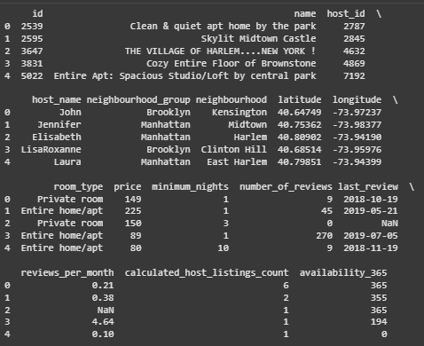
First five rows of the dataset
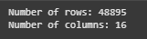
Number of rows and columns
Points:
- Dataset includes 48,895 Airbnb listings in New York City in one year, 2019, containing 16 attributes of a listing.
- Major features consist of listing and host identifiers, geographic data, room categories, rates, availability and review features.
- Data has a combination of numeric, categoric, and date variables, which give a basis of statistical and visual analysis.
- Preliminary analysis shows that there are missing values and possible outliers, which require data cleaning to proceed with additional analysis.
S.N:
The data set gives a thorough description of Airbnb listings in New York City, such as host information, location, types of rooms, price, and information on reviews. It includes 48,895 rows and 16 columns, out of which some of the attributes are categorical, numerical and date. Initial analysis shows that there are gaps in the values of columns such as price and minimum nights. These aspects suggest the relevance of preprocessing of data in order to achieve accurate exploratory analysis.

Slide 3: Data Cleaning
Before imputation | After imputation
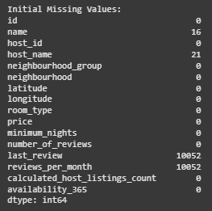 | 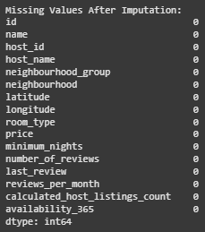
Null value handling
Points:
- There are missing values in some of the columns, such as name, host either name, last review, and reviews per month.
- Imputation of numerical missing values (reviews/per month) is done with the median to preserve integrity of distribution.
- Name, host name and categorical missing values are filled-in with the mode in order to maintain the most common category.
- All the missing values are solved after imputation so that a complete dataset could be used in further exploratory analysis (Dhillon et al. 2021).
S.N:
Null value check showed that there are missing values in categorical and numerical attributes. In particular, last review, in addition to reviews/per/month, had large missing data, whereas name and host name contained small missing data. Numerical columns are imputed using median, whereas categorical columns are imputed using mode. This strategy made sure that every absent data is addressed in a systematic way where an effective exploratory data analysis and consequent modeling activities are to be performed.

Slide 4: Data Cleaning CNTD…
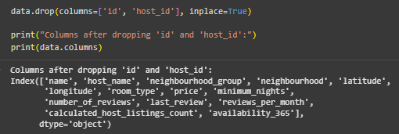
Removing id columns
Points:
- “id” column has been dropped because it is just a unique identifier that is not relevant to an analysis.
- “host id” is also deleted to reduce on those attributes that are applicable in the pattern and trend.
- Elimination of identifier columns eases the dataset and minimizes the redundancy without any changes in the anaematic results.
- These procedures would help prevent bias on the part of the further exploratory and multivariate analyses due to unique identifiers.
S.N:
Columns such as id, host, id and host host have been excluded since they do not add any value to analysis other than providing uniqueness. Retaining these identifiers would add unnecessary noise on the statistical summaries, as well as visualizations. Their selection narrows down the data set and only the variables that expose the tendencies in the pricing, the type of rooms, occupancy and the dynamics of reviews. In its turn, the preprocessing phase enables the exploratory data analysis to become more efficient, such that the insights gained would be predicated on the substantive features, as opposed to meaningless identifiers.

Slide 5: Data Cleaning CNTD…
Number of duplicated rows
Points:
- The validity of data is verified by testing of duplication of the rows to remove repetitions.
- No records are duplicated and therefore they are listed only once in the dataset.
- No duplicates allow statistical analyses and visualisations to be an accurate representation of the actual structure of listings.
- This verification process improves the precision of the further exploratory and multivariate analysis.
S.N:
The data also has a strict check against duplication of rows hence showing accuracy of data. The analysis is used to verify the lack of duplicate lists, which means that each jury in Airbnb corresponds to one listing. This avoids distortion of statistical calculations and trend analysis and visual representations that would otherwise have been caused by duplicate records. Keeping separate records, therefore, increases the validity and reliability of the exploratory analysis and supports the validity of the conclusion related to the pricing, room types, and host behaviors.

Slide 6: Data Cleaning CNTD…
Before Capping | After Capping
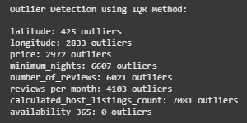 | 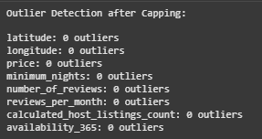
Points:
- “Interquartile Range (IQR)” technique is used to determine the presence of outliers in the columns containing numerical values, namely, price, minimum number of nights, number of reviews, and number of reviews per month.
- Both maximum and minimum realistic values of each numeric variable are computed to identify extreme values.
- Values that went beyond these limits are limited to minimize their effects on analysis without losing any records (Gong, 2025).
- This process reduces the extreme set of cases on the further statistical analysis and graphic representations.
S.N:
Substantive numerical variables are analyzed to identify outliers, thus avoiding the possibility of the large scores to skew the results of analysis. Through the use of IQR approach, upper and lower limits are set per column and the entries that do not fit within the limits are not eliminated but bounced against the respective quotas thus retaining a complete dataset. This initial processing operation protects the integrity of the data so that the statistical summaries and visualizations capture the listing characteristics that represent the data instead of being influenced by outliers.

Slide 7: Data Cleaning CNTD…
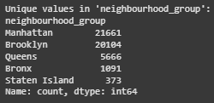
Unique values in neighbourhood_group
Points:
- There are five categories in the column that represent the boroughs of New York City.
- The highest number of listings is recorded in Brooklyn and Manhattan, 21,661 and 20,104 listings respectively.
- Queens, the Bronx, and Staten Island have significantly fewer listings, which shows that Airbnb is concentrated in central boroughs.
- This allocation plays a significant role in understanding the pricing trends, the frequency of different types of rooms, and the trends in the review patterns in boroughs.
S.N:
The relative analysis of the neighbourhood-group column shows that Manhattan and Brooklyn is the prime concentration of Airbnb listings that constitute about 80 per cent of the data set. Queens, the Bronx, and Staten Island have a significantly lower listing, which shows differences in short-term rental activity at each borough level. This division gives a background on further understanding of price change, room type completion, and host conduct. The insights are critical towards recognizing markets with high demands and making strategic decisions about the market.

Slide 8: Data Grouping
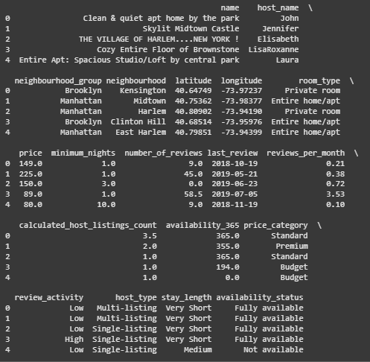
Dataset after creating new columns
Points:
- The creation of new derived columns to categorize both numeric and categorical variables is used to enable a more detailed level of analysis.
- Price is divided into Budget, Standard, Premium, Luxury, and Ultra-Luxury to facilitate the analysis of prices (Han, and Kwak, 2023).
- Other derivatives variables are review activity, host type, length of stay and availability status to represent listing frequency, host experience, minimum stay and listing availability.
- Such classifications allow aggregation and comparison between categories to facilitate easier understanding of listing features and market patterns.
S.N:
In order to improve the exploratory analysis, a number of derived columns are added. Price category variable is a factor that classifies the listings into specific price categories, whereas the review activity is an indicator of the number of guest reviews. Host_type distinguishes between a single listing and multi-listing host. One of the columns is stay length that classifies the listings based on minimum number of nights required and availability status that indicates how many times a listing is available. These changes will enable aggregation and enable more informative comparisons of listing patterns and behavior across New York City.

Slide 9: EDA univariate analysis

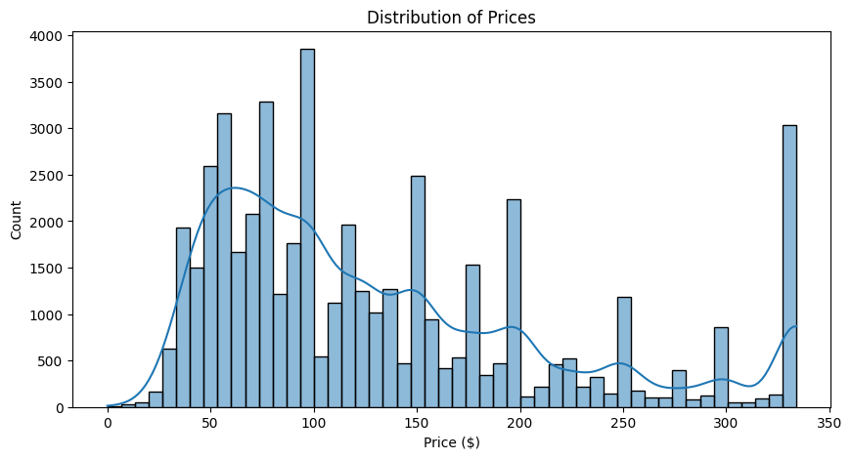 | 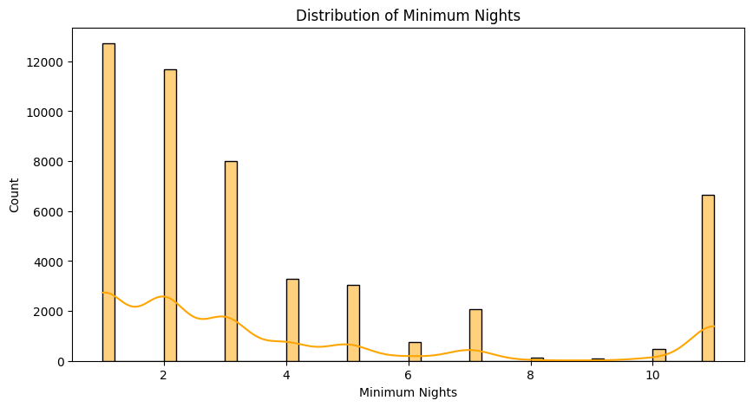
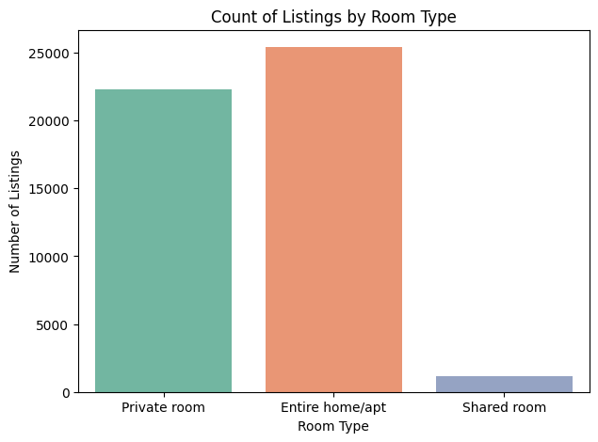 | 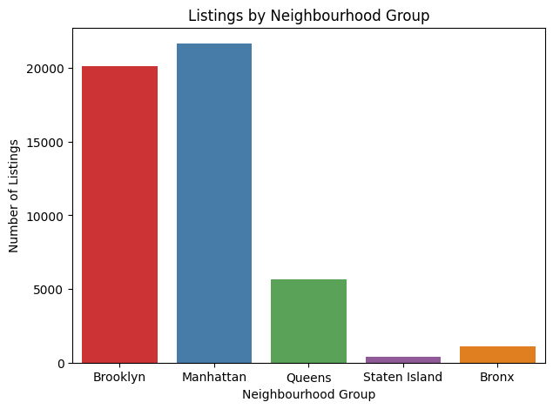
Points:
- Most Airbnb properties cost less than 150, with a substantial concentration at 100 and a few properties of very high prices.
- Majority of the listings are at least 1 or 2 night stay and the longer stays are less frequent.
- Market is dominated by entire home/apartment listings and then private rooms with shared rooms being quite rare (Jain, 2025).
- Most of the listing lies in Manhattan and Brooklyn and there are fewer properties in Queens, Staten Island, and the Bronx.
S.N:
The univariate analysis provides the key features of the Airbnb NYC 2019 data. The distribution of pricing indicates that most of the listings are not expensive, but there are some expensive listings that result in a long-tailed distribution. Minimum night stands are usually low and they are favourable to high frequency of guest turnover. Room type analysis shows that whole homes/apartments are most common, borough analysis confirms that the majority of listings are located in Manhattan and Brooklyn. These patterns give a background insight into listing patterns which can be further developed through multivariate analysis.

Slide 10: EDA univariate analysis CNTD…

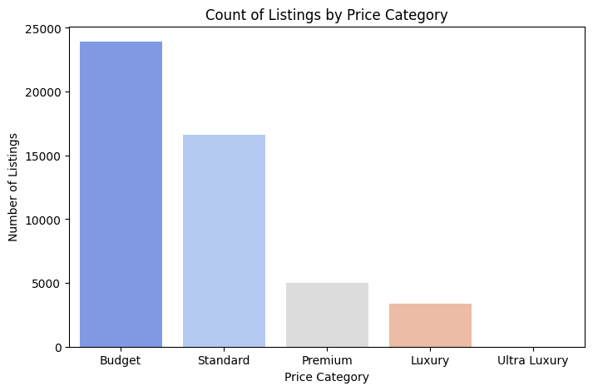 | 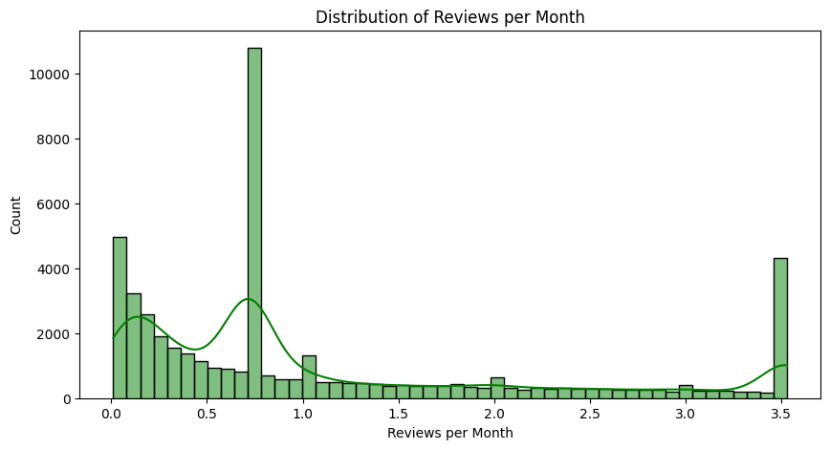
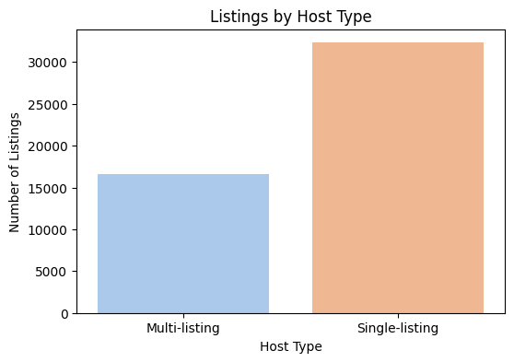 | 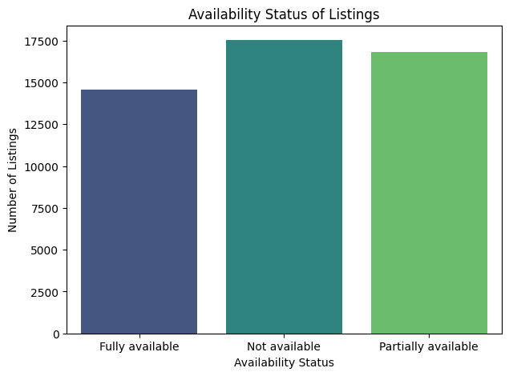
Points:
- Listings are mostly categorized as either Budget or Standard with an exception of Ultra Luxury listing being fairly scarce.
- Month-to-month review is extremely skewed in low values indicating that a significant number of listings receive fewer guest reviews.
- Market is dominated by single listing hosts and multi-listing hosts are fewer.
- Listing availability is divided into fully and partly available properties, and the number of listings is lower, and not available at all.
S.N:
Additional univariate studies identify important categorical and derived variables. Price categories prove that Airbnb market is highly concentrated at lower price segments, whereas luxury is considered a minor part. The frequency of reviews per month indicates that the majority of the properties get little guest reviews. Single-listing hosts are predominant as indicated by host analysis which shows that most of the hosts are single operators. Availability patterns demonstrate the equality between fully and partially available listings, which gives an understanding of the accessibility of listing in the city.

Slide 11: EDA multivariate analysis
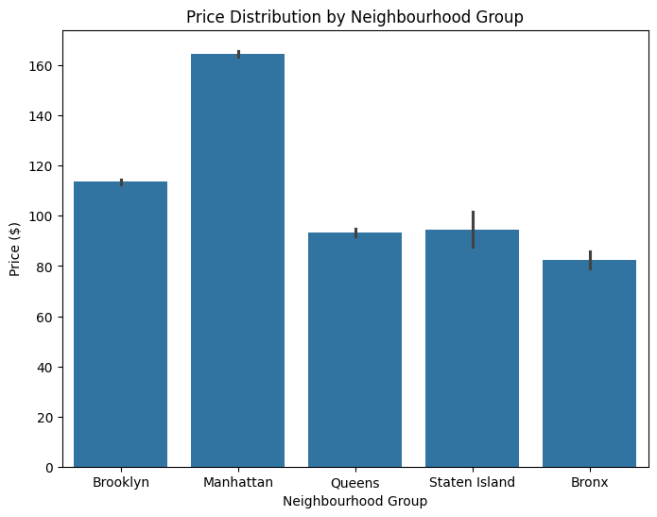 | 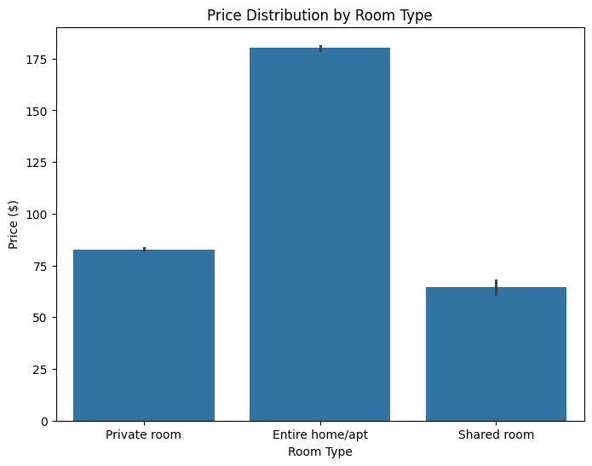
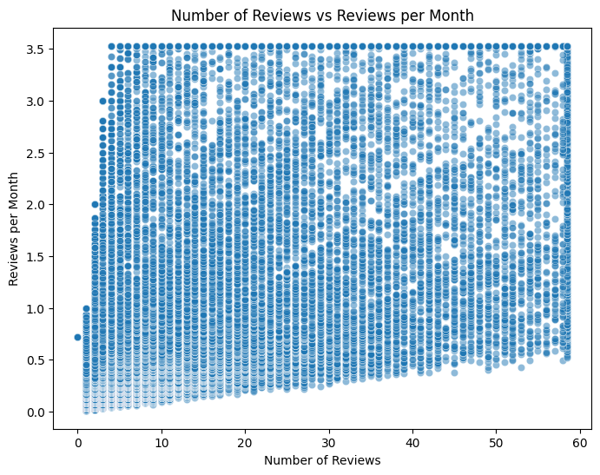 | 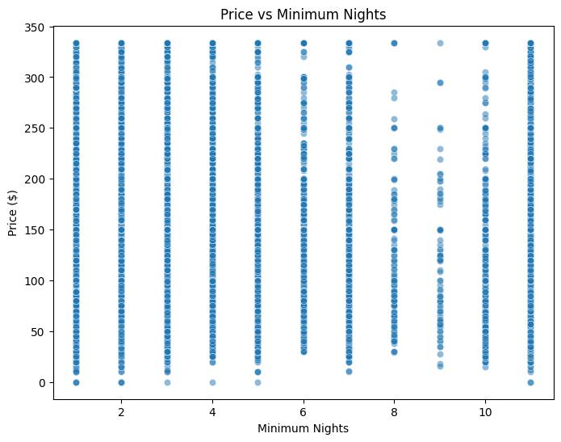
Points:
- There are great differences in average prices across neighborhoods with the highest average price in Manhattan and the lowest in the Bronx.
- The difference in prices is also visible in the room types as the entire home is the most expensive, then there are private rooms, and among them shared rooms, which are the cheapest.
- There is a weak positive correlation between the quantity of reviews and the number of reviews in a month which suggests that more active listings are likely to get more frequent reviews (Voltes-Dorta, 2025).
- Price has a low level of correlation with minimum nights, and there are cases where listings with very high minimum night requirements are charged high prices.
S.N:
The interaction between price and other listing features is demonstrated in multivariate analysis. The Manhattan listings are at the top in average prices and hence high demand and location centrality whereas the Bronx has the lowest average prices. The type of a room plays a significant role in pricing as whole houses are priced more than shared rooms or personal. Review trends show that more reviews each month on a listing that has undergone review. Price and minimum nights display some low general correlation, but the extreme minimum night requirements are sometimes associated with higher prices, which identifies uncharacteristic listings.

Slide 12: EDA multivariate analysis CNTD…
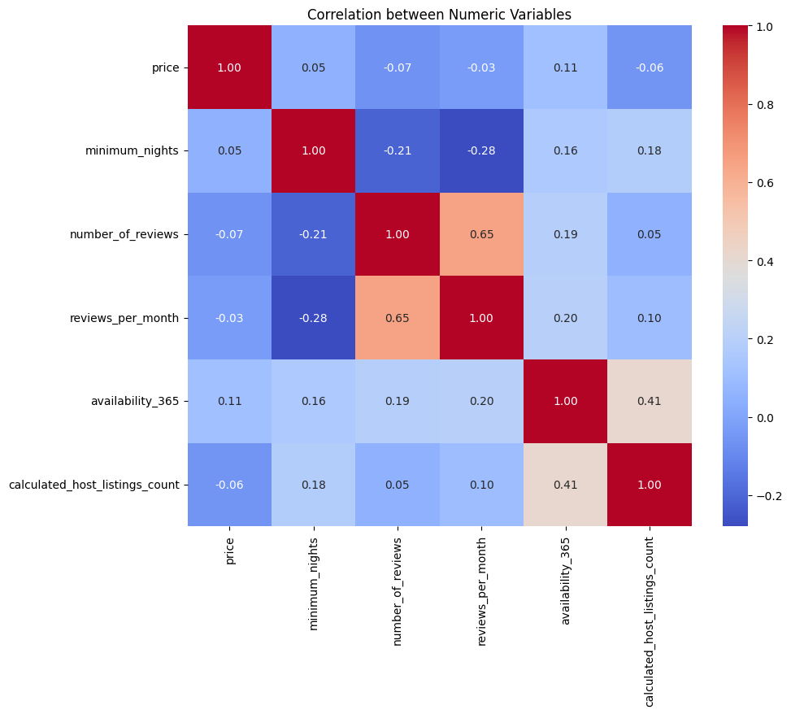 | 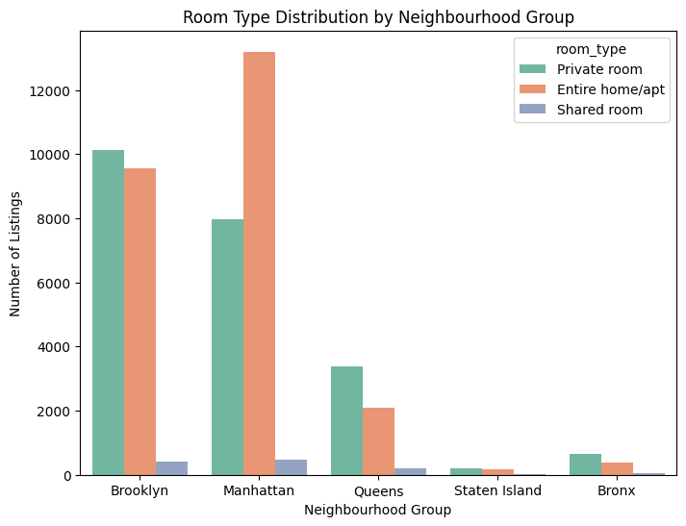
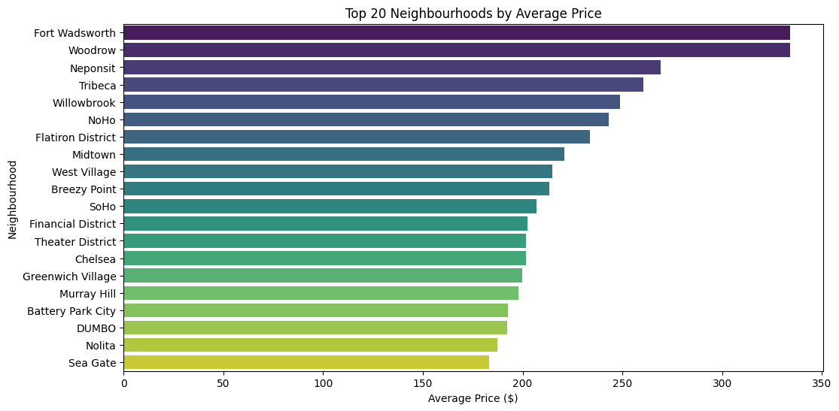 | 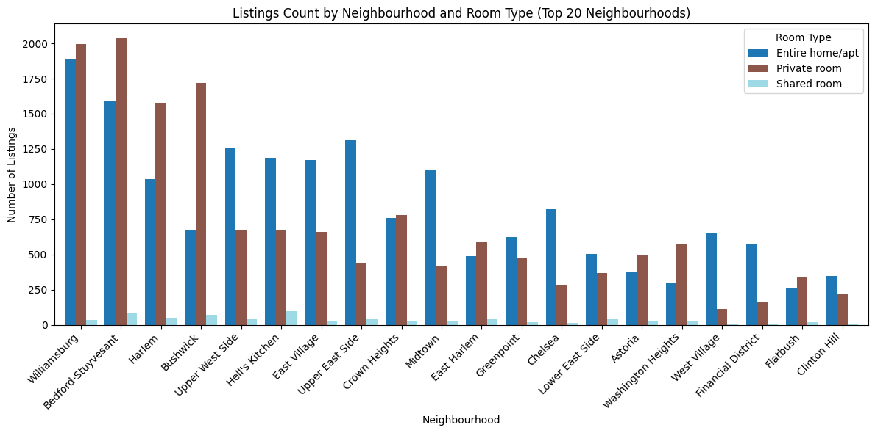
Points:
- The correlation of numerical variables with price is low whereas the correlation of number of reviews and reviews per month is positive and strong meaning that more frequently reviewed listings get more total reviews.
- Distribution of the type of rooms within the different boroughs indicates that Manhattan and Brooklyn dominate with all-in-one-homes and the much more common in Brooklyn are the private rooms.
- The highest 10 neighborhoods based on highest prices are still high end Manhattan neighborhoods and this depicts a significant price difference in the entire city.
- Whole houses/apartments are always the most expensive on average, with Manhattan being the most expensive of all types of rooms and other boroughs (Outer) having cheaper opportunities of living privately or sharing.
S.N:
The correlation analysis shows that the price has a weak correlation with other numeric variables and the listings with a greater number of reviews are likely to have higher frequencies of monthly reviews. Room type distribution demonstrates that Manhattan and Brooklyn are the busiest boroughs, and the whole rooms take the lead in Manhattan. The top 10 neighborhoods with average price analysis reveal that there is a concentration in the luxury areas of Manhattan and this indicates steep pricing differences. Comparison of prices between the types and boroughs proves that Manhattan is the most expensive and the others (Brooklyn and Queens) are cheaper.

Slide 13: Recommendations and Conclusion
Points:
- The pricing strategy must be based on the neighborhood and the room type and higher rates will be assigned to the whole house in the highly sought-after regions such as Manhattan.
- Hosts with multiple listings are able to maximize availability and reviews to increase occupancy and competitiveness in the market.
- High-demand areas should be invested in and marketed, and low-cost listings should be targeted at Brooklyn and Queens to capture price-conscious guests.
- Monitoring on the activity of the reviews and the booking pattern can be data-driven and inform operational improvements and strategic decisions.
S.N:
The analysis indicates that the main factors that determine prices include location and type of room, with the entire-home listings in Manhattan having the highest rates. Multi-listing hosts can maximize availability and contact with guests to achieve greater occupancy. High-demand neighborhoods should be placed first in investment strategies, whereas lower-end travelers can be marketed in the outer boroughs of Brooklyn and Queens. Regular tracking review frequency and booking patterns allow the hosts to make constructive operational and strategic choices, enhancing the performance and position in the market.

Slide 14: References
- Dhillon, J., Eluri, N.P., Kaur, D., Chhipa, A., Gadupudi, A., Eravi, R.C. and Pirouz, M., 2021, January. Analysis of airbnb prices using machine learning techniques. In 2021 IEEE 11th Annual Computing and Communication Workshop and Conference (CCWC) (pp. 0297-0303). IEEE.
- Gong, Y., 2025, May. Predicting New York City Rent through Machine Learning——Based on Airbnb Data. In Proceedings of the 2025 5th International Conference on Internet of Things and Machine Learning (pp. 115-122).
- Han, S. and Kwak, I.Y., 2023. Mastering data visualization with Python: practical tips for researchers. Journal of Minimally Invasive Surgery, 26(4), p.167.
- Jain, S., 2025. A Decade of NYC's Airbnb: Data-Driven Perspectives on Hosting Patterns and Market Dynamics. Grenze International Journal of Engineering & Technology (GIJET), 11.
- Voltes-Dorta, A., 2025. Price competition among short-term Airbnb listings in New York City following Local Law 18. Current Issues in Tourism, 28(13), pp.2047-2051.

Slide 15: Thank you

