UWTSD
Designing a Smart Traffic Light Controller
Electronics 1: ACDA5002
Louise Caygill (2110765)  Word Count: 2575* | 25/04/2023

Contents
Figures 1
Introduction 2
Component Research 2
Circuit Design 4
System Operation 7
Software and Code 8
Physical Parts List 12
Testing and Simulation 12
Future Planning and Conclusion 13
Reference List 14

Figures
Figure 1: Traffic Light Cycle Illustration 2
Figure 2: Truth Table for Binary Output 3
Figure 3: Distance Formula 4
Figure 4: PIC Connections for Schematic in Fig 5 5
Figure 5: Schematic Layout 6
Figure 6: Code Flow Chart 7
Figure 9: Parts Breakdown 12
Figure 10: Switch Statement in Code 12

Introduction
Traffic lights are used to control the flow of traffic, and to signal to pedestrians when it is time to cross [1]. They are a common feature in the UK and elsewhere in the world and it is universally understood that red is stop, and green is go. Due to the increasingly heavy number of road users, congestion is an ever-growing issue and can in fact be caused by traffic lights themselves [2]. Fuel consumption and pollution may also be increased by traffic jams at lights.
A way to ease this issue is to create a smart traffic light system. The basis of this system being the ability to detect the presence and density of traffic and to control the lights accordingly. For example, using sensors, it would be able to detect the larger presence of vehicles at one of the junctions over the other, therefore the direction with the heaviest traffic would be prioritised and either allowed more time for vehicles to pass, or more turns if there are more than two directions. It would also be beneficial for emergency services, offering a clearer route through to a scene, by turning the lights in its path green [3].
This report details the creation and testing of a circuit designed to control a series of smart traffic lights using a PIC18F45K50, also discussed are the components used, the schematic and design, software, and testing and simulation using Proteus. The circuit will operate on a vehicle density basis, by making use of analogue sensors to detect the presence of vehicles, as well as making use of a default fixed time slot system. These analogue inputs will alter how the circuit performs for a set length of time, skipping to the designated direction if there are no vehicles detected at the others, before returning to its default state. Also included is a cost breakdown for parts to create the schematic using a breadboard.

Component Research
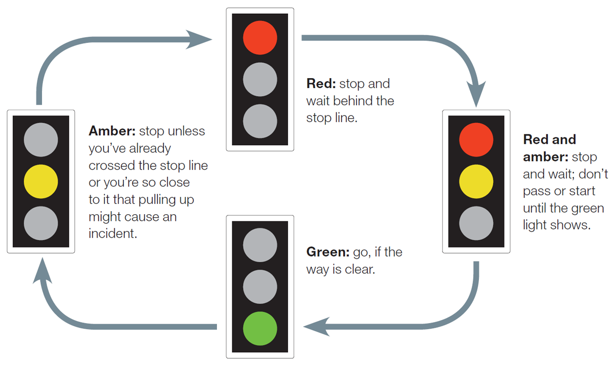
In order to create the circuit first the operation of standard traffic lights needs to be considered. In the UK, a traffic light (assuming it starts with red) will show red, then red and yellow at the same time to indicate that the light is about to turn green, the red and yellow will then turn off and the green will illuminate on its own. When returning from green to red, the green will turn off and the yellow light will illuminate on its own, before going back to red when the yellow turns off. As illustrated in Figure 1 [4] below.
Figure 1: Traffic Light Cycle Illustration
To accurately depict traffic lights in the simulation, red, yellow, and green LEDs are used for each direction. As the lights are separate in the real world, the LEDs in the simulation should be separate too, meaning that bidirectional, colour changing LEDs need not be used. For the pedestrian crossing, a bidirectional LED can be used, the simulation in this report, however, makes use of singular LEDs for continuity, and for ease of reading the schematic layout. This will also be beneficial when planning out the physical construction, as it is more cost effective to buy more of one type of LED, than to buy several types. Forward voltage for LEDs is on average between 1.8V and 4V depending on the colour and material of the LED [5]. For example, a red LED is likely to need a lower forward voltage than an amber, despite being made out of the same materials. This circuit only makes use of red (~1.8V), yellow (~2.2V) and green (~3.5V), therefore the circuit is powered by the standard 5V given by a power rail in Proteus, with 100Ω resistors in series to limit the current supplied to the LEDs.
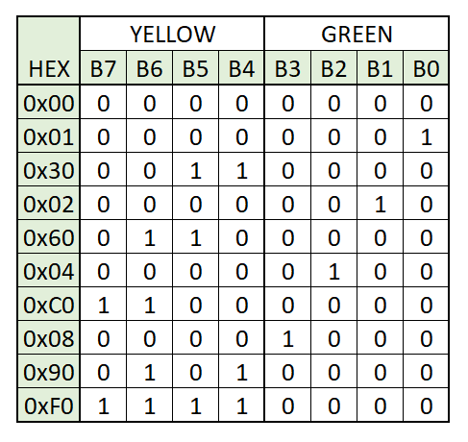
A PIC is a Peripheral Interface Controller and is a type of microcontroller, based on RISC (Reduced Instruction Set Computer) architecture that can be programmed to complete a series of operations. Peripheral comes from the fact that they were originally created to control the peripheral devices of data processing computers [6]. RISC architecture uses a smaller, more generic yet optimised set of instructions, rather than a more specialised or complex set, reducing execution time [7]. The PIC18F45K50 [8] was chosen for its high speed, number of pins and internal clock. For this assignment, multiple connections need to be made on separate pins, the 18F45K50 has forty pins and therefore enough for each task to be satisfied. The 18F24K50 has a 16KB memory and twenty-eight pins [9], compared to the 32KB and forty of the 18F45K50. The 18F25K50 [10], matches the memory at 32KB, but still only has twenty-eight pins, making itself not right for the task without additional processors being added. By having its own internal clock, an external crystal oscillator is not required, freeing up the pin connections.
Figure 2: Truth Table for Binary Output
The 7-segment display used is a common anode type. This means that the segments all share one common power source and are on by default. Therefore, setting the lines low, will allow the segments a route to ground and turn them off [11]. A common cathode is reversed, the grounds of each segment are connected and off by default with the lines needing to be set high in order to complete the circuit and turn each segment on. The circuit has two 7-segment displays in order to be able to display “10”. As the left-hand display is only used to display “0” or “1” it is able to be controlled using only two pins. The right uses binary translated into hexadecimal to display the correct digits. The truth table in Figure 2 demonstrates how these values are translated from binary. A “1” here representing an LED being illuminated and a “0” the LED being off. The port runs from bottom to top, hence why yellow is on the left and the pin numbers count down. The red LEDs on port C are controlled in the same way but spread over the eight binary positions.
Ultrasonic sensors are commonly found in vehicle parking sensors and obstacle detection systems, as well as in medical settings to produce imagery of internal organs. They create and transmit an ultrasonic soundwave using piezoelectric crystals, the reflected transmission then enters the receiver, and the sensor is able to determine the distance between the sensor and the target object based on the time taken for the signal to be received after being transmitted. The formula used is seen in Figure 3 below, where D = distance, T = time and C = the speed of sound [12]
$$D= \frac{1}{2}TC$$
Figure 3: Distance Formula
A PIR is a Passive InfraRed sensor that measures the infrared light radiating from objects in order to create a signal. In a PIR there are two sections, left and right, when one of these sections detects heat or light, it generates a positive differential between the two halves. When the subject being detected moves into the other half, this differential is then reversed, creating a negative charge. It is these changes that creates the signals that are detected [13].
An ultrasonic sensor is generally less susceptible to interference through smoke, and airborne particles, making it slightly more reliable [12].
This assignment originally asked for PIR or ultrasonic sensors to be used. However, due to the version of Proteus licensed, these sensors were unable to function. In order to complete the assignment, in their place potentiometers or variable resistors are used to simulate the presence of cars. These produce a similar analogue output to the sensors, that the PIC is then able to read. As they are not controlling anything by themselves, simply producing a high or low output, a value of 1KΩ is suitable.
This assignment is written using the C coding language, rather than Python for example, as it is able to provide a higher application speed and performance. C is a procedural programming language which is compiled, whilst Python is object orientated and interpreted [14]. C is also a lower-level language, making it better for embedded applications, as it is closer to machine level understanding. So, whilst C is objectively a more difficult language to learn, it is better for hardware applications [15], over the higher-level languages, like python.

Circuit Design
Resistors R21 through R27 are pull down resistors used to pull lines that are automatically set high down to ground so that they can be controlled with the code. Resistors R1 to R20 are current limiting resistors used to limit the current entering the LEDs and the 7-segment display from the PIC for brightness control and overcurrent protection, which can cause the LED to overheat or burnout.
There are 14 LEDs in total, comprised of four yellow, with five each of red and green to simulate the traffic lights, and for the “walk”, “don’t walk” lights for the pedestrian crossing.
Four potentiometers are connected into the circuit in order to represent the presence of a car at a particular set of lights. Providing an analogue input value into pins A0 – A3 respectively, which is then read by the PIC and informs the programme which set of lights to turn green.
Finally, there are eight push buttons which are used for the pedestrians to press to call the “crossing” function, during which all the traffic lights will turn red, and the two 7-segment displays will count down from ten. There are eight in order for there to be one either side of each road.
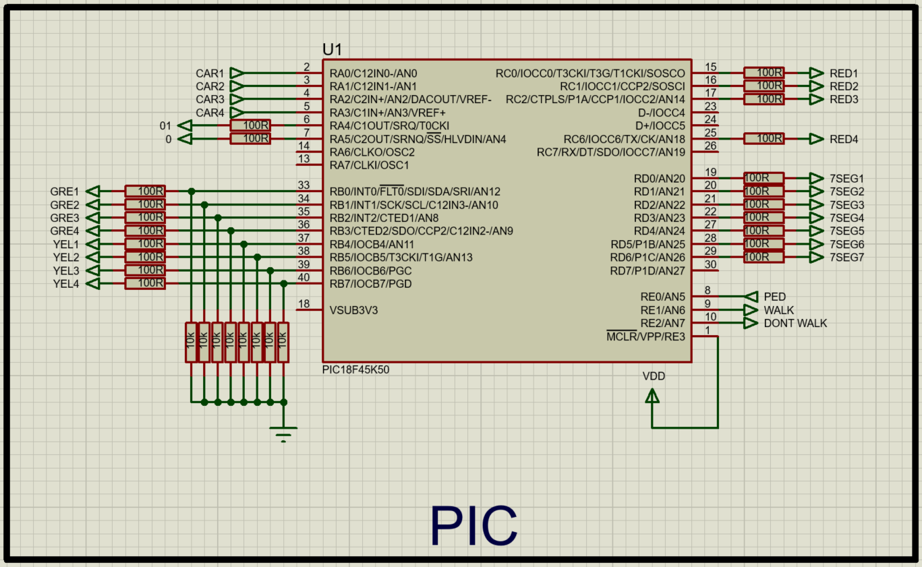
The circuit design, as shown in Figure 5 overleaf, is laid out to imitate a 4-way junction from above, in order to make it easier to read and link the potentiometers to the matching set of lights. Figure 4 and Figure 5 depict a moment where the pedestrian crossing function has been called by the pressing of one of the eight momentary buttons. Figure 4 below shows the connections for the PIC in the schematic; to make the schematic less busy and more easily readable, nets have been used for connections in place of wires.
Figure 4: PIC Connections for Schematic in Fig 5
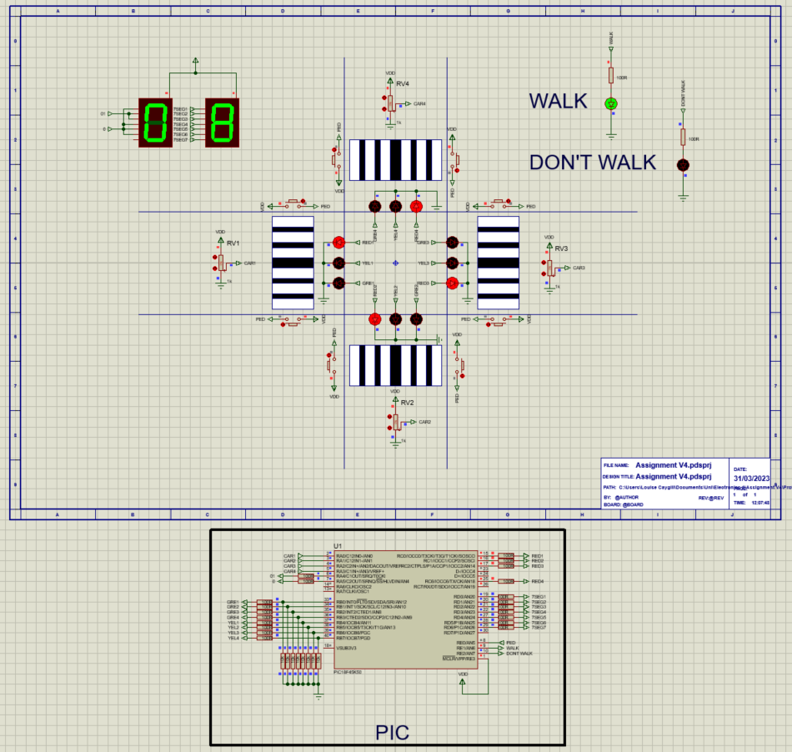
Figure 5: Schematic Layout

System Operation
The code is written as such that upon start the programme will run the default function of cycling the lights and will check if the input from the potentiometers is higher than 127. If it is, it will then run the function tied to the set of lights where the analogue input is high enough. For example, if RV1 is higher than 127, function “CAR_1” is called, and traffic light 1 is set to green whilst the rest are red for one second. If there is input from the pedestrian button (“PED”) then the function “crossing” is called. This function sets all the lights to red and counts down from 10 in 1 second intervals on the 7-segment display. Once 0 has been reached, the 7-segment turns back off, and the programme goes back to the default lights cycle.
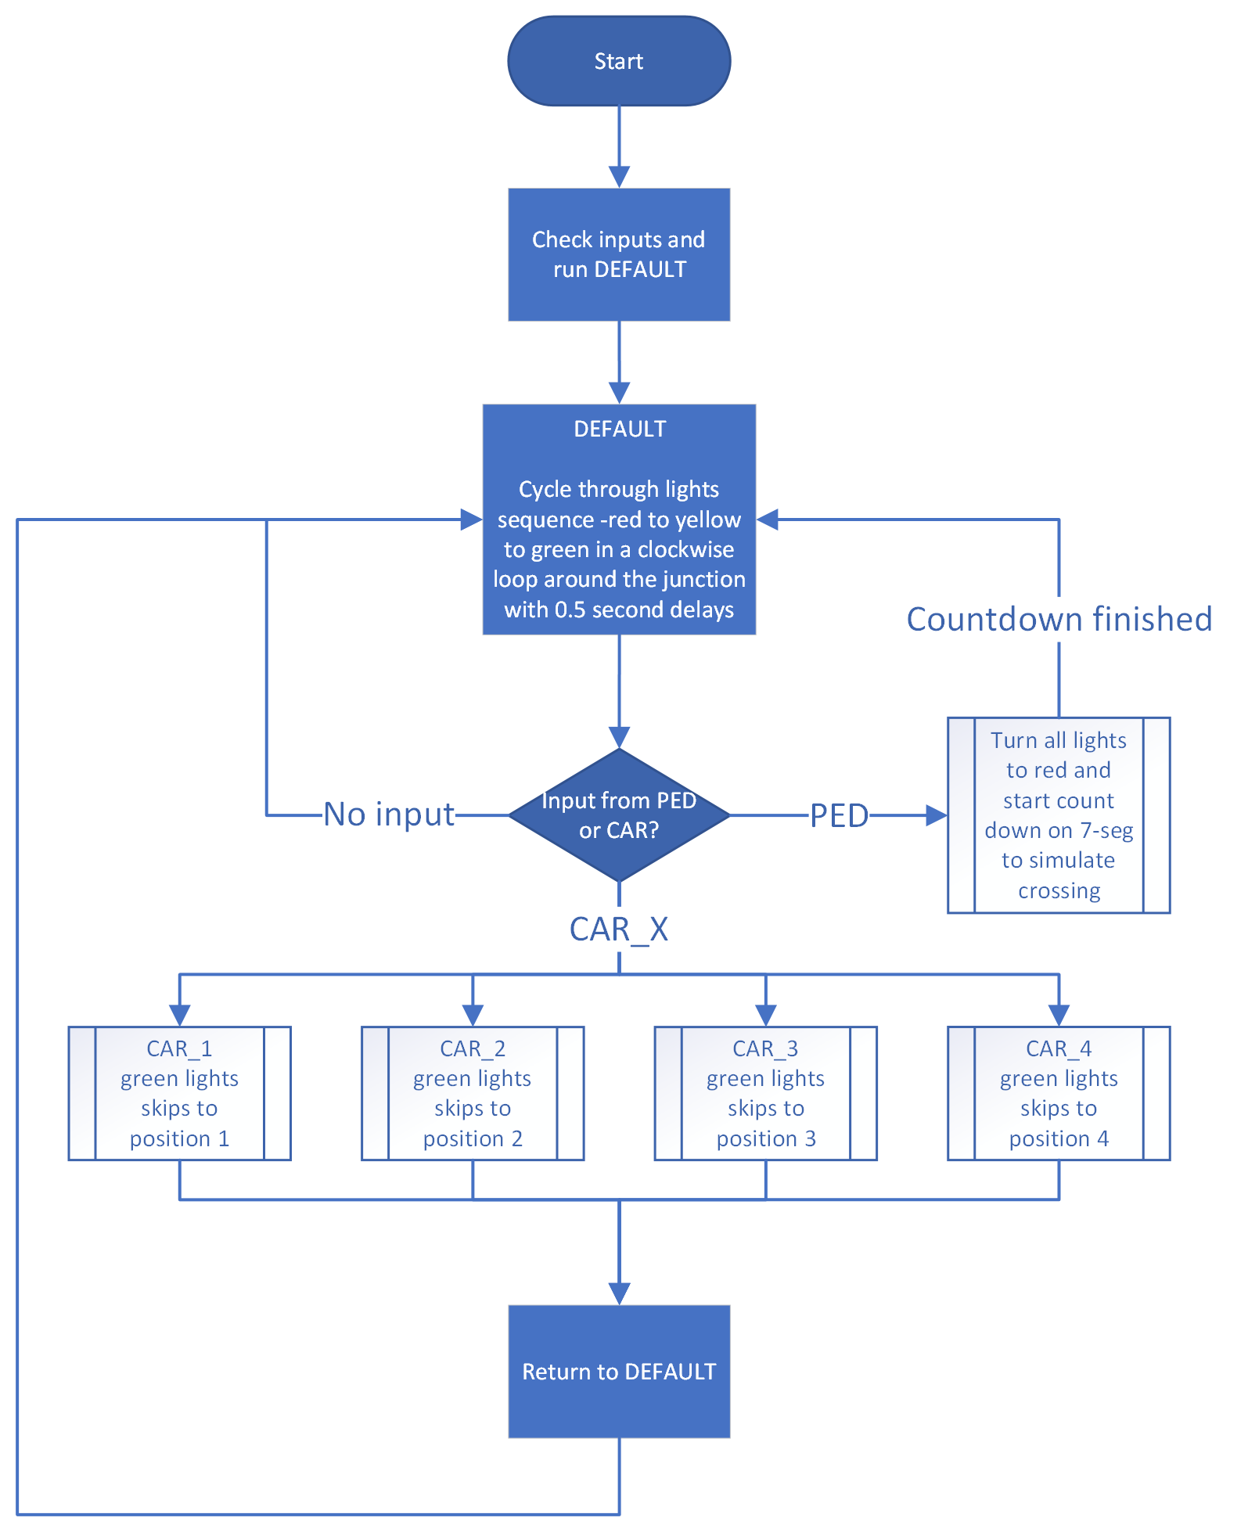
The flowchart below in Figure 6: Code Flow Chart demonstrates how the programme runs.
Figure 6: Code Flow Chart

Software and Code
This assignment was created using Proteus, version 8.14, with the compiler CCS for PIC. The main.h and main.c files were created and compiled in CCS, before being imported into Proteus. The below table holds the full code in the left-hand column, and the comments in the right hand.
Code | Comments
#include <main.h>  #define PED PIN_E0  void analog_0(void);  void analog_1(void);  void analog_2(void);  void analog_3(void);  void LIGHTS();  void CAR_1();  void CAR_2();  void CAR_3();  void CAR_4();  void CROSSING();  unsigned int traffic;  unsigned int adc_0;  unsigned int adc_1;  unsigned int adc_2;  unsigned int adc_3;  void main()  {  setup_adc_ports(sAN0 | sAN1 | sAN2 | sAN3, VSS_VDD);  setup_adc(ADC_CLOCK_INTERNAL|ADC_TAD_MUL_0);  while(TRUE)  {  analog_0();  analog_1();  analog_2();  analog_3();  if(adc_0>127)  {  while(adc_0 > 127)  {  CAR_1();  break;  }  }  if(adc_1>127)  {  while(adc_1>127)  {  CAR_2();  break;  }  }  if(adc_2 > 127)  {  while(adc_2 > 127)  {  CAR_3();  break;  }  }  if(adc_3 > 127)  {  while(adc_3 > 127)  {  CAR_4();  break;  }  }  if(!input(PED))  {  LIGHTS();  }  if(input(PED))  {  CROSSING();  }  switch(traffic)  {  case 1: output_b(0x01);  output_c(0x46);  output_high(PIN_E2);  output_low(PIN_E1);  delay_ms(500);  break;  case 2: output_b(0x30);  output_c(0x46);  output_high(PIN_E2);  output_low(PIN_E1);  delay_ms(500);  break;  case 3: output_b(0x02);  output_c(0x45);  output_high(PIN_E2);  output_low(PIN_E1);  delay_ms(500);  break;  case 4: output_b(0x60);  output_c(0x45);  output_high(PIN_E2);  output_low(PIN_E1);  delay_ms(500);  break;  case 5: output_b(0x04);  output_c(0x43);  output_high(PIN_E2);  output_low(PIN_E1);  delay_ms(500);  break;  case 6: output_b(0xC0);  output_c(0x43);  output_high(PIN_E2);  output_low(PIN_E1);  delay_ms(500);  break;  case 7: output_b(0x08);  output_c(0x07);  output_high(PIN_E2);  output_low(PIN_E1);  delay_ms(500);  break;  case 8: output_b(0x90);  output_c(0x07);  output_high(PIN_E2);  output_low(PIN_E1);  delay_ms(500);  break;  default: break;  }  }  }  void LIGHTS()  {  traffic++;  }  void CAR_1()  {  output_b(0xf0);  delay_ms(500);  output_c(0x46);  output_b(0x01);  delay_ms(1500);  }  void CAR_2()  {  output_b(0xf0);  delay_ms(500);  output_c(0x45);  output_b(0x02);  delay_ms(1500);  }  void CAR_3()  {  output_b(0xf0);  delay_ms(500);  output_c(0x43);  output_b(0x04);  delay_ms(1500);  }  void CAR_4()  {  output_b(0xf0);  delay_ms(500);  output_c(0x07);  output_b(0x08);  delay_ms(1500);  }  void CROSSING()  {  output_b(0xf0);  output_c(0x00);  delay_ms(750);  output_b(0x00);  output_c(0xff);  output_d(0x40);  output_a(0x20);  output_low(PIN_E2);  output_high(PIN_E1);  delay_ms(500);  output_d(0x10);  output_a(0x00);  delay_ms(500);  output_d(0x00);  output_a(0x00);  delay_ms(500);  output_d(0x78);  output_a(0x00);  delay_ms(500);  output_d(0x02);  output_a(0x00);  delay_ms(500);  output_d(0x12);  output_a(0x00);  delay_ms(500);  output_d(0x19);  output_a(0x00);  delay_ms(500);  output_d(0x30);  output_a(0x00);  delay_ms(500);  output_d(0x24);  output_a(0x00);  delay_ms(500);  output_d(0x79);  output_a(0x00);  delay_ms(500);  output_d(0x40);  output_a(0x00);  delay_ms(500);  output_d(0xff);  output_a(0xf0);  delay_ms(500);  }  void analog_0(void)  {  set_adc_channel(0);  delay_us(30);  adc_0 = read_adc();  }  void analog_1(void)  {  set_adc_channel(1);  delay_us(30);  adc_1 = read_adc();  }  void analog_2(void)  {  set_adc_channel(2);  delay_us(30);  adc_2 = read_adc();  }  void analog_3(void)  {  set_adc_channel(3);  delay_us(30);  adc_3 = read_adc();  } | //define global pins  //define functions  //global variables  //initialise adc channels and clock  //check for input from CAR1 - if there is a car, skip lights to set 1  //break added as program getting stuck in function when adc is under 127  //check for input from CAR2 - if there is a car, skip lights to set 2  //break added as program getting stuck in function when adc is under 127  //check for input from CAR3 - if there is a car, skip lights to set 3  //break added as program getting stuck in function when adc is under 127  //check for input from CAR4 - if there is a car, skip lights to set 4  //break added as program getting stuck in function when adc is under 127  //if statement to check for input from PED, if no input it adds to the traffic count  //check for input from PED, if there is run through the pedestrian crossing routine  //switch statement for traffic lights to cycle through when no input from CAR[X] or PED  //end of main while loop bracket  //end of main loop bracket  //functions  //cycle through lights switch  //set set 1 to green, rest to red  //set 2 to green, rest to red  //set 3 to green, rest to red  //set 4 to green, rest to red  //pedestrian crossing simulation, set all lights to red and count down from 10 on two 7-segs  //read adc channel 0  //read adc channel 1  //read adc channel 2  //read adc channel 3

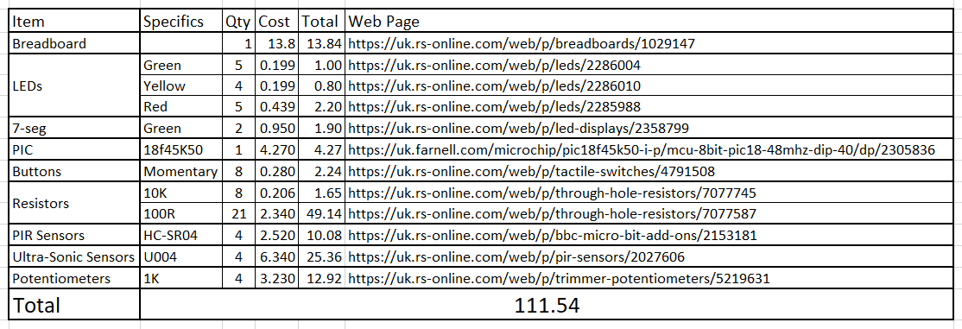
Physical Parts List
Figure 7: Parts Breakdown
The physical counterpart to the simulation includes the PIR and ultrasonic sensors which were unable to be used in the simulation, of which there will be four of each. For the PIR, a U004 by M5Stack was chosen, as it is a self-contained unit, with a +5V power source, meaning it can be run from the +5V provided by the PIC [16], [17]. However, there is a 2-second delay with this sensor, which given that this is a test circuit is acceptable. The HC-SR04 ultra-sonic sensor was chosen as it can also be powered by +5V, is widely available, inexpensive, and easy to use [18].

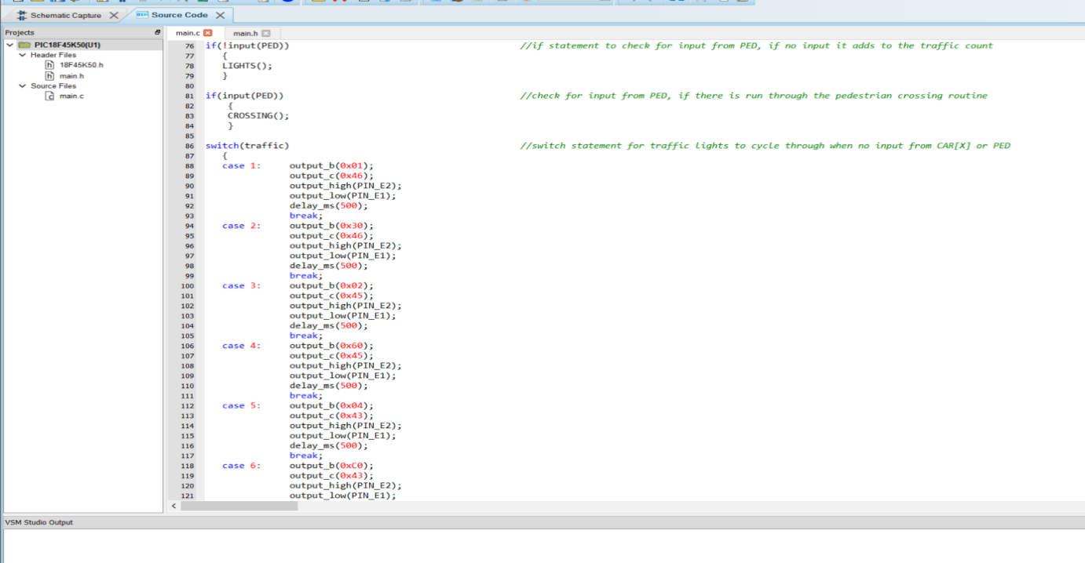
Testing and Simulation
Figure 8: Switch Statement in Code
The outputs for this assignment are largely as expected, the only issue is that when a pedestrian or car is initiated, all of the yellow lights turn on for each of the junctions before the correct green light, or the crossing function is called. This is due to the code not being able to tell which set of lights is currently green, in order to set the correct light to yellow. Figure 8 shows the switch statement that controls the default light sequence, where the lights are controlled using hexadecimal values to set specific lines of a port high. For example, output B controls the green and yellow lights, whilst the reds are run from output C. Therefore, 0x01 on port B will only illuminate one green LED, leaving the rest of the greens and yellows off.

Future Planning and Conclusion
To improve it is beneficial to use long range sensors to see how many cars are waiting at one particular junction and skip junctions with fewer cars in order to ease traffic, instead of simply requiring the presence of a few cars. A similar system could also be used for pedestrians looking to cross the road, in order to make sure that pedestrians are able to continuously cross when a certain number is reached and keep foot traffic moving [19].
As mentioned previously in the introduction, having sensors that are able to identify vehicle types or vehicle sounds will aid the response time of emergency vehicles by being able to create a clearer route by turning specific lights green [3]. This would require the implementation of long-range transmitters in emergency vehicles, plus the addition of sonic sensors that listen for sirens on the lights themselves.
Additionally, work is being undertaken to include AI (Artificial Intelligence) into traffic management [20]. This AI will learn from scenarios that it creates and find better options and adapt to the situation, as well as predicting the behaviour and actions of pedestrians and cars, to better be able to inform which lights to change or prioritise, further reducing congestion, accidents and traffic caused by traffic lights.
In conclusion, traffic lights can at times increase the amount of pollution and congestion experienced by road users, by not considering the volume of traffic from certain directions. To combat this, a smart set of traffic lights is a key component. A density-based traffic light system that is able to detect and monitor the presence of vehicles from one direction over the other is beneficial to all road users through flow management.
This report detailed the creation and testing of a virtual set of smart traffic lights, controlled by analogue inputs from potentiometers in place of ultrasonic sensors, and by momentary buttons. The components selected all proved to be suitable and fit for purpose, with the PIC18F45K50 being more than capable of performing all the operations required. The code created to run the operation performs the overall task as expected. However, there is an issue where when a pedestrian button, or car potentiometer is high, all of the yellow LEDs illuminate before the correct green or red LEDs are turned on. In the future this could be fixed by running an additional function to detect which set of lights is about to change and setting the LEDs accordingly.

Reference List
- “Traffic Lights: Need to Know”. BSM.com. [Online]. Available: https://www.bsm.co.uk/traffic-lights [Accessed Mar 31, 2023].
- E. Al-Ezaly et al. “An innovative traffic light recognition method using vehicular ad-hoc networks,” nature.com, Mar. 10, 2023. [Online]. Available: https://www.nature.com/articles/s41598-023-31107-8. [Accessed Apr 4, 2023].
- F. Reeves, “New smart traffic lights to reduce congestion - 'More efficient'”, express.co.uk. [Online]. Mar. 29, 2022. Available: https://www.express.co.uk/life-style/cars/1587656/traffic-light-changes-road-safety-warning-new-technology-ford. [Accessed March 31, 2023].
- “Traffic Lights in the UK - Meanings, Sequence & Rules for Learner Drivers,” theorytest.org. [Online]. Available: https://theorytest.org.uk/traffic-lights/ [Accessed Mar 28, 2023].
- W. Storr. “Light Emitting Diode or the LED Tutorial,” electronics-tutorials.ws. [Online]. Available: https://www.electronics-tutorials.ws/diode/diode_8.html [Accessed Apr 4, 2023].
- R. Y, "What is a PIC Microcontroller? Definition, Architecture, Advantages and Disadvantages of PIC Microcontroller," Electronicsdesk.com. [Online]. Available: https://electronicsdesk.com/pic-microcontroller.html.
- R. N. Siddiq. “What is RISC architecture?” educative.io. Available: https://www.educative.io/answers/what-is-risc-architecture [Accessed April 04 2023].
- “PIC18F45K50”. Microchip.com. [Online]. Available: https://www.microchip.com/en-us/product/PIC18F45K50 [Accessed Mar 29, 2023].
- “PIC18F24K50”. Microchip.com. [Online]. Available: https://www.microchip.com/en-us/product/PIC18F24K50 [Accessed Mar 29, 2023].
- “PIC18F25K50”. Microchip.com. [Online] Available: https://www.microchip.com/en-us/product/PIC18F25K50 [Accessed Mar 29, 2023].
- “Difference between Common Anode and Cathode seven segment display”. Engineersgarage.com. [Online] Available: https://www.engineersgarage.com/common-anode-and-cathode-7-segment-display/. [Accessed Mar 28, 2023].
- D. Jost. “What is an Ultrasonic Sensor?”. Fierceelectronics.com. Oct. 7, 2019. [Online]. Available: https://www.fierceelectronics.com/sensors/what-ultrasonic-sensor [Accessed Apr 5, 2023].
- “PIR Motion Sensor”. Learn.adafruit.com [Online]. Available: https://learn.adafruit.com/pir-passive-infrared-proximity-motion-sensor/how-pirs-work [Accessed Apr 5, 2023].
- “Difference Between C and Python”. Interviewbit.com. Apr. 10, 2023. [Online]. Available: https://www.interviewbit.com/blog/difference-between-c-and-python/ [Accessed Apr 12, 2023].
- P. Pedamkar, "C vs Python | 10 Most Valuable Differences You Should Know," educba.com. [Online]. Available: https://www.educba.com/c-vs-python/. [Accessed Apr 12, 2023]
- “PIR Motion Sensor - M5Stack”. Mouser.com. [Online] Available: https://www.mouser.co.uk/new/m5stack/m5stack-pir-motion-sensor/ [Accessed Apr 5, 2023].
- “PIR”. Docs.m5stack.com. [Online]. Available: https://docs.m5stack.com/en/unit/pir [Accessed Apr 5, 2023]
- "Complete Guide for Ultrasonic Sensor HC-SR04 with Arduino”. Randomnerdtutorials.com. [Online]. Available: https://randomnerdtutorials.com/complete-guide-for-ultrasonic-sensor-hc-sr04/ [Accessed Apr 5, 2023]
- K. Ahuja. “SMART TRAFFIC LIGHTS SIGNAL FEWER STOPS FOR MOTORISTS”. Driving.co.uk. Apr 7, 2021. [Online]. Available: https://www.driving.co.uk/news/roads/smart-traffic-lights-fewer-stops-motorists/. [Accessed Apr 4 2023].
- "AI traffic light system could make traffic jams a distant memory | Aston University,". Aston.ac.uk. May 10, 2022. [Online]. Available: https://www.aston.ac.uk/latest-news/ai-traffic-light-system-could-make-traffic-jams-distant-memory-0 [Accessed Apr 4, 2023].

