Using GIS to show the relevance of C-difficile comparison of area and GP practice.
By Christine Woods.

Supervisor: Beverley Holland
Second Marker: Gaynor Thomas

Project submitted as part of the requirements for the award of BSc (Hons) Computing (Computer data and information systems.)

April 2022

UWTSD – B Holland
Christine Woods 1704446
Declaration by Christine Woods

The work of this report has been completed under the supervision of University Wales Trinity St David. I declare that this report is the product of my own work and is not being submitted for any other degree etc.



ABSTRACT

Swansea Bay Health Board is continually looking for ways to develop understanding around prescribing within the community.
The over prescribing of antibiotics [1] has been at the forefront of ongoing investigation between the Health Board and prescribers within Primary Care.
The association of C-difficile and antibiotic prescribing is widely known whilst the understanding behind the correlation of the two needs to be presented for information, education and training purposes to GP cluster personnel.
In order for understanding to be simplified visualisations can show a picture of events that are easy to follow whilst being informative. Geographical Information Systems are a way of showing disease prevalence whilst giving the added benefit of overlaying factual information to supply visualisations that are easy to understand and can be manipulated depending on the findings.
In order to produce a dashboard, different application tools were trialled with a set of aims and objectives to achieve the building of a visualisation that could be used by the Medicines Management team. Given that at the beginning of the project there was nothing in place to show where C-difficile cases were and if there were any patterns or trends which correlated with prescribing any form of dashboard would be progression.
Once the application was chosen (Tableau), the data used had been collected and whilst informative was not robust and required deep cleansing before use.
There was a certain level of expectation for the results although during previous attempts to pull together data sets for analysis had shown that expected outcomes did not come to fruition.
Using methodology suited to the project the dashboard built went under continual review often being adapted to allow for user input.
The dashboard showed areas of disease with an overlay of hotspots of C-difficile cases. Whilst being informative it threw more questions than answers at the user. Trends are seen in areas but this may be due to caveats such as built up areas where prescribing would be expected to be higher or in areas where there is high deprivation where again prescribing would be expected to be higher. This however is a success, by giving these results is has encouraged further questioning and delving into the data.
The use of a dashboard should be informative but also to highlight areas that could be of concern or that need to be reviewed.
By producing a visualisation that uses data that is not robust it has encouraged departments to work together by sharing data and producing a high end data set that can be used to build a dashboard that reflects a true picture.
The project is still on going and will be used within the Medicines Management team as intended. Currently just showing the C-difficile cases within the health board over a given period has initiated discussions of trends and which areas require investigation.

Contents
ABSTRACT 3
CHAPTER 1 - INTRODUCTION 6
1.1 What is Clostridium difficile and how does it affect Swansea Bay University Health Board? 6
1.2 The aims and objectives of the project. 7
1.3 Project expectation 7
CHAPTER 2 - RESEARCH & REVIEW OF LITERATURE 8
2.1 C-difficile 8
2.1.1 History of C-difficile 8
2.1.2 Where does C-difficile come from and what are the affects? 9
2.1.3 How is C-difficile disease contracted? 9
2.1.4 Risk factors 9
2.1.5 Treatment 10
2.1.6 C-difficile in the primary care setting 10
2.1.7 How to tackle cases within primary care 10
2.1.8 What have Health Boards in Wales done? 10
2.1.9 What are SBUHB doing? 12
2.1.10 Historical overview 12
2.2 Visualisation systems 14
2.2.1 Visualisation requirements 14
2.2.2 Data requirements 14
2.2.3 System requirements 15
2.3 Previous studies 15
2.3.1 GIS 15
2.3.2 Tableau 23
CHAPTER 3 - DEVELOPMENT METHODOLOGY 25
3.1 Research 25
3.2 Development Method 28
CHAPTER 4 - DESIGN & IMPLEMENTATION 30
4.1 Design (data) 30
4.2 Data required 31
CHAPTER 5 – EVALUATION 37
CHAPTER 6 - CONCLUSIONS AND RECOMMENDATIONS 39
6.1 Conclusion 39
Recommendations 40
CHAPTER 7 – REFLECTION 41
CHAPTER 8 – REFERENCES 43
CHAPTER 9 – Bibliography 45
APPENDICES 46

Table of figures

Figure 1 - SBUHB monthly numbers of C.difficile by location type (Apr10-May21) 6
Figure 2 Discovery Cycle of C-difficile 8
Figure 3 Wales Health Board Antibacterial Items per 1000 STAR PU (13) trend 11
Figure 4 SBU IT Portal dashboard availability 13
Figure 5 Use of themes show population. The use of icon + size showing clinic visits 16
Figure 6 Potential spatial accessibility index. 17
Figure 7 Clinic area with potential spatial accessibility 18
Figure 8 Swansea Bay highlighting MMR uptake, GP practice belonging to 2 clusters. 19
Figure 9 Interactive Tableau Dashboard – showing prescribing by Cluster, Practice and Prescriber 23
Figure 10 Interactive Tableau Dashboard – showing the usage of BNF medicines 23
Figure 11 Interactive Tableau Dashboard showing which 4C Antibacterials were prescribed and by which prescriber 24
Figure 12 Project Phases 29
Figure 13 Initial spreadsheet column headings 30
Figure 14 Request sent to information department 31
Figure 15 Main 4C includes more than 4 drugs as shown above. 32
Figure 16 Map showing C-difficile cases with over lay of prescribing history 34
Figure 17 Depth of colour on area to show high prescribing 36
Figure 18 - Tableau dashboard 37
Figure 19 Design showing prescribing and cases of disease 41

CHAPTER 1 - INTRODUCTION

1.1 What is Clostridium difficile and how does it affect Swansea Bay University Health Board?

Clostridium difficile [1] (also known as C.difficile or C.diff) cases in Swansea Bay University Health Board (SBUHB) [2] have risen during previous years. The Health Board has a dedicated team tackling the increase in reported C-difficile cases. C-difficile is associated with the prescribing of antibiotics, by analysing the prescribing data the Health Board can identify areas of usage that may have contributed to this.
The team introduced a set of restrictive antibiotic guidelines in June 2018 which significantly reduced the number of C. difficile cases for in-patient cases. The number of out-patient cases increased (as shown in Chart 1 below).
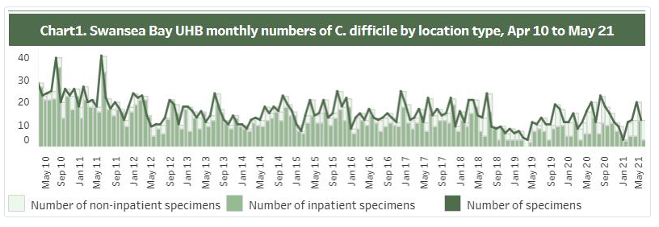
Figure 1 - SBUHB monthly numbers of C.difficile by location type (Apr10-May21)

1.2 The aims and objectives of the project.

There is a clear aim for the project with a number of objectives that will be completed to ensure that the project is completed fully
- The aim
The aim is to explore Geographical Information systems and other dashboard software and how these can better highlight and help SBUHB to analysis and explore prescribing data within the Health Board highlighting areas of concern where C-difficile cases are found within Primary Care.
- Objective 1
The main objective is to provide mapping visualisations of SBUHB that highlights any clusters of cases with relevant information that can be drilled down in the hope that patterns between cases of C-difficile and GP practice prescribing can be seen.
- Objective 2
To use and compare various software types to provide maps highlighting clusters of interest whilst overlaying prescribing information to ascertain if there are any patterns which will lead to intervention.
- Objective 3
Use the chosen software to investigate prescribing patterns along with cases of infection to give an educated over view of disease prevalence highlighting areas that need to be targeted.

1.3 Project expectation

The project will set out to find relevant data that provides up to date information that can be easily updated. This data will be used to provide understandable visualisations easily identifying areas of concern. A layer of prescribing information will give the ability for users to drill down into the information for investigation purposes.
Three applications will be used to highlight the benefits of each source to ensure system efficiency.
- Tableau [3] – analytics platform
- MapInfo Pro [4] – complete solution
- Microsoft Excel – data collection and cleansing
During the project life cycle the reader will gain understanding of C-difficile and how it affects patients and the wider population. Implementation of applications using meaningful data will highlight areas for the antimicrobial team to concentrate on. An over view of the applications used will be included to ascertain which system should be used for continual data source for future investigations.
The next section will discuss areas of research and literature highlighting material that shows previous studies for this topic.

CHAPTER 2 - RESEARCH & REVIEW OF LITERATURE

Pharmacy Medicines Management Department has a direct link to Primary Care prescribing, the department constantly monitors prescribing of drugs along with disease prevalence and how it may be reduced. There is a team in place that monitors Antimicrobials prescribing within hospitals and primary care settings. On review of infection rates the department reviews the data which leads to education, training and reporting. By finding correlations between disease rates and prescribing rates interventions can be put in place to reduce the rates of prescribing which will lead to lower infection rates.
This section will set out to discuss what C-difficile is. How it affects the public and what the Health Board is trying to do about it.
Systems for analysis and reporting will be discussed.
Literature reviews will be carried out to find out if there have been studies around C-difficile areas and Primary Care prescribing, similarly literature views will discuss previous studies around systems used to best highlight these areas.

2.1 C-difficile

Background of C-difficile, what it is, where it comes from and how to manage it.

2.1.1 History of C-difficile

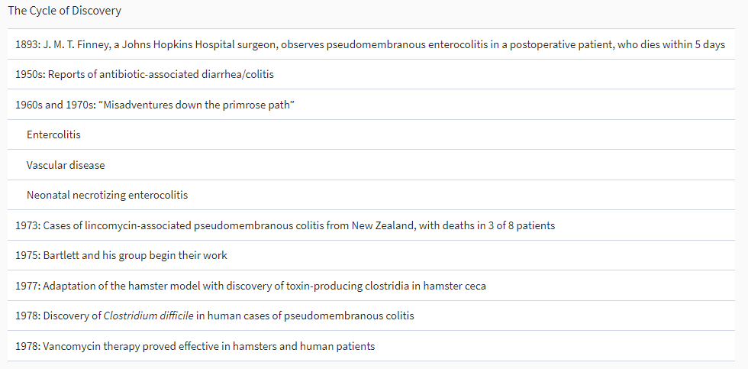
Figure 2 Discovery Cycle of C-difficile
As can be seen in the Table above C-difficile infection discovery is dated as far back as 1893. John Bartlett started investigations into Clostridium Difficile antibiotic associated diarrhea (CDAD) and pseudomembranous colitis in 1975 [5] in which time extensive investigations were carried out. By 1989 he had discovered everything about this disease and the subsequent illness that it causes. This disease has also been named as the leading cause in hospital associated infections.

2.1.2 Where does C-difficile come from and what are the affects?

C-difficile naturally occurs in the gut. When this is found and is at normal levels it is not thought to be an infection. It is not only found in humans but also in animals. It is called “difficile” as this is the French word meaning “difficult”. Aptly named as it is not easy to grow in laboratory conditions.
Poisons are formed by some of the bacteria, it is these toxins that can give the host severe diarrhea along with Colitis (inflamed colon). Patients may also suffer from a raised temperature, stomach pain, loss of appetite and feeling nauseous.
There is a link between the disease and long term antibiotic usage as the normal bacteria found in the gut is reduced and can trigger C-diff growth that is found in the intestine.
Statistics show that [6]
About 1 in 6 patients who get C. diff will get it again in the subsequent 2-8 weeks.
One in 11 people over age 65 diagnosed with a healthcare-associated C. diff infection die within one month.

2.1.3 How is C-difficile disease contracted?

The bacteria found in C-difficile is passed in faeces which can then be spread. The lack of hand washing has been identified as one of the main reasons this bacteria is spread [7]. Once the bacteria are transferred onto another object it can last for a lengthy period (weeks, even months) and can then be digested by anyone that may come into contact with it.
1 in 30 healthy adults have C-difficile bacteria within their system with no symptoms of illness and are unaware that they are a carrier.

2.1.4 Risk factors

Anyone can contract C-difficile symptoms can vary between patients. There is a higher chance of contracting the disease for the >65, patients that have previously been in hospital or care homes (especially those that have been in for a lengthy period) and patients that have recently been on broad spectrum antibiotics [8], more than one type at the same time, or long term antibiotics.
It also effects those that have underlying health conditions such as bowl disease, kidney disease or cancer. Those that have weakened immune systems have a bigger risk i.e. patients having chemotherapy or those taking steroids.
Those patients that are prescribed Proton Pump Inhibitors (used to reduce the amount of stomach acid produced) are also within the higher risk category.

2.1.5 Treatment

There are several treatments once diagnosis has been made [6]. Segregation if within a hospital environment, stopping antibiotics already being taken, course of antibiotics known to kill the bacteria, surgery to remove infection bowel area (rare).
Treatment response can be 2 weeks for a full recovery although disease often returns within 1-5 cases where follow up treatment will be required.
A person with the disease is classed as still being infectious 48 hours after symptoms have cleared.
There are over 600 strains of C.difficile identified by Ribotyping [8] some of which are difficult to treat.

2.1.6 C-difficile in the primary care setting

The rise in out-patient cases has shown that there is a significant need to address prevention within Primary Care settings.
Numerous projects across Wales were introduced following funding given by The Welsh Government [9]to Health Boards with high C-difficile rates with the aim to reduce healthcare associated infection rates. Swansea Bay Health Board put a specific team in place with the aim of educating the public. Using different methods such as focus groups, discussions with all prescribers around prescribing habits, multi-disciplinary working, holding events, putting videos and material together, advertising, updating guidelines, engaging with community pharmacy, long standing campaign running etc. and the rates were reduced over a 3-year period.

2.1.7 How to tackle cases within primary care

If this was an easy thing to do it would have been completed by now. Professionals have been trying to find ways to reduce infection rates and although there is a difference the rates are still not as low as they should be.
By providing analysis with easy to understand dashboards the idea is that the findings will direct further engagement with hard facts to show what needs to be done and where.

2.1.8 What have Health Boards in Wales done?

There are 7 Health boards in Wales each of which tackles infection rates differently but all adhere to the same action plan “Tackling antimicrobial resistance 2019-2024” produced by the government [10].
There is an abundance of web sites & initiatives monitoring and tackling antimicrobial resistance. In an approach to standardize data collection, interpretation and sharing, GLASS (Global Antimicrobial Resistance and Use Surveillance System) [11] was formed.
The Welsh health Circular [12] published a paper “AMR improvement goals and HCAI reduction expectations by March 2019: Primary and Secondary Care antimicrobial prescribing goals: C-difficile, S Aureus bacteremias and gram negative bacteremias”. The introduction is as follows
“Antimicrobial Resistance (AMR) is one of the greatest threats to human and animal health. O’Neill estimated that globally by 2050, 10 million or more deaths may be attributable to AMR if no action is taken, overshadowing other causes of death such as cancer and road traffic accidents. Antimicrobial resistance already imposes a significant burden of morbidity and mortality on the population of Wales through the failure of empiric antibiotic treatment of infections, and the spread of difficult-to-treat multi-drug resistant organisms.”
“Key drivers of AMR Antimicrobial resistance are antimicrobial usage, burden of disease and transmission of resistance.”
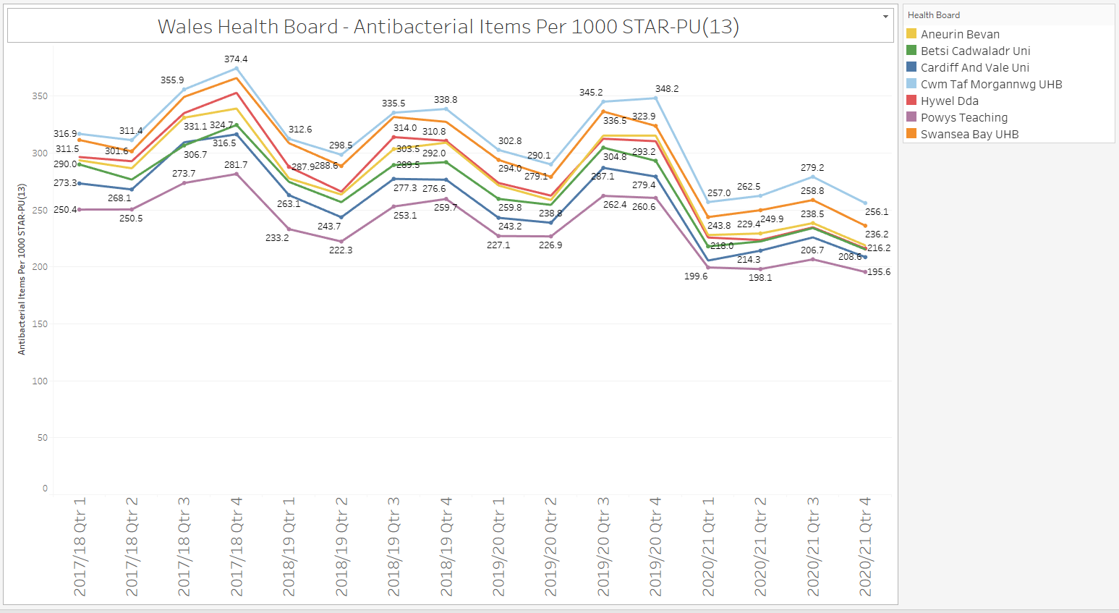
Figure 3 Wales Health Board Antibacterial Items per 1000 STAR PU (13) trend
(Star-PU is an adjusted rate that removes confounding effects of age and sex in the comparison of prescribing between geographical areas.)

In August 2019 Betsi Cadwaladr University Health Board reported a 38.7% reduction in C-difficile cases within Primary Care following initiatives put into place to cut antibiotic prescribing [13].
By reducing their antibiotic prescribing by 12.6% this resulted in nearly 40% reduction in C-difficile cases within Primary Care (reduction reported as 271 cases in 2017/2018 to 166 in 2018/2019). It also reports the health board saved £185,000 due to this decrease.
Swansea Bay Health Board have continued to second highest for the last 2 years although C-difficile cases show a 19.79% decrease between Apr 19-Mar 20 & Apr 20 –Mar 21.

Looking at these astounding figures it begs the question of how is this information recorded? Is it recorded in the same way by each health board? If not, then is there a chance that information is being missed/not collected? What are the caveats? In order to maintain accurate statistics there will be the need to ascertain how each case is recorded.

2.1.9 What are SBUHB doing?

Swansea Bay health board are finding new innovative ways to capture and display data. Dashboards are being used as an investigative tool for viewing up to date data that paints a picture. Having the ability to drill down into the data whilst changing visualisations assists when questions are asked and gives an immediate answer. Previously if a question arose it would take time to retrieve the required information and make a visual. Now at the click of a button a question can be turned into a visualisation.
With prescribing data laid on top of incident data many questions can be answered. It can assist in change, intervention and learning. Periodical data can also show change and its effects.
Data collection for C-difficile in SBU has not been cleansed and is currently being collected on various spreadsheets. This is not efficient and gives room for error.

2.1.10 Historical overview

How do we learn? How are decisions made using data?
Data is only as good as the way it is used to portray information. Technology has moved on at such a rate that whereas before we would use outcomes to review performance we can now predict the future by using historical data.
Not everyone can look at a visualisation and understand it. It needs to be fit for purpose ensuring that it is understandable.
Historically Health Boards across the country have collected data in excel sheets that have been overloaded with data whether it has been of use or not. Pulling out required data can then be laborious.
Data extracted showing change over time periods can easily identify how previous decisions have affected outcomes and can then be used to inform future decisions. With the addition of visualisations that show these changes easily there is a much better understanding of what has happened and how to change the course of actions for future changes.
Data mining, data capture and useful visualisations have become a resource that any given project cannot be without and is used by all departments’ not just clinical ones. Looking on the SBU Intranet Site there are a number of dashboards that are for everyone to view
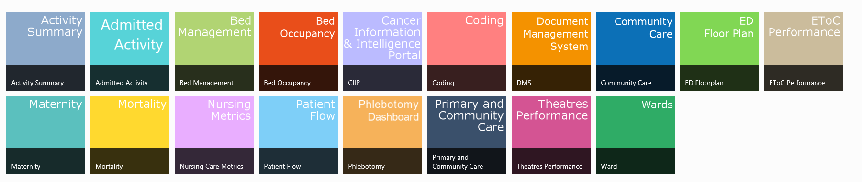
Figure 4 SBU IT Portal dashboard availability
On review of these dashboards there is more than one application used.

2.2 Visualisation systems

There are numerous applications that can be used to provide analysis and visualisations that highlight areas of interest. This project will use two of the main systems
- Tableau
- Map Info Pro
Both systems have Geographical Mapping abilities that will allow data to be drilled down to encourage further discussions.
Both provide excellent mapping features but differ in the way that they are used. Medicines Management currently use Tableau as its main statistical application. Map-Pro is used at the local University for training students. The two system will be used and analysed on a number of features.

2.2.1 Visualisation requirements

There is currently no visual data that shows correlation between C-difficile cases in Primary Care and the Prescribing in Primary Care. Having monthly/quarterly information that may be shared by user groups will assist in knowledge, understanding and assist with decision making.
The system should have
- Easy to understand visualisations
- Filters for period details to show change over time
- Filters to show prescribing data within a given area/GP practice.
- Themes should highlight required areas and correlations of concern
- Identification of areas within the Health Board and GP practice
- Mapping visualisation should show relevant areas with the design being of use to the user
- Information overlay – prescribing data will be required when mouse is hovered over area along with practice details and C-difficile counts

2.2.2 Data requirements

- Collection of data will need to be determined along with the most functional way to cleanse the data to ensure that going forward this is completely in the most time effective manner.
- Data update should also be easy to maintain; transferal of monthly/quarterly data requirements need to be assessed.
- Prescribing data required in sync with area
- Required data source is needed for C-difficile cases due to current data input coming from manually updated excel spreadsheet. Going forward talks have been provoked to ensure that the required data set will be available for future analysis.

2.2.3 System requirements

- Both application (Tableau & MapPro) should be compared to ensure the chosen application is visually correct, easy to use, easy to update and cost effective
- The system needs to be easily accessible by users within the Health Board
- The system needs to be easily accessible by users outside of the Health Board to ensure information can be shared easily (or have a way to translate data for sharing)

The following chapter will discuss previous research carried out that shows for and against the use of GIS in making informative Health Care decisions.

2.3 Previous studies

2.3.1 GIS
When has GIS been successful for making health care decisions? Why has it proven to be so successful?
An article “Using a GIS to support the spatial reorganization of outpatient care services delivery in Italy” published in November 2018 [14] discusses how spatial statistics were used to provide evidence based statistics that assisted in the reorganization of Health Care.
By providing real time measures with required variables the future of the service could be calculated and the required changes for the service could be shown.
This resulted with three strategies showing areas of interest for new resources whilst maintaining patient care.
Having evidence based information shows facts rather than suggestion without result. The stake holders are given the advantage of actual results rather than a suggested one.
The use of GIS within epidemiology shows how locational information along with disease statistics can simulate relationships within time and space.
This would be massively beneficial to use within the C-difficile study. Being able to show the disease uptake over a given period alongside the locational information as-well as prescribing history could give an historical picture of where the disease is, how it has changed and how prescribing measures has effected it. With this information the hope would be that changes in some of these findings would also have a change on disease impact.
The article goes on to discuss how spatial data shows how services are distributed and with an in depth understanding of how services must continue to be of a high standard, change can impact both delivery and efficiency.
By using demand and supply processes alongside area, (3 main divisions of size were used) calculations were performed to provide the ranges and averages used for analysis. Travel distance was calculated using the mean, minimum and maximum travel times.
As shown in figure 0-4 below the use of themes with icons plus size easily established the population sizes and number of clinics visited within a given period. It allows for a visualisation that shows information that would otherwise be figures on a page.
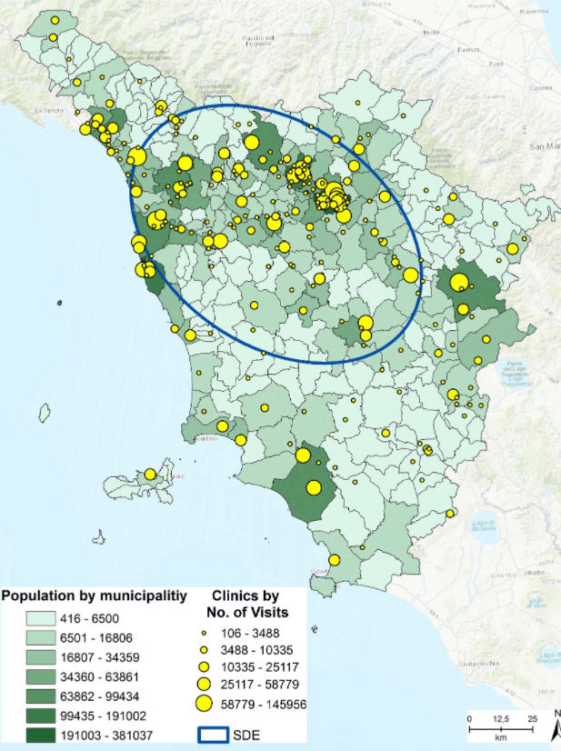
Figure 5 Use of themes show population. The use of icon + size showing clinic visits
Showing the current population size with the amount of clinic visits gives the current situation. To find the potential area for future clinics requires a different visualisation as shown below.
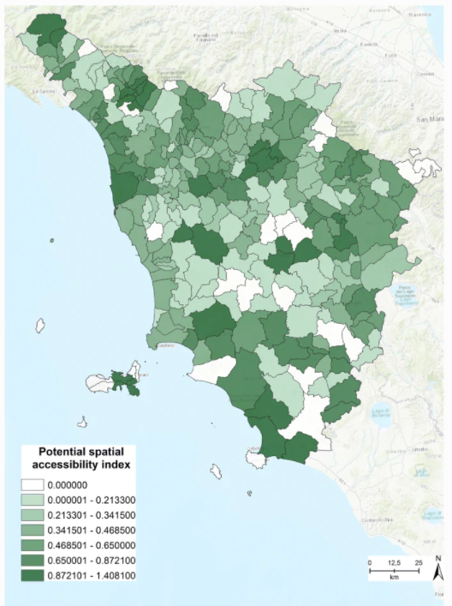
Figure 6 Potential spatial accessibility index.
The user can easily identify the most accessible clinic area for potential service changes.

With both of these visuals in mind the question was to find the best potential area with the highest clinic visit rate. The below figure provides evidence to show this which leads to managerial decision making.
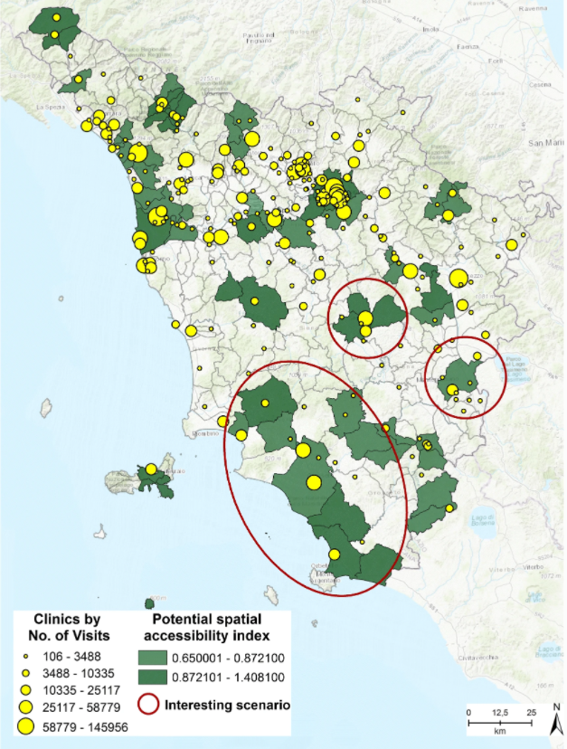
Figure 7 Clinic area with potential spatial accessibility
The article led to three scenarios used for this decision making.

A previous study completed by C Woods “Graphical Information Systems: Geodemographic analysis using GIS software” [15] shows how layers of information can lead to a better understanding of the data. The project looked of the low uptake of the MMR (measles, Mumps and Rubella immunization) during 2003/2004. Using certain criteria, the mapping showed if there were reasons for this such as deprivation, demographics, behavioral etc.
By showing the correlations between the given variables it gave an insight into how communities behave and shows if there are particular reasons for this.
For example, by overlaying GP practices and highlighting particular clusters with information also showing the uptake of vaccine
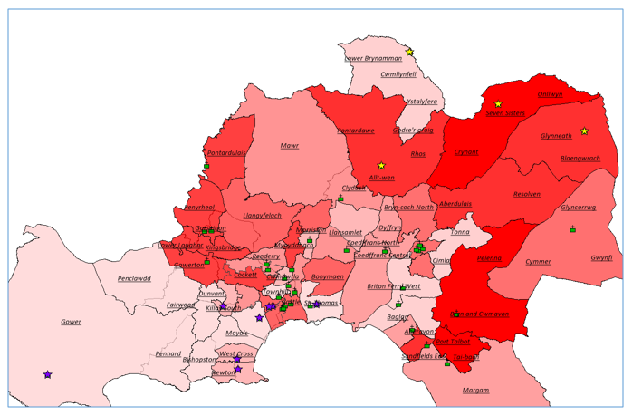
Figure 8 Swansea Bay highlighting MMR uptake, GP practice belonging to 2 clusters.
This visualisation started conversations about how clusters interact with their patients? Did they do anything in particular at this time to encourage vaccinations? If so, what did they do? How has this helped? Could this be used for discussions with other clusters that did not have such a high uptake?
As with most data more questions are produced than answered but this is how investigation and learning begins.
In the case of C-difficile there are a number of questions that need answering, is C-difficile in the community in particular areas? Has it changed over time? Are certain clusters behaving differently to others? And if so, what are they doing differently? Due to Covid has there been an increase in cases and could this be because of non-face to face appointments? No doubt many other questions will follow.

The aim of this study is to increase awareness of the importance of implementing a comprehensive geographical health information infrastructure, to support policy makers and healthcare managers with evidence-based solutions for the provision of health care services related to the needs

The overall aim (as stated above) when accompanied with related research concluded that GIS software is a valued tool when supporting the health care sector in decision making.
The results showed recommendation for the use of GIS when making informed decisions and showed the advantages of its use when tackling challenges of providing better health care whilst still maintaining a high standard of service. The report shows recognition that GIS is a valued tool, supporting decision making for mapping distribution of needs.
A more recent study [15] “Leveraging GIS and spatial analysis for informed decision-making in COVID-19 pandemic” discusses how GIS was used to understand spatial clustering and transmission trends of Covid-19 which inevitably led to decision making for slowing disease transmission.
The opening paragraph of the study mentions that GIS has been used in one way or another across scientific disciplines for some time, going back as far as the mid-1960. This highlights that although it may not have been at the forefront of decision making and analysis as it is now that it was still a relied upon source even then.
The use of GIS and the tracking of cases easily bought light to the significance of the disease and its impact. Different levels of GIS showed global changes along with local changes to show the impact on countries, regions, cities and villages.
Correlations were seen between different factors such as
- Temperatures
- Wind speed
- Solar radiation
- Daylight hours
- Humidity
The above list was not exhaustive, a number of related studies looked at different areas which highlighted different results i.e. vulnerable groups which was informative when deciding which areas needed to be targeted first. It also highlighted areas of fast responders which could be used in a different manor.
Whatever the result and however used, spatial data was the required provision.
The usefulness of GIS software has been shown in the previous two literature reviews but which system should be used. With various systems available how does the user know which one will best suit their needs?
The college of Arts and Sciences in Malaysia completed a report that looked at exactly this [16]. By looking at 4 different systems and reviewing some of the main features it could be determined which system would be most likely the best to use:
- Functionality
- Cost
- User-friendliness or usability
- Effectiveness
- Efficient
- Error tolerant
- Learnability
- Satisfying
- Consistency
By comparing these a set of principles can be shaped that can then be translated into a set of requirements with measures that can assist in selection of GIS packages.
Looking at the software packages strengths and limitations the requirements were easily identifiable.
For example, one of the suggested packages limitations showed that the clipping of images was time consuming and often had erroneous results – this would mean double checking the results with no faith in the visualisations. It would also mean that one of the most important features “The Visualisations” take time to arrange. As discussed by Calovi, M. & Seghieri, C. [14] the themes in GIS allow the user to highlight areas of interest when using spatial referencing, having laborious image limitations surely defeats the object?
Of course the software needs to have good functionality. There would be no point in having a system that could only integrate with one set of data i.e. it could show an area on a map but not have the ability to overlay other information. There are many components required to have a functional system
- A computer (Hardware)
- Software package
- Usability information (Data)
- People
- Method
The cost is a significant factor when choosing a system. Cheaper may not always be best as it may not have the required ability whereas a system that is higher in price may not be affordable.
What if the system has bad consistency? I.e. data structure must have a set of pre-established rules to ensure that the structure is maintainable and usable. Accurate data will depend on its source and will require constant development to ensure continued improvement.
Usability functions (user friendliness) is considered to be one of the main issues when using GIS as discussed by Ezekiel Mwangi et al. [17] and can often determine its success or failure. Usability functions set out by Jacob Nielson [18] compile of 5 main components
- Learnability
- Efficiency
- Memorability
- Errors
- Satisfaction
Each of which measures the system functionality and improvement for ease of use. These components are great for normal features of a system although GIS is more web dependent and therefore would require more than content, satisfaction and interaction review. With this in mind Ezekiel Mwangi et al. [17] included a list of website usability elements [19]
− Interactivity
− Personalization
− Privacy,
− Security content
− Learnability
− Design structure
− Navigation
− Performance, and
− Memorability
- Accessibility
- Interactivity
- Personalization
- Privacy
- Security content
- Learnability
- Design structure
- Navigation
- Performance
- Memorability
Using these usability features the findings were that systems were not made for novice users and that it was a pre determination that the user would have an ability rate beyond this. The consideration of web ability along with application ability should be taken into account when determining the use of a system. It also concluded that the system should be assessed on functionality of the system but also on the usability and the need for further research on the relationship between the elements and the importance of usability.
On review of the literature it has shown how important GIS is, how the functionality is used for business decision making, what is expected of a system and how the choices and inclusion of determinate application software should be made. It shows that the literature reviews are in favour of GIS but there are a number of aspects that need to be considered to ensure that the system makes good business sense.
The next section will look at the development methodology – it will determine which structured process/methodology will be used and why.

2.3.2 Tableau

Preliminary studies carried out by C Woods [15]“Investigating how to achieve better GP Practice participation in information with visualisation and overview” show how Tableau was used to inform practitioners about their prescribing using interactive dashboards which highlight drug use by Clusters, Practices and prescribers. For the purpose of the project report all data was anonymised.
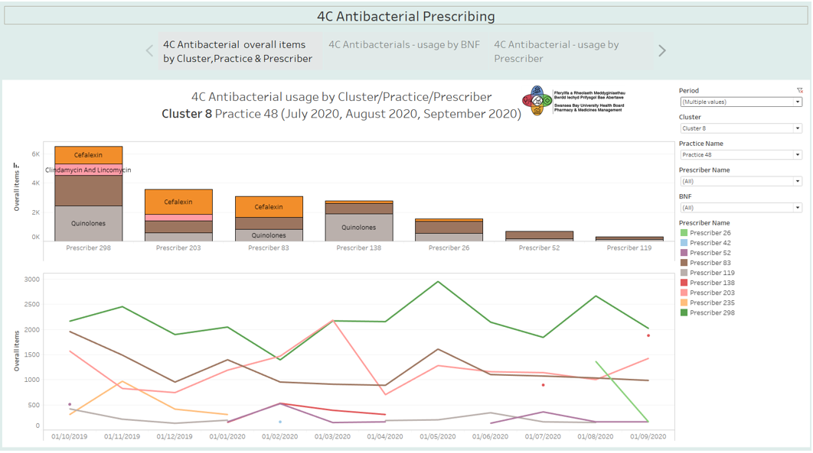
Figure 9 Interactive Tableau Dashboard – showing prescribing by Cluster, Practice and Prescriber
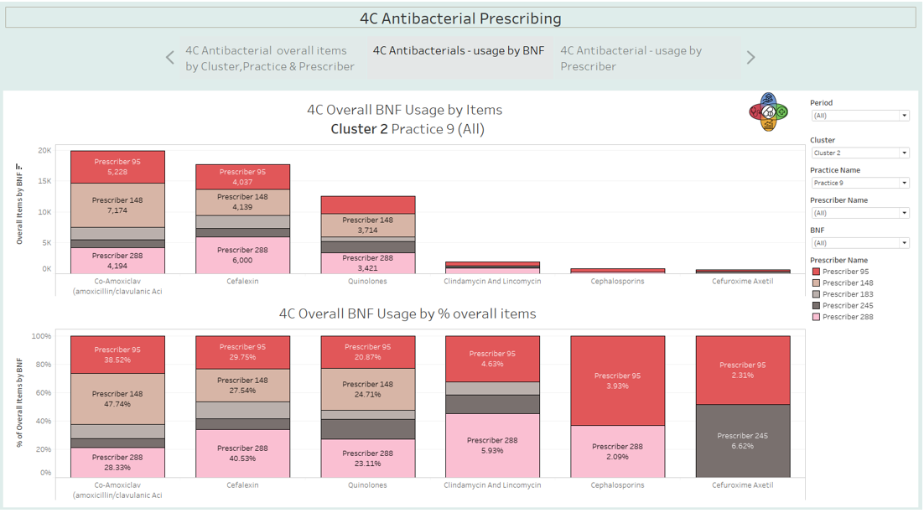
Figure 10 Interactive Tableau Dashboard – showing the usage of BNF medicines
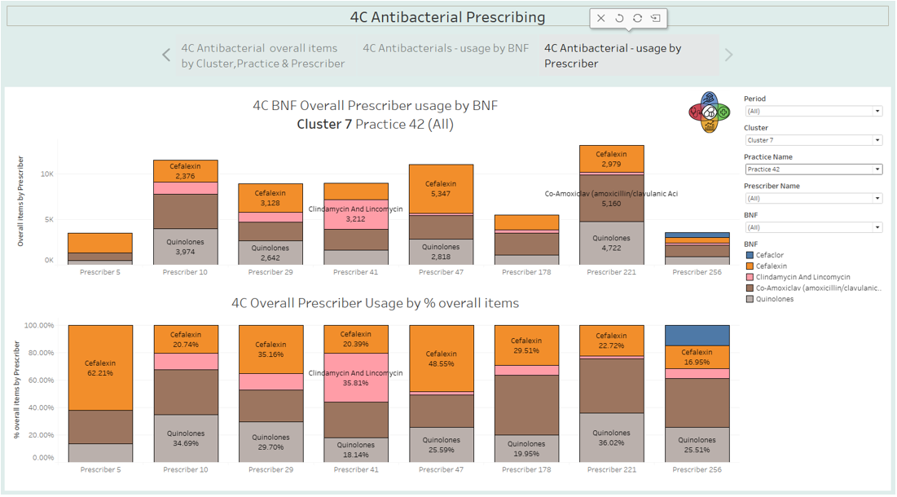
Figure 11 Interactive Tableau Dashboard showing which 4C Antibacterials were prescribed and by which prescriber
The summary for this project showed that the use of dashboards helped with in house discussions by showing each practitioner their own prescribing whereas in previous years the only way to discuss this would be with an excel spreadsheet heavily laden with data showed by graphs that presented further questions that could not be drilled down.
With an interactive dashboard the comparisons can be seen immediately and questions that arise can be answered by changing the view and shown.
The project focus was on 4C prescribing within practices. A dashboard for each practice was circulated for use as a tool within practice to back up discussions and help with training whilst giving the ability to scrutinise practice habits.

CHAPTER 3 - DEVELOPMENT METHODOLOGY

3.1 Research

The overarching research methodology was experimental (hypothesis testing) using a case study.
The main hypothesis drive was that visual data is more readily observed and accepted by the reader and hopefully actioned upon quicker.
This fits in with our approach to educate clinicians on over prescribing of drugs.
Positivism Philosophy uses large samples of data used to feed the dashboard. Focus groups will lead the path taken to analyse and decide on further steps (Pharmacists, Consultants, Data Analysts and Team members).
Quantitative research uses measurable data (the collection of C-difficile data and the prescribing data from Caspa) to produce the dashboard and is then discussed in the form of interviews and meetings over teams with stake holders who direct future progress and development. By showing the visualisations to the stake holders they can evaluate the dashboard and can provide insight as to the expectations of future development. By having a series of interviews software development was ongoing to ensure that the content and evaluations were measurable and that any questions that may arise during the analyse were then answered. The initial development of 3 systems showed which had the best usability functions for the end users.
Validity is proven as the data is specifically collected to show the main prescribing patterns and instances of disease and will feed the visualisation systems.

The comparison table below shows the three chosen software applications with the listed features
 | Tableau |  | Map Info Pro |  | Excel
Learnability | 7/10 | Although complex the system has good learnability features that make it easy to use | 3/10 | The system is complex taking time to learn | 8/10 | Given that excel is a Microsoft package there is generally already some level of learning which is easy to manage. Skills are easily to progress
Efficiency | 8/10 | Although complex the software is very efficient, tasks can be completed quickly once learned | 5/10 | The system uses many different sources with different accesses which can be hard to learn | 7/10 | The software can easily perform tasks that have already been learned
Memorability | 8/10 | The system design is easy to remember and recall is high | 4/10 | The number of systems used to obtain data can have different routes which can be hard to remember | 5/10 | Although the tasks can be remembered easily, the options are not as vast as the other two systems
Errors | 8/10 | System updates (if purchased) allow for less bugs within the system | 2/10 | Errors seem to be continuous with no help systems readily available | 5/10 | Errors occur frequently with easy on line help topics (this is due to user input more often than not)
Satisfaction | 9/10 | User experience is entertaining gaining the end result proves to show this | 5/10 | When visualisations are built with accompanied information that provides in depth learning is easy to use | 6/10 | The ability to provide diagrams etc. that are easy to use and share is satisfying.
Accessibility | 8/10 | There are certain barriers for users within the system that could be better. I.e. resizing of images, lack of headings etc. | 6/10 | System does not easily resize and options for size change etc. are limited | 6/10 | Changes are standardized and can easily be found although the main structure is hard to change
Interactivity | 9/10 | System prompts are well used with navigation assistance. System is fully interactive. | 5/10 | Error codes are hard to understand. Goals are not always achievable | 6/10 | Basic functions are easy to use with prompts that assist
Personalization | 5/10 | The system requires update for each new visualisation | 4/10 | The system does not allow for personal settings and therefore requires update each time | 8/10 | Functionality allows to set up the system with various fonts and views etc. that are remembered
Privacy | 7/10 | Privacy settings easy to understand | 4/10 | Privacy settings hard to control | 5/10 | User preference for settings allows for different levels of privacy
Security Content | 7/10 | Access control is high allowing for high security levels | 4/10 | Sharing of information easy | 5/10 | Different levels of security easy to set
Learnability | 5/10 | Constant use allows for learnability but hard to get to grips with | 3/10 | System is not easy to use although results are good | 8/10 | The more usage allows for good usability
Design Structure | 7/10 | Looks good – choice of designs is high | 2/10 | Design does not allow for understandable interaction | 5/10 | Range of designs good, easy to identify different areas
Navigation | 8/10 | Easy to travel around the site | 2/10 | Hard to navigate | 5/10 | Easy to navigate
Performance | 8/10 | High performance | 7/10 | Good performance | 7/10 | Good performance
Memorability | 8/10 | Easy to remember | 3/10 | Not easy to remember | 7/10 | Fairly easy to remember

This was completed by 3 members of the Medicines Management Team.

3.2 Development Method

In order to gain understanding regarding C-difficile and how it may be transmitted there should be a way of collecting information and placing into a type of visualisation so that it can be easily identifiable if there is a correlation between prescribing and disease. This led to discussions around providing a visualisation that leads to knowledge, understanding and training against further infection.
The planning stage decided on what we wanted to show and in which design format, measures were discussed and identified.
Data collected by the Infection Team and GP prescribing will show patterns and trends, together with the experience of all involved a deductive approach will be used.
Analysis was carried out and conclusions drawn in the form of visualisations that could be shared.
The strategies used were software development, experiment and document review
Software Development – The software packages chosen for this project are Tableau, MapInfo Pro and Excel. Tableau has been chosen due to its use already within the department and its excellent visualisation properties, MapInfo Pro for its mapping abilities and Excel for its constant use across all disciplines. All three are available meaning that there will be no access issues.
Initial findings showed that Tableau was the system that would be used due to its ease of use, visualisation strength and the fact that the application was already part of the software package used in the department. By following a time line the development was shared ensuring that usability values for the end user and the developer were of a high standard.
Experiment – by sharing the initial dashboard with the wider team it can show the difference in understanding for those that have a high understanding of the subject and for those that have little understanding of the subject.
Document review – meetings were set up to assess undergoing design and future requirements including the data collection and data captured around prescribing.
The research will be reliable when the results are shown in a visualisation, it can be run sequential times to ensure that the same results are shown. In order to validate the project a team of users have been interviewed to ensure that the correct research has been completed and the right questions asked. The data collected is the only available data for the C-difficile cases. Going forward a bespoke set of data will be available to ensure there are no issues with validity. Although the results are discussed at a Health Board level they are also generalised as the data shows Cluster and GP Level.
Currently the Health Board uses Excel, Tableau, Power BI, and Click View (among others) for developing dashboards, power points and other forms of data sharing.
In recent years Medicines Management have used Tableau as its main software application for the implementation of dashboards due to the extended visualisations that can be easily understandable to analytical experts as well as those that do not have such expertise. The audience can have such a vast range the visualisation need to cater for every persons understanding.
This methodology will allow the project to develop and find the best way to collect data, design visualisations and share them to the wider audience. The project can use real data with real evidence to assist in decision making from management.
Given that the project life cycle will depend on the outcomes of trials the best methodology to use is Waterfall.
The waterfall development process sets out phases for the life cycle of the project and must be completed in succession. It has the advantage of working better for smaller teams, the MM Team is minimal. Its simplistic style allows for easy understanding.
Sequencing during the life cycle is dependent on accuracy to give the user the requirements needed. In order for this to be successful the requirements must be agreed upon before the design stage can be implemented.
Waterfall methods give the advantage of a set time frame, the end product once decided upon and finalised will be reported on either monthly or quarterly and will need to available for the user. Using a sequential life cycle allows for repetition using updated data sets which allow for business intelligence to show change over time.
The project phases are as follows:

Conception | The antibiotic team requested data showing clusters of C-difficile with the ability to drill down to show cluster and area within cluster. Required to share information, to use for education and learning.
Initiation and analysis | Requirements – an interactive visualisation that can easily be updated on a monthly or quarterly basis that can be shared and understood at different levels of professionalism.
Design | The software should be easy to navigate with additional features showing trends and disease instances/growths within areas. Ability to change time periods with overlay of prescribing information. Colours should highlight areas of concern/areas of growth. Ability to hover over areas with information highlights.
Construction & Coding | The data included will require cleansing and testing to ensure accuracy.
Testing | Testing of the system before sharing for user testing.
Implementation | Handing over the software for team use.
Figure 12 Project Phases
Having a clear framework allows for implementation without constant review from peers. Given that the end users have large workloads and constant meetings/reviews are time consuming. Having decided on the requirements at the beginning of the project there does not need to be constant updates or changes.

CHAPTER 4 - DESIGN & IMPLEMENTATION

The forefront of any visualisation is the image that is viewed but without solid data sets the images will not give a true reflection. The data gathered is not currently from a reliable source and is being gathered by hand. This gives much room for error. First review of the data shows that many columns are not required for this software build and therefore the data requires cleansing. Going forward there will need to be discussions about how the data is collected and who by. Currently the ownership of data cleansing will be time consuming with large error margins. The team currently collecting data is small and has been used for a different purpose. Should the implementation of this visualisation prove to be successful the wider NHS informatics team will be included to see if data gathering can be more efficient, until such time the data will be cleansed for the purposes of this project.

4.1 Design (data)

Firstly, the main part of the design will depend on the information that is included. The original spread sheet consists of 56 columns with varying levels of information:
Ribotyping | Discharge date | Surgery GP letter sent to | Hospital
Duplicate | GP Name | Letter type | Ward
Reinfection | medical | date sent | Comment
Weekly report | GP Phone | Returned and sent to ward | PCR Tox
Episode | GP Postcode | Dropdown list | pii
specimen number | CAI | Outbreak on ward | care home resident Y/N
Date_Collected | Previous positive | Site link | date pii triggered
Date and Time Received | HAI | Doctor | WGS link
NNN | Ward of possible  acquisition | PatType | Specimen Location Hospital
CRN | HCAI status | Spec | DOA
Surname | MDRO | Test_Set | Location
Forename | MARO | Result_Full | ACQ
Age | Year | Import Date | Gender
DOB | month | Admission date | mmm/yy
Figure 13 Initial spreadsheet column headings
As shown in the table above the headings are not formatted with duplicate information which will lead to errors. For the purposes of this project the certain headings were excluded.
Data cleansing/collection was made easier with the assistance of the information department who have access to the WPAS system where patient details are saved. Although the capture of data requires updating the assistance of information means that an SQL query can be run which returns the required fields without having to manually enter the data which would be time consuming. By using a vlookup the information is easily transferred and is also cleansed to ensure the spreadsheet is formatted correctly.

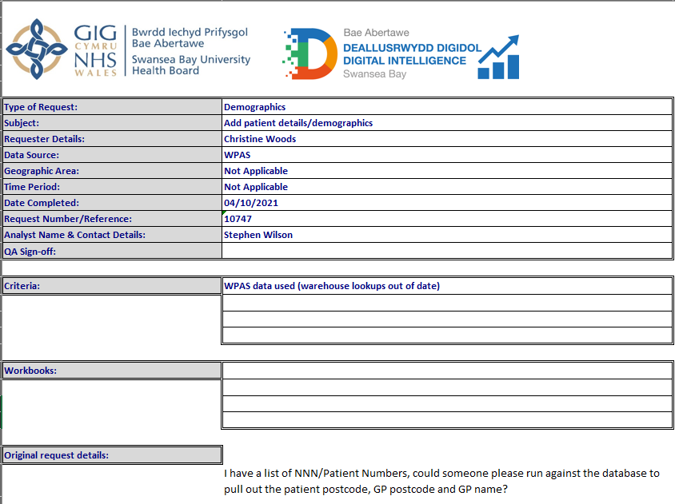
Figure 14 Request sent to information department
Before the implementation takes place a paper design was used to show how the system should look and the end user involved to ensure that the system is fit for purpose. Often the people that actually use the system are not involved in the design, this often leads to systems holding the wrong information or not including the required information.
The antimicrobial team requirements were that there was a map that can overlay cases of C-difficile with over laying prescribing information to show any correlation. It needs to be easy to use and the information easy to understand. Once the correlations are made it should easily identify prescribing information along with practice/GP names etc. It was decided that this would be best using a hover/click button.
With the postcode it easy to find out the coordinates to enable a map in GIS by using a site on the web [22]. This does require the postcode to be formatted in excel to return the correct postcode.

4.2 Data required

The GIS application will provide the ability to overlay data to show if there are any similarities between disease and prescribing history.
A patient taking antibiotics may have several side effects, one of which is diarrhoea, this occurs in 2-25% of patients taking antibiotics. One of the factors will depend on which antibiotic is being taking, the reason behind this being that the gut flora is disrupted, current guidance shows that 20-20% of cases are caused by C-difficile infection [23]
Using the GIS system, patients that have been diagnosed with infection can be highlighted by home address and also GP Surgery address. Overlaying prescribing information can highlight if there is any correlation between the both.
The main antibiotics (although not the only ones) that are associated with the disease are
- Clindamycin
- Cephalosporins
- Quinolones
- Co-amoxiclav
(Otherwise known as the 4C’s)
There may be other contributory factors such as
- Age
- Frailty
- Co-morbidities
- Exposure to disease
- Antibiotic duration
- Multiple antibiotic courses
Using CASPA prescribing data [24] we can show which practices prescribed the 4C antibiotics and when. To start with the data will highlight the 4Cs which can then be drilled down.
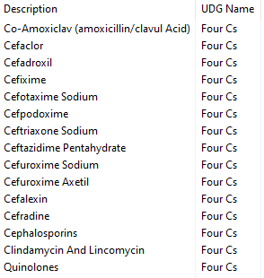
Figure 15 Main 4C includes more than 4 drugs as shown above.
The data collection period used will be consistent with the raw data collection of incidents of C-difficile in the community, this ranges over a 3 yearly period (June 2018 – June 2021).
Both data sets are required for the GIS to perform the required tasks. For this to happen a common denominator is required to ensure the data sets can “speak to each other”.
GP surgeries have a unique Wcode which can also be found in the PAS system. The information team can provide this code on request (although this may take up to 2 weeks!)

Cleansing of data has shown to be time consuming and in need of complete reconstruction. The main caveat of this project will be that the data collection will need to be reviewed. However, using the data available will back up the implementation.
For the first phase of development a meeting was set for 19th November 2021 where initial update and design was explored to ensure that the project will be providing the requirements as set out by the antimicrobial consultant and the information manager.
Whilst developing the dashboards using Tableau and Map Pro it became apparent that the two systems work in completely different ways. The usability of Map Pro is not as easy to use as Tableau. The blending of data is not as simple along with initial collection of data although Map Pro did seem to provide a visual using polygon information which allowed for areas to be colour coded depending on the fields required. As can be seen in the appendix the areas shown can easily decipher given targets. This data is however hard to find.
If Tableau has the same ability, then it will be interesting to see if the same visualisations are achievable.
Areas to be explored were blending of data and how easy it is to use various data sources depending on requirement and how accurate it is.
During this process it became apparent that in order to blend data and provide accurate information a great deal of time was spent studying the different techniques.
Dates were set for review of the systems where updates could be given and discussions took place around what was working and what wasn’t. It is only at this point that the creator and the user can visually compare the needs and requirements of the visualisation.

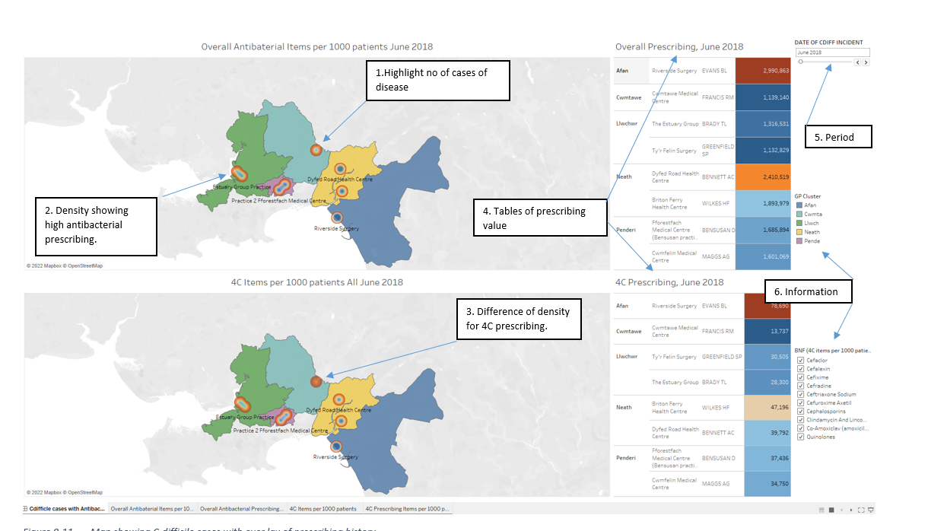
Figure 16 Map showing C-difficile cases with over lay of prescribing history

Following a meeting with the team on the 19th November 2021 the dashboard as shown in figure 0-11 was implemented. The visualisation was shared between the creator and Manager the following month. (Time line disrupted due to pandemic issues).
Item | Showing | Explanation | Thoughts | Going forward
1. | Number of C-difficile cases | Highest numbers calculated shown by circular detail | Good visuals showing overall number of cases | Instead of using area of colour to show cluster, try using area of colour to show disease prevalence
2. | Density | By showing density it provides visualisations showing areas of high antibacterial prescribing | Good visual although does not easily show difference in prescribing | Good visualisation but choice of what is shown needs to be reviewed
3. | Density change | The density in this area is higher than in the above image which show 4C prescribing | Understanding would need to be explained | Again, good visualisation but not prominent enough
4. | Table of antibiotic prescribing | Figures showing levels of prescribing also using colour range. | Should the visualisations speak for themselves? | Information could be in the tool tip
5. | Period | Period choice over 2 years | Drop down or timed period theme may be a better choice? | Use a drop down and a timed moving visualisation
6. | Information | Key for clusters. Choices to drill down 4C prescribing | Only shows the clusters where there is disease | Keep the drill down option

By reviewing the dashboard thoughts were shared for improvement. Again more questions arose from the discussions as shown below.

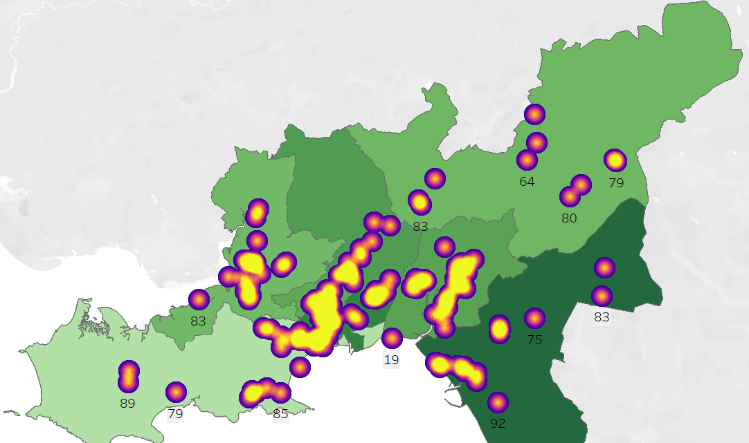
Figure 17 Depth of colour on area to show high prescribing
By using the hotspots to show amount of disease and the colour of area to show high prescribing the visualisation makes for better understanding. The hover tooltip shows that the darker green colour is 137.23 items per 1000pus and the area under the largest cluster of disease is 126.73 items per 1000pus which is in keeping with showing higher levels of prescribing have more cases of C-difficile. Is this a true reflection? Or is this because there is a higher population?
The addition of average age in the labels does not give a clear indication for the question “Is the age a contributory factor when reviewing disease prevalence”
Does this prove that data can be manipulated in so many ways to eventually show what is required or does it prove that data never lies?

CHAPTER 5 – EVALUATION

Following a series of meetings, the dashboard was reviewed. The overall evaluation of the dashboard is that in order to understand the movement of prescribing compared with the cases of disease reported the dashboard provided an ideal view showing the requirements.
It allows for understanding for all users that is easy to follow and shows trends in real time.
However, the initial data capture requires upgrade (this is underway within the Health Board) to ensure that the relevant data sets are continually reported and that the data capture is robust compared to the current situation where the data is being fed into the system by hand and by various different input users.
The prescribing measures are robust and feed the dashboard with data that can be trusted and relied upon.
The dashboard provides a map view showing changes and patterns that highlight different parameters.
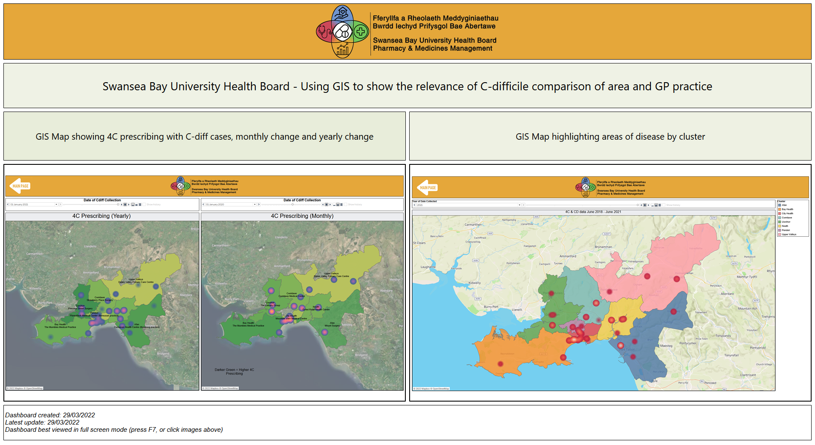
Figure 18 - Tableau dashboard
Originally the thought process was that with the 4C prescribing falling within SBU Health Board that the data would correlate to show the fall in C-difficile cases within the community. Although there are significant changes within the data that supports this it was not felt that the visualisation captures the overall concept. This may however have to do with the data collected as previously discussed. It is felt that with a more robust data set that this would be the case.
Moving forward the dashboard has highlighted the need for further visualisations with supporting evidence to assist in the education and training along with understanding the shifts and patterns surrounding the data.
Geographical Information Systems provide a new way of viewing data which gives a better understanding of occurrences along with when and how these changes have affected different areas. By using a dash board the data can be transformed into an easy to use story board.
When using the Tableau system, the graphs are set as a video capture which can scroll through at a set time. By using this feature, it is easy to identify changes on a month to month basis.
The expected findings would be that the 4C prescribing has decreased within SBU over the later months which should then show a decrease in instance of disease.
Geographical charts provide good insight to any changes that occur on a monthly basis. It was decided it would be beneficial to have the availability of year on year comparison as well as month on month view. Would this be better achieved using a suite of visualisations?
This project has taken place during the Covid pandemic which has effected the performance and management of time scales and available resources. Working from home has meant that the team has had to re-evaluate ways of working. The use of teams has changed the way that work was completed and also the way in which future work will be carried out. There are many draw backs to working from home such as not being able to discuss progress or share ideas, but there are many positives. Before the pandemic the Health Board tackled car sharing to help with the pollution, by having it practically forced upon us has shown that it is a productive way of working without years of trials.
This project has had time restraints placed upon it due to having to set aside work time frames, working in Pharmacy has meant that staff have been relocated etc. and more important tasks completed. As times are changing working in different ways has become the fore front of computer technology.
By showing the progress over teams to a varied audience it has helped to share the GIS systems to those that may not have otherwise been involved.

CHAPTER 6 - CONCLUSIONS AND RECOMMENDATIONS

6.1 Conclusion

To conclude the project there are many things to discuss:
- Has the project worked? At the beginning of the project the thought process was that with the right data set trends would be identifiable to show correlations between prescribing patters and instance of disease. As with any data crunching there is always the possibility that the end result is not what is actually set out to show at the start. The data shows that over a 3-year time period the higher prescribing areas do have a higher C-difficile infection rate but it provides more questions than answers.
- The areas that show high rates of C-difficile disease are in the areas with high deprivation (main town areas), does this contribute to C-difficile disease?
- The periods used June 2018 – June 2021 show prescribing patterns that are reduced during certain months, this could be due to the general changes in seasons that ordinarily show differences in prescribing i.e. winter months have higher prescribing due to winter diseases.

- Is the dashboard accurate? Using data that has not been collected in a standard format has questioned if it is accurate and if the results are correct.

- Have the main usability functions been met?
- Learnability: The system is easy to use with simple navigation options
- Efficiency: They dashboard provides efficient information
- Memorability: Once used it is easy to remember how to use the dashboard
- Errors: During 25 x opening and using the dashboard there were 2 x errors that required re-boot of the system
- Satisfaction: The overall thought is that given the right data the system would be beneficial when analysing the information.

- Have all of the aims and objectives been met?
- The aim
The dashboard has given the team an opportunity to explore Geographical Information systems and other dashboard software to see which one highlights and helps SBUHB to analysis and explore prescribing data within the Health Board highlighting areas of concern where C-difficile cases are found within Primary Care.
- Objective 1
The main objective is to provide mapping visualisations of SBUHB that highlights any clusters of cases with relevant information that can be drilled down in the hope that patterns between cases of C-difficile and GP practice prescribing can be seen – the expected outcome was to show a decrease in cases due to the 4C prescribing falling, some areas show this although some areas where a fall was expected has not been highlighted. This leads to further theories of whether this will take for the data to taper off over a period of time? If so, how long?
- Objective 2
To use and compare various software types to provide maps highlighting clusters of interest whilst overlaying prescribing information to ascertain if there are any patterns which will lead to intervention – three software applications were explored and one decided upon.
- Objective 3
Use the chosen software to investigate prescribing patterns along with cases of infection to give an educated over view of disease prevalence highlighting areas that need to be targeted – discussions held showed that although the expected outcome was not proven it did provide visuals for discussion and also questions arose regarding if the changes would be seen immediately or over time.

- Was the correct system identified for use with GIS?
Tableau provided visualisations that could not be met with Excel and Power BI. Again this provides questions around whether this is down to the system or the amount of knowledge already obtained by the user. Tableau is a big part of Medicine Managements suite of data sets and has therefore been used for many previous projects whereas Power BI has not been used.
Medicines Management pay for the software which can then have a Reader downloaded for free by the user. The software is expensive but does provide excellent visuals. It is however, not Health Board wide which begs the questions if there were staff changes would the software become unused? The Health Board uses Power BI which would lend to sharing of dashboards and information, by using Tableau does this isolate learning?

Recommendations

The dashboard will be handed over to the Antimicrobial Team which will then be used and updated regularly.

Going forward the inclusion of bespoke data collected by the informatics department and microbiology will give more accurate figures. The addition of further analysis charts would show different areas of the disease/prescribing (i.e. box and whisker charts to show outliers in prescribing, trend charts to show disease within care homes which could be used for education within community).
Quarterly updates would be beneficial, especially to view the changes for months where disease prevalence is expected to be higher or lower.
Due to the fact that the Health Board uses Power BI as the main data visualisation application it may be worth using the data to produce a dashboard that may be more widely shared and viewed. The visualisation may not be as graphic but the overall sharing may reach a wider audience which leads to better understanding.
Training and Education sessions to be arranged, this could be on a Cluster Level or GP Level. Decisions around how and when to share to be discussed.
For future visualisations the Antimicrobial pharmacist has asked that a similar dashboard is produced that shows a year on year break down to highlight areas before being able to drill down into monthly data. This led to discussions around Cluster level data and if one practice had high prescribing or high cases of disease this would bring the cluster level up. To drill down into the data to show each practice level information would be required but could be in the form of a table that could be seen when the cluster was hovered over.
Trying to find clear correlations has proven difficult in this area but it is not alone. Antibacterial, PPI’s all show areas that cannot be clear.
The current data set doesn’t allow for Items per 1000 patients – this means that one practice may have a high level of C-diff cases attached to it but this could because they have a higher list size in which case this would be expected. In order to make the figures correlate a calculation needs to added to the date to divide the list sizes by a 1000 patients.
On review the antimicrobial consultant agreed that showing the correlation between prescribing and disease was of high importance whilst remembering that up to now there has been no analysis within SBU regarding this meaning that the simple view of highlighting where cases are of high importance. This can then have other measures incorporated within the data to identify trends etc.
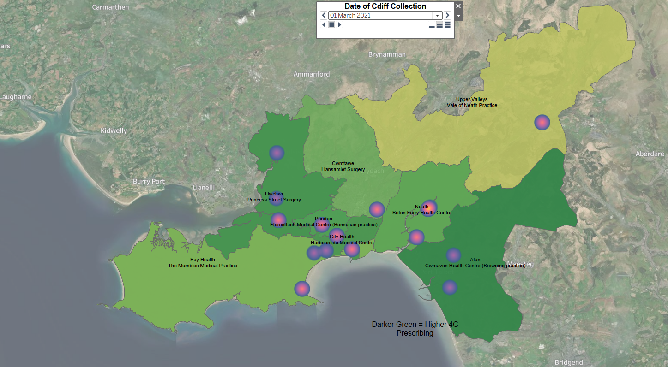
Figure 19 Design showing prescribing and cases of disease

CHAPTER 7 – REFLECTION

On reflection the dashboard has been successful. Initial thoughts were that the correlation of C-difficile cases and high prescribing would have been highlighted in a more obvious way but due to the caveats as previously mentioned there would always be a chance that the outcome would not meet expectation.
An ethics form has not been required as the Tableau prescribing dashboard has been anonymised and the GIS dashboard uses information that can be found within the public domain.
However, the implementation of the dashboard has highlighted areas of disease and by using GIS this can easily be viewed by the user.
Future work will need to be completed and this will be a project that will continue to explore trends and patterns which in turn will lead to discussion and future findings.
The Covid pandemic had a massive impact on time constraints, development and project expectation. Given that members or the team were relocated and Covid measures meant that all other projects have taken a back step it has still been a project that has come to fruition.
The choice of application was heavily decided upon due to the department already financing its availability and thoughts are that it was favored due to user experience. Perhaps if users had time to gain the same expertise on other applications it would have been a different choice.
Overall the project has been successful and will continue to be used and developed.

CHAPTER 8 – REFERENCES

[1] | NHS, "Clostridium difficile," NHS UK, 23 November 2018. [Online]. Available: https://www.nhs.uk/conditions/c-difficile/. [Accessed 10 June 2021].
[2] | S. B. U. H. Board, "Swansea Bay UHB," Digital Health and Care Wales, 2021. [Online]. Available: https://sbuhb.nhs.wales/. [Accessed 10 June 2021].
[3] | Tableau, "Tableau - analytics people love to use," Tableau, 2021. [Online]. Available: https://www.tableau.com/en-gb. [Accessed 10 June 2021].
[4] | MapInfo, "MapInfo Pro," MapInfo , 2021. [Online]. Available: https://www.precisely.com/product/precisely-mapinfo/mapinfo-pro. [Accessed 10 June 2021].
[5] | S. L. Gorbach, "John G. Bartlett: Contributions to the Discovery of CVlostridium difficile Antibiotic-Associated Diarrhea," Clinical Infectious Diseases, vol. 59, no. suppl_2, pp. S66-S70, 2014.
[6] | C. f. D. C. a. Prevention, "C.diff," 2021. [Online]. Available: https://www.cdc.gov/cdiff/what-is.html. [Accessed 10 June 2021].
[7] | V. S. I. J. A. D. C. J. Sirisha Kundrapi, "A randomised Trial of Soap and water hand wash versus alcolol hadn rub for removal of Clostridium difficile spores fron hands of patients," Infection Control & Hospital Epidemiology, 10 May 2016. [Online]. Available: 1. Eckert C, Barbut F. Clostridium difficile associated-infections. Med Sci (Paris). 2010 Feb;26(2):153-8.. [Accessed 10 June 2021].
[8] | N. Guidance, "Clostridium difficile infection:risk with broad-spectrum antibiotics," Nice, 17 March 2015. [Online]. Available: https://www.nice.org.uk/advice/esmpb1/chapter/full-evidence-summary-medicines-and-prescribing-briefing. [Accessed 10 June 2021].
[9] | W. Government, "Gov.Wales," Welsh Government servoces and information, 2021. [Online]. Available: https://gov.wales/. [Accessed 8 July 2021].
[10] | H. Government, "Tackling antimicrobial resistance 2019-2024," HM Government, 24 Jan 2019. [Online]. Available: https://assets.publishing.service.gov.uk/government/uploads/system/uploads/attachment_data/file/784894/UK_AMR_5_year_national_action_plan.pdf. [Accessed 8 July 2021].
[11] | W. H. Organisation, "GLASS," 2021. [Online]. Available: https://www.who.int/initiatives/glass. [Accessed 8 July 2021].
[12] | W. Government, "Welsh Health Circular :AMR IMPROVEMENT GOALS & HCAI REDUCTION EXPECTATIONS BY MARCH 2019:," 4 May 2018/2019. [Online]. Available: https://gov.wales/sites/default/files/publications/2019-07/amr-improvement-goals-hcai-reduction-expectations-by-march-2019.pdf. [Accessed 8 July 2021].
[13] | D. Andola, "Health board sees 40% reduction in CLostridium difficile cases after cutting antibiotic prescribing," the Pharmaceutical Journal, no. https://pharmaceutical-journal.com/article/news/health-board-sees-40-reduction-in-clostridium-difficile-cases-after-cutting-antibiotic-prescribing, 2019.
[14] | M. S. C. Calovi, "Using a GIS to support the spatial reorganization of outpatient care services delivery in Italy," BMC Health Serv Res, vol. 18, 2018.
[15] | C. Woods, "Graphical Information Systems: Geodemographic analysis using GIS software," Swansea, 2021.
[16] | M. M. H. Rakibul Ahasan, "Leveraging GIS and spatial analysis for informed decision-making in COVID-19 pandemic," Health Policy Technol, vol. 1, pp. 7-9, 2020.
[17] | Z. B. M. D. A. T. Ahmed Babalaji Ndanusa, "Geospatial Data Pre-processing Packages:Contribution towards an Enhanced Open-source Package," Journal of Multidisciplinary Studies, vol. 6, no. 3, pp. 14-18, 2018.
[18] | E. &. K. &. M. Mwangi, "A review fo Web Based GIS Isaubility Elements," Journal of Information Technology, vol. 4, 2017.
[19] | N. N. Group, "Usability 101: Introduction to Usability," Nielson Norman Group, 3 January 2012. [Online]. Available: https://www.nngroup.com/articles/usability-101-introduction-to-usability/. [Accessed 29 July 2021].
[20] | D. Schobesberger, Towards a framework for improving the usability of web-mapping products, Vienna: Alle Rechte Vorbenhalten, 2012.
[21] | C. Woods, "Investigating how to achieve better GP Practice participations in information with visualisation and overview," Swansea, 2021.
[22] | F. M. tools, "Free Map tools," [Online]. Available: https://www.freemaptools.com/convert-uk-postcode-to-lat-lng.htm. [Accessed 15 October 2021].
[23] | NICE, "Introduction and current guidance for Clostridium Difficile infection," 2021. [Online]. Available: https://www.nice.org.uk/advice/esmpb1/chapter/full-evidence-summary-medicines-and-prescribing-briefing. [Accessed 28 October 2021].
[24] | S. S. Partnership, "CASPA," Dec 2021. [Online]. Available: https://nwssp.nhs.wales/ourservices/primary-care-services/our-latest-news/caspa-data-december-2020/. [Accessed 28 October 2021].

CHAPTER 9 – Bibliography

[1] | S. L. Gorbach, “John G. Bartlett: Contributions to the Discovery of Clostridium difficile Antibiotic-Associated Diarrhea,” Clinical Infectious Diseases, vol. 59, no. suppl_2, pp. S66-S70, 2014.
[2] | NHS, “Clostridium difficile,” NHS UK, 23 November 2018. [Online]. Available: https://www.nhs.uk/conditions/c-difficile/.
[3] | S. B. U. H. Board, “Swansea Bay UHB,” Digital Health and Care Wales, 2021. [Online]. Available: https://sbuhb.nhs.wales/.
[4] | Tableau, “Tableau - analytics people love to use,” Tableau, 2021. [Online]. Available: https://www.tableau.com/en-gb.
[5] | MapInfo, “MapInfo Pro,” MapInfo , 2021. [Online]. Available: https://www.precisely.com/product/precisely-mapinfo/mapinfo-pro. [Accessed 10 November 2021].
[6] | C. f. D. C. a. Prevention, “C.diff,” 2021. [Online]. Available: https://www.cdc.gov/cdiff/what-is.html. [Accessed 10 November 2021].
[7] | V. S. I. J. A. D. C. J. Sirisha Kundrapi, “A randomised Trial of Soap and water hand wash versus alcolol hadn rub for removal of Clostridium difficile spores fron hands of patients,” Infection Control & Hospital Epidemiology, 10 May 2016. [Online]. Available: 1. Eckert C, Barbut F. Clostridium difficile associated-infections. Med Sci (Paris). 2010 Feb;26(2):153-8.. [Accessed 22 November 2021].
[8] | N. Guidance, “Clostridium difficile infection:risk with broad-spectrum antibiotics,” Nice, 17 March 2015. [Online]. Available: https://www.nice.org.uk/advice/esmpb1/chapter/full-evidence-summary-medicines-and-prescribing-briefing. [Accessed 10 January 2022].
[9] | W. Government, “Gov.Wales,” Welsh Government servoces and information, 2021. [Online]. Available: https://gov.wales/. [Accessed 10 January 2022].
[10] | H. Government, “Tackling antimicrobial resistance 2019-2024,” HM Government, 24 Jan 2019. [Online]. Available: https://assets.publishing.service.gov.uk/government/uploads/system/uploads/attachment_data/file/784894/UK_AMR_5_year_national_action_plan.pdf. [Accessed 15 January 2022].
[11] | W. Government, “Welsh Health Circular :AMR IMPROVEMENT GOALS & HCAI REDUCTION EXPECTATIONS BY MARCH 2019:,” 4 May 2018/2019. [Online]. Available: https://gov.wales/sites/default/files/publications/2019-07/amr-improvement-goals-hcai-reduction-expectations-by-march-2019.pdf. [Accessed 8 July 2021].

APPENDICES

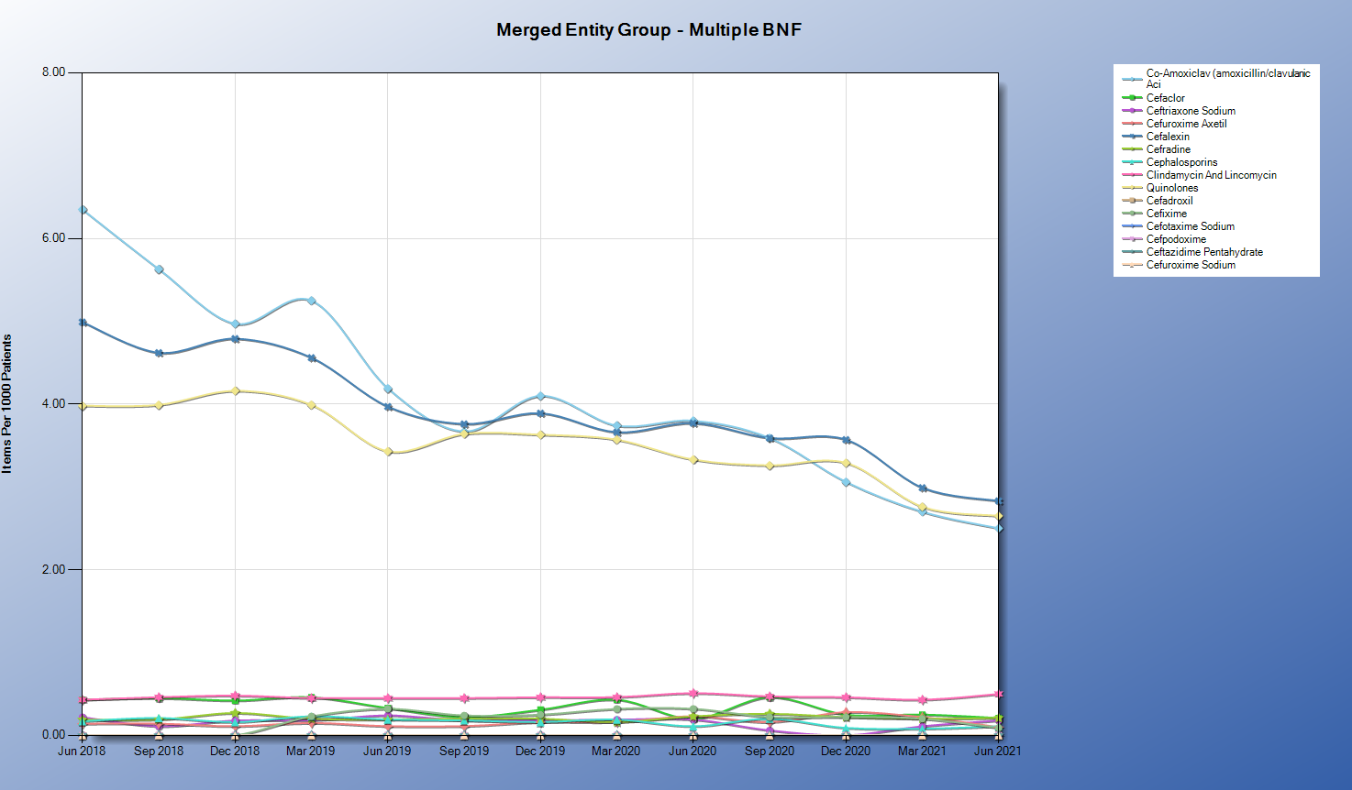
4C Items by practice June18-Jun21 showing the main prescribed 4Cs

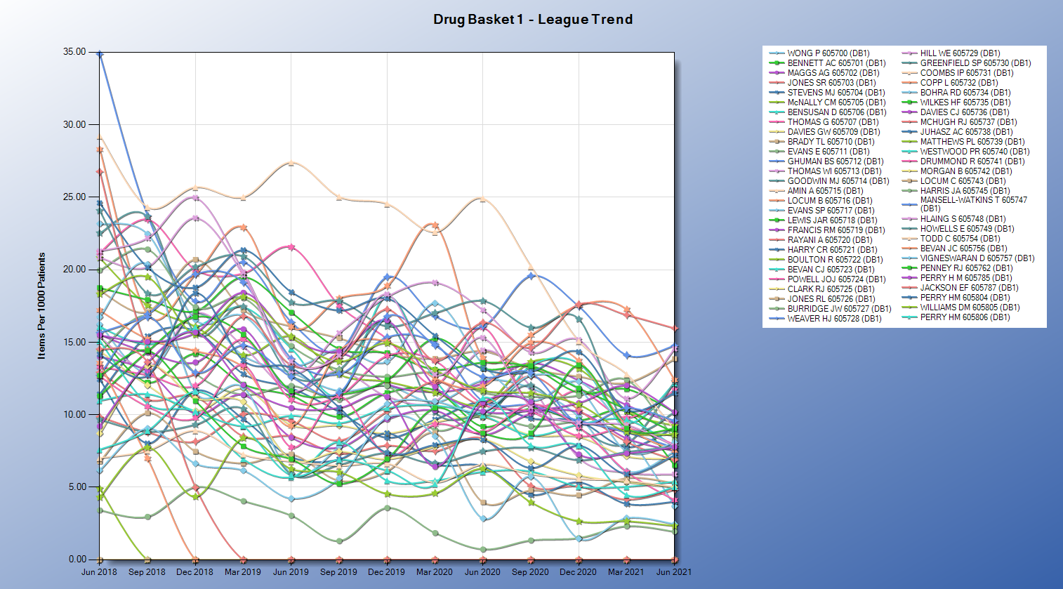
Items per 100 patients 4C drugs June18-June21 – shows decrease overall even though busy

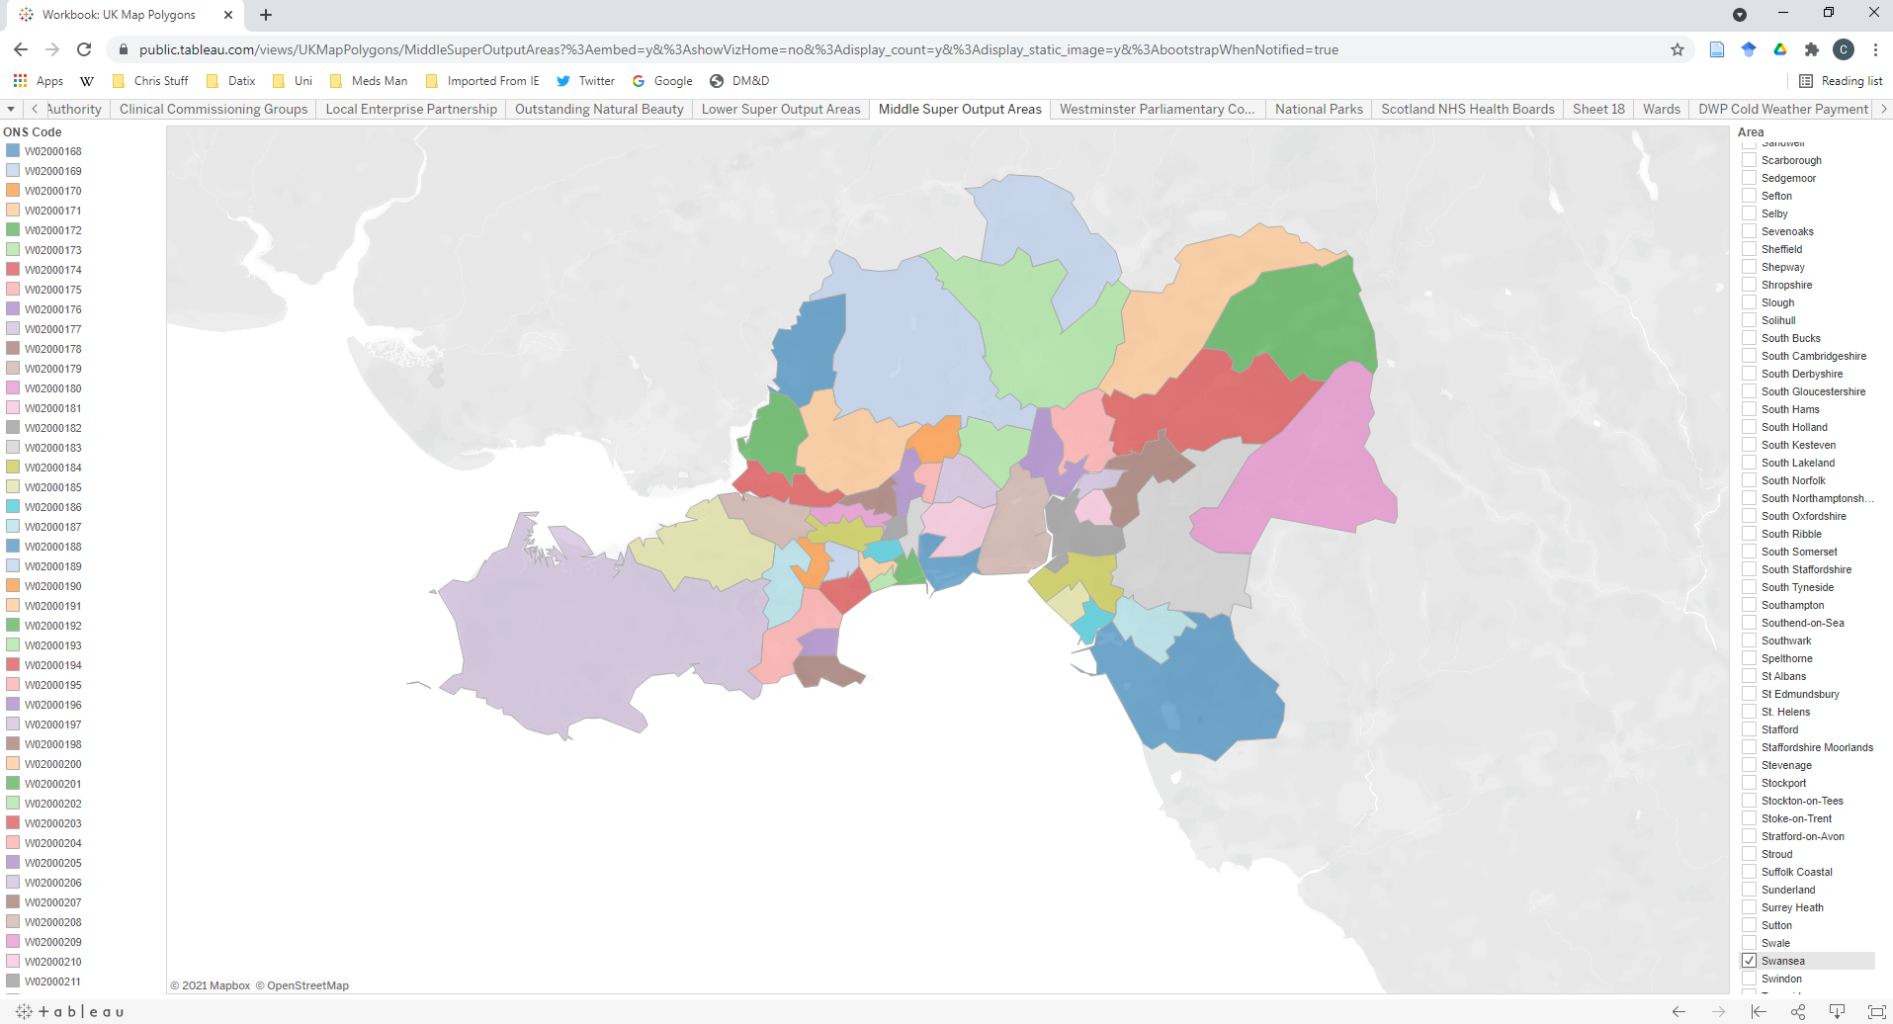
https://public.tableau.com/views/UKMapPolygons/MiddleSuperOutputAreas?%3Aembed=y&%3AshowVizHome=no&%3Adisplay_count=y&%3Adisplay_static_image=y&%3AbootstrapWhenNotified=true
Tableau Public online help with polygons for Swansea/Neath Port Talbot area.

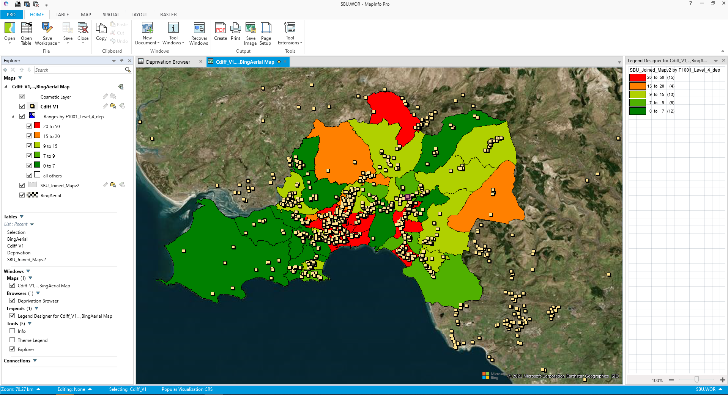
MapPro coloured area definition by deprivation with count of C-difficile cases

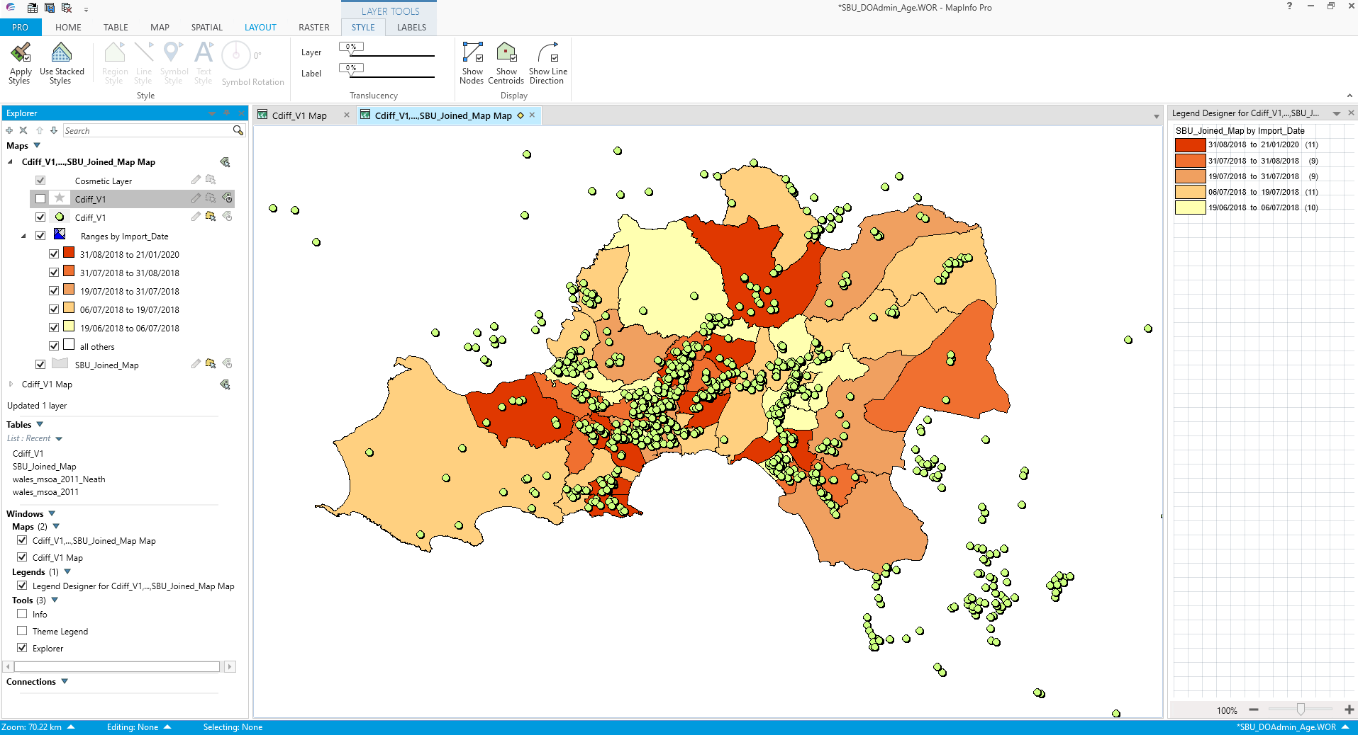
Similar dashboard showing year of recorded incidents with each instance highlighting age (when hovered)

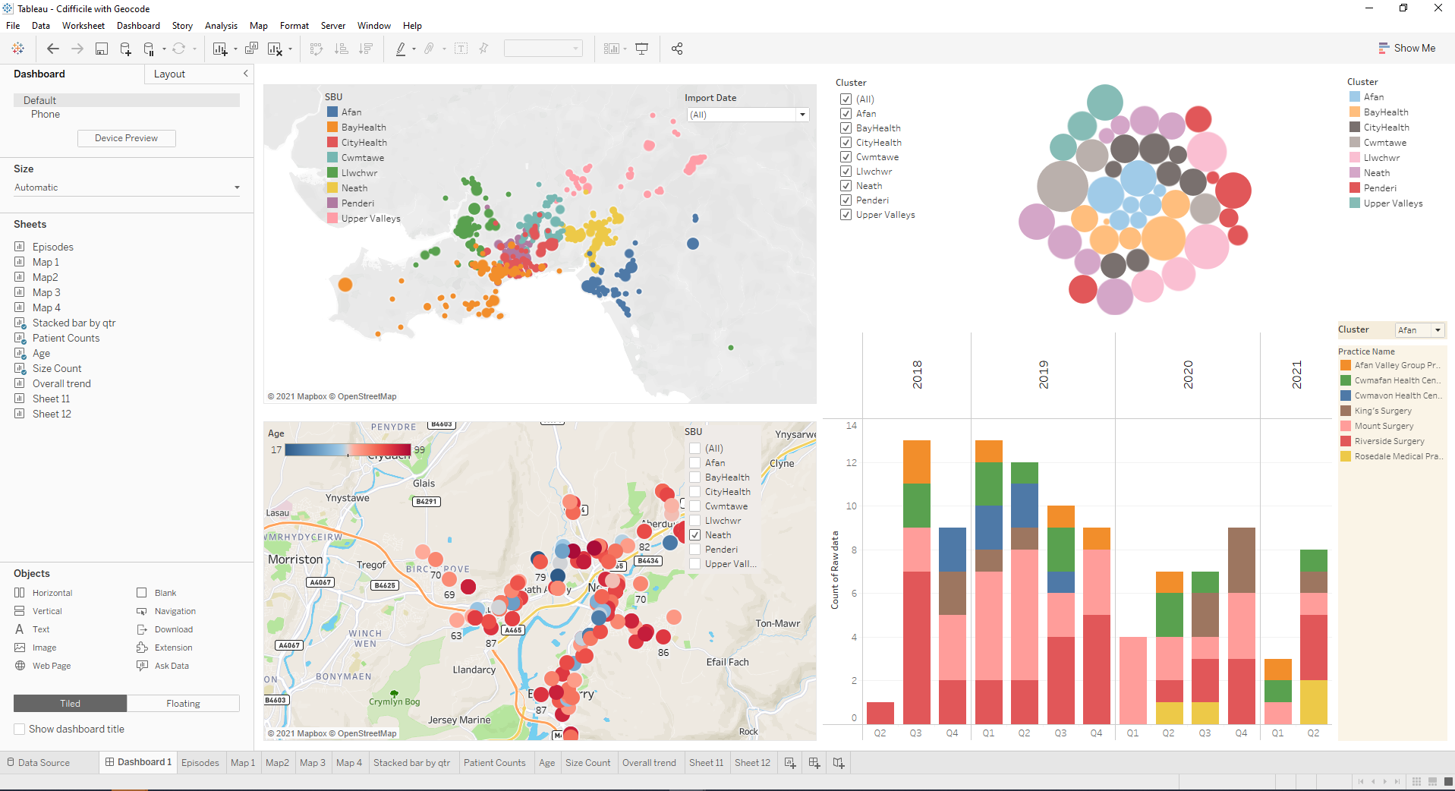
Tableau dashboard used for discussions in meeting with Antimicrobial Consultant and Data Information manager 19.11.21 for ideas in how to develop dashboard to show requirements.

Final dashboard with completed GIS Maps.

