A Sense of Place
How Museums in Wales Represent Going Back To Our Roots And Sharing Our History Through Food.

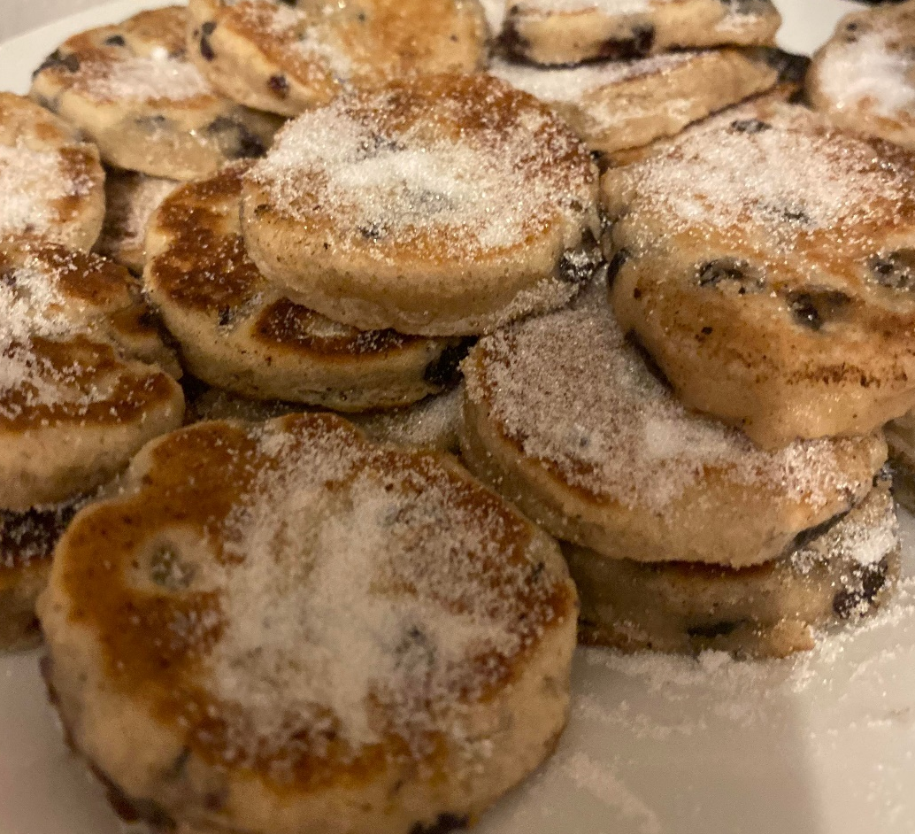
Figure 1. Driscoll, Laura Cait. Piacu ar y Maen. 2021. Authors Personal Collection

Laura Cait Driscoll | 1500941
Submitted in partial fulfilment for the award of the degree of Masters of Arts in Heritage Practice
University of Wales Trinity Saint David
2023



Master’s Degrees by Examination and Dissertation
Declaration Form
1. This work has not previously been accepted in substance for any degree and is not being concurrently submitted in candidature for any degree.
Name Laura Cait Driscoll
Date 24th January 2023

2. This dissertation is being submitted in partial fulfilment of the requirements for the degree of Ma Heritage Practice
Name Laura Cait Driscoll
Date 24th January 2023

3. This dissertation is the result of my own independent work/investigation, except where otherwise stated.
Other sources are acknowledged by footnotes giving explicit references.
A bibliography is appended.
Name Laura Cait Driscoll
Date: 24th January 2023

4. I hereby give consent for my dissertation, if accepted, to be available for photocopying, inter- library loan, and for deposit in the University’s digital repository
Name Laura Cait Driscoll
Date 24th January 2023
Supervisor’s Declaration.
I am satisfied that this work is the result of the student’s own efforts.
Signed: …………………………………………………………………………...
Date: ………………………………………………………………………….

Acknowledgements

Firstly, I would like to express my heartfelt thanks to the staff at University of Wales Trinity Saint David who helped me to pursue my research topic. Firstly, an especial thanks go to Professor Louise Steel and Professor Katharina Zinn who had faith in me to change my dissertation topic to pursue a study that I was passionate about. Secondly, I want to thank my academic support Nuala Davies for all of her encouragement over the past year of writing this dissertation.
Closer to home, I have had my personal family history and stories of baking and meals passed down to me through the generations. I have been raised with the warm feelings of home and comfort coming from the kitchen thanks to my mum and nans and this has encouraged me to want to delve deeper into Welsh food heritage and traditions and the way we keep these stories alive.
Since starting my friendship with Hazel Thomas she has encouraged me on a personal and researcher level, helping me pursue this topic once she saw my passion for it. Your skills, insight and passion for baking and communities have been truly inspirational.
To my friends, thank you for forever being patient and so supportive of me. Your friendship and kind words have helped me immensely whenever I needed to laugh or have a break, or even sending feel good videos. To Alex, thank you. Thank you for being a pillar of support through my undergraduate and masters, thank you for believing in me when I did not believe in myself.
To my family, especially my parents Amanda and Andrew, thank you for your unconditional love and support. For your constant encouragement and understanding for when I go off the radar and throw myself in to work and studies. Thank you for reminding me that I am capable of doing my Masters and believing me every step of the way. You are some of the strongest people I know and that has given me the strength to do this. I want to dedicate this dissertation to you all, and also to my Bamps Patrick, Nan Meryl, Nan Rae and Bampi Terry, who always encouraged me to realise what is important in life and how to pursue that. Even though the last three of them never saw me attend university I know that every single one of them have been with me on every step of this journey. εїз

Contents

Abstract 4
Chapter 1 - Introduction 5
1.1 Introduction 5
1.2 Literature Review 5
1.3 Methodology 10
Chapter 2- What is Welsh food heritage? How does it emerge? 12
Chapter 3: What is food representation in museums? How does Wales recognise this? 28
Chapter 4: Conclusion 55
Bibliography 58
Table of Figures 65

Abstract

Wales is not a country recognised famously for its food heritage, it is a country rich in culture and tradition and food falls greatly within that, but it is not often a conversation starter, especially within a museum context. Food is a key element in understanding culture and as museums play a crucial role in preserving local culture, it makes sense that they should go hand in hand. This thesis aims to fill the gap within the Welsh food heritage and the museum studies landscape. The impact that food has made within communities, and the communities that food traditions have arisen from. This study shows the ways in which food heritage has adapted through locality, historical and colonial impact and the ways in which Welsh museums have represented that change and to what extent. It dissects the sense of national belonging explored between heritage sites and the importance of documenting culture for the purpose of conserving and safeguarding it.

Chapter 1 - Introduction

1.1 Introduction
“Home is where the hearth is,
But we have always been tied to our land”

Drawing upon multiple sources ranging from journalism, food histories, folklore, cookbooks and museum exhibits, this paper will outline current thinking on food as an element of Welsh cultural heritage and provide a critical review of the literature on Welsh food history to date. The paper intends to encourage society to recognise and celebrate food as part of Wales’s intangible cultural heritage as well as highlight the importance of the way we remember the food in practice. It will discuss the United Nations Educational, Scientific and Cultural Organization’s (UNESCO) inclusion of food on their representation list of the intangible cultural heritage of humanity in 2010. It will discuss the growing scholarship on Welsh food history, outlining how new techniques, archives, and sources are providing a clearer picture of this under-researched emerging discipline. Museums are recognised as being a vital component of cultural representation and preservation, as well as being tourist attractions. This research will look at the ways in which museums in Wales have used a variety of displays to represent food whether that be on a micro or macro level, and how these displays engage with their visitors and what could be done to further expand the visitor experience going forward using examples of good practices from Sydney Living Museum.

1.2 Literature Review

In the world of heritage, people are used to considering buildings, historical sites and artefacts as examples of cultural heritage. There is a wealth of other types of heritage to be considered, however, which are intangible. These include dance traditions, social practices, rituals, festive events, as well as food traditions and food practices.
The United Nations Educational, Scientific and Cultural Organization (UNESCO) identifies food as an intangible heritage of humanity. UNESCO identifies that the importance of intangible cultural heritage is “not the cultural manifestation itself but rather the wealth of knowledge and skills that is transmitted through it from one generation to the next.” Intangible Heritage is identified as having four attributes. Firstly, it must be traditional, contemporary and living at the same time. Welsh food traditions and recipes are seen to have links to past practices as well as being part of the Welsh identity today. Secondly, intangible heritage must be inclusive. Captured in their definition of inclusive intangible heritage, is the notion that expressions of cultural heritage are shared between people, “Whether they are from the neighbouring village, from a city on the opposite side of the world or have been adapted by peoples who have migrated and settled in a different region.” These expressions are connected to identity and feelings of being part of a community as well as society.
Thirdly, intangible heritage needs to be representative of the community from which it comes. It emerges through “knowledge of traditions, skills and customs” which are passed through the community between generations. Finally, intangible cultural heritage is community-based, that is it must be identified through the value given to it by the community itself. Outsiders are unable to determine what is held to be a cultural heritage for a group or community.
Wales food heritage has not had a high profile, which may be linked to the colonial experience which devalued Welsh culture and traditions. However, Welsh food heritage deserves to have a chance to be celebrated and shared as it does hold value and experiences in relation to Welsh identity.
Something that this thesis focuses on is the way that intangible heritage links in with Welsh Food Histories and the integration within museums. Food being inclusive, representative, and well as community based are important aspects of this and will highlight the links made.

Di Fiore has made a study of heritage and food history and asserts that there is a value of food as an expression as heritage within culture in Europe. Di Fiore examines the process by which food and food practices become heritage. She highlights the ways that ‘historicizing the processes that produce cultural paradigms enables them to be deconstructed.’ This can be shown in the ways in which when food becomes a part of a historical event – it becomes important heritage due to association. Di Fiori highlights an example of this with the Neapolitan pizzaiuolo. “The authenticity of the Neapolitan heritage allegedly dates from 1889, when the Neapolitan pizzeria Brandi produced a pizza in homage to Queen Margherita: the colours of tomato, mozzarella cheese and basil supposedly alluded to the Italian flag.” Although this has been queried on a historical basis, this localised heritage has now been absorbed into intangible Italian heritage.
Di Fiore demonstrates that the seemingly ordinary, everyday aspects of our lives, our food, is able to be heritage and that it belongs to our identity and connects to our sense of belonging. She provides an academic validation of the importance of food as heritage which gives a rationale for museums to develop ways to incorporate food into their displays
Di Fiore is important to this thesis because she discusses the ways in which food is an integral part of heritage alongside it being intangible heritage within Europe.
This thesis has as its central theme the notion that food is heritage. Llerena in Food Conjures Memory: Making Memory in the Museum highlights how food is one of the principal components in understanding culture. She believes that by excluding food from the public spaces and within the domain of the museum whilst representing the other aspects of a society’s culture means that you are denying the ‘significance of food as a defining element in the culture and history of exhibitions.’ Llerena states that ‘in museums, food displays and aromas conjure memories of the human experience: for example time, family, celebrations, migration or war, Food can evoke memory, create a sense of place and help define the human story.’ This highlights how these are a range of experiences where food plays a part of social memory, whether it is central to a celebration event or noticeable by its scarcity.
Llerena when talking about food within history museums uses North American museums as an example, stating that they often use food to compliment other themed exhibits, but the food is ‘usually a plastic display… dried cornstalks; exotic spices in glass displays cases or spoils of war in military museums.’ This type of display is extremely common within museums, and unfortunately gives a very limit experience of what food culture might be. Llerenas research raises questions about the way in which food is represented in museums, and these are examined within this research for museums in Wales. Plastic food displays do help to give some information however an opportunity is missed to draw upon the sensory elements of the way food plays a role within our heritage and memory. Is it possible for Welsh museums to develop more interactive displays which allow visitors to use their senses in hands on food making activities, cooking, tasting and smelling. Food is rarely something that plays the leading role within museums, nor is it shown to be crucial to understanding who we are as people, as a society, where we have been and where we are going. Llerenas research demonstrates that there is a missed opportunity in developing this aspect of museum displays. Llerena compares museums to heritage sites, believing that the later tend to be more inclusive of food. Many have ‘working historical kitchens to feed the public, which provide a holistic experience.’
However, she does provide another view of this, which is that many heritage sites often glorify the historic cuisine of the elite class without addressing the exploitation of the working class or Indigenous people. There is a parallel with heritage presentations within the United Kingdom, where often the elite classes within Wales were English. The local Welsh tended to lose their traditions which were often not seen within the cuisine of heritage sites such as those of National Trust manor houses. Llerena sums this up perfectly, ‘By blatantly omitting or silencing any mention of the historical contributions of others, historians and museologists perpetuate the same imperialist ideology that have affected the world for centuries.’ Welsh heritage presentations may also be guilty of this, this is examined within this paper.
Máirtín Mac Con Iomaire has made a study focused on recognising food as part of Ireland’s intangible cultural heritage. Iomaire highlights how he uses Brolcháin’s argument that Ireland’s lingering postcolonial shame shows that there needs to be a ‘serious reengagement with Irish Heritage’ The ways Iomaire highlights the tangible vs intangible heritage within Ireland sets a good basis for this thesis to discuss the Welsh equivalent. Wales shares a similar colonial experience to Ireland under the English. Wales is no stranger to the feeling of lingering postcolonial shame, and in many ways has struggled to promote its own cultural heritage and identity confidently. This is particularly noticeable in the case of Welsh food traditions which are associated with rural life and in many cases poverty.
Graves work is based on the food stories surrounding Wales, where the food comes from within its landscape and what it was used for traditionally up to the present day. He visits a range of locations, meeting the real people who produces the Welsh food we know today, from working water mills, to organic farms. Graves highlights the ways in which ‘most of the best dishes are time-worn’ most of the best food knows where it came from, what story it fits into and even what story it is a reaction against.’ The book follows a range of case studies and histories of Wales and takes the reader through a journey of nine different sections based on nine different food products. Graves sets a good foundation to be able to aid the research of this thesis through the stories told and vision created. However, this thesis will be looking at stories and histories beyond Graves research, including looking at the reality of the differences between the miners within the South Wales Coast and the South Wales Valleys.

1.3 Methodology

This research is an exploration into food as heritage, in relation to Welsh food heritage. There is an investigation into how such heritage is represented within the museum setting using best practices in comparison to the case studies from Wales. As discussed within the literature review, there is a growing body of research into the area of food as heritage and into the museum practices around heritage and food heritage. This forms a body of research for my thesis.
It is important to understand what museums and heritage sites are doing to promote food heritage in their different contexts. To understand this, examples of good and less good practice have been chosen to offer a comparison. Sometimes food is given priority as part of heritage and sometimes it can be completely ignored. There is a huge variety of ways in which museums use food as part of their representations. There are full scale sensory experiences such as, grinding wheat to then make into flour that then goes into bread that can be cooked and tasted, to simple scale models of plastic food in displays. A range of Welsh museum case studies were chosen to identify and show the variety of food representation within historical sites. These were also used to highlight the challenges faced by curators in presenting food heritage. These are compared with some examples of good practice found in other museums around the world.
Food heritage representation is a fairly new phenomenon within museums and therefore I wanted to look at a selection of museums across the spectrum and with varying degrees of success within displaying food heritage. Key to the analysis is a focus on visitor experience and engagement.
The overarching theoretical perspective is that of intangible and tangible heritage. This embraces a multitude of food heritage aspects from the tangible heritage which include the pots and pans displayed and used alongside the food, to intangible of cultural recipes and almanacs relating to food growing and processing alongside food traditions that are brought forward through memory and experiences.
A key theoretical approach to the study Is that of visitor engagement as explored by Taheri, Jafari and O’Gorman, their work gives an understanding into the different levels of visitors’ engagement within tourist attractions such as museums, and is a vital aspect in the success of heritage management and marketing.They establish the links between what drives engagement and the level of engagement that happens, this research will link to discovering what aspects of presentations and displays that engage with the visitors during their visit to museums.
Related to the idea of engagement are the experiential aspects incorporated within heritage representation. These can be evaluated through the phenomenological approach which takes into account the sensory aspects of a museum experience. These could include what aspects this thesis will be looking for, from visual displays that stimulate memories, the making of food and the sensory experiences that can trigger emotions, creative experiences and activities that are able to develop empathetic responses from the visitors.

Sydney Living Museum is an example of good practice of phenomenological experiences and displays, especially surrounding food in museum and heritage sites. As a global example this is able to translate throughout a range of museums, depending on funding and capacity. For Wales, this means looking at the ways in which Welsh food heritage is able to be identified, and how it is currently represented well, or not so well, and the ways in which it can be improved or expanded.

Chapter 2- What is Welsh food heritage? How does it emerge?

“Food for us comes from our relatives, whether they have wings or fins or roots. That is how we consider food. Food has a culture. It has a history. It has a story. It has relationships.”

This chapter is crucial to the research topic presented as it will introduce what food heritage is, and the importance of food heritage and traditions that appear within Wales. It will begin by examining the importance of food culturally, then move on to see how this translates to Welsh food. It will look at the ways in which the changes of foodscapes across Wales, the ways they have been impacted by hybridity and the ways in which Wales is reclaiming its links to the land and sea with an increase of communities and people becoming more invested in the food traditions and recipes.

Of all the places in our life, it must be the kitchen that generates the warmest thoughts of home, in more ways than one, leading to food traditions being considered an important part of family history. Food is a key element in understanding culture, recollections of how people think of the meals and good they have eaten fit in to their understanding of who they are. Sutton, a food historian, emphasises the significance of the juxtaposition of two cultural domains, eating and remembering. Since time immemorial humanity has been centred on food. People have sought food, foraged food, hunted food, and created communities around food as well as produced rituals and festivals to celebrate food. Food can come to mean so much more than simply sustenance, it has clear as well as obscure cultural functions which ‘blend the pragmatic and symbolic’. Over time, through historical events and experiences, it can come to carry meanings and values dear to the members of a community. This has been described by Sjöholm as heritagisation. The heritagisation of food “refers to the transformation of [food], places and practices into cultural heritage as values are attached to them, essentially describing heritage as a process” Over recent years food and food heritage has seen an increase in awareness and attention, especially with researchers such as DiFiore, Sutton and Graves. This awareness is linked to the emergence of several initiatives linked at recognising, safeguarding, and promoting tangible and intangible heritage within the foodscape. Foodscapes are defined as places where people are exposed to food messages such as house, school or streets as well as intangible environments such as media and food knowledge from traditions. UNESCO in 2010, included the Mediterranean diet, Mexican cuisine, and the gastronomic meal of the French within the ‘Intangible Cultural Heritage Of Humanity’ list. This list highlighted and recognised the need to protect food and culinary cultures, due to their importance within community and personal identity, as well as their role in fostering the economic, political and social empowerment of local communities. Geyzen identifies this as a ‘heritage turn’, an increase within a strand of research that explores the link between identity crises and the attempts to reidentify communities through the development of food related heritage projects. This highlights that the term heritage does not and should not just refer to the past. Heritage is something which provides a link through the representation or even the reinterpretation of the past.
Issues and contentions
An important consideration when attempting to define Welsh food heritage is to be clear about whose heritage we are trying to identify. This links to notions of Welsh identity and what it means to be Welsh. Being Welsh is not just one thing, it is important to remember the variation of Welsh experiences across the country, within communities and in individual experiences. The diverse communities within Wales need to be considered; for example food traditions of the South Wales mining communities may be different to those of farming communities of West Wales. The differences surrounding the rural foodscapes within West Wales may be different due to the anglicisation of traditions and food cultures within the borders of Wales. Nationalism and national identity are conventionally seen to be aligning concepts. However, in a conversations regarding Wales, there is seen to be a division of the country of ‘more Welsh’ and ‘less Welsh’ regions, drawing on the ‘symbolic attributes of land and landscape’ Evans highlights that the colonialisation of Wales by the English, and later the industrialisation that affected South Wales, is what helped to produce heterogeneity amongst the Welsh. The industrialisation of Wales not only involved internal migration from rural areas to the industrial regions, it also brought forward migration from England as well as abroad, leading to a hybridity of cultures. Thus, industrial Wales became Anglophone Welsh, simultaneously departed from and blended with traditional Welsh culture. The colonialism within Wales is seen throughout the different areas of Wales through its infrastructure, which has contributed to boundaries and differences between the areas. North Wales have more connections with Lancashire than Cardiff, and South Wales have better connections to Bristol than Llanelwy. This highlights the tangible divisions between the areas, but this also exists intangibly, due to the hybridity of areas and the variety of communities that exist between them, it highlights the diversity that Wales experiences, and this thesis will look at how that is reflected within food heritage. To refer back to the UNESCO characterisation of food heritage, food heritage must be ‘recognised by the communities and individuals that create, maintain and transmit it’ as such, it should be identified firstly by those communities themselves, rather than be imposed on them by an outside authority, however well meaning.
Identifying food traditions as heritage within a community presents its own problems. The ordinary everyday experiences of preparing food, eating and sharing recipes can be seen as the mundane and are not recognisable as heritage or special until seen from the outside looking in. However, as Timothy highlights, food traditions are ‘loaded with ethnic symbolisms, the passing of intergenerational knowledge… enduring tastes, socio-spiritual practices, political power struggles, connections to nature, stories of sustenance and survival… indigenous and colonial inspiration, and poverty and wealth,’ showing how food is really important to cultural heritage as well as to heritage tourism. The ways in which food heritage emerges, becomes unique to a place and is recognised, needs to be examined. This may be to scrutinise the ways in which food is part of Welsh cultural life, including such things such as agricultural shows, celebrations and festivals as well as the rituals of everyday life.
Food heritage is often associated with the upper-class ritual and prominent historical events, especially when connecting to national history. If, as Di Fiore suggests, food heritagisation occurs due to food becoming a part of a historical event – it becomes important heritage due to association with a historic event. It is crucial to look at what notable events have occurred within Wales to create an association with food. A difficulty emerges immediately when we think of Wales due to the quiet heritage around food, as key events were often focused on poverty and struggle that motivated community action in the forms of riots and strikes, for example the Rebecca Riots, Merthyr Riots and more recently the Miners’ Strike. While specific commemorative foods and traditions may not have emerged from such protests, the struggles and poverty faced by these communities may well have contributed to the simple and practical household economics which characterise Welsh food culture. Due to this, there is an emphasis on what the land and community is able to provide by way of ingredients. This is very similar to the Mediterranean diet, recognised by UNESCO for its intangible heritage, it involves a ‘set of skills, knowledge, rituals, symbols and traditions concerning crops, harvesting, fishing, animal husbandry, conservation, processing, cooking, and particularly the sharing and consumption of food.’ The diet was shaped by poverty, hardship and climatic conditions rather than big events.
A key feature of the modern history of Wales is one of colonialisation and such an experience is unlikely to produce celebratory traditions in the way of the kind Di Fiore discusses. However, this does not mean that the food traditions in Wales are not important to the heritage, only that their emergence and significance needs to be more carefully investigated. Welsh food heritage comes about through a number of contributing factors, it cannot be seen without considering the colonial context and the community traditions. It is firmly rooted in traditional rural, mining and fishing economies. At its heart, Welsh food heritage can be categorised as simple, understated, homely and community centred.

Food traditions become heritage through historical events which embed them into the cultural narrative. Welsh food traditions emerged in part from the pre-anglicisation of Wales, the rituals within rural Wales and the hybridity that followed the colonialism and industrialisation of Wales. Food traditions are often defined as becoming heritage through the historical events which embed them into our cultural narrative. In Wales, however, it is more difficult to trace the emergence of food traditions back to a particular national event. Rather, the traditions have emerged through enduring family practices which are shared throughout the community. It can be believed that the poverty and struggles faced by the people of Wales may have been what strengthened the community cohesion, for example, the miners’ strike. During the miners’ strike, the NUM put on Christmas parties for the children where every child was given a five-pound note. Alongside this, the education department worked with the national union of teachers to get free meals for the children, most of whom were from families of miners who would not have been able to afford their food otherwise. This helped to reinforce the reliance on community food, sharing produce and recipes to be able to manage with little. For many Welsh people, food memories and their personal traditions are like treasures, like a sensory heirloom, and that is what childhood food memories do, they help us navigate our lives, and explain what it meant, whether it was negative or it was comforting.
If there is a nationally shared experience, it is that of colonialism and hybridity that Wales has faced postcolonialism. It is important to examine how this experience may have impacted on food traditions in Wales. This section explores a wide range of what is seen as traditional Welsh food, how the food traditions have come about, and how they have been impacted.

Porphya umbilicalis, Bara Lawr
The Welshman’s Caviar, Laverbread. A seaweed that is seen as the ‘crowning joy and sharpest point of division of all Welsh foods.’ Made from the seaweed laver, it is a food that has been around for centuries. Although it is unknown when laverbread became a staple part of the Welsh diet, it was mentioned by Giraldis Cambrensis (Gerald of Wales) in 12th Century Pembrokeshire. Laverbread is a food most popular for those in coastal Wales, becoming a staple food for those who were able to go and pick laver from the rocks and use it as part of breakfast with some bacon or as part of a main meal. Laver helped to provide a wide range of nutrients to those who ate it, especially those which were hard to supplement into the working man’s diet. During the 1970s, BBC Radio 4 Food and Farming highlighted how the traditions around laverbread was starting to decline post-industrial revolution, with the decline of the mining communities and the rise of popularity of processed ready meals within the communities and ease of access, especially for the communities away from the sea. In 2014 Dan Salidono visits Wales, forty years after the initial broadcast to discover if laverbread was still as popular as it was leading up to the 70s. Derek Cooper in the 70s broadcast highlighted how ‘nowadays there’s not enough people to pick laverbread on a commercial scale so it has to be imported from places far away such as Scotland and Ireland, but it’s still there for the taking on the seashore, there are a few left who now and again collect enough for their own use.’ This is still true today in some ways, but in other ways, Wales is starting to reclaim their heritage and links to sea food. A stall holder from Swansea market in 2014 presents to us the notion that ‘Swansea… is known for their cockles and laverbread, people from America, Australia make a beeline to come here, so let us hope it stays but you can never say, it would be sad to lose our cockles and laverbread’, this shows the prominence of laverbread to the communities of Swansea, going as far as it being known in other countries that Wales is known for its laverbread. In some areas it has become more artisan than traditional, but it is a food that is nationally recognised as a Welsh coastal staple.

Cocs Cregyn, Cocs Rhython
Shelled cockles, Unshelled boiled cockles
As highlighted above, the coast of Wales is known for its cockles. They are found all around the Welsh coast, ‘from the Dee estuary on the north-eastern border all the way round to Glamorgan.’ Due to this, cockles are a significant part of the food heritage of these coastal communities. Some communities used to use so many cockles that their ‘villages were decorated with discarded cockle shells’ Cockle shells are a natural by product that can be used for many purposes, these include ‘chicken grit, aggregate, sand replacement and ornamental uses.’ There are many ecological benefits for cockle shells that help the local area as well as using the cockles for nutrients. Cockles themselves have a range of recipes associated with them. A common dish in Wales is bara menyn, a thick cockle source made from boiled cockles, milk, chives and salt mixed with flour. , BBC Radio 4 Food and Farming has a focus on the cockles in Gower, emphasizing how ‘a natural product of the Gower coast cockles, a great favourite of the mining valleys, cockles have been in Swansea market for generations… the ones selling on the market would have been the ones cockle picking a mile away.’ However, although cockles are a staple to the Welsh coast, there has been a decline of sellers ‘only three (cockle) businesses here now... there was twenty odd cockle stalls.’
But those families who still harvest cockles commercially sums up the connection that these cockle farmers have to their trade from the moment they started all the way to the present day, ‘You had nothing else to do, only do your job, and sometimes they used to say that there was saltwater going through our veins, not blood, we were born out of that estuary.’ This presents the notion that these traditions are something that are so embedded into a family, into their culture, their heritage. By having these cockle sellers still around, still farming, still selling shows that it is a piece of history, it is a piece of tradition that you can still see, sample and taste. A perfect way to endorses this, is what a cockle farmer of a family business states, that ‘food that is produced here is coloured by my ancestry, it’s part of me.’ Our intangible is so intricately linked with our tangible heritage through food.

Picau y ar maen
Welsh Cakes are one of the most popular foods people may think of when they think of Wales. They have been a favourite, especially during teatime, in most parts of Wales ‘since the second half of the nineteenth century.’ They were usually cooked on a bakestone and the Welsh names given to these cakes were usually based on the different regional Welsh name for the bakestone or the way they looked. These included pice bach, tishan lechwan or tishan ar y mân (bakestone cakes), but in English they became known generally as Welsh Cakes. Highlighting the anglicisation of the Welsh language post colonialism. Beca Lyne-Pirkis, a Welsh baker describes the important connection she feels when making Welsh Cakes with her children. “There’s nothing like the smell of when you’re grating the nutmeg into the bowl, when you’re then cooking the first batch on the bakestone, it just instantly transports me back to being with nan when I was a little girl and helping her roll out the dough, cut out the Welsh cakes and then baking them in batches, and eating one warm from the bakestone with a cup of tea, it’s just comfort food.” This highlights the ways in which personal and familial traditions are often what shapes Welsh food culture.

Cawl
Stew or soup. Cawl was the word used by the physicians of Myddfai (herbalists, living and working in and around the Carmarthenshire village of Myddfai) to describe a liquid that was able to be drunk. This was often translated into English as pottage. Cawl is often named in different ways depending on the county it was made, and the ingredients involved. Cawl often involves root vegetables and meat, mainly lamb or beef. Cawl was a working man’s dinner all the way from the 15th century up until the present day. This was often a miner’s main meal of the day; stew was a main component of the diet. Women used to make stew with whatever meat you had left and would last 5 days, and it was often said that the more you boil the tastier it was. During the miners’ strike, women’s groups distributed food donations but also ran soup kitchens to help support the miners and their families who needed. It was a cheap, accessible, and easy food to make. Cawl, although traditionally a peasant dish, it has a fondness throughout generations that has kept it popular to the modern the day, whether that is due to the comfort of it, the diversity of which it could be made or the affordability. In 1826, Margaret Dods (Christian Isobel Johnstone) states that ‘The French take the lead of all European people in soups and broths; the Scotch rank second, the Welsh next; and … the English, as a nation, though with many honourable exceptions, are at the very bottom of the scale.' This highlights how even when compared to other European countries as far back as the 19th century, Wales was ranked third by a Scottish journalist and author. Cawl is a fitting example of a food that has been upheld through Welsh cultural heritage and ingrained tradition, even with its anglicised name of stew.

Caws bobi
Rarebit is an historically Welsh favourite food, one which poses a range of questions due to its name, often in history and cookbooks referred to as ‘Welsh Rabbit’ before it was later changed to rarebit or caws bobi. The dish is typically served as ‘melted cheese, mixed with mustard powder, pepper, and brown ale, served on toast. Buck rarebit is Welsh rarebit topped with a poached egg.’ The importance of Welsh Rarebit as part of tradition and culture is highlighted in the way that there is a Welsh Rarebit Day on September 3rd. There is a range of theories as to why it was called rabbit and why it was called Welsh. Владимировна splits these theories into social status and foreignness. A social status theory is that the name Welsh Rabbit has come from the potential mocking of the people of Wales, this is due to the fact that the Welsh were typically known as a notoriously poor cohort, and due to this only those better off would have been able to afford meat from the butchers, and whilst rabbit was the meat of the poor people in England, it is believed that the poor man’s meat of Wales, was cheese. The foreignness theory can be seen as linked to the colonial feelings within Wales, the word Welsh was seen to be used despairingly by the English to describe something that was considered inferior or foreign, This is also seen in other circumstances such as a louse being referred to as a Welsh cricket, a painted floor was a Welsh carpet, the verb Welsh/Welch was used to describe a debt that was failed to be paid.
‘The inhabitants of Wales suffered almost as much at the hands and from the tongues of the English as did the Scottish and the Irish. The traditional enemies used ‘Welsh’ to signify anything poor, stupid, or crooked.’
Welsh Rabbit seems to be one of the last phrases that is still around as a part of the mockery from the English in the present day, however it is more known as rarebit in the areas. Postcolonialism can be seen here as in the ways in which the Welsh communities have been taking back their heritage and culture, reclaiming the names of food and other items.

Bara brith
Speckled Bread. Welsh tea bread. Bara brith is a staple food for a lot of Welsh families, the origins are unknown as many families tend to pass down their own recipes throughout their generations. There is a shared experience within Wales that comes about from humility that is linked with picau y ar maen as well as bara brith. There is no hierarchy involved with the cooking of these cakes, often used within meetings, bake sales, open days and more as a staple of Welsh culture. During the late 1900s bara birth would have been made from any left-over dough from that week. It would have been all piled together in a bowl ready for it to have fruit mixed into it as well as the tea. When the Welsh steelers migrated to Patagonia in 1865, they brought with them their own recipes. The Argentinians understand their Welsh teatime cake to be 'torta negra galesa' or ‘torta negra’ in Welsh this would be translated as teisen du, the English being Welsh black cake or black cake. This fruit cake is now seen more as Patagonian rather than Welsh as it is believed that the settlers created thee recipe on the basis of the original bara birth recipe but adapted it to the area that they were now living. As is the case within Welsh society, bara brith (torta Negra) proved ideal within times of hardship due to the fact that the cake was able to last longer compared to other sweet desserts. Bara brith is an example of Welsh food culture and heritage, born out of poverty rather than a grand event, but important to familial traditions and the communities nonetheless.

One way in which the colonial experience has left its mark on Welsh heritage is in the naming of foods, which are often anglicised. A key component of Welsh life and is the idea that we cannot allow Wales to lose its soul and essence of its language. A Welsh proverb highlights this Cenedl heb iaith, cenedl heb galon (a nation without a language, a nation without a heart). It is shown that throughout time food names have lost their essence of Welsh language, cawl in the South of Wales is referred more often as simply stew. Picau Ar Y Maen are more familiarly known as Welsh Cake, a noticeable exception is Bara Brith which has resisted being known by the anglicised name of Speckled Bread. The food themselves, however, have retained a particular home-grown Welsh quality and have resisted adaptations to hybrid versions. This fact is significant and may well be a sign that the steadfast loyalty to the traditional recipes is a subtle form of resistance to the English ways of doing things and may explain why certain Welsh foods essential elements to Welsh gatherings are such as chapel events, committee meetings, and funerals. Community events always feature a staple from the Welsh traditional foods such as bara brith and Welsh Cakes, can this be interpreted as revealing the ambivalence of the colonised, to use the term of Homi Bhabha, giving prominence to their own traditions. Food and food practices have been examined by many scholars as being important markers of identity, specifically those of immigrant or colonialised identity. Members of these groups feel that they are ‘in-between’ people, often unable to identify with their original homeland traditions or the colonialised practices. Many colonised groups undergo an identity crisis on a personal and societal level, which can often make them feel uprooted and nomadic. Insistence on Welsh food traditions in community settings reinforces a steadfast sense of identity.
Food heritage needs to be a continuous, living, breathing entity for it to be meaningful. According to UNESCO it needs to be ‘recognised by the communities and individuals that create, maintain and transmit it.’ Is Welsh food heritage in danger of becoming a relic of the past?
Derek Cooper in 1974 highlighted the Welsh food story in the following ‘The youngsters no longer come in singing from the sands, the cockles arrive by road from England, the laverbread has to be imported from Scotland, the coracles are down to a handful, the old bakestone has taken its place in the folk museum, the inheritance is ebbing away and that’s sad.’
But that is not how it ends, in the past 50 years, these foods have not disappeared, and Derek would perhaps, be inspired by a new generation, taking a renewed pride in Welsh food.
Deiniol ap Daffydd, a local food supplier based in Llanrwst speaking more recently on BBC Radio 4 in 2014, explains ‘the landscape, the food produced in the landscape, my history and my language, that’s why I came back to Wales, because I’m not the one to deny my children the right to have that in them, that’s what national pride is, and food that’s produced here is coloured by my ancestry.’ This highlights that there is a process at work that is drawing people back to their Welsh roots, culture and heritage through food. There is an increase of Welsh communities wanting to the continuity of Welsh culture through their familial links, Daffydd shows us how he, like many others in Wales wants their children, their families, and themselves to be able to connect to the identity they were born in to, the identity from their ancestors as well as their culture and traditions.

Contemporary foodways and identities are a way in which to assess the long history of colonial encounters. The cherished links between food practices and the personification of identity and politics have made food a central area for the working out of colonial struggles of various kinds. This then poses the question of how Welsh food practices reflect the colonial experience. Is it possible to identify the experiences of the food heritage in Wales? The story of the Welsh conquest by England and the Welsh resistance is repeated in a range of brochures, guidebooks and displays when you visit castles in Wales. It is said that at medieval and Victorian banquets staged at Welsh castles, tourists would eat traditional Welsh food and be entertained with traditional music. Although it is not clear what the Welsh foods were, the fact that it was at one point a key feature highlights the importance of Welsh traditions. However, as time goes on, the Act of Union was passed in 1536 by Henry VIII which prohibited the use of Welsh in public administration and the legal system alongside the Act of Uniformity in 1549 which demanded that all public worship acts be conducted in English, the Welsh language, and therefore the Welsh traditions were greatly impacted.
This impact can be seen through the colonial experiences explained by Homi Bhaba in the location of culture, by using the three elements of hybridity, mimicry, and ambivalence. These are highlighted within Welsh culture as Hybridity can be identified through the languages used in Wales in the modern day. Welsh and English have been combined at times to create Wenglish, a term which was introduced in the 1980s by John Edwards, where he describes the language as ‘a unique blend of residual Welsh and the distinctive patterns of spoken English… and needs to be seen as the oral badge of identity for many who live in these areas and a vital element in their social heritage.’ Mimicry and hybridity are seen within Welsh food culture due to the anglicisation of words, picau y ar maen becoming Welsh Cakes, Rarebit being a butchery of the word rabbit and more, these can also link in closely with ambivalence as this is the resentment that hides within the hybridity and mimicry, the ways in which communities would look like they are going along and accepting of the changes made by the English, but there is secretly ambivalence there. This could be highlighted within the use of Wenglish, not quite Welsh and not quite English as well as the names still sometimes holding on to their Welsh culture for example, bara brith.
Food heritage has only been formally recognised fairly recently as intangible heritage by UNESCO in 2010, taking nearly a decade from the creation of their list of intangible heritage defined as ‘the totality of tradition-based creations of a cultural community expressed by a group or individuals and recognized as reflecting the expectations of a community in so far as they reflect its cultural and social identity’ in 2001 The World Heritage List is UNESCO's program for protecting world cultural and natural heritage, primarily representing tangible, monumental monuments of past cultures and natural environments since 1972. Within Wales, there are four recognised UNESCO World Heritage Sites these include, The Slate Landscape of Northwest Wales, Castles and Town Walls of King Edward I, Pontcysyllte Aqueduct and Canal and the Blaenavon Industrial Landscape.
Following on from this, A variety of experts’ meetings were held in the 1980s, and in 1989 UNESCO issued a Recommendation on the Safeguarding of Traditional Culture and Folklore. These defined practices that countries could put in place to preserve their intangible cultural heritage. Although there is a range of recognition within food traditions enshrined by UNESCO, and Wales has recognised tangible heritage sites – including Blaenavon Industrial Landscape where Big Pit resides, Welsh food heritage has yet to be formally recognised. Whether this is to do with the size of Wales or due to the fact that UNESCO has identified that intangible heritages need to be represented by the community it comes from, meaning that the communities that Welsh heritage, traditions and recipes emerge from are the people who are able to determine that heritage and put it forward.

Chapter 3: What is food representation in museums? How does Wales recognise this?

‘Food history is as important as a baroque church. Governments should recognize the cultural heritage and protect traditional foods. A cheese is as worthy of preserving as a sixteenth-century building.’

In the last chapter, Welsh food, its heritage, and traditions were highlighted. Having shown the importance of these topics, this chapter will present the ways in which museums within Wales represent the Welsh food culture. It will begin by examining the approaches that museums can take to engage with visitors when looking food, it will then move on to showing how Sydney Living Museum is an example of good practice, using it as a basis when looking at the Welsh museums for what they have done that is good, and what they could add for a fuller experience within the topic.

Our food reflects our circumstances, economically, geographically, and socially. During times of hardship, food is limited and often locally sourced or homegrown. As a lens into the past, food provides a means of investigating and understanding our history. The awareness surrounding food offers us an invitation to compare our own food traditions and habits with those of the past generations, to appreciate the differences as well as to discover direct connections through similarities, with people of the past in Wales. The Welsh black oats are a good example of this. Oats such as Hen Gardie, Ceirch Llwyd, and Ceirch du Bach are native oats, grown on Welsh soils for hundreds of years. The seeds were saved by the communities who had grown them and are considered collectively owned by the commons which without this happening, would have been lost. Welsh food and the changes they have faced highlight the connection of food with identity, the seeds have been highlighted as something that is so integral to the culture of the communities, they then made sure to protect it, even with changes in the landscape and growing in the areas. The seeds themselves represent heritage values and identities on macro and micro scales as the seeds are now a heritage variety and it is impossible to plant the seeds without remembering the bigger picture and the history surrounding them. These histories and stories are fundamental to Welsh museum representations. Ultimately curators are faced with a variety of choices for how they present food history. The moment the visitor meets an artefact or display and what is evoked from that moment, how much is that moment manipulated or controlled by the curator? There should be a focus on visitor engagement as a priority, whilst balancing the authenticity of the display, working to ensure that there is no bias in the representations.

Issues and contentions
There is a big debate within the museum sector about the purpose of a museum. This may vary and likewise may encompass several purposes. The International Council of Museums defines museums as a:
‘not-for-profit, permanent institution in the service of society that researches, collects, conserves, interprets and exhibits tangible and intangible heritage. Open to the public, accessible and inclusive, museums foster diversity and sustainability. They operate and communicate ethically, professionally, and with the participation of communities, offering varied experiences for education, enjoyment, reflection, and knowledge sharing.’
A space in which there can be a preservation of the past, but also being able to present narratives about the past whilst holding memories.
Food in museums can be a powerful tool to help facilitate some of these purposes and contribute in a unique way. Food has a sensory quality that leads to evoking memories, it is also a way to quickly communicate a person’s circumstances and lived experience.
The phenomenological has been used in recent research to highlight the quality of a visitors experience within a museum and tourism when it includes the five senses seeing (visual), hearing (auditory), smelling (olfactory), touching (tactile), and tasting (gustatory) There has been significant evidence in research to incorporate sensory aspects into improving tourist experience and creating an attachment through phenomenology. Phenomenology creates a point of contact for museum visitors to the past through the sensory experiences they have with food, through cooking as well as eating.
The Phenomenological approach can link in with the concept of concrete memories. Concrete memories comprise of three key features: familiarity, sensory remembering, and ownership. This highlights how it is possible to make heritage more personal to people through their senses, as well as showing how museums are a tool to address the production and consumption of our heritage, how we package it for the consumer as well as the responsibility to be authentic.
There were some limits faced when conducting research for this thesis. Due to only being able to visit each location once in person, the case studies only give a snapshot of the museums and what they do. If multiple observations were made over a range of days, there may have been added displays and events on. For example, when schools visit Castell Henlys, they are able to make bread from the flour ground on site . Due to this, some data has come from the museum websites in addition to the research conducted on-site. Another issue was being unable to visit Sydney Living Museum to get a hands-on experience of their displays, which have been used as an example of best practice.

Sydney Living Museum has created a successful visitor experience around food heritage using the phenomenological approach and evoking memories. The Sydney Living Museum manages a range of properties that date from 1788 to 1950, as well as the contemporary museum of Sydney. Born out of the need to engage audiences and to unlock a greater visitor experience, they have used food as a vessel of connectivity and communication of the past as well as present to their visitors. The museum uses period pieces and items that are attached to the historical families associated with each space, this highlights their need to enhance visitors’ existing impressions of everyday life, crafting holistic imagery with food as the connector. This holistic approach includes going beyond the traditional static hands-off displays often seen in museums and using the house museum’s kitchens, pantries, dining rooms, and gardens as a way to interconnect and suggest the activities and lifestyles that would have taken place in these rooms at multiple points in history. An example of this is seen in their harbourside villa previously owned by William Charles Wentworth.
‘Pineapples are seen growing in the kitchen garden, crowning an epergne in the dining room and again in the kitchen, where pineapple jam is made, and in the pantry where the jam is stored. In turn, jelly molds in the kitchen relate to a jelly “cooling” in its mold in the larder and a “made” (resin) jelly on the dining table.’

This example demonstrates the subtle connections that contribute to the creation of a cohesive picture of life in that household. It also presents heritage and historical associations and ideas such as class and gender division, social and cultural change, cultivation and agriculture, cookery and preservation, and technology. This shows the potential that can be integrated within other museums for food histories, especially when using key aspects such as cultural associations.
Sydney Living Museum brought in the Eat Your History initiative in 2011. This initiative highlights their attempt to be an ‘immersive, experimental and interactive experience’ rather than have a strictly informative delivery which is often the case with food within museums. It relates to and utilises real practices as well as lived experiences. Eat Your History was to shift thinking from impartial to subjective, material to personal. It uses sensorial, experiential, and hands-on activities as well as using food to enliven static spaces to make history more accessible. Including its A Shared Table project.
The museum’s buildings demonstrate the evolution of food throughout the developments of technology, culture, politics, and economics as well as social changes within Australian society. Alongside its physical displays for people to visit, the museum created a blog to display its content that may not otherwise be available to visitors, such as time-consuming cooking activities within the kitchen. Up until 2020, The Cook and Curator blog provided an accessible form of delivering historical content, again using an informal tone rather than a teaching approach. Hill and Newling highlight the importance and success of this method when they tell us that it
‘Achieved its three key aims: to create an online platform to promote SLM and its properties to a wide audience through food stories; to create an accessible archive of research material for the organisation (including being used as a pre and post-visit resource for educational programs); and as a means of assessing the potential and viability of a food-related publication in the market.’
The success is especially emphasised as the museum has now launched their own book called Eat Your History with stories and recipes from Australian Kitchens. Such an approach could be developed within Welsh museums such as St Fagans Living History Museum and Llanerchaeron Manor House where a range of histories and recipes would have been shared throughout the different time periods highlighted on their site.

Another way in which Sydney’s Living Museum addresses food is through an audience-focused interpretation with their A Shared Table project. The Shared Table was created to be inclusive; the museum wanted their visitors to feel as though they could be fully engaged with the museum’s concept to ‘sit at our tables, peek inside our kitchen cupboards, leaf through our cookbooks and be introduced to our residents.’ The museum used designers to use symbolic elements and integrate them into the exhibits, making the sections ‘inviting, immersive and… interactive.’
The museum and its exhibits highlight the ways in which food can be used and presented to the public. It is often a worry for museums about using real food due to vermin or rotting if the displays are not kept updated, or even using fake food that is so unrealistic it makes the exhibit less effective.
Even a museum with good practice such as the Sydney Living Museum also has these issues. Fake foods that are custom-made can be out of reach due to budget and time constraints, subsequently, the curators and design team of Sydney Living Museum were not satisfied that the quality up close would be suitable for their display. They ended up using fake food and foliage for centrepieces or fruit bowl displays that had been behind Perspex, and even then, these had been positioned at least half a meter from the viewer’s point of view. Another downside of using fake food is the key association, aroma. When looking at phenomenology, a key point within that is olfactory senses and their importance within museum displays. Our olfactory senses evoke powerful associations and as described by Beca Lyne-Pirkis in section one, and her experience of being transported back to baking Welsh cakes with her nan when she smells the nutmeg and the cakes cooking. Smell is a key component often missed within museum displays, although synthetic smells can be made in the UK and the USA, these are often costly and limited to specialised events. A way that the museum managed to combat this was by using dried spices and tea samples that were displayed in lidded cups, or concealed in a fuel stove. As visitors explore hands-on exhibits they are able to release the smells as they lift lids and open cupboards. These are items that need to be replenished often as the effects and smells fade.
The museum also managed to bring in real food, which had been freeze-dried to combat the issues of pests. Other real foods that has been used are ones of low perishability, these included ‘a portion of aged, salted pork, stone ground flour, dried peas, rice and – the only faux rendition- beeswax to emulate the daily allowance of butter.’ These give an example of where real food can be used within other museum displays within Wales.
To add another dimension, as well as an auditory element, a video had been added to their exhibition. A film was made using a primary account of King George III’s birthday meal in 1788, where museum staff volunteers wore period costume shirtsleeve and were
‘Filmed dining on authentic food and wine, prepared using eighteenth-century recipes and served a la Francaise. As the meal progressed and the brandy flowed, the table became messier and the “huzzahs” more enthusiastic. The footage was filmed from an overhead camera, showing the proceedings of the table itself (only the diners’ forearms are shown), and the film was projected from the gallery ceiling onto a viewing screen embedded into the “governor’s table.” Replica late eighteenth-century chairs allowed visitors to sit at the table and engage in the festivities unfolding before them.’
This is a fascinating example of good practice. Engaging and innovative processes are embedded into the way that the museum presents food history, letting visitors become a part of the display itself. Evoking human emotion, and empathy as well as having fun whilst learning. It is possible to imagine such an approach being reimagined in a Welsh context, for example, a medieval bardic feast within a Welsh castle or a stately meal in a manor house such as Llanerchaeron. Even imaging having your packed lunch down at a coal mine, using the sounds of the miners working and chatting whilst others eat their cheese sandwiches.
Lastly, the museum encouraged their visitors to share their own food stories and food culture, through recipes, memories and thoughts using cards for them to write on to add to their display. This is a notable example of intergenerational feedback and engagement as well as a way to connect to all generations and learn their food stories. As much as museums may want to cover everything, it is not always possible, however having an interactive display that visitors can add to create a sense of belonging. This is where the communication, the stories, the memories, the traditions, the culture, the history comes from. A way to further the reach of the museums as well allowing for online engagement through social media.

Discussion
The Sydney Living Museum presents an excellent example of good practice in the representation of food heritage, one from which Welsh museums could learn. The key message is that food histories can help break down barriers that stand between visitors and their full engagement with their heritage. A full engagement within museums and heritage sites links to the empathetic response to displays, and heightened engagement with the displays as well as it helps to build concrete memories as described by Low that bring forward the sense of familiarity, a sensory connection and a feeling of ownership. Even though food representation within a museum setting presents its own set of challenges and concerns, it is fundamentally one of the most impactful tools with which to captivate an audience. Although food is fundamentally a logical component within in-house museums, it also presents its own purposes in other types of museums. Food displays and stories can lend themselves just as strongly within social history museums, but it also serves a function within science museums, ancient or classical museums as well as archaeology museums. All types of museums can bring forward another dimension to their displays through the use of food.
An obvious thing to consider whilst curating displays that include food is the risk management of a collection when using perishable products, this includes heritage fabric and controlled environments during the planning phase. Whilst fake food is often the answer given when looking at food displays, it is often unsatisfactory for audiences unless expertly or potentially expensively crafted for realism. A ‘fake’ dimension to displays which is accessible however and adds value to displays is the use of synthetic olfactory stimulants. If these stimulants smell realistic rather than fake, they can add a multidimensional aspect to food displays, especially as olfactory senses are often able to evoke food memories and experiences.
Although digital technology may be perceived as too modern or intrusive to historical environments, they often add a lot of value to displays as seen in the A Shared Table project by the Sydney Living Museum. Digital technology is proving to be a great engagement tool as audiences are often used to and more accepting of virtual interactions and digital devices in the present day.
Opportunities for direct sensory interaction with real food can be part of a museum experience through hands-on components or associated with tasting activities. They do not need to be held in controlled heritage or exhibition spaces, but can be added to tours or neutral spaces, perhaps in collaboration with local businesses or councils.
Having a team who is willing to try new practices, and have the space to do this is key for successful food heritage representation in museums and other heritage sites. This is not always possible due to funding or administrative risks and planning but would add a lot of value to displays if possible.
There is a perception around authenticity that everything in a display needs to be authentic, however, not every component of the experience need to be authentic (or even satisfactory) so long as the combination of elements generates the required nostalgic feelings There needs to be a feeling of the requirement to take a risk and a budget that allows a museum to trial different things and experiment within their capacity as curators.

Welsh museums and food representation
Traditionally, Welsh museums appear to have divorced food history and food from museum experiences, unless they are highlighting the food of the rich. The exhibition of food in museums is often omitted or reduced to the background. Food history, however, can be contextualized within the greater representations of museums of different genres that use food, bringing memories to life, making historical connections, and conjure memories. Nowhere is the question of identity more passionately debated and fiercely defended than in Wales. Undoubtedly, Welsh food heritage has a part to play in representing and celebrating Welsh identity.
A range of sites within Wales was chosen to examine as part of the research for this thesis. These include St Fagan’s Living History Museum, Big Pit (a mining museum on a UNESCO heritage site), Castell Henlys (an Iron Age site) and Llanerchaeron (a National Trust Site).
With the Sydney Living Museum as an example of good practice of food representation within museums, factors such as visitor interaction and a variety of innovative displays, the Welsh museums visited are critiqued and analysed.

St Fagans Living History Museum
‘[The task] was not to create a museum which preserved the dead past under glass but one which uses the past to link up with the present to provide a strong foundation and a healthy environment for the future of their people.’
- Iorwerth C Peate, 1948

St Fagans is a living history museum based in Cardiff, South Wales. As it is a living history museum, it presents one of the best opportunities to bring in food culture, traditions, and heritage through their displays. For Wales, where a lot of our food traditions come from family rather than grand events it would be considered a key museum to recognise these food traditions, because when it was launched in 1948, it was to ‘reflect the everyday lives of ordinary people.’ Prof G J Williams in a radio appeal in 1958 highlighted how a ‘folk museum must illustrate not only the material side of life and culture but also the activities of mind and spirit… it is not only a matter of great importance but also of extreme urgency.’ As food is so closely linked with national identity, it would be paramount for the integration of it within the museum displays to fulfil the original aims of the museum which included its need ‘to cross the bridge of memories.’
St Fagans uses a multidimensional approach to their displays. There are traditional displays that are behind glass and rope, often these are archaeological remains or items that are too delicate to be touched. Visitors can wander through a series of reclaimed and restored historical buildings from different areas of Wales, styled to represent the period of the architecture, many of these are homes. Rhyd-y-car Terrace presents typical Welsh home styles from 1805, 1855, 1895, 1925, 1955 and 1985. The earlier homes have fires lit in the hearth and cooking utensils on display, the later homes show the adaptation to the modern day, with gas and electric heating and cooking appliances. Food displays within the buildings show a representation of what each type of family would have eaten within the era represented. In comparison to the Sydney Living Museum which presents real foods that have been preserved, St Fagans however, often defers to fake food made of plastic. These displays can often look unrealistic, and also offer limited sensory engagement.
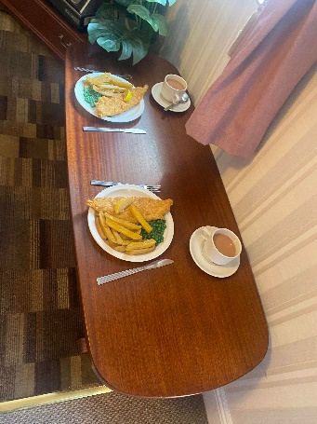
Figure 2 Driscoll, Laura-Cait. A Modern Meal at St Fagans Living History Museum. 23rd October 2022. Authors Personal Collection
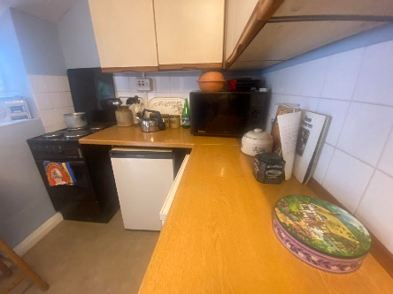
Figure 3 Driscoll, Laura-Cait. A Modern Kitchen at St Fagans Living History Museum. 23rd October 2022. Authors Personal Collection

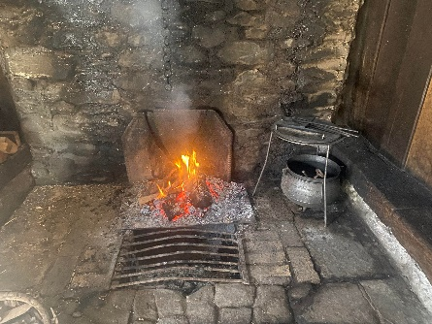
Figure 4. Driscoll, Laura Cait. St Fagans Fireplace Kitchen. 23rd October 2022. Authors Personal Collection
When it comes to the olfactory aspect of displaying food heritage, although they use the senses regarding heating the buildings with fire, they do not go that one step further to add the cooking of real food or the use of synthetic smells within their buildings. This feels like a missed opportunity to enhance a visitor experience and trigger memories. Visitors are unable to go back through time using their senses.
Although they do have real dried herbs within some buildings, they are often so old that they are fragile and falling apart as well as no longer have a smell. This is something, as stated by Sydney Living Museum, that needs to be, replenished often as the effects and smells fade.
As St Fagans original plan was for the museum to “teach the world about Wales and the Welsh about their own fatherland”, there is a noticeable absence of food in the context of being something so integral to the experience of Welsh people, traditions, and culture. This absence means it is difficult for the museum to evoke empathy and memories from its visitors. The museum does engage with the food aspect of the Welsh people with some of the buildings such as the bakery and shop, but it is missing from some of the houses where relatability would play a key role.
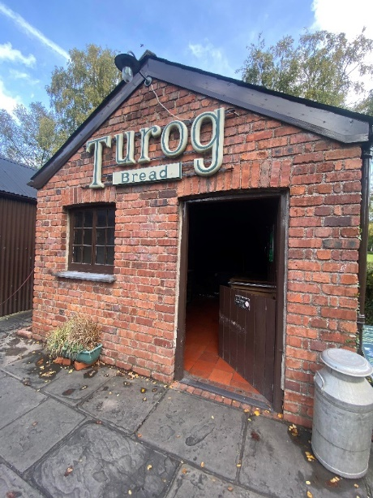
Figure 5. Driscoll, Laura Cait. St Fagans Traditional Bakery. 23rd October 2022. Authors Personal Collection
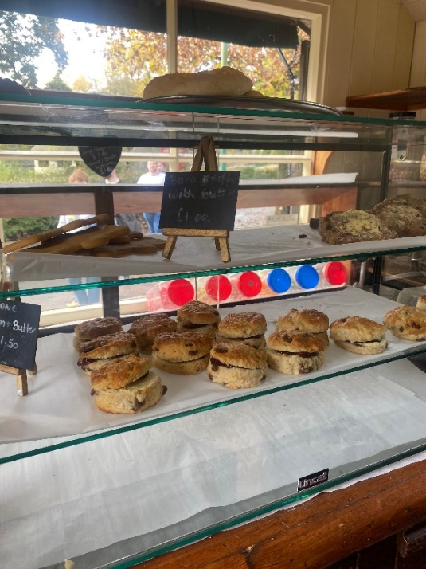
Figure 6. Driscoll, Laura Cait. St Fagans Cakes at Bakery. 23rd October 2022. Authors Personal Collection
St Fagans has a range of online collections available which include historical recipes that they have collated from different areas of Wales. This is a positive way forward for the museum, especially the ones that have videos attached to demonstrate how to make the recipes. This approach has been successful in the Sydney Living Museum where curators also include a separate blog space. Visitors to the site can post food stories, recipes, videos and more providing an interactive tool that is easy to access for visitors who want to explore further and those who are unable to visit the museum itself to still feel connected to the food traditions and culture. This potentially is something that St Fagans could develop to enhance their online content. If Welsh food heritage is to be experienced as UNESCO outlines, it needs to be ‘created, maintained and transmitted’ by members of the communities themselves. Museums like St Fagans have a role to play in encouraging these discussions and conversations relating to the food heritage of Wales.
There are many things that St Fagans do well within their museum, but there are also things that they could implement to take it one step further. It is relevant to note that many museums depend on the funding given and are constrained by the practicalities of risk assessments they need to take, if there are staff who are specifically there to put these ideas forward or if they even have the resources available to them. There has to be a willingness to be innovative with displays and also the administrative structure and funding that allows for the innovations to be put in place.

Llanerchaeron National Trust Manor House

‘There may have been a time when preservation was about saving an old building here or there, but those days are gone. preservation is in the business of saving communities and the values they embody’
- Richard Moe National Trust for Historic Preservation

Llanerchaeron is a Georgian villa, designed by an architect John Nash in 1970. In this house, visitors can explore both sides of Edwardian life, both above and below the stairs. The servants’ area of the house shows the distinction between the everyday life of the family who resided there compared to their staff. The kitchen is Edwardian in style which sometimes has museum staff there baking Welsh cakes to share with visitors. This brings in the different senses for visitors, including taste, smell, and sight. The Kitchen (figure 8) itself is open to the public to explore, open the recipe books, touch the herbs that are drying, see taxidermy specimens of game animals presented as being ready to be prepared by the cook as well as be able to go into the pantry(figure 7) and see all the jars of pickled food. All of the food that they have on display is real. The dining room itself is behind a rope, with no food on display, just the silverware (figure 6).
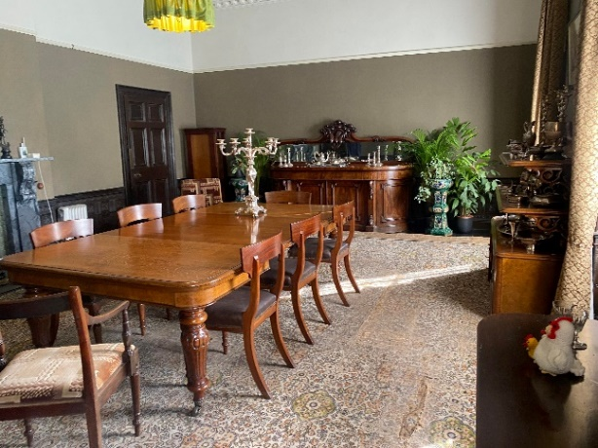
Figure 7. Driscoll, Laura Cait. Llanerchaeron Dining Room. 5th June 2022. Authors Personal Collection
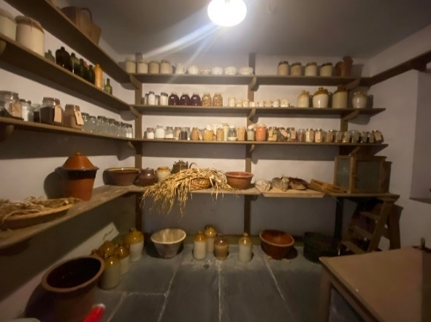
Figure 8. . Driscoll, Laura Cait. Llanerchaeron Kitchen Pantry. 5th June 2022. Authors Personal Collection
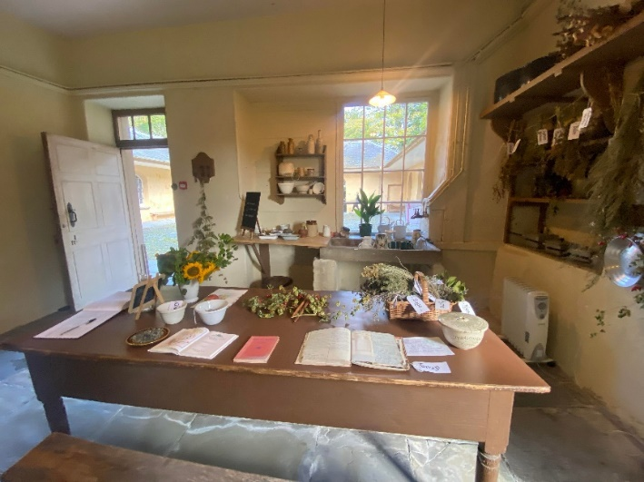
Figure 9. . Driscoll, Laura Cait. Llanerchaeron Kitchen Area. 5th June 2022. Authors Personal Collection
One of the most interesting parts of the museum is that it presented a behind-the-scenes look at how the privileged life of the well-to-do was created and maintained. The inner workings of the courtyard of Llanerchaeron have a range of services shown there including the dairy scullery, cheese press room and store, bakehouse, smokehouse, brew house and salting room are fascinating to see and could certainly be further enhanced by demonstrations and interactive activities.
Llanerchaeron has immense potential to bring to life the feeling of bustle and productivity that would have characterised the staff courtyard in its heyday. Multisensory food exhibits and displays would certainly help to generate concrete memories and stimulate the conversation regarding Welsh good heritage and community connection to it. For example, using the courtyard to experience churning butter, making cream and cheese that can be stored in the cheese press room and using the kitchen to pickle and preserve the vegetables from the gardens, adding even more experiences that even good practice museums such as the living museum do not seem to do, it already uses the range of senses within its displays and uses different types of displays such as rooms left as they were and rooms and items that a visitor can explore. Something that the museum could add following the example of the Sydney Living Museum is the A Shared Table project. It is possible to imagine the involvement of community volunteers or re-enactment to dress in period clothing relevant to the manor house and re-enact one of the dinners that would be seen around the table in the dining room, using archival evidence or a period-specific meal using the recipe booklets in their kitchen. This would bring immersive technology and experiences to the site for visitors to get involved in.
The shop at Llanerchaeron sells its own garden produce from the site, which includes seasonal vegetables, fruit and flowers which are grown in the walled garden. The museum has a dedicated team of staff and volunteers who tend to their plants, pick the vegetables and fruit to then prepare them to sell in their shop. This is evidence of how the site is still using food as a way to not only make money, but to get visitors to experience the fruit and vegetables that would have been grown in the area for many years, and by using the recipes within the kitchen they could potentially go home and make a period meal in their own time and take forward the experiences and traditions that one step further. The walled garden already provides a sensory adventure with its diverse collection of heritage apple and pear varieties which are often scrumped by the younger visitors as they walk around or during their annual apple day. The substantial herb garden tempts visitors to touch and smell the herbs as they loll over the paths. This inevitably stimulates memories and recollections of personal food stories. The museum could perhaps encourage this through collaborative projects of sharing and collating recipes.
One thing Llanerchaeron could do is to also partake in videos of making the recipes or sharing recipes in an online format for visitors and the general public to be made aware of what people during the 1700s onwards would have eaten in West Wales, especially those who were in the manor house.

Big Pit Mining Museum

‘Discover Wales’s rich mining heritage in this award-winning interactive museum and experience the sights, sounds, smells and atmosphere of an authentic coal mine by taking our world-famous underground tour.’

Big Pit is a Mining Museum based in the UNESCO World Heritage Site of the Blaenavon Industrial Landscape. It is ‘one of the few mining museums where visitors can descend in the pit cage and visit the places where generations of the coal miners worked.’ The site was a working coal mine between 1880 to 1980 and was opened again to the public as a tourist site in 1983. The visitors to the museum would follow a certain route whilst there, this would include starting the journey by going on a tour down the mine, seeing where the miners worked, the conditions they worked in and what was done where, they would then tour above the ground, going around the outdoor stores, going up to the pit baths and ending at the canteen.
The aim of the museum is to take the visitor on a journey of what life for men working down in the pit may have been like. This includes, to some degree, their food. The museum has been careful to keep its historic buildings the same as when they were used by miners, whilst incorporating displays of miners’ belongings that are kept behind glass for preservation. These include a miner’s water jack as well as their Tommy box food container (figure 9). These highlight the limited amount of food and drink that were able to be taken down the mines(figure 10_. What they took down with them is all that they had until the end of the shift. This was often cheese and onion sandwiches as they were unable to taste much else with the coal dust in the air.
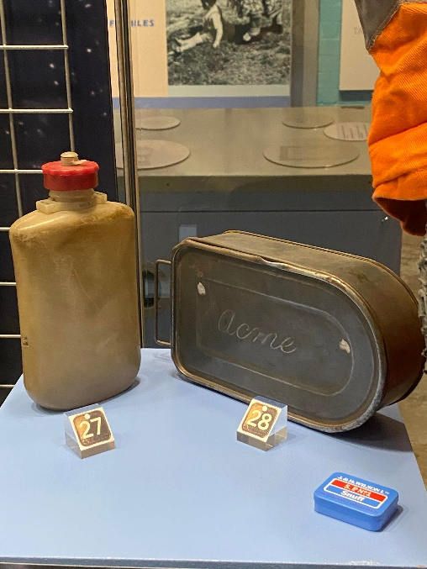
Figure 10. . Driscoll, Laura Cait. Big Pit Museum Display of a Water Jack and Tommy Box Food Tin. 8th October 2022. Authors Personal Collection
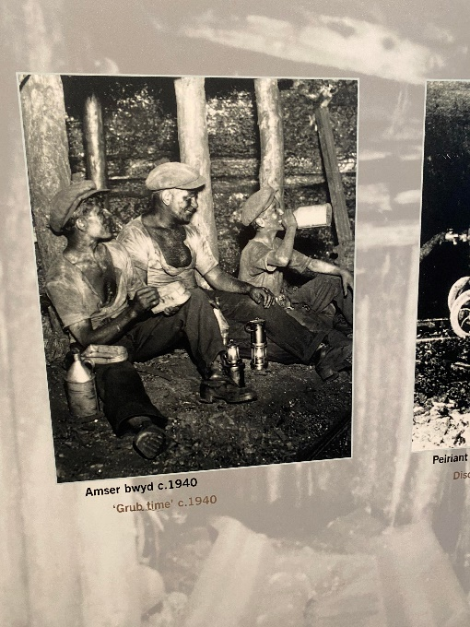
Figure 11. Driscoll, Laura Cait. Big Pit Museum Display of Miners Eating Their Lunch Underground. 8th October 2022. Authors Personal Collection
Amgueddfa Cymru is responsible for Big Pit as well as St Fagans and five other museums within Wales. In 2015 they described their purpose as being able to
‘Inspire people through our museums and collections to find a sense of well-being and identity, to discover, enjoy and learn bilingually, and to understand Wales’s place in the wider world. Our work is based on the principle that culture is created by people and communities. Our collections and other resources partly come from the society of which we are part, and are continually renewed through our work with the public… We are accountable for our use of these resources to the nation we serve’
This approach is highlighted in the way that the museum shows all aspects of the miners’ life, often going beyond those that were based specifically in Blaenavon. The curators have designed a section of their exhibit dedicated to the life at home for the miners and their families which includes a poster entitled Grow Your Own which is displayed on a pig sty. The intention is to show the home production of food stuff that some may have had to supplement their income. This exhibit could be enhanced further if they were to include aspects such as a recreation of kitchen gardens and vegetable plots rather than just the written word.
A dedication to ‘our mam’ and the work they did to budget, clean the house, and organise soup kitchens is given. The dedication is a lovely way to highlight the household economy whereby the miner and his wife form an economic unit. However, this could be developed in a more multisensory way, such as stories being told through speakers, archive photography and recreations.
Although there is limited information on the food that miners themselves had down the mines during the Industrial Era, the museum does have information pamphlets on food that they ate at home, which included meat and vegetable soup (cawl) which often lasted for days. They also have a plastic exhibit that showcases the differences in food between what was eaten during the times of the mines being open compared to the ‘modern day,’ although the modern-day representation has not been updated since the early 2000s. The plastic exhibit highlights the contentions that Sydney Living Museum raised, which is that plastic food happens to look fairly unrealistic especially when close to the viewers. This could be altered to look more realistic if the fake food were set back from the glass or if they had food that has been dried or fake food made from clay or other materials for a more realistic aspect. Llerena raises the point that although plastic food can help give information, all the food displays behind glass, miss out on olfactory senses being engaged within the displays. Although the museum engages with the sights, sounds smell and atmosphere of an authentic coal mine when underground, that engagement is less developed when going through the museum displays above ground.
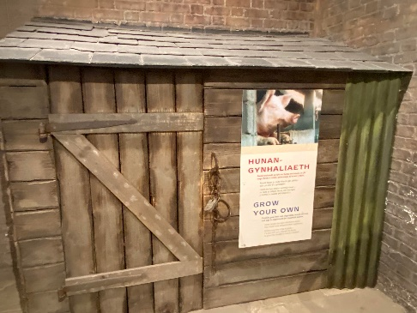
Figure 12. . Driscoll, Laura Cait. Big Pit Museum Display of a Pig Sty. 8th October 2022. Authors Personal Collection
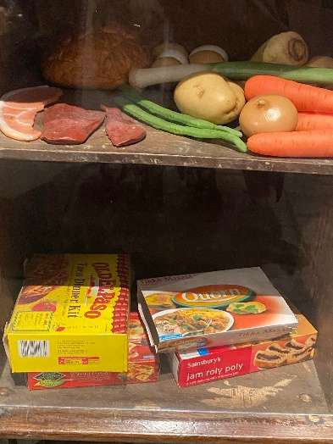
Figure 13. . Driscoll, Laura Cait. Big Pit Museum Display of Plastic Food Behind Glass. 8th October 2022. Authors Personal Collection

One of the buildings that are still being used in a similar capacity as during the Industrial Era is the canteen. It was originally built as part of the pithead baths. The canteen historically provided light refreshments such as hot drinks and cakes instead of full meals. This was often to do with the men being down the mines all day so never resurfacing for lunch, only emerging at the end of their shift where they would want a hot drink and maybe a cake to enjoy whilst they waited for their bus. In recent times the canteen is now used as a place for visitors to enjoy full meals as well as cakes and a snack. Even going as far as providing a ‘miners lunch’ for children which includes a sandwich, juice, and some snacks, it is reminiscent of a miner’s lunch whilst having a modern-day twist, this is a good way however, for children to be empathetic with the miners through encouragement to consider what would have been eaten down the mines.
Something that Big Pit could add to their museum is to engage their visitors in a conversation about what miners ate and where, when they do their tour underground. This would highlight that the miners ate below ground and that the context affected the sensory experience of eating food. A little-known but interesting fact about eating food down the mine is that it changes a lot of tastes, this includes an onion losing its acidity and being eaten like an apple, and the fact that bananas are never included in the packed lunch as they quickly turn to mush. This anecdotal information comes from family history but is not generally included in the tours.
Furthermore, by following the museum’s statement that they ‘are continually renewed through our work with the public’ the community element of the museum could be enhanced by engaging with those who have lived in the area and had family members down the mines. Mining families could be invited to bring in the local recipes and stories of what they ate, whether that be a general meal every week or what they did on special occasions, such as being brought up on bread pudding as the main sweet treat or iced slices if you were lucky and had eggs available to you. The dinners they had from leftovers, such as the gravy left over from Sundays going into a pan with vegetables and meat slices, something that when put on a plate may have looked like ‘slop’ but with slices of bread was able to blow your mind. In industrial villages in North and South Wales, there used to be a prominent cottage industry where if the family were hit by sickness or industrial strife, the wife would create cash through other sources. She would do what was needed to create income through making faggots, or brewing diod fain and selling it from home or at a local market. Not only did this help the families create income, it also helped the local community through providing affordable and traditional Welsh food and drink.
Another aspect they could consider is looking at the community stories surrounding food, such as the ways that the bakehouse in Blaenavon would be a place where people from town could take their meats and cakes on Christmas Eve to be cooked ready for Christmas day. This was due to the fact that people were unable to cook everything at home as coal fires were difficult to cook with. During these times you would have seen people carrying their tin pans of cake or meat through the town to take to the baker.

Castell Henllys Iron Age Site
‘Heritage is always about people, which means it is not always the finest examples of something that needs to be saved, but the ones that have changed – or could change – lives most. Listing or expert approval is not necessarily a measure of heritage worth but of academic preference. Heritage is not synonymous with excellence.’
Peter Luff, Former Chairman of the National Lottery Heritage Fund

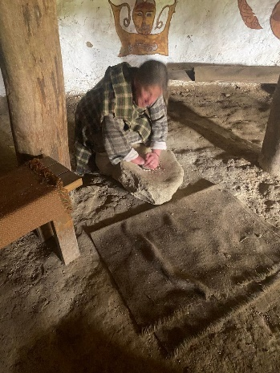
Figure 14. Driscoll, Laura Cait. A Museum Staff Member Grinding Wheat for Flour at Castell Henllys. 16th October 2022. Authors Personal Collection
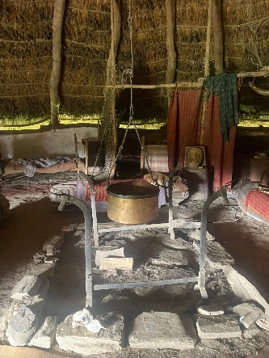
Figure 15. Driscoll, Laura Cait. Round House Cooking Area at Castell Henllys. 16th October 2022. Authors Personal Collection
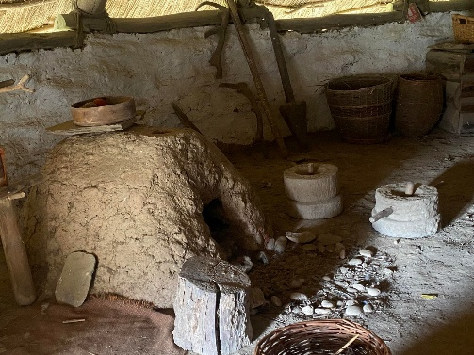
Figure 16. Driscoll, Laura Cait. Clay Bread Oven at Castell Henllys. 16th October 2022. Authors Personal Collection
Castell Henllys is an Iron Age village, the only one in Britain, is an experimental archaeology project where roundhouses have been reconstructed on the spot where they would have stood over 2,000 years ago. The historic site has food embedded throughout their museum, from signs in their café on herbs, how it is possible to still use the same ones as the Celts did and how they use them to the displays of traditional cooking materials and wheat grinding in the round houses. Historically, Castell Henllys would have been home to a big community of people that would have lived and worked together, producing food and materials.
The heritage site takes visitors on a journey, starting at the café, walking through the forest depicting myths and legends, passing prehistoric breeds of livestock grazing in the fields before arriving at the round houses where visitors can explore each one that represents a range of Iron Age living and working spaces as well as a granary. Alongside the cooking materials within the roundhouses for example pots (figure 14) and animal bones displaying evidence of food production, querns stones are also found (figure 13) within the roundhouses to showcase how to grind grain by hand. This is an experience that all visitors can partake in during their visit to the heritage site, and when schools visit, they can take it one step further and make bread out of the grains and a full sensory experience to the visit. However, these would be thrown out at the end of the day due to not having time to bake all the bread and it would have been unsanitary to give out to members of the public. The costumed interpreters, who represent members of the Demetae tribe are there to share knowledge of the life of those living at the roundhouses before, during, and after the Roman invasion.
The heritage site represents where food comes from and the bread part of the diet well, but a lack of pottery and artefacts made from more delicate materials which were not able to be preserved in the archaeological records, it is impossible to know all different parts of the diet past the bread and bones of animals.
The site, if given the time and finances, could add more dimension to its displays, by having food cooking all the time for food such as bread or oat cakes which may have been eaten during that time, is cheap, and easy to make. They could take the herbs grown in their gardeners’ patch of land and dry them in the roundhouses, presenting an olfactory as well as visual experience to the sites.

Discussion
Visits to these museums were helpful in understanding multiple different aspects from food representations, the opportunities for visitor interaction, the different types of displays used as well as looking at the innovative aspects captured within the sites. Nostalgia is a tool which, if used successfully, can motivate individuals to travel halfway around the world in order to be able to experience and reinforce their own identities.
Different museums within Wales, represent various aspects and areas of Welsh life. From the big estate kitchens at Llanerchaeron portraying both the life and wealth of the inhabitants as well as the servant quarters to Big Pit showing the minimum that miners and their families may have lived on, especially through the limited food they could take down the mine shaft. All four museums visited are representative not only of our history, but they are key for remembering the traditions and food cultures. Each one has a range of ways in which they can enhance the representations of each area. There are many food examples of the innovative ways they are working in already such as grinding flour, smelling the fires, and experiencing the food eaten. However, there are ways in which they can enhance their representations such as cooking food, sharing recipes and stories online and in person and using technology to portray feasts that could have taken place on-site. These displays can be very evocative linking a phenomenological connection that we can all share and relate to. This all leads to a sense of empathy with people when we think of how they eat and what they eat, immediately giving a connection to people of the past by seeing their food culture.
Heritage tourism depends on the feeling of authenticity within the displays, meaning that curators need to be give attention to how they stage or recreated ethnic and cultural traditions. It is possible for there to be a high perception of authenticity achieved during displays and events even if it is staged far away from the original source of the tradition.
Museums themselves are important heritage attractions that should be offering authentic cultural experiences, especially those which are on the original sites, or in original buildings such as those discussed. The visitors first-hand experience of authenticity can be evoked through the use of material objects, demonstrations, and technology, it is even more important for there to be a positive perception of authenticity displayed when representing food culture in Wales as it is such an integral
Some museums may get it wrong, whether that be by being too broad in their representation, or missing food completely from their displays. However, these are not criticisms of the museums, instead, they can be used as opportunities to provide useful lessons for curators. The UNESCO saying is true when researching food histories within Wales and safeguarding intangible heritage in the museums.
‘If intangible cultural heritage is not nurtured, it risks becoming lost forever, or frozen as a practice belonging to the past. Preserving this heritage and passing it on to the future generation strengthens it and keeps it alive.’
Although UNESCO identifies that it is the communities themselves which need to recognise their heritage and continue the traditions, perhaps it should also be up to museum curators within those societies to work with those who follow these traditions and practices. They could work to create a platform for the knowledge to be represented and safeguarded in a place that should have authentic representations of Welsh life and history.

Chapter 4: Conclusion

The purpose of this study was to analyse the ways in which museums within Wales represent a sense of place, going back to our roots and sharing our heritage through food histories and traditions. The stories of Welsh food have been almost ignored within Welsh history, often kept as a side topic but never fully in the forefront. This study has readdressed its importance, showing that food is a key part of the history and traditions of communities within Wales.
Food traditions and culture within Wales have been greatly impacted by a range of events. Firstly, colonialisation of the country had the effect of undermining confidence in a Welsh identity that was socially and structurally made secondary to English through language and institutions. Different areas of Wales have been impacted tangibly and intangibly and this can be seen in the emergence of industrialisation and the movement of people from England and abroad to Wales which created Anglophone Welsh. These scenarios have changed the foodscape of Wales, creating more of a hybridity of language surrounding the naming of food as well as food cultures. This has been shown in the ways food names have changed as well as recipes themselves, adapting to the area and community changes.
Wales’s cultural food heritage is something which is ever evolving and does not come from big events, instead the economic situations of households and communities have born meals and foods which characterise traditional Welsh food culture. Many of the food traditions are born from living off what is available whether that is by land or by sea, and in some cases through poverty and hardship.
At its heart, Welsh food heritage can be categorised as simple, understated, homely and community centred. Food heritage of Wales comprises a range of traditions based around local ingredients such as laver, cockles, lamb and home-grown fruits and vegetables. Recipes are created in the home and shared within the community, including diod fain, picau ar y maen, bara brith and cawl.
Welsh food heritage is not necessarily a homogenised experience, rather it reflects the many different communities, coastal, rural and industrial. Many other countries have been represented and recognised as having food traditions that need to be saved and protected within UNESCO, whereas Wales has had none. This could be down to the lack of engagement within Wales and their food, especially many food traditions were born out of poverty and communities may be reluctant to recognise the heritage of such food, however despite their humble origins, they are still important to be remembered and recognised.
Some museums have been very successful in promoting food heritage and using the particular qualities of food to engage visitors. Phenomenological approaches that exploit the sensory aspects of food have shown to be effective in enhancing the visitor experience, stimulating and creating concrete memories, and stimulating conversations and activities that promote the continuing development of community food heritage. Interactive food exhibits can help enhance the authenticity of the visitor experience, which helps to promote food heritage.
This study has gone some way to enhance the understanding of the role food has to play within society, and how museums can represent this in a multidimensional way. Museums in Wales present various approaches to the representation of Welsh food culture. Some have had food within the forefront of the displays whilst others have barely addressed it. Examples of good practice, offer insight into some different ways in which Welsh museums can develop engagement further with food heritage. While time and budgets may hinder the exploration and development of innovative, multisensory displays, there is much that can be considered to enhance the contribution made by Welsh museums to celebrate and highlight Welsh food heritage.
Further study would be valuable to expand the understanding of Welsh food heritage. It should include stories coming from oral histories from those who have lived Welsh culture and traditions. There is a need to create a shared story that celebrates Welsh food heritage as a source of pride and Welsh identity that is able to encompass communities in all the different parts of Wales. Communities and museums can work collaboratively to stimulate the conversation around what part food and food traditions play in homes and communities around Wales.

Word Count: 15,770

Bibliography
‘A Brief History of St Fagans’, Museum Wales <https://museum.wales/stfagans/stfagans-history/> [accessed 24 August 2022]
A, Emelianova Nadezhda, ‘Sociolinguistic Conditions of Functioning of the Welsh Variety of the English Language (Wenglish)’, Language and Culture, 3, 2014, 40–48
Abd Rahman, Nur Hidayah, Zainab Khalifah, and Hairul Ismail, ‘Entanglement between Visitor and Attractions through Sensory Experiences Perspective in the Context of Cultural Heritage Tourism’, 2018
‘About Amgueddfa Cymru’, Museum Wales <https://museum.wales/about/work-for-us/background/> [accessed 23 January 2023]
‘About Castell Henllys’, Pembrokeshire Coast National Park <https://www.pembrokeshirecoast.wales/castell-henllys/about-castell-henllys/> [accessed 12 January 2023]
admin, ‘Cenedl Heb Iaith, Cenedl Heb Galon’, Institute of Welsh Affairs, 2013 <https://www.iwa.wales/agenda/2013/02/cenedl-heb-iaith-cenedl-heb-galon/> [accessed 15 November 2022]
Almansouri, Mohammad, Ruud Verkerk, Vincenzo Fogliano, and Pieternel Luning, ‘Exploration of Heritage Food Concept’, Trends in Food Science & Technology, 111 (2021) <https://doi.org/10.1016/j.tifs.2021.01.013>
Anderson, Benedict Richard O’Gorman, Imagined Communities: Reflections on the Origin and Spread of Nationalism (Verso, 1991)
van Balgooy, Max, ‘A Visitors’ Perspective on Visitor Engagement : Understanding Visitors’ Needs Will Greatly Inform Our Work in Engagement’, Museum, 96 (2017), 40–43
‘BBC Radio 4 - The Food Programme, A Taste of Britain Revisited - Wales’, BBC <https://www.bbc.co.uk/programmes/b04fy2bl> [accessed 4 January 2023]
Bender, David A., ‘Welsh Rarebit’, in A Dictionary of Food and Nutrition (Oxford University Press, 2014) <https://www.oxfordreference.com/display/10.1093/acref/9780191752391.001.0001/acref-9780191752391-e-5779> [accessed 7 January 2023]
Bendix, Regina, ‘Life Itself: An Essay on the Sensory and the (Potential) End of Heritage Making’, Traditiones, 50.1 (2021), 43–51 <https://doi.org/10.3986/Traditio2021500104>
Bessière, Jacinthe, ‘“Heritagisation”, a Challenge for Tourism Promotion and Regional Development: An Example of Food Heritage’, Journal of Heritage Tourism, 8.4 (2013), 275–91 <https://doi.org/10.1080/1743873X.2013.770861>
Bhabha, Homi K., The Location of Culture, 2nd edn (London: Routledge, 2004) <https://doi.org/10.4324/9780203820551>
———, ‘The Other Question: Difference, Discrimination and the Discourse of Colonialism’, in Literature Politics & Theory (Routledge, 2003)
Bohata, Kirsti, Postcolonialism Revisited: Writing Wales in English (University of Wales Press, 2009)
Brauch, Julia, and Anna Lipphardt, ‘Foodscapes: The Culinary Landscapes of Russian-Jewish New York’, in Jewish Topographies (Routledge, 2008)
Breverton, Terry, Physicians of Myddfai: Cures and Remedies of the Mediaeval World (Cambria Books, 2012)
Bruley, Sue, ‘The Politics of Food: Gender, Family, Community and Collective Feeding in South Wales in the General Strike and Miners’ Lockout of 1926’, Twentieth Century British History, 18.1 (2007), 54–77 <https://doi.org/10.1093/tcbh/hwl045>
Cambrensis, Gerald of Wales Giraldus, The Journey Through Wales and the Description of Wales, ed. by Betty Radice, trans. by L. Thorpe, Annotated edition (Harmondsworth ; New York etc.: Penguin Classics, 1978)
Carss, David N., Ana C. Brito, Paula Chainho, Aurélie Ciutat, Xavier de Montaudouin, Rosa M. Fernández Otero, and others, ‘Ecosystem Services Provided by a Non-Cultured Shellfish Species: The Common Cockle Cerastoderma Edule’, Marine Environmental Research, 158 (2020), 104931 <https://doi.org/10.1016/j.marenvres.2020.104931>
Cater, Carl Iain, Katja Poguntke, and Wyn Morris, ‘Y Wladfa Gymreig: Outbound Diasporic Tourism and Contribution to Identity’, Tourism Geographies, 21.4 (2019), 665–86 <https://doi.org/10.1080/14616688.2019.1571095>
Chhabra, Deepak, Robert Healy, and Erin Sills, ‘Staged Authenticity and Heritage Tourism’, Annals of Tourism Research, 30.3 (2003), 702–19 <https://doi.org/10.1016/S0160-7383(03)00044-6>
Csergo, Julia, ‘Food As a Collective Heritage Brand in the Era of Globalization’, International Journal of Cultural Property, 25.4 (2018), 449–68 <https://doi.org/10.1017/S0940739118000322>
Day, G. A., and H. Mackay, ‘Place and Belonging.’, Understanding Comtemporary Wales., 2010, 26–57
Development, PodBean, ‘The Sensory Heirloom of Food & Memory’ <https://asavouredlife.podbean.com/e/the-sensory-heirloom-of-food-memory/> [accessed 22 August 2022]
Di Fiore, Laura, ‘Chapter 2 Heritage and Food History : A Critical Assessment’, 2020 <https://directory.doabooks.org/handle/20.500.12854/30400> [accessed 21 August 2022]
Dietler, Michael, ‘Culinary Encounters: Food, Identity, and Colonialism. In The Archaeology of Food and Identity, Edited by Katheryn Twiss, Pp. 218-242. Carbondale: Center for Archaeological Investigations Press, University of Southern Illinois. 2007’, The Archaeology of Food and Identity, 2007 <https://www.academia.edu/273518/Culinary_encounters_food_identity_and_colonialism_In_The_Archaeology_of_Food_and_Identity_edited_by_Katheryn_Twiss_pp_218_242_Carbondale_Center_for_Archaeological_Investigations_Press_University_of_Southern_Illinois_2007> [accessed 14 November 2022]
‘Eat Your History: A Shared Table | MHNSW’ <https://mhnsw.au/whats-on/exhibitions/eat-your-history-shared-table/> [accessed 5 January 2023]
‘Eating and Shopping at Llanerchaeron|Wales’, National Trust <https://www.nationaltrust.org.uk/visit/wales/llanerchaeron/eating-and-shopping-at-llanerchaeron> [accessed 12 January 2023]
Edwards, John R., Talk Tidy - the Art of Speaking Wenglish (D.Brown & Sons Ltd, 1985)
Evans, Daniel John, ‘Welshness in “British Wales”: Negotiating National Identity at the Margins’, Nations and Nationalism, 25.1 (2019), 167–90 <https://doi.org/10.1111/nana.12390>
Evans, Neil, ‘Writing Regional History’ <https://www.academia.edu/25559921/Writing_Regional_history> [accessed 26 January 2023]
‘Faggots, Herring, and Small Beer: Food for Sale’, Peoples Collection Wales <https://www.peoplescollection.wales/content/faggots-herring-and-small-beer-food-sale> [accessed 23 January 2023]
Geyzen, Anneke, ‘Food Studies and the Heritage Turn: A Conceptual Repertoire’, Food and History, 12.2 (2014), 67–96 <https://doi.org/10.1484/J.FOOD.5.108963>
Graves, Carwyn, Welsh Food Stories (Calon, 2022)
Griffiths, Ralph Alan, ‘Union, Act of (Wales)’, in The Oxford Companion to British History (Oxford University Press, 2009) <https://www.oxfordreference.com/display/10.1093/acref/9780199567638.001.0001/acref-9780199567638-e-4321> [accessed 23 January 2023]
Gruffudd, Pyrs, ‘Remaking Wales: Nation-Building and the Geographical Imagination, 1925–1950’, Political Geography, 14.3 (1995), 219–39 <https://doi.org/10.1016/0962-6298(95)93185-L>
Hannah Glasse, The Art Of Cookery, 1747 <http://archive.org/details/TheArtOfCookery> [accessed 7 January 2023]
Hendrickson, Robert, Animal Crackers: A Bestial Lexicon, Open market ed edition (New York: Penguin, 1983)
Hoffmann, Richard C. (Richard Charles), ‘Remembrance of Repasts. An Anthropology of Food and Memory (Review)’, Journal of Modern Greek Studies, 24.2 (2006), 472–74 <https://doi.org/10.1353/mgs.2006.0023>
Hollinshead, Keith, ‘Touirsm and the Restless Peoples: A Dialectical Inspection of Bhabha’s Halfway Populations’, Tourism Culture & Communication, 1.1 (1998), 49–77
Ishak, Noriza, Mohd Salehuddin Mohd Zahari, M.S. Shazali, Rosmaliza Muhammad, and S Hannita, ‘Acculturation, Foodways and Malaysian Food Identity’, in Current Issues in Hospitality and Tourism Research and Innovations, 2012, pp. 359–63 <https://doi.org/10.1201/b12752-71>
Johnston, Josée, and Michael Goodman, ‘Spectacular Foodscapes: Food Celebrities and the Politics of Lifestyle Mediation in an Age of Inequality’, Food Culture and Society An International Journal of Multidisciplinary Research, 18 (2015) <https://doi.org/10.2752/175174415X14180391604369>
Johnstone, Christian Isobel, The Cook and Housewife’s Manual, by Margaret Dods, 1826
Jones, Aled, and Bill Jones, ‘The Welsh World and the British Empire, c.1851–1939: An Exploration’, The Journal of Imperial and Commonwealth History, 31.2 (2003), 57–81 <https://doi.org/10.1080/03086530310001705606>
Jones, Tecwyn Vaughan, ‘Welsh Nots, Welsh Notes and Welsh Nuts: A Dictionary of Phrases with the Word “Welsh”’, Folklore, 112.2 (2001), 230–31
Jones, Vilma Nancy, and Claudia Monica Sager, ‘Convergencia multilingüística en un campo lexical. El habla en una provincia de la Patagonia argentina: Chubut (Multilingual convergence in a lexical field. Speech in a province of Argentine Patagonia: Chubut)’, Revista del Centro de Ciencias del Lenguaje, 24, 2001, 85–97
Knight, Jeremy, Blaenavon: From Iron Town to World Heritage Site, UK ed. edition (Little Logaston, Woonton, Almeley, Herefordshire: Logaston Press, 2016)
Koziol, Christopher, ‘How Heritage’s Debate on Values Fuels Its Valorization Engine: The Side Effects of Controversy from Alois Riegl to Richard Moe’, Change Over Time, 3.2 (2013), 244–57 <https://doi.org/10.1353/cot.2013.0012>
Kurin, Richard, ‘Safeguarding Intangible Cultural Heritage in the 2003 UNESCO Convention: A Critical Appraisal’, Museum International, 56.1–2 (2004), 66–77 <https://doi.org/10.1111/j.1350-0775.2004.00459.x>
Kwik, J., ‘Traditional Food Knowledge: A Case Study of an Immigrant Canadian “Foodscape”’, Environments, 36 (2008), 59–74
Latham, K.F., ‘What Is “the Real Thing” in the Museum? An Interpretative Phenomenological Study’, Museum Management and Curatorship, 30.1 (2015), 2–20 <https://doi.org/10.1080/09647775.2015.1008393>
‘Learn at Big Pit: National Coal Museum’, Museum Wales <https://museum.wales/bigpit/learning/> [accessed 23 January 2023]
Levent, Nina, and Irina D. Mihalache, Food and Museums (Bloomsbury Publishing, 2018)
‘Llanerchaeron | Ceredigion | Wales’, National Trust <https://www.nationaltrust.org.uk/visit/wales/llanerchaeron> [accessed 12 January 2023]
Llerena, Zella, ‘Food Conjures Memory: Making Memory in the Museum’, 2009 <https://tspace.library.utoronto.ca/handle/1807/78750> [accessed 21 August 2022]
Low, Kelvin E.Y., ‘Concrete Memories and Sensory Pasts: Everyday Heritage and the Politics of Nationhood’, Pacific Affairs, 90.2 (2017), 275–95 <https://doi.org/10.5509/2017902275>
Lublin, Geraldine, ‘The War of the Tea Houses, or How Welsh Heritage in Patagonia Became a Valuable Commodity’, E-Keltoi: Journal of Interdisciplinary Celtic Studies, 1.1 (2009) <https://dc.uwm.edu/ekeltoi/vol1/iss1/3>
Mac Con Iomaire, Máirtín, ‘Recognizing Food as Part of Ireland’s Intangible Cultural Heritage’, Folk Life, 56.2 (2018), 93–115 <https://doi.org/10.1080/04308778.2018.1502402>
‘Meet the Tribe’, Pembrokeshire Coast National Park <https://www.pembrokeshirecoast.wales/castell-henllys/about-castell-henllys/meet-the-tribe/> [accessed 23 January 2023]
‘Museum Definition’, International Council of Museums <https://icom.museum/en/resources/standards-guidelines/museum-definition/> [accessed 28 November 2022]
Newling, Jacqui, Eat Your History: Stories and Recipes from Australian Kitchens (NewSouth Publishing, 2015)
O’Connor, Kaori, ‘The Secret History of “the Weed of Hiraeth”: Laverbread, Identity, and Museums in Wales’, Journal of Museum Ethnography, 22, 2009, 82–101
Ortega, Gena Philibert, From the Family Kitchen: Discover Your Food Heritage and Preserve Favorite Recipes (Penguin, 2012)
‘Our Rare Welsh Oats’, The A Team Foundation <https://www.ateamfoundation.org/blog-1/2019/5/3/our-rare-welsh-oats> [accessed 28 November 2022]
Parliament, UK, Act of Uniformity 1949 <http://archives.parliament.uk/index.php?> [accessed 23 January 2023]
Peate, Iorwerth Cyfeiliog, AMGUEDDFEYDD GWERIN. FOLK MUSEUMS. WELSH & ENG
Philpott, Sarah, ‘“Traditional Dishes Were Borne out of Poverty”: A Brief History of Welsh Food’, New Statesman, 2018 <https://www.newstatesman.com/culture/food-drink/2018/11/traditional-dishes-were-borne-out-poverty-brief-history-welsh-food> [accessed 22 August 2022]
Pitchford, Susan R, ‘Ethnic Tourism and Nationalism in Wales’, Annals of Tourism Research, 22.1 (1995), 35–52 <https://doi.org/10.1016/0160-7383(94)00068-4>
Richardson, Jim, ‘Why Do Stories Matter to Museums and How Can Museums Become Better Storytellers?’, MuseumNext, 2023 <https://www.museumnext.com/article/why-do-stories-matter-to-museums-and-how-can-museums-become-better-storytellers/> [accessed 26 January 2023]
‘Roundhouses’, Past to Present Archaeology <https://pasttopresent.org/2022/02/01/roundhouses/> [accessed 23 January 2023]
Sjöholm, Jennie, ‘Heritagisation, Re-Heritagisation and De-Heritagisation of Built Environments: The Urban Transformation of Kiruna, Sweden’ <https://www.academia.edu/26396031/Heritagisation_Re_Heritagisation_and_De_Heritagisation_of_Built_Environments_The_Urban_Transformation_of_Kiruna_Sweden> [accessed 27 October 2022]
‘Soups - Recipes from Scotland - National Library of Scotland’ <https://digital.nls.uk/recipes/themes/baking/index.html> [accessed 4 January 2023]
Stourton, James, Heritage: A History of How We Conserve Our Past (Apollo, 2022)
Sutcliffe-Braithwaite, Florence, and Natalie Thomlinson, ‘National Women Against Pit Closures: Gender, Trade Unionism and Community Activism in the Miners’ Strike, 1984–5’, Contemporary British History, 32.1 (2018), 78–100 <https://doi.org/10.1080/13619462.2017.1408540>
Sutton, David, ‘The Sensory Experience of Food: Memory as a Sense’, Food, Culture and Society <https://www.academia.edu/2135666/The_Sensory_Experience_of_Food_Memory_as_a_Sense> [accessed 22 August 2022]
Sutton, David E., ‘Food and the Senses’, Annual Review of Anthropology, 39.1 (2010), 209–23 <https://doi.org/10.1146/annurev.anthro.012809.104957>
———, Remembrance of Repasts: An Anthropology of Food and Memory (Berg Publishers, 2001)
Taheri, Babak, Aliakbar Jafari, and Kevin O’Gorman, ‘Keeping Your Audience: Presenting a Visitor Engagement Scale’, Tourism Management, 42 (2014), 321–29 <https://doi.org/10.1016/j.tourman.2013.12.011>
Tai, Steph, ‘In Fairness to Future Generations of Eaters’, Georgetown Environmental Law Review, 32 (2019), 515
TEDxTC - Winona LaDuke - Seeds of Our Ancestors, Seeds of Life, dir. by TEDx Talks, 2012 <https://www.youtube.com/watch?v=pHNlel72eQc> [accessed 23 January 2023]
‘The Cook and the Curator | Eat Your History | Sydney Living Museums’ <https://blogs.sydneylivingmuseums.com.au/cook/> [accessed 5 January 2023]
Tibbott, Sara Minwel, Welsh Fare: Selection of Traditional Recipes, New Edition (Cardiff: National Museums and Galleries of Wales, 1976)
Timothy, Dallen J., and Amos S. Ron, ‘Understanding Heritage Cuisines and Tourism: Identity, Image, Authenticity, and Change’, Journal of Heritage Tourism, 8.2–3 (2013), 99–104 <https://doi.org/10.1080/1743873X.2013.767818>
Timothy, Dallen J., and Gyan P. Nyaupane, eds., Cultural Heritage and Tourism in the Developing World: A Regional Perspective (London: Routledge, 2009) <https://doi.org/10.4324/9780203877753>
Trichopoulou, Antonia, and Pagona Lagiou, ‘Healthy Traditional Mediterranean Diet: An Expression of Culture, History, and Lifestyle’, Nutrition Reviews, 55.11 (1997), 383–89 <https://doi.org/10.1111/j.1753-4887.1997.tb01578.x>
UNESCO, ‘International Round Table: “Intangible Cultural Heritage – Working Definitions”’, in Annotated Agenda (Piedmont, Italy, 2001) <https://ich.unesco.org/doc/src/00075-EN.pdf> [accessed 23 January 2023]
———, ‘Recommendation on the Safeguarding of Traditional Culture and Folklore’, UNESCO <https://en.unesco.org/about-us/legal-affairs/recommendation-safeguarding-traditional-culture-and-folklore> [accessed 2 October 2022]
‘UNESCO - Browse the Lists of Intangible Cultural Heritage and the Register of Good Safeguarding Practices’ <https://ich.unesco.org/en/lists> [accessed 23 January 2023]
‘UNESCO - Mediterranean Diet’ <https://ich.unesco.org/en/RL/mediterranean-diet-00884> [accessed 26 January 2023]
‘UNESCO - Proclamation of the Masterpieces of the Oral and Intangible Heritage of Humanity (2001-2005)’ <https://ich.unesco.org/en/proclamation-of-masterpieces-00103> [accessed 23 January 2023]
‘UNESCO - What Is Intangible Cultural Heritage?’ <https://ich.unesco.org/en/what-is-intangible-heritage-00003> [accessed 23 September 2022]
‘UNESCO World Heritage Sites in Wales’, Wales, 2022 <https://www.wales.com/visit/unesco-world-heritage-wales> [accessed 2 October 2022]
‘Visiting the Villa at Llanerchaeron|Wales’, National Trust <https://www.nationaltrust.org.uk/visit/wales/llanerchaeron/visiting-the-john-nash-villa-at-llanerchaeron> [accessed 12 January 2023]
Wales, Museum, ‘National Museum of Wales Learning Resources’ <https://museum.wales/media/36220/Primary-School-Visits.pdf> [accessed 23 January 2023]
WalesOnline, ‘Women’s Role in the Miners’ Strike, 25 Years On...’, WalesOnline, 2009 <http://www.walesonline.co.uk/lifestyle/showbiz/womens-role-miners-strike-25-2116379> [accessed 4 January 2023]
‘Welsh Food - Traditonal Cooking, Food and Recipes from Wales’, Historic UK <https://www.historic-uk.com/CultureUK/Traditional-Welsh-Food/> [accessed 11 November 2022]
‘Welsh Foods’, Museum Wales <https://museum.wales/collections/welsh-foods/?id=120> [accessed 4 January 2023]
Wood, Elizabeth, and Kiersten F. Latham, ‘The Thickness of the World: Exploring the Curriculum of Museums through Phenomenological Touch’, Journal of Curriculum Theorizing, 27.2 (2011) <https://journal.jctonline.org/index.php/jct/article/view/347> [accessed 1 January 2023]
Владимировна, Кульгавова Лариса, ‘History And Mystery Of Welsh Rabbit’, in SCIENTIFIC DEVELOPMENTS: EURASIAN REGION -International scientific conference theoretical and applied developments (presented at the Международная научная конференция теоретических и прикладных разработок «Научные разработки: евразийский регион» (International scientific conference of theoretical and applied developments ‘Scientific developments: the Eurasian region’), Moscow: Д.Р. Хисматуллин. – Москва: Издательство Инфинити, 2019), pp. 38–41

Table of Figures

Figure 1. Driscoll, Laura Cait. Piacu ar y Maen. 2021. Authors Personal Collection 0
Figure 2 Driscoll, Laura-Cait. A Modern Meal at St Fagans Living History Museum. 23rd October 2022. Authors Personal Collection 36
Figure 3 Driscoll, Laura-Cait. A Modern Kitchen at St Fagans Living History Museum. 23rd October 2022. Authors Personal Collection 36
Figure 4. Driscoll, Laura Cait. St Fagans Fireplace Kitchen. 23rd October 2022. Authors Personal Collection 36
Figure 5. Driscoll, Laura Cait. St Fagans Traditional Bakery. 23rd October 2022. Authors Personal Collection 37
Figure 6. Driscoll, Laura Cait. St Fagans Cakes at Bakery. 23rd October 2022. Authors Personal Collection 38
Figure 7. Driscoll, Laura Cait. Llanerchaeron Dining Room. 5th June 2022. Authors Personal Collection 40
Figure 8. . Driscoll, Laura Cait. Llanerchaeron Kitchen Pantry. 5th June 2022. Authors Personal Collection 40
Figure 9. . Driscoll, Laura Cait. Llanerchaeron Kitchen Area. 5th June 2022. Authors Personal Collection 40
Figure 10. . Driscoll, Laura Cait. Big Pit Museum Display of a Water Jack and Tommy Box Food Tin. 8th October 2022. Authors Personal Collection 43
Figure 11. Driscoll, Laura Cait. Big Pit Museum Display of Miners Eating Their Lunch Underground. 8th October 2022. Authors Personal Collection 44
Figure 12. . Driscoll, Laura Cait. Big Pit Museum Display of a Pig Sty. 8th October 2022. Authors Personal Collection 45
Figure 13. . Driscoll, Laura Cait. Big Pit Museum Display of Plastic Food Behind Glass. 8th October 2022. Authors Personal Collection 46
Figure 14. Driscoll, Laura Cait. A Museum Staff Member Grinding Wheat For Flour at Castell Henllys. 16th October 2022. Authors Personal Collection 48
Figure 15. Driscoll, Laura Cait. Round House Cooking Area at Castell Henllys. 16th October 2022. Authors Personal Collection 48
Figure 16. Driscoll, Laura Cait. Clay Bread Oven at Castell Henllys. 16th October 2022. Authors Personal Collection 49

Carwyn Graves, Welsh Food Stories (Calon, 2022).
‘UNESCO - What Is Intangible Cultural Heritage?’ <https://ich.unesco.org/en/what-is-intangible-heritage-00003> [accessed 23 September 2022].
‘UNESCO - What Is Intangible Cultural Heritage?’
‘UNESCO - What Is Intangible Cultural Heritage?’
‘UNESCO - What Is Intangible Cultural Heritage?’
Laura Di Fiore, ‘Chapter 2 Heritage and Food History: A Critical Assessment’, 2020 <https://directory.doabooks.org/handle/20.500.12854/30400> [accessed 21 August 2022].p35
Di Fiore.
Zella Llerena, ‘Food Conjures Memory: Making Memory in the Museum’, 2009 <https://tspace.library.utoronto.ca/handle/1807/78750> [accessed 21 August 2022].p.1
Llerena. p.2
Llerena.p.7
Llerena. p.7
Llerena. p.8
Máirtín Mac Con Iomaire, ‘Recognizing Food as Part of Ireland’s Intangible Cultural Heritage’, Folk Life, 56.2 (2018), 93–115 <https://doi.org/10.1080/04308778.2018.1502402>.p.2
Graves.
Babak Taheri, Aliakbar Jafari, and Kevin O’Gorman, ‘Keeping Your Audience: Presenting a Visitor Engagement Scale’, Tourism Management, 42 (2014), 321–29 <https://doi.org/10.1016/j.tourman.2013.12.011>.p.1
TEDxTC - Winona LaDuke - Seeds of Our Ancestors, Seeds of Life, dir. by TEDx Talks, 2012 <https://www.youtube.com/watch?v=pHNlel72eQc> [accessed 23 January 2023].
Gena Philibert Ortega, From the Family Kitchen: Discover Your Food Heritage and Preserve Favorite Recipes (Penguin, 2012).p.1
David E. Sutton, Remembrance of Repasts: An Anthropology of Food and Memory (Berg Publishers, 2001).
Llerena.p.1
Richard C. (Richard Charles) Hoffmann, ‘Remembrance of Repasts. An Anthropology of Food and Memory (Review)’, Journal of Modern Greek Studies, 24.2 (2006), 472–74 <https://doi.org/10.1353/mgs.2006.0023>.p.472
Jennie Sjöholm, ‘Heritagisation, Re-Heritagisation and De-Heritagisation of Built Environments: The Urban Transformation of Kiruna, Sweden’ <https://www.academia.edu/26396031/Heritagisation_Re_Heritagisation_and_De_Heritagisation_of_Built_Environments_The_Urban_Transformation_of_Kiruna_Sweden> [accessed 27 October 2022]. P.26
Julia Brauch and Anna Lipphardt, ‘Foodscapes: The Culinary Landscapes of Russian-Jewish New York’, in Jewish Topographies (Routledge, 2008).
Josée Johnston and Michael Goodman, ‘Spectacular Foodscapes: Food Celebrities and the Politics of Lifestyle Mediation in an Age of Inequality’, Food Culture and Society An International Journal of Multidisciplinary Research, 18 (2015) <https://doi.org/10.2752/175174415X14180391604369>.
J. Kwik, ‘Traditional Food Knowledge: A Case Study of an Immigrant Canadian “Foodscape”’, Environments, 36 (2008), 59–74.
Julia Csergo, ‘Food as a Collective Heritage Brand in the Era of Globalization,’ International Journal of Cultural Property, 25.4 (2018), 449–68 <https://doi.org/10.1017/S0940739118000322>.
Anneke Geyzen, ‘Food Studies and the Heritage Turn: A Conceptual Repertoire,’ Food and History, 12.2 (2014), 67–96 <https://doi.org/10.1484/J.FOOD.5.108963>.
Cultural Heritage and Tourism in the Developing World: A Regional Perspective, ed. by Dallen J. Timothy and Gyan P. Nyaupane (London: Routledge, 2009) <https://doi.org/10.4324/9780203877753>.p.42
Benedict Richard O’Gorman Anderson, Imagined Communities: Reflections on the Origin and Spread of Nationalism (Verso, 1991).
Daniel John Evans, ‘Welshness in “British Wales”: Negotiating National Identity at the Margins’, Nations and Nationalism, 25.1 (2019), 167–90 <https://doi.org/10.1111/nana.12390>.p.167
Daniel John Evans.p.168
Pyrs Gruffudd, ‘Remaking Wales: Nation-Building and the Geographical Imagination, 1925–1950’, Political Geography, 14.3 (1995), 219–39 <https://doi.org/10.1016/0962-6298(95)93185-L>.p.220
Neil Evans, ‘Writing Regional History’ <https://www.academia.edu/25559921/Writing_Regional_history> [accessed 26 January 2023].
Daniel John Evans.p.168
Daniel John Evans.p.168
Daniel John Evans.
G. A. Day and H. Mackay, ‘Place and Belonging.’, Understanding Comtemporary Wales., 2010, 26–57.
‘UNESCO - What Is Intangible Cultural Heritage?’
Dallen J. Timothy and Amos S. Ron, ‘Understanding Heritage Cuisines and Tourism: Identity, Image, Authenticity, and Change’, Journal of Heritage Tourism, 8.2–3 (2013), 99–104 <https://doi.org/10.1080/1743873X.2013.767818>.p.99
Di Fiore.
Daniel John Evans.p.168
‘UNESCO - Browse the Lists of Intangible Cultural Heritage and the Register of Good Safeguarding Practices’ <https://ich.unesco.org/en/lists> [accessed 23 January 2023].
‘UNESCO - Mediterranean Diet’ <https://ich.unesco.org/en/RL/mediterranean-diet-00884> [accessed 26 January 2023].
Antonia Trichopoulou and Pagona Lagiou, ‘Healthy Traditional Mediterranean Diet: An Expression of Culture, History, and Lifestyle’, Nutrition Reviews, 55.11 (1997), 383–89 <https://doi.org/10.1111/j.1753-4887.1997.tb01578.x>.p.387
Daniel John Evans.
Florence Sutcliffe-Braithwaite and Natalie Thomlinson, ‘National Women Against Pit Closures: Gender, Trade Unionism and Community Activism in the Miners’ Strike, 1984–5’, Contemporary British History, 32.1 (2018), 78–100 <https://doi.org/10.1080/13619462.2017.1408540>.p.93
PodBean Development, ‘The Sensory Heirloom of Food & Memory’ <https://asavouredlife.podbean.com/e/the-sensory-heirloom-of-food-memory/> [accessed 22 August 2022].
Kirsti Bohata, Postcolonialism Revisited: Writing Wales in English (University of Wales Press, 2009).
Graves.
Gerald of Wales Giraldus Cambrensis, The Journey Through Wales and the Description of Wales, ed. by Betty Radice, trans. by L. Thorpe, Annotated edition (Harmondsworth ; New York etc.: Penguin Classics, 1978).
Sara Minwel Tibbott, Welsh Fare: Selection of Traditional Recipes, New Edition (Cardiff: National Museums and Galleries of Wales, 1976).
‘BBC Radio 4 - The Food Programme, A Taste of Britain Revisited - Wales’, BBC <https://www.bbc.co.uk/programmes/b04fy2bl> [accessed 4 January 2023].
‘BBC Radio 4 - The Food Programme, A Taste of Britain Revisited - Wales’.
‘BBC Radio 4 - The Food Programme, A Taste of Britain Revisited - Wales’.
Graves.p.77
Graves.p.79
David N. Carss and others, ‘Ecosystem Services Provided by a Non-Cultured Shellfish Species: The Common Cockle Cerastoderma Edule’, Marine Environmental Research, 158 (2020), 104931 <https://doi.org/10.1016/j.marenvres.2020.104931>.p.5
Graves.
‘BBC Radio 4 - The Food Programme, A Taste of Britain Revisited - Wales’.
‘BBC Radio 4 - The Food Programme, A Taste of Britain Revisited - Wales’.
‘BBC Radio 4 - The Food Programme, A Taste of Britain Revisited - Wales’.
‘Welsh Foods’, Museum Wales <https://museum.wales/collections/welsh-foods/?id=120> [accessed 4 January 2023].
‘Welsh Foods’.
Terry Breverton, Physicians of Myddfai: Cures and Remedies of the Mediaeval World (Cambria Books, 2012).
Graves.p.202
Sue Bruley, ‘The Politics of Food: Gender, Family, Community and Collective Feeding in South Wales in the General Strike and Miners’ Lockout of 1926’, Twentieth Century British History, 18.1 (2007), 54–77 <https://doi.org/10.1093/tcbh/hwl045>.
WalesOnline, ‘Women’s Role in the Miners’ Strike, 25 Years On...’, WalesOnline, 2009 <http://www.walesonline.co.uk/lifestyle/showbiz/womens-role-miners-strike-25-2116379> [accessed 4 January 2023].
Christian Isobel Johnstone, The Cook and Housewife’s Manual, by Margaret Dods, 1826.
‘Soups - Recipes from Scotland - National Library of Scotland’ <https://digital.nls.uk/recipes/themes/baking/index.html> [accessed 4 January 2023].
Hannah Glasse, The Art Of Cookery, 1747 <http://archive.org/details/TheArtOfCookery> [accessed 7 January 2023].p.146
David A. Bender, ‘Welsh Rarebit’, in A Dictionary of Food and Nutrition (Oxford University Press, 2014) <https://www.oxfordreference.com/display/10.1093/acref/9780191752391.001.0001/acref-9780191752391-e-5779> [accessed 7 January 2023].
Кульгавова Лариса Владимировна, ‘History And Mystery Of Welsh Rabbit’, in SCIENTIFIC DEVELOPMENTS: EURASIAN REGION -International scientific conference theoretical and applied developments (presented at the Международная научная конференция теоретических и прикладных разработок «Научные разработки: евразийский регион» (International scientific conference of theoretical and applied developments ‘Scientific developments: the Eurasian region’), Moscow: Д.Р. Хисматуллин. – Москва: Издательство Инфинити, 2019), pp. 38–41.p.38
Владимировна. P.38
Владимировна.p.38
Владимировна.p.39
Владимировна.p.39
Tecwyn Vaughan Jones, ‘Welsh Nots, Welsh Notes and Welsh Nuts: A Dictionary of Phrases with the Word “Welsh”’, Folklore, 112.2 (2001), 230–31.p.230
Robert Hendrickson, Animal Crackers: A Bestial Lexicon, Open market ed edition (New York: Penguin, 1983).
Geraldine Lublin, ‘The War of the Tea Houses, or How Welsh Heritage in Patagonia Became a Valuable Commodity’, E-Keltoi: Journal of Interdisciplinary Celtic Studies, 1.1 (2009) <https://dc.uwm.edu/ekeltoi/vol1/iss1/3>.p.77
Vilma Nancy Jones and Claudia Monica Sager, ‘Convergencia multilingüística en un campo lexical. El habla en una provincia de la Patagonia argentina: Chubut (Multilingual convergence in a lexical field. Speech in a province of Argentine Patagonia: Chubut)’, Revista del Centro de Ciencias del Lenguaje, 24, 2001, 85–97.
Lublin.p.72
Lublin.p.77
Homi K. Bhabha, The Location of Culture, 2nd edn (London: Routledge, 2004) <https://doi.org/10.4324/9780203820551>.
Noriza Ishak and others, ‘Acculturation, Foodways and Malaysian Food Identity’, in Current Issues in Hospitality and Tourism Research and Innovations, 2012, pp. 359–63 <https://doi.org/10.1201/b12752-71>.
Keith Hollinshead, ‘Touirsm and the Restless Peoples: A Dialectical Inspection of Bhabha’s Halfway Populations’, Tourism Culture & Communication, 1.1 (1998), 49–77.
Bhabha, The Location of Culture.
‘UNESCO - What Is Intangible Cultural Heritage?’p.95
‘BBC Radio 4 - The Food Programme, A Taste of Britain Revisited - Wales’.
‘BBC Radio 4 - The Food Programme, A Taste of Britain Revisited - Wales’.
Michael Dietler, ‘Culinary Encounters: Food, Identity, and Colonialism. In The Archaeology of Food and Identity, Edited by Katheryn Twiss, Pp. 218-242. Carbondale: Center for Archaeological Investigations Press, University of Southern Illinois. 2007’, The Archaeology of Food and Identity, 2007 <https://www.academia.edu/273518/Culinary_encounters_food_identity_and_colonialism_In_The_Archaeology_of_Food_and_Identity_edited_by_Katheryn_Twiss_pp_218_242_Carbondale_Center_for_Archaeological_Investigations_Press_University_of_Southern_Illinois_2007> [accessed 14 November 2022].
Susan R Pitchford, ‘Ethnic Tourism and Nationalism in Wales’, Annals of Tourism Research, 22.1 (1995), 35–52 <https://doi.org/10.1016/0160-7383(94)00068-4>.
Pitchford.
Ralph Alan Griffiths, ‘Union, Act of (Wales)’, in The Oxford Companion to British History (Oxford University Press, 2009) <https://www.oxfordreference.com/display/10.1093/acref/9780199567638.001.0001/acref-9780199567638-e-4321> [accessed 23 January 2023].
UK Parliament, Act of Uniformity 1949 <http://archives.parliament.uk/index.php?> [accessed 23 January 2023].
John R. Edwards, Talk Tidy - the Art of Speaking Wenglish (D.Brown & Sons Ltd, 1985).p.11
UNESCO, ‘International Round Table: “Intangible Cultural Heritage – Working Definitions”’, in Annotated Agenda (Piedmont, Italy, 2001) <https://ich.unesco.org/doc/src/00075-EN.pdf> [accessed 23 January 2023].
‘UNESCO World Heritage Sites in Wales’, Wales, 2022 <https://www.wales.com/visit/unesco-world-heritage-wales> [accessed 2 October 2022].
UNESCO, ‘Recommendation on the Safeguarding of Traditional Culture and Folklore’, UNESCO <https://en.unesco.org/about-us/legal-affairs/recommendation-safeguarding-traditional-culture-and-folklore> [accessed 2 October 2022].
UNESCO, ‘Recommendation on the Safeguarding of Traditional Culture and Folklore’.
Steph Tai, ‘In Fairness to Future Generations of Eaters’, Georgetown Environmental Law Review, 32 (2019), 515.p.21
David E. Sutton, Remembrance of Repasts.
‘Our Rare Welsh Oats’, The A Team Foundation <https://www.ateamfoundation.org/blog-1/2019/5/3/our-rare-welsh-oats> [accessed 28 November 2022].
‘Museum Definition’, International Council of Museums <https://icom.museum/en/resources/standards-guidelines/museum-definition/> [accessed 28 November 2022].
Jim Richardson, ‘Why Do Stories Matter to Museums and How Can Museums Become Better Storytellers?’, MuseumNext, 2023 <https://www.museumnext.com/article/why-do-stories-matter-to-museums-and-how-can-museums-become-better-storytellers/> [accessed 26 January 2023].
Nur Hidayah Abd Rahman, Zainab Khalifah, and Hairul Ismail, ‘Entanglement between Visitor and Attractions through Sensory Experiences Perspective in the Context of Cultural Heritage Tourism’, 2018.
Kelvin E.Y. Low, ‘Concrete Memories and Sensory Pasts: Everyday Heritage and the Politics of Nationhood’, Pacific Affairs, 90.2 (2017), 275–95 <https://doi.org/10.5509/2017902275>.
Nina Levent and Irina D. Mihalache, Food and Museums (Bloomsbury Publishing, 2018).p.177
Levent and Mihalache. P.179
Levent and Mihalache.p.179
Levent and Mihalache. P.180
Levent and Mihalache.p.180
Levent and Mihalache.p.180
Levent and Mihalache.p.181
‘The Cook and the Curator | Eat Your History | Sydney Living Museums’ <https://blogs.sydneylivingmuseums.com.au/cook/> [accessed 5 January 2023].
Jacqui Newling, Eat Your History: Stories and Recipes from Australian Kitchens (NewSouth Publishing, 2015).
‘Eat Your History: A Shared Table | MHNSW’ <https://mhnsw.au/whats-on/exhibitions/eat-your-history-shared-table/> [accessed 5 January 2023].
Levent and Mihalache.p.182
Levent and Mihalache.p.183
Levent and Mihalache.p.184
Levent and Mihalache.p.184
Levent and Mihalache.p.184
Levent and Mihalache.p.187
Levent and Mihalache. P.188
Low.
Levent and Mihalache.p.189
Levent and Mihalache.p.190
Deepak Chhabra, Robert Healy, and Erin Sills, ‘Staged Authenticity and Heritage Tourism’, Annals of Tourism Research, 30.3 (2003), 702–19 <https://doi.org/10.1016/S0160-7383(03)00044-6>.p.705
Llerena.
Kaori O’Connor, ‘The Secret History of “the Weed of Hiraeth”: Laverbread, Identity, and Museums in Wales’, Journal of Museum Ethnography, 22, 2009, 82–101.p.84
Iorwerth Cyfeiliog Peate, AMGUEDDFEYDD GWERIN. FOLK MUSEUMS. WELSH & ENG.
‘A Brief History of St Fagans’, Museum Wales <https://museum.wales/stfagans/stfagans-history/> [accessed 24 August 2022].
‘A Brief History of St Fagans’.
Peate.p.61
Levent and Mihalache.p.184
Peate.p.61-62
UNESCO, ‘Recommendation on the Safeguarding of Traditional Culture and Folklore’.
Christopher Koziol, ‘How Heritage’s Debate on Values Fuels Its Valorization Engine: The Side Effects of Controversy from Alois Riegl to Richard Moe’, Change Over Time, 3.2 (2013), 244–57 <https://doi.org/10.1353/cot.2013.0012>.p.250
‘Llanerchaeron | Ceredigion | Wales’, National Trust <https://www.nationaltrust.org.uk/visit/wales/llanerchaeron> [accessed 12 January 2023].
‘Eating and Shopping at Llanerchaeron|Wales’, National Trust <https://www.nationaltrust.org.uk/visit/wales/llanerchaeron/eating-and-shopping-at-llanerchaeron> [accessed 12 January 2023].
Museum Wales, ‘National Museum of Wales Learning Resources’ <https://museum.wales/media/36220/Primary-School-Visits.pdf> [accessed 23 January 2023].
‘Learn at Big Pit: National Coal Museum’, Museum Wales <https://museum.wales/bigpit/learning/> [accessed 23 January 2023].
‘About Amgueddfa Cymru’, Museum Wales <https://museum.wales/about/work-for-us/background/> [accessed 23 January 2023].
Llerena.
‘About Amgueddfa Cymru’.
‘Faggots, Herring, and Small Beer: Food for Sale’, Peoples Collection Wales <https://www.peoplescollection.wales/content/faggots-herring-and-small-beer-food-sale> [accessed 23 January 2023].
Bruley. P.56
‘Faggots, Herring, and Small Beer’.
‘Faggots, Herring, and Small Beer’.
Jeremy Knight, Blaenavon: From Iron Town to World Heritage Site, UK ed. edition (Little Logaston, Woonton, Almeley, Herefordshire: Logaston Press, 2016).
Knight.
James Stourton, Heritage: A History of How We Conserve Our Past (Apollo, 2022).
‘About Castell Henllys’, Pembrokeshire Coast National Park <https://www.pembrokeshirecoast.wales/castell-henllys/about-castell-henllys/> [accessed 12 January 2023].
‘Meet the Tribe’, Pembrokeshire Coast National Park <https://www.pembrokeshirecoast.wales/castell-henllys/about-castell-henllys/meet-the-tribe/> [accessed 23 January 2023].
‘About Castell Henllys’.
‘Roundhouses’, Past to Present Archaeology <https://pasttopresent.org/2022/02/01/roundhouses/> [accessed 23 January 2023].
Chhabra, Healy, and Sills.
Richard Kurin, ‘Safeguarding Intangible Cultural Heritage in the 2003 UNESCO Convention: A Critical Appraisal’, Museum International, 56.1–2 (2004), 66–77 <https://doi.org/10.1111/j.1350-0775.2004.00459.x>.

