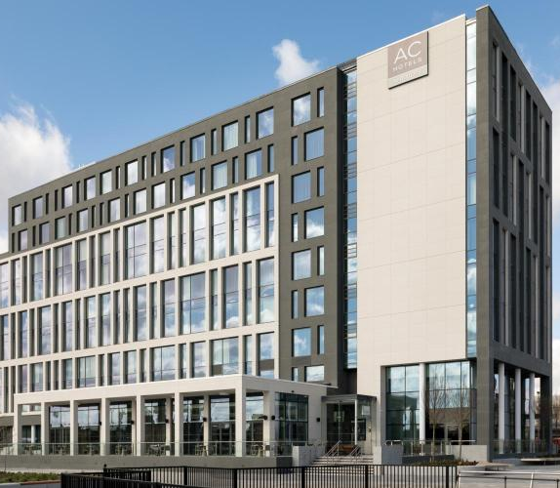
HOTEL CONSULTANCY REPORT-2022
Prepared By:CreDrive Consultantcy Limited
Client: James Conard,Operation Manager
AC Belfast

Name: Mohamed Mallik
Student ID: 2012833

Table of Contents
Executive Summary 1
Introduction 4
Scope & Analysis 4
Hotel Background 4
Facilities and Services 5
COVID-19 Measurements 5
Scopes Required Improvement 6
PESTEL Analysis 7
SWOT Analysis 9
Main Body 11
Analysis of the Issues 11
Infrastructural Issues 11
Service-related Issues 13
Strategic Analysis 15
Finding and Analysis 17
Room Service 17
Infrastructural Concerns 18
Talent Management 19
Action Plan 19
Recommendation 21
Conclusion 22
Reference list 23

List of Tables
Table 1: SWOT Analysis 9
Table 2: Action Plan 19
List of Figures
Figure 1:PESTEL Analysis 7
Figure 2: Infrastructural Requirements 12
Figure 3: Assessment of Current Talent Management 15
Figure 4: SOSTAC Analysis 16

Executive Summary
The UK’s tourism and hotel business has been developing and changing fast since 2010. The country is among the top largest tourist destinations by the number of visitors, attracting as many as 40.9 million tourists in 2019 alone. This sector contributed roughly £131.5 billion to the UK’s GDP in 2021. Employment in the UK lodging and food service industries, by establishment size, in the year 2021. In 2021, the British hospitality and food service industries employed around 2.4% of the country's labour force. Businesses that specialise in lodging and related services for tourists are part of the hotel sector. The hotel industry presents its own special challenges. Hotels, unlike other companies, are open around the clock and offer guests more than simply a product or service. In most cases, individuals can visit a business, fullfill their needs, and be on their way in an hour or less. Customers staying at hotels often spend twenty hours or more there.
Here, this consultant report focuses on AC Hotel Belfast, a reputed hotel in Northern Ireland for its central location, close proximity to the airport, major tourist spots and views, friendly staff, delicious on-site dining options, and relaxing accommodations. CreDrive Consultancy Firm has developed the following report for Mr. James Conard to assess the performance of its hotel management. The investigation of this hotel has revealed several ongoing and potential issues. AC Hotel Belfast is conveniently located near the airport and a number of popular attractions. It is very important that the hotel chain's name is associated with Marriot’s name and that clients have a positive impression of the brand. Some preliminary data about the AC Hotel Belfast process as a whole have been collected. All of the precautions taken during COVID-19 were accounted for. Afterwards, a PESTEL study was performed to consider the broader context. Among various factors, the political segment includes the domestic political conditions and power structure of the UK’s political system. Northern Ireland has its own regional power structure with a stable power balance. Also, economic indicators can play a role in studying the country’s economic structure. UK’s business and economic climate is superior because of the country's advanced economic and political infrastructure. As businesses aren’t alien to the jurisdiction of legal entities and rules, the hotel must comply with various local and global laws and regulations. Throughout this report, we've employed SWOT and SOSTAC analysis tools. Some issues have been detected based on internal study and input from customers. While guests have commended the friendly front desk employees and tasty meals, they have also noted many issues, including the hotel's lack of cleanliness, slow room service, loud air conditioning, high prices, and a lack of vegan alternatives. Therefore, the paper divides these concerns into two sections to better identify the difficulties. Some necessary actions are discussed below. Priorities include rearranging furniture, improving the room's layout, updating the plumbing and electrical systems, installing soundproofing in boardrooms, and installing noise-free AC systems. Also, the objectives mentioned in the SOSTAC analysis can be attained by coordinating managerial and infrastructural resources. The hotel's room service will suffer if it doesn't have competent employees. Employees must be chosen for their competence, optimism, and orientation if they are to help with the myriad of HR problems. One-on-one interviews will be useful for determining employee motivation and ensuring the engagement of the present employees. Employees will be more driven to provide excellent service to clients if they are regularly evaluated, rewarded for their efforts, and encouraged to take ownership of the company's goals via employee engagement programs. As a result, the hotel needs to think about ways to improve the training programs and the human resource policies. The investigation's findings and analysis make explicit mention of these problems. The report includes a strategy and some suggestions for how AC Hotel Belfast can improve its standing in the long run. The following action plan can be implemented.
SL No | Problem | Solution | Duration | Estimated costs*
1 | Uncomfortable room layout | Redesign the furniture and TV setup | 4 months | £50,000
2 | Noisy Air-conditioning | Change noise ACs | 1 month | £30,000
3 | Water supply in the bathrooms | Ensure a better water supply | 1 month | £25,000
4 | Problems in some washrooms | Change the bathroom layouts in the selected rooms | 2 months | £75,000
5 | Insufficient lighting | Install LEDs lights with a smart controlling system | 1 month | £25,000
6 | Lack of better curtains | Install two-layer curtains | 1 month | £25,000
7 | Lack of better utilities (USB, charging port) | Install USB and required ports in rooms | 1 month | £30,000
8 | Lack of training programmes | Arrange in-house training programmes with a consultancy firm | 7 months  (Based on phrases) | £45,000
The amount is estimated in the action plan. The management needs to assess its pricing policy and negotiate with its in-house restaurant for more vegan items and reasonable prices. By taking steps to improve current services, the hotel can enjoy more than 85% retention of customers and a higher rating. Based on the action plan a few recommendations can be given such as regular auditing of services can help the hotel get insights related to response rate, service quality and productivity. As Northern Ireland is becoming a hub of higher tourist inflow, the hotel needs to focus on digital marketing to create awareness among potential and existing clients regarding its offerings and presence. To match customers’ expectations, hotels need to achieve higher service standards. AC Hotel Belfast must focus on scopes to develop employees’ skills.

Introduction
By the year 2025, the UK’s tourism and hospitality industry is expected to have a worth of £257 billion. The hotel sector, a subset of the tourist and hospitality industry, also has great development potential. This specific sector has already reached a market size of £16.4 billion in terms of revenue and it continues to grow (ons.gov, 2019). To thrive in this market, it is vital to maintain efficient management of the operations and services of hotels to attract and retain guests and remain ahead of the competition. The key elements for success in this sector are service excellency, an efficient and effective workforce and creativity, the core offering is relatively the same- accommodation (O’fallon and Rutherford, 2011). This consultancy report focuses on the overall operational activities of AC Hotel Belfast. We, CreDrive Consultancy Limited, were approached by the client, Mr James Conard, Head of Operations of the hotel to assess key areas regarding existing and potential challenges and opportunities. Thus, the report has covered the problem areas of AC Hotel Belfast, including slow room service, infrastructural problems, outdated talent management, scarcity of trained staff, operational issues, higher prices and insufficient food items. For the internal and external audit of the issue area, SWOT and PESTEL frameworks were utilized to identify the strategic gaps. The major part of the report provides a comprehensive analysis of the difficulties and issues connected to the hotel’s operations and services. The findings and analysis section includes the results of the research in the form of a table. An action plan designed for the organisation is provided in the following section. Later, to overcome existing and potential challenges and obstacles, we have made some key recommendations. The conclusion section outlines the whole outcomes of the report.

Scope & Analysis

Hotel Background
Operated by the world’s top hotel management groups, Marriott, AC Hotel Belfast is considered one of the iconic travel destinations in the UK’s Northern Ireland. Situated beside River Lagan, the hotel provides an exceptional and beautiful riverside view, including serene views of Belfast Hills and the Titanic Quarter, to the stayers. The hotel has around six accommodation types, counting one-bedroom suites. The hotel’s design is eye-catching and hosts various amenities for clients. The combination of minimalistic touch and luxurious facilities makes AC Belfast a unique choice for customers. The hotel has a riverside restaurant, named Novelli at City Quays, operated by multi-Michelin-starred chef Jean Christophe Novelli. The hotel is nearby various tourist spots, such as Ulster Museum, SSE Arena, City Hall and ICC Belfast (AC Hotel Belfast, 2021).

Facilities and Services
AC Hotel Belfast is recognized for its world-class services and facilities served to customers. The hotel is just 2.6 miles from Belfast City Airport, allowing travellers and tourists to get easier accommodation. It has discounted parking facilities for the customers. There are 188 rooms equipped with glass-enclosed double showers, intercoms, modern furniture and comfortable beds, coffee makers, mini-fridges, controllable air conditioning and heating, safe lockers, and 49-inch Smart TVs with streaming services. Each room is given facilities, such as room cleaning, clothes washing and dying, and food delivery service. Based on clients’ feedback, the management constantly improves its cleanliness standards. Without any doubt, customers’ security and privacy get more attention. AC Belfast is not exceptional. The hotel’s security is maintained by trained teams. To balance customers’ privacy and security, the management keeps regular check-ups (Hill, 2018).
The hotel has its own fitness room where customers can do daily exercises. It provides spa and massage services to customers. To host meetings and events, there are two boardrooms. Customers can have the in-house catering service for weddings, receptions and social gatherings. As a riverside hotel, it has a riverside terrace. Also, AC Belfast is pet-friendly allowing a maximum of two dogs per room (Marriott, 2022). According to Tripadvisor, AC Belfast is considered a top-rated hotel in the UK’s Northern Ireland.

COVID-19 Measurements
As COVID-19 has caused a severe blow to the daily lives, AC Hotel Belfast has taken steps to ensure the safety of customers. As the UK government issued rules to bar the spread of the virus, the hotel management focused on various concerns including cleanliness and hygiene. Under its social distancing plan, the hotel installed signage and used posters and marks to limit social gatherings and restrain customers from physical interaction without required measures. The restaurant initially halted the in-house serving to customers. Some restrictions were withdrawn after the government announced the relaxation of rules (BBC, 2021). The hotel has been maintaining its hygiene and cleanliness tasks, along with the additional requirements for COVID-19. The maintenance teams focus on disinfecting the public spaces and installed various points to ensure access to hygiene products, such as hand sanitisers, face masks and other disinfectant materials. The hotel has an isolation quarter to separate any suspected or actual infected customers. To avoid any transmission of the virus, AC Hotel Belfast ensured contactless check-in and check-out facilities for customers. Still, some measures exist to ensure customers’ safety (Bonner, Magennis and Desmond, 2020).

Scopes Required Improvement
AC Hotel Belfast is known for its quality services and facilities. Yet, based on the feedback taken from the customers and clients, some issues can be notable. Areas related to the operational procedure, human resource management, technology and marketing can have scopes for improvement (Mansour Ghazi, 2016). Here, those issues are mentioned.
- Inconsistent service quality
- Higher food price
- Need for more vegan options on the menu
- Noisy air conditioning
- General coffee machine
- Lack of training facilities for employees
- Limited marketing tactics, etc.
Here, some areas can be improved through understanding the internal and external analysis of the environment. Many invisible areas can be discovered from those analyses. Thus, PESTEL and SWOT analysis are required tools used in the following sections based on the information related to AC Hotel Belfast.

PESTEL Analysis
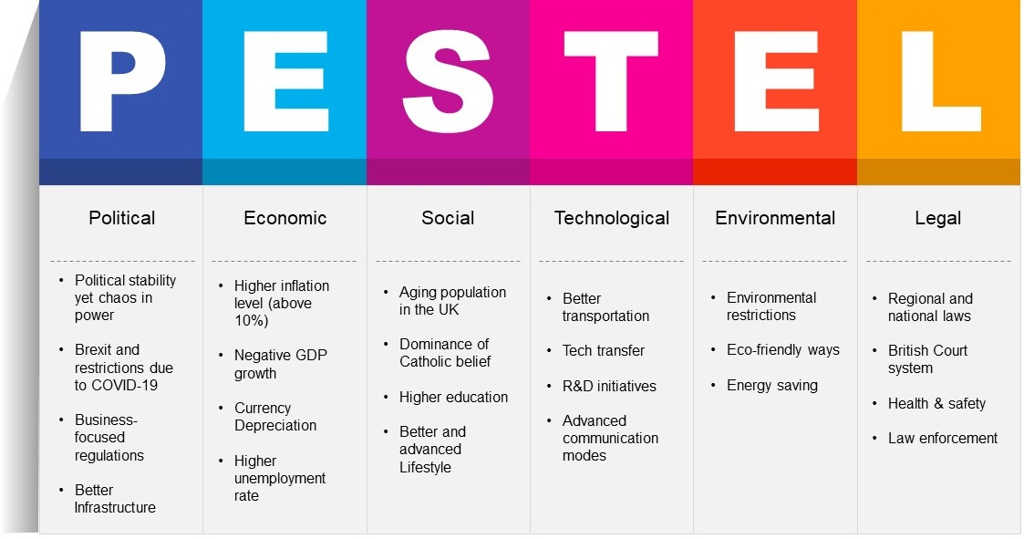
PESTEL analysis is a critical tool used by organizations to reflect on the external environmental factors that can influence operational activities and opportunities. A wide range of impact analyses can profoundly be found in this tool. Furthermore, the macroenvironmental elements that have an effect on an organization's operations and bottom line are the focus of this analysis (Burrow and Becraft, 2017). AC Hotel Belfast is operated under the management of Marriott, the world’s top hotel management firm. Due to the occurrence of some global incidents, such as COVID-19, the Russo-Ukrainian War and political turmoil, the hotel has been facing some challenges from the external environment (Butler, 2022). In the following, the PESTEL analysis is discussed.
Figure 1:PESTEL Analysis
Source: (Needle and Burns, 2019)
Political: In terms of a favourable business environment, businesses prefer to have a balanced political system and easier and turmoil-free power transition. As politics plays in formulating policies that can affect businesses, the extent of this factor is prevalent (Welford, 2014). Current political crises are visible in the UK and a few other select locations. It has been a rough few years for the UK, what with Brexit and all the leadership bickering. However, the government is keen to assist local businesses in expanding their operations. Many governments have found it difficult to keep their tourism and hospitality industries afloat in the face of COVID-19 and the Ukraine-Russia conflict (BBC, 2022).
Economic: Economic factors include issues related to interest rate, GDP growth, employment rate, forex market, currency valuation, and other economic concerns. The importance of understanding a country’s economic factors along with the global economy is critical for businesses to put their investment in any concerned field (Wetherly and Dorron Otter, 2014). There is hope that the United Kingdom's (UK) tourist and hospitality sector will help stimulate the economy. But inflation and growing living costs may be problematic for the business. The current inflation rate is hovering over 10%, along with higher energy prices. The UK’s economy has shrunk by 2%, according to a recent report. Due to Brexit, the overall macroeconomy of the country is going through a rocky transition (Bonner, Magennis and Desmond, 2020).
Social: Here, the understanding of societies and demographic studies are highly considered. Lifestyle, income level, educational backgrounds, culture and other socio-cultural concerns are in the segment (Burrow and Becraft, 2017). The UK’s society hosts various diverse cultures. In Northern Ireland, the dominance of catholic belief is prevalent. The lifestyle of people is advanced and various amenities are available. The combination of Irish and English cultures makes the society attractive to tourists. Also, Asian culture adds a better outlook on global citizenship (Butler, 2021).
Technological: Technology shapes the process of a business to get more effective and efficient dimensions. Better inclusion of advanced technology can help businesses grow further and fulfil the market need (Needle and Burns, 2019). Since the advent of modern technology in the UK, companies have been able to expand their operations on the World Wide Web. Even enhanced communication is helping expansion. Connections to the internet and mobile networks are stable enough to be widely used. Digital booking systems and payment gateways make hotel bookings easier for travellers and customers (Fraj, Matute and Melero, 2015).
Environment: As environmental factors are getting more global attention, businesses need to take care of the surrounding environment (Welford, 2014). In the UK, pollution is an issue in the countryside since it is a potential consequence of a high population density. Inappropriate trash disposal by visitors is a major problem that can have far-reaching ecological consequences. It's possible that governments may have to take extreme action if the current crisis continues to worsen. Also, hotels are required to use eco-friendly materials, products and processes. Customers are now more aware of their carbon footprint. Hotels and restaurants in the UK need to reflect on the country’s environmental laws and regulations (Deloitte, 2020).
Legal: In the UK, hotels need to abide by the regulations regarding construction and recruitment. Due to the restrictive laws on immigration, many hotels cannot employ foreign workers and employees (Wetherly and Dorron Otter, 2014). Brexit has created the process lengthier. Even, travel laws can create some challenges for the tourism and hospitality industry that may limit the inflow of tourists in Northern Ireland. The British legal system has a long history, yet it is also constantly developing. They may incorporate a new company if they decide they need one to carry out their plans (Edrawsoft, 2021).

SWOT Analysis
The strengths and weaknesses of a company, both internally and externally, may be better understood with the use of this study (Sarsby, 2016). The given SWOT analysis will help our client, Mr James, determine the internal and external opportunities and threats facing AC Hotel Belfast.
Table 1: SWOT Analysis
Strengths  No Cancellation Fees  In-house Restaurant  Nearby the Airport  Modern Hotel Structure and Design  Pet-friendliness | Weaknesses  Noisy Air-conditioning  Season-based Customer Demand  Lack of In-house Training for Employees  Improper Room Layout  Higher Price
Opportunities  Growing Tourism Market in Northern Ireland  Minimalistic and Creative Designing  Technological Advancement | Threats  Economic Recession  Increasing Dominance of Third-part Apps  Higher Legal Standard  Government Intervention  Higher Bureaucratic Trap in Immigration and Travelling
Source: (Sarsby, 2016)
Strengths
Being nearby the airport is a key strength for AC Hotel Belfast. It allows travellers to have a quick route to the hotel. Its location is conveniently situated in close proximity to some iconic tourist spots. In addition, the spectacular view of Belfast Hill is sure to please any potential guests. The hotel doesn’t charge any cancellation fees. Its in-house restaurant run by a Michelin chef provides guests with a better taste of food. The hotel is pet-friendly (AC Hotel Belfast, 2022).
Weaknesses
Customers complained about the high prices at the hotel, as noted in the many one- and two-star reviews posted across several booking platforms. The trend of guest inflow relies on the seasons that pose a seasonal demand for the hotel. Air-conditioning is noisy and the rooms seem to be very cold. Customers face troubles with lighting and television. Room service providers and housekeepers both lack the training to improve service quality (Al-Balushi, 2018).
Opportunities
Being nearby tourist places can be better scope for AC Hotel Belfast. As the tourist inflow is growing, the hotel can provide various offerings to both foreign and local travellers and guests. Opportunities to implement better ERP can increase the productivity of the hotel. Its focus on minimalistic design can be an attractive option for guests (Aznar et al., 2016).
Threats
The current UK economy is going through a recession that can cause a severe threat to AC Belfast and limit the number of travellers. Hotel management expenses will rise due to a combination of factors, including a scarcity of employees caused by recent changes to immigration policy and higher energy and commodity prices. In addition, the rivalry to provide quiet and comfort will expand with the rise of services like Airbnb and tiny cottage-style hotels. Government intervention in environmental factors can increase legal costs and other expenses (Butler, 2022).

Main Body

Analysis of the Issues
AC Hotel Belfast has a recognised reputation for maintaining cleanliness and hygiene standards. Based on various travel-rating websites, including TripAdvisor, some pieces of negative feedback have been discovered. Those issues are related to the higher price, slow room service, problems with water supply, uncomfortable beds, stiff bedsheets, poor lighting and heating, and noisy air-conditioning. Clients and customers have also complained that the room layout needs to be remodelled since they prefer to have a serene view of River Lagan. The concerns related to a better fitness centre and spa facility are being raised by the clients and guests (Marriott, 2022). Renovation is required in boardrooms to have better interior design and noise-cancelling facilities. Here, the mentioned issues can be classified into two parts infrastructural issues and service-related issues. The design and layout-related concerns can be addressed through infrastructural changes and renovation. Service-related matters including training of employees and internal issues can be resolved through managerial steps (Dobbelstein and Brehm, 2012).

Infrastructural Issues
The overall infrastructure of AC Hotel Belfast is satisfactory, yet there is room for a better layout and design for the concerned areas, such as boardrooms. Some problems related to this part are mentioned below.
- The odd placement of certain televisions in rooms (at precisely the same right angle as the bed).
- Many rooms have the noisy air-conditioning
- In some rooms, the bathrooms have some water supply issues. Some need to be redesigned considering a better showering experience.
- Some visitors have complained that the rooms have poor lighting, although many clients prefer low light.
- As the out layer of the whole building is covered with glasses, better curtains need to be installed.
- Many guests have complained about the lack of space for keeping makeup and other items in the washroom.
- Some of the room's utilities (USB ports, phones, etc.) are broken.
- Boardrooms require redesigning of their layouts and the instalment of a better noise-cancelling system.
To resolve the above-mentioned issues, some steps that AC Hotel Belfast can consider are mentioned below.
Steps Required
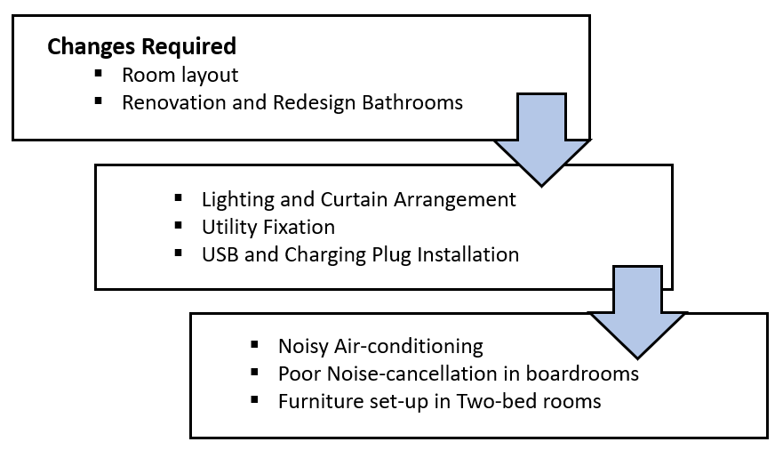
Figure 2: Infrastructural Requirements
Source: Own
Change in Room Layout
AC Hotel Belfast has a better room layout. But the setup of the furniture has caused problems for the guests and clients. It is essential to have a flexible room setup so that stayers can move freely within the room and enjoy views and services. 188 rooms of AC Hotel Belfast feature reversed televisions. Some two-bed rooms seem too congested, as per customers’ feedback. Thus, the layout of 50 of these rooms must have renovation. Single rooms can have more minimalistic features that can attract more guests. In the boardrooms, the layout needs to be more exquisite to match clients’ requirements (Deroos, 2010).
Fixtures and fittings for the Bathrooms
Without any doubt, the water connection and spotless washroom facilities are considered the top services of any hotel. Although the overall condition of washroom facilities at AC Hotel Belfast doesn’t need any additional renovation, some washrooms are outdated and require renovation with modern facilities. Some guests complained about the water supply issue which must address during the renovation. This renovation may require 2 months while water supply issues can be fixed within 3 weeks
Poor Lighting
Every space will feature a choice between two different lighting schemes. This option will allow guests to select their preferences. Additionally, the arrangement of curtains can be done in two layers so that daylight can be used for those who enjoy higher illumination. LED lights can be an option to arrange the lighting system (Jackson, 2018).
Faulty Utilities and Related Issues
Some rooms have back-dated utility facilities that require to be replaced. Within a month, all malfunctioning utilities and antiquated equipment will be swapped out for brand-new models. Here, plugs and USB facilities can be prioritised. In order to properly identify and replace this, a sufficient amount of effort and money is required. In the boardrooms, a better noise-cancellation system requires to be implemented. Beds in rooms must be replaced with comfortable ones (Mansour Ghazi, 2016).

Service-related Issues
Considering the service facilities at AC Hotel Belfast, some service facilities are not matching the standard of the hotel. Several customers pointed out the higher price of the services provided by the hotel. One other prevalent complaint from past visitors is that the price is too costly in comparison to the quality of the services provided. Room service sometimes doesn’t respond quickly. Despite the upbeat and helpful front desk staff, the room service is very sluggish. Here, there is a lack of ensuring catering services that are designated for the events taking place in the boardrooms. Some customers complained about poor room services, as they found the bedsheets strained and stiff. Thus, cleanliness is top of the list. Apart from this, the in-house restaurant provides some limited options that exclude many vegetarian items (Wikhamn, 2019). Vegan guests sometimes cannot get preferred items. The price of food is comparatively higher, although it’s a Michelin restaurant.
Steps Required
Hygiene and Cleanliness
As per the complaints, the cleaning teams only clean and maintain the rooms on an as-needed basis, and many rooms aren't touched until after visitors have checked in. Dissatisfied customers have also noted a lack of cleanliness in the fitness centre. Bedsheets and other products are required to be clean and preferable. But, in AC Hotel Belfast, this process takes time and customers are served below-standard cleanliness. The ratio of supervisors to rooms is insufficient, therefore problems will go unresolved until later. Here, better training of employees and adequate room service providers can be solutions (Whittington et al., 2020).
Room Services
As the hotel sector is a prominent segment in the service industry, customers prefer better services for what they pay for. They feel appreciated and cared for when their requests are responded to immediately. Better room services can play a distinguished role in the sector’s success. Here, the importance of hospitality management is extensive, by its very nature as a service industry, hotels must accommodate a wide variety of customers with varying wants and tastes. In AC Hotel Belfast, customers can connect to the service desk through the intercom but the service requested arrives late in many cases. A dynamic auditing team can be placed to check on room service. Employees need to have designated areas to serve (Torrington et al., 2017).
In-house Restaurant and Its Menu
AC Hotel Belfast has an in-house restaurant. As mentioned earlier, the restaurant has limited vegan options and the price of the food is relatively higher, as per the customers’ feedback. Many vegan guests cannot have food options that can meet their appetites. Thus, customers have voiced their worries about the menu options. Vegetarian and vegan alternatives are restricted, but meat-based dishes are plentiful. The good point is that the service of the restaurant is laudable. Here, to ensure more vegan options, it is necessary to hire additional chefs who can prepare those items (Burnes, 2017). The management can consult with the restaurant to have reasonable pricing with better food quality. Even, the complimentary breakfast can be improved by including better items.
Training and Development
Training and development at any hotel are required for ensuring better service from employees. Considering the importance of a quality and dynamic workforce, hotels need to set up various levels of training programmes (Ashton, 2017). Here, many of the furloughed employees never returned to AC Hotel Belfast, even though they were guaranteed they would be rehired. To meet immediate talent needs, several young and unskilled employees were hired. Although the quality of service given by the front desk staff as well as the parking services is universally praised, that of the staff designated room services is yet to match this level of standard. At the hotel, the extent of training facilities is limited and staff couldn’t be enrolled in the required training programmes due to immediate inclusion to service (Baron and Armstrong, 2007). Here, a plan given below can be followed to resolve the issue.
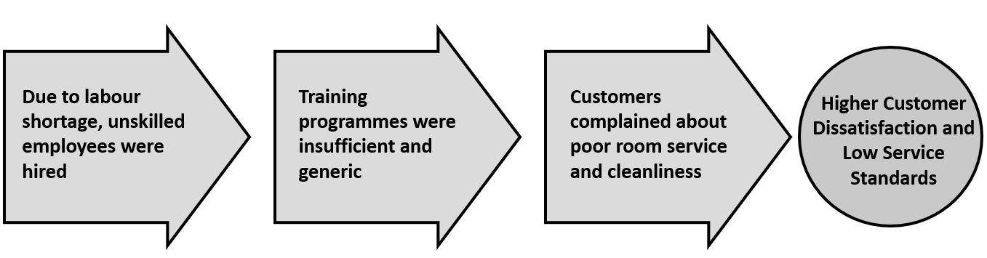
Figure 3: Assessment of Current Talent Management
Source: Own
From the above figure, some critical areas can be concluded regarding talent development. Due to an immediate talent shortage, AC Belfast had to recruit employees without focusing on higher levels of skills and providing a talent development scope (Brierley, 2006). In the analysis, the concerns are related to better room services. Two areas are required better training facilities: room services and long-term talent management. Before focusing on new hires, the hotel needs to train staff designed to room service for better service quality. How to measure the service quality provided and maintaining a checklist for daily service auditing should get more attention in the training programme (Burrow and Becraft, 2017). To encourage employees to adopt new changes, better compensation plans and performance need to be placed under new talent management. AC Hotel Belfast can retain its reputation by focusing on dynamic talent management. Notably, the training programmes must address some long-term concerns, such as communication, productivity, efficiency and customer-inclusive service patterns. The core area thus required to be improved is training staff for overall service excellency (Cappelli and Keller, 2014).

Strategic Analysis
The SOSTAC model is an essential tool used in marketing and business planning. It is useful for pinpointing the most pressing issues facing a business and crystallizing the goals that define its current and realistic targets. Also, the SOSTAC Model is focused on working on agile marketing to identify business objectives, understand situations and control the taken steps (Marenna Van Reijsen et al., 2013). Specifically, it is the SOSTAC model given in the figure below that addresses situation analysis, business objectives, tactic management and controlling mechanisms.
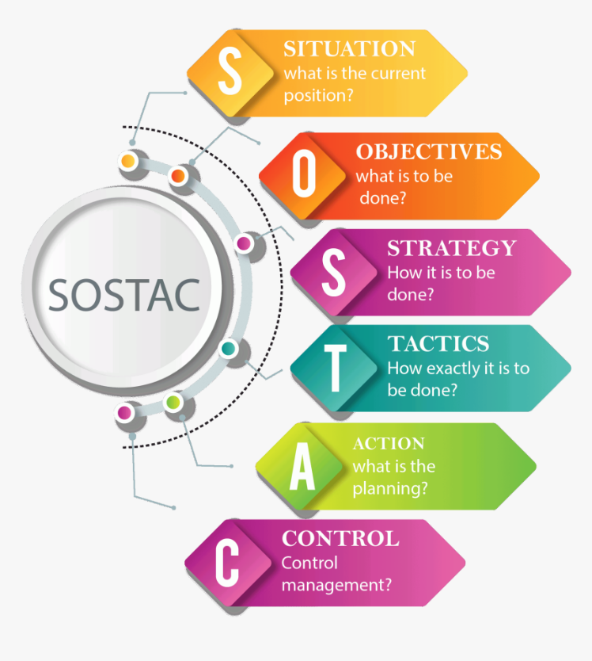
Figure 4: SOSTAC Analysis
Source: (Strong, 2014)
Situation Analysis: The situation at AC Belfast Northern is more favourable than the extension of negative feedback. Concerns related to infrastructural and service-oriented issues still prevail. Poor cleanliness, uncomfortable room layout, lack of skilled staff in room service, higher prices and infrastructural problems are major issues. Customers still prefer the hotel and have a more than 75% retention rate (Statista, 2018). Here, AC Hotel Belfast enjoys a good brand image. Thus, the problems have been identified and will be resolved within six months.
Objectives: AC Hotel Belfast aims to secure around 90% positive feedback and more than 85% customer turnover. The hotel intends to offer preferable accommodation at a reasonable rate to attract more visitors. Also, it focuses on 15-20% operating cost reduction by following strategic infrastructural and managerial plans.
Strategy: The hotel aims to focus on a differentiation strategy, where the hotel will focus on particular niches. AC Hotel Belfast needs to focus on employee empowerment, as they are responsible to serve better room service. Here, the importance of digital marketing is required to be mentioned. The hotel needs to focus on digital marketing to attract more customers for its different offerings (De Pelsmacker, van Tilburg and Holthof, 2018).
Tactics: AC Hotel Belfast needs to coordinate inner resources, as the hotel is operated by the top hotel chain, Marriot. To arrange training programmes, the hotel must engage its employees in the whole process. Also, a budgetary plan needs to be implemented to fund required projects (Buttrick, 2009).
Actions: In the case of talent management, the hotel can include a consultancy firm to manage its strategic training programmes. A team needs to be formed including interior designers and other experts to assess and fix issues related to the infrastructural concerns and renovation. Later, the management can reassess and negotiate with the restaurant to lower the food price (Burnes, 2017).
Control: AC Hotel Belfast needs to monitor each project designed to the key problems. Based on the assessment, a majority of projects will be completed within 8 months. Some may require some extra time considering the extent of their operational activities. Gnatt Chart is a tool to monitor such projects. Here, a monitoring team should be formed to report details to concerned areas to avoid any delay (Chand, 2010).

Finding and Analysis
Here, some critical findings are mentioned that AC Hotel Belfast has been facing. From the above-mentioned analysis and some tools, several critical areas are highlighted in the segments.

Room Service
Based on the current scenario analysis, the following concerns have been identified regarding room services.
Problems | Requirements
Strained and stiff bedsheets | More than 300 bedsheets based on softness and quality need to be bought. Additional bedsheets can be used in case of any emergency.
Higher time in order execution | Staff need to be designed for key service areas where they can perform their core tasks without hassles. The staff took more than 20 minutes than the required time to fulfil customers’ request.
Lack of regular service auditing | A checklist regarding service execution is absent. Regular service quality check is important and AC Hotel Belfast
Lower cleanliness in some rooms | Absence of required skilled staff to take care of cleanliness. Training for staff is required.
Those mentioned problems are related to the failure of providing quality service. There is a gap to audit the service quality and response rate. Here, some problems can be solved by training and skilled staff and some by better material purchases. AC Hotel Belfast can follow some solutions stated in the action plan.

Infrastructural Concerns
Based on the current scenario analysis, some concerns given below are mentioned.
Problems | Requirements
Uncomfortable room layout | The room layout has been causing problems for guests. TV and furniture set-up need to be redesigned.
Problems in some bathrooms | Around 50 bathrooms have some design and utility-related problems that need to be resolved by concerned experts and teams.
USB and charging plugs | AC Northern Ireland needs to convert some plugging slots for better customer service
Poor lighting | The hotel has some extent of poor lighting. Thus, the installation of LED lights and two-layer curtains can be a possible solution to ensure the desired lighting
Noisy Air-conditioning and outdated noise-cancelling systems in boardrooms | Air-conditioning can be replaced with better ones. Installation of noise-cancelling is required to conduct noise-free events.
Many guests complained about this arrangement as they couldn’t enjoy the shows comfortably. The comfy atmosphere is ruined by a few strategically placed seats. To fix this, the renovation team has to adjust the angles at which these components are placed. Also, renovation and redesigning the interior in some parts, including boardrooms, must be considered.

Talent Management
Problems | Requirements
Lack of training | Staff couldn’t have enough training for room service and quality checks. Thus, they should be trained in multiple phases through on-job training and seminars.
Lack of motivation plan | Employees sought job security and career growth in the hotel along with a better compensation plan. AC Hotel Belfast needs to focus on such concerns
Outdated recruitment policy | The hotel needs to take consultancy from an HR firm to make a dynamic HR policy.
More importantly, AC Hotel Belfast is not an outlier to the hotel chain's policy of furloughing many workers throughout the Covid-19 epidemic era which created a talent shortage. Thus, there is a need for both short and long-term training facilities. The hotel’s strengths and possibilities will reveal where this hotel has room to grow in order to address the problem at hand.
Also, the management needs to negotiate with the in-house restaurant run by a Michelin chef to make reasonable pricing and include more vegan options, as many complained about the higher price and lack of vegan items.

Action Plan
An action plan for AC Hotel Belfast is prepared based on the findings of the report. The action plan includes the estimated amount of time and money required to execute the projects regarding problems found. In the following, the action plan is given.
Table 2: Action Plan
SL No | Problem | Solution | Expectations | Duration | Estimated costs*
1 | Uncomfortable room layout | Redesign the furniture and TV setup | To provide comfort and hassle-free movement within the room | 4 months | £50,000
2 | Noisy Air-conditioning | Change noise ACs | To ensure better airflow | 1 month | £30,000
3 | Water supply in the bathrooms | Ensure a better water supply | To maintain water supply whenever guests use bathrooms | 1 month | £25,000
4 | Problems in some washrooms | Change the bathroom layouts in the selected rooms | To provide a better showering experience | 2 months | £75,000
5 | Insufficient lighting | Install LEDs lights with a smart controlling system | To ensure better lighting | 1 month | £25,000
6 | Lack of better curtains | Install two-layer curtains | To provide customers with scope to limit lighting from outside | 1 month | £25,000
7 | Lack of better utilities (USB, charging port) | Install USB and required ports in rooms | To fulfil customers’ requirements for better utilities | 1 month | £30,000
8 | Lack of training programmes | Arrange in-house training programmes with a consultancy firm | To improve employees’ skills and room services | 7 months  (Based on phrases) | £45,000
9 | Lack of vegan options | Include more vegan options for guests and collect data before they check-in | To provide a better food experience for vegan guests | 2 months | £20,000
10 | Inadequate noise-cancelling system in boardrooms | Set up a dynamic noise-cancelling system | To conduct noise-free events and ensure a desirable state in boardrooms | 3 months | £45,000
* Amount of money is hypothetical

Recommendation
AC Belfast Norther Ireland can follow the action plan proposed by the firm. The indication of the betterment of services in the hotel relies on how well those projects are executed. Based on the report, some key recommendations can be highlighted. These recommendations are associated with the long-term objectives of AC Hotel Belfast.
- Implementation of regular service auditing: Regular auditing of services can help the hotel get insights related to response rate, service quality and productivity. Employees’ performance can also be evaluated, along with operational efficacy (Chand, 2010).
- Inclusion of digital marketing: As Northern Ireland is becoming a hub of higher tourist inflow, the hotel needs to focus on digital marketing to create awareness among potential and existing clients regarding its offerings and presence. This will ensure better communication with customers and the retention rate will rise (De Pelsmacker, van Tilburg and Holthof, 2018).
- Higher service standards: To match customers’ expectations, hotels need to achieve higher service standards. These standards are related to service quality, cleanliness, operational efficiency and employee performance. Nevertheless, the importance of a better interior can play a critical role. AC Hotel Belfast needs to utilise its location and surrounding opportunities to gain more leverage in the market (Dedeoğlu and Demirer, 2015).
- Employee Development: AC Hotel Belfast must focus on scopes to develop employees’ skills. Communication, conflict handling, crisis management and room service are critical areas that require constant upgradation. Thus, a regular assessment of staff is essential. Maintaining a consultancy firm regarding this issue can provide the hotel with regular updates about its workforce (Hatum, 2014).

Conclusion
AC Hotel Belfast, known for its convenient location, good service, satisfying in-house restaurant, and comfortable rooms, is the subject of this consultant study. This report is prepared for the client, Mr James Conard, by the firm, CreDrive Consultancy Firm, to reflect on its hotel management. The services have uncovered several difficulties at this hotel, both in the present and in the future. The proximity of AC Hotel Belfast to both the airport and several tourist spots is a major location advantage. Its brand image and hotel affiliation with Marriot play a critical role. Initially, some pieces of information have been gathered related to the overall procedure of AC Hotel Belfast. Measures taken during COVID-19 were included. Later, PESTEL analysis was conducted to reflect on the external environment. SWOT and SOSTAC have been used in this report. From the internal analysis and customer feedback, some problems have been identified. Although customers consistently praised the hotel's helpful front desk staff and quality food options, the hotel's poor cleanliness, lengthy room services, noisy air-conditioning, pricey food and limited vegan options are some problems faced by AC Hotel Belfast. Thus, this report categorises these issues into two segments to pinpoint problems. Later, some required steps are mentioned. Fixing up the furniture setup and room layout, installing better utility facilities, setting better noise-cancelling systems in boardrooms, and ensuring good lighting and noise-free air conditioning are top priorities. Without skilled staff, the hotel cannot ensure smooth room services. Thus, better training programmes and dynamic HR policies must be taken into consideration. These issues are clearly mentioned in the finding and analysis. An action plan and some recommendations are included so that AC Hotel Belfast can secure a better position in the long run.

Reference list
AC Hotel Belfast (2022). AC Hotel Belfast | Hotels. [online] Visit Belfast. Available at: https://visitbelfast.com/partners/ac-hotel-belfast/.
Al-Balushi, M. (2018). Issues Affecting Omanization of the Hotel Sector. JOURNAL OF TOURISM AND HOSPITALITY MANAGEMENT, 6(2). doi:10.15640/jthm.v6n2a14.
Ashton, A.S. (2017). How human resources management best practice influence employee satisfaction and job retention in the Thai hotel industry. Journal of Human Resources in Hospitality & Tourism, 17(2), pp.175–199. doi:10.1080/15332845.2017.1340759.
Aznar, J., Sayeras, J., Galiana, J. and Rocafort, A. (2016). Sustainability Commitment, New Competitors’ Presence, and Hotel Performance: The Hotel Industry in Barcelona. Sustainability, 8(8), p.755. doi:10.3390/su8080755.
Baron, A. and Armstrong, M. (2007). Human capital management : achieving added value through people. London: Kogan Page.
BBC (2021). Firms warn of ‘devastating’ impact of new restrictions. BBC News. [online] 10 Dec. Available at: https://www.bbc.com/news/business-59612416.
BBC (2022). Cost of living crisis ‘worse than Covid-19 for hospitality sector’. BBC News. [online] 9 Aug. Available at: https://www.bbc.com/news/uk-england-manchester-62468609.
Bonner, K., Magennis, E. and Desmond, A. (2020). The Impact of Covid-19 on Northern Ireland Business Activity. [online] Available at: https://www.ulster.ac.uk/__data/assets/pdf_file/0007/661444/UUEPC_The-Impact-of-Covid19-on-Northern-Ireland-Business-Activity_Final-Report_-25_09.pdf.
Brant, A. (2018). How Our Hotel Chain Uses Data to Find Problems and Humans to Fix Them. [online] Harvard Business Review. Available at: https://hbr.org/2018/05/how-our-hotel-chain-uses-data-to-find-problems-and-humans-to-fix-them.
Brierley, E. (2006). Talent on tap getting the best from freelancers, interims and consultants. London Chartered Institute Of Personnel And Development.
Burnes, B. (2017). Managing Change. 7th ed. Great Britain: Prentice Hall.
Burrow, J. and Becraft, M.B. (2017). Business management. Boston, Ma: South-Western Cengage Learning.
Butler, S. (2021). Hospitality industry warns of looming crisis as staff forced to isolate. [online] the Guardian. Available at: https://www.theguardian.com/business/2021/jun/30/hospitality-industry-warns-of-looming-crisis-as-staff-forced-to-isolate.
Butler, S. (2022). ‘Everything is going up’: UK hospitality sector struggles as inflation soars. [online] The Guardian. Available at: https://www.theguardian.com/business/2022/jul/20/uk-hospitality-sector-struggles-as-inflation-soars.
Buttrick, R. (2009). The project workout. London: Prentice Hall.
Canning, M. (2021). Belfast’s AC Marriott reduces its losses as hotel industry warns of staffing challenges. belfasttelegraph. [online] Available at: https://www.belfasttelegraph.co.uk/business/northern-ireland/belfasts-ac-marriott-reduces-its-losses-as-hotel-industry-warns-of-staffing-challenges-41855368.html [Accessed 30 Nov. 2022].
Cappelli, P. and Keller, J. (2014). Talent Management: Conceptual Approaches and Practical Challenges. Annual Review of Organizational Psychology and Organizational Behavior, 1(1), pp.305–331. doi:10.1146/annurev-orgpsych-031413-091314.
Chand, M. (2010). The impact of HRM practices on service quality, customer satisfaction and performance in the Indian hotel industry. The International Journal of Human Resource Management, 21(4), pp.551–566. doi:10.1080/09585191003612059.
Collings, D.G. and Mellahi, K. (2009). Strategic talent management: A review and research agenda. Human Resource Management Review, 19(4), pp.304–313. doi:10.1016/j.hrmr.2009.04.001.
Collings, D.G., Scullion, H. and Caligiuri, P. (2019). Global talent management. New York, Ny: Routledge.
Daniels, J.D., Radebaugh, L.H. and Sullivan, D.P. (2018). International business : environments and operations. 16th ed. Harlow: Pearson Education Ltd.
De Pelsmacker, P., van Tilburg, S. and Holthof, C. (2018). Digital marketing strategies, online reviews and hotel performance. International Journal of Hospitality Management, [online] 72, pp.47–55. doi:10.1016/j.ijhm.2018.01.003.
Dedeoğlu, B.B. and Demirer, H. (2015). Differences in service quality perceptions of stakeholders in the hotel industry. International Journal of Contemporary Hospitality Management, 27(1), pp.130–146. doi:10.1108/ijchm-08-2013-0350.
Deloitte (2020). Impact of COVID-19 on the Hospitality Industry. [online] Deloitte Netherlands. Available at: https://www2.deloitte.com/nl/nl/pages/consumer/articles/impact-of-covid-19-on-the-hospitality-industry.html.
Deroos, J.A. (2010). Hotel Management Contracts—Past and Present. Cornell Hospitality Quarterly, 51(1), pp.68–80. doi:10.1177/1938965509354865.
Dobbelstein, T. and Brehm, C. (2012). Perception of cost, cost drivers, human resource management, long and short term critical success factors in the hotel industry: Recommendations for hotel management. African Journal of Business Management, 6(41), pp.10568–10577. doi:10.5897/ajbm12.773.
Edrawsoft (2021). Detailed PESTEL Analysis of Hotel Industry | EdrawMax Online. [online] Edrawsoft. Available at: https://www.edrawmax.com/article/hotel-industry-pestel-analysis.html.
Fisman, R. and Sullivan, T. (2014). The org : how the office really works. London: John Murray.
Fraj, E., Matute, J. and Melero, I. (2015). Environmental strategies and organizational competitiveness in the hotel industry: The role of learning and innovation as determinants of environmental success. Tourism Management, 46, pp.30–42. doi:10.1016/j.tourman.2014.05.009.
Gert Noordzij (2014). Project management of hotel opening processes : exploring better ways to open new hotels. North Charleston: Createspace Independant Publishing Platform.
Hatum, A. (2014). Next generation talent management : talent management to survive turmoil. Palgrave Macmillan.
Hill, G. (2018). AC Hotel Belfast. The Telegraph. [online] 7 Sep. Available at: https://www.telegraph.co.uk/travel/destinations/europe/united-kingdom/northern-ireland/belfast/hotels/ac-hotel-belfast-hotel/.
Jackson, E. (2018). Hotel management. New York, Ny: Larsen & Keller.
Kollewe, J. (2022). Two-thirds of UK’s top restaurants in the red after Brexit, Covid and inflation. [online] the Guardian. Available at: https://www.theguardian.com/business/2022/aug/08/two-thirds-of-uks-top-restaurants-in-the-red-after-brexit-covid-and-inflation.
Lahap, J., Ramli, N.S., Said, N.M., Radzi, S.M. and Zain, R.A. (2016). A Study of Brand Image towards Customer’s Satisfaction in the Malaysian Hotel Industry. Procedia - Social and Behavioral Sciences, [online] 224, pp.149–157. doi:10.1016/j.sbspro.2016.05.430.
Lewis, R.E. and Heckman, R.J. (2006). Talent management: a Critical Review. Human Resource Management Review, 16(2), pp.139–154.
Madera, J.M., Dawson, M. and Neal, J.A. (2013). Hotel managers’ perceived diversity climate and job satisfaction: The mediating effects of role ambiguity and conflict. International Journal of Hospitality Management, 35, pp.28–34. doi:10.1016/j.ijhm.2013.05.001.
Mansour Ghazi, K. (2016). Hotel Maintenance Management Practices. Journal of Hotel & Business Management, 5(1). doi:10.4172/2169-0286.1000136.
Marenna Van Reijsen, Zweers, T., Huub Janssen, Marketing and Broekhoff, M.A. (2013). Interactieve marketing. Amsterdam: Pearson, Cop.
Marriott, H. (2022). AC Hotels by Marriott Belfast (Belfast) – 2022 Updated Prices | Expedia.co.uk. [online] Expedia.co.uk. Available at: https://www.expedia.co.uk/Belfast-Hotels-AC-Hotels-By-Marriott-Belfast.h23228765.Hotel-Information.
Mathis, R.L. (2019). Human resource management. Boston, Ma: Cengage Learning.
Needle, D. and Burns, J. (2019). Business in Context : an introduction to business and its environment. 7th ed. Annabel Ainscow.
O’fallon, M.J. and Rutherford, D.G. (2011). Hotel management and operations. Hoboken, N.J.: Wiley.
Öğüt, H. and Onur Taş, B.K. (2012). The influence of internet customer reviews on the online sales and prices in hotel industry. The Service Industries Journal, 32(2), pp.197–214. doi:10.1080/02642069.2010.529436.
ons.gov (2019). Tourism industry - Office for National Statistics. [online] Ons.gov.uk. Available at: https://www.ons.gov.uk/businessindustryandtrade/tourismindustry.
Patalay, A. (2021). How Covid changed the hospitality industry. Financial Times. [online] 21 Oct. Available at: https://www.ft.com/content/1b6c7110-6d84-4c07-8e9a-3e1721767f50.
Reis, C. (2016). Careers and talent management : a critical perspective. New York ; London: Routledge, Taylor & Francis Group.
Ružić, M.D. (2015). Direct and indirect contribution of HRM practice to hotel company performance. International Journal of Hospitality Management, 49, pp.56–65. doi:10.1016/j.ijhm.2015.05.008.
Sarsby, A. (2016). Swot Analysis: a Guide to SWOT for Students of Business Studies. England: Leadership Library.
SRIVASTAVA, S.K., CHANDRA, B. and SINHA, A.P. (2019). Effectiveness of Knowledge Management on Customer Relationship Management in Hotel Business Performance. Journal of Environmental Management and Tourism, 9(6), p.1277. doi:10.14505//jemt.9.6(30).17.
States., U. (2018). SWOT analysis : a tool for making better business decisions. Washington, D.C.: U.S. Dept. Of Agriculture, Risk Management Agency.
Statista (2018). Topic: Travel and tourism in the United Kingdom (UK). [online] www.statista.com. Available at: https://www.statista.com/topics/3269/travel-and-tourism-in-the-united-kingdom-uk/.
Strong, H. (2014). Marketing and management models : a guide to understanding and using business models. New York, Ny: Business Expert Press.
Team, M.S. (2021). Hilton PESTLE Analysis | PESTEL Analysis of Hilton. [online] MBA Skool-Study.Learn.Share. Available at: https://www.mbaskool.com/pestle-analysis/companies/18162-hilton.html.
Torrington, D., Hall, L., Atkinson, C. and Taylor, S. (2017). Human resource management. 10th ed. Harlow, U.K.: Pearson Education Limited.
Welford, R. (2014). Corporate Environmental Management 1 : Systems and strategies. Hoboken: Taylor and Francis.
Wetherly, P. and Dorron Otter (2014). The business environment : themes and issues in a globalizing world. Oxford: Oxford University Press.
Whittington, R., Regnér, P., Angwin, D., Johnson, G. and Scholes, K. (2020). Exploring strategy. 12th ed. Harlow, England Pearson.
Wikhamn, W. (2019). Innovation, sustainable HRM and customer satisfaction. International Journal of Hospitality Management, 76, pp.102–110. doi:10.1016/j.ijhm.2018.04.009.
World Traveller (2022). Review: AC Hotel by Marriott Belfast, Northern Ireland. [online] World Traveller 73. Available at: https://worldtraveller73.com/2022/06/04/review-ac-hotel-by-marriott-belfast-northern-ireland/.

