Consultancy Project

An Investigation into the Marketing Issues at the National Waterfront Museum

By Ffion Jones and Ffion Merrick

BA Tourism Management - University of Wales, Trinity Saint David

P144611 and P144697

Private and Confidential

Date of Publication - 02/05/18

Client Contact Name - Jenny Walford

Client Contact E-mail - jenny.walford@museumwales.ac.uk

EXECUTIVE SUMMARY

This report is of a consultancy project with the National Waterfront Museum, with the focus on their marketing issues. The aim of the report is to investigate how effective their current marketing is, identifying any problems, with the hope that the consultancy team can help provide some solutions in order to improve upon the success of the museum.

Focus is made on primary and secondary research, in order to find evidence of marketing issues in the museum, including surveys, literature, and analysis of official documents and TripAdvisor reviews. Analysis of these findings will be conducted, in order to give an overall view as to who they aim to market for and where their marketing problems lie, finally giving recommendations and conclusions, which are primarily more emphasis and presence for promoting on social media platforms.

CONTENTS PAGE

1.0 Introduction PAGE 4
1.1 Aims PAGE 4
1.2 Objectives PAGE 4
2.0 Methodology PAGE 5
3.0 Findings PAGE 6
3.1 Survey PAGE 6
3.2 Negative Perceptions PAGE 8
3.3 Social Media PAGE 8
3.4 TripAdvisor PAGE 10
3.5 Official Documents PAGE 11
3.6 Comparison PAGE 11
4.0 Analysis PAGE 12
4.1 Survey PAGE 12
4.2 Social Media PAGE 13
4.3 Negative Perceptions PAGE 14
4.4 TripAdvisor PAGE 14
4.5 Official Documents PAGE 15
4.6 Comparison PAGE 17
5.0 Recommendations PAGE 18
6.0 Conclusion PAGE 19
7.0 Appendix PAGE 21
8.0 References PAGE 23

1.0 INTRODUCTION
This consultancy project is being done on the National Waterfront Museum, because problems have been identified within the organisation regarding their marketing. Marketing is a key aspect of any organisation because it initially attracts a customer to visit, and sparks word of mouth. In recent years, marketing has moved online, through the use of social media platforms like Facebook, Twitter and Instagram. Marketing also has a major impact on the perception of an organisation, with the better marketing plans giving a more affluent perception of the organisation, however, if a marketing plan comes across boring then it is likely to give people a negative perception of the organisation. Good marketing also means that seasonality isn’t a large problem for attractions, because of the way they market and what they promote invites enough people in all year around. These are issues that the National Waterfront Museum in Swansea appear to be struggling with, as they have little presence on social media, there is a general struggle with negative perceptions of museums, and seasonality is an issue for them.

Improvements need to be made in these areas because social media is one of the most effective forms of marketing in the 21st century, seasonality issues can cause large problems for attractions that offer free entry like the National Waterfront Museum, and negative perceptions of museums can put people off visiting them. Research has been conducted via surveys, official statistics as well as analysis of TripAdvisor reviews, in order to substantiate the problems identified and to also help provide potential solutions, and analysis of this research will be undertaken in this report.

The anticipated outcome of this consultancy project is to provide insight for the organisation into their current issues, what the facts are and what the public’s view is, and to be able to provide some ideas and solutions to help improve how successful they are.

1.1 AIM
The aim of this project was to investigate the National Waterfront Museum’s current marketing strategy and its effectiveness, identifying areas for improvement or any issues that need to be addressed. This is the overall target of the project, and is what the consultants aim to achieve upon completion of the project.

1.2 OBJECTIVES
The objectives set for the project are smaller goals, that when met, will lead to overall completion of the aim. The first objective is to combat the issue of negative perceptions of museums through improvement of their marketing. The next objective is to find a solution to their social media presence problem, and the final objective is to see whether it is worth the investment into marketing through leaflets.

2.0 METHODOLOGY

Research methods have been used in order to collect data to provide context to the issues being raised during this project, and provides a base for solutions to these issues. According to Bryant, 2017, research involves enquiring, gathering of data or information, and taking specialised approaches to analysing what has been gathered, and is conducted for a variety of reasons, including to understand, describe, predict or control and educational or psychological phenomenon or to empower individuals in such context.

There are two types of research methods, qualitative and quantitative, both have their unique qualities and downfalls, which is why a combination of both have been used. Qualitative research is concerned with real life collection of data, focusing on open questions for example interviews, where it is not a simple yes or no answer, as there is more depth to the response. This makes it more accurate and higher quality research, but it is harder to analyse and are not representative of a large sample group, but rather individual opinions. Quantitative research however is more focused on getting a high quantity of responses, these typically are closed questions, restricted to for example yes or no, or a linear scale. Facke teal (2014) say that it focuses on description and contextualisation of data, but related to the frequency of occurrences. This makes it easier to analyse and are representative of a large sample group, but they do not have the depth or detail that qualitative research provides. As a result, a combination of these have been used during this consultancy project.

Within these two types of research methods, there are two more ways that research can be conducted, primary and secondary research. Primary research is where new data is collected by the researchers, usually through surveys, etc. Secondary research is where already collected data is used, through journals, books, newspaper articles, published reports and so on. A combination of these will be used in order to get both an up to date representation of the topic from primary research, as well as being able to use already collected data through secondary research to provide a basis and context to the topic and the issues.

For this consultancy project, the primary research that was conducted were surveys, via the online service Survey Monkey, which was distributed across social media platforms Facebook, Twitter and Snapchat. This will provide us with a combination of qualitative and quantitative data. The secondary research that will be conducted will include the use of news articles, literature, analysis of TripAdvisor reviews, official reports and statistics from the National Waterfront Museum, as well as comparing the National Waterfront Museum to other competitors.

3.0 FINDINGS
Museums have evolved with society, but not always at the same pace. Throughout their history, museums have constantly struggled to overcome modern challenges. Museum marketing appears to be relatively new in the industry of arts marketing, with many old issues which museums still struggle with in regards to marketing. One of the biggest challenges in regards to museum marketing that museums face, is the museums mission, changes in customer needs and wants and the development of new technologies in museums for example the emergence of virtual museums (Komarac, 2014). As a result, social media is becoming a large player in marketing for most if not all businesses. It is used because it has time, audience, relations and cost advantages. Costs can be reduced through social media, because of the large distribution that is involved with mass media, and because of the cost reducing advantages, it is considered that social media has become the most preferred marketing driver among the business environment, and as a result many businesses employ social media as the best way to reach their customers (Kazim Kirtis, 2011).

3.1 SURVEY
A survey was undertaken on Survey Monkey, and distributed on social media platforms such as Facebook, Twitter and Snapchat. These allow a varied response in regards to age group and from where. Below are some of the responses that have been put into graphs, and analysis of them will be done in section 4.1.
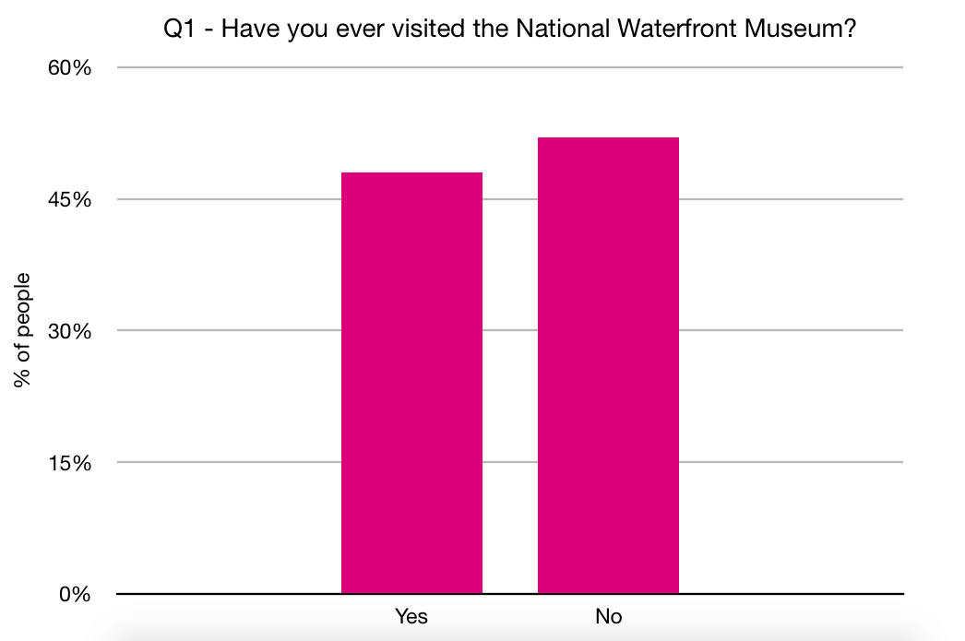

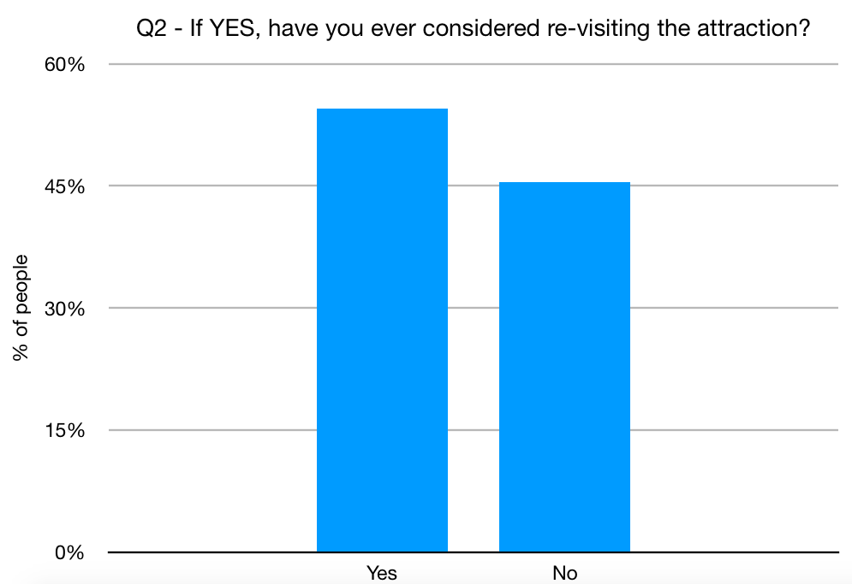

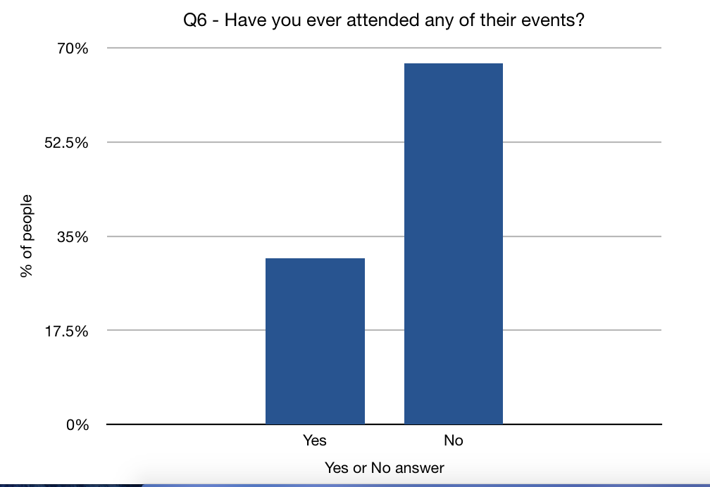

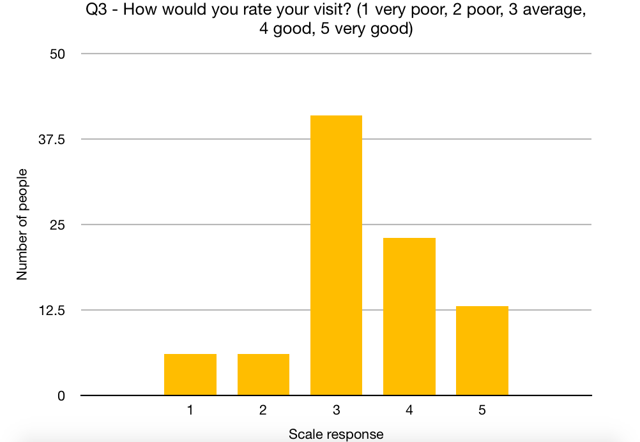

3.2 NEGATIVE PERCEPTIONS
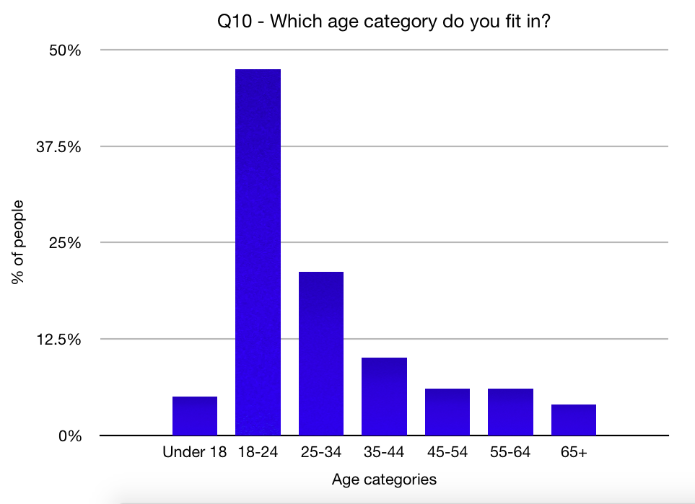
There is a known negative perception on museums, therefore a key part in this consultancy project for the National Waterfront Museum is to find out why this is, and any evidence of negative perceptions in relation to the National Waterfront Museum. Museums house the history of the area, or environment, however, instead of going to museums, people can quite easily read about it in numerous academic and popular books, in magazines and digitally on the internet. The internet allows for anonymous feedback that may be useful in establishing the public’s attitudes on specific aspects (Giles et al, 2016). There has been a shift in museums to the adoption of a more ‘visitor orientated’ approach, with the desire to popularise museums/develop new audiences, and provide an awareness of the educational and social roles that museums can play within the community (Studart, 2000).

There is a widespread sense of museums being under threat due to lack of attendance, budget cuts or technological advance, however museums are in a unique position of being a trusted place of information. There is a lack of trust in society with organisations such as the government and social media, as they are seen as being biased or operating under agendas, whereas museums are being seen as the ‘guardians’ of factual information, presenting all sides of the story in an unbiased manner (Museums Association, 2013).

3.3 SOCIAL MEDIA
Digital marketing refers to the promotion of products and brands among consumers, through the use of all digital media and counter points (Laurent, 2014). Research has shown that social media advertising is growing at 20% a year, and that by 2019 it will be worth $50.2billion, and it allows businesses to track and measure social media campaigns, also making it easier for companies to get information about customers and to connect with them. The main difference between offline word of mouth marketing and word of mouth conversations in the digital world is that companies can observe and monitor the online buzz much more directly and get information more efficiently (McCluskey, 2012). Social media is a significant part of social lives as well as a main source of news for many others - as a result social media adverts blend seamlessly into the news feed therefore more effective than interruptive banner formats, especially on mobile devices (PR Newswire).

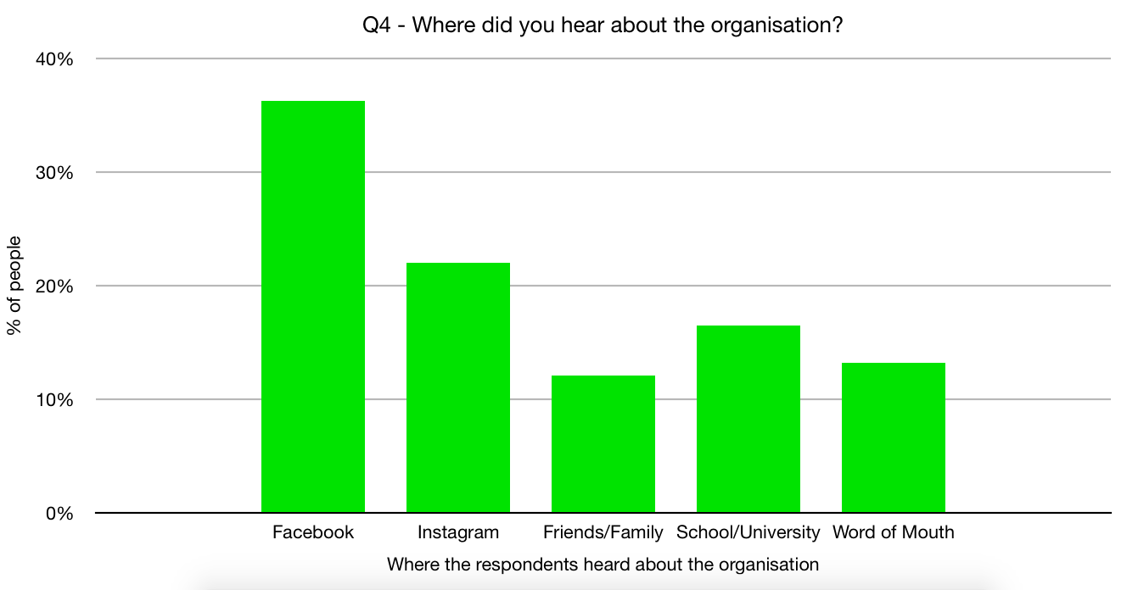
With social media marketing, it can only work by pulling customers in, which attracts mainly the people who are interested in the product or service being advertised, and social media campaigns are usually better for retaining customers rather than gaining new ones. Baer, as cited in McCluskey (2012), says the point of social media is to activate fans, not to collect them like baseball cards. The number of Facebook fans or Twitter followers is not as important as how well the company motivates those fans or follower to remain good customers, and those businesses who understand this give their fans or followers a series of ‘motivating assignments’ such as uploading a picture or sharing information with friends. Each social media platform have many different strengths, many put all their focus into Facebook, however, in order to attract and retain the most amount of customers, businesses should start by asking customers what its they prefer, if long-term success is to be had (McCluskey, 2012).

From this secondary research, the researchers adapted their questions in the survey they created, to finding out where the respondents heard about the organisation, with some of the potential options being some social media sites, if they had a knowledge of social media account, and which social media site they would prefer for the National Waterfront Museum to market on. Below are some the findings from these questions from the survey.

Further analysis into these findings, will be made in section 4.2.

3.4 TRIPADVISOR
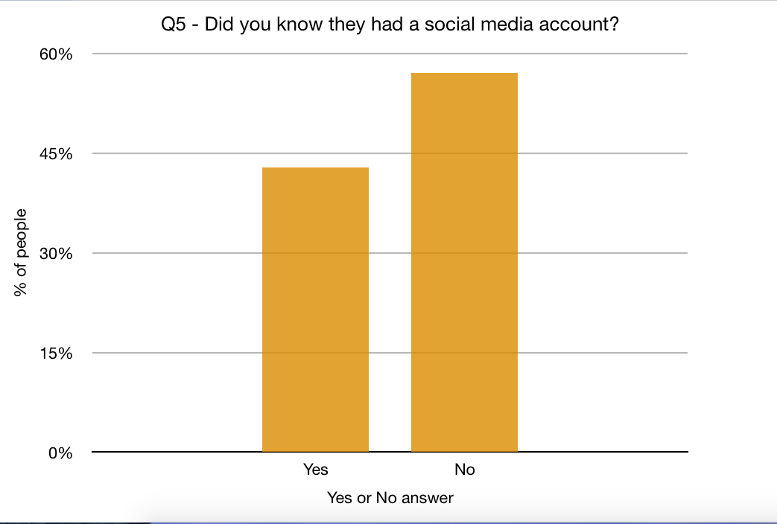
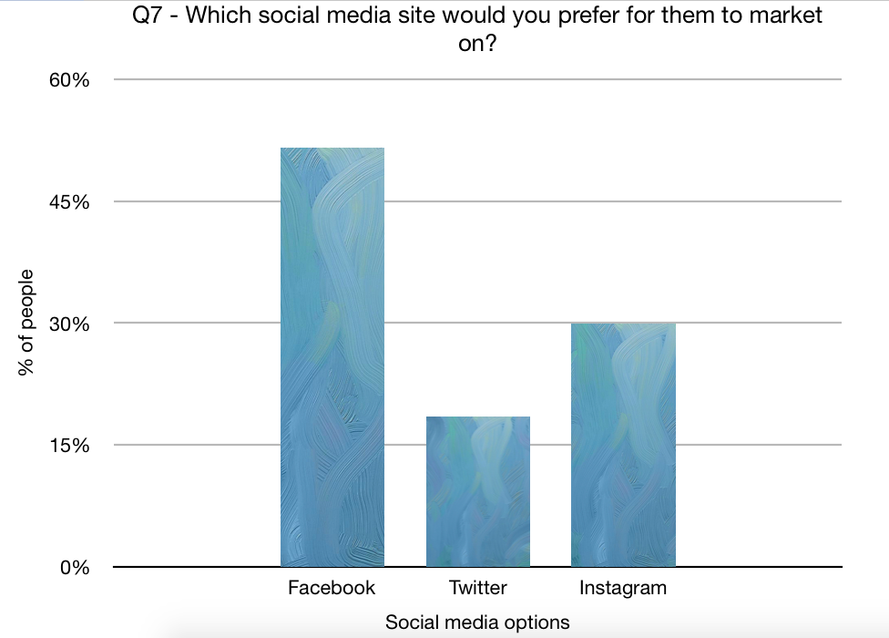
TripAdvisor was used to search for a variety of reviews written by customers, following their visit to the Museum. By looking at these reviews, the reporters were able to see what the organisation can do to improve its performance and to make sure what would make the customers return.

3.5 OFFICIAL DOCUMENTS

Meetings were done with Jenny Walford, Marketing Officer (minutes shown in Appendix 1) in order to gain some basic information at the beginning of the consultancy, in order to find out what problems they think they have, as well as giving ideas as to what the consultants think need work on. The consultancy team also requested if Jenny was able to send official documents regarding visitor numbers and visitor profiles, which may help the consultants to adapt their marketing recommendations to the visitors they attract.

As part of this consultancy, documents regarding their visitors and plans were requested from the National Waterfront Museum, to which they sent the consultancy team numerous documents that were deemed relevant. One of the documents was the National Waterfront Museum Summer Visitor Survey 2017 - Summary report, in which summarised statistics regarding visitors motivation for visiting the museum, how they travelled to the museum and how long it took, how efficient the signage for the museum was when travelling, if they were first time visitors and why, the main attraction to go to the museum, how they heard about the museum, the most interesting fact they had learned about, why some visitors didn’t find their visit very interesting, the rating of their overall visit and where the visitors came from. From this we got information regard motives, and any downsides to the museum, identified by the visitors own experiences.

Another document was their Strategic Plan for 2017/2018, which focused on looking forward to 2017-2021, their 5 year strategic plan. They also sent the consultancy team a document with a survey about how visitors heard about events in 2016, as well as a visitor profile document for the years 2015/2016, which identifies group and individual visitor profiles, how they generate revenue and a rating of their experience. Finally the team were sent a National Waterfront Museum Audience Development Plan 2013/14 - 2016/17. This identified their current marketing position and who is involved, Swansea’s population, their visitor and demographic profile, motivation and satisfaction levels and their competitors within Swansea.

More in-depth analysis of these documents will be made in section 4.5, which will help in providing a clearer picture on exactly who they currently attract and how the consultancy team and help improve upon that.

3.6 COMPARISONS
To find out how well the National Waterfront Museum are performing; a comparison was made with the Swansea Museum due to it being a competitor. Comparing visitor figures was also made to see if the organisation had reached their yearly target number, and a comparison on how each organisation markets in relation to the number of visitors they received will be made.
4.0 ANALYSIS

4.1 SURVEY MONKEY
A survey was created on the online service called Survey Monkey, and the survey consisted of 10 questions, designed to find out what the publics view is on the National Waterfront Museum, including if any they think anything could be improved upon and how, ranging from closed and open questions, allowing the consultancy team to have a variety of in depth but also easy to analyse responses. The first question was a simple yes or no answer question, to ‘Have you ever been to the National Waterfront Museum?’, to which the responses were relatively even in yes and no, but with the more favourable response being no, however the majority of people who answered the second question of ‘Have you ever considered re-visiting the National Waterfront Museum?’ Answered with yes, and those who answered no added on that the reasons being were that they didn’t live close enough, there was nothing new to motivate them to return, they have been once and don’t feel the need to go again, they have seen everything the museum has to offer, they didn’t enjoy their visit or that they need new attractions in order for them to re-visit. This is interesting because, it appears that to the public who answered the survey seem to think that the National Waterfront is a one time trip, and those that wouldn’t re-visit feel they don’t need to because there is nothing new there and that they feel they have seen everything. However, the museum have many events on throughout the year, so this might be a sign that their marketing of their events is not as effective as they think as many people think they have seen everything there is to see there.

Out of the 87 people who answered the third question, which was a linear scale question asking them to rate their experience between 1-5, with 1 being very poor, 2 being poor, 3 being average, 4 being good, and 5 being very good, the most popular response was 3, that they had an average experience. Good was the second popular response, then very good, and poor and very poor were equal in responses. This scale demonstrates that most people have average to good experiences at the museum, which shows that people do enjoy going, so the question that needs to be answered in this project, how can the museum re-attract the people who have already been before, to come back again, even if they feel they have seen everything there is to see.
The fourth question in the survey asks where they heard about the organisation, with the options to choose from being Facebook, Instagram, Family/Friends, School/University, or through Word of Mouth. The most popular answer to this question was Facebook, followed by Instagram, then School/University, then by Word of Mouth, and the Family/Friends being the least popular choice. Other suggestions were given on this question, including Twitter and one response was they have never heard of the National Waterfront Museum. It is interesting to note that social media is where the museum is most talked about from this question, demonstrating it is being talked about in the online world.

The fifth question asks the respondents if they knew that the museum had a social media account, with 57% answering no. This is an issue, because the museum is clearly being talked about on social media, but their presence and marketing on social media isn’t as obvious. This shows that their presence on social media is an issue that needs to be resolved. The sixth question asks whether they have been to any events at the museum, with over 69% answering no. Many of the reasons for this were that they were not interested, they never knew they have events on or that they do not have time to go to them. The fact that one of the popular answers were that they never knew they have events on, prove their marketing isn’t doing as good of a job promoting these events as they may think.

The seventh question asks the respondents which social media platform they would want the National Waterfront Museum to promote on, and over 51% said Facebook would be the best platform to use, with Instagram coming second at over 29% and Twitter being third at over 18%. This tells the consultants that people want the museum to promote on social media, Facebook being the most popular social media site to promote on for long term success. The eighth questions asked what the museum could improve upon, and the top three answers were, make no changes, put on better events, and to market what’s on, with a popular response also being to market on social media. These responses show to the consultants that the public don’t think they market enough, or that they don’t see their marketing, and that they should market on social media, which is one of the primary objectives of this project. It is also interesting to see that many thing there shouldn’t be any changes made, especially when responses from previous questions show that people think that they have been once and seen everything and feel they don’t need to re-visit.

The ninth question asked the public who they could improve on these aspects pointed out in the eighth question, with the most popular response being use social media to promote themselves. This provides more evidence for the consultancy team that the National Waterfront Museum’s presence on social media is ineffective at its current stage and that it needs to be improved upon. The final question asks about what age group they lie in, with most of the respondents being in the 18-24 age range, and the second and third most popular age ranges were 25-34 and 35-44. This is good because the team have gathered responses from the typical family age ranges.
The responses from the survey show and provide further evidence that marketing on social media is a missing link in the National Waterfront Museum’s marketing plan, as a lot of people think they need to market what they have a lot more and should do so on social media.

4.2 SOCIAL MEDIA
There are many good and bad sides to social media and marketing on social media and in this section the consultants discuss these and weigh up whether it is worth doing. Social media is supposedly going to be worth $50.2 billion by 2019, suggesting it might be a good method of marketing into invest into from a business perspective. Social media marketing allows for organisations to be able to track and measure their campaigns, and allows them to connect with customers, as well as reaching a large and diverse audience. Marketing on social media allows organisations to market their business and what they are trying to sell, without being too over the top as their marketing can easily be blended into people’s news feeds, making them noticeable, but not unavoidable. Marketing on social media also allows for monitoring trends but also gives businesses the ability to start specific trends and conversations and monitor their progress and success, for example, using hashtags on Twitter is how many start a trend, and the easy access of the hashtag makes it easy for the businesses to track and monitor them. However, a downside to social media and marketing on social media, is that this is very little control from the organisations stand point in terms of what is being said, as negative news travels faster than positive news does. This makes it harder to control what has been said and how far it travels, because social media and the internet is a worldwide source.

4.3 NEGATIVE PERCEPTIONS
Negative perceptions of museums are very influential of people’s decision whether to go to a museum, but they do not represent the public as a whole, and it is unknown in what ways they are representative. Negative perceptions are naturally occurring data, being a part of people’s world, and their attitudes are not ‘fixed’, all depends on what they are responding too (Giles et al, 2016). This gives the consultancy team some room to try and help change the negative perceptions on museums.

In today’s society, it is hard to justify the existence of a museum without considering the museums commitment to society in regards to their responsibility to represent and address itself to a variety of audiences. There is a lot of criticism in regards to the museum sector and children’s museums and science centre, in that they cannot truly be considered as ‘museums’ because some of them do not have ‘real’ museum objects. Falk and Dierking as cited in Studart (2000), state that the museum experience is a based on a combination of 3 contexts, physical context, which are the exhibits themselves, the personal context, which is the interest and experiences of the visitors, and the social context, whether they visit the museum alone, with family, friends, with a school group and so on. Being able to market to each context in an effective way will help with long term success for the National Waterfront Museum.

4.4 TRIP ADVISOR
One secondary research the reporter used to collect information based on visitor’s views on the Museum was TripAdvisor. This site is used to showcase a review written by tourists who visited an attraction to find their views on what they thought was either worth their visit or not. From looking at a variety of reviews, the National Waterfront Museum has many different opinions from their customers, ranging from terrible to excellent.

Since being open in 2005, the non- profit organisation has managed to receive around 457 reviews, with 45% of which rating the attraction as ‘excellent’, 29% rated ‘very good’, 14% as ‘average’, 7% ‘poor’ and the remaining 5% as ‘terrible’. The reviews range from different countries such as the United Kingdom, Australia, New York and Las Vegas, with the first one being written back in August 2006. This just shows that the museum attracts tourists from all over the world.

As mentioned by, (Aly7622, 2018), they rated the Museum as a 2 out of 5 due to it being a “Lovely building but very dull museum” and found the museum being very poor, especially upstairs despite thinking that the location is ideal. Meanwhile (Tangoj63, 2018) rated their experience as ‘excellent’ due to it containing “lots of interactive exhibits and plenty to interest old and young and it’s free”. With both reviews being different, they were both from the same week and shows that everyone’s experiences are different and it’s hard to cater for every tourist who visits.

Based on the marketing aspect within the Waterfront, some reviews on TripAdvisor both mentioned a problem with advertising their closure when undertaking industrial action. Written in August 2015, both ‘ladawncp’ and ‘gailnrich23’ had scored the attraction a 1 out of 5 as they both ended up paying a fee at the car park, only to find out they were closed due to industrial action taking place, with (ladawncp, 2015) saying “not even a notice on their website” and (gailnrich23, 2015) writing “shame it didn’t say anything in the car park before taking ours and who knows how many other people’s money!!”. From both reviews, it shows that the Museum should take their approach to marketing into consideration by advertising any closures on their website, as well as through their social media.

By reading reviews on TripAdvisor, the museum’s able to work on all aspects within their organisation which doesn’t satisfy the tourists’ needs by working on to achieve the best possible results. Due to the organisation not having enough interaction on their social media sites, reading reviews like these would benefit them, as they’re able to take their comments into consideration and will also be able to know which areas within their marketing side needs to be addressed. It just shows how important written reviews are to a business. Screenshots of some of the reviews are shown in Appendix 2.

4.5 OFFICIAL DOCUMENTS
This summary report helps give an idea of the motivation behind people’s visits to the museum, and all factors associated with their visit including how they travelled there, their experience, and their rating of their overall visit. In regards to whom filled out the survey, 32% were first time visitors, and 67% said they had visited before. Those who hadn’t visited before said it was because they were not aware of the museum, a comment that hasn’t arisen until recent years.
When asked why they hadn’t visited before, 59% said it was because they did not live locally.
From this survey, the most frequent responses given as to why they visited the museum were because of the school holidays or for somewhere to take children, and for Roald Dahl Day. This demonstrates how they are attracting the children and families demographic, and 77% of the sample said they were visiting the museum with a family group, which is 3% increase since the previous year’s survey, further showing that they attract the family demographic. It seems that most people favoured travelling by car to get to the museum, at 88%, it was the most popular, up 22% from the previous year, and the most common travel time was 30 minutes, showing that most of their visitors are fairly local to the National Waterfront Museum. Travel times have remained very consistent across the last 6 years, with a constant mode travel time of 30 minutes, and an average travel time of between 35-45 minutes. The percentage of those travelling an hour however, fell from 14% in 2016 to 7% in 2017. This shows how they are attracting more local people, but not attracting people from a further distance.

In regards to signage, those who rated the signage poor were first time visitors to the museum. This is not promising in regard to how they market because if first time visitors are attracted to the museum but find it difficult to get there, they will not want to make the effort to return again, which means resources being spent on marketing may theoretically be going to waste because their poor signage is putting people off from returning to visiting the museum. One of the main draws for visitors to the museum was the availability of children’s activities and special events, followed by the museum being a good rainy day outing and something to do with with children and in the school holidays.

Respondents have asked how they had heard about the museum, living locally was the most popular response at 26%, followed bu word of mouth, the website and having a leaflet through the door. The most interesting thing respondents found about the museum was learning about Welsh industry during their visit, with emphasis on the coal industry, and how hard life was and how hard people worked. Of those who found an aspect of their visit less interesting, some commented on things not working, and some said the museum itself was the least interesting part. Identifying what people found the most and least interesting, can help tell the consultancy team what main aspects of the museum to focus on when marketing the museum. For the overall rating of their visit, 47% rated it as excellent, 32% said it was very good, 10% rated it good and 2% felt it was a poor visit, and there was a 10% decrease in the excellent rating compared to the previous year which makes the consultants wonder what changed in the museum for the rating to go down. The majority of respondents who answered the survey were from Wales (59%), with 12% coming from the rest of the UK and 3% from outside the UK.

From this survey, the consultancy team understand that the majority of visitors are families, from the local area, and that the most interesting aspect people have identified is learning about the Welsh history, which may suggest that emphasis on Welsh history should be included in the marketing.

From another survey provided by the staff at the National Waterfront Museum regarding 4 events in 2016, 25% had heard about the events through the website, but only 3% had heard about them through Twitter or Facebook. The website has important visibility in regards to people finding out information about the museum and what is on, but the social media platforms Twitter and Facebook do not reach many people, showing this is an area for improvement for the marketing team at the National Waterfront Museum. 18% had heard about the events during a visit to the museum, but had no prior knowledge about the events until they made a visit to the museum. 9% of people had heard about the events through Swansea What’s On, and 9% through Museum’s What’s On, showing they are both equally as important and effective in drawing in visitors.
In regards to the visitor profile’s of the museum, the individual visitor profiles come in at 42% were with children, and 79% were from Wales. The group visitor profile show that 37% were with children, with 56% being from Wales and 44% from abroad. This demonstrates how the museum is attracting those with children, and is viewed as a child friendly museum, but also that it primarily does attract people within Wales and the local area. The rating of experience was roughly around 8/10 for both the individual and group visitor profiles, with the majority of people saying they would visit again and recommend visiting the museum. These high ratings show how those who do visit the museum, enjoy it and would visit again. This data however is from 2015/2016, and compared to the data gathered from the online survey via Survey Monkey, many people from the survey said they wouldn’t visit again because they have already been once and don’t see the need to visit again.

In the National Waterfront Museum Audience Development Plan 2013/14-2016/17, they identify their current marketing position, where media coverage is obtained mostly locally, and that they promote through an integrated mix of marketing, press and PR activity. With media coverage being mainly local, it explains why the majority of visitors are local and from Wales, because that is primarily where the media coverage is. Whilst it is good to get local people involved and visiting, in order to attract people from a further distance, they need to promote and marketing accordingly, and just basing their media coverage primarily in local areas, will not attract those from a further distance.

What the official documents from the National Waterfront Museum tell the consultancy team is that their most popular visitors are families or those with children, and come primarily from the local area. Targeting these aspects of the demographic in their marketing strategy will help bring in more people with children and families, and will help motivate the locals to learn about their local heritage through the museum.

4.6 COMPARISON
The Museum advertises their organisation by using different forms of social media such as Facebook and twitter, despite having limited information and uses sources such as leaflets, brochures, flyers and booklets. Situated on the same road as the National Waterfront Museum, Swansea Museum is another popular attraction located in Swansea. They are a competition to the Waterfront as they are both a museum attraction but are also within walking distance of each other. Both organisations try to market by using a variety of sources, such as Facebook, twitter, Instagram and their websites, as well as containing leaflets and brochures. From looking at both of their social media sites, Swansea Museum has more followers on all sites, with 2,979 on Facebook, whilst the Waterfront has 1,586. On twitter, the Swansea Museum has a total of 10.7k, with the Waterfront having 7,974 and on Instagram, the Swansea Museum has 486 followers, meanwhile the Waterfront Museum doesn’t have a created account. By looking at these figures, it shows that the Waterfront Museum should expand on their marketing skills by creating an Instagram account to have more followers. This could boost their reputation and could possibly attract even more customers from a variety of destinations.

The graphs below show how many customers the Waterfront Museum has managed to attract between the years of April 2016, to March 2018. From the figures shown, their busiest months within the two years are July, August and September, with August attracting 35,315 between April 2016- March 2017 and 34,920 between April 2017- March 2018. The reason being for this could be due to it being a part of the Summer holidays, therefore families have more time to visit the Museum. January is the least popular month, with only 14,909 visits in 2017, and 16,762 in 2018. This could be due to the number of events happening in the month of January. In 2016, the Waterfront Museum managed to attract a total of 265,235 tourist, and the total amount of tourists who visited the Museum in the year of 2017 was 266,692. This shows that they managed to attract an extra 1,457 tourists but still haven’t reached their target. Their yearly target is to attract around 270,000, therefore it shows that they are yet to attract as many tourists and to reach their goal but could achieve their goal by keeping up to date with their social media sites and creating an account via Instagram could possibly boost up their numbers.
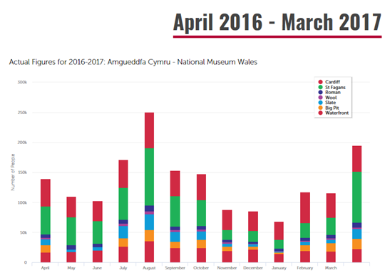
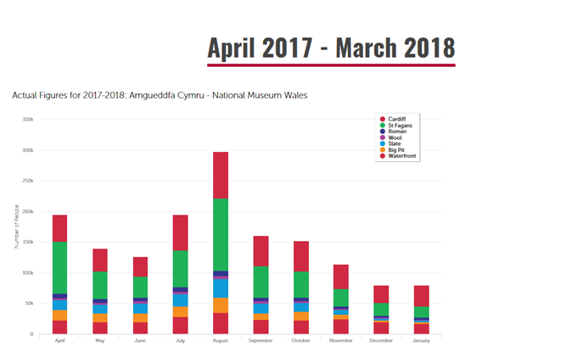

5.0 RECOMMENDATIONS
To attract more tourists to their organisation and to achieve their goal of attracting 270,000 tourists a year, the consultants came up with recommendations on how they think the Museum could benefit form for long- term success. The recommendations are shown below:

- To reach a wider audience, the Museum should expand on their social media by creating an account via Instagram as they have millions of users and could possibly attract more customers.

- The current perception of the Museum is that it’s classed as ‘dull’, and to change this they should make their marketing look more modernised and interactive.

- Continue to invest in the making of the leaflets and to include more resources into promoting on social media.
6.0 CONCLUSIONS
Following the research and analysis of the marketing issues at the National Waterfront Museum, it is clear that negative perceptions have an impact on whether people visit, so marketing the museum as a more modern and interactive place to visit. It is also clear that their lack of social media presence is a downfall in regards to their marketing, because social media is such a diverse and unique way of promoting an organisation in today’s digital world. In regards to investment into leaflets, the consultancy team recommend continuing to invest into leaflets but also putting more resources into promoting on social media as well.
7.0 APPENDIX
Appendix 1
MINUTES - Meeting with Jenny Walford
Date -

Report on the waterfront museum
Suggestions on what should be done to improve on attracting social media
Look at target market/different age groups
How culture affects on the wellbeing

Drop in events number of tourists if leaflets aren’t printed - is it worth the investment?
Advertised at the train station

270,000 a year is their target for visitor numbers

Council shutting out the car park by the museum - how would people go without a car park
Lose money due to no money coming in from the car park

Do they need more signs on the road?
Think of advertising to attract customers
Visitor survey

Requested from Jenny if we could have some documents regarding visitor numbers, any surveys they have done in the past that could help the team with coming up with solutions. Below show emails between the team and Jenny.
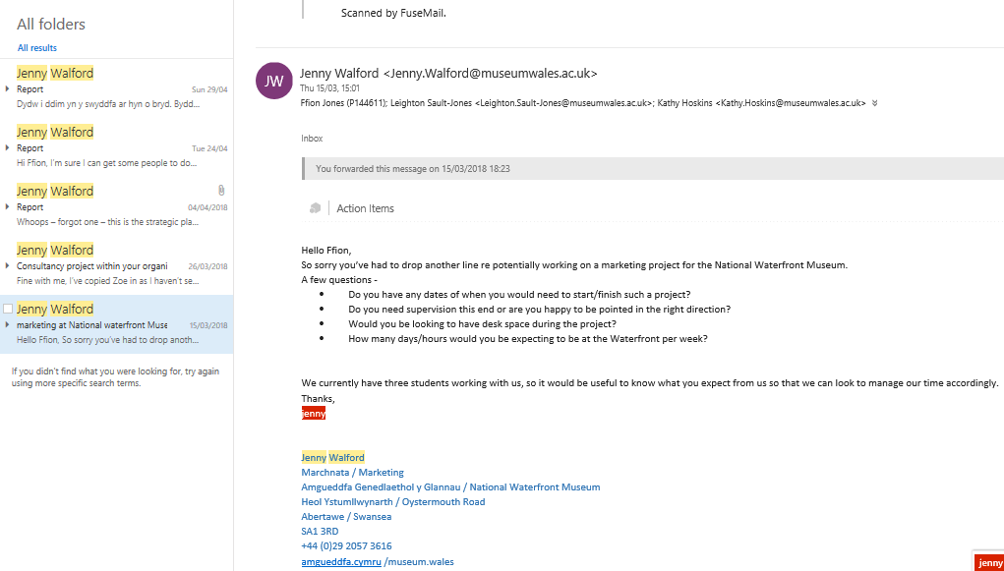

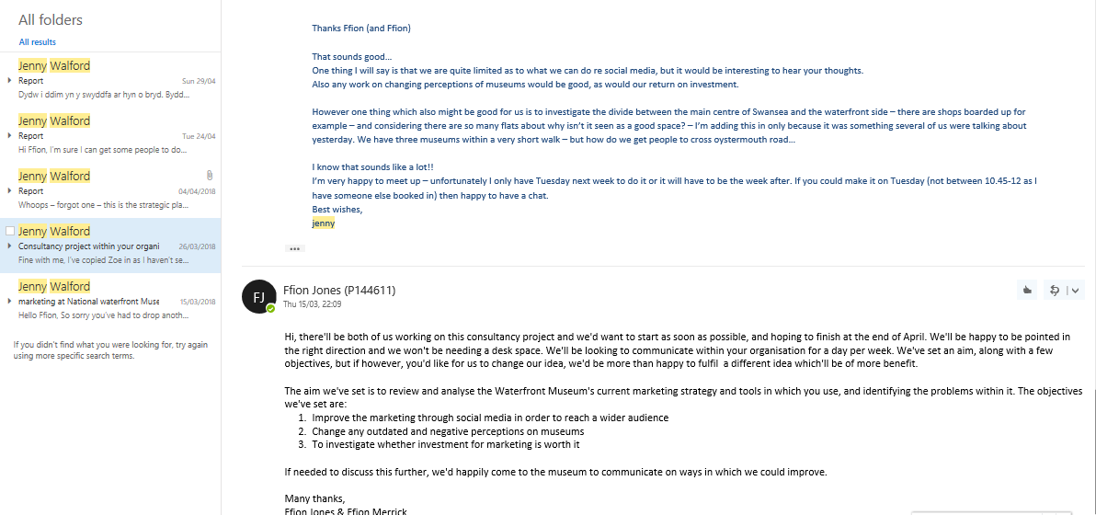

Appendix 2

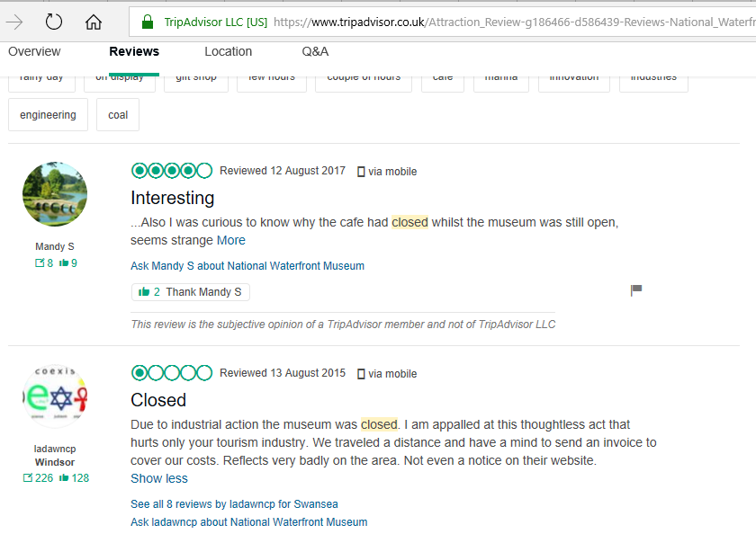
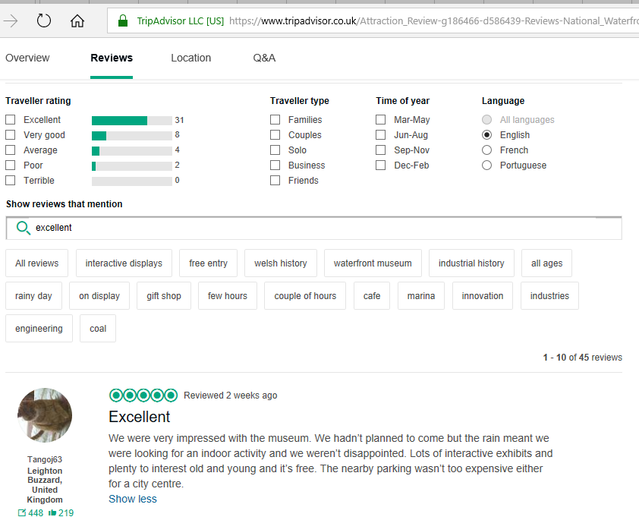
8.0 REFERENCES

Brida J, Meleddu M, Pulina M, 2016. Understanding museum visitors’ experience: a comparative study. Part of: Journal of Cultural Heritage Management ; Customer Services ; Integrated Approach. Journal Article. Vol 6(1). Pp 47-71.

Brida J, Nogare C, Scuderi R, 2017. Learning at the museum: factors influencing visit length. Part of: Tourism Economics. Vol 23 (2). P 281. Peer Reviewed Journal Article.

Bryant A, 2017. Research Methods. Grounded Theory and Grounded Theorising, Chapter 2. Oxford University Press.

Did you hear about the event? Official Document - via Jenny Walford. National Museum Wales - National Waterfront Museum.

Facke C, Gurzynski-Weiss L, Plonsky L, 2014. Research Methods. Part of - Fäcke, C, (ed.) Manual of Language Acquisition. (pp. 31-49). Mouton De Gruyter: Berlin, Germany. Book Chapter.

Full Year Results Presentation - Visitor Profile Survey 2015-2016. Official Document via Jenny Walford. National Museum Wales - National Waterfront Museum

Glaser B, 2008. Qualitative and Quantitative Research. Grounded Theory Review: An International Journal, 01 June 2008. Vol 7(2) Journal Article.

Giles M, Sayer D, Walter J, Williams H 2016. ‘Digging the dead in a digital media age’. Williams, H. and Giles, M., eds. Archaeologists and the Dead.Vol. 9780198753537. Oxford, U. K.: Oxford University Press, pp. 367-395. University of Bath.

Kazim Kirtis A, Karahan F, 2011. To be or not to be in social media arena as the most cost efficient marketing strategy after the global recession. Part of - Procedia - social and behavioural sciences. Volume 24. Pages 260-268.

King, R, 2011. Marketing Methods Best Practices. Part of - Journal of Financial Planning, suppl. Practice Management, Denver. (Jan/Feb 2011) PP 18-19.

Komarac T, 2014. ‘A NEW WORLD FOR MUSEUM MARKETING? FACING THE OLD DILEMMAS WHILE CHALLENGING NEW MARKET OPPORTUNITIES’ Part of - Trziste = Market. Vol 26 (2). Pp 199-214. Peer Reviewed Journal - article.

Laurent, F, 2014. How to measure digital marketing metrics for assessing impact and designing success. Publisher - London: Palgrave Macmillan UK: Imprint: Palgrave Macmillan. Book.

McCluskey, C, 2012. Where does the good will go? Long term effects of social media marketing. Part of - EContent, Mar 2012, Vol.35(2), pp.8-10. Article.

McDonald M, Mouncey P, 2009. Marketing accountability how to measure marketing effectiveness. Publisher - London ; Philadelphia ; Kogan Page. Book.

Michael Trusov, Randolph E. Bucklin, Koen Pauwels (2009) Effects of Word-of-Mouth Versus Traditional Marketing: Findings from an Internet Social Networking Site. Journal of Marketing: September 2009, Vol. 73, No. 5, pp. 90-102.

National Museum Wales. (2018). April 2016 - March 2017. [online] Available at: https://museum.wales/visitor-figures/april2016-march2017/ [Accessed 2 Apr. 2018].

National Waterfront Museum Audience Development Plan 2013/14-2016/17. Official Document via Jenny Walford. National Museum Wales - National Waterfront Museum

National Waterfront Museum Summer Visitor Survey 2017. Official Document via Jenny Walford. National Museum Wales - National Waterfront Museum

No Author, 2013. Museums Association. BritainThinks. Museums Galleries Scotland, Welsh Government, Arts Council England. ‘Public Perceptions of - and attitudes to - the purposes of museums in society. A report prepared by BritainThinks for museums association.’ https://www.museumsassociation.org/download?id=954916 Online. Accessed - 03.04.18

PR Newswire, 2016. The effects of social media on advertising and marketing. Part of - PR Newswire, Dec 22, 106. Newspaper Article.

Studart D, 2000. The perceptions of behaviour of children and their families in child-orientated museum exhibitions. Part of: Doctoral Thesis, University of London. University College London - Dissertation.

Strategic Plan 2017/18. Official Document via Jenny Walford. National Museum Wales - National Waterfront Museum

TripAdvisor, 2018. National Waterfront Museum, Swansea. https://www.tripadvisor.co.uk/Attraction_Review-g186466-d586439-Reviews-or250-National_Waterfront_Museum-Swansea_Swansea_County_South_Wales_Wales.htm Online. Accessed - 03.04.18

Visitor Profile - Powerpoint. Official Document via Jenny Walford. National Museum Wales - National Waterfront Museum

