Module: Strategic Management for SMEs
Module code: BMSW6104
Student name & id: Alexandra Merauta 2121306
Lecturer: Abdallah Naser

Task 1

Table of Contents
Introduction 3
Critically Appraising the Inkey List’s Current Strategic Direction 4
Challenges and Considerations 6
Strategic Recommendations 7
Environmental Scanning and Analysis for The Inkey List 8
PESTLE Analysis 8
SWOT Analysis 9
Stakeholder Analysis for The Inkey List 10
Critically evaluating the expectations of the different stakeholders and their relative power 11
Strategic Growth Choices for The Inkey List 12
Proposed Strategy: Market Development and Product Development 13
Justification for Market Development and Product Development 14
Key Strategic Recommendations for The Inkey List 14
Implementation Challenges 15
Conclusion 17
References 18

Introduction
Strategic management refers to developing structural plans for a company to accomplish its objectives and goals where it can make resource allocation effectively and make greater profits as well. In this regard, I have chosen the UK-based skincare company small medium enterprises named The Inkey List which was founded in 2018 by Colette Laxton and Mark Curry. Since then, it has snowballed and achieved notable success in the beauty sector.

Figure 1 Official Logo of Inkey List
Source: (The INKEY List UK, 2024)
The company aims to democratize skincare by offering high-quality, affordable products that prioritize transparency of ingredients and education. The Inkey List sets itself apart by demystifying skincare, opening it up to a broad audience, and enabling customers to choose their moisturizers with expertise. A variety of serums, cleansers, and moisturizers are available in the brand's product lineup, each is made with one or a small number of essential components. This strategy is in line with the emerging customer desire for skincare products that are clear and uncomplicated. By emphasizing cost, obstacles that frequently occur within the beauty business are taken down. The desire for skincare items that are not merely efficacious but also eco-friendly has increased in recent years. An ever-growing number of environmentally aware consumers are drawn to The Inkey List because of its dedication to sustainable practices, which include recyclable packaging and materials supplied responsibly. Throughout its accomplishments, The Inkey List still has to contend with issues that small and medium-sized businesses (SMEs) frequently confront, such as supply chain management, market competitiveness, and preserving brand uniqueness. Nonetheless, the firm has opportunities for its future growth because of its strategic approach. The strategic management of The Inkey List will be thoroughly examined in this study, with an emphasis on the company's present strategic orientation, external forces, stakeholder expectations, and expansion prospects. The study will assess the internal and external environments, pinpoint important opportunities and risks, and provide viable plans for long-term success using techniques like PESTLE and SWOT analysis. The report's rigorous evaluation of those components attempts to provide useful insights that further The Inkey List's objective of making skincare affordable for customers.

Critically Appraising the Inkey List’s Current Strategic Direction
Since its inauguration in 2018, The Inkey List has made a name for itself in the very competitive skincare marketplace by driving home ingredient transparency, cost-effectiveness, and customer education. Moreover, This Company has built a strong belief that a better decision may drive from better information where knowledge is conceived as the heart of what we do Inkey list company serves us better knowledgeable products.
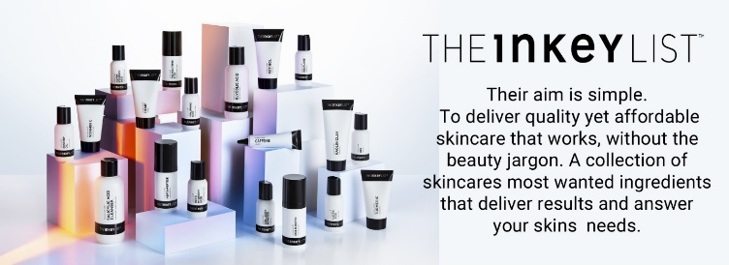
Figure 2 Inkey List Vision
Source: (The INKEY List UK, 2024)
The company's development and market penetration have been driven by several vital features that form the foundation of its strategic orientation yet, for long-term success, several of all of these elements require a detailed investigation.
Transparency and Consumer Education
Transparency is a fundamental principle for not only The Inkey List's policy but also for every company engaged in skincare products. The company places an enormous emphasis on simple lists of components and the formulations of products that help the typical customer understand skincare. This strategy not only allows trust but also gives clients the ability to make wise choices. By erasing obstacles that frequently terrify customers, the brand clears up scientific language and builds a dedicated base that values the goods' utility and simplicity (Hamermesh, 2014). The Inkey List also makes substantial expenditures in consumer education, conveying skincare expertise via digital channels. The company stands out in a competitive market because of its educational focus, which also positions it as a personal care rather than just a product supplier. This tactic improves client loyalty and engagement and thereby transforms how users view the brand.
Affordability and Accessibility
Affordability is one of the most important parts of The Inkey List's strategic objective. Through reasonable rates along with higher product quality, the brand is now offering effective skincare to a wider range of consumers. This liberalization of skincare is especially attractive in a market where luxurious items and luxury goods continuously have a superior position. The Inkey List has drawn in a wide range demographic of consumers through its reasonable bargains, including younger generations who may not have as much wealth as they used to but are likewise establishing themselves as more interested in skincare.
Digital Marketing and Social Media Engagement
Social media and digital marketing have been used efficiently by The Inkey List to build relationships with its prioritize-based customers and influence its target audience. Through the use of social media sites like TikTok, and Instagram, Facebook, Twitter the Inkey List disperses useful information like ingredient analysis and beauty advice in addition to marketing its goods. This digital approach is in line with the current consumer trend, which is to look for businesses that provide more than simply products. The Inkey List's devotion to content-driven marketing contributes to the growth of a devoted following of customers who respect the brand's educational bent. User-generated content and agreements with influencers in the skincare space also help brands become more visible and credible, which heightens their standing in the market (Rao, 2010).
Product Innovation and Development
The product line of The Inkey List has been identified by the concentration it has on one or a small number of active products. Customers searching for precise remedies free of complex approaches find this simplicity appealing.
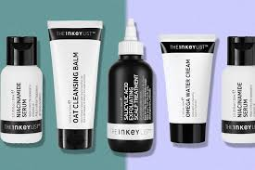
Figure 3 Products of Inkey List
Source: (The INKEY List UK, 2024)
The firm keeps fresh and sensitive to customer necessitate by frequently introducing emerging goods to its lineup, such as peptides and niacinamide, which are popular skincare trends. Though there are also similar products that exist in the skincare market this company stands with its new ideas to be competitive in the market.

Challenges and Considerations
In today’s market scenario though, this company assures its lots of strength but also it faces numerous challenges in its existing strategic direction and these are described below:

Figure 4 Challenges of Inkey list in the SME sector
Source: (Self Made)
The strong competition in the skincare sector, where other businesses are implementing comparable transparency and affordability tactics, is one of the many obstacles The Inkey List has in carrying out its present strategic objective. Vulnerabilities in the supply chain put item supplies and consistent quality at risk, which is important for preserving trust among clients. Furthermore, the market has become oversupplied, meaning that multiple items with comparable aspects exist, mandating enduring differentiation by brand. Navigating complicated regulatory frameworks becomes crucial as the company grows internationally. Finally, even if The Inkey List's environmental activities are praiseworthy, they must be advanced to satisfy changing customer demands and keep a competitive edge.

Strategic Recommendations
There are some strategic recommendations for Inkey List to gain market efficiency and become a sustainable business icon for skincare products perspectives and these key strategies are listed below within a chart:
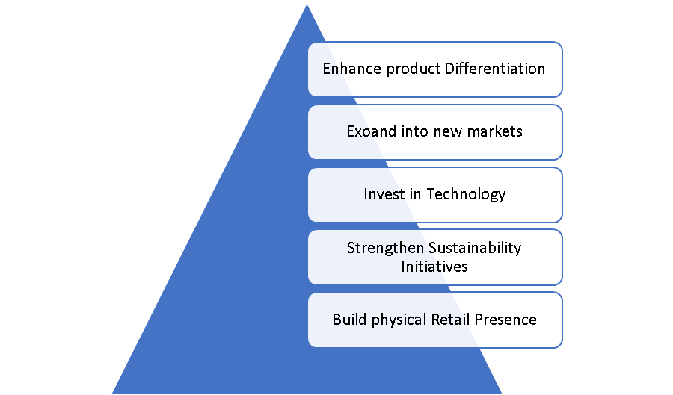
Figure 5 Strategic Recommendation for Inkey List’s
Source: (Self Made)
To sustain development, The Inkey List needs to boost product differentiation through the debut of products that target certain skincare issues, utilizing unique elements to make an impression in a crowded market. One way to reach formulating customer bases is by venturing into underutilized overseas markets, namely those in Asia and Latin America. The consumer experience will be improved by investing in technology to provide individualized grooming solutions, such as virtual consultations and AI-driven suggestions. Consumer values will be aligned with the strengthening of sustainability measures through the adoption of more environmentally conscious containers and the examination of refillable possibilities. Furthermore, increasing the quality of your retail presence through joint ventures or exclusive boutiques might draw in new clients who value having personal conversations with shoppers.

Environmental Scanning and Analysis for The Inkey List

PESTLE Analysis
It means several key factors that have a huge impact on the Inkey list brand and the term describes political, economic, social, technological, legal, and environmental factors wholly exert numerous impacts on this company these issues are discussed below:
Political
Regulatory Compliance: The Inkey List works in the EU and UK, where rules in connection with cosmetic safety must be adhered to meticulously. Regulations that change after Brexit could affect the procurement of ingredients and import/export activities.
Brexit Implications: Strategic planning must be undertaken to manage risks since mutually beneficial agreements and tariffs may impact operational costs and supply network security (Jeyarathmm, 2008).
Economical
Pricing Strategy: Because of Inkey List's affordable rates it has a competitive edge in an economic environment of uncertainty by noticeable individuals that require thrifty suggestions.
Consumer expenditure: Discretionary fees on skincare products are influenced by fluctuations across the economy. The beauty industry has shown resilience in its handling of economic downturns, with customers positioning a greater emphasis on self-care.
Social
Consumer Awareness: Demand for ethical sourcing and ingredient dissemination in products is emerging. Socially passionate customers are drawn to The Inkey List because of its emphasis on knowledge.
Skincare Trends: There are chances for variety in products and focused marketing tactics due to the increasing dependence on individualized skincare and a sense of well.
Technological
Digital marketing: The growing popularity of various social networking pages and digital platforms makes available the ability to begin the construction of examined campaigns for advertisement that raise the visibility of brands and interaction between businesses and consumers (Yadav, 2022). Besides in the era of modern technology online advertisements with content creator videos aid in the digital marketing of skincare products.
Product Development: As preferences of consumers alter more effective skincare products may be crafted thanks to scientific developments in formulation methods.
Legal
Cosmetic Safety Regulations: Market expansion implies strict adherence to worldwide cosmetic standards, causing the need for an ongoing monitoring of legislative developments.
Intellectual property: To steer clear of copying as well as preserve brand integrity in a saturated marketplace, taking care of product ingredients and distinguishing characteristics is Groundwork.
Environmental
Sustainability: Eco-friendly Cosmetic items are getting more and more pertinent to consumers. This trend is aided by The Inkey List's adherence to ethical sourcing and environmental packaging.
Regulatory Pressure: As environmental laws dealing with packaging waste and green habits increasingly more stringent, ongoing innovation and adaptation are needed.

SWOT Analysis
Strengths
Brand Transparency: In today’s competitive world Inkey List company made it possible to create its brand transparency where Consumer loyalty and trust are strengthened when aspect lists and benefits of the item are shared unambiguously. The inexpensive pricing of skincare products permits a wider audience to get them.
Consumer Education: Educating customers about products and skincare practices fosters an engaged following and fosters the reputation of the Inkey list.
Weaknesses
Limited Retail Presence: Brand exposure to customers who stick with in-store buying experiences may be constrained by a dependency on sales over the Internet (Kleiböhmer, 2017).
Niche Product Focus Shoppers looking for comprehensive formulations may find a few products valuable due to the focus on specific compounds.
Threats
Competition is violent: There is a lot of conflict in the skincare market that provides reminiscent products with increased transparency, determining frequent innovation necessary.
Vulnerabilities in the Supply Chain: Shortages of ingredients or other supply chain disruptions may modify the availability of products and the reputation of brands.
Market Saturation: A diminished variety and price global competitiveness may result from an oversupplied market with analogous offers, thus resulting in a claim on profitability.
Opportunities
The Inkey List is on the edge to capitalize on many noteworthy chances in the skincare industry. The brand's market share may be drastically higher due to stepping inside foreign markets, especially in areas where skincare has recently become in increasing demand. Besides, scaling into adjacent categories and creating new formulas are two ways that product diversification might draw in a wider customer base (Williams, 2009). The company's dedication to sustainability and moral business conduct aligns nicely with consumers' morphing tastes, giving it a chance to stand out even more and magnetize eco-aware customers.

Stakeholder Analysis for The Inkey List
Customers, staff members, manufacturers, retail partners, investors, and regulatory agencies represent a number of the main stakeholders involved in the Inkey List. Powerful consumers dire need apparent, transparent, and affordable goods as well as educational material, which has a big impact on marketing and revenue. Medium-power workers look for scenarios for promotions and an engaging work a sense of atmosphere which governs output and imaginations.

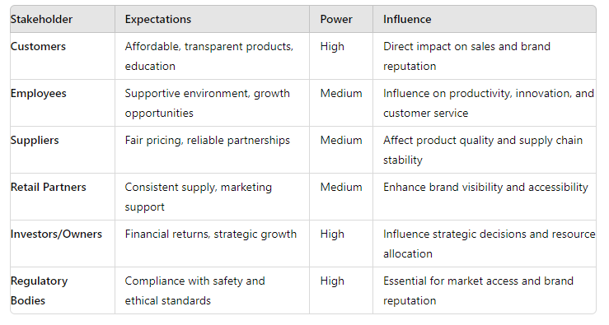
Table 1 Different Types of Stakeholders of Inkey List
Source: (Self Made)
Medium-power suppliers also want long-term cooperation and reasonable prices, so this has an impact on supply chain stability and product quality. Retail partners seek steady marketing and supply support to raise brand awareness; their influence is medium. High-power investors shape the course of the firm by focusing on monetary gains and strategic expansion. High-power regulatory organizations additionally demand adherence to moral and safety norms, which are necessary for market entry and brand veracity. Maintaining these different demands in check is deemed crucial for Inkey List's sustainable and profitable growth.

Critically evaluating the expectations of the different stakeholders and their relative power.
Consumers: As their mainstay of income, they enjoy a high demand for curiosity and affordability for useful goods. About their profound impact, the success of brands can be directly affected by customer enthusiasm and pleasure. Negative online reviews may spread fast, compromising the organization's reputation and profit margins.
Employees: Because of their job duties in customer service, marketing, and product development, employees have a medium power. Employee anxiety can result in layoffs and lower output, although satisfaction with job duties fosters innovation and improves customer experience (Mir, 2018). Retention and performance depend substantially on the ongoing preservation of a good job environment.
Suppliers possess a medium power impact on the viability of the supply chain and the quality of the products. While postponements can have an impact on sales and production, strong, punctual alliances represent ongoing product supply. Forging equitable, ongoing relations with suppliers is critical to the viability of functions.
Apart from these stakeholders, there are also retail partners of Inkey list with their medium power exhibits because they have an effective collaboration and have a large mutual shared objective in their motto to be a global power. Besides Investors also hold high power on this company’s strategic direction as well as its financial decision. Finally, Regulatory bodies whose direction is termed as non-negotiable because the safety and ethical standards are crucial to follow by Inkey list managerial operation. So, in this regard, it is being understood that customers and the regulatory bodies are deemed as the highest power and they can exert a large impact on Inkey List market operation and its compliance. So, it is urged to maintain these overall stakeholders' expectations effectively to be a sustainable business as a whole.

Strategic Growth Choices for The Inkey List
Available Strategic Growth Options

Figure 6 Available Strategic Growth Options for Inkey List
Source: (Self Made)
There are several strategic growing possibilities useful for The Inkey List. Growing your share within current areas through better promotions and attempts at loyalty is known as market penetration. The overall objective of market development is to reach new geographical markets, especially those that are expanding quickly, like those in Asia and the Americas. Creative skincare products that accommodate fresh trends, such as suitable skincare regimens or products with a sustainability focus, are part of product development. Afterwards, diversification is experiencing growth in the product line and lessening dependence on the face skincare industry by venturing into allied categories like wellness or hair care. These marketing strategies all provide approaches to improve consumer perception and prod its expansion.

Proposed Strategy: Market Development and Product Development
Ansoff Matrix Analysis
Market Development: As already mentioned earlier The Inkey List has the potential to reach underserved foreign markets, especially those in Latin America and Asia. The rise in disposable incomes and cultivating public knowledge of skincare in these areas indicate substantial growth offerings. By making full use of its pre-existing internet site and connections with regional merchants, the brand may effortlessly penetrate new regions, making its marketing tactics align with local tastes.
Product Development: By delivering cutting-edge methods that adhere to certain skincare obligatory and moment trends, including microbiome-friendly or anti-pollution products, The Inkey List could bring about innovation within its product range. Moreover, branching out into the corresponding sectors like body or hair care may result in new prospective customers and increase the array of sources of income.

Justification for Market Development and Product Development
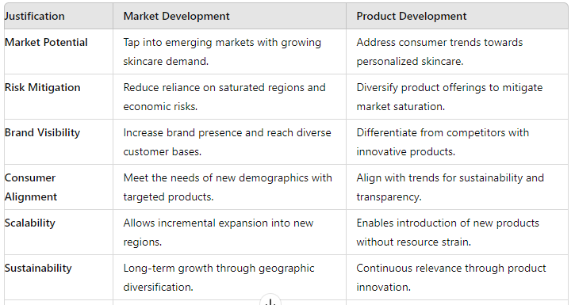
Table 2 Justification for Market Development and Product Development
Source: (Self Made)
Through the expansion of the marketplace, The Inkey List may lessen its dependency on concentrated regions and mitigate economic risks by engaging new countries with higher disposable revenue and expanding awareness of skincare. Regional growth draws in a wide range of clients and raises brand awareness. Product development, on the other hand, keeps up with consumer tastes toward customized and eco-friendly skincare, setting the brand apart from rivals and improving its position in the market. The Inkey List satisfies rising buyer needs by launching newer formulas and seeking related industries like hair care. This promotes long-term viability and further solidifies the brand's diligence to openness and education. This two-pronged strategy promotes brand integrity while setting up scalable broadening.

Key Strategic Recommendations for The Inkey List
Strengthen Product Differentiation: The Inkey List ought to create innovation by secreting creative formulas to the target. This information certain skincare issues and uses specific components to stand out in a competitive marketplace. This may support keeping a competitive advantage and draw in customers looking for specific products and services.
Boost Global Market Presence: focuses on in need of countries in Latin America and Asia, where there is a rising need for skincare products. Develop arrangements with local leaders to raise the reputation of your company, and adjust marketing methods to align with the tastes.
Utilize Technology for Personalization: Make expenditures in AI-powered platforms that offer made according to skincare advice. This elevates consumer experience and boosts association, and crafts tools for a more dependable brand community.
Strengthen Sustainability Efforts: Use alternative packaging choices, that involve refillable containers, to increase the scope of eco-friendly activities. This enhances brand loyalty by drawing environmentally concerned customers and aligning with consumer values.
Expand Physical Retail Presence: To increase brand awareness and attract shoppers who choose in-store shopping experiences, form alliances with important merchants, or think about opening special pop-up stores. Apart from that, background marketing could drive brand engagement.
Focusing on the resilience of the supply chain: Create aggressive strategies to reduce interruptions in the supply chain by expanding your supplier base and reflecting increasingly adaptable dealing with logistics options. This is a certain steady product quality and availability.

Implementation Challenges
Several impediments must be tackled in carrying out The Inkey List's strategic orientation, specifically as a smaller or medium-sized business (SME). The option to spend on R&D, marketing, and technology required for distinctive products and global expansion may be hampered by a lack of funding. It may be challenging and resource-intensive to handle regulatory compliance across several markets, necessitating constant observation to stay out of trouble with the law. Furthermore, it is difficult to keep supply chains resilient in the face of worldwide disruptions, which calls for investments in various suppliers and logistical techniques (Yadav, 2022). Here are some pointed challenges that SMEs face like the company that I have worked for Inkey List issues are:
- Employee Engagement
- Market saturation
- Technological Investment
- Retail Expansion
- Operational Efficacy
- Limited
Financial Resources
- Regulatory Compliance
- Supply Chain Resilience
- Sustainability Efforts

The adoption of sustainable practices necessitates striking a balance between cost-effectiveness and environmentally beneficial measures, such as green packaging, although can be costly to execute on a large scale. Employee development and engagement are critical, but SMEs sometimes struggle to offer competitive pay as well as education opportunities, which can hinder innovation and retention.

Conclusion
To summarize, The Inkey List determines itself in the skincare sector by bringing out affordability, transparency, and customer education. The top objective of the strategy's direction is to satisfy the demands of customers for exclusive products at economical rates that have been supported by transparent ingredient information. This strategy has improved the company's position in an aggressive marketplace and made stronger brand loyalty. The external environment is multifaceted with potential like extending into foreign markets and seeing a rise in demand for sustainable products, as shown by the PESTLE and SWOT research studies. Regardless, difficulties such as heated rivalry, handicaps in the supply chain, and adherence to regulations indicate domains that require strategic emphasis. The Inkey List can handle variations in the market with efficacy by utilizing its unique assets in transparency and education. By stakeholder research, the brand's objective has been defined by the tremendous power held by clients, financiers, and government agencies. Long-term success depends on upholding the laws and providing unique, customized items to maintain client happiness. Additionally, staying on top of product quality and efficiency during operation depends on collaboration among suppliers and staff engagement. The Inkey List had been directed to grow into new areas, use technology to provide tailored skincare medication, and improve the product its uniqueness through separated formulas. Keeping a competitive edge requires funding staff development and encouraging creativity. Sustainable growth will be supported by forming strategic alliances and robust supply networks.
Overall, The Inkey List has an excellent opportunity for additional growth because of its strategic approach, which is based on customer transparency and trust. The brand can fulfil the requirements of a varied and expanding consumer base and keep innovating by solving difficulties and seizing opportunities. In the increasingly competitive skincare business, setting lasting success will require maintaining an appropriate balance between expansion and fundamental principles of operation.

References
‘2. Framework for Environmental Analysis (2023) Economic Analysis of Environmental Policies, pp. 7–33.
BEMBENEK, B. and KOWALSKA, K. (2016) ‘SMEs development within industrial clusters – a strategic challenge for Cluster Management’, Modern Management Review [Preprint].
Emerald Group Publishing (2010) Strategic management. Emerald Group Publishing.
Environmental analysis: Glossary of terms (2021). Environmental Analysis and Valuation, Inc.
Hamermesh, R.G. (2014) Strategic management. New York: Wiley.
Jeyarathmm, M. (2008) Strategic management. New Delhi: Himalaya Pub. House.
Kleiböhmer, W. (2017) Environmental analysis. New York: Elsevier.
Knowledge Powered Skin & Haircare products (2024) The INKEY List UK. Available at: https://www.theinkeylist.com/ (Accessed: 01 July 2024).
Lu, J.W. and Beamish, P.W. (2021) ‘The internationalization and performance of smes’, Strategic Management Journal, 22(6–7), pp. 565–586. doi:10.1002/smj.184.
Md. Dahalin, Z. (2020) ‘Strategic application portfolio in SMEs*’, Malaysian Management Journal, 6.
Mir, A. (2018) Strategic management: Basic MCQS. CSMFL PUBLICATIONS.
Pavlák, M. and Písař, P. (2020) ‘Strategic management controlling system and its importance for SMEs in the EU’, Problems and Perspectives in Management, 18(3), pp. 362–372.
Rao, P.S. (2010) Strategic management. New Delhi: Himalaya Pub. House.
Williams, K. (2009) Strategic management. New York, N.Y: DK Pub.
Wright, P.L., Kroll, M.J. and Parnell, J.A. (2015) Strategic management: Concepts. Upper Saddle River, NJ: Prentice Hall.
Yadav, R.K. (2022) Strategic management. Laxmi Publications Pvt. Ltd.: Laxmi Publications Pvt Ltd.

