2129789

Professional Career Development Reflection and Application
Ana Maria Grosu
PROFESSIONAL CAREER DEVELOPMENT

- -Introduction

- – Findings

2.1.-Self Assessment
2.1.1-SWOT Analysis
2.1.2- Conversion and Matching Strategies
2.1.3-Johari Window
2.1.4- Learning Styles

2.2-Development Areas
2.2.1 -Smart Objectives
2.2.2 -Personal Development Plan

3.0 – conclusion
References
Appendices

1.0 INTRODUCTION

Professional career development is important for career success because my main objective is to introduce strategies to my personal reflection and career planning, I want to gain confidence and competence as effective employees, one of the main ones is to understand the skills that I want to improve and my competence.
Main objective will be to understand everything.
My main opinion about why professional career development is important for success is that every single person is learning in their own way, practice makes everything perfect, in this module I learn that every skill that you developed in your lifetime can be upgrade it with knowledge, reading and writing.
With the time I developed my digital skills, the multilingual skills and the communication skills, having the internet as an opportunity and as well the library.
In this module I have learned about SWOT analysis, that is a reflection about my strength, weakness, opportunities and threats that I have. The main objective on this one is to prove myself that If I have any weakness, I can convert them in strengths and so on.
I have learned about matching strategies and about models of reflection and about skills audit that show the skills that I already have, the skills that I need, if I have any gaps and how to gain new skills.
SMART is another subject that I will speak in this assessment.
Therefore the purpose of this report is to make myself believe that I can develop the skills required for any future career.

2.0-Findings

2.1.-Self Assessment
2.1.0 -Skills audit
2.1.1-SWOT Analysis
2.1.2- Conversion and Matching Strategies
2.1.3-Johari Window
2.1.4- Learning Styles

2.2-Development Areas

2.2.1 -Smart Objectives
2.2.2 -Personal Development Plan

2.1SELF-ASSESSMENT

2.1.0 SKILLS AUDIT

According to THE OPEN UNIVERSITTY a skills audit (showed in appendices 1) is a document that shows all the skills you currently have and how advanced are they, it shows as well what skills you need for your dream job, if you have any difficulties in your skill set and how to improve and gain the skills that you may need in the future.
An example of the personal skills that I have are:
I have ability to get on with people from different backgrounds, I am an extrovert person, I do enjoy working with people and I like learning new things.
With my work I gained some skills that I am proud of like managing people, teaching and training others, ability to read other people’s body language and many also.
A summary of my current strengths, skills and qualities that I achieved so far are my digital skills and customer service skills.
A summary of what I need to work on, to develop or improve are my anxiety problems.
My priorities are work more, read more, find new interest, focus on what make me happy and find a perfect job that I will love in the future.

2.1.1 SWOT ANALYSIS

A SWOT analysis stand for the four of strengths, weaknesses, opportunities and threats.
Corporate finance institute induce that a SWOT analysis is a framework to help and make you understand internal and external forces that can create opportunities or challenges, risks for an organisation.
Creating a SWOT analysis about your personality can help you improve your skills in work, so during the classes I had the task to create one.
Strengths are based on the basics that you can do better than others, a talent, any competences that are valuable in work.
A top three from my strengths are multilingual, digital skills and photography skills.
Starting with the first strengths, I am a multilingual person, I am speaking Romanian, English, French, Spanish, Portuguese, Turkish and Italian.
I started learning different languages with the time because my main passion is traveling and knowing new cultures.
Second strength is digital skills, I had an exam three years ago based on digital skills that worked with Microsoft work, Microsoft power point, Microsoft excel, and HTML, I received that qualification with a result of 75% from 100%, being approved as an experimented IT user.
The third one is photography skills, I started being a photographer four years ago, after finishing some courses, some of them being online because of the pandemic and some of them in person.
Weaknesses are based on something that makes you feel uncomfortable doing it, I personally name them red flags, something that you fear.
My personal weaknesses are based on different communication skills, everybody is scared about doing grammar mistakes, and for me being a foreigner that is my main weaknesses.
Opportunities are based on positive solutions for work in the future, having experience can help you finding jobs in an industry that you can easily move.
For me internet is an opportunity, because I can search any information, I am not concern about it.
Threats are the obstacles in your career, something that other person can do better than you, something that you are not sure you are good at it.
Next step on this would be trying to convert the weaknesses in strengths and threats in opportunities.
For me trying to improve all my weaknesses is on the top list, that requires practice like communication skills, they require me that I need to practice speaking more with people and reading more.
In another way of thinking, if I try to change threats in opportunities, that will become a challenge because many feelings may come around.

2.1.2 CONVERSION AND MATCHING STRATEGIES

Conversion and matching strategies are based on converting the swot analysis, trying to convert weaknesses in strength and threats in opportunities, trying to discover the best way for you to improve yourself.
I had an example on my weaknesses that is I am afraid to say no, for me saying no is disappointing especially if that person really needs your help.
As an example, for the threats is academic writing that is a fear for me, I think that practice makes everything perfect, so the academic writing is not founded in every day by day.

2.1.3 JOHARI WINDOW

Johari Window was created by Joseph Luft and Harry Ingham in 1955 that relates that his technique is designed to help people better understand the self-relationship, as well as relationship with others.
The window is created from four quadrants, an open area that is everything you know about you, and you want to share with the others, a blind area that means anything you don’t know about you, but other people are seeing it.
A hidden area that relates that anything you know about yourself, but you don’t want to share with others and an unknown area that is any aspect unknown to you or anyone else.
An example for the first quadrant is the main skills that I have, for the second quadrant is that I am a shy person on the first meeting.

2.1.4 LEARNING STYLES

2.1.4 a HONEY AND MUMFORD LEARNING STYLE

Showed in figure 3, the Honey and Mumford Learning style stands for a cercle that has four parts, first is reflector, second being the activist, third being the theorist and the fourth being the pragmatist.

Based on Honey Mumford Questionnaire answers I am on Reflectors area, that is a description of a person that wants to stand back to ponder experience and observe them from many different perspectives.
I am a person that likes to collect data from everybody, and I prefer to think about it before taking any conclusion.
I am a person that likes sitting on meeting and discussion, I enjoy seeing people in action, as well I like listening people discussion and get involved.

2.1.4 b THE BOUD REFLECTIVE CYCLE

David Boud, Rosemary Keogh and David Walker made The Boud Reflection Model (showed in appendices 2) in 1985 which focuses on learning by reflecting on one’s practice.
They show that a reflective practitioner of any kind can reflect on their personal practice to understand better activities and background in order to improve what they need to do with their responsibilities in work.
Like is shown on fig1. The Boud Triangle starts with the description of the events, so I will give an example of my work.
I am working in a company of stocktakes, we are working with big teams of people so during the time I have been promoted from rank of audit to supervisor.
The position of supervisor is an important responsibility, I had to take care of the people and as well of the breaks, the inventory papers, the team and to reach the target of the store.
A stocktake was schedule for 30th March 2020, 40 people were schedule for the stocktake, 10 were missing because of pandemic, so I had the biggest struggle in that day.
From the 30 people that they stayed, 12 were experienced and the rest they were basically new hires.
Based on all of those I did struggle in that day, but everything went really well.

2.1.4.c VARK LEARNING STYLES

Reflection on appendices number 3.
During the stocktake I had to give people break, struggle with reaching the targets and be sure that the stocktake is going financially well.
Learning.
I learn that being inpatient and nervous doesn’t help, so I did relax and tried to solve all the problems in the most professional way.
Everything went well, we reached the target, the store was finished a little bit later that it was supposed to but with positive feedback from the store manager.
Based on my answers on Vark learning style questionnaire I have been sent to read/write study strategies that is letter R.
This strategy relates that I should take more information from lists. Headings, dictionaries maybe textbooks what is true.
I do love learning from manuals, notes and essays.
I am a person that is writing out words again and again, to read my notes again and again, rewrite the ideas and principles into other words.
I am an organised person that like colours and diagrams, and add them into statements, as well as turn reactions, actions and diagrams.

2.2- DEVELOPMENT OBJECTIVES

2.2.1SMART OBJECTIVES

Smart is a definition of specific that state exactly what you need to achieve, measurable that include a quality or quantity measure, achievable that shows you that the task is feasible, realistic that is asking if they are sufficient resources and time-bound that requires the start and end dates.
As an example of a smart objective is that I need to improve is my academic writing, communication skills and the problems that I have with anxiety in the future six months.
A second example is the courses that I want to do by the end of this year, some courses that will help me in my future career.

2.2.2 PERSONAL DEVELOPMENT PLAN

A personal development (showed in appendices 4.1,4.2,4.3,4.4) plan like showed on figure 3 as an example made by me, stand for a method to formalise knowledge, skills and experiences to achieve success.
That is a lifelong process, is a positive method for you as a business, company, society or personal.
Benjamin Franklin says that that if you are not struggling enough to plan that means you planned already to fail.
I have added a personal development plan in figure three, with four examples that will show an example for each column from the table.

3.0 – Conclusion

In conclusion I want to resume all the things that I have learned in this module with all the lectures presented.
Many of the lectures that I had they helped me demonstrate myself that any skills that I was struggling until now or even did not have it, they may be a solution for my future career and maybe the company that I will create.
In all this lectures I did discover a lot of personal skills that I did not know that I have, with the skill audit I have discover many of the skills presented that are some skills that I never discovered on myself.

References
- The Open University Official Site
- Hannah Grimes Centre of Entrepreneurship
- Self-Awareness Official site
- ELN – E LEARNING network
- University of Oxford
- Very well mind site
- Chartered Management institute
- University personal development
- The university of Edinburgh
- Essential Audit Skills Martin Holzke 2011

Appendices
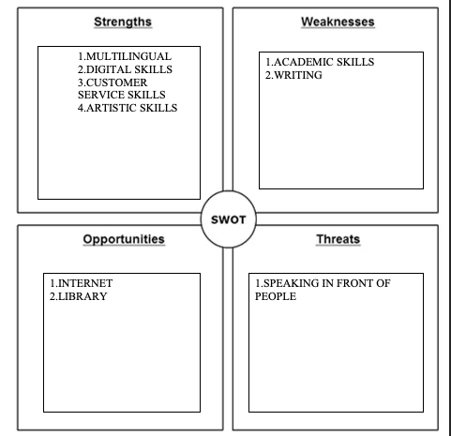

APPENDICES 1.

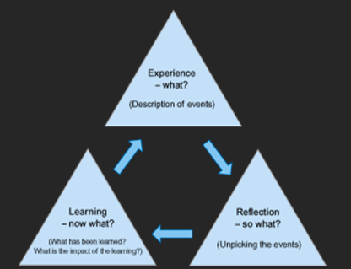
APPENDICES 2.

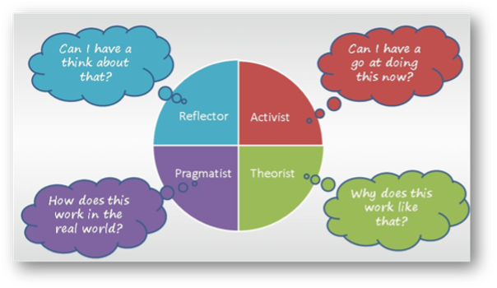
APENDICES 3.

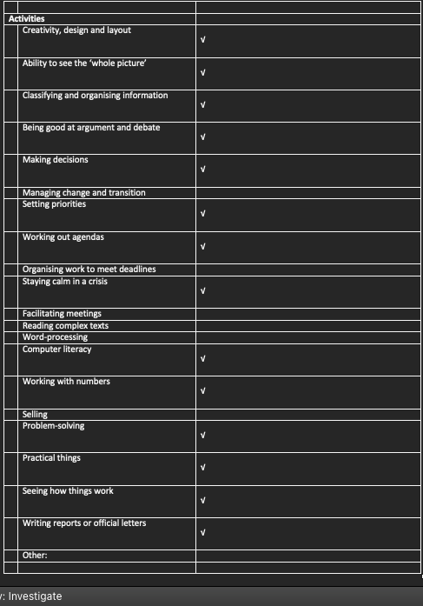
APPENDICE 4.1

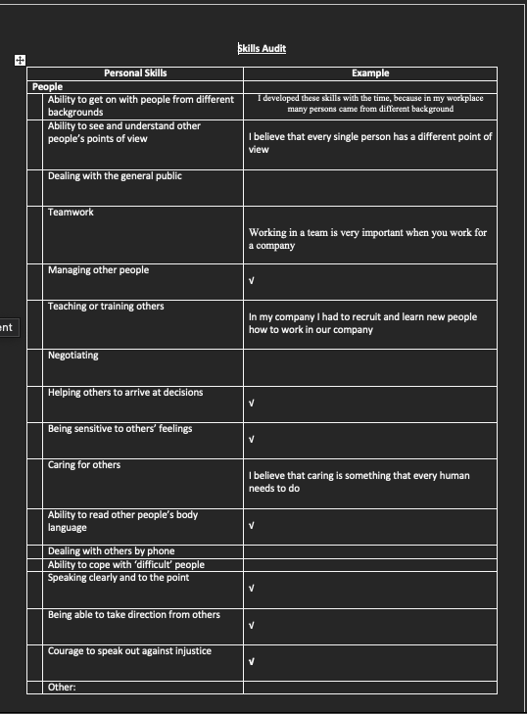
APPENDICE4.2

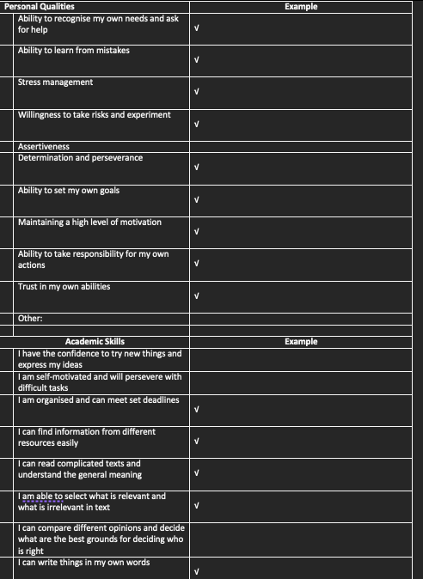
APPENDICE4.3
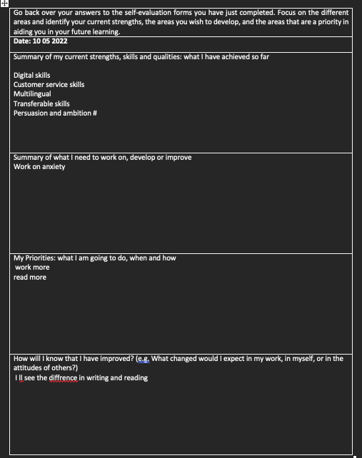APPENDICE4.4

