DS 1 Template

My Screenshots/Photos
- Please add 4–6 screenshots or photos of your digital life.
- You can use your phone or laptop.
- For each screenshot, write one or two sentences explaining what it shows.

Screenshot/Photo 1
[My Digital Skills Assessment]
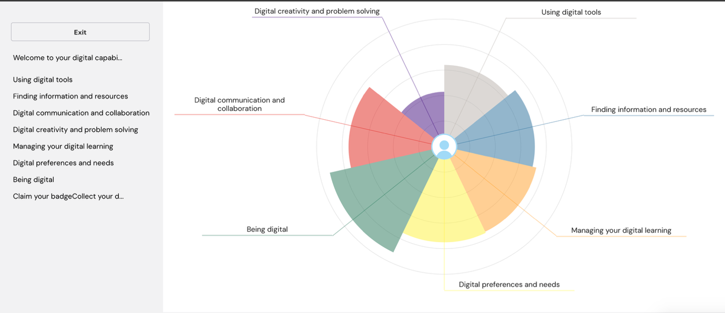
[This screenshot shows my digital skills. It helps me understand what I am good at and what I need to improve.]

Screenshot/Photo 2
[My Digital Skills Assessment Results]
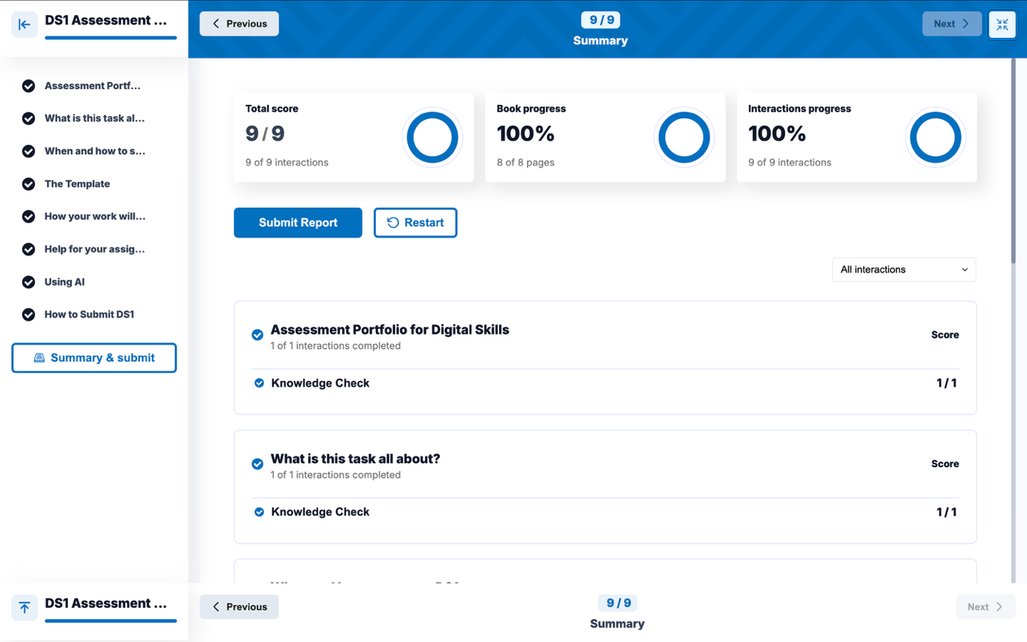
[This screenshot shows the summary of my DS1 digital skills assessment. I completed all the activities and achieved a total score of 9 out of 9.]

Screenshot/Photo 3
[Evaluating Online Information]
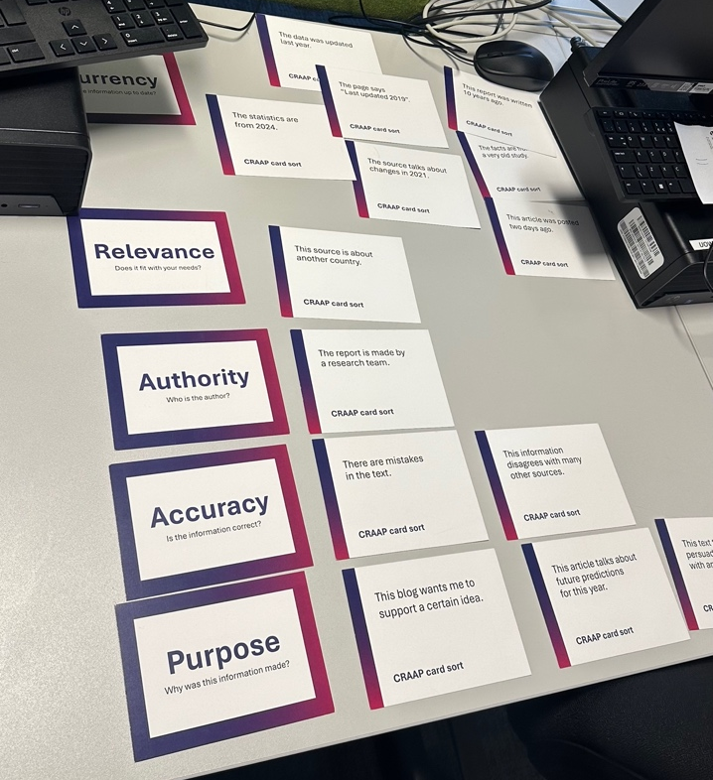
[This photo shows a class activity about checking information. It helped me learn to decide if a source is reliable.]

Screenshot/Photo 4
[Digital Helper]
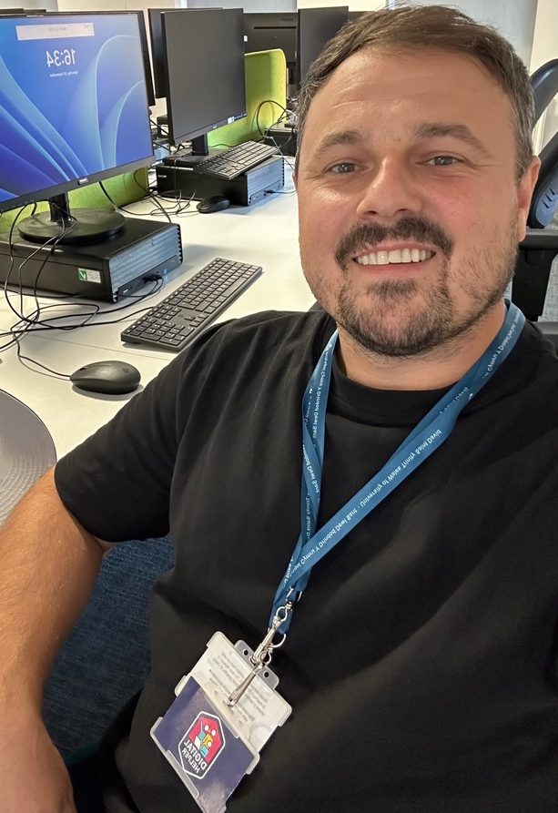
[This photo shows me as Digital Helper. I help people whit digital tools and technology.]

Screenshot/Photo 5
[My Student Portal]
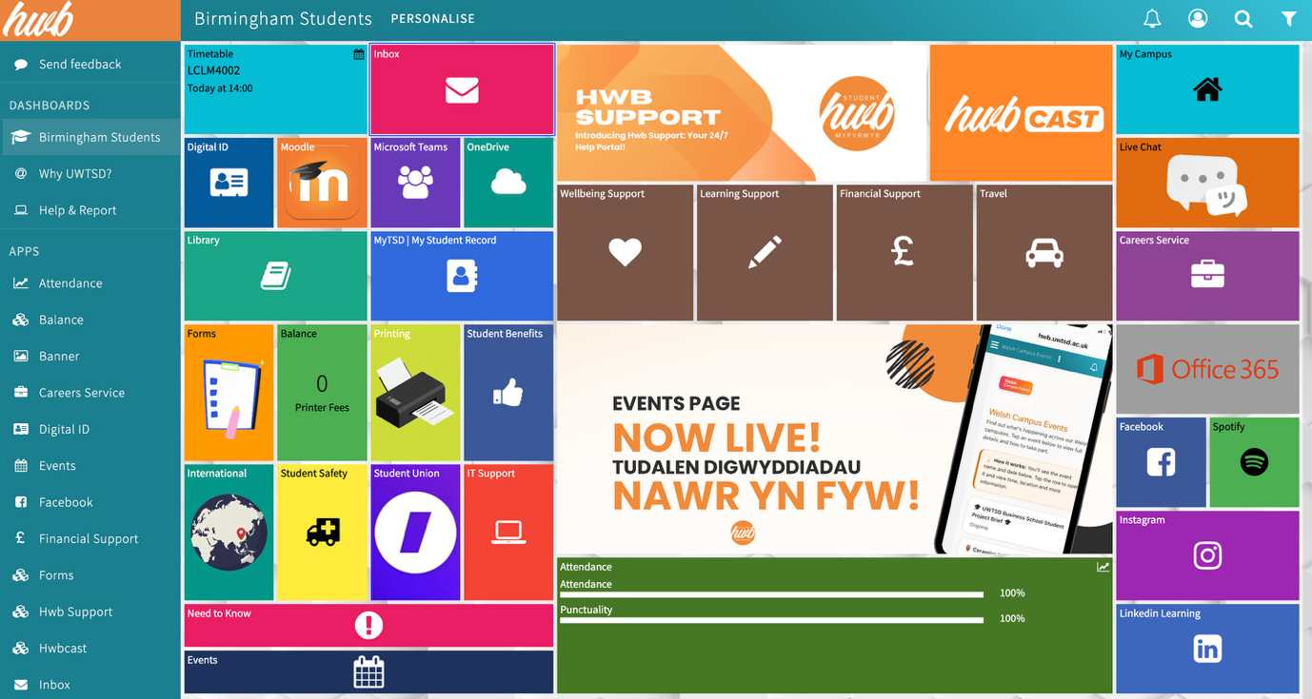
[This screenshot shows my university student portal. I use it to access my courses, study tools and student services.]

Screenshot/Photo 6
[Using Online Academic Resources]
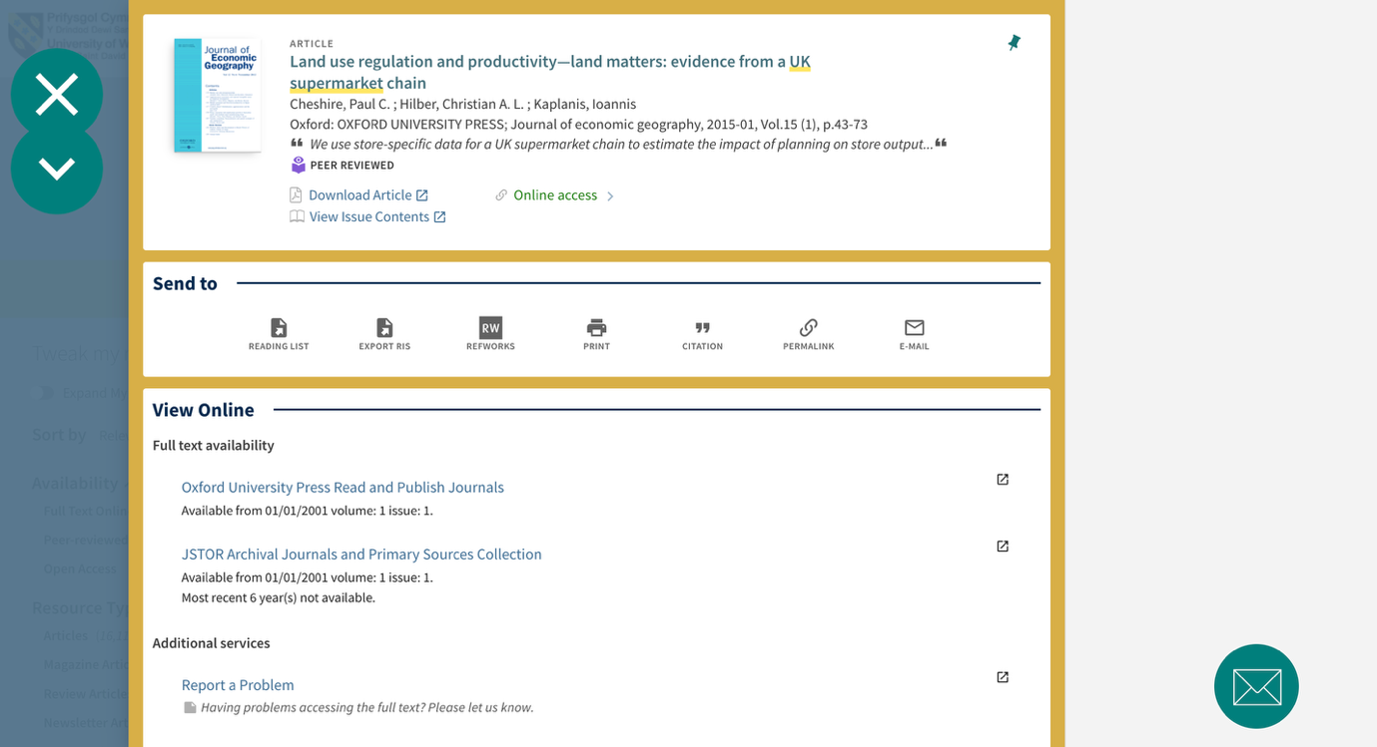
[This screenshot shows an online academic article. I use articles like this to find information for my studies.]

My Short Reflection
- Write 5–8 simple sentences about your digital life.
- You can use the sentence starters below if helpful.

- I use digital tools every day for my studies and other activities.
- I use my student portal, Moodle and Microsoft Teams to access my university work.
- I also use online article to find information for my studies.
- I feel confident when I use common digital tools.
- I am learning how to check if online information is reliable.
- I also help other people whit digital skills as a Digital Helper.
- Digital skills are important for my studies and my future.

Sentence starters
- I use digital tools to …
- I feel confident when I …
- I want to improve …
- I often use these tools: …
- I sometimes feel nervous about …
- I hope this module will help me …
- Digital skills are important for me because …
You can write more if you want.

Submission Checklist
Before you submit, please check:
​​​ ☒ I added 4–6 screenshots
☒ I wrote short sentences for each screenshot
☒ I wrote my short reflection
☒ My work is my own
☒ My file opens correctly
​​☒ My file opens correctly

