

MODULE CODE: BMIH5007

MODULE: FINANCIAL MANAGEMENT FOR THE HOTEL INDUSTRY
Case study
Name : Mircea-Catalin Leva
Identification Number : 2244690
Module leader:Tristan Hawkins

Table of Contents

Assignment 2: Report 5
1. Introduction 5
2. Evaluation of the trends in the financial performance of the past three years of The City Hotel 5
2.1 Trends of revenue and expenses 5
2.2 Profitability trends 6
2.3 Patterns of liquidity 7
2.4 Trends of solvency 8
3. Determination of the key reasons for the decline in profit to focus on real-world events and the current economy 9
3.1 Rising labour costs and hotel staff shortages 9
3.2 Cost of living crisis 11
3.3 Changing consumer behaviour 12
4. Turnaround strategy to revitalize the financial health and develop a brand reputation of the Hotel 12
4.1 Delivering personalized services to customers to improve experience 12
4.2 Promoting digital presence and innovation to develop brand value 12
4.3 Controlling operational costs and maximizing profit 13
5. Conclusion 13
Reference List 14
16

1. Introduction
Financial management is the process of managing financial resources and reporting transactions to organize an organization's activities to maximize profit for accessing the business position. The report is prepared to evaluate the financial management capacity of the case company, The City Hotel in the fiscal years 2021-2023. Additionally, assessing trends in financial performance based on profitability, solvency, liquidity, and other related metrics of the hotel to consider the real-world events in the current economy helps develop a suitable strategy for improving performance. The report aims to measure the financial performance trends of The City Hotel in the past three years and suggest a strategy for maintaining sustainable brand value.

2. Evaluation of the trends in the financial performance of the past three years of The City Hotel

2.1 Trends of revenue and expenses
In The City Hotel, the revenue and expenses in the last three years of 2021-2023 indicate a major fluctuation that impacts the overall fiscal condition. Revenue involves the inflow of funds into the business from its operational activities although expenses consist of the outflow to manage both direct and indirect spending in business activities (Bansal, 2022). In this context, the hotel faced major uncertainty in its financial condition that affected its profitability. Further, changes in demand from consumers, uncertain economic conditions, stiff competition, and high operational costs influence the revenue and expenditure levels (He et al., 2023). As per decline in revenue, occupancy rates, and customer satisfaction in the hotel impacts the overall financial position. Thus, the consideration of the revenue and expense trends helps to make informed decisions for the company to reduce costs and optimize the capacity to maximize income.
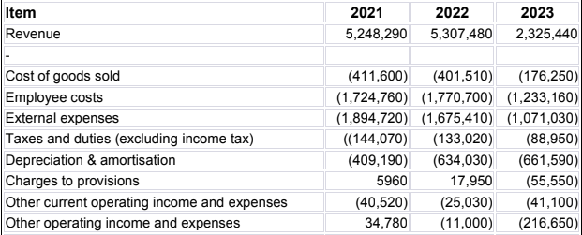
Table 1: Revenue and expenses of The City Hotel
The above table reveals a declining shift in revenue and expenses although increasing value of depreciation and amortization along with charges to provisions lowers the profit from operations. Further, the shift in preferences of guests for selecting other hotels lowers the occupancy rates and affects the income levels of The City Hotel. As per the low occupancy rates in a hotel leads to low turnover and profit also dissatisfaction among guests due to poor services has affected the brand value Based on that, the negative trends in revenue have been reflected in The City Hotel and impacted the financial performance although the cost levels are optimum. Therefore, optimizing the service quality and competing with other hotels in terms of improving guest expenses facilitates revenue and also reduces costs developing the financial condition of the hotel.

2.2 Profitability trends
The profitability trends represent the changes in profit levels in a business in different accounting years to analyse the revenue generated from operations. Based on that, The City Hotel has faced a major decline in revenue due to negative expenses received from customers. As per poor pricing strategy of rooms in hotels leads to shifting towards alternative accommodation providers that influence the profitability condition of hotels . Hence, to stay competitive in the market, The City Hotel needs to manage costs while setting competitive prices of rooms to drive occupancy rates and enhance profitability.
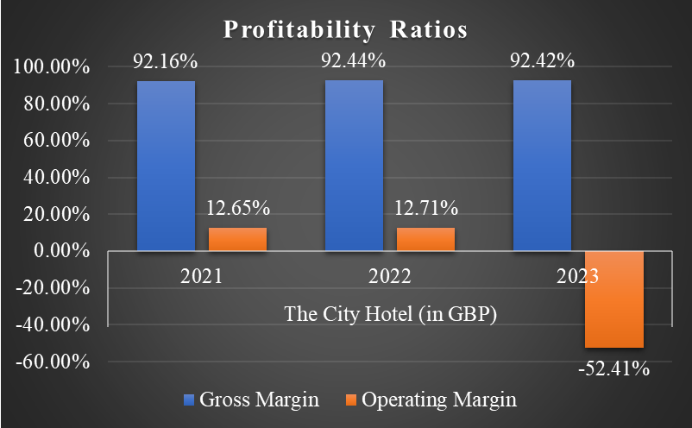
Figure 1: Profitability ratios
The above graphical representation depicts an exponential trend and the operating margin shows a negative decline in the profitability condition of The City Hotels in the financial year 2021-2023. Additionally, the levels of gross profit are efficient although the operating margin has become negative due to increasing costs and low engagement of consumers in the hotel. Further, the availability of too many alternatives for guests leads to changing consumer preferences and shifts demand levels based on stiff competition in the hospitality sector . Therefore, The City Hotel needs to manage consumer demand while seeking feedback to improve service delivery and enhance profitability conditions.

2.3 Patterns of liquidity
The pattern of liquidity in The City Hotel showcases decremental shifts that influence the cash flow levels. In addition, the change in financial policies for maintaining optimum cash reserves influences the liquidity condition of a business (Laghari and Ahmed, 2023). In this case, the hotel has faced a major decline due to low revenue and profit that influenced the cash flow levels to meet the emergency requirements. Thus, the optimum level of cash holdings in the hotel facilitates the liquidity position and optimizes the financial performance.
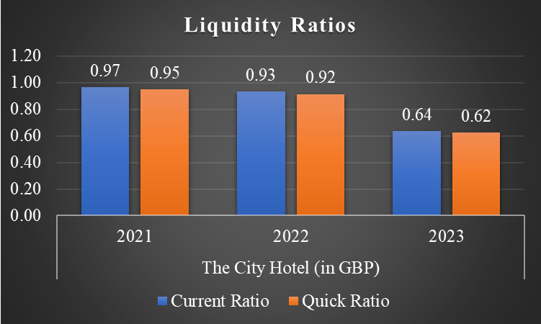
Figure 2: Liquidity ratios
The above liquidity ratios highlight a decreasing trend from the fiscal year 2021 to 2023 due to the availability of insufficient current liabilities to cover short-term liabilities. Low occupancy rates in hotels reduce the cash inflow and lead to difficulty in meeting financial constraints (Adanse, Khayiya, and Maranga, 2024). In this way, while fulfilling short-term financial obligations in the hotel to use liquid assets efficiently embrace resilience in liquidity conditions. Hence, to fulfil daily requirements in the hotel while managing cash flow and optimizing the use of short-term assets robust the liquidity condition and drive performance.

2.4 Trends of solvency
Solvency trends measure the ability of firms to manage long-term financial obligations and improve the capital structure to reduce financial risk. In this way, to focus on the solvency condition of The City Hotel evaluate the high usage of debt as compared to assets and equity that lead to financial distress in business. Based on the low level of revenue in business resulted in an increase in debt levels to finance the long-term obligations and increase the burden of liabilities while affecting the solvency position (Arhinful and Radmehr, 2023). Therefore, controlling the debt levels in the hotel helps in improving solvency conditions.
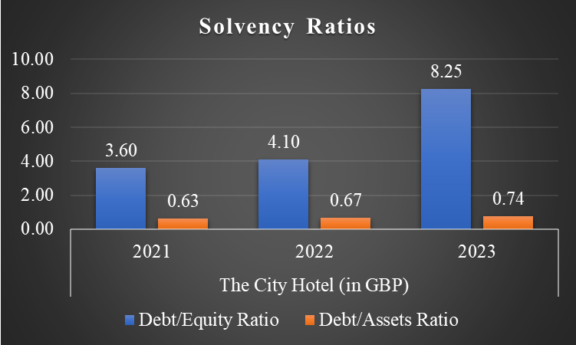
Figure 3: Solvency ratios
The above graph reveals an upward trend as the usage of debt is high and the low involvement of equity and assets in the past three years created a negative impact on the solvency condition of The City Hotel. Further, controlling the debt levels in capital structure and optimizing the use of assets and equity facilitate the solvency condition of a business (Ngoc, Nguyen, and Pham, 2023). In this context, the hotel needs to use equity capital and assets to finance long-term investment decisions while minimizing debt levels. Thus, the improvement in customer satisfaction facilitates the brand value of the hotel and enhances the equity capital from the market to reduce financial risk and improve the solvency position.

3. Determination of the key reasons for the decline in profit to focus on real-world events and the current economy

3.1 Rising labour costs and hotel staff shortages
In the UK, the challenge related to the staffing crisis after Brexit has influenced the performance of restaurants and pubs. Further, the hospitality sector has faced a staffing crisis in the UK due to a lack of supply of skilled people from the EU in post-Brexit resulting in issues with hiring staff. Thus, the issue leads to the high cost of hiring skilled labour or providing training to existing staff in The City Hotel which reduced the overall profit.
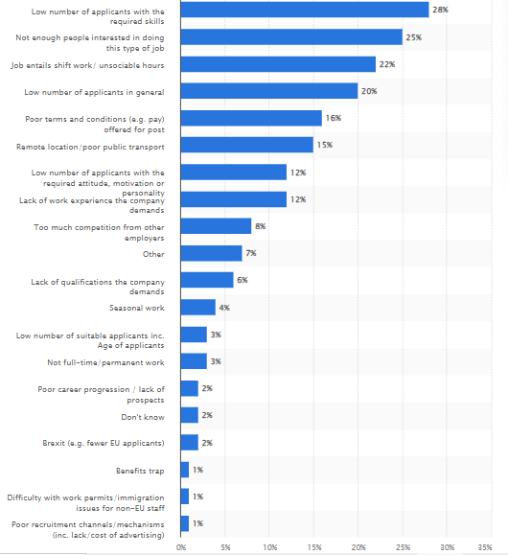
Figure 4: Causes of labour shortage in the UK hotel and restaurant sector
(Source: Statista, 2023)
The major cause of labour shortage in the UK hotel and restaurant sector noticed by 28% of employers is a low number of applicants with required skills and 25% stated that not more people are interested in doing this kind of job (Statista, 2023). Additionally, the other reasons for labour shortage are also specified that lead to inefficient delivery of services by The City Hotel in the UK and impact customer satisfaction resulting in lower profit. Therefore, the issue of labour shortage in the UK economy influences the financial performance of the hotel.

3.2 Cost of living crisis
The cost-of-living crisis in the UK has also affected the business operations of the hospitality sector. Inflation led to a decline in customer bookings as per low consumer demand and sales went down by 30% also increasing wages by 10% to retain staff, energy costs doubled, and food costs increased by 20% resulting in a major challenge to survive in the UK market by hospitality sector (Otte, 2023). Further, the UK inflation hits 9.4% as fuel prices rise, lowering the number of diners that visit restaurants. Hence, the cost-of-living crisis influences the profitability condition of The City Hotel due to the rising cost of operation and declining revenue generation capacity.
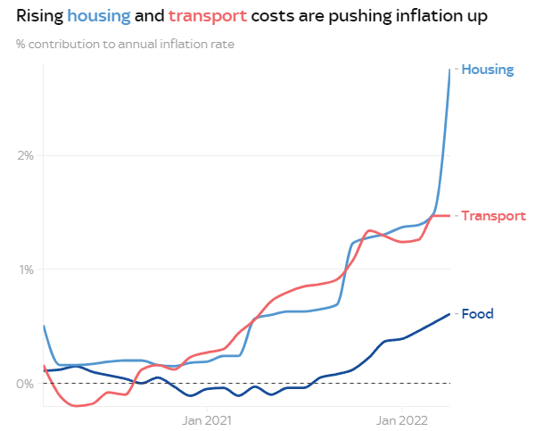
Figure 5: Increasing housing, transport, and food costs in the UK
(Source: Borrett and Rao, 2022)
The largest contributors to inflation are housing, transport, and food costs which increased to 2.8%, 1.5%, and 0.6% in 2022 respectively (Borrett and Rao, 2022). Overall, inflation led to increased overall operational costs of The City Hotel which increased the prices of products and services resulting in lower occupancy rates.

3.3 Changing consumer behaviour
The changing consumer behaviour in the UK hotel industry influences financial performance as the availability of more alternatives as per technological advancement and digital transformation leads to major difficulty in continuous upgradation. Further, the availability of new accommodation and services platforms has created a major impact on customers' behaviour within the UK hotel industry . Therefore, the difficulty in understanding consumer preferences in The City Hotel leads to lower revenue and a decline in profit from the operations.

4. Turnaround strategy to revitalize the financial health and develop a brand reputation of the Hotel

4.1 Delivering personalized services to customers to improve experience
In The City Hotel, the implication of Customer Relationship Management (CRM) systems along with developing loyalty programs for the customers facilitates personalized delivery of services to enhance the experience level. Offering rewards to customers and using CRM systems helps to develop interaction with guests in hotels and establish long-term mutual relationships to promote loyalty (Sofi et al., 2020). Therefore, this strategy might be beneficial for The City Hotel to develop a positive brand value in the market while emphasizing its financial position.

4.2 Promoting digital presence and innovation to develop brand value
The development of a website for the hotel facilitates engagement of guests in online mode and develops brand value as per User Experience (UX). Further, the engagement of social media platforms such as Instagram, Facebook, and YouTube embrace customer reach in The City Hotel. However, the implication of technologies such as online check-in and check-out, digital booking facility, AI-driven chatbots, Wi-Fi, and tech-friendly rooms facilitate innovation in service delivery (Jha, 2023). Thus, the hotel needs to consider this strategy to develop online brand value through digital presence and adopt innovation through technological advancement to drive financial performance.

4.3 Controlling operational costs and maximizing profit
Lowering the financial burden of long-term debts through reducing costs and eliminating waste of food and beverages in The City Hotel ensures operational efficiency. Further, the investment in energy-efficient systems along with promoting online booking facilitates the revenue generation capacity of hotels (Wu et al., 2022). Additionally, establishing effective rates of rooms helps to develop the occupancy rate of guests in the hotel and enhance customer satisfaction. Overall, the initiatives towards setting better prices of rooms, lowering costs through energy-efficient systems, and optimizing revenue through direct interaction with guests enhance the profitability of The City Hotel.

5. Conclusion
In conclusion, the overall financial performance analysis of The City Hotel has evaluated the declining profitability and cash flow levels although the increasing debt burden from 2021 to 2023 influences the overall business condition. Further, the computation of solvency, liquidity, and profitability ratios indicates unfavourable trends for the business as the UK economy has created a negative impact on the hotel industry due to the cost of inflation crisis, changing consumer behaviour, and staff shortage or high labour cost resulting in a low profit. The strategy related to personalized service delivery for enhancing the consumer experience, controlling operational costs to maximize profit, and developing a digital presence while promoting innovation to ensure the sustainable brand value of the hotel. Moreover, efficient financial management while making informed decisions as per understanding trends of different ratios facilitates the performance of The City Hotel.

Reference List
Assignment 2:
Adanse, J., Khayiya, R. and Maranga, V. (2024). Influence of optimal room occupancy strategies on revenue maximisation during slack periods in selected 3- to 5-star hotels in Ghana. Research in hospitality management, [online] 14(1), pp.57–69. doi:https://doi.org/10.1080/22243534.2024.2357035.
Arhinful, R. and Radmehr, M. (2023). The Impact of Financial Leverage on the Financial Performance of the Firms Listed on the Tokyo Stock Exchange. SAGE Open, [online] 13(4). doi:https://doi.org/10.1177/21582440231204099.
Bansal, M. (2022). Expense shifting and revenue shifting in the income statement: substitutes or complements? South Asian Journal of Business Studies. [online] doi:https://doi.org/10.1108/sajbs-07-2021-0273.
Borrett , A. and Rao, G. (2022). Cost of living crisis: Four charts that explain what’s happening with inflation. [online] Sky News. Available at: https://news.sky.com/story/cost-of-living-crisis-four-charts-that-explain-whats-happening-with-inflation-12615349 [Accessed 13 Oct. 2024].
He, Z., Ni, S., Jiang, X. and Feng, C. (2023). The Influence of Demand Fluctuation and Competition Intensity on Advantages of Supply Chain Dominance. Mathematics, [online] 11(24), pp.4931–4931. doi:https://doi.org/10.3390/math11244931.
Jha , P. (2023). AI Chatbots reduce costs and improve guest services in hotels . [online] economictimes. Available at: https://hospitality.economictimes.indiatimes.com/news/speaking-heads/bavaria-diaries-omnivore-redefined/98353038 [Accessed 14 Oct. 2024].
Laghari, F. and Ahmed, F. (2023). Cash flow management and its effect on firm performance: Empirical evidence on non-financial firms of China. PLoS ONE, [online] 18(6). doi:https://doi.org/10.1371/journal.pone.0287135.
6 I. and Koncul, N. (2016). Changes in consumer behaviour – the challenges for providers of tourist services in the destination. Economic Research-Ekonomska Istraživanja, [online] 29(1), pp.914–937. doi:https://doi.org/10.1080/1331677x.2016.1206683.
Ngoc, T., Nguyen, X.H. and Pham, K. (2023). The Effect of Capital Structure on Firm Value: A Study of Companies Listed on the Vietnamese Stock Market. International Journal of Financial Studies, [online] 11(3), pp.100–100. doi:https://doi.org/10.3390/ijfs11030100.
Otte, J. (2023). ‘An all time low’: UK hospitality bosses say industry is fighting for survival. [online] The Guardian. Available at: https://www.theguardian.com/business/2023/jul/21/an-all-time-low-uk-hospitality-bosses-say-industry-is-fighting-for-survival [Accessed 14 Oct. 2024].
Sofi, M.R., Bashir, I., Parry, M.A. and Dar, A. (2020). The effect of customer relationship management (CRM) dimensions on hotel customer’s satisfaction in Kashmir. International Journal of Tourism Cities, [online] 6(3), pp.601–620. doi:https://doi.org/10.1108/ijtc-06-2019-0075.
Statista (2023). Reasons for hard-to-fill vacancies in the hospitality sector in the UK 2019. [online] Statista. Available at: https://www.statista.com/statistics/506893/reasons-difficult-recruitment-hospitality-sector-united-kingdom-uk/ [Accessed 13 Oct. 2024].
Wu, Y., Xin, B., Zhu, H. and Ye, Z. (2022). Energy-Saving Operation Strategy for Hotels Considering the Impact of COVID-19 in the Context of Carbon Neutrality. ProQuest, [online] p.14919. doi:https://doi.org/10.3390/su142214919.

