

Module: ECAD7004
Student Number: 2318487
Word count: 4930
Research Question – How does the practice of cold calling in the classroom affect pupil confidence?

Research Question – How does the practice of cold calling in the classroom affect pupil confidence?

Introduction:
Cold calling is a teaching method where the teacher selects a learner to answer questions during whole class discussions without warning or the learner volunteering. The research question for this case study is ‘How does the practice of cold calling in the classroom affect pupil confidence?’. The purpose of this research activity is to investigate the practice of cold calling in the classroom and the impact it has on pupil confidence, particularly amongst the increasing rates of anxiety and mental health issues among learners post-Covid. Understanding the prior can inform practitioners regarding their teaching strategies and contribute to creating more supportive classroom environments which actively promote positive mental health outcomes alongside positive learner outcomes.
As a Psychology graduate, I have always been interested by the intersection of mental health and education. And so, through this research, I aim to provide a multi-dimensional perspective of the practice of cold calling, including individual differences in coping mechanisms, the impact of teacher-learner relationships and the role of classroom dynamics.
The current research project is a form of professional research that fulfils the standard of professional networks and communities (Welsh Government, 2019), contributing to a Professional Learning Passport (PLP). As the research is a form of educational research, it will need to ensure that those participating are treated with respect and confidentiality is maintained – thus it will follow the BERA (2018) ‘code of conduct’. For this reason, the context of the school and those involved will be anonymised.
The research project was conducted in a mixed comprehensive school in South Wales with a learner age range of 11 – 18 years old. According to the schools latest ESTYN report (Estyn, 2018), the school has a learner population of 1,700 on roll, including 357 learners in sixth form. 6% of pupils qualify for free school meals (FSM). This is significantly lower than the national average of 17%. Moreover, the proportion of learners with special educational needs (SEN) is 12%, again, below the Welsh average of 21.5%. The data collection for this research project took place in a year 10, form classroom and a year 8 humanities lesson, where learners were asked to complete a questionnaire on their experiences and opinions of cold calling. The learners were of mixed ability and age ranges. Year 10s being between 14-15 years old and year 8’s being between 12-13 years old. Interviews were conducted with teachers of various disciplines to gather their insight into the implementation of cold calling as a teaching method in their classroom.

Overview of relevant literature:
What is cold calling?
Active learning has been consistently promoted in teaching spaces as it encourages collaboration and engagement in the teaching and learning process, with discussion-based teaching being one of the most prevalent methods regarding active learning (Bonwell & Eisen, 1991). Cold calling is used by practitioners to increase learner engagement and participation. Dallimore et al. (2005) states that due to the randomness of cold calling in its selection of learners, it ultimately increases engagement and participation in lessons due to the equal and random chances of learners being chosen to participate in class discussions. This in turn is meant to promote higher forms of reflective thinking, as well as information retention (Ewens, 2000). The effectiveness of this is often based of learner participation levels which is difficult to obtain if you are using an approach based on learners volunteering to participate, such as the ‘hands up’ approach, where learners put their hands up to share their ideas in classroom discussions. Therefore, even though discussions allow learners to clarify misunderstandings and internalise explanations from their peers, learners who are unwilling to participate may not benefit as much (Arbaugh & Benbunan-Fich, 2006).

Anxiety and Confidence
Now, why may some learners be unwilling to participate? Mental health challenges such as anxiety and depression have heightened over the past few years and are understandably recognised as significant barriers to learning (The Guardian, 2022; 2023). Anxiety is a feeling of uneasiness, dread and fear which can present itself in physical forms too, such as sweating, heart palpitations and flushed cheeks. This is a natural response when humans feel under threat but can have lasting negative effects on confidence if persistent (Mind, 2021). More specifically, anxiety during whole class discussions which use cold calling have been shown to negatively impact learner engagement and participation and even learner cognitive and affective outcomes (Broeckelman-Post et al. 2016; Bostani et al. 2014). Eddy et al. (2015) found that this is often due to learners having a fear of judgement by peers and concerns about performance evaluation, both of which can hinder the learners’ ability to actively engage in classroom discussions and articulate their ideas confidently. An important scholar to note in this argument is Rocca (2010), who believed that cold calling repeatedly undermines confidence and self-worth, resulting in reduced levels of participation and discussion. Rocca’s study integrated an extensive range of research conducted over 51 years, providing an in depth understanding of student participation in the classroom. Though Rocca did outline many advantages of student participation, addressing major issues of class size and student anxiety were addressed throughout, emphasising the need for educators to rethink their approach to student participation in classrooms. A key aspect to note, Rocca’s study complies research with diverse contexts and methodologies, which in turn, makes it challenging to draw universally applicable conclusions. On the other hand, Dallimore et al. (2013), contests numerous research in the field of student participation and cold calling heavily focused on the negative impacts of involuntary learner participation and states that cold calling, not only heightens voluntary participation, but also found that it does not make learners feel uncomfortable. Dallimore et al. (2013) had comprehensive data collection through robust data sets as he used both quantitative and qualitative measures with research including data from multiple classes and over an extended period. However, his study did not account for diverse student demographics and primarily focuses on undergraduate students in business administration courses. This would limit the generalisability of their findings to other disciplines and classroom dynamics. Similarly, the research conducted for this research project will be limited in terms of scope and generalisability as it is at university level with data being collected within a short period of time. However, this research project aims to add to the existing body of complex research regarding cold calling and whether it does have positive or negative impacts on learner anxiety and confidence. Furthermore, this study will heavily focus on the learner's perspective as there is a large lack of comparative data from their perspective on the teaching strategy, with much research focussing on the opinion and application of cold calling from teachers.

Explanation of Case Study:
Case study research is a form of qualitative research which involves a detailed examination and in-depth analysis of a specific instance or case within its real-life context (Yin, 2018). This form of research often aims to gain a greater understanding of the nuances and complexities of the case in question. Furthermore, case study-based research is widely used across multiple disciplinaries, including healthcare, psychology, business and sociology. With most case studies allowing researchers with a flexible approach to study complex phenomena in natural settings. The data collection for case studies involves an array of quantitative and qualitative data collection methods, analysing sources of data such as interviews, observations, questionnaires and surveys. Collecting quantitative data from data collection techniques such as the use of questionnaires can help the researcher identify key trends and patterns in their collected data. While on the other hand, collecting qualitative data from data collection techniques such as observations and interviews can aid the research in gaining a deeper understanding of the trends and patterns, allowing them to gather rich and detailed information for analysis.
Yin (2018) states that the primary goal of a case study is to generate detailed insights and understandings of a phenomena as opposed to generalising findings to broader populations. This is not to say that the findings of case studies should not be generalised, but rather to highlight that specific conclusions based on case studies are quite limited regarding the scope of research. Instead, they can be used as a good basis of information to inform other areas of research and studies (Zucker, 2016). The persistent ambiguity surrounding the use of case studies is also highlighted by Gerring (2004) who claims that due to the various research methods used in different case studies, it is rather difficult to delineate its strengths and weaknesses. Therefore, it is important to note the dual nature of advantages and disadvantages when it comes to using case studies as a form of research. Merriam (1998) supports this perspective, underlining that researchers should consider various scientific methodologies in order to offer unique insights into the phenomena under investigation. In essence, case study research supplements and complements other research methods, offering a distinct approach to comprehend complex phenomena.
For the purpose of this study, the perspectives on cold calling from both teachers and learners were analysed. Male and female teachers, of various subject areas and ages were interviewed to understand their perception of cold calling and how it is used in classrooms. As for learners, they were given a questionnaire with both open and closed questions, regarding their experience with and perception of cold calling and how it is used in the classroom. Two classes participated in this questionnaire, one year 8 humanities class and one year 10 form class.

Ethical considerations:
Many ethical considerations had to be made prior to undertaking this research. In regard to education, rules set out by BERA (2018) are followed and all registered teachers must adhere to the ‘Code of Professional Conduct and Practice’ by the EWC. Following the standards set by BERA (2018), this research was conducted with anonymity and confidentiality of the participants involved while conducting the research and sharing the results. All interview answers were typed up on a password protected laptop and did not mention any of the teachers' names for full anonymity. Furthermore, the paper questionnaires filled out by learners were all anonymised with learners being told prior to filling out the questionnaires that they do not need to put their names on them. Once all the questionnaires were filled out the data was then inputted into a password protected laptop with all data being anonymised, only using statistics and answers without the learner’s names.
Most importantly, prior to any research being conducted, all learners were given information sheets and consent forms based off a university template – both forms were on one double-sided sheet of paper, with one side sharing information and the other with the consent form. The information sheets informed learners and parents that the research was part of a PGCE research project and included the name of the researcher as well as providing full details of the purpose of the research and what the research entailed e.g. filling out an anonymous questionnaire (see appendix). Furthermore, parents/guardians were assured that all results would remain anonymous and that their child’s participation was voluntary. The consent form part of the sheet asked parents/guardians to confirm they had read the information sheets, understood that their child could withdraw at any time, that the information given by their child would be used in a university assignment and finally, whether they agreed for their child to take part in the study. Once these consent forms were taken home, signed, and handed back to the researcher, the learner was then able to participate in the study. Prior to, during and after learners completing the research questionnaire, they were asked to give verbal assent in the case that learners may wish to withdraw consent on any grounds. Learners were also verbally informed that they could leave out any questions if they felt uncomfortable answering them as the questionnaire asked about their personal experiences with cold calling in a classroom environment. As for interviews, teachers were given a verbal brief of the study and asked for verbal consent to participate in teacher interviews for a university research project.

Research methods:
This section will justify research methods used to answer the chosen research question.
The sampling method used for this research project was opportunity sampling. This involves selecting participants who are readily available and willing to participate in the current study, with participants often being chosen by the researcher during the selection process. In this case, two classes (which I am most familiar with) were chosen to participate in the study. As both classes are based on my teaching schedule and availability, there was no randomisation and the participants were already part of pre-existing groups, giving easy access for participation. This was the same for teacher interviews as opportunity sampling was also used, asking teachers that were available at the time and that I had spoken to and built good relationships, allowing me as a researcher to feel comfortable asking for their participation in the study. Morning (2014) underlined the practicality of opportunity sampling as it allows for researchers to generate data efficiently while using minimal resources, which rang true for this research project as it allowed for quicker execution of data collection due to the convenience and availability of participants. However, there are some drawbacks of using this form of sampling. Punch (2013) claims that although this form of sampling is easy to implement, in terms of the generalisability of results, the approach is limited as it may not be able to provide the researcher with a fully representative sample population. With this considered, it is still important to acknowledge the useful initial insights opportunity sampling can provide within in short data collection period.
Questionnaires were used to gain insight into cold calling and confidence from a learner's perspective. This questionnaire was double-sided and asked open and closed questions on learner’s experiences and perception of cold calling to gain both qualitative and quantitative data for analysis. Cohen (2018) highlights the diverse use of questionnaires due to the variety of question formats and options such as open and standardised lines of questioning, while additionally underlining that these forms of data collection are often reliable, cheap and efficient due to the short amount of time they take to complete. Like most methods of research and data collection, questionnaires are not without their limitations. Champagne (2014) stressed the ethical considerations that researchers must examine and underlined that researchers should aim to reduce putting too much pressure on participants through asking questions heavily based on their recall of specific events or by asking questions deemed too demanding. These may lead to poor quality responses from learners or even respondent fatigue if they are faced with too many questions of a demanding manner e.g. a constant series of open questions requiring learners to write a lot (Denscombe, 2017). Therefore, a researcher must consider the type of questions included to encourage a well answered questionnaire.
Due to this, the questionnaire consisted of 10 questions - 8 closed questions and 2 open questions, prompting a more developed response from the learner. Most closed questions had two responses of ‘yes’ or ‘no’ whereas others included multiple choice answers and multiple-choice answers in a Likert-scale form. As the perception of cold calling on learners and their confidence in the classroom was being researched, multiple choice options to the questions on their feelings were used e.g. excited, anxious. It also focused on how it affected their confidence e.g. positively, negatively or not at all. The three point Likert-scale was then used for questions focusing on the frequency of cold calling in the classroom and frequency of experiencing anxiety when being cold called e.g. often, sometimes or never. Likert-scales prove useful in exploring differentiation in responses that are appropriate and needed for research through a simple answer scale, all reducing respondent fatigue through simple and effective questioning (Dillman et al., 2014). However, some researchers may argue that the three point Likert-scale was an oversimplistic approach to research and argue that five-point to eleven-point scales are more beneficial in research (Friedman and Amoo, 1999). For example, a five-point scale includes more intermediate options which can reduce central tendency bias as participants may have chosen the middle category of a three-point scale as a default answer if they were unsure or wanted to complete the questionnaire quickly. Thus, having more points on a Likert-scale would enhance the sensitivity of measurement, allowing the researcher to detect subtle differences in responses.
As for open questions, the questionnaire limited these to two questions. The first asking, how cold calling affects the learner’s anxiety and the second being, how teachers can create a supportive environment when asking questions in the classroom. The second question is trying to grasp how learners prefer being asked questions during feedback, perhaps if they prefer a hands up approach and strategies that can aid in them feeling comfortable in the classroom. Blair, Czaja and Blair (2013) underline the flexibility of using open ended questions, stating that they facilitate a deeper understanding of participants without leading the participant to a particular answer, and in doing so often provides more authentic and sometimes unexpected responses. All of the prior, encouraged the use of open questions in this data collection method.
Finally, teachers were also interviewed for this chosen research question. As it is important to understand the view of the practitioner in using cold calling, why they use it, how they use it and if they think it affects learner confidence. Similar to the benefits of using open ended questions, these interviews offer flexibility when questioning and allow researchers to capture richer data as you are able to follow the natural flow of conversation and adjust questions in real time – as well as ask for deeper clarification of responses (Creswell & Creswell, 2017). Four classroom teachers were interviewed for this research question, two female teachers and two male teachers, all from different subject disciplines. They all had 7 prompt questions to follow during the interview and prompt and direct answers in order to help answer the research question. The questions asked about the use, benefits and drawbacks of using cold calling on learners and if they themselves had observed any limitations of the practise in terms of learner anxiety and engagement and what they could do to mitigate these experiences. These prompt questions allowed all teachers to have given responses in line with one another with the differentiation of their personal experiences of the practice of cold calling. Furthermore, these questions were all linked to the questionnaire learners had to fill out and allowed for data to complement each other and flow well during analysis. This would essentially aid the researcher in finding any plausible links and relationships between certain questions and attitudes towards cold calling from both learners and teachers alike.

Data Presentation and Analysis:
As both questionnaires and interviews were conducted generating a mix of quantitative and qualitative data, the data collection will follow thematic analysis in order to identify clear themes and correlations voiced by participants and their responses to key questions. Thematic analysis entails the systematic organisation of data being identified and being placed in overarching themes which aid in answering the research question. Furthermore, Maxwell (2005) emphasised the idea that after data collection, key themes in research should be identified in order to facilitate analysis, create meaningful insights and interpretations of findings. Additionally, due to the limited word count for this research project, using a thematic approach to data analysis and generalising data into key themes is most appropriate and efficient – and allows for a deeper analysis of results (Terry et al., 2017).
For questionnaires, pie charts were used to present responses of learners, including specific percentages to demonstrate accurate data representation. As for interviews, these will be talked about in depth through the results section using quotations from interviews and will be linked to key themes of this research question as the data collected was exhaustive. The interviews with different subject teachers will also be talked about in relation to questionnaire responses by learners to provide a nuanced interpretation of results.
Results and Discussion:
Due to the word count restriction regarding this research project, this section will concentrate on the most pertinent themes and questions related to the research project in question. Themes include; experience of cold calling, impact of confidence, anxiety and focus, concerns of the practice and finally, strategies to mitigate negative effects of cold calling.
In total, four teachers were interviewed and out of 45 students, 27 gained consent to participate in the questionnaire for the research project. The pie charts will only show student responses, with responses from teacher interviews being discussed in relation to them.

Figure 1. Experiencing cold calling
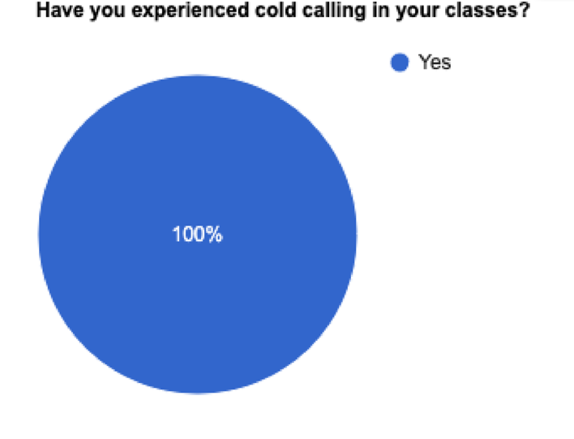
As shown in figure 1, 100% of students who participated in the questionnaire had experienced cold calling in the classroom. This immediately highlights the prominent usage of the teaching strategy in classrooms. All the teachers interviewed stated that they often use cold calling as a teaching tool in their classroom with two teachers claiming that this was due to ‘better engagement’ from learners and ensuring that all learners stay focused during the lesson. This emphasises the fact that whole class feedback and discussions are still a predominant activity in many classrooms, with cold calling being a popular tool used by most teachers (Pauli and Reusser, 2015).

Figure 2. How do learners feel when their teacher uses cold calling.
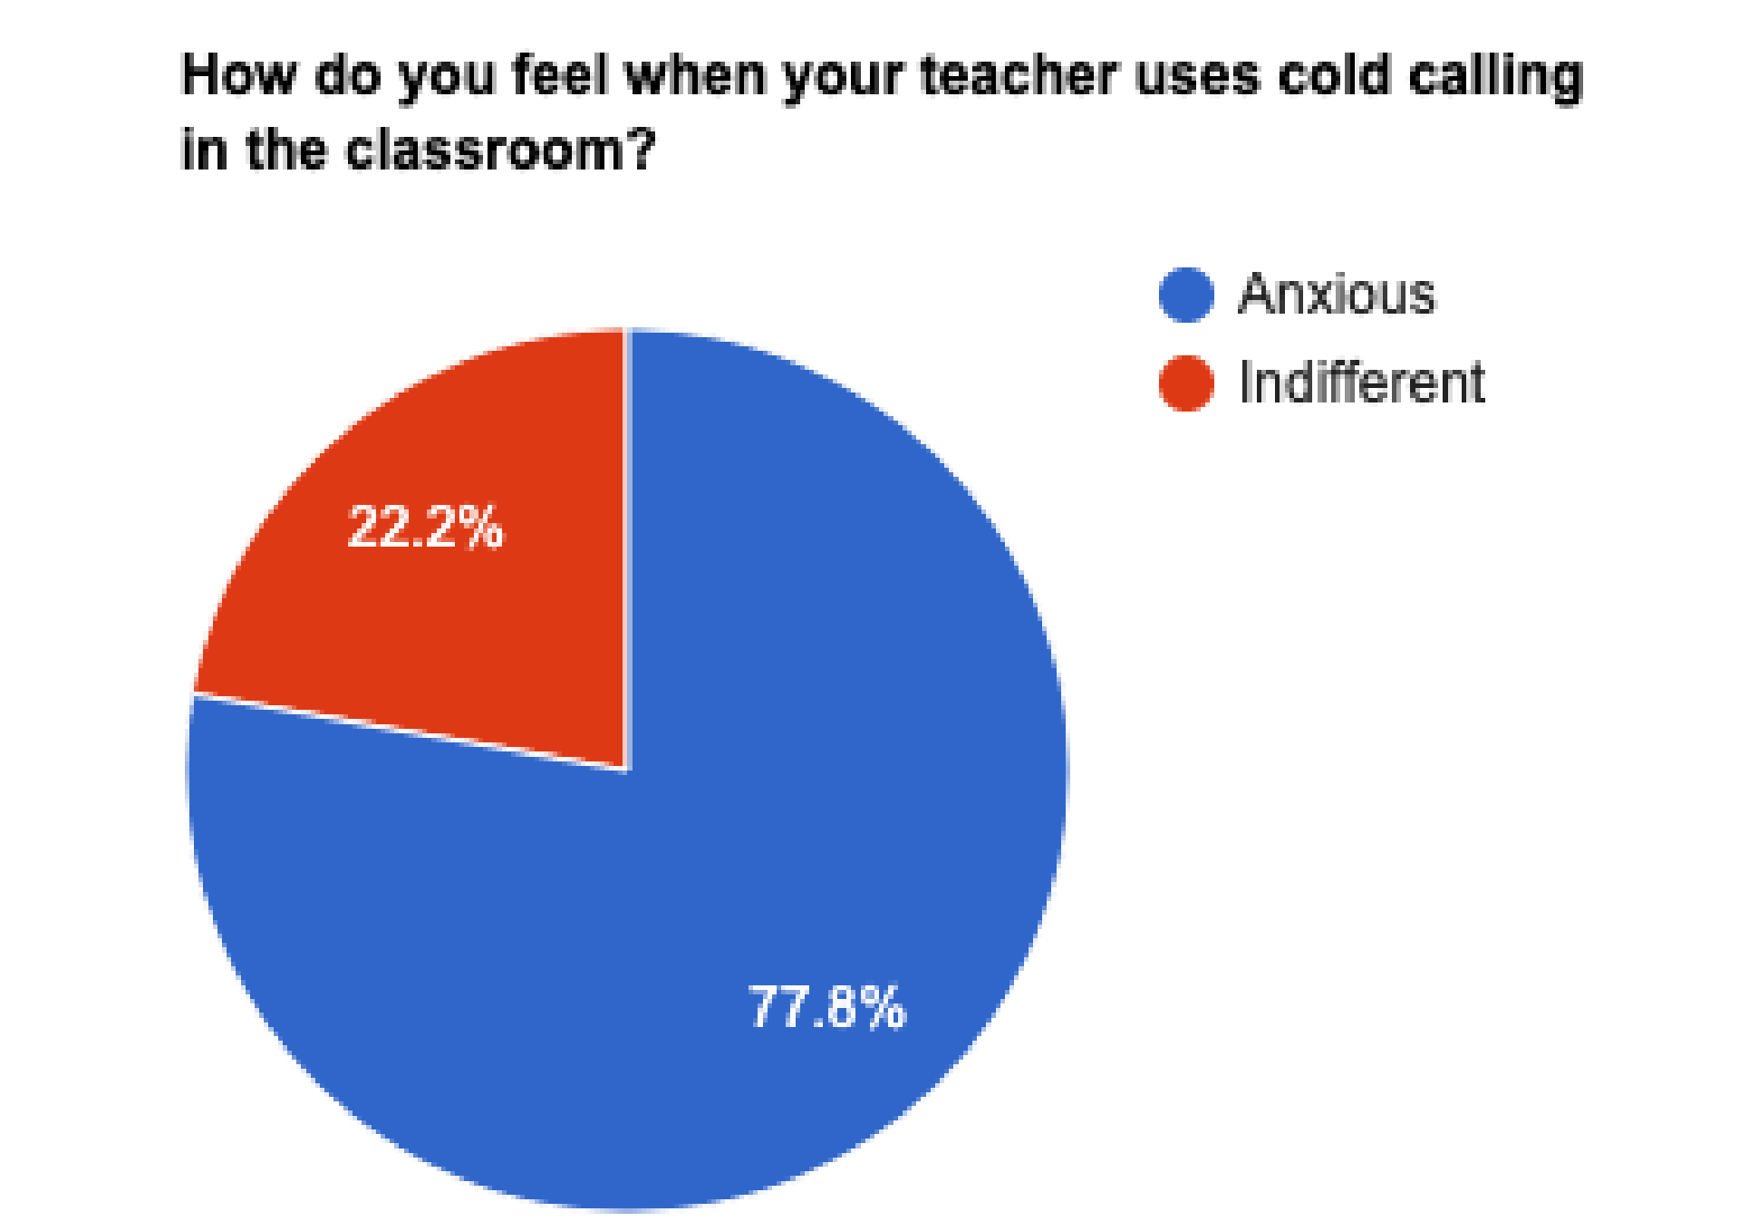
For this question, learners had the following emotions to choose from; excited, anxious, focused, indifferent and other. However, the 27 participants only answered with either anxious or indifferent. An overwhelming majority of students stated that when teachers use cold calling in the classroom they feel anxious, this to a researcher, can highlight a possible lack of comfortability in the teaching environment which goes against Dallimore et al., (2013) who argues that using cold calling as a strategy to engage non-volunteering students in classroom discussions does not make learners uncomfortable. This was also acknowledged by teachers during their interviews as when discussing anxiety, and anxiousness in learners, teachers all agreed that cold calling was ‘anxiety inducing’, this was specifically used by a PE teacher who stated that due to the practice raising anxiety at the beginning for learners, it is important to know your learners before attempting to cold call. Despite having separate interviews, this view was also supported by a Biology teacher who went as far as saying, if you don’t know your class, cold calling can do ‘more harm than good’ to learners. All contrasting Dallimore et al., (2013) previous statement.

Figure 3. Cold calling and staying focused.
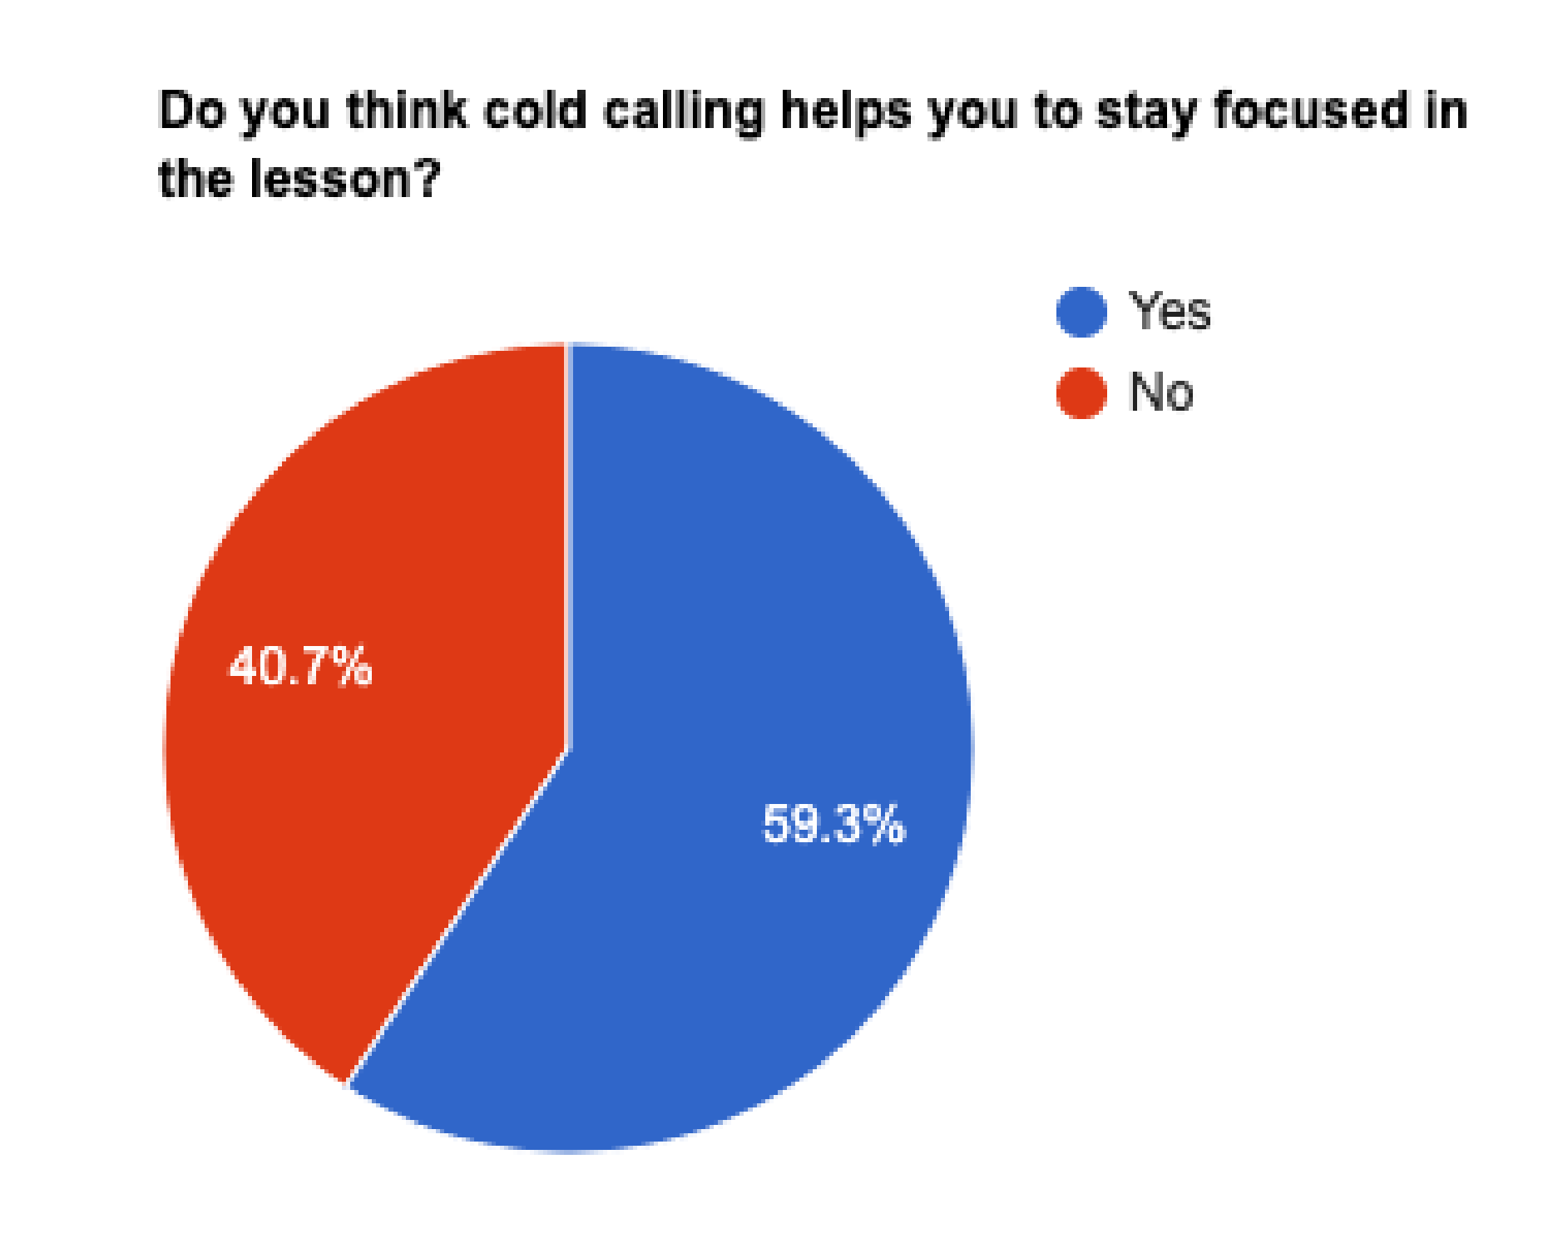
Figure 3 shows that 59.3% of learners claim that cold calling helps them stay focused. This implies that the strategy is effective in maintaining learner engagement during lessons – emphasising what teachers echoed when answering question one of the interview (see appendix). As all teachers stated that they used cold calling to maintaining engagement and focus during their lessons.

Figure 4. Cold calling and confidence.
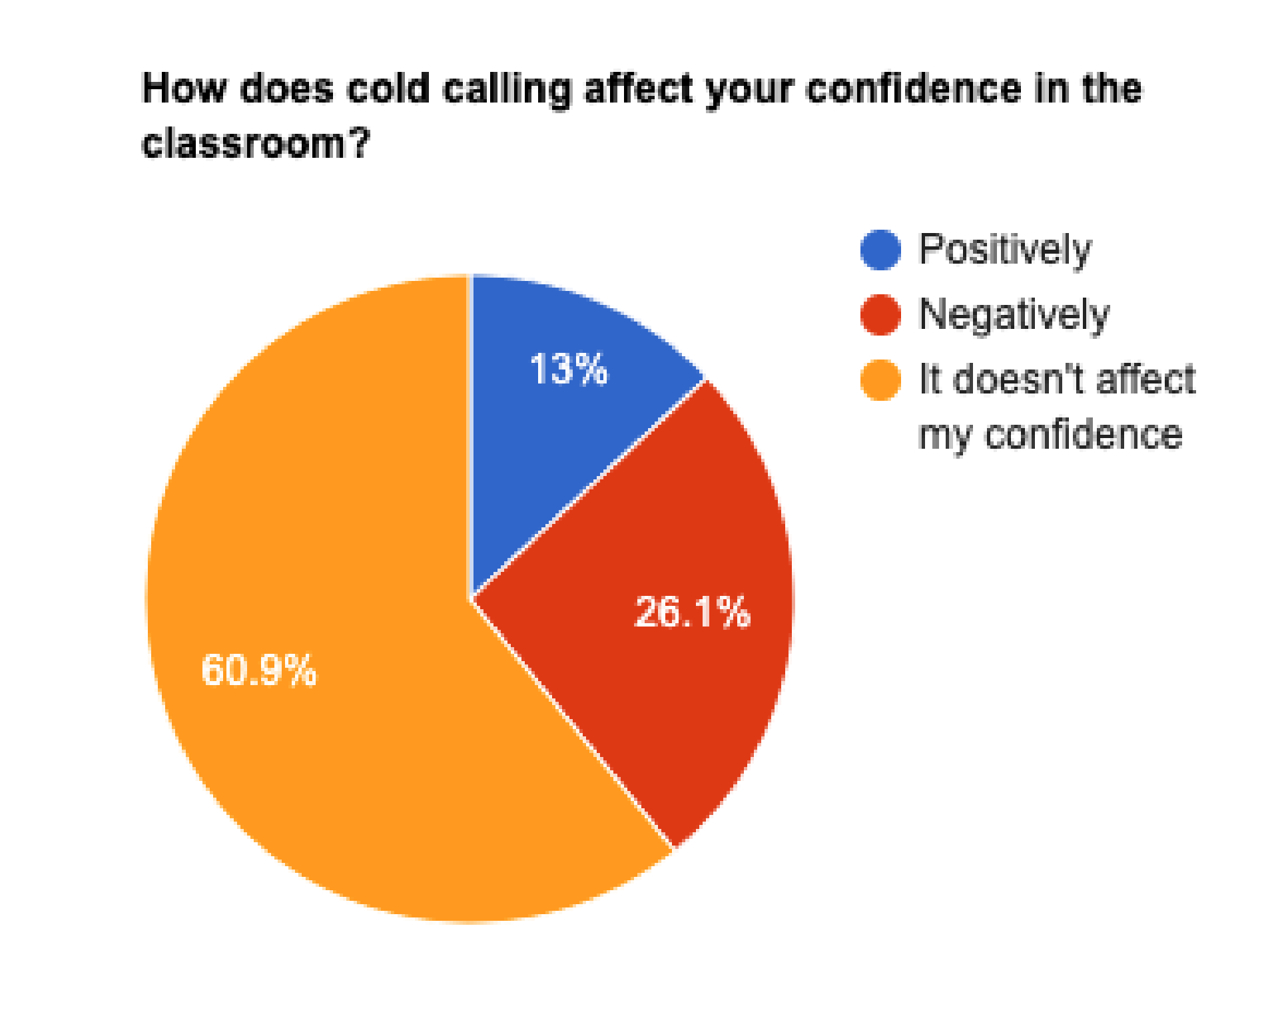
60.9% of learners stated that cold calling does not affect their confidence. However, where learners stated cold calling did affect their confidence, it was more negative (26.1%) than positive (13%). When teachers were asked the potential benefits of cold calling, all of them agreed that cold calling was a great tool to boost learner confidence. To use direct quotes, the History teacher believed that cold calling would ‘inevitably boost confidence’ when being used consistently during class feedback. Both the PE teacher and Geography teacher used the same phrase of ‘they’ll become more confident’ when asked about the benefits of cold calling for learners. Despite this, the learner responses in figure 4 show a different story, with only 13% of learners supporting the opinions of teachers. Their responses also contrast researchers such as Dallimore et al. (2013) who claimed cold calling supports learner confidence and participation in the classroom. However, researchers such as Rocca (2010) support the findings in figure 4. and stated that not only does cold calling have negative effects on learners such as lowering their self-esteem but also deteriorates learner confidence in class feedback – supporting the 26.1% of learners underlining the negative effects of cold calling on their confidence. Despite this, it is important to note that the majority of learners stated that cold calling did not affect their confidence, even though 77.8% feel anxious when being cold called. This suggests that learners are capable of overcoming and managing their initial anxiety and highlights that cold calling may not translate into a long-term negative effect on their overall confidence – despite the initial temporary discomfort for most.

Figure 5. Concerns of Cold Calling.
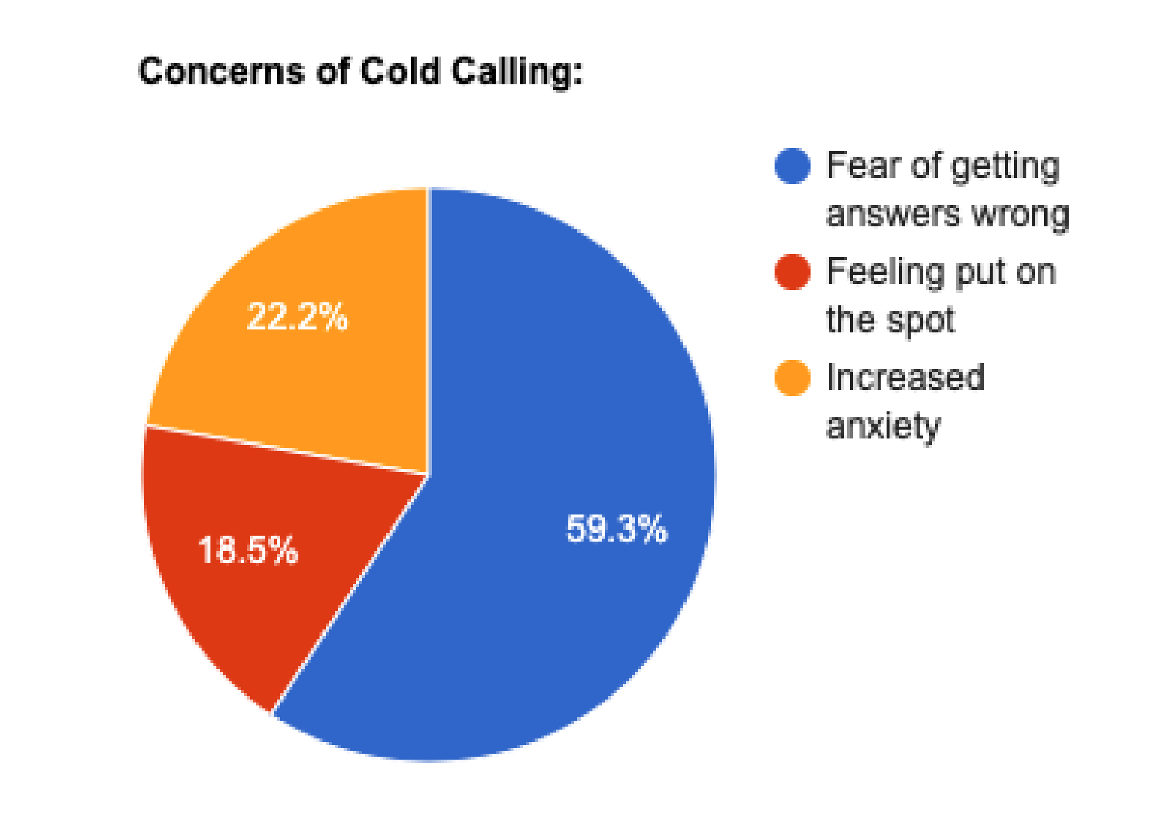
Linking to negative effects of cold calling on pupil confidence and anxiety, both learners and teachers were asked about any concerns they had about cold calling. It is evident that the most prominent concern in relation to being cold called is the ‘fear of getting answers wrong’, with over 59% stating that was their biggest concern. This was followed by ‘increased anxiety’ with 22.2% of learners and ‘feeling put on the spot’ with 18.5% of learners. This section is a vital area of focus as it underlines the psychological factors of cold calling on learners that may hinder their overall participation and learning experience. The fear of getting answers wrong being a major concern for learners aligns with numerous research findings which indicate that cold calling creates a high-pressure learning environment which can undermine the willingness and confidence for learners to engage in whole class feedback (Cooper, Downing & Brownell, 2018). Furthermore, this could have detrimental effects on learner confidence as it has been highlighted that high levels of anxiety in learners has a negative influence on their school experience (Mckeachie, 1984; Vitasari et al., 2010). 59.3% of learners who fear getting the wrong answer during cold calling is not uncommon, especially in instances of active learning. As cold calling is a form of active learning during feedback, it has often been linked to the multifaceted issue of the threat of failure in a classroom, which overall lowers self-confidence and self-worth in the learner (Covington, 1992).
When interviewed, all teachers agreed that cold calling can heighten anxiety in the classroom. In particular, the Biology teacher interviewed stated that cold calling, ‘if done poorly, it will only heighten their anxiety’ and ‘if done well, it should alleviate some of that anxiety’. This was an interesting insight as they acknowledged that anxiety will increase regardless, when cold calling, but it was a teacher's correct approach to cold calling that would alleviate anxiety and act as a stepping stool for confidence. When asked to elaborate, the teacher stated that using the ‘correct level of questioning’ should reduce their anxiety, providing the example ‘you wouldn’t ask a D student an A question’ and that you should always tailor your questions. The History teacher also agreed that tailoring questions and knowing your students is the best approach when cold calling and that ‘choosing learners who you already know have the correct answer’ should boost confidence. This was incredibly insightful as it matched with many open responses given by learners when asked about how teachers could create a supportive environment when asking questions in the classroom. 12 out of 27 learners stated that teachers should choose people who ‘know the answer’ and others stated that teachers should let learners know that ‘it’s okay’ if they get the answer wrong. Furthermore, when learners were asked if they prefer the ‘hands up approach’, 88.9% said yes – simply reinforcing the unpopularity of cold calling for learners as opposed to teachers. Interestingly, the PE teacher acknowledged that the ‘hands up’ approach may have been more popular amongst students and stated that it is up to the teachers to ‘breed a culture of not being afraid of failing’ in order to create a supportive and safe environment where cold calling is able to build confidence, rather than break it.

Conclusion and Recommendations:
This research project explored the impact of cold calling on pupil confidence utilising a mixed methods approach. This was done using both qualitative interviews and quantitative questionnaires, uncovering reliable and consistent data from learners and teachers. However, it is important to note that the use of opportunity sampling limited the generalisability of the findings due to the specific and small sample size gained. Triangulating data from both teacher and learner perspectives heightened the validity of methods and allowed for a nuanced view on the effect of cold calling on pupil confidence.
This research has largely highlighted the negative effects cold calling can have on learners, despite finding it helps learners focus, the majority of learners claimed that cold calling was anxiety inducing. Although most learners claimed that cold calling did not affect their confidence, the impact of cold calling was more negative than positive when investigating confidence and anxiety separately.
In light of this research, educators should consider fostering a supportive classroom environment, tailoring questions to individual learner ability and normalising mistakes in order to reduce the anxiety associated with cold calling. As for my own development, I aim to ensure that I build good relationships with learners so that they feel at ease and supported in the classroom environment. Once a good relationship with the learners is established, I hope to gradually introduce cold calling to help mitigate any initial negative impacts it may have. Future research should investigate the long-term effects of cold calling on learner engagement and confidence across multiple educational settings and age groups to find ways to support the learning of all learners and their emotional well-being in the classroom.

References:
Benbunan-Fich, R. & Arbaugh, J.B., 2006. Separating the effects of knowledge construction and group collaboration in learning outcomes of web-based courses. Information & Management, 43(6), pp.778-793.
Blair, J., Czaja, R.F. & Blair, E.A., 2013. Designing surveys: A guide to decisions and procedures. Sage publications.
Bonwell, C.C. & Eison, J.A., 1991. Active Learning: Creating Excitement in the Classroom. 1991 ASHE-ERIC Higher Education Reports. ERIC Clearinghouse on Higher Education, The George Washington University, Washington, DC.
Bostani, M., Nadri, A. & Nasab, A.R., 2014. A study of the relation between mental health and academic performance of students of the Islamic Azad University Ahvaz Branch. Procedia-Social and Behavioral Sciences, 116, pp.163-165.
British Education Research Association (BERA), 2018. Ethical Guidance for Education Researchers (4th ed.). Available at: https://www.bera.ac.uk/publication/ethical-guidelines-for-educational-research-2018 (Accessed: 4th March 2024).
Broeckelman-Post, M., Johnson, A. & Reid Schwebach, J., 2016. Calling on Students Using Notecards: Engagement and Countering Communication Anxiety in Large Lecture. Journal of College Science Teaching, 45(5).
Champagne, M.V., 2014. The Survey Playbook: How to Create the Perfect Survey. CreateSpace Independent Publishing Platform.
Cohen, L., 2018. Research methods in education. Routledge.
Cooper, K.M., Downing, V.R. & Brownell, S.E., 2018. The influence of active learning practices on student anxiety in large-enrollment college science classrooms. International Journal of STEM Education, 5, pp.1-18.
Covington, M.V., 1992. Making the grade: A self-worth perspective on motivation and school reform. Cambridge University Press.
Creswell, J.W. & Creswell, J.D., 2017. Research design: Qualitative, quantitative, and mixed methods approaches. Sage publications.
Dallimore, E.J., Hertenstein, J.H. & Platt, M.B., 2005. Faculty-generated strategies for “cold-calling” use: A comparative analysis with student recommendations. Journal on Excellence in College Teaching, 16(1), pp.23-62.
Dallimore, E.J., Hertenstein, J.H. & Platt, M.B., 2013. Impact of cold-calling on student voluntary participation. Journal of Management Education, 37(3), pp.305-341.
Denscombe, M., 2017. EBOOK: The good research guide: For small-scale social research projects. McGraw-Hill Education (UK).
Dillman, D.A., Smyth, J.D. & Christian, L.M., 2014. Internet, phone, mail, and mixed-mode surveys: The tailored design method. John Wiley & Sons.
Eddy, S.L., Brownell, S.E., Thummaphan, P., Lan, M.C. & Wenderoth, M.P., 2015. Caution, student experience may vary: Social identities impact a student’s experience in peer discussions. CBE—Life Sciences Education, 14(4).
Ewens, W., 2000. Teaching using discussion. In R. Neff & M. Weimer (Eds.), Classroom communication: Collected readings for effective discussion and questioning. Madison, WI: Atwood Publishing, pp. 21-26.
ESTYN, 2018. A report on Olchfa Comprehensive School. Available at: https://www.estyn.gov.wales/system/files/2020-08/Olchfa%2520School_0.pdf (Accessed: 4th April 2024).
Friedman, H.H. & Amoo, T., 1999. Rating the rating scales. Journal of Marketing Management, Winter, pp.114-123.
Gerring, J., 2004. What is a case study and what is it good for? American political science review, 98(2), pp.341-354.
Kosslyn, S.M., 2006. Graph design for the eye and mind. OUP USA.
Maxwell, J.A., 2005. Qualitative Research Design: An Interactive Approach (2nd ed.). Thousand Oaks, CA: Sage.
McKeachie, W.J., 1984. Does anxiety disrupt information processing or does poor information processing lead to anxiety? International Review of Applied Psychology.
Mind, 2021. Anxiety and Panic Attacks. Retrieved from https://www.mind.org.uk/media/7089/anxiety-and-panic-attacks-2021-pdf-version.pdf (Accessed: 15th April 2024).
Morek, M., Heller, V. & Kinalzik, N., 2022. Engaging ‘silent’ students in classroom discussions: a micro-analytic view on teachers’ embodied enactments of cold-calling practices. Language and Education, 37(6), pp.731-749. doi: 10.1080/09500782.2022.2155474.
Moring, B., 2014. Research methods in psychology: Evaluating a world of information. WW Norton & Company.
Pauli, C. & Reusser, K., 2015. The importance of classroom discourse for students’ learning is uncontested today. Socializing Intelligence Through Academic Talk and Dialogue, pp.181.
Punch, K.F., 2013. Introduction to social research: Quantitative and qualitative approaches.
Rocca, K.A., 2010. Student participation in the college classroom: An extended multidisciplinary literature review. Communication education, 59(2), pp.185-213.
Terry, G., Hayfield, N., Clarke, V. & Braun, V., 2017. Thematic analysis. The SAGE handbook of qualitative research in psychology (2nd ed.), pp.17-37.
The Guardian, 2022. Warnings of mental health crisis among COVID generation of students. Available at: https://www.theguardian.com/society/2022/jun/28/warnings-of-mental-health-crisis-among-covid-generation-of-students (Accessed: 10th April 2024).
The Guardian, 2023. Rise in school absences since COVID driven by anxiety and lack of support, say English councils. Available at: https://www.theguardian.com/education/2023/apr/23/rise-in-school-absences-since-covid-driven-by-anxiety-and-lack-of-support-say-english-councils (Accessed: 10th April 2024).
Vitasari, P., Wahab, M.N.A., Othman, A., Herawan, T. & Sinnadurai, S.K., 2010. The relationship between study anxiety and academic performance among engineering students. Procedia-Social and Behavioral Sciences, 8, pp.490-497.
Welsh Government, 2019. Professional Standards for Teaching and Leadership. Available at: https://hwb.gov.wales/storage/19bc948b-8a3f-41e0-944a-7bf2cadf7d18/professional-standards-for-teaching-and-leadership-interactive-pdf-for-pc.pdf (Accessed: 4th April 2024).
Yin, R.K., 2018. Case study research and applications (6th ed.). Thousand Oaks, CA: Sage.
Zucker, D.M., 2016. How to do case study research. In Teaching research methods in the social sciences. Routledge, pp.191-202.

Appendices:

- Questionnaire on Cold Calling

Questionnaire: Cold Calling on Pupil Confidence

What is cold calling? Cold calling is when a teacher asks a pupil to answer a question in front of the class, without the pupil putting their hand up. Opposite to the ‘hands up’ approach.

1. Experience with Cold Calling:
Have you experienced cold calling in your classes?
- Yes
- No
How frequently do you experience cold calling in your classes?
- Very often
- Sometimes
- Never
2. Perceptions of Cold Calling:
How do you feel when your teacher uses cold calling in the classroom?
- Excited
- Anxious
- Focused
- Indifferent
- Other (please specify):
Do you think cold calling helps you to stay focused in the lesson?
- Yes
- No

3. Impact on Confidence and Anxiety:
How does cold calling affect your confidence in the classroom?
- Positively
- Negatively
- It doesn't affect my confidence

(Turn page)

Do you experience anxiety when you might be asked a question by your teacher?
- Yes, often
- Sometimes
- Never
If you experience anxiety, how does cold calling affect this?

What concerns, if any, do you have about cold calling?
- Fear of getting answers wrong
- Feeling put on the spot
- Increased anxiety
- Other (please specify):
Do you prefer the ‘hands up’ approach (when teachers only choose people with their hands up to answer)?
- Yes
- No
4. Strategies and Support:
How can teachers create a supportive environment when asking questions in the classroom?

5. Additional Comments:
Please feel free to share any additional thoughts or experiences regarding cold calling in the classroom.

Reminder: All answers will remain anonymous.

- Interview Questions

- How do you perceive the role of cold calling in the classroom environment, particularly in facilitating student engagement and learning?
- For students with anxiety, how might cold calling impact their experience in the classroom?
- In your experience, what are the potential benefits of cold calling for student learning and participation?
- Conversely, what concerns do you have about the practice of cold calling in terms of student confidence and engagement? How do you address these concerns in your teaching practice?
- Can you share any strategies or techniques you employ to mitigate any negative impacts of cold calling on student confidence?
- How do you balance the need for student engagement through participation with ensuring a supportive and inclusive classroom environment?
- Have you observed any differences in the impact of cold calling on students with varying levels of confidence or learning styles, including those who may experience anxiety in the classroom? How do you adapt your approach accordingly?
- How do you assess the effectiveness of cold calling in your classroom, particularly in relation to student confidence and overall learning outcomes? What indicators do you look for?
- Are there alternative methods or approaches you use to encourage student participation and engagement without relying heavily on cold calling, particularly for students who may feel anxious about speaking up in class?
- In your opinion, how can teachers strike a balance between promoting active participation through techniques like cold calling and fostering a positive, supportive learning atmosphere that nurtures student confidence, particularly for students who may experience anxiety in the classroom?

- Ethics Form
APPLICATION FOR ETHICAL APPROVAL

RESEARCH STUDENTS
This form is to be completed by the student within SIX months for full-time students and TWELVE months for part time students, after the commencement of the research degree or following progression to Part Two of your course.

Once complete, submit this form via the MyTSD Doctoral College Portal at (https://mytsd.uwtsd.ac.uk).

This document is also available in Welsh.

RESEARCH STAFF ONLY
All communications relating to this application during its processing must be in writing and emailed to pgresearch@uwtsd.ac.uk , with the title ‘Ethical Approval’ followed by your name.

STUDENTS ON UNDERGRADUATE OR TAUGHT MASTERS PROGRAMMES should submit this form (and receive the outcome) via systems explained to you by the supervisor/module leader.

In order for research to result in benefit and minimise risk of harm, it must be conducted ethically. A researcher may not be covered by the University’s insurance if ethical approval has not been obtained prior to commencement.

The University follows the OECD Frascati manual definition of research activity: “creative work undertaken on a systematic basis in order to increase the stock of knowledge, including knowledge of man, culture and society, and the use of this stock of knowledge to devise new applications”. As such this covers activities undertaken by members of staff, postgraduate research students, and both taught postgraduate and undergraduate students working on dissertations/projects.

The individual undertaking the research activity is known as the “principal researcher”.

Ethical approval is not required for routine audits, performance reviews, quality assurance studies, testing within normal educational requirements, and literary or artistic criticism.

Please read the notes for guidance before completing ALL sections of the form.

This form must be completed and approved prior to undertaking any research activity. Please see Checklist for details of process for different categories of application.

SECTION A: About You (Principal Researcher)
1 | Full Name: |  | Sumayyah Islam
2 | Tick all boxes that apply: |  | Member of staff: | ☐ | Honorary research fellow: | ☐
 | Undergraduate Student | ☐ | Taught Postgraduate Student | ☒ | Postgraduate Research Student | ☐

3 | Institute/Academic Discipline/Centre: | Athrofa Teacher Education
4 | Campus: | Swansea Campus
5 | E-mail address: | 2318487@student.uwtsd.ac.uk
6 | Contact Telephone Number:
 | For students:
7 | Student Number: | 2318487
8 | Programme of Study: | PGCE History
9 | Director of Studies/Supervisor: | Dr Catherine Morgan

SECTION B: Approval for Research Activity
1 | Has the research activity received approval in principle?  (please check the Guidance Notes as to the appropriate approval process for different levels of research by different categories of individual) |  | YES | ☒ | NO | ☐
 |  |  |  |  | Date
2 | If Yes, please indicate source of approval (and date where known): Approval in principle must be obtained from the relevant source prior to seeking ethical approval | Research Degrees Committee |  | ☐
2 |  | Institute Research Committee |  | ☐
2 |  | Other (write in)  Catherine Morgan |  | ☒ | 14/03/23

SECTION C: Internal and External Ethical Guidance Materials
 | Please list the core ethical guidance documents that have been referred to during the completion of this form (including any discipline-specific codes of research ethics, location-specific codes of research ethics, and also any specific ethical guidance relating to the proposed methodology). Please tick to confirm that your research proposal adheres to these codes and guidelines. You may add rows to this table if needed.
1 | UWTSD Research Ethics & Integrity Code of Practice | ☒
2 | UWTSD Research Data Management Policy | ☒
3 | British Educational Research Association (BERA), 2018. Ethical Guidelines for Educational Research. | ☒

SECTION D: External Collaborative Research Activity
If there are external collaborators then you should gain consent from the contact persons to share their personal data with the university. If there are no external collaborators then leave this section blank and continue to section E.
1 | Institution
2 | Contact person name
3 | Contact person e-mail address
4 | Is your research externally funded? |  | YES | ☐ | NO |  | ☐
5 | Are you in receipt of a KESS scholarship? |  | YES | ☐ | NO |  | ☐
6 | Are you specifically employed to undertake this research in either a paid or voluntary capacity? | Voluntary | YES | ☐ | NO | ☐
7 |  | Employed | YES | ☐ | NO | ☐
8 | Is the research being undertaken within an existing UWTSD Athrofa Professional Learning Partnership (APLP)? | If YES then the permission question below does not need to be answered. | YES | ☐ | NO |  | ☐
9 | Has permission to undertake the research has been provided by the partner organisation? | (If YES attach copy)  If NO the application cannot continue | YES | ☐ | NO |  | ☐

Where research activity is carried out in collaboration with an external organisation
10 | Does this organisation have its own ethics approval system? | YES | ☐ | NO | ☒
 | If Yes, please attach a copy of any final approval (or interim approval) from the organisation (this may be a copy of an email if appropriate).

SECTION E: Details of Research Activity
1 | Indicative title: | How does the practice of cold calling in the classroom affect pupil confidence?
2 | Proposed start date: | 14/03/24 | Proposed end date: | 31/07/24
Introduction to the Research (maximum 300 words per section)
Ensure that you write for a Non-Specialist Audience when outlining your response to the points below:
- Purpose of Research Activity
- Proposed Research Question
- Aims of Research Activity
- Objectives of Research Activity
Demonstrate, briefly, how Existing Research has informed the proposed activity and explain
- What the research activity will add to the body of knowledge
- How it addresses an area of importance.
3 | Purpose of Research Activity  The purpose of the research activity is to investigate the impact of cold calling in the classroom on pupil confidence, especially amongst the growing rates of anxiety and mental health issues among children and learners. Cold calling is a teaching method where pupils are randomly selected to answer questions or participate in classroom discussions, which in turn may influence pupils’ confidence levels and exacerbate feelings of anxiety. Understanding how this practice affects pupil confidence and anxiety can inform teaching strategies and contribute to creating supportive classroom environments which promote positive mental health outcomes alongside positive pupil outcomes.  (this box should expand as you type)
4 | Research Question  How does the practice of cold calling in the classroom affect pupil confidence?  (this box should expand as you type)
5 | Aims of Research Activity  The primary aim of this research activity is to analyse the relationship between cold calling the classroom and pupil confidence, specifically aiming to:  - Determine the effects of cold calling on pupils’ self confidence and willingness to participate in classroom activities  - Explore pupils’ and teachers’ perceptions of cold calling  - Identify potential factors that may mediate the relationship between cold calling and pupil confidence  (this box should expand as you type)
6 | Objectives of Research Activity  - Examine the correlation between cold calling practices and pupil confidence levels, with a focus on anxiety  - Explore pupils’ perceptions and experiences of cold calling in the classroom and impact on confidence  - Identify potential strategies and adjustments to cold calling practices that can mitigate possible negative effects on pupil confidence and anxiety  (this box should expand as you type)
Proposed methods (maximum 600 words)
Provide a brief summary of all the methods that may be used in the research activity, making it clear what specific techniques may be used. If methods other than those listed in this section are deemed appropriate later, additional ethical approval for those methods will be needed. You do not need to justify the methods here, but should instead describe how you intend to collect the data necessary for you to complete your project.
7 | The research activity will consist of a multitude of research methods in order to comprehensively investigate the relationship between cold calling in the classroom and pupil confidence. The approach will use both quantitative and qualitative research methods in order to gain insight from participants.  Quantitative research methods:  Questionnaire - using a Likert-scale  Learners will be given a questionnaire on cold calling; one aspect of the questionnaire will include a Likert-scale where learners can state their level of confidence regarding cold calling.  The questionnaire will also consist of many closed questions which both teachers and learners will answer, which will result in quantitative data to compare during future analysis.  Qualitative research methods:  Questionnaire – The questionnaire will also have some open answer questions in which both the learner and teacher can expand on their previous answers and give more in depth responses of their attitudes towards the practice of cold calling.  Interviews – A range of school teachers will be interviewed, including a mix of subject teachers ( male and female ) and their approaches to cold calling  The interview will be semi structured and will allow for open-ended discussions about the perceived effects of cold calling on confidence levels, as well as any associated challenges or benefits which may provide insight into their rationale for using the strategy.  Observations: Classroom observations will include both a general observation and a participant observation (where I will also ask learners questions regarding cold calling during my observation)  During general observations, I will see how the teachers cold call on students, if they use a program to help or cold call organically. I will also be observing the pupils’ response, including their reaction/body language/response to being cold called. The general frequency and nature of cold calling will also be observed which may also add to our quantitative data above.  After the data is collected, quantitative data through questionnaires and classroom observations will be analysed using statistical methods to identify patterns and correlations between cold calling practices and pupil confidence. In regard to qualitative data from interviews and participant observations, these will be thematically analysed to uncover any recurring themes, experiences and perceptions related to cold calling and confidence.  (this box should expand as you type)
Location of research activity
Identify all locations where research activity will take place.
8 | Secondary school in South Wales Area  (this box should expand as you type)
Research activity outside of the UK
If research activity will take place overseas, you are responsible for ensuring that local ethical considerations are complied with and that the relevant permissions are sought. Specify any local guidelines (e.g. from local professional associations/learned societies/universities) that exist and whether these involve any ethical stipulations beyond those usual in the UK (provide details of any licenses or permissions required). Also specify whether there are any specific ethical issues raised by the local context in which the research activity is taking place, for example, particular cultural and/or legal sensitivities or vulnerabilities of participants. If you live in the country where you will do the research then please state this.
9 | (this box should expand as you type)

10 | Use of documentation not in the public domain: Are any documents NOT publicly available? | NO | ☒
10 |  | YES | ☐
11 | If Yes, please provide details here of how you will gain access to specific documentation that is not in the public domain and that this is in accordance with the current data protection law of the country in question and that of England and Wales.  (this box should expand as you type)

 | Does your research relate to one or more of the seven aims of the Well-being of Future Generations (Wales) Act 2015? | YES | NO
12 | A prosperous Wales | ☐ | ☒
13 | A resilient Wales | ☐ | ☒
14 | A healthier Wales | ☒ | ☐
15 | A more equal Wales | ☒ | ☐
16 | A Wales of cohesive communities | ☐ | ☒
17 | A Wales of vibrant culture and thriving Welsh language | ☐ | ☒
18 | A globally responsible Wales | ☐ | ☒
19 | If YES to any of the above, please give details:
This research aims to contribute to a healthier and more equitable Wales by exploring the impact of teaching methods, such as cold calling, on student confidence and well-being.

(this box should expand as you type)

SECTION F: Scope of Research Activity
 | Will the research activity include: | YES | NO
1 | Use of a questionnaire or similar research instrument? | ☒ | ☐
2 | Use of interviews? | ☒ | ☐
3 | Use of focus groups? | ☐ | ☒
4 | Use of participant diaries? | ☐ | ☒
5 | Use of video or audio recording? | ☐ | ☒
6 | Use of computer-generated log files? | ☐ | ☒
7 | Participant observation with their knowledge? | ☒ | ☐
8 | Participant observation without their knowledge? | ☐ | ☒
9 | Access to personal or confidential information without the participants’ specific consent? | ☐ | ☒
10 | Administration of any questions, test stimuli, presentation that may be experienced as physically, mentally or emotionally harmful / offensive? | ☐ | ☒
11 | Performance of any acts which may cause embarrassment or affect self-esteem? | ☐ | ☒
12 | Investigation of participants involved in illegal activities? | ☐ | ☒
13 | Use of procedures that involve deception? | ☐ | ☒
14 | Administration of any substance, agent or placebo? | ☐ | ☒
15 | Working with live vertebrate animals? | ☐ | ☒
16 | Procedures that may have a negative impact on the environment? | ☐ | ☒
17 | Other primary data collection methods. Please indicate the type of data collection method(s) below. | ☐ | ☒
 | Details of any other primary data collection method:  (this box should expand as you type) | ☐ | ☒
If NO to every question, then the research activity is (ethically) low risk and may be exempt from some of the following sections (please refer to Guidance Notes).

If YES to any question, then no research activity should be undertaken until full ethical approval has been obtained.

SECTION G: Intended Participants
If there are no participants then do not complete this section, but go directly to section H.

 | Who are the intended participants: | YES | NO
1 | Students or staff at the University? | ☐ | ☒
2 | Adults (over the age of 18 and competent to give consent)? | ☒ | ☐
3 | Vulnerable adults? | ☐ | ☒
4 | Children and Young People under the age of 18? (Consent from Parent, Carer or Guardian will be required) | ☒ | ☐
5 | Prisoners? | ☐ | ☒
6 | Young offenders? | ☐ | ☒
7 | Those who could be considered to have a particularly dependent relationship with the investigator or a gatekeeper? | ☐ | ☒
8 | People engaged in illegal activities? | ☐ | ☒
9 | Others. Please indicate the participants below, and specifically any group who may be unable to give consent. | ☐ | ☒
 | Details of any other participant groups:  (this box should expand as you type) | ☐ | ☒

Participant numbers and source
Provide an estimate of the expected number of participants. How will you identify participants and how will they be recruited?
10 | How many participants are expected? | Interviews: 4 classroom teachers (minimum)  Participants for observation and questionnaires: 25-60 pupils  (this box should expand as you type)
11 | Who will the participants be? | Classroom teachers of different genders and subject areas  School pupils (Year 8 and/or Year 10)  (this box should expand as you type)
12 | How will you identify the participants? | Opportunity sampling  Teachers – Will ask teachers if they are free to participate in a short interview for my research project  Pupils – Will try and ask classes I have both observed and taught, in order to have good, open responses  (this box should expand as you type)

 | Information for participants: | YES | NO | N/A
13 | Will you describe the main research procedures to participants in advance, so that they are informed about what to expect? | ☒ | ☐ | ☐
14 | Will you tell participants that their participation is voluntary? | ☒ | ☐ | ☐
15 | Will you obtain written consent for participation? | ☒ | ☐ | ☐
16 | Will you explain to participants that refusal to participate in the research will not affect their treatment or education (if relevant)? | ☒ | ☐ | ☐
17 | If the research is observational, will you ask participants for their consent to being observed? | ☒ | ☐ | ☐
18 | Will you tell participants that they may withdraw from the research at any time and for any reason? | ☒ | ☐ | ☐
19 | With questionnaires, will you give participants the option of omitting questions they do not want to answer? | ☒ | ☐ | ☐
20 | Will you tell participants that their data will be treated with full confidentiality and that, if published, it will not be identifiable as theirs? | ☒ | ☐ | ☐
21 | Will you debrief participants at the end of their participation, in a way appropriate to the type of research undertaken? | ☒ | ☐ | ☐
22 | If NO to any of above questions, please give an explanation
The questionnaire will have closed answers, the participant should tick any of the boxes, and will not have another option for a N/A answer. But if they do not want to answer they are able to leave the question answer blank.

(this box should expand as you type)

 | Information for participants: | YES | NO | N/A
24 | Will participants be paid? | ☐ | ☒ | ☐
25 | Is specialist electrical or other equipment to be used with participants? | ☐ | ☒ | ☐
26 | Are there any financial or other interests to the investigator or University arising from this study? | ☐ | ☒ | ☐
27 | Will the research activity involve deliberately misleading participants in any way, or the partial or full concealment of the specific study aims? | ☐ | ☒ | ☐
28 | If YES to any question, please provide full details
 | (this box should expand as you type)

SECTION H: Anticipated Risks

Outline any anticipated risks that may adversely affect any of the participants, the researchers and/or the University, and the steps that will be taken to address them.

If you have completed a full risk assessment (for example as required by a laboratory, or external research collaborator) you may append that to this form.
1 | Full risk assessment completed and appended? |  | Yes | ☐
1 |  |  | No | ☒
2 | Risks to participants  For example: sector-specific health & safety, emotional distress, financial disclosure, physical harm, transfer of personal data, sensitive organisational information
 | Risk to participants:  Emotional distress -  Engaging pupils in discussions about confidence and experiences may evoke an emotional response, especially with negative experiences. As the questionnaire will have open questions for them to write about their experiences with cold calling.  Demand characteristics – risk that participants may feel the need to give a positive or biased responses  (this box should expand as you type) | How you will mitigate the risk to participants:  Create a supportive environment where confidentially is emphasised and participants feel comfortable expressing themselves.  Reiterate that the questionnaire results are all anonymous in order to promote open and honest answers.  (this box should expand as you type)
3 | If research activity may include sensitive, embarrassing or upsetting topics (e.g. sexual activity, drug use) or issues likely to disclose information requiring further action (e.g. criminal activity), give details of the procedures to deal with these issues, including any support/advice (e.g. helpline numbers) to be offered to participants. Note that where applicable, consent procedures should make it clear that if something potentially or actually illegal is discovered in the course of a project, it may need to be disclosed to the proper authorities
 | (this box should expand as you type)
4 | Risks to the investigator  For example: personal health & safety, physical harm, emotional distress, risk of accusation of harm/impropriety, conflict of interest
 | Risk to the investigator:  Concerns of coercion and participants right to withdraw  (this box should expand as you type) | How you will mitigate the risk to the investigator:  It will be reiterated and made explicit to participants that they are free to withdraw at any time and it will not affect their study.  (this box should expand as you type)
5 | University/institutional risks  For example: adverse publicity, financial loss, data protection
 | Risk to the University:  Reputational damage  (this box should expand as you type) | How you will mitigate the risk to the University:  Ensure adherence to the UWTSD code of conduct as well as their code of ethics and research standards in order to ensure good practice.  (this box should expand as you type)
6 | Environmental risks  For example: accidental spillage of pollutants, damage to local ecosystems
 | Risk to the environment:  Paper waste  (this box should expand as you type) | How you will mitigate the risk to environment:  Will make sure to use precise amount of paper copies (forms, questionnaires) in order to reduce waste.  (this box should expand as you type)

 | Disclosure and Barring Service
 | If the research activity involves children or vulnerable adults, a Disclosure and Barring Service (DBS) certificate must be obtained before any contact with such participants. | YES | NO | N/A
7 | Does your research require you to hold a current DBS Certificate? | ☒ | ☐ | ☐
8 | If YES, please give the certificate number. If the certificate number is not available please write “Pending”; in this case any ethical approval will be subject to providing the appropriate certificate number. | 001850149661

SECTION I: Feedback, Consent and Confidentiality

1 | Feedback  What de-briefing and feedback will be provided to participants, how will this be done and when?
Participants will be told the purpose and aims of the research prior to and after participating in any interviews, questionnaires or participant observations.

(this box should expand as you type)
2 | Informed consent  Describe the arrangements to inform potential participants, before providing consent, of what is involved in participating. Describe the arrangements for participants to provide full consent before data collection begins. If gaining consent in this way is inappropriate, explain how consent will be obtained and recorded in accordance with prevailing data protection legislation.
Prior to handing out consent forms, participants will be told the aims and purpose of the research. As the participants are aware of the purpose and aims of the research, they will be able to provide informed consent prior to data collection.
The consent forms will then be signed by their parents and handed back to me (the researcher) in order to ensure parental consent prior to the pupils completing the questionnaire.

(this box should expand as you type)
3 | Confidentiality / Anonymity  Set out how anonymity of participants and confidentiality will be ensured in any outputs. If anonymity is not being offered, explain why this is the case.
Participants will be told prior to data collection that all of their responses will remain anonymous, in hopes to receive open and honest responses from the participants.
Participants are just answering the questionnaires and will not be asked to provide a name, but just to answer the questions in front of them.

(this box should expand as you type)

SECTION J: Data Protection and Storage

 | Does the research activity involve personal data (as defined by the General Data Protection Regulation 2016 “GDPR” and the Data Protection Act 2018 “DPA”)? | YES | NO
1 | “Personal data” means any information relating to an identified or identifiable natural person (‘data subject’). An identifiable natural person is one who can be identified, directly or indirectly, in particular by reference to an identifier such as a name, an identification number, location data, an online identifier or to one or more factors specific to the physical, physiological, genetic, mental, economic, cultural or social identity of that natural person. Any video or audio recordings of participants is considered to be personal data. | X | ☐
 | If YES, provide a description of the data and explain why this data needs to be collected:
2 | Interviews with teachers will be carried out regarding their opinions on the practice of cold calling. The data and information from these interviews will remain anonymous as their names will not be shared during data interpretation and results discussion in the research project.  (this box should expand as you type)
 | Does it involve special category data (as defined by the GDPR)? | YES | NO
3 | “Special category data” means sensitive personal data consisting of information as to the data subjects’ –  (a) racial or ethnic origin,  (b) political opinions,  (c ) religious beliefs or other beliefs of a similar nature,  (d) membership of a trade union (within the meaning of the Trade Union and Labour Relations (Consolidation) Act 1992),  (e) physical or mental health or condition,  (f) sexual life,  (g) genetics,  (h) biometric data (as used for ID purposes), | X | ☐
 | If YES, provide a description of the special category data and explain why this data needs to be collected:
4 | Data is regarding pupil confidence but will also focus on anxiety and well-being. This will be expanded more in teacher interviews as opposed to pupil observation, asking teachers if they think cold-calling might affect a learners well-being.  (this box should expand as you type)

 | Will data from the research activity (collected data, drafts of the thesis, or materials for publication) be stored in any of the following ways? | YES | NO
5 | Manual files (i.e. in paper form)? | ☒ | ☐
6 | University computers? | ☐ | ☒
7 | Private company computers? | ☐ | ☒
8 | Home or other personal computers? | ☒ | ☐
9 | Laptop computers/ CDs/ Portable disk-drives/ memory sticks? | ☒ | ☐
10 | “Cloud” storage or websites? | ☒ | ☐
11 | Other – specify: | ☐ | ☒
12 | For all stored data, explain the measures in place to ensure the security of the data collected, data confidentiality, including details of backup procedures, password protection, encryption, anonymisation and pseudonymisation:
All of the data will be anonymous and unidentifiable.
Pupil or teacher names will not be recorded in interviews, observations or questionnaires. Only their subject areas will be recorded.

(this box should expand as you type)

 | Data Protection
 | Will the research activity involve any of the following activities: | YES | NO
13 | Electronic transfer of data in any form? | ☐ | ☒
14 | Sharing of data with others at the University outside of the immediate research team? | ☐ | ☒
15 | Sharing of data with other organisations? | ☐ | ☒
16 | Export of data outside the UK or importing of data from outside the UK? | ☐ | ☒
17 | Use of personal addresses, postcodes, faxes, emails or telephone numbers? | ☐ | ☒
18 | Publication of data that might allow identification of individuals? | ☐ | ☒
19 | Use of data management system? | ☐ | ☒
20 | Data archiving? | ☐ | ☒
21 | If YES to any question, please provide full details, explaining how this will be conducted in accordance with the GDPR and Data Protection Act (2018) (and any international equivalents, where appropriate):
 | (this box should expand as you type)
22 | List all who will have access to the data generated by the research activity:
Sumayyah Islam

(this box should expand as you type)
23 | List who will have control of, and act as custodian(s) for, data generated by the research activity:
Sumayyah Islam

(this box should expand as you type)
24 | Give details of data storage arrangements, including security measures in place to protect the data, where data will be stored, how long for, and in what form. Will data be archived – if so how and if not why not.
Interviews – Data from interviews will be recorded on paper as throughout the interview, handwritten notes will be made. No names will be recorded. Data from these interviews will then be cleaned and recorded on computer format (Microsoft Word) until the assignment and project is finished. Again, all of this data will be anonymised as no names will be recorded – only teacher responses and subject disciplines.

Questionnaires – These will be in paper form and no names will be recorded on these either. Data from these paper questionnaires will then be cleaned and recorded on computer format (Microsoft Word) until the assignment and project is finished. Again, all of this data will be anonymised as no names will be recorded – only pupil responses.

(this box should expand as you type)
25 | Please indicate if your data will be stored in the UWTSD Research Data Repository (see https://researchdata.uwtsd.ac.uk/ ). If so please explain. (Most relevant to academic staff)
 | (this box should expand as you type)
26 | Confirm that you have read the UWTSD guidance on data management (see https://www.uwtsd.ac.uk/library/research-data-management/) | YES | ☒
27 | Confirm that you are aware that you need to keep all data until after your research has completed or the end of your funding | YES | ☒

SECTION K: Declaration
The information which I have provided is correct and complete to the best of my knowledge. I have attempted to identify any risks and issues related to the research activity and acknowledge my obligations and the rights of the participants.

In submitting this application I hereby confirm that I undertake to ensure that the above named research activity will meet the University’s Research Ethics and Integrity Code of Practice which is published on the website: https://www.uwtsd.ac.uk/research/research-ethics/
1 | Signature of applicant: | Sumayyah Islam | Date:  14/03/2024

For STUDENT Submissions:
2 | Director of Studies/Supervisor: |  | Date:
3 | Signature: |  | Date:

For STAFF Submissions:
4 | Academic Director/ Assistant Dean: |  | Date:
5 | Signature: |  | Date:

Checklist: Please complete the checklist below to ensure that you have completed the form according to the guidelines and attached any required documentation:
☒ | I have read the guidance notes supplied before completing the form.
☒ | I have completed ALL RELEVANT sections of the form in full.
☒ | I confirm that the research activity has received approval in principle
☐ | I have attached a copy of final/interim approval from external organisation (where appropriate)
☐ | I have attached a full risk assessment (where appropriate) ONLY TICK IF YOU HAVE ATTACHED A FULL RISK ASSESSMENT
☒ | I understand that it is my responsibility to ensure that the above named research activity will meet the University’s Research Ethics and Integrity Code of Practice.
☒ | I understand that before commencing data collection all documents aimed at respondents (including information sheets, consent forms, questionnaires, interview schedules etc.) must be confirmed by the DoS/Supervisor, module tutor or Academic Director.

RESEARCH STUDENTS ONLY
Once complete, submit this form via the MyTSD Doctoral College Portal at (https://mytsd.uwtsd.ac.uk).

RESEARCH STAFF ONLY
All communications relating to this application during its processing must be in writing and emailed to pgresearch@uwtsd.ac.uk , with the title ‘Ethical Approval’ followed by your name.

STUDENTS ON UNDERGRADUATE OR TAUGHT MASTERS PROGRAMMES should submit this form (and receive the outcome) via systems explained to you by the supervisor/module leader.

- Consent Form and Information Sheet

CONSENT FORM

Cold Calling on Pupil Confidence

Name of Researcher: Miss S Islam

Please tick initial box

1.I confirm that I have read and understand the information sheet for the above study.

2. I understand that my child’s participation is voluntary and that I am free to withdraw my child from the study at any time, without giving any reason.

3. I understand that my child can choose to withdraw at any time, without giving a reason.

4. I understand that the information given by my child will be used in a university assignment.

5. I understand that my child’s name will not appear at any time.

6. I agree for my child to take part in the above study.

_____________________ _____________________________ __________
Child’s name Parent signature Date

When completed, please return to Miss S Islam by the 24th April 2024.

INFORMATION SHEET

Cold Calling on Pupil Confidence

Dear Parent / Guardian,

I am currently a student teacher at Olchfa School, pursuing a PGCE qualification at Yr Athrofa, University of Wales Trinity Saint David. As part of my qualification, I must complete a research project on a chosen topic.

I would like to invite your child to participate in my research project. The title of the project is Cold Calling on Pupil Confidence. Cold calling is a teaching method where pupils are randomly selected to participate in class discussions - contrasting the ‘hands up’ approach. My project aims to understand the positive/negative impacts cold calling in the classroom can have on pupil confidence.

Your child will be completing a 5–10-minute questionnaire, discussing the practice of cold calling and their personal experience with the teaching method. This will all be done on paper. All results will remain anonymous.

All names will be kept strictly confidential and will only be known by myself and my research partner. Your child’s participation in this study is completely voluntary so you or your child can withdraw from the study at any stage. Your child will also be asked to give their assent before the beginning of the study.

After careful and precise analysis of the data obtained from the questionnaire, I would be happy to provide you with a copy of the findings at your request. The results of the research will be discussed in a university assignment that will contribute to my PGCE course. The results of this study will be stored on computer and all raw data will be destroyed once the assessment has been marked.

I thank you in advance for your time. If any questions do arise, feel free to contact me at your convenience.

Yours sincerely,

Miss S Islam

