Click-on Wales (IWA website: www.iwa.org.uk ) 27 April 2015

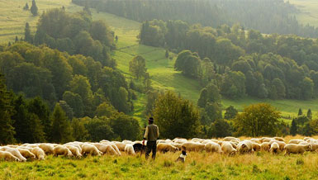

Mind the gap: What gap? – An urban/rural dimension
Andy Bevan says the rural economy is being left out of the debate around Wales’ wealth.
April 27th, 2015
There has been a lively economic debate on these pages since the IWA published its Economic Strategy for Wales in March 2015 and particularly since the Learned Society of Wales/IWA symposium in Portmeirion in mid-April. The debate has focused on “closing the gap” between GVA per head in Wales and the much higher GVA per head of the UK as a whole. There has been recent controversy too over the advocacy of city regions as a key to Wales’ economic future and salutary warnings (from Dr Daniel Evans on 16 April and Dr John Ball on 22 April) against the shortcomings of Foreign Direct Investment.
Let’s examine this concept of “the gap” a bit further. The majority of the land area of Wales (the whole of the West and the Valleys) still produces less than 75% of the EU average GDP per head – even after the accession of Poland, Latvia, Hungary, Bulgaria, Romania et al – and is still classified as a Convergence area (as shown below), qualifying for special EU structural and cohesion funding. So, where’s the most worrying gap: between Wales and the UK, between Convergence Wales and the UK, or between Convergence Wales and UK South-East’s Golden Triangle? Each of these “gaps” presumes a different perspective and a different scale of challenges. And, in all of this, rural Wales is most often overlooked.

Image: Convergence Funding areas in Wales
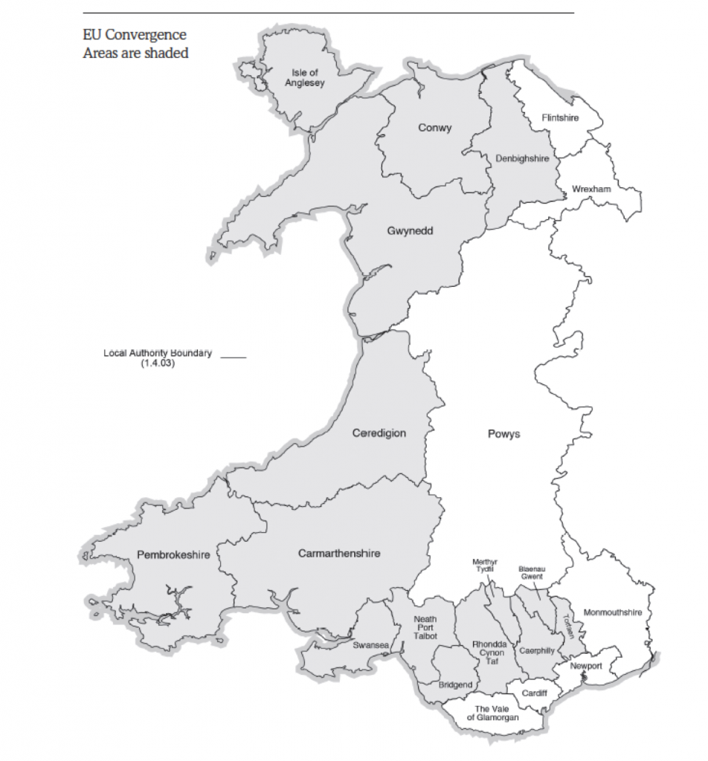
But there is a school of thought developing about a new rural paradigm which makes it important to re-value our rural areas and their resources. Equally, we need to examine the economic whirlpool which exists within the M25, sucking in resources, inflating accommodation costs to unaffordable levels, and we should question its logic.
On the IWA website there is a podcast interview with Professor Steve Gibbons (LSE Department of Geography and Environment) which seeks to tease out some of the key points which he made at the Portmeirion symposium. In the interview, Lee Waters asks Prof. Gibbons whether he thinks that Wales should focus its economic efforts on the cities, rather than “spreading wealth across the country ”. The question is clearly set in the context of seeking ways to close the productivity gap between Wales and the UK as a whole.
In reply, Steve Gibbons argues that “We don’t know how to stimulate economy and bring high-tech clusters to remote and peripheral areas, but we do know that the mechanisms for this exist in big cities.” He goes on to suggest that Welsh economic policy should concentrate on the “big cities of the south” and admits that there may be a cost to other areas as a result. Asked if cities are “engines of growth , he replies, “That is what I think the evidence and the theory (sic) points to.”
Perhaps we shouldn’t read too much into that; after all, it is a truism. For more than 300 years , in developing economies, there has been a general shift of population from the country to the town, accelerating urbanisation – and ultimately the rise of metro-cities.
We should take care, though, to avoid the mistake of simply advocating at the level of Wales what is happening to the UK economy as a whole, with certain sectors (finance in particular) in London and the SE expanding (unsustainably) at the expense of the rest of the UK and at the cost of affordability and liveability within the M25 itself as well. It seems that “the theory” which Steve Gibbons is referring to in his interview is none other than the theory of the free market. Surely, though, we should avoid in Wales an abnegation of responsibility for social planning, democratic governance and considerations of sustainability?
This debate ties in neatly with two current and burgeoning strands of thought in economic geography and planning:
- The concept of place-based city development – as outlined by keynote speaker, Prof. Robin Hambleton (Centre for Sustainable Planning and Environments, UWE) at the RTPI Cymru Spring Conference in Llandudno on 12 March. This challenges the short-termist, dividend-maximising social irresponsibility of rootless, multinational capital in favour of a long-term approach based on social “loyalty” to local communities and values. Welsh academics have spoken out loud and clear too. Dr Daniel Evans (WISERD) wrote on these pages 16 April: “Capital’s inherent mobility means that firms are never tied to one particular region. Once they have squeezed as much profit as possible out of a region, they have the ability to move to new regions at a moment’s notice.” On 27 May last year, Dr Calvin Jones (Cardiff Business School) argued: “The Economics of Place is the Economics of Empire, then and now…For example the ‘problem regions’ of 1930s Britain are largely the ‘problem regions’ of today – eighty years of economic history, a World War, fundamental industrial transformation and the death of an empire has done precisely nothing to rearrange the hierarchy of places in Britain…”
- Studies in the new rural paradigm (cf Prof Terry Marsden, Cardiff School of Planning and Geography and Ina Hörlings, Wageningen University). Their approach has been developed in practice and further clarified in the Rural Alliances project, in which they have both been active, along with academic partners at UWTSD’s School of Business and Marburg University’s Faculty of Geography, working with 10 rural partners in 6 countries across north-west Europe since 2011.
Looking back a bit, in March 2011 Steve Gibbons himself was co-author of a paper entitled The amenity value of English nature. In this paper, we read: “We analysed 1 million housing transactions over 1996-2008 and considered a large number of environmental characteristics. Results reveal that the effects of many of these environmental variables are highly statistically significant, and are quite large in economic magnitude…Increasing distance to natural amenities such as rivers, National parks and National Trust sites is unambiguously associated with a fall in house prices…Overall, we conclude that the house market in England reveals substantial amenity value attached to a number of habitats, designations, private gardens and local environmental amenities.”
This analysis aligns more comfortably with the approach argued by Prof. Terry Marsden, keynote speaker at the Rural Alliances Conference in Brecon 24-26 March, when he drew attention to the “New Rural Paradigm”, identified by the OECD in 2009, which points to the need for rural areas and rural resources to complement urban growth in a planned and sustainable way. Terry Marsden argued that there is a need for a new, multi-sector, place-based approach to rural development, with closer links between the rural and urban economy. He pointed out that rural areas are the source and origin of “distributed and distributive” systems and that rural eco-system services are dispersed, not centralised. For example, the Brecon Beacons National Park provides 90% of water services to Cardiff, and 78% to Swansea and the three National Parks in Wales provide £557 million GVA (1.2% Wales Economy) attracting 12 million visitors and providing 13,000 jobs across Wales.
As we face the challenges of carbon descent and the need for more localised production and distribution, we ignore the “rural areas” at our peril. Their needs and resources must be factored in to the debate about “gaps”. Let’s remember too that, in Wales, there is a big and important tract wedged in the no man’s land between “rural” and “big city”: the depressed, post-industrial peri-urban, small town and semi-rural areas of the South Wales Valleys, Ffestiniog and the North-East.
Tags: Andy Bevan, regional wealth, Rural economy, wealth, wealth gap
Andy Bevan is based at University of Wales Trinity St David, Lampeter, working on Rural Alliances, an EU Interreg IVB NWE project. He was author of the IWA Senedd Paper, A Real Citizen Service for Wales in 2014.
Published on: Monday, April 27th, 2015
Posted in: Economy, Featured Article.
Subscribe to RSS 2.0 feed.
You can leave a response, or trackback from your own site.

