
Research, build, and deploy a Virtualised Enterprise network
Network Operating Systems and Services


Leo richards
2418519

Contents
Research Report 2
Hypervisors 2
IP Addressing. 3
Routing 5
Network Services 6
Technical Documentation 7
Choice of hypervisor 7
Technical Documentation. 8
Downloaded the Type 2 hypervisor (VirtualBox) 9
downloaded the iso files from the official websites 10
Created all 4 machines with sufficient amounts of hard disk space and RAM. 11
S-DC adapters 11
ClientS1 adapters 12
LCD Adapters 12
Successful ping between servers 13

Research Report

Hypervisors
A hypervisor is a virtualisation layer that allows multiple operating systems to run concurrently on the same physical hardware [1]. There are two primary types of hypervisors: Type 1 and Type 2. A Type 1 hypervisor, also known as a bare-metal hypervisor, runs directly on the host hardware without an underlying operating system [2]. Examples include Microsoft Hyper-V Server and VMware ESX [2]. This architecture provides high performance, strong isolation between virtual machines, and improved security because the attack surface is reduced.
In contrast, a Type 2 hypervisor runs on top of a conventional host operating system such as Windows or Linux. Examples include Oracle VirtualBox and VMware Workstation. Although Type 2 hypervisors introduce slightly more overhead due to their dependence on a host operating system, they are significantly easier to install and manage, making them well-suited to testing and learning environments [3].
As this network is being implemented within an educational laboratory environment, a Type 2 hypervisor becomes the more practical and appropriate solution. In academic settings, infrastructure is typically deployed on standard desktop or laptop hardware rather than dedicated enterprise servers. A Type 2 hypervisor allows virtual machines to run on an existing host operating system, simplifying installation and configuration without requiring specialised hardware.
Additionally, Type 2 hypervisors provide flexibility for experimentation and learning. Virtual machines can be easily created, modified, or removed while testing services such as Active Directory, DNS, DHCP, and routing between subnets. Features such as snapshots and cloning allow systems to be restored quickly if configuration errors occur, enabling repeated testing without permanently affecting the host system.
Furthermore, hosted hypervisors support a wide range of operating systems, allowing Windows Server 2022 and Debian Linux to run simultaneously on the same machine. This compatibility is essential for implementing the required topology. Therefore, although Type 1 hypervisors are commonly used in enterprise data centres, Type 2 hypervisors are the most suitable choice for this educational network.

IP Addressing.

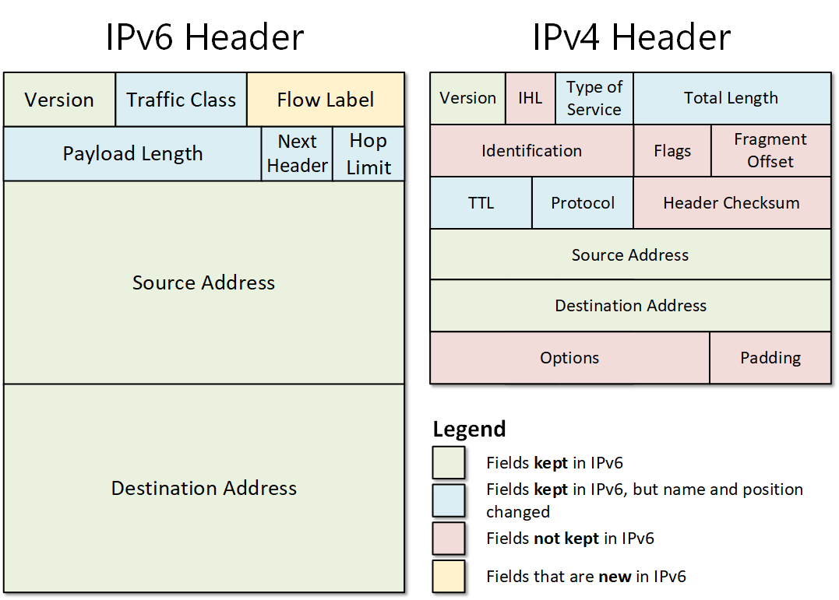

[6]

Data transmitted over the Internet employs packet switching, a method in which information is divided into smaller packets that travel independently across interconnected networks. Each packet carries both the source and destination IP addresses, enabling network devices to identify where the data originated and where it needs to be delivered. Upon reaching the destination device, the packets are reassembled to reconstruct the original data. Thus, IP addresses are crucial for ensuring accurate and reliable data transmission across the Internet. [7]

Routers and switches facilitate the efficient flow of data between networks. Switches operate within a local network, forwarding data using MAC addresses, while routers function at the network layer, utilising IP addresses to direct packets between different networks. By analysing routing tables, routers identify the most efficient paths, enabling communication between geographically distant locations, such as the Swansea and London sites in the NOSS2026 network. [8]

IP addressing plays a significant role in enhancing network functionality and efficiency. IPv4 employs 32-bit addresses formatted in dotted-decimal notation; however, its limited address space prompted the introduction of IPv6, which utilises 128-bit hexadecimal addresses, offering improved scalability, security, and routing efficiency. [6]
Subnetting further optimises IP address utilisation by segmenting networks into smaller parts. This practice reduces broadcast traffic, enhances performance, and bolsters security. In summary, IP addressing is fundamental to structured communication, efficient routing, and scalable network design in today's enterprise networks. [9]

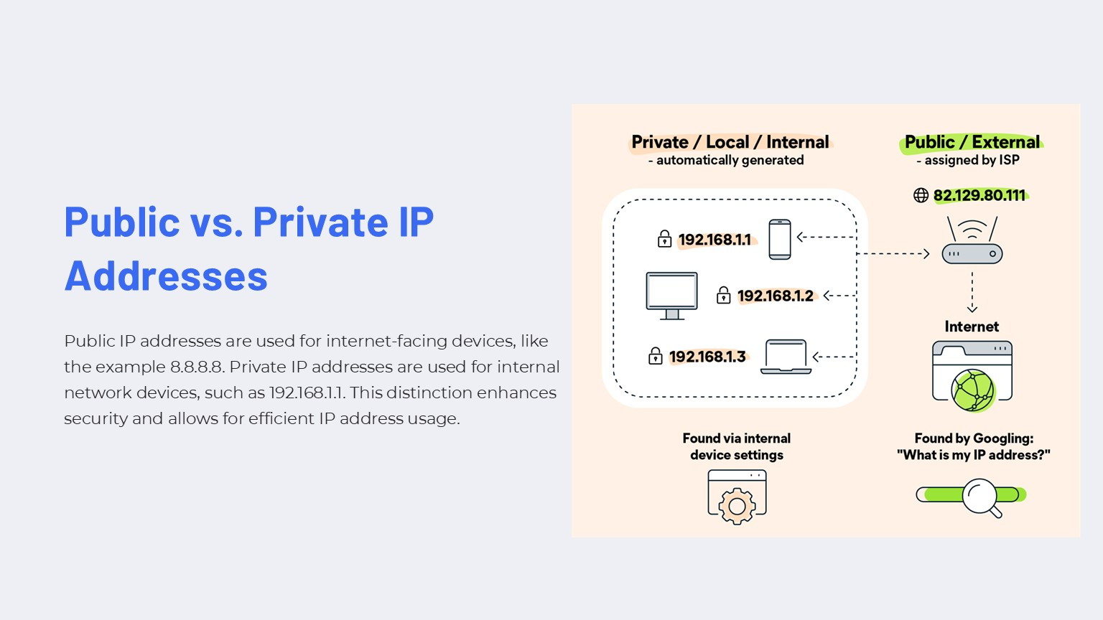 [10]

Routing
Routing is the process of selecting paths for data packets to travel between different networks. Routing protocols enable routers or routing-capable devices to exchange information about network destinations and determine the most efficient route for packet delivery. Each routing device maintains a routing table that is consulted when forwarding packets, ensuring data reaches its intended destination. [11]
Routing can be implemented using either static or dynamic methods. Static routing involves manually configuring routes on network devices. These routes do not change unless an administrator modifies them. Static routing is simple, predictable, and introduces minimal overhead, making it suitable for small or stable network environments. However, it does not automatically adapt to network changes or failures. In contrast, dynamic routing uses protocols such as RIP, OSPF, and EIGRP to automatically discover and update routes. Dynamic routing is more scalable and resilient but introduces additional complexity, bandwidth usage, and processing overhead. [11]
For the given topology, static routing is the most appropriate approach. The network consists of a limited number of clearly defined subnets, with the Debian server acting as a DHCP Relay between networks and the Windows Server providing core services such as DNS and Active Directory. Static routes ensure reliable and predictable connectivity between these subnets without the need for complex routing protocols. Additionally, static routing reduces attack surface and administrative overhead, aligning well with the security and simplicity requirements of a controlled domain environment. This approach supports stable communication between servers and clients while remaining easy to manage and troubleshoot.
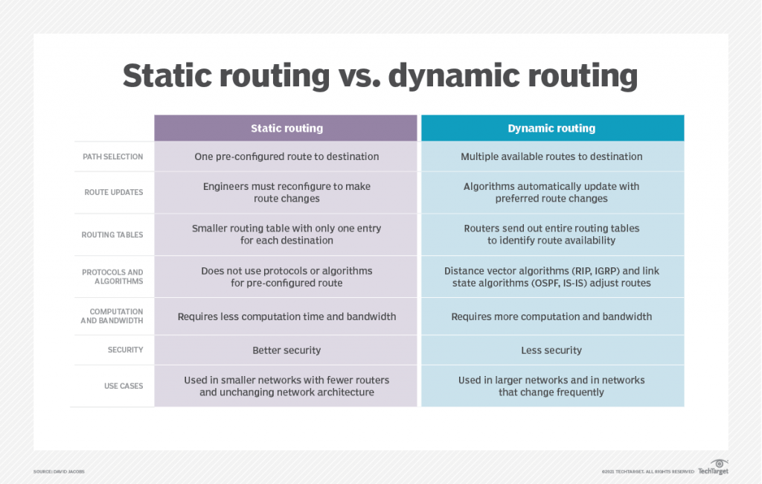

[12]

Network Services
Network services are essential for secure communication and centralised management. Recent academic and industry literature highlights that enterprise network services such as VPNs, DHCP, Active Directory Domain Services (AD DS), and Certificate Authorities (CAs) are most effective when securely governed rather than deployed. VPNs remain essential for extending organisational access across untrusted networks; however, research shows that misconfigured VPNs and weak authentication are frequent causes of data breaches. Best practice, therefore, prioritises strong encryption, modern tunnelling protocols, and multi-factor authentication to mitigate risks of credential theft and interception.
DHCP is widely recognised for improving scalability and reducing human error through automated IP address management. Nevertheless, its centralised nature introduces availability and security risks, such as rogue DHCP servers or incorrect option distribution. Literature recommends DHCP relay for segmented networks, combined with reservations for critical systems and Layer 2 protections to maintain integrity and reliability.
AD DS is consistently identified as a high-value attack target due to its central role in identity and access management. Studies stress that poor privilege separation and excessive administrative rights significantly increase the risk of domain compromise. Consequently, modern best practices emphasise least privilege, tiered administrative models, and hardened domain controllers to limit lateral movement (Microsoft, 2023).
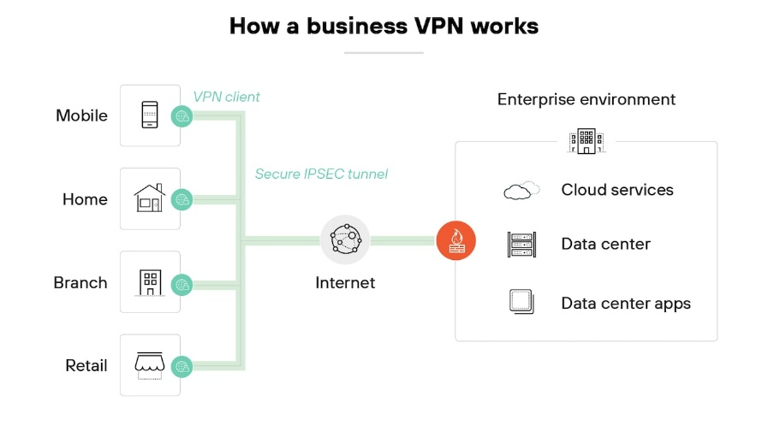
Finally, Certificate Authorities underpin trust across VPNs, authentication services, and encrypted communications. to minimise the impact should a compromise occur. Collectively, these services form the security backbone of enterprise networks when implemented with strong governance and continuous oversight.
[13]

Technical Documentation

Choice of hypervisor
Based on research into virtualisation, routing, and core network services, the decision to use a Type 2 (hosted) hypervisor for this network is both practical and appropriate for implementing the proposed topology. The network supports important services, including Active Directory Domain Services, DNS, DHCP, VPN connectivity, and a Certificate Authority, which can be effectively deployed using virtual machines within a hosted virtualisation environment. Research shows that Type 2 hypervisors are commonly used in development, testing, and educational environments because they provide flexibility, accessibility, and compatibility with standard desktop hardware while still supporting multiple operating systems simultaneously.
A Type 2 hypervisor runs on top of a host operating system, allowing virtual machines to share the host’s hardware resources. Although this architecture introduces slightly more overhead compared with Type 1 hypervisors, it significantly simplifies deployment and management. This is particularly beneficial in environments where dedicated enterprise hardware is not available. Within this topology, Windows Server 2022 and Debian Linux can run as separate virtual machines while maintaining logical separation of services such as domain management, DHCP relay, and client connectivity.
Industry guidance highlights that hosted hypervisors provide useful capabilities such as virtual networking, snapshot management, and rapid virtual machine deployment, which are valuable when configuring and testing network services. These features allow administrators to experiment with configurations and restore systems quickly if errors occur. Therefore, while Type 1 hypervisors are typically used in enterprise data centres for maximum performance and isolation, a Type 2 hypervisor is more suitable for this network implementation due to its ease of deployment, flexibility, and compatibility with an educational laboratory environment.

Downloaded the Type 2 hypervisor (VirtualBox)
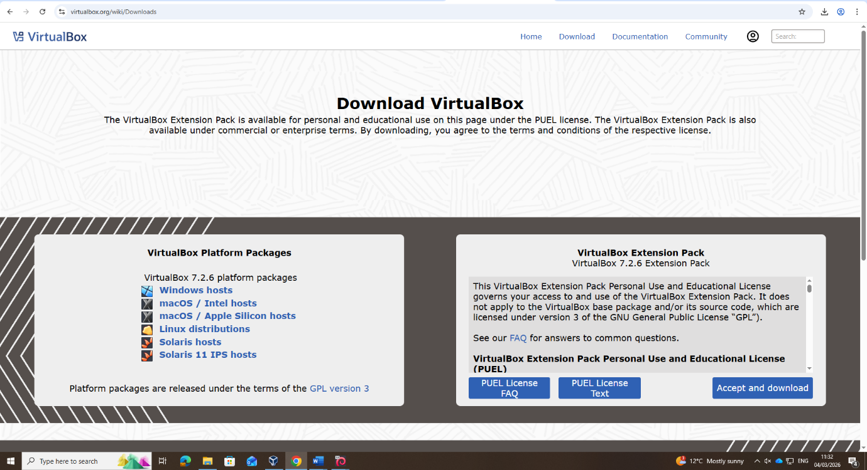

downloaded the iso files from the official websites
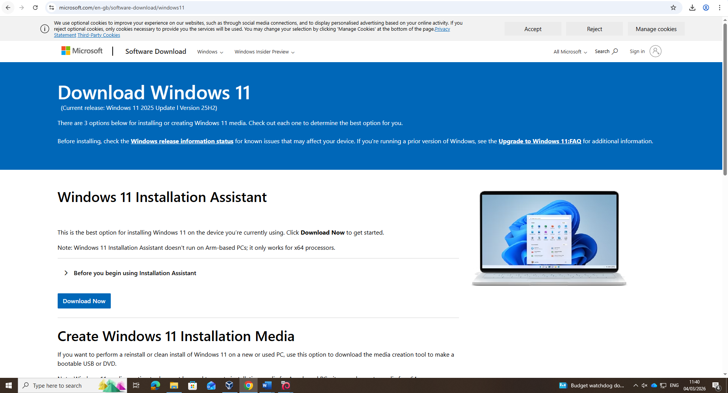

Created all 4 machines with enough hard disk space and RAM.
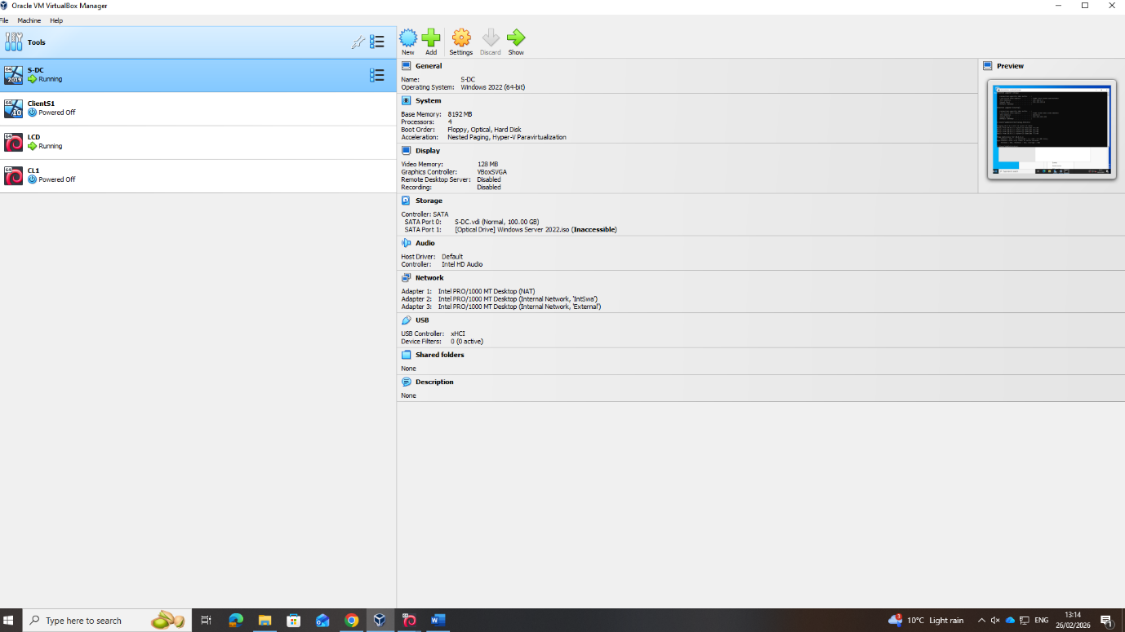

S-DC adapters
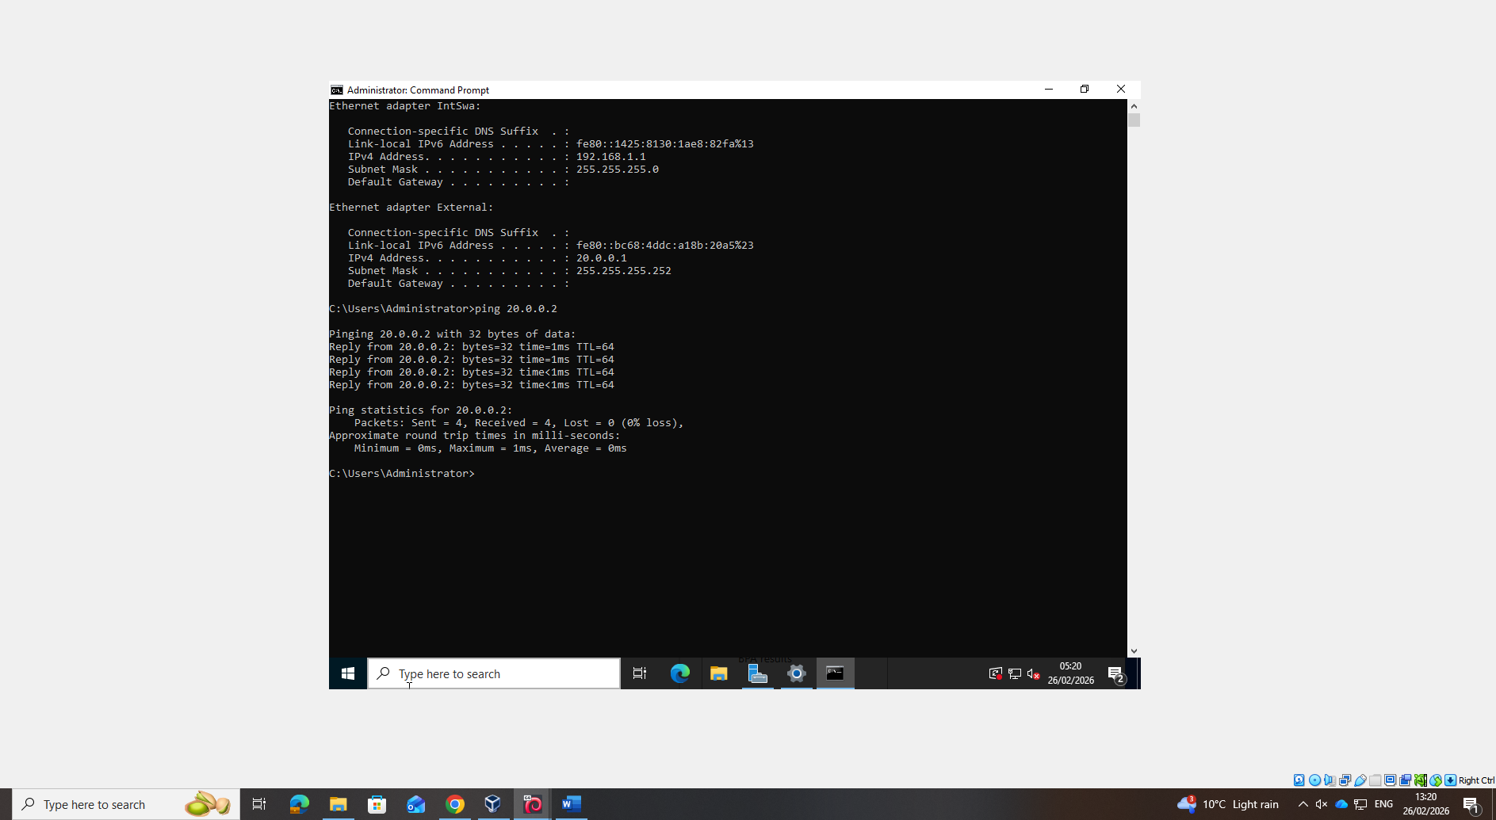

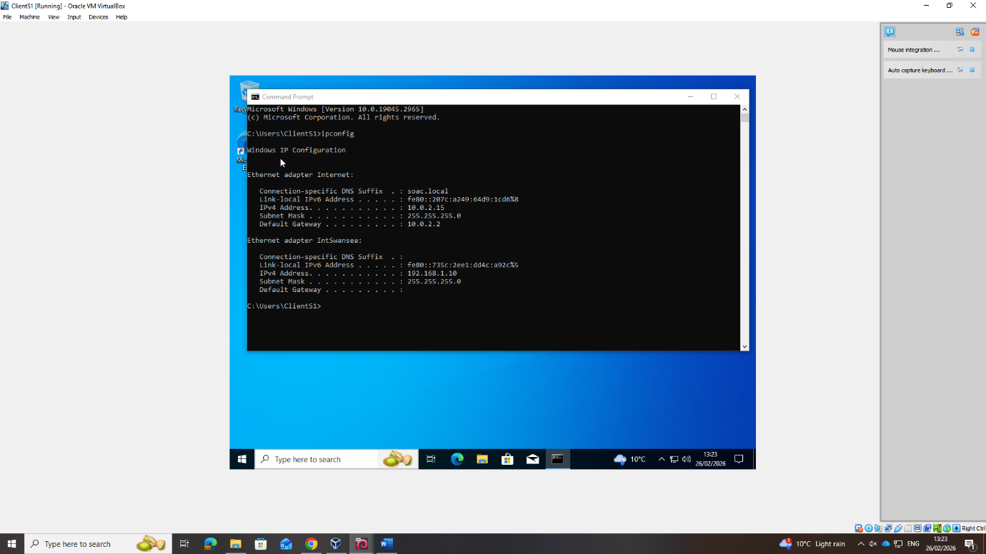
ClientS1 adapters

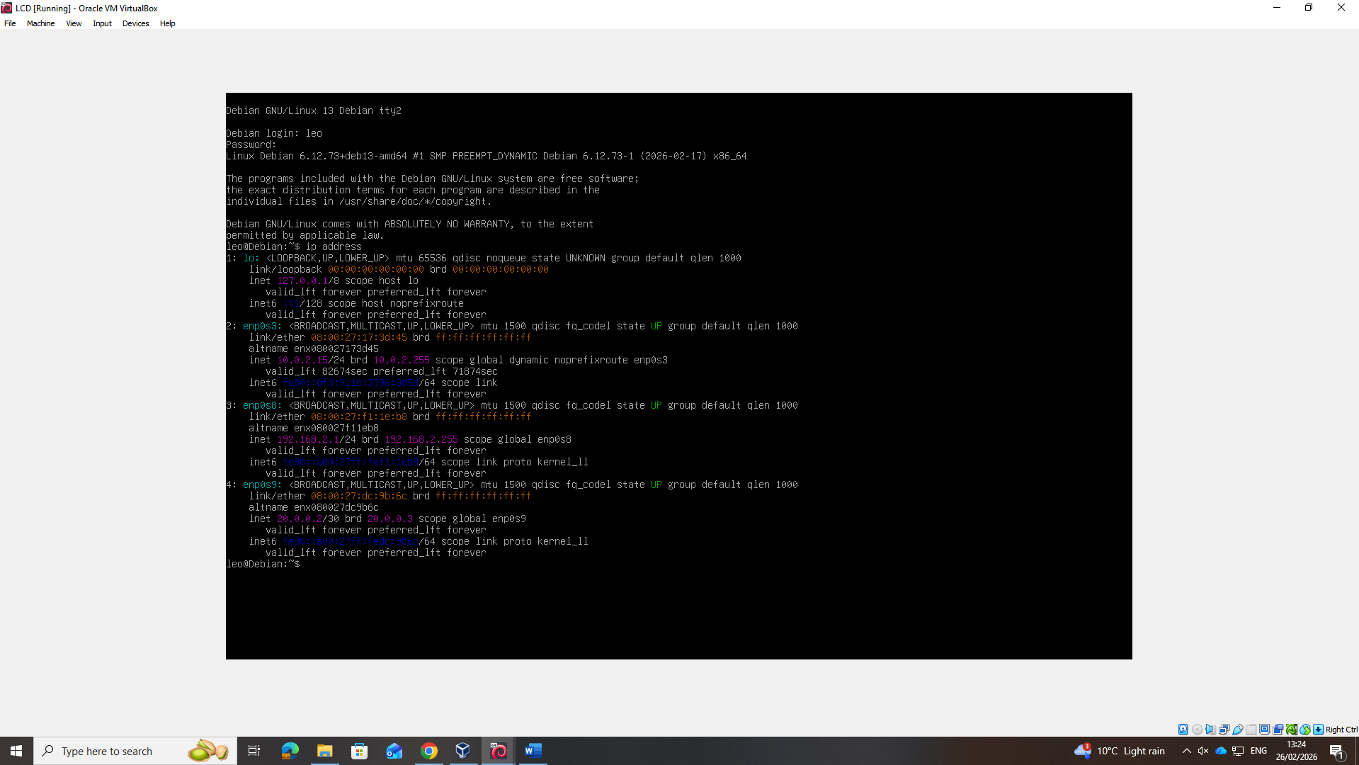
LCD Adapters

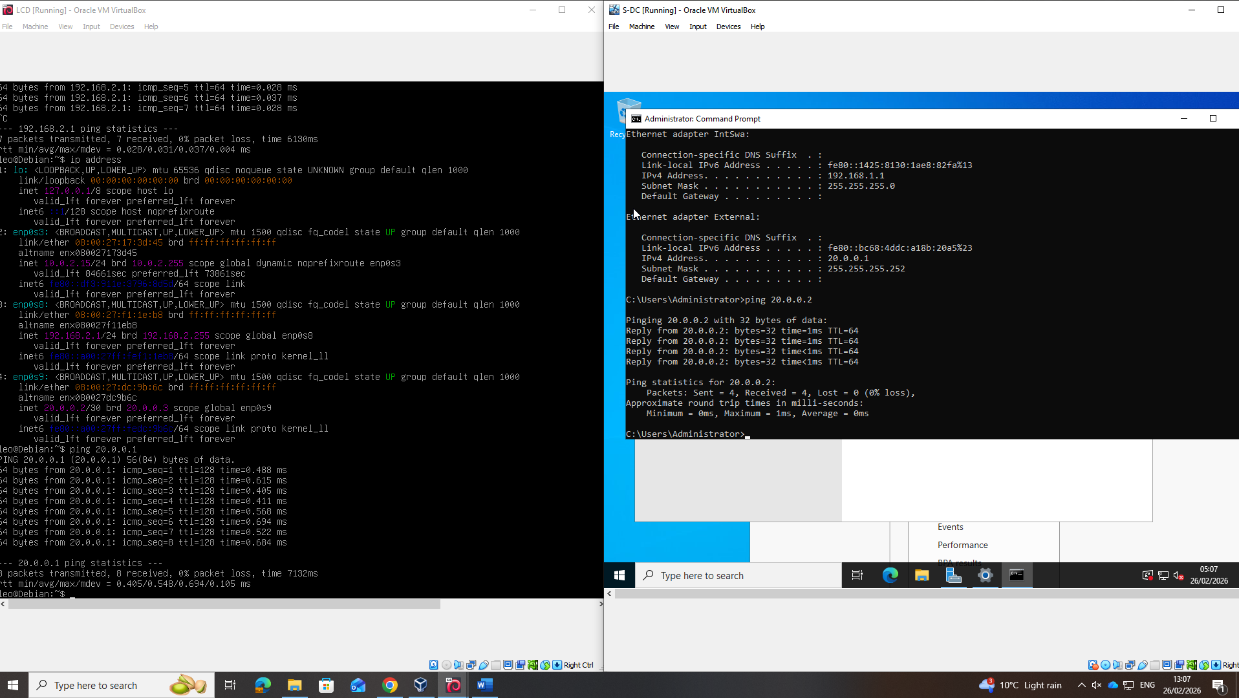
Successful ping between servers

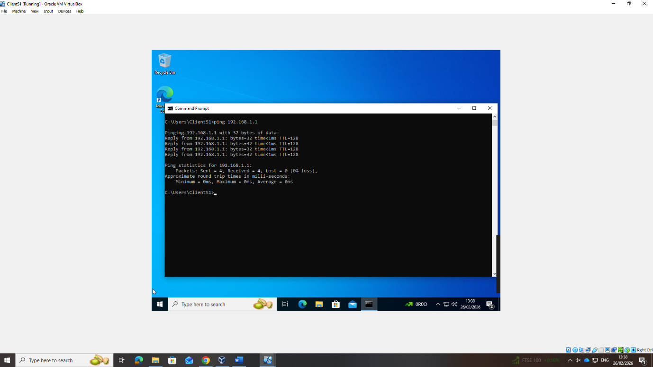
ClientS1 to S-DC successful ping.

Ping is unsuccessful when trying to ping across networks.
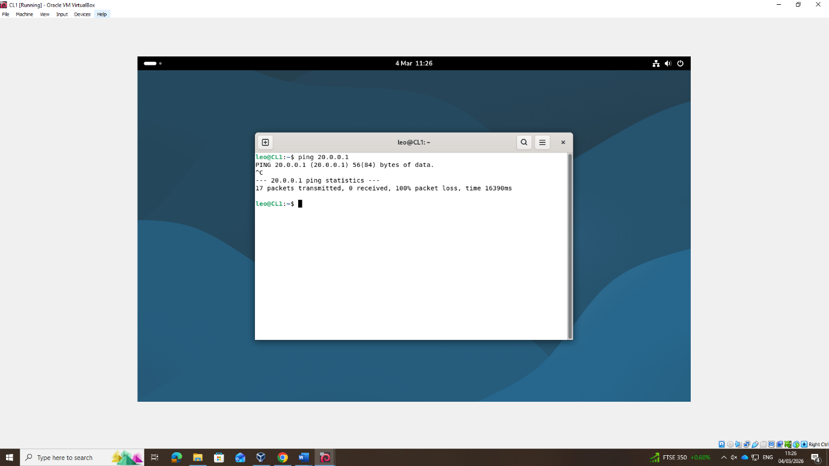

Personal Reflection
The deployment of the network topology for the NOSS2026 environment provided practical insight into the configuration and management of enterprise network services within a virtualised infrastructure. The network was implemented using a Type 2 hypervisor, allowing multiple virtual machines to run concurrently on a single host system. This approach enabled the deployment of Windows Server 2022 and Debian Linux systems while maintaining logical separation between services such as Active Directory Domain Services (AD DS), DNS, and DHCP.
During the deployment phase, careful attention was given to IP addressing and subnet configuration to ensure effective communication between network segments. The topology included separate subnets for the Swansea server network and the client network, connected through a point-to-point link between the Windows Server and the Debian server. The Debian server was configured as a DHCP relay agent, enabling client devices on a different subnet to obtain IP addresses from the Windows Server DHCP service. This configuration reinforced the importance of correct routing and relay configuration when implementing services across multiple network segments.
Testing was conducted to verify connectivity and service functionality across the network. Tools such as ping, ip addr, and ip route were used on the Linux systems to confirm correct IP assignment, routing tables, and network reachability. On the Windows systems, network configuration and service availability were validated using built-in diagnostic tools and DHCP lease verification. Successful communication between the Windows and Debian clients demonstrated that the DHCP relay and routing configuration were functioning correctly.
Overall, the deployment and testing process reinforced the importance of accurate configuration, structured IP addressing, and systematic troubleshooting when implementing network services in a virtualised environment.

Bibliography

[1] | N. Academy, “IPv4 vs IPv6 - Understanding the differences,” [Online]. Available: https://www.networkacademy.io/ccna/ipv6/ipv4-vs-ipv6.
[2] | M. K. T. R. P. R. S. a, The Comprehensive Review: Internet Protocol (IP) Address a Primer for Digital Connectivity, vol. 17, no. 7, pp. 178 - 189, 2024.
[3] | R. B. &. A. K. Godishala, “The Transport Layer, Network Services, Network Communication Devices,” Building a Secure Infrastructure, pp. 201-206, 2026.
[4] | C. Okoh, “Enhancing Data Security Through VLSM Subnetting and TCP/IP Model in an ENT,” Enhancing Data Security Through VLSM Subnetting and TCP/IP Model in an ENT, vol. 14, no. 23, 2024.
[5] | P. Browning, “Learn IP Addressing From Scratch,” 16 aug 2024. [Online]. Available: https://www.101labs.net/learn-ip-addressing-from-scratch/.
[6] | K. R. Deep Medhi, “Routing Protocols: Framework and Principles,” Network routing, no. 2, 2018.
[7] | Tekmart Data Center Team, “The differences between Static and dynamic routing.,” 20 July 2021. [Online]. Available: https://tekmart.co.za/t-blog/the-differences-between-static-and-dynamic-routing/.
[8] | Cyberpedia, “What Is a VPN? A Complete Guide to Virtual Private Networks,” [Online]. Available: https://www.paloaltonetworks.com/cyberpedia/what-is-a-vpn.
[9] | A. S. Thyagaturu, P. Shantharama, A. Nasrallah and M. Reisslein, “Operating Systems and Hypervisors for Network Functions: A Survey of Enabling Technologies and Research Studies,” Operating Systems and Hypervisors for Network Functions: A Survey of Enabling Technologies and Research Studies, vol. 10, 2022.
[10] | R. O. P. S. B. P. Ankita Desai, “International Journal of Innovative Technology and Exploring Engineering,” Hypervisor: A Survey on Concepts and, vol. 2, no. 3, p. 222, 2013.
[11] | I. J. N. K. a. V. T. Borislav Đorđević, “Comparison of type-2 hypervisor performance,” 2022.
[12] | C. Wulf, M. Willig and D. Göhringer, “A Survey on Hypervisor-based Virtualization of Embedded Reconfigurable Systems,” 2021.
[13] | P. L. M. L. Aidan Finn, Windows Server 2012 Hyper-V Installation and Configuration Guide, 2012.

