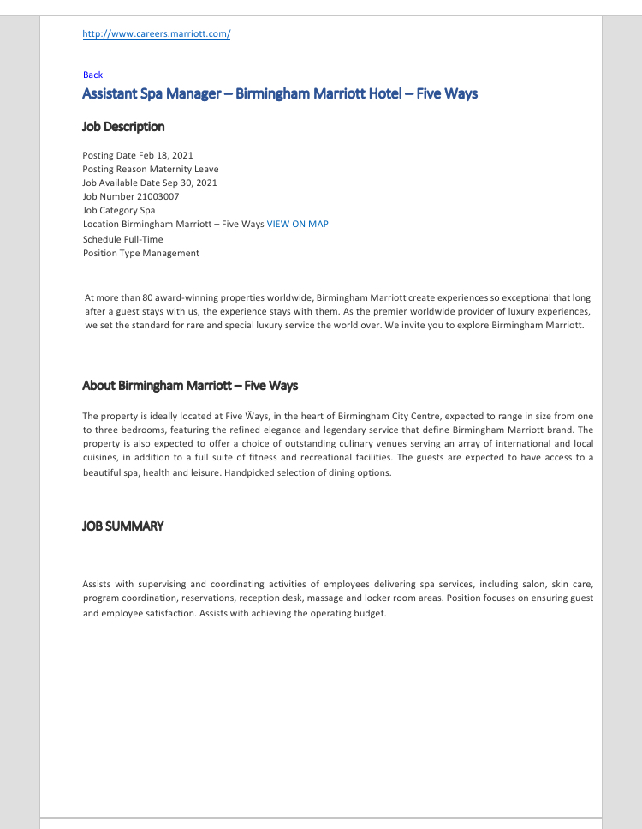
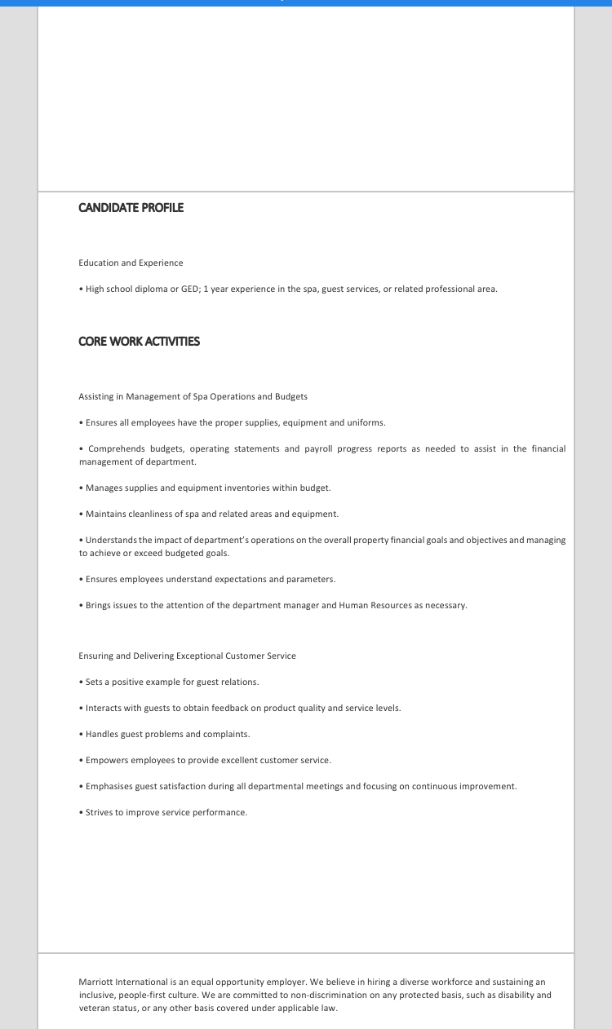

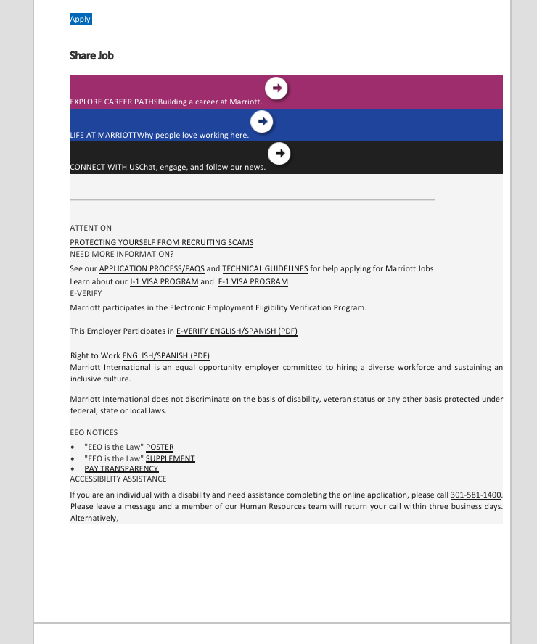

Kushna Begum
12B Cannon Hill Road
Birmingham B12 9NN

Hiring Manager: Abdi Rahman
Birmingham Marriott Hotel
12 Hagley Road
Five Ways
B16 8SJ

18 Feb 2021

Dear Hiring Manager,

I am writing this letter to express my interest in the Assistant Spa Manager Position opening at your Hotel.
I can offer you 2 years of experience and 1 year of education in managing communications within the Marriott brand, I have excellent project-management skills, and a great eye for detail, all of which should make me an ideal candidate for this opening.
I have attached my resume for your review. I would welcome the chance to discuss with you personally how my skills and strengths can best serve your Hotel.

Sincerely,

Kushna Begum

Phone: 07929344517
Email: 1813048@student.uwtsd.ac.uk



