L4 - Information Engineering (ACCB4013)
Student Number:1908634
Lecturer: Bev Holland
Date: 13/01/2020

Top Process
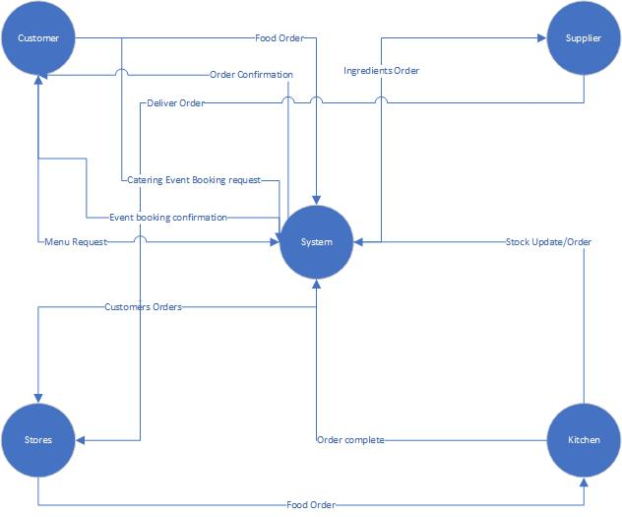
Here I have l shown how my system would process a customer order, booking an event and also update stock. This is also showing how it would place a new order from the supplier if the stock was getting low.

Level 1
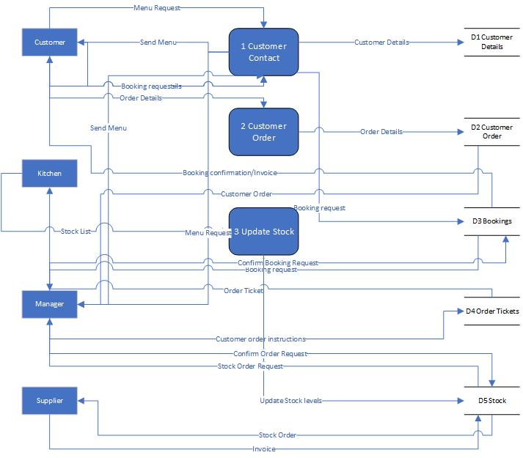
As you can see here I have outlined in more detail how each process would work and what data stores I would use to hold all of the information. This also shows how I would interact with each data store.

1.0
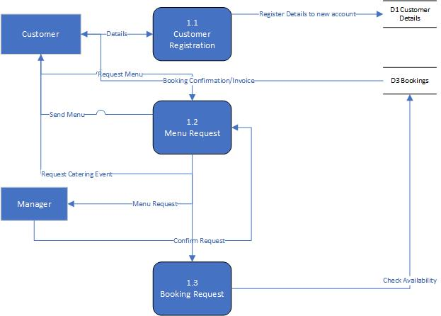
This goes into more detail on how a customer would interact with our system, this shows creating their initial account and then requesting a menu and booking an event
2.0
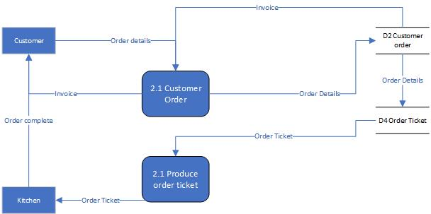
This goes into more detail on how a customer would order food with us, it also shows how the order would get to the kitchen after it has been placed and verified.
3.0
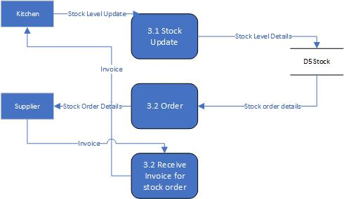
This diagram goes into more detail on how the system could be used to keep track of stock and order more stock.
ERD
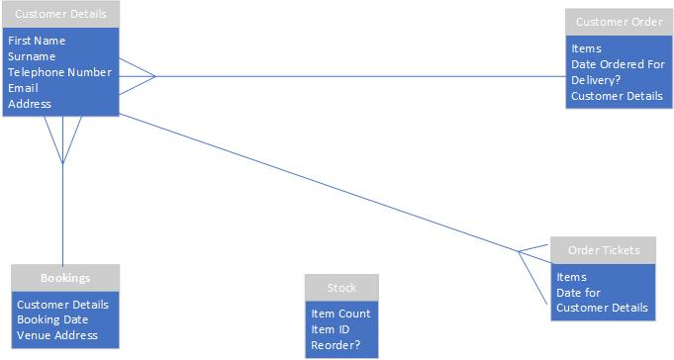
This shows how the data stores will link together and it also shows the type of relationship between each data store. I have not linked the stock data store as I believe that it would not connect to any of the shown data stores due to the fact that it would be used solely to update and order stock. This does not link to order tickets, customer order, bookings or customer details.

