Project Management
Project Management report
M5X00615

Student: David Price
Student number: P131188
Lecturer: Susan Maw
Table of Contents
Table of figures 3
Introduction 4
Risk management 4
Code of practice 7
Sustainability issues 7
Ethical and Legal issues 7
Issue 1 8
Issue 2 8
Issue 3 8
Quality Assurance issues 9
Objective 1 9
Objective 2 9
Objective 3 10
Objective 4 10
Conclusion 10
References 11
Bibliography 12

Table of figures
Figure 1 - A framework for software risk management.[4] 5
Figure 2 - Risk Matrix. 6

Introduction
This report will give an overview of the suggested improvements of a company called Dynamix, the suggested improvement will be a website that is a more modernized and user friendly. This report will look to identify all the possible risks and obstacles that this project may collide with over the duration of the design phase, implementation phase and the project closure phase, after identifying those risks this report will look at how to subsidize the management of those risks with multiple strategies to prevent any further obstacles and mishaps for future reference.
This report will include a detailed plan and managing of the project from start to project closure, with an inside look on what jobs were assigned amongst what members and how the plan was initially scheduled and how the plan was modified throughout the different phases of the project and if the deadline that was set in the initial project plan was successfully achieved with the updated project plan.

Risk management
Identifying risks early on in a project is vital to preventing the impact of the risks from happening, to categorize the seriousness of the risks they can be strategically laid out a matrix from most impactful to least. “Risk management processes concerned with threats and opportunities will do better, but will still tend to be focussed on uncertain events or circumstances. This does not facilitate consideration of aspects of variability that are driven by underlying ambiguity and lack of information.”[1]
Identifying risks can range from human errors to natural disasters/causes, so categorizing these and having procedures in place to deal with them can be quite the quandary. The risks can impact the future of a project as it might affect different aspects of the project depending on what the risk is. As this is a small project consisting of one member, the project shouldn’t necessarily stray off-course compared to a company with numerous amount of people working on a single project, so the risks identified in this report would not necessarily affect a project of a bigger magnitude. “Risk management reduces the risk of financial distress, it reduces the present value of the costs of financial distress and hence increases firm value.”[2]
Risk management is a way of categorizing risk into smaller divided risk assessments such as:
- Risk identification
- Risk analysis
- Risk planning
- Risk monitoring
“Objective of risk management is to reduce different risks related to a pre-selected domain to an acceptable. It may refer to numerous types of threats caused by environment, technology, humans, organizations and politics.”[3]

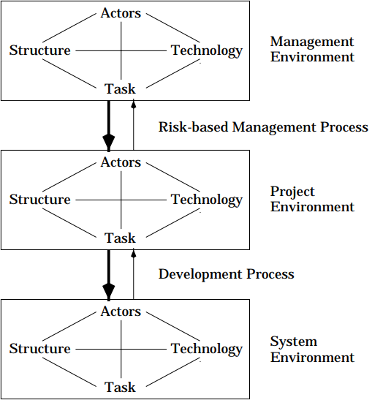 Figure 1 - A framework for software risk management.[4]
A strategy proposed to evaluate the seriousness of the risks identified is to mark them in a matrix grid as stated earlier where you can give an overview of what risks lie where on the scale of what is of high importance and seriousness.
The possible risks that have affected this project are:
R# - Risk number
- Scope may change due to certain factors
- Poor organization and timescale for the project, overdue deadline etc.
- Incomplete resources available to complete the project on time
- Technology may improve drastically by the time the project is due to release (Moore’s Law)
- Team members might get unwell and slow down the progress
- External environmental factors (Earthquakes, snowing etc)
- Leadership quality isn’t there, project strays off course.
- Poor implementation of the project so delayed and late changes may need to be made
- Mediocre design and overall plan causes delays
For every risk identified an equal management strategy should be provided, so for every risk identified in this project must have a viable strategy to manage the outcome and prevent high impact problems. “Alignment of project management and business strategy is an internal collaborative state where project activities continually support the achievement of enterprise strategic goals.”[5]
The strategies for the risks are as followed:
R1, R8, R9. A solution to this would be to back-long your work and start from scratch and use the information to make changes and start anew or if too late in the project there would be a rule that if something gets added to the scope then something must come out so you still have the exact number objectives within the scope.
R2, R3. Recognise the problems that caused the delay and mitigate the damages that it has caused, identify possible alternatives within your team and important actors.
R4. Acknowledge and monitor possible new innovations in the field of technology so the project will be compatible when the release date is scheduled, if your project isn’t compatible with new technology or isn’t up to date with new regulations needed to use the new technology then start again from a saved back-up to work forward from there to accommodate the new technology.
R5, R7. Offer rewards to zero absences, give some members an incentive to work on project. Monitor member performance and how they handle tasks.
R6. Monitor the weather for upcoming weeks so plans are set in advance to prevent unspent project costs and delays. Work comes to a halt, make work available from home to members.
When completing the matrix of the assessment of risks, it is important to zone a section of the grid to where risks falling within that shaded zone are needed to be treated as urgent actions needs to be taken. “Risk ranking is based on a matrix whose axes are the ranks of consequences and probability. The combination of ranks of consequence and likelihood creates risk rank.”[6].
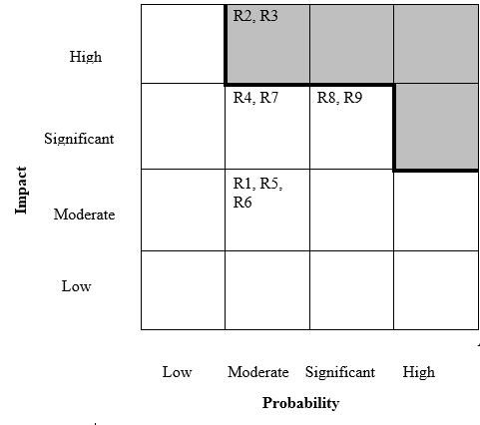Figure 2 - Risk Matrix.

Code of practice

Sustainability issues
Sustainability is “is development that meets the needs of the present without compromising the ability of future generations to meet their own needs.”[7]. Sustainability issues are usually talked amongst three factors or states, “Sustainability is usually discussed as a state or, better, a development in which three kinds of (conflicts of) interests are met (or resolved) simultaneously”[8].
The three orders are:
- Economic
- Social
- Environmental
A viable and sustainable business should try to meet the requirements of all these interests, by doing so will essentially help the planet in all different ways, emissions/waste etc.
There are three orders of sustainability, these orders have lasting effects on the earth and the society. The orders are ways to categorise what impacts need urgent actions, which are imminent and directly problematic due to the existence of big and small businesses, and governments. In this scenario, looking at three orders of impacts that this project might be wary of and what might be impacted.
- The first order is a direct outcome of IT’s existence (e.g. Emissions.)
- Second order is outcome from IT’s application to reduce other impacts (e.g. Improving transportation)
- Third order is the long-term sociable and structural changes (e.g. Energy and transportation potency)
First Order | Second Order | Third Order
Emissions | Improved work attendance | Transportation intensity
E-waste | Travel substitution | Energy intensity
The impacts listed in the second order have a much higher overall impact than those in the first order, in most IT projects nowadays there is always suggestions of improving the efficiency of using energy this play a huge part in the planning of an IT project. Identifying what options will give the project the least negative effect on the orders, trying to achieve and identify the impacts a project might have is key.

Ethical and Legal issues
The ethical and legal issues surrounding specifically IT and technology in general over the years have become a major talking point, it involves everyone without them knowing about it or not. As humans, we rely more on technology that ever before in day to day life, so with that comes very complex and daunting issues. “Technologies and business practices have dramatically changed, but the law has been slower to adapt. Computers, electronic networks, and information systems are now used to routinely process, store, and transmit digital data in most commercial fields”[9].
Security and privacy are usually the main concerns when talking amongst this topic, consumers want to be able to trust companies with their data if it ranges from buying clothing to purchasing a service from a company, you want to have trust that your data is safe between you and the business. “The information security professional plays an important role in an organization’s approach to managing liability for privacy and security risks.”[10]. Companies can avoid ethical and legal issues can be avoided by abiding the following code of conducts set out by regulators:
- BCS
- IEEE
- ICO (GDPR)
This is a very broad and complex topic but to relate this is Dynamix.coop, the following will look at possible scenarios where ethical could be an issue. Comparing BCS to IEEE on how they perceive possible scenarios:

Issue 1
Issue | BCS | IEEE
Discrimination in the workplace | BCS states to conduct your professional activities without discrimination.[11] | IEEE states to treat all persons fairly and not to engage in acts of discrimination based on race, gender etc.[12]

Issue 2
Issue | BCS | IEEE
Pressure to compromise | BCS states to reject any forward persuasion or inducement made in the workplace[11] | IEEE mentions to avoid real or perceived conflicts of interests and to undertake tasks if qualified or experienced with full disclosure of pertinent limitations[12]

Issue 3
Issue | BCS | IEEE
Unsafe working conditions | BCS mentions to have regard for public health and well-being of others. [11] | IEEE says to hold paramount the safety, welfare of the public, Comply with ethical design.[12]

As for legal issues in project management, “The GDPR applies to ‘personal data’ meaning any information relating to an identifiable person who can be directly or indirectly identified in particular by reference to an identifier.”[13]. A more complex tunnel of communications with potential business partners and more secured clientele data storage will be enough to comply with GDPR code of conduct, as this is a charity not a lot of personal information is stored. A secure place of storage and a strict attitude to follow GDPR guidelines is enough to maintain trust with the client and business, and with the regulators.

Quality Assurance issues
The process of providing a quality assurance can be achieved by a SMART analysis, this allows companies/businesses to pinpoint or setting goals and objectives. “Project objectives define what a project must achieve for it to be judged to be complete and successful and hence able to be closed.”[14]
These goals are as followed:
- Specific
  - What needs to be done?
  - Why should this be done?
  - Who are needed to complete this goal?
- Measurable
  - A measured or quantifiable process to accurately show to achieve goals
- Attainable
  - If the goal identified is achievable
- Relevant
  - Does this benefit the company in the long-term?
- Time-bound
  - A deadline or time-scale of the goal.
  - Is it worth it?
By following these criteria’s will allow a more accurate representation going forward for a company/business and what the future is going to be and look like. “SMART objectives also helps you to think about and identify elements of the evaluation plan and measurement, namely indicators and performance measures.”[15]. It gives a valid indication of what needs to be achieved, which is most important, and the time-scale needed to achieve these.

Objective 1
Specific: | Increase number of visitors on the website
Measurable: | Google analytics, check for:  - Bounce rate  - Exit rate  - Time spent on page  - Traffic sources  - Unique sessions
Attainable: | Highly achievable, optimise the website for better search engine results
Relevant: | It fits with the organizations objectives
Time-bound: | Optimising could take upwards of a month, but for visitor change would take a few months to monitor change over that period

Objective 2
Specific: | Co-operate and work with other businesses
Measurable: | Promote this charity, monitor visitors on website/in store/ phone calls. Branch out and achieve networking.
Attainable: | Contact multiple businesses to work alongside this charity
Relevant: | It fits with the organizations objectives
Time-bound: | Time-bound hard to accurately give a time-scale as it depends on other third parties and what happens in unforeseeable future.  Setting up and working with a company could take as little as 1-2 months, after that monitor activity on all social media profiles and headquarters activity.

Objective 3
Specific: | Improve customer satisfaction and availability
Measurable: | Monitor amount of calls, work on an online customer service live chat
Attainable: | Helps promote business and allows user to easily contact the company for enquiries.
Relevant: | It fits with the organizations objectives
Time-bound: | The building process of a live chat could take less than 1 month, the training of employees on using the live chat could take upwards of 1-2 months.

Objective 4
Specific: | Reduce maintenance costs of the website
Measurable: | Measuring the maintaining of this website can be measured in upkeep and costs of the website and the man-hours put into keep this website online.  Have updated technology and security applications
Attainable: | Helps speed up the user experience online and prevents any downtime.
Relevant: | It fits with the organizations objectives
Time-bound: | 1-3 months to purchase and install new technology.

Conclusion
This report has gone on to show what rules are needed to be followed when implementing an application that the public will eventually use, how to manage personal data and how to comply with the regulations set out by the governing bodies. This report delves into how all of this affects Dynamix, on how to maintain the safety of data whilst improving the overall experience they have when visiting your company online.

References
[1] R. Atkinson, L. Crawford, and S. Ward, “Fundamental uncertainties in projects and the scope of project management,” Int. J. Proj. Manag., vol. 24, no. 8, pp. 687–698, 2006.
[2] R. M. Stulz, “Rethinking Risk Management,” J. Appl. Corp. Financ., vol. 9, no. 3, pp. 8–25, 1996.
[3] H. Berg, “Risk management: procedures, methods and experiences,” Rt a, vol. 1, no. 17, pp. 79–95, 2010.
[4] K. Lyytinen, L. Mathiassen, and J. Ropponen, “A framework for software risk management,” J. Inf. Technol., vol. 11, no. 4, pp. 205–226, 1995.
[5] A. . Shenhar, D. Milosevic, D. Dvir, and D. Thamhain, Linking Project Management To Business Strategy. 2007.
[6] D. Ristic, “Characteristics of Risk Matrices,” Saf. Eng., vol. 3, no. 3, pp. 121–127, 2013.
[7] G. H. Brundtland, “Our Common Future: Report of the World Commission on Environment and Development,” United Nations Comm., vol. 4, no. 1, p. 300, 1987.
[8] C. Sartorius, “Second-order sustainability - conditions for the development of sustainable innovations in a dynamic environment,” Ecol. Econ., vol. 58, no. Nr.2, pp. 268–286, 2006.
[9] Princeton University, “Legal Issues and Information Security.”
[10] E. Warren, “Legal, Ethical, and Professional Issues in Information Security,” Jo-Mo.Com, pp. 89–116, 1962.
[11] et all Rogério dos Santos Alves; Alex Soares de Souza, “Code of Conduct for Bcs,” Igarss 2014, no. 1, pp. 1–5, 2014.
[12] I. Code et al., “IEEE code of ethics. IEEE, 2006,” no. February 2006, p. 2006.
[13] ICO, “Guide to the General Data Protection Regulation (GDPR),” 2017.
[14] Department for Business Innovation and Skills, “Guidelines for Managing Projects - How to organise plan and control projects,” Management, no. November, pp. 1–45, 2010.
[15] G. Doran, “SMART objectives summary,” Manage. Rev., vol. 70, no. 11, pp. 35–36, 1981.

Bibliography
https://www.theirm.org/media/886059/ARMS_2002_IRM.pdf
http://www.cimaglobal.com/Documents/ImportedDocuments/cid_tg_intro_to_managing_rist.apr07.pdf
http://www.hse.gov.uk/pubns/indg163.pdf
http://www.who.int/management/general/risk/managementofrisk.pdf
https://assets.publishing.service.gov.uk/government/uploads/system/uploads/attachment_data/file/550692/Tool_4.pdf
http://www.mtpinnacle.com/pdfs/RiskMatrix.pdf
https://www.ideals.illinois.edu/bitstream/handle/2142/8356/librarytrendsv49i3_opt.pdf?sequence=3
http://thesai.org/Downloads/Volume8No10/Paper_19-The_Ethical_and_Social_Issues_of_Information_Technology.pdf
https://arxiv.org/ftp/arxiv/papers/1507/1507.08447.pdf

