University of Wales Trinity Saint David

Ordnance, Munitions and Explosives



Advanced Chemistry of OME - ACDA6020

Laboratory Report
Preparation of Methy-3-Nitrobenzoate and Nitroguanidine

Natalie Coplin - 2113351

Date – 12/2025

Lecturer: Ewa Kazimierska

Contents
List of Figures 3
List of Tables 3
List of Equations 3
1. Introduction 4
1.1. Hypothesis 4
1.2. Key Variables 4
1.3. Mechanisms – electrophilic aromatic substitution (EAS) 4
1.4. Mechanisms – N-nitration 4
1.5. Reagent roles and reaction conditions 5
1.6. Balanced Equations 5
1.7. Importance of nitration in Energetics 5
2. Results 6
2.1. Methyl-3-nitrobenzoate 6
2.2. Nitroguanidine 6
3. Discussion 8
4. Conclusion 10
5. References 11

List of Figures
Figure 1 Simplified EAS mechanism [6] 4

List of Tables
Table 1 Methyl benzoate nitration results 6
Table 2 Guanidine nitrate nitration results 7
Table 3 Potential sources of experimental error 9

List of Equations
Equation 1 Balanced equation for methyl benzoate reaction 5
Equation 2 Balanced equation for guanidine nitrate reaction 5
Equation 3 Theoretical yield from reaction 6
Equation 4 Percentage yield of methyl-3-benzoate 6
Equation 5 Percentage yield of nitroguanidine 7

Introduction
The purpose of this experiment is to synthesise methyl-3-nitrobenzoate from methyl benzoate via electrophilic aromatic substitution and nitroguanidine from guanidine nitrate via n-nitration.

Hypothesis
In both experiments, crystalline solids are expected to form. Methyl benzoate when nitrated with nitric acid in concentrated sulphuric acid will form methyl-3-nitrobenzoate with white-to-pale yellow crystals when nitrated. Nitration of guanidine nitrate with sulphuric acid is expected to produce nitroguanidine, forming fine white crystalline needles [1] [2]. Under well-controlled conditions, yields are expected to be near theoretical values.

Key Variables
For this experiment the variables are:
Independent – not applicable.
Dependent – yield, physical characteristics, purity of products.
Control – reaction temperature, concentration and volume of reactants.

Mechanisms – electrophilic aromatic substitution (EAS)
Nitration of aromatic compounds, such as methyl benzoate, is an example of EAS. Concentrated sulphuric acid protonates nitric acid, producing a nitronium ion and water (NO₂⁺ - the electrophile). The aromatic ring donates an electron pair to the nitronium ion, forming an σ bond with a carbon on the aromatic ring. This temporarily disrupts ring aromaticity, generating a sigma complex. Aromaticity is restored when the hydrogen is subsequently removed, and the nitro aromatic compound is produced. [3] [4] [5].
A simplified EAS reaction is shown in Figure 1, where H represents the proton/hydrogen and E represents the NO₂ group.
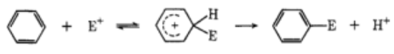
Figure 1 Simplified EAS mechanism [6]

Mechanisms – N-nitration
N-nitration is a similar process to EAS but rather than substituting a hydrogen molecule onto an aromatic ring, a nitro group attaches directly to a nitrogen on the guanidine nitrate molecule. A strong acid, such as sulphuric acid is required to protonate the nitric acid on the guanidine nitrate, this produces a nitronium ion, which subsequently attacks a nitrogen atom and replaces a hydrogen, forming an N-NO₂ bond. [7]

Reagent roles and reaction conditions
Nitric acid – nitrating agent (in the presence of sulphuric acid).
Sulphuric acid – catalyst and protonating agent.
Ethanol – solvent for the recrystallisation of methyl-3-nitrobenzoate.
Methyl benzoate – aromatic substrate.
Guanidine nitrate – substrate.
Nitration reactions are exothermic, generating significant heat until equilibrium is reached. Elevated temperatures increase the likelihood of multiple substitutions. Maintaining a reaction temperature, below 10°C, minimises unwanted byproducts [8] and improves safety by reducing the risk of thermal runaway and explosions [9].

Balanced Equations
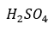
Methyl benzoate reaction:

Equation 1 Balanced equation for methyl benzoate reaction
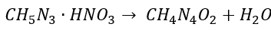
Guanidine nitrate reaction:

Equation 2 Balanced equation for guanidine nitrate reaction

Importance of nitration in Energetics
Nitration methods are fundamental synthesis routes for producing energetic materials. Introducing nitro groups into compounds produces valuable energy dense material [10] [11]. Many explosives including RDX, HMX, nitroglycerine, and nitrocellulose are all produced by nitration [12] [13]. As nitro groups contain oxygen, their addition improves the oxygen balance of the material, allowing for a more complete combustion [14].

Results

Methyl-3-nitrobenzoate
The results from the nitration of methyl benzoate are shown in Table 1. Calculations shown for clarity.
Table 1 Methyl benzoate nitration results
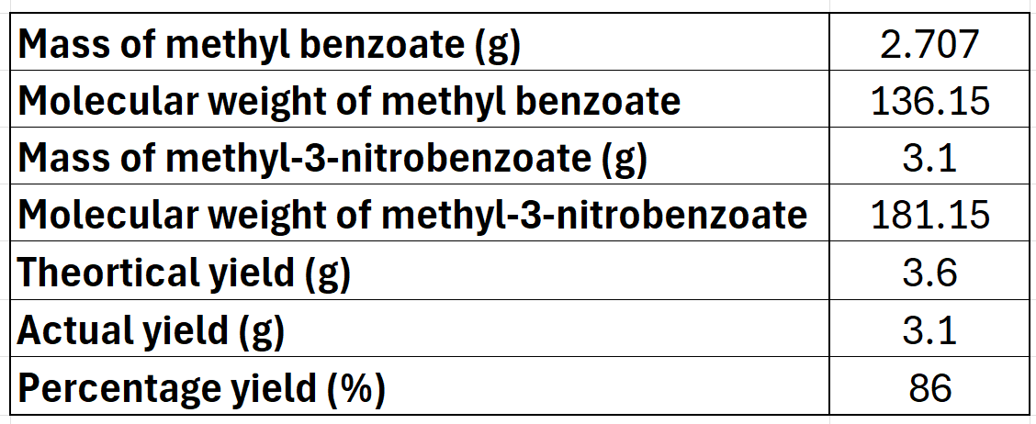
The theoretical yield for the methyl benzoate reaction was calculated as shown in Equation 3.
$$theoretical yield=mass of methyl benzoate× \frac{Mr (methyl 3 nitrobenzoate)}{Mr (methyl benzoate)}$$
Equation 3 Theoretical yield from reaction
Where:
Mr = molecular weight
$$theoretical yield=2.707× \frac{181.15}{136.15}=3.60g$$
Calculate the percentage yield using Equation 4:
$$Percentage yield=\frac{actual yield}{theortical yield} ×100$$
Equation 4 Percentage yield of methyl-3-benzoate
$$Percentage yield=\frac{3.1}{3.6} ×100$$
$$Percentage yield= 86\%$$

Nitroguanidine
The results from the nitration of guanidine nitrate are shown in Table 2 with calculations below.

Table 2 Guanidine nitrate nitration results
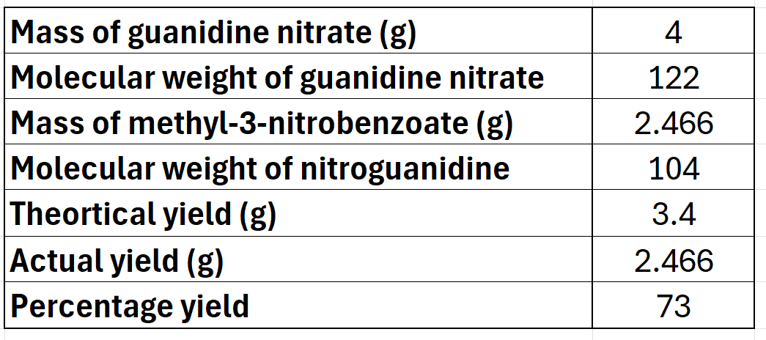
Calculate the percentage yield using Equation 3.
$$Percentage yield= \frac{mass of NQ}{mass of guanidine nitrate}×\frac{Mr guanidine nitrate}{Mr nitroguanidine}×100$$
Equation 5 Percentage yield of nitroguanidine
$$Percentage yield= \frac{2.466}{4}×\frac{122}{104}×100$$
$$Percentage yield= 72\%$$

Discussion
The hypothesis predicted that actual yields would approach theoretical values under ideal conditions. Results showed differences of 13.9% for methyl-3-nitrobenzoate and 28% for nitroguanidine. The differences are not unexpected as ideal conditions could not be perfectly replicated. The methyl-3-nitrobenzoate difference suggests better control, however, both yields could be improved.
Yield and purity may be improved by slower mixing, better temperature control in both reactions and thorough washing of the sample to remove residual acids and prevent further reactions. All labware must be clean and dry to limit contamination, including from water, which may influence nitronium formation and regioselectivity [15]. During recrystallisation using the minimum solvent necessary avoids over-diluting the product, easily increasing yield. Ensuring complete transfer of material between containers provides maximum product recovery – maintaining a good yield.
The performance of nitroguanidine is greatly influenced by its purity. For example, the sensitivity of the explosive may be affected by changes in its crystal structure. Irregular shapes are more prone to hot spot formation and may initiate more readily. However, studies have shown that changing the morphology of nitroguanidine crystals can improve its mechanical and physical performance, and thermal stability, so there is a balance to be struck [16] [17] [18]. The melting point may be lower with the inclusion of impurities, therefore ensuring a high purity of nitroguanidine provides predictable behaviour and allows for safe handling.
Grinding of nitroguanidine prior to its use can help improve performance through uniform crystal sizes and smaller particle sizes, lowering its sensitivity to impact [19]. Packing density and burn rate will change depending upon the size of crystals – fine compact particles burn more consistently. When dispersed within mixtures such as in propellant compositions, fine particles will produce a more homogeneous blend with known properties, increasing its safety.
Both experiments were subject to sources of error; these are discussed in Table 3.
Table 3 Potential sources of experimental error
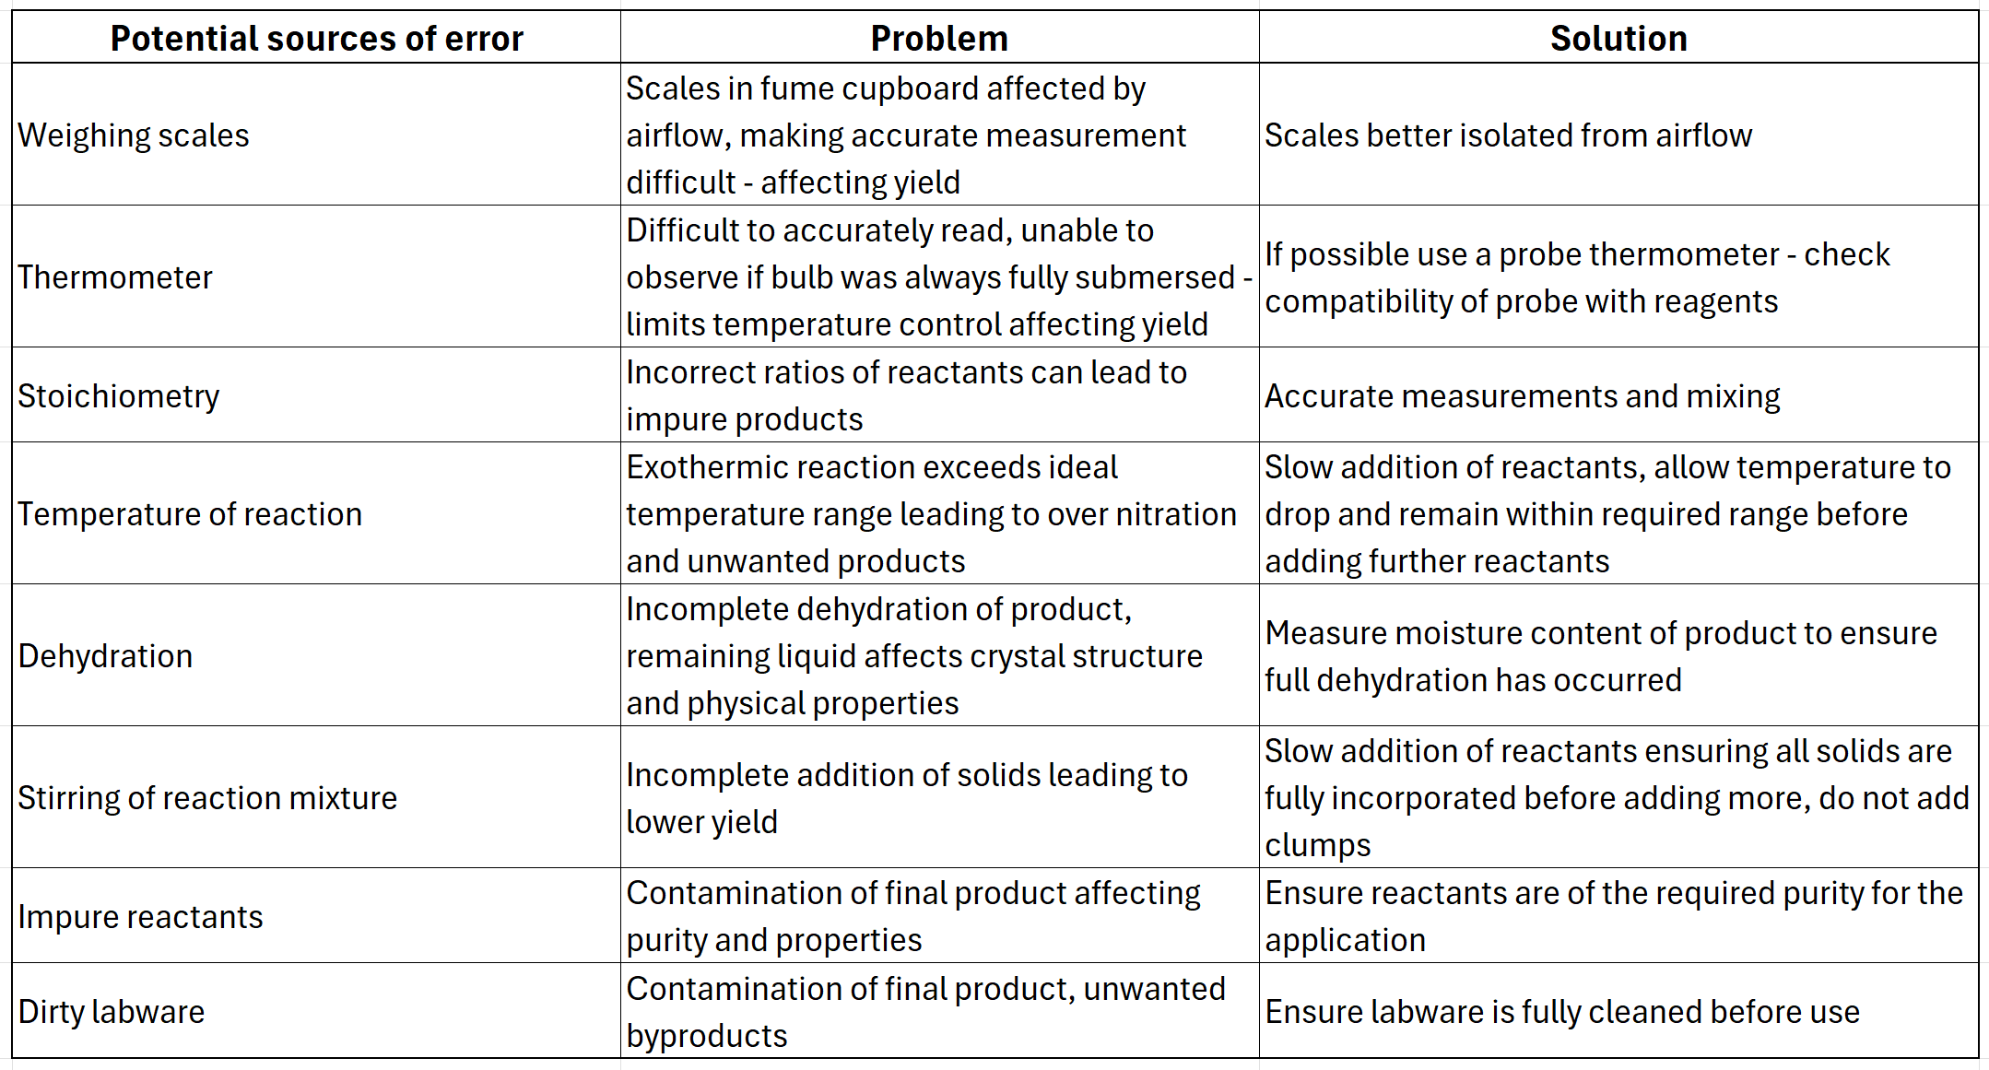

Conclusion
Electrophilic aromatic substitution and N-nitration reactions were successfully performed, producing methyl-3-nitrobenzoate and guanidine nitrate respectively. Manual processes and limited control over laboratory conditions likely influenced the yield and purity of products, yet the obtained yields of 86% and 72% are encouraging for first attempts at this process.
Further work includes refining laboratory techniques and improved control of the reaction temperature. Explore methods for automation to increase both purity and yield. Proper confirmation of the products and variants would be advantageous. This could be performed using techniques such as Fourier Transform Infrared Spectroscopy or Nuclear Magnetic Resonance [20] [21]. The purity could be analysed using High Performance Liquid Chromatograph or by observing the melting point. Pure products have a narrow band with a sharp melting point – however, this only provides a tentative indication of purity [22] [23].

References

[1] | PubChem, “Nitroguanidine,” National Center for Biotechnology Information, 2025. [Online]. [Accessed 04 December 2025].
[2] | Thermo Fisher Scientific, “Methyl 3-nitrobenzoate,” Thermo Fisher Scientific, [Online]. Available: https://www.thermofisher.com/order/catalog/product/A15155.18. [Accessed 09 December 2025].
[3] | N. Stamenković, N. P. Ulrih and J. Cerkovnik, “An analysis of electrophilic aromatic substitution: a “complex approach”,” Royal Society of Chemistry, vol. 23, pp. 5051-5068, 2021.
[4] | M. Mąkosza, “Electrophilic and Nucleophilic Aromatic Substitutions are Mechanistically Similar with Opposite Polarity,” Chemistry – A European Journal, vol. 26, no. 67, pp. 15346-15353, 2020.
[5] | C. T. Wigal, “Nitrating Acetanilide or Methyl Benzoate: Electrophilic Aromatic Substitution,” H.A.nEIDIG, Lebanon, 1998.
[6] | A. G. Olah, “Mechanism of electrophilic aromatic substitutions,” American Chemical Society, vol. 4, pp. 240-248, 1971.
[7] | J.-P. Zhao, L. J. Ding, P. C. Wang, Y. Lui, M. J. Huang, X. L. Zhou and M. Lu, “Electrochemical Nonacidic N-Nitrosation/N-Nitration of Secondary Amines through a Biradical Coupling Reaction,” Advanced Synthesis and Catalysis, vol. 362, no. 22, pp. 5036-5043, 2020.
[8] | H. Bahua, D. Sudarsono, M. I. Fakhruddin, S. M. Suharno, B. Srijanto, B. Marwoto, P. Yunianto and E. Rismana, “Effect of initial temperature of reactant and mixed acid composition in adiabatic production of nitrobenzene,” The 8th International Symposium on Applied Chemistry, vol. 2902, no. 1, 2023.
[9] | H. Chen, L. Chen, W. Wu, Z. Guo, X. Zhao and W. Chen, “Adiabatic kinetics calculations considering pressure data,” Process Safety and Environmental Protection, vol. 158, pp. 374-381, 2022.
[10] | Y. Qian, M. Chen, J.-H. Zhan, J. Zhao, G. Zhang, F. Sun, B. Sun and W. Xu, “Thermal runaway mechanisms and kinetics of benzene nitrification system based on microcalorimetry experiments and ReaxFF molecular dynamics simulation,” Thermochimica Acta, vol. 725, 2023.
[11] | S. S. Patel, D. B. Patel and H. Patel, “Synthetic Protocols for Aromatic Nitration: A Review,” Chemistry Select, vol. 6, no. 6, pp. 1337-1356, 2021.
[12] | W.-B. Yi and C. Cai, “Synthesis of RDX by nitrolysis of hexamethylenetetramine in fluorous media,” Journal of Hazardous Materials, vol. 150, no. 3, pp. 839-842, 2008.
[13] | J. Akhavan, “Manufacture of Explosives,” in The Chemistry of Explosives, The Royal Society of Chemistry, 2022, pp. 133-165.
[14] | J. C. Oxley, “Chapter 8 - The Thermal Stability of Explosives,” in Handbook of Thermal Analysis and Calorimetry, Elsevier B.V., 2003, pp. 349-369.
[15] | K. M. Plasse, T. R. Mooney, M. Mastyugin, C. Maximilian and B. Torok, “Chemo-and regioselective aqueous phase, co-acid free nitration of aromatics using traditional and nontraditional activation methods,” Frontiers in Chemistry, vol. 12, 2024.
[16] | Z. Luo, Y. Cui, W. Dong, Q. Xu, G. Zou, C. Kang, B. Hou, S. Chen and J. Gong, “Morphological diversity of nitroguanidine crystals with enhanced mechanical performance and thermodynamic stability,” Journal of Crystal Growth, vol. 480, no. 15, pp. 132-140, 2017.
[17] | J. Zhang, “Study on recrystallization process of nitroguanidine by directly adding cold water to control temperature,” Open Chemistry, vol. 22, no. 1, 2024.
[18] | D. Liang, W. Zhang, X. Wei, S. Wang, B. Wang and Z. Wang, “Preparation and characterization of ultrafine nitroguanidine with different aspect ratios,” American Chemical Society, vol. 9, no. 1, 2023.
[19] | J. S. Li, S. W. Wu and K. T. Lu, “Study on Preparation of Insensitive and Spherical High Bulk Density Nitroguanidine with Controllable Particle Size,” Propellants Explosives Pyrotechnics, vol. 41, no. 2, 2015.
[20] | B. Z. Rameev and B. Aktas, “NMR & MW techniques for detection of explosive and illicit materials,” in 9th International Kharkiv Symposium on Physics and Engineering of Microwaves, Millimeter and Submillimeter Waves, Kharkiv, Ukraine, 2016.
[21] | J. R. Castro-Suarez, L. C. Pacheco-Londoño, M. Vélez-Reyes, M. Diem, T. J. Tague and S. P. Hernandez-Rivera, “Open-Path FTIR Detection of Explosives on Metallic Surfaces,” in Fourier Transforms - New Analytical Approaches and FTIR Strategies, Intech, 2011.
[22] | J. A. Mathis and B. R. McCord, “The analysis of high explosives by liquid chromatography/electrospray ionization mass spectrometry: multiplexed detection of negative ion adducts,” Rapid Communications in Mass Spectrometry, vol. 19, no. 2, pp. 99-104, 2004.
[23] | J. P. McCullough and G. Waddington, “Melting-point purity determinations: Limitations as evidenced by calorimetric studies in the melting region,” Analytica Chimica Acta, vol. 17, pp. 80-96, 1957.

