
Master of Business Administration
Module Title: International Business Concepts
Module Code: LCMB7034
Student Name: Shravan Nalumasu
Student ID Number:2432622
Lecturer: Jean Wang
Word Count: 5096
Submission Date: 27th April 2026

Title: A Critical Analysis of the UK Pharmaceutical Industry:
Institutional Competitiveness and Political Strategy

Table of Contents
1. Introduction 4
2. Industry Overview of the UK Pharmaceutical Industry. 4
2.1 Introduction of Pharmaceutical industry within the context of UK 4
2.2 The Size, Scope, and Economic Importance of the Industry. 5
2.3 The Major Domestic, Multinational Firms Operating and their Relative Positioning 6
3. Porter’s Diamond: Critical Application 8
3.1 Factor Conditions 9
3.2 Demand Conditions 10
3.3 Related and Supporting Industries. 10
3.4 Firm Strategy, Structure and Rivalry. 10
3.5 Government and Corporate political activity. 10
3.6 Porters Diamond weaknesses. 11
3.7 Implication on Global Context 11
4. Pfizer in the UK- Institutional & Political Strategy Analysis 11
4.1 Corporate Overview 12
4.2 Political and Corporate Political Activity 13
4.2.1 Formal Active or Donations to Political Affairs. 13
4.2.2 Policy Access and policy Regulatory influence. 13
4.2.3 Strategic Risk Benefit Analysis. 14
4.3 Economic Environment Analysis 14
4.4 Cultural and Social Aspects Analysis- Hofstede Model 15
4.5 Technological Aspects and its Implications. 16
4.6 Legal Environment and Patent Risk. 17
4.7 Institutional & Governance Environment 17
5. Conclusion 18
SECTION 2- Reflection Using Gibbs’ Reflective Cycle 20
2.1. Description 20
2.2. Feelings 20
2.3. Evaluation 21
2.4. Analysis 21
2.5. Conclusion 22
2.6. Action Plan 22
References 24

1. Introduction
The UK pharmaceutical sector is located strategically on the life sciences networks throughout the globe especially as a host country of multinational research activity and regulatory participation. According to Collinson et al. (2020), the role played by firms in capitalizing on institutional environments is increasingly becoming the source of competitiveness in the knowledge-heavy industries, as opposed to just domestic production benefits. Hasanah (2024) also argues that multinational enterprises that operate in the globally linked industries need to harmonize innovation strategy with the governance systems, political institutions and regulatory infrastructures.
This report is a critical assessment of the global competitiveness of the UK pharmaceutical industry based on the Diamond framework of Porter but taking into account the perspective of institutional and corporate political activities. It posits that, the industry is strategic because of credibility on governance, and political embeddedness but not cost-based advantage. The UK operations of Pfizer are examined as a focal case in an attempt to determine how foreign multinationals can respond strategically to this institutional environment.

2. Industry Overview of the UK Pharmaceutical Industry.

2.1 Introduction of Pharmaceutical industry within the context of UK
The pharmaceutical industry in the UK does its business under a governance environment which is developed in relation to international guidelines on business responsibility. The OECD (2023) Guidelines to Multinational Enterprises provide the statement regarding accountability, transparency and engagement with stakeholders, which have a direct impact on multinational pharmaceutical companies. OECD (2024) also focuses on business integrity mechanisms as the key to avoiding corruption and maintaining investor trust in a highly regulated industry.
Supranational controls are used to reinforce institutional transparency by the European Commission (2023) transparency register and European Parliament (2023) lobbying registration systems. Transparency International (2023) illustrates the Corruption Perceptions Index that institutional credibility affects the global views on the stability of governance. But well-established mechanisms of governance also establish a systematic review of corporate political activity, making multinational companies doing business in the UK more responsible. Strategic manoeuvrability is thus limited and at the same time the institutional environment improves legitimacy. This is evident from the past studies and reports of the sector and the related organisations.

2.2 The Size, Scope, and Economic Importance of the Industry.
The competitive structure of the UK pharmaceutical industry is characterized by the high rate of research concentration and international revenue reliance of the major competitors. The sector is well developed and is having the capacity of millions. During covid, the sector served as a backbone for the entire globe. According to Rizhamadze (2020), GlaxoSmithKline has traditionally based its business model on diversified pharmaceutical and vaccine products, backed by huge investment in research and development. Wei (2021) additionally shows that pipeline sustainability and strategic restructuring are the primary factors leading to investor valuation of GSK, based on the equity forecasting analysis, as opposed to a fixed product sales.
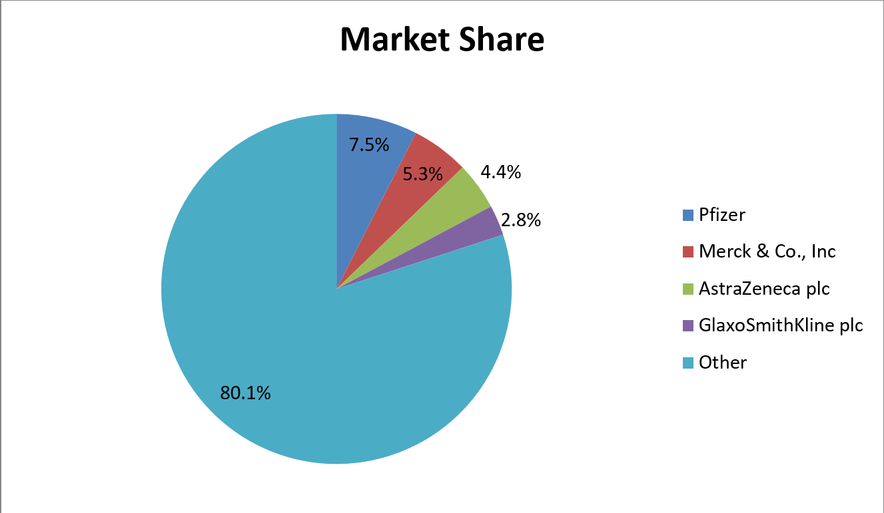
Figure-1: GSK’s share of market
(Source- Sadik, 2020)
Collinson et al. (2020) note, as part of the global strategic view, that pharmaceutical competitiveness is determined by intellectual property protection and global integration of research networks. This is further supported by Hasanah (2024), who claims that innovation-oriented industries need to have coordinated international strategy on regulatory jurisdictions. The pharmaceutical companies of the UK have been working under internationally spread production and research systems, which implies that the ability to coordinate with the rest of the world is very crucial to the domestic competitiveness, and not by sheer national production size. The economic significance of the sector is then that it has the control over intangible resources of high value and is embedded into global systems of innovation.

2.3 The Major Domestic, Multinational Firms Operating and their Relative Positioning
The UK pharmaceutical companies exhibit different adaptation strategies to global competition exhibited by their strategic positioning. Rizhamadze (2020) clarifies that GSK has experienced a lot of portfolio rationalisation, which has included a strategy of divestment to enhance its focus in operations. This is supported by Wei (2021), who claims that capital market expectations are favoring more and more firms that streamline their product portfolios and focus on high-growth therapeutic segments. Garcia (2020) gives empirical data of big-scale divestment deals in the pharmaceutical and consumer health sector, explaining how companies redistribute funds to focus more on competition. Sadik (2020) also emphasizes that enterprise risk management models are the core of pharmaceutical strategy especially in the management of litigation of patents and regulatory risks.
Firm | Innovation Intensity | Portfolio Discipline | Global Revenue Dependence | Political & Governance Exposure | Strategic Risk Profile
GSK | High R&D reliance with restructuring focus | Divestment-led portfolio concentration | Significant international earnings | Subject to transparency and regulatory scrutiny | Patent cycle vulnerability
AstraZeneca | Pipeline-driven growth strategy | Focused therapeutic specialisation | Predominantly non-UK revenue base | Embedded in UK research ecosystem | High R&D investment exposure
Pfizer | Scale-based innovation diversification | Globally integrated product portfolio | Highly diversified global markets | Formal compliance and political activity reporting | Litigation absorption capacity
Roche | Oncology-centred innovation model | Specialised high-margin focus | Strong European revenue integration | Operates within EU transparency regime | Regulatory alignment risk
Novartis | Diversified therapeutic segments | Strategic capital reallocation | Global multi-market earnings | Active institutional engagement | Portfolio restructuring exposure
Table-1: Key Firms Comparison
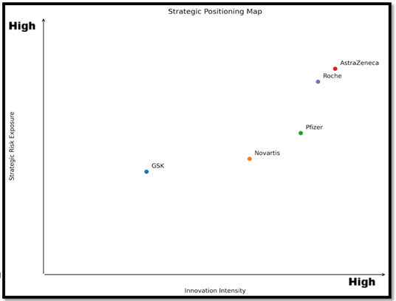
Figure-2: Positioning map
(Source- Self-made)
Conversely, Pfizer has a competitive size as indicated by global monetary performance. According to Pfizer (2024), the annual revenues of the company are more than tens of billions of US dollars, which indicates the status of one of the biggest pharmaceutical companies in the world. This financial strength will improve its capacity to absorb litigation risk, to invest in political activities as well as to maintain long-term commitment of investments in research and development in host countries like the UK. The competitive advantage in the UK market is thus a combination of innovation capability, as well as the financial magnitude and the ability to absorb risk.

3. Porter’s Diamond: Critical Application
Diamond Determinant | UK Pharmaceutical Industry Position | USA Position | China Position | Strategic Interpretation (Global Context)
Factor Conditions | Advanced scientific workforce, strong institutional quality, credible regulatory system (MHRA), world-class universities | Largest R&D investment globally, strong venture capital ecosystem, deep capital markets, elite research institutions | Rapidly expanding STEM workforce, heavy state-backed investment, improving research infrastructure | UK competes on research quality and governance credibility; USA dominates capital intensity and commercialization scale; China competes on state-supported expansion and scale efficiency
Demand Conditions | NHS-driven sophisticated healthcare standards, strict NICE cost-effectiveness assessments | Largest pharmaceutical market globally, high drug pricing flexibility, strong private insurance market | Massive population base, expanding middle class, evolving reimbursement system | UK domestic demand pushes compliance-driven and cost-effective innovation; USA rewards breakthrough innovation with high margins; China offers scale-driven market expansion opportunities
Related & Supporting Industries | Integrated biotech clusters (Oxford–Cambridge–London), strong academia-industry collaboration | Highly developed biotech clusters (Boston, San Francisco), strong VC networks, global supply chains | Growing biotech hubs (Shanghai, Shenzhen), increasing contract manufacturing strength | UK ecosystem strong in research spillovers; USA ecosystem strongest in commercialization and funding depth; China increasingly dominant in manufacturing and supply chain scale
Firm Strategy, Structure & Rivalry | Intense patent litigation, strong generics competition, global firms like GSK and AstraZeneca | Highly competitive Big Pharma rivalry, aggressive M&A activity, strong IP enforcement | Increasing domestic champions, evolving IP regime, government-influenced competition | UK firms operate under innovation pressure with pricing constraints; US firms leverage financial scale and aggressive strategy; Chinese firms compete via speed, cost, and policy alignment

Table-2: Diamond Model Determinants

3.1 Factor Conditions
According to Diamond by Porter, advanced factor conditions form the basis on which national competitive advantage is founded especially in the knowledge intensive industries as claimed by Poliquin and Hou (2022). The UK pharmaceutical industry is very competitive, which is highly connected with the knowledge base of the country, research facilities, and regulatory bodies. These factor conditions are even enhanced by institutional quality. The IMF (2025) governance diagnostic framework notes that the effectiveness of regulations, rule of law and institutional accountability are the areas that improve investor confidence and minimise the uncertainty in operations.

3.2 Demand Conditions
The advanced healthcare demands, as well as the regulatory inspection of the pharmaceutical market in the UK, influence the domestic demand conditions. According to Collinson et al. (2020), high-technology domestic markets frequently drive innovation by seeking products of a higher standard and regulation compliance. The healthcare system of the UK has strict evaluation standards, which make pharmaceutical companies invest a lot of money in the clinical efficacy and safety standards.

3.3 Related and Supporting Industries.
The UK pharmaceutical sector is subjected to a network of related biotech and research environments which support potential innovation strength. In order to develop a competitive advantage domestically, Collinson et al. (2020) contend that related industries clusters can increase knowledge spillovers and collaborative efficiency. The sanctity of biotechnology companies, contract research organisations and dedicated legal advice networks add to the UK ingrained life sciences base.

3.4 Firm Strategy, Structure and Rivalry.
The pharmaceutical industry in UK is characterised by high levels of competition especially by patent litigation and the presence of competitive generics markets. Holman (2020) proves that patent conflict, including that between pharmaceutical incumbent and generics manufacturers, determines the competitive strategy and contributes to the timing of innovation. Pakpahan and Hutahayan (2025) also demonstrates that induced infringement decisions in pharmaceutical litigation increase the exposure to legal risks, which are directly related to market entry.

3.5 Government and Corporate political activity.
The role of government in determining pharmaceutical competitiveness is central to the regulation, procurement and policy involvement. According to Pakpahan and Hutahayan (2025), the extent of corporate political activity plays a significant role in the outcome of organisations within regulated industries. Within the UK pharmaceutical scene, the companies are interacting with policymakers and influencing the standards of regulation, pricing mechanisms, and the access to the market.

3.6 Porters Diamond weaknesses.
Although diamond of national competitive advantage offers a systematic approach to examining the competitive advantage of a country, it has shortcomings in fragmented industries in the world. According to Collinson et al. (2020), the growth of multinational enterprises is being conducted in global value chains that blur the explanatory ability of models that work exclusively on the national level.

3.7 Implication on Global Context
The UK has in the global pharmaceutical market a quality and research-intensive niche, as opposed to competing within scale or cost. The US is the dominating power with depth of capital, ability to commercialize, and high-margin market incentives which are rewards of breakthrough innovation. According to Collinson et al. (2020), China, in its turn, enjoys the benefits of state-supported investment, mass production, and blistering market growth to enhance itself on a global scale. The UK has the strength of scientific excellence, regulatory credibility, and ecosystem working together, which is strategic (United Nations Global Compact, 2025). Nonetheless, its small domestic market size and price limitation also implies that it only needs to use global alliances, export based strategies, and innovation-based differentiation to remain competitive in the international market.

4. Pfizer in the UK- Institutional & Political Strategy Analysis
Factor | UK Pharmaceutical Context | Strategic Implication
Political | Strong regulation (MHRA), NHS price control | Stability supports predictability but limits pricing freedom
Economic | High R&D intensity, reimbursement pressure | Innovation-led strategy needed to offset margin constraints
Social | High expectations for fair access and transparency | Reputation and ethical alignment are essential
Technological | Advanced research base, biotech clusters, strong clinical trial networks | Sustains innovation advantage but requires continuous investment
Legal | Robust IP protection, frequent patent disputes | Protects exclusivity but increases litigation risk
Environmental | Growing ESG and sustainability expectations | Compliance and green practices affect long-term legitimacy

Table-3: PESTLE Analysis

4.1 Corporate Overview
Pfizer is a company that is among the most internationally integrated drug companies that operate in the UK life sciences industry. According to Pfizer (2024), the company has high levels of global revenues that are backed by a robust research and development spending that has allowed the company to have a diversified therapeutic portfolio as well as absorb patent-related volatility (Wedayanti and Pulungan, 2023). In markets with governance-intensive business, like the UK, financial scale is strategically important in that compliance costs and litigation exposure and regulatory adaptation are long-term capital investment. The result of this economic strength is enhanced capacity of Pfizer to sail through institutional complexity whilst maintaining investment in innovation. Another strategic pillar that goes parallel is governance architecture. Formal compliance systems and ethical oversight mechanisms and internal reporting structures identified by Pfizer (2021) are aimed at reducing the legal and reputational risk. Structured compliance in the UK context, where regulatory monitoring and stakeholder demands are high, is associated with an increase in institutional legitimacy and decreasing exposure to governance failures. The UK presence of Pfizer is hence indicative of a twin pillar of financial capability and institutional fit in a high accountability environment.

4.2 Political and Corporate Political Activity

4.2.1 Formal Active or Donations to Political Affairs.
Corporate political activity (CPA) is a strategic process whereby Pfizer interacts with the political environment that determines the pharmaceutical market. Wei et al. (2022) posit that corporate political ties are intangible strategic resources that define regulatory and competition performance. Political engagement in a structured way in industries where pricing, approval and procurement decisions are manipulated by government actors is a tool of lessening uncertainty and shaping policy orientation. Pfizer (2025) also publicly reveals its Political Action Committee (PAC) contributions and political engagement practices and is an indication of transparency in political participation. Pakpahan and Hutahayan (2025) show that political contributions and organized involvement can improve organisational performance when they help to overcome policy access and information asymmetry benefits. Such engagement can enhance anticipatory capacity on change in regulation in the UK where pharmaceutical policy frameworks have a direct influence on market access.

4.2.2 Policy Access and policy Regulatory influence.
Political contributions then are not just a form of symbolic gesture but a tool of organized policy discourse within formal ranges of governance structure. In addition to the monetary input, political involvement offers a relationship entry point to policy makers and regulators. Wei et al. (2022) highlight that corporate political networks have the ability to benefit strategic foresight because it provides companies with early information about the direction of policy reforms. This access would be especially helpful in the pharmaceutical industry, where the approval of drugs and price regulation are quite complicated. Nevertheless, Jia et al. (2021) warn that companies can easily control the exposure of political action to prevent regulatory capture. High transparency institutional environment in the UK can lead to publicity and regulation backlash because of over-exposure to lobbying. Political involvement should thus be expected to be in line with the norms of participatory governance and not seem transactional. Regulatory influence, therefore, stimulates strategic predictability and reputational sensitivity and disciplined disclosure practices, at the same time.

4.2.3 Strategic Risk Benefit Analysis.
In strategic terms, corporate political action can positively influence the competitive positioning of Pfizer through enhanced regulatory strategy, higher relational capital and less uncertainty of policies. Wei et al. (2022) conceptualize political ties as strategic resources that could affect the firm-level performance in regulated settings. In the pharmaceutical market of the UK, these relationships can create an easier passage through pricing reforms and compliance transition. Nonetheless, as Pakpahan and Hutahayan (2025) also observe, there are also the negative organisational results that can be brought about by political engagement in case it is perceived to be too much or too obscure. This reliance on political capital could serve to hurt the long-term legitimacy and especially in sectors that are directly linked to the welfare of the population. Political embeddedness is hence a two-sided strategic tool. It enhances competitive strength when governed openly within the governance norms but is a liability when it is not in line with the expectations of the stakeholders.

4.3 Economic Environment Analysis
In the present-day market, there is a high probability of the products being sold to the target audience, as the above graph shows that the potential market share is high. To determine long-term attractiveness of UK to Pfizer, it is necessary to synthesise the institutional stability, innovation capacity and political embeddedness. According to Collinson et al. (2020), multinational enterprises are in search of environments which have both high factor conditions and predictability in regulations. UK has good human capital, research infrastructure and rule-of-law protections that help in fostering innovativeness and competitiveness through innovation.
Hasanah (2024) points out that global strategy in connected markets is also based on finding a way through governance systems as opposed to taking advantage of cost differentials. In this view, the UK has value in its institutional credibility and research ecosystem and not in its efficiency in production. Regulatory foresight is improved by political embeddedness and arbitrary risk is minimized by the stability of governance. However, the intensity of governance and the litigation exposure add to the cost of operations. Reputational sensitivity is magnified by the transparency requirements, and there is a strategic uncertainty presented by patent disputes. Ethical supervision and compliance investment becomes a part of the long-term operation. Nevertheless, the UK is still a strategically appealing country, with its foreseeable legal framework, strong institutional credibility and immersion into the global research networks. The innovation resilience and governance alignment are the mechanisms of maintaining a competitive advantage in this environment instead of cost leadership. UK is thus a high-governance, an innovation-based market in which long-term strategic sustainability is tied to institutional legitimacy, institutionalized political participation and ongoing regulatory evolution.

4.4 Cultural and Social Aspects Analysis- Hofstede Model
The cultural dimensions theory of Hofstede can be used in analysing the cultural aspects of the UK pharmaceutical environment. UK is ranked high on individualism, that is, individuals and organizations demand corporate responsibility and ethical conduct, especially in the medical field (Pfizer, 2025). A low power distance signifies the anti-concentrated power attitude, the growing distrust of lobbying and political participation. Moderate uncertainty avoidance helps to uphold a structured regulation format e.g. MHRA and NICE, which strengthens compliance expectations. According to Selenko et al. (2025), the indulgence and pragmatic orientation of the UK is also fairly high and influences the discussion of drug prices and their availability. In the case of Pfizer, transparency, fairness, and institutional norms are proposed to be aligned so that the legitimacy and trust of stakeholders would be ensured.
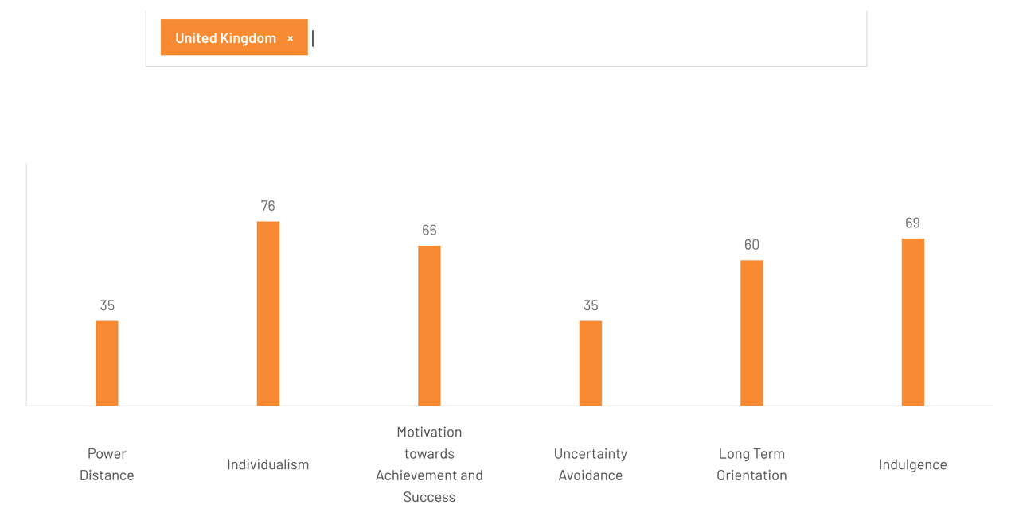
Figure-3: Hofstede Model
(Source- The Cultural Factor, 2025)

The limits of legitimacy of the corporate political behaviour are determined by the national institutional culture. According to Shahid and Saif (2025), corporate political engagement strategies are determined by cultural expectations in terms of governance and sustainability. In the highly-regulatory countries, where the civil society exercises control over the state, companies have to connect political engagement with the wider ethical discourse. Selenko et al. (2025) point out that the attitude of employees to corporate political activity can depend on the results of the perceived compatibility with organisational values. In the case of Pfizer in the UK, political involvement should be introduced as an organized policy discussion in favor of healthcare system development as opposed to the commercial self-interest. Cultural alignment conditions the efficacy of political strategy hence, turning the process of engagement into a legitimacy sensitive activity, which is engrained into societal norms.

4.5 Technological Aspects and its Implications.
The resource dependence theory is an effective approach to examine the strategic exchange between Pfizer and the UK institutions. According to Kohtamaki (2023), organisations have to rely on outside actors who have control over key resources, which sets up structural interdependence between firms and institutional stakeholders. Resource gatekeepers such as regulatory bodies and the healthcare systems of the public are predominant in the pharmaceutical area. The UK revenue realisation of Pfizer is contingent on approval of regulations, pricing bargaining and acquisition choices of publicly organised healthcare. Lee et al. (2021) show that CSR strategies are adjusted by multinational subsidiaries when subjected to institutional pressures of the host country. In the UK, a legitimate position among health care authorities means that the organization is aligned to the requirements of transparency and accountability to the community.
The further entrenchment of Pfizer into the UK innovation ecosystem is through research partnerships with universities and clinical trial networks. These collaborations increase the sharing of knowledge and pipeline R&D capabilities but increase institutional dependence. Reliance on regulatory approval and research partnership support the relevance of governance alignment and political participation. It is the resource interdependence that institutional compliance is therefore made a strategic requirement and not a discretionary decision. In the current market, there is a strong likelihood of the products being purchased by the intended audience, as evidenced by the above graph, which indicates a high potential market share.

4.6 Legal Environment and Patent Risk.
Intellectual protection of property is a backbone of the competitive architecture of the pharmaceutical industry and the legal environment is a factor of determinism of profitability and strategic sustainability. Holman (2020) proves that judicial interpretation of induced infringement plays a great role in determining how original firms protect patents against generics competitors. These kinds of rulings transform the litigation strategy, advertising communication and life cycle management of patented products. In the case of Pfizer in the UK, patent enforcement gives the company stability in the form of revenue when it enjoys the exclusivity but also opens the company to vigorous legal proceedings.
The decisions made by courts in pharmaceutical litigation can widen the liability and restrict the strategic capacity to label products and positioning in the market. This makes the environment structurally adversarial where competitive rivalry is witnessed beyond product innovation to juridical contestation. In the case of Pfizer, there are reasonable predictability in the UK in the context of powerful intellectual property frameworks, but the litigation is very expensive and reputational. According to OECD (2023) Guidelines on Multinational Enterprises, there are high demands on accountable behavior even in the context of competitive legal proceedings. The adherence to the level of transparency and ethics in the litigation process becomes required to the level of institutional legitimacy.

4.7 Institutional & Governance Environment
The institutional and governance environment are essential components of the strategic management system. The institutional and the governance environment are necessary elements of the strategic management system. Pfizer operations in the UK are situated in institutional mechanism of governance that stabilises and disciplines multinational activity. According to Andreadakis (2023), jurisdictional fragmentation tends to leave gaps in accountability by multinational corporations. In the UK, such gaps are however minimised through effective regulatory bodies and control systems which heighten the scrutiny of corporate behaviour. There are OECD (2024) principles of business integrity that underline transparency and ethical governance, as well as anti-corruption, as the key expectations of multinational enterprises. Additional indicators of the IMF (2025) governance diagnostic are regulatory effectiveness and rule of law as the determinants of institutional credibility. In the case of Pfizer, the ability to operate in an environment where there is a predictable system of governance will increase investor confidence and minimize the arbitrary regulatory risk. As observed by Transparency International (2023), the corruption perception indexes have implications on the reputational status across the world and the trustworthiness of the capital market. The relatively good governance score in the UK increases the legitimacy of Pfizer in the global markets.

5. Conclusion
This report has critically appraised the competitiveness of the UK pharmaceutical industry in the international market in the prism of Porters Diamond and incorporated the institutional and corporate political activity views. As it is revealed in the analysis, the competitive power of the industry is not based on the advantages of the costs but rather on the advanced conditions of factors, the highly developed demand structures and a thoroughly established governance framework. Institutional credibility and the knowledge-intensive environment in the UK gives multinational enterprises a stable platform on which they can grow by driving it with innovation. Nonetheless, the issue of competitiveness in the industry is becoming progressively influenced by political embeddedness and regulatory navigation. Corporate politics and systematic interaction with the policymakers affect access to markets, compliance requirements and strategic placement. Political connectivity is thus a strategic resource and reputational exposure source.
Long-term sustainability is still focused on governance issues. The presence of high standards of transparency, risks of litigation, institutional accountability structure puts pressure that necessitates complex compliance mechanisms and responsible corporate behaviors. The companies in the UK need to maintain a constant trade-off between the level of innovation and the legitimacy of the regulations. Finally, the sustainability of the UK pharmaceutical industry is pegged on the capacity to sustain institutional credibility and be able to respond to the global regulatory complexity and competitive strain. Scientific innovation alone will not help to define long-term competitive advantage, but strategic alignment to the expectations to governance and transnational institutional dynamics will.

SECTION 2- Reflection Using Gibbs’ Reflective Cycle
Gibb’s reflective model a six-stage structured framework designed to facilitate learning from experience, particularly in professional or academic contexts. This section will be using the Gibb’s reflective model for analysing my overall feelings and experience throughout the project.

2.1. Description
The present assignment involved a critical analysis of the UK pharmaceutical business through the prism of Porters Diamond model and institutional and corporate political activity approaches. Synthesising strategic management theory with the frameworks of governance, legal analysis and multinational enterprise behaviour were parts of the process of research. Collinson et al. (2020) stress that, the international business environments are affected by intricate interplay of firms, institutions and a global value chain, which preconditioned the multi-dimensional nature of the research process. Instead of using one analytical prism, I needed to combine the political, legal and institutional variables into a competitive model.
The task hence went further to describe the industry and critically analyze the functioning of multinational firms in the system of governance and regulatory framework.

2.2. Feelings
First, I was puzzled by the complexity of the institutions of pharmaceutical sector especially in terms of political involvement and regulatory embeddedness. Hasanah (2024) emphasizes that multinational organizations have to experience and work around interdependent governance and market relationships, and such theoretical framing was indicative of the theoretical challenge I experienced in my effort to incorporate political activity into the Porters model.
However over the course of the research, I realised that this complexity was not a drawback but rather that of the core of the concept of competitive advantage in regulated industries. Also, it is also about proper experience and understanding how things work. This is because with passage of time I managed to get maximum confidence and my understanding of the entire thing changed.

2.3. Evaluation
The combination of the corporate political activity theory into a conventional competitiveness model was one of the best in my research process. As Wei et al. (2022) prove that corporate political ties are strategic resources in industries with strong regulation in place, this enabled me to think of political embeddedness as a competitive ability instead of mere compliance behaviour. This point of view enhanced the analytical intensity of the Porters Diamond application. Moreover, Pakpahan and Hutahayan (2025) claim that corporate political activity determines the organisational performance and long-term performance. The use of this insight helped me to critically evaluate the impact that the political involvement of Pfizer in the UK governance environment may have on regulatory positioning and strategic influence.
Nonetheless, I also realised that I needed to exercise prudent judgement between institutional analysis and the industry structure analysis so as not to overemphasise political dimensions at the cost of economic factors.

2.4. Analysis
On a further reflection, I discovered that the greatest learning outcome was that of realising that accountability is an important strategic constraint and an opportunity. Andreadakis (2023) holds that multinational corporations are in space of accountability that needs well-organized governance system to determine responsible behaviour. This understanding explained the role of the governance credibility as reputational capital and regulatory discipline in the UK pharmaceutical setting. The UK strategy of Pfizer seems to focus on the structured disclosure and institutional compliance in order to reduce this risk. Sustainability of political benefit has to lie in the continued legitimacy accompanied by the continued influence within well established governance limits. The OECD (2023) Guidelines on Multinational Enterprises also enhanced the significance of responsible business ethics in creating corporate legitimacy. Including such principles in my analysis of the industry enabled me to consider the compliance frameworks, not as a form of restraint, but as a strategic positioning tool that determines investor confidence and stakeholder trust.
Also, Lee et al. (2021) reveal that the subsidiaries of multinational corporations modify the practices of corporate social responsibility due to the institutional pressures of the host countries. This view enhanced my perception of how the UK activities of Pfizer are influenced by institutional demands, such as transparency, ethical practice and stakeholder interaction. The critical analysis of these dimensions helped me realise that the competitiveness in the pharmaceutical sector in the international arena cannot be narrowed down to innovation capacity. Instead, it is a result of an action-based process between institutional legitimacy and political embeddedness and strategic adaptation. This analytical synthesis added to my overall evaluation to a very great extent.

2.5. Conclusion
Looking back at the process in general, I realise that the implementation of Gibbs cycle allowed me to think critically and not reactive in a manner of description. As Kohtamaki (2023) emphasizes, the institutional environment is largely predisposed to its resource dependencies, which enabled performance outcomes, and this idea became the focus of my comprehension of the competitiveness of the UK pharmaceutical industry.
The reflections process also made me realize that multinational enterprises are not isolated entities that are not affected by system of governance structures but are rather entrenched in institutional networks which affect strategic decisions. In my analysis, my focus was therefore not the purely economic form of competitiveness but rather the institutionally meditated and politically mediated form of competitiveness. This change of attitude is one of the important changes in my perception of the international business strategy.

2.6. Action Plan
Development Area | Resources Needed | Process for Change | Evaluation Method | Timeline
Integrating global governance into strategy | UN Global Compact principles; OECD governance frameworks | Embed transparency, human rights and anti-corruption indicators into strategic models | Compare analytical depth in future assignments; supervisor feedback | 2 months
Strengthening political–legal–economic synthesis | Corporate political activity and institutional theory literature | Systematically integrate political, regulatory and economic variables in case analyses | Improved coherence using marking rubric benchmarks | 3 months
Enhancing ethical competitiveness evaluation | Sustainability reports; responsible business conduct standards | Link profitability analysis with legitimacy and compliance considerations | Reflective review of balance between financial and ethical analysis | 2 months
Improving structured analytical application | Advanced IB frameworks and structured templates | Apply consistent analytical frameworks across all research projects | Greater clarity, critical depth and argument consistency | 4 months

References
Andreadakis, S. (2023) Accountability and multinational corporations: Minding the gap and mechanisms for responsible business. Brunel University London. https://bura.brunel.ac.uk/handle/2438/28149
Collinson, S., Narula, R., Qamar, A. and Rugman, A.M. (2020) International business. 8th edn. Harlow: Pearson Education. https://www.researchgate.net/publication/332705536_International_Business_8th_edition
European Commission (2023) Transparency register. Available at: https://commission.europa.eu/about/service-standards-and-principles/transparency/transparency-register_en
European Parliament (2023) Lobby groups and transparency. Available at: https://www.europarl.europa.eu/at-your-service/en/transparency/lobby-groups
Garcia, J. (2020) ‘GlaxoSmithKline sells $3.35 billion stake in Hindustan Unilever’, UWIRE Text, pp. 1–1. https://economictimes.indiatimes.com/markets/stocks/news/gsk-sells-3-35-billion-stake-in-hindustan-unilever/articleshow/75598105.cms?from=mdr
Hasanah, L. (2024) ‘Global strategies: Navigating the complexities of international business in a connected world’, Advances in Business & Industrial Marketing Research, 2(1), pp. 36–47. https://advancesinresearch.id/index.php/ABIM/article/view/251
Holman, C.M. (2020) ‘GlaxoSmithKline v. Teva: Holding a generic liable for an artificial act of inducement’, Biotechnology Law Report, 39(6), pp. 425–439. https://irlaw.umkc.edu/cgi/viewcontent.cgi?article=1226&context=faculty_works
IMF (2025) Frequently asked questions on governance diagnostic. Available at: https://www.imf.org/en/About/FAQ/governance-diagnostic
Jia, N., Markus, S. and Werner, T. (2021) ‘Theoretical light in empirical darkness: Illuminating strategic concealment of corporate political activity’, Academy of Management Review. https://fsi9-prod.s3.us-west-1.amazonaws.com/s3fs-public/2023-05/jia-markus-werner_-_secrecy_in_cpa_-_in_amr.pdf
Kohtamäki, V. (2023) ‘Performance agreement through the lens of resource dependence theory’, Journal of Education Policy, 39(4), pp. 1–23. https://www.tandfonline.com/doi/pdf/10.1080/02680939.2023.2245791
Lee, J.Y., Choi, J., Lew, Y.K. and Park, B.I. (2021) ‘How do institutions matter for MNE subsidiaries’ CSR in host countries?’, BRQ Business Research Quarterly, 27(3). https://journals.sagepub.com/doi/10.1177/23409444211044732
OECD (2023) OECD Guidelines for Multinational Enterprises on Responsible Business Conduct. Available at: https://www.oecd.org/en/publications/2023/06/oecd-guidelines-for-multinational-enterprises-on-responsible-business-conduct_a0b49990.html
OECD (2024) Business integrity. Available at: https://www.oecd.org/en/topics/sub-issues/business-integrity.html
Pakpahan, S.M. and Hutahayan, B. (2025) ‘The role of corporate political activity in shaping organizational outcomes: A systematic literature review’, F1000Research, 14, 1046. https://sites.duke.edu/thefinregblog/2022/02/10/%EF%BF%BCcorporate-political-donations-and-firm-value-following-the-capitol-riot/
Pfizer (2021) Corporate compliance. Available at: https://www.pfizer.com/about/responsibility/compliance (Accessed on 24th February 2026)
Pfizer (2024) Annual reports. Available at: https://investors.pfizer.com/Investors/Financials/Annual-Reports/default.aspx (Accessed on 24th February 2026)
Pfizer (2025) Pfizer Political Action Committee and political contributions report. Available at: https://www.pfizer.com/about/programs-policies/political-partnerships/political_action_committee_report
Poliquin, C. and Hou, Y. (2022) ‘The value of corporate political donations: Evidence from the Capitol riot’, SSRN Electronic Journal. https://sites.duke.edu/thefinregblog/2022/02/10/%EF%BF%BCcorporate-political-donations-and-firm-value-following-the-capitol-riot/
Rizhamadze, K. (2020) ‘Analyzing business model, narrative and numbers of GSK (GlaxoSmithKline)’, Eurasian Journal of Social Sciences, 8(1), pp. 35–41. https://www.researchgate.net/publication/340562982_ANALYZING_BUSINESS_MODEL_NARRATIVE_AND_NUMBERS_OF_GSK_GLAXOSMITHKLINE
Sadik, K.Y. (2020) Enterprise risk management analysis of GlaxoSmithKline Bangladesh Limited. https://dspace.bracu.ac.bd/xmlui/handle/10361/15130
Selenko, E., Schilbach, M., Brieger, S.A., Van Hootegem, A. and De Witte, H. (2025) ‘The political consequences of work: An integrative review’, Journal of Management. https://journals.sagepub.com/doi/10.1177/01492063241301337
Shahid, M. and Saif, A. (2025) ‘Linking national culture to corporate political activity in pursuit of environmental sustainability’, The Global Management Journal for Academic & Corporate Studies, 15(2), pp. 150–170. https://gmjacs.bahria.edu.pk/index.php/gmjacs/issue/view/2
The Culture Factor. (2025). Country Comparison Tool. Theculturefactor.com. https://www.theculturefactor.com/country-comparison-tool?countries=united+kingdom (Accessed on 24th February 2026)
Transparency International (2023) Corruption Perceptions Index. Available at: https://www.transparency.org/en/cpi/2023 (Accessed on 24th February 2026)
United Nations Global Compact (2025) The ten principles. Available at: https://unglobalcompact.org/what-is-gc/mission/principles (Accessed on 24th February 2026)
Wedayanti, M.D. and Pulungan, B.I. (2023) ‘Corporate social responsibility political interaction strategy: A case study’, Corporate and Business Strategy Review, 4(3), pp. 56–65. https://www.researchgate.net/publication/372840744_Corporate_social_responsibility_political_interaction_strategy_A_case_study
Wei, Y., Jia, N. and Bonardi, J.P. (2022) ‘Corporate political connections: A multidisciplinary review’, Journal of Management, 49(6), pp. 1870–1910. https://journals.sagepub.com/doi/abs/10.1177/01492063221136839
Wei, Z. (2021) Equity research: GlaxoSmithKline strategy and forecast. Doctoral dissertation. https://run.unl.pt/bitstreams/3d908aa1-e9ac-4068-a2fc-1fcaa1d13d84/download
‌

