BMSW 4004: Problem Solving and Decision Making
Group Presentation
On
The shortage of employees in the UK- a case study on Proper Care

Task 1

Introduction
Following the mandate, the UK chose to leave the European Union quite a long while prior. Notwithstanding, it is more proper to go against Brexit given that the UK's exit from the EU could hurt trade, and speculation, and result in labor supply deficiencies. A decrease in migration because of the Brexit understanding might bring about a work lack and modify working circumstances for UK residents. Most often, migrants work in positions with lower pay or more regrettable working circumstances; subsequently, assuming that they leave the country, the UK could run out of laborers. Thus, organizations, especially those in the medical care industry, are encountering employee deficiency. Today, we will talk about this particular issue and endeavor to spread out a functional arrangement.

Nature, impact, and scope of the problem
Official NHS measurements show the decrease in NHS staff degrees of consistency for the UK in the year after the EU mandate, for EU and other non-EU residents. With roughly 110,000 British residents selecting to leave this foundation (both briefly and forever) between June 2016 and June 2017, there have been extensive issues in keeping UK representatives. The maintenance rate for British residents is as yet higher (88.4%) than it is for EU residents (83.2%).
Such high paces of the end for disciplinary explanations behind the two sorts of workers are concerning in light of the fact that, following Brexit, it will be more challenging to fill the hole by employing from other EU countries.
Due to a nonstop decrease in the expert climate throughout recent years, an enormous number of representatives are stopping the NHS (Iacobucci, 2019).
Because of a staffing setback, conditions for the enduring representatives have deteriorated, which has caused an expansion in specialist takeoffs. A maturing populace and expanded wellbeing requests have required more clinical intercessions and more elevated levels of clinical information (Mendes, 2019). Opportunities grew from 98,475 in March 2018 to 107,743 in June 2018, regardless of proficiency acquires diminishing times of stay and the interest forever workers.

PESTLE Analysis
Political: From the underlying commitment of the In/Out mandate through the political and lawful contentions about the enactment of Article 50 and the ongoing discussion about the compromise between free versatility and the single market, Brexit has been a profoundly political subject (Iacobucci, 2019).
Economic: The UK's economy is vigorously dependent on its association with the EU, and the UK's choice to leave the EU will essentially affect British firms and work, contingent upon the economic accords that are set up during the separation techniques (Jonas, 2019).
Social: Additionally, there is developing strain on the public authority to safeguard the privileges of EU residents to remain in the UK after Brexit, for the EU to consent to something similar for UK residents living abroad, and to ensure that the work market, especially in the public area, isn't harmed by the limitations on the opportunity of development (Jessop, 2018).
Technological: A captivating setting for organizations after Brexit is likewise made by the developing meaning of Blockchain. Fundamentally, blockchain empowers safely distributed approval, which empowers exchanges to occur without the contribution of an outsider mediator.
Legal: The most influenced firms will be the people who import products much of the time, yet all organizations might take a couple of straightforward insurances to guarantee that their cargo forwarder or carrier is prepared for Brexit (Hantzsche and Young, 2019
Environmental:: Because more vehicles would be halted because of this superior consistency, offices at ports like Dover will be extended. Notwithstanding, the Port of Dover can't develop since it is situated between a street and a real estate parcel assigned as an Area of Outstanding Beauty.

Cause and Effect Analysis

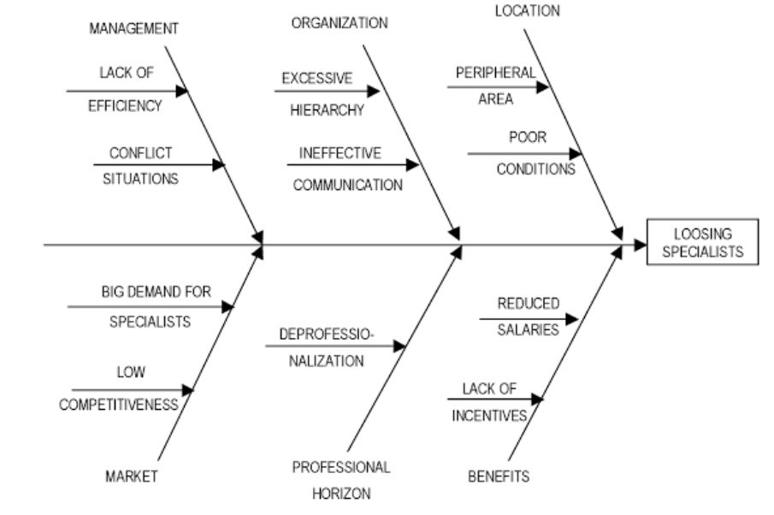
Cause and Effect Analysis
Figure 1: Fishbone Diagram of Employee Shortage (Umfreville and Piñeiro, 2018)
From the diagram, it is visible that Brexit's impact and the unemployment situation in the UK have a true cause-and-effect relationship.

Evaluation of employee shortages

There has been rising tension on Prime Minister Theresa May to simplify it to recruit NHS faculty from abroad because of fears of a colossal mass migration of unfamiliar specialists from Britain or, at any rate, a continuous decrease because of the trouble in employing non-British staff once Britain leaves the EU (Jessop, 2018). Sajid Javid, the home secretary, declared in June 2018 that the public authority would raise the compensation roof for gifted specialists, including specialists and attendants.
Notwithstanding such defense, the necessity for future EU residents to apply for a visa to work may discourage. Furthermore, there are at present no designs to adjust the base compensation band so that lower-level NHS workers can be recruited from beyond the United Kingdom.
Past measures to hold EU laborers, there is likewise a transition to give and diminish the reliance a shot unfamiliar specialists and select more British laborers (Tesra, 2019)
A House of Lords Select Committee on the Long Term Sustainability of the NHS report noticed that there has been a well-established dependence on outside nationals in the NHS.39 The board expresses that the drawn-out arrangement is for the public authority to guarantee the stock of thoroughly prepared well-being and social consideration laborers from inside the country (Hantzsche and Young, 2019)
The report noticed a shortfall of a public long haul methodology which could get the important prepared staff required in wellbeing and social consideration over the course of the following 10-15 years. They highlighted the divided idea of staff arranging the nation over as an issue still to be settled (Jonas, 2019).

Conclusion
Diminishing the quantity of settlers living and working in Britain was one of the essential avocations for deciding in favor of Brexit. A particular interest and clear red line that Theresa May's organization has not yet crossed in conversations is the limitation on the free development of individuals and laborers. Consequently, in spite of the way that guidelines on portions for gifted settlers in the wellbeing area have been changed, it will be more enthusiastically for EU residents to work for the NHS in post-Brexit Britain. Because of the difficulties in keeping faculty despite crumbling working circumstances, the ramifications of such a deficiency of laborers will be extreme for the NHS. A few specific segments of the wellbeing administration have lost laborers, however not every one of them. While not all areas of medical care have lost workers, a few explicit regions, like nursing, have experienced a critical loss of staff. The issue has been tended to with various strategies.

References
Hantzsche, A. and Young, G., 2019. The Economic Impact of Prime Minister Johnson's New Brexit Deal. National Institute Economic Review, 250, pp.F34-F37.
Iacobucci, G., 2019. No-deal Brexit will have a "catastrophic" impact on the NHS, BMA warns. BMJ, p.l5343.
Jessop, J., 2018. 'A No-deal Brexit Could Knock 10% off UK GDP': No-Deal Fact Checker. SSRN Electronic Journal,.
Jonas, T., 2019. Government publishes additional no-deal Brexit medicines regulation guidance. The Pharmaceutical Journal,.
Lancet, A., 2019. Brexit: deal or no deal?. The Lancet, 393(10174), p.848.
Mendes, A., 2019. How will a no-deal Brexit impact medicines in the UK?. British Journal of Community Nursing, 24(2), pp.92-93.
Tesra, M., 2019. VMD is ready for Brexit, deal or no deal. Veterinary Record, 185(13), pp.387-387.
Umfreville, C., Omar, P., Fannon, I. and Carballo Piñeiro, L., 2018. Recognition of UK Insolvency Proceedings Post-Brexit: The Impact of a ‘No Deal’ Scenario. International Insolvency Review, 27(3), pp.422-444.

