A Guidance Handbook for keyworkers detailing the importance of good communication in Transitions in Early years Childcare

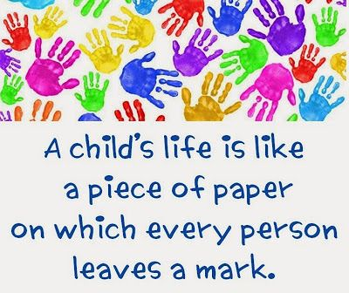
(Source: Pinterest, no date)

Contents Page Number
Introduction 3

Transitions 5

The Needs of the Child 7

The Role of the Adult 11

Partnerships 15

Interventions 16

Proposed Outcomes 18

Reference List 20

Introduction

This guidance handbook has been written to give guidance to key workers/ practitioners on the importance of transitions in early years education. Also, detailing why good communication between keyworkers, parents and everyone else involved in a child’s life is effective for a smooth transition process.
This handbook is aimed at keyworkers who are working with children between the ages of 3 and 4 that are transitioning from a flying start play group setting up to a foundation phase primary school nursery setting.
The guidance sections that will be talked about in this handbook are the needs of the child, your role as the adult, interventions, and proposed outcomes.
This handbook is going to be full of research for theorists that has proven why good communication between the key worker, the child and all other adults involved with the child: Parents, carers and any multi-agency professionals that may be involved with a child is key to a smooth and stress-free transition.
A transition is a process that happens in everyone’s life and is an inevitable part of every child’s journey through life. It is a proven fact that happy and well settled children are more eager and open to learning. Some children may need a higher level of support to adjust during the transition process as they are moving to an unfamiliar place with many new people (Gunning, 2020).
A parent has supported their child from birth in many areas from feeding the child to then helping them when the child began to walk, talk and play and through many more aspects of the child’s life. Therefore, involving and communicating well with the parents/ primary caregiver during the transition process and beyond, will not only make the transition enjoyable and less stressful for the child and parents, but it also helps the practitioner/key worker get a better understanding of the child.
There are many key factors a key worker will need to know about a child before they start at the early years setting such as the child’s needs, likes and dislikes, their capabilities with daily routines/self-care and the relationship the child shares with their parents/ primary care giver (Bruce, 2012).

“Friedrich Froebel emphasised the importance of parent’s and family living with and learning with their children. Adults can learn as much from children as children learn from adults.”
(Bruce, Page 24, 2012)

Transitions
According to (Education Scotland, 2020):
Transitions in education are when young and older children move from home to an early years childcare setting, from there to a primary school, from a primary school to a secondary school, through each year group and from secondary to further education and beyond.
Researchers believed there are two types of transitions: horizontal and vertical (Vogler et al., 2008; Firth et al., 2009).
Horizontal transitions refer to less challenging daily changes to a child’s life or routine such as, sitting nicely on mats to participate in 1 to 1 or group activities, sit at tables to eat their food/snacks, tidy up toys/activities after they have finished playing with them or playing outside with friends informally. Even though these activities may not seem like a big thing, to a child they are still classed as transitions as some children may not have these types of rules and routines in their home lives.
Vertical transitions are changes that make a big difference to a child’s everyday routine such as starting a more official childcare setting or starting school for the first time (Welsh Government, 2017).
Vertical transitions are the type of transitions this handbook is more focused on. Although, horizontal transitional changes also greatly affect a child’s experience of vertical transitions (Welsh Government, 2017).

It is important for practitioners to know that moving from a small play group setting to a larger foundation phase school nursery can be a very stressful and unsettling time for not just the child but the parents/ primary care givers too, as they are entrusting you with the care of their child. For this reason, a smooth transition where everyone involved is comfortable and happy is vital to the child’s learning and development and reassures the parents. If a child’s transition period is unsettling and not enjoyable it can have a big effect on everyone involved, especially the child (Bruce, 2012).
Although as practitioners you will try to be as encouraging and enthusiastic about the child’s upcoming transition as you can, but it can still be a very frightening time for the child (Drake, 2020).
There are many influential theorists whose work focused on education. Here are some that will appear in this handbook: Bronfenbrenner (1979), Froebel (1782-1852), Maslow (1943-1954) and Bowlby (1907-1990). Although some of these theorist’s work is very dated their research and believes are the reason why early years childcare is so highly valued today.

The needs of the child
All children should feel included and valued in their early year’s environment. A Child should never be excluded or disadvantaged because of ethnicity, religion or culture, home language, poverty, family background, additional learning needs, disability, gender or abilities (Welsh Government, 2015).
Children need to have rich and stimulating experiences in their nursery setting. This is controlled by the key workers and practitioners and must be well thought out and well organised (Welsh Government, 2015).
As stated in the section above transitions to foundation phase settings can be a daunting time for a child. Not only are they moving up to a bigger and more formal setting they are also having to spend more time away from their parents/ primary care giver.
All children of a young age develop an attachment. A child’s mother is normally their main primary attachment. Attachment – is a fondness or affection someone feels for something or someone.
As Bowlby’s (1907 – 1990) attachment theory suggests. A secure attachment is when a child feels happy and secure in their surroundings, and when their mother (usually) is positive, sensitive and responsive towards the child consistently. So even though children will feel distressed and feel a sort of lose when their mother is away from them for a longer period than they are used to, they are also assured she will return.
If key workers/ practitioners show care, love and friendliness towards a child they can sometimes become a child’s secondary attachment figure.
UNCRC – United nations Convention on the rights of the child is an international agreement that encourages the human rights of children under the age of 18.
There are 54 articles in the UNCRC to ensure that children grow up happy, healthy and safely. Each article is equally important to the well-being of children’s rights, but there is one that details how important it is to communicate with a child about matters affecting them. Wales was the first country to take on these rights and make them legislation (Unicef,
Article 12 – a child has the right to have a say in matters that directly affect them and their abilities to develop.
The rights of the child articles link into Abraham Maslow’s (1943) Hierarchy of needs theory. He believed that humans have different levels of needs. He tiered these needs into a pyramid. Working from the base up they are: basic human needs, safety, love and belonging, esteem and self-actualisation.
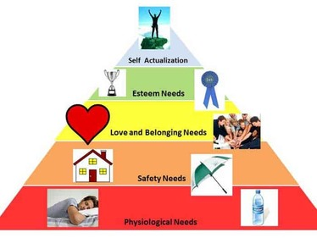

Maslow’s theory could be used in early years education to determine the reasons behind a child’s behaviour and their motivation to work and learn. Are all their needs being met at home? Are they fed a well-balanced healthy diet? Are they shown love and affection? Do they feel secure?
Because for a child to be successful in their learning they need to be well rested, fed well, feel safe at home and have confidence in themselves (University of Reading).

Fredrich Froebel (1782 – 1852) was the creator of the kindergarten (play group) for early years children. His work led the path to the way early years education is highly thought of and valued today.
Frobel believed to better strengthen a child’s development of the outdoors the child needs to be able to explore these things. He emphasised the importance of children having hands on experiences with the outdoor world. He suggested although it is important for a child to observe and describe a garden full of plants and flowers it is not enough. To fully understand the importance of what is seen and described the child should be able to look after the plants, flowers and insect life through digging, sowing seeds, planting flowers, tending to plants and trees and feeding small wildlife and insects (Bruce, 2012).
This also applies in the social life of the child whether they are at home or in their early years setting. Adults and children both learn through one another as they play or work together. It is often said by educators that children learn through other children, but Frobel believed that children and adults learn through each other, (Bruce, 2012).
Play is an essential part of a child’s development it creates opportunities to learn while having fun. Research by many theorists shows that play is a very important factor in a child’s development, but Froebel really believed that all aspects of play were beneficial to a child’s development. Outdoor play, songs/games and to play with gifts (toys). (Froebel trust, 2012).
Gifts(toys) were a focal point in Froebel’s work, he created gifts for children to better develop their knowledge and skills. The most influential gift he created was blocks, he suggested they promote curiosity, imagination, exploration and open-ended play. They looked a bit different to the blocks you may use today but the concept behind the blocks is still very much the same. He believed by playing with these blocks children learned geometry that would later on in life teach them a more abstract understanding of geometry. He also believed they gave the children opportunities to learn about size, shape and measurements. By playing with blocks it not only benefits a child’s creativity and imagination. It also allows the practitioner to observe and record a child’s progress. (Froebel trust, 2012).
‘Serve and return’ What is meant by the term ‘serve and return’ – a serve is when a child gives out something this could be them showing you something they have done or learnt, pointing at something that interests them or even a cry (usually in smaller babies). A return is the positive response they receive from an adult this could be a vocal response or even a smile, thumbs up or a hug. These ‘serves and returns’ play a big part on a child’s brain development. Positive returns show the child they are valued, and that the adult is interested in what they are doing. These interactions between a child and adult has a big impact on a child’s brain development. Over time if a child receives a lot of negative responses or no response at all to their serve’s it can over time have a detrimental effect on a child’s brain development (Harvard university, 2017).
As early childhood settings such as foundation phase nurseries are a very busy place with lots going on it may not be as easy to respond to each child, responses do not always need to be verbal a smile or gesture to show the child you have acknowledged what they are showing you will still class as a positive response to them (Harvard university, 2017).

Socrates – “Wisdom begins with wonder.”
(Hartley, 2018)

The role of the adult
It is crucial to begin communication between the flying start key workers and the foundation phase key workers as early as possible. There will be many children starting the foundation phase from many different childcare settings. This can be a very stressful time for the foundation phase key workers so to make sure each child’s needs is catered to communication must begin plenty of time before the children are due to start (Welsh Government, 2017).
Before a child joins the foundation phase daily a few ‘stay and play’ sessions may be arranged for the child and parents to meet the key workers/ teachers, other children that may be starting at the same time as them or have already started and to see where they will be going and what they may be doing daily. These sessions will begin the transition process. At the first session parents will be able to join their child. This will give key workers/ teachers a chance to begin their communication with the parents and will also give the parents a chance to have any questions they may have answered. Parents will also be asked to fill in an ‘All about me’ page. Which gives the key workers all the information on the child’s needs and self-care skills before they start. With having this information early key workers can then properly prepare for the child to start and facilitate any additional resources if needed (Welsh Government, 2017).
This piece of guidance links in with Bronfenbrenner’s belief that everyone involved in a child’s life plays a big part in their development. Bronfenbrenner (1977) theory looked beyond a child’s individual development. Instead, he looked at all the influencing factors surrounding a child’s life and the impact they have on the development. He called this the ecological system. He spilt this system into 5 smaller systems.
They were the Microsystem. This is the closest system to a child. Family, friends, classmates and teachers. The people included in this system have a direct contact with a child.
The Mesosystem, Exosystem, Macrosystem and the
Chrono system.
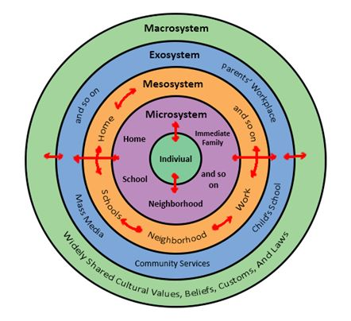

This theory is one of the main reasons why good communication between all people directly involved with a child is vital to their development. Using this theory in practice today also benefits a child to feel secure, happy and comfortable in their nursery setting.
To create a transition where the child feels secure and confident in their environment, the practitioners and parents must work together in an atmosphere of mutual respect (Welsh Government, 2016).
Keyworkers also need to be made aware of any children that may be vulnerable, have additional learning needs, disabilities or have cultural differences as the transition process will need be facilitated to these children’s specific needs. Also, Early years age children’s physical, intellectual, emotional and social development changes very quickly. (Welsh Government, 2017).
Children may be at different stages of development not one child’s development is the same as another. Therefore, activities and work will need to be prepared for the different levels of learning of the child/children (Gopnik, 2016).
The Foundation phase is a curriculum aimed at children between the ages of 3 and 7. There are 7 statutory areas of learning that should be covered:
- Personal and social development, well-being and cultural diversity
- Language, Literacy and communication skills
- Mathematical development
- Welsh development
- Knowledge and understanding of the world
- Physical development
- Creative development
As practitioners it is your job to teach children these 7 areas of learning in a fun, loving, comfortable and nurturing environment (Welsh Government, 2015).
Tina Bruce who is greatly influenced by Fredrich Froebel’s work and has also worked in a Froebelian style school and written many books. Believes children should be taught with a holistic approach that centres on creativity, play and first-hand experiences.
A holistic approach in education is when all aspects of a child’s development are interlinked.
There are 7 main parts that holistic development focuses on:
- Physical and gross motor skills
- Fine motor skills
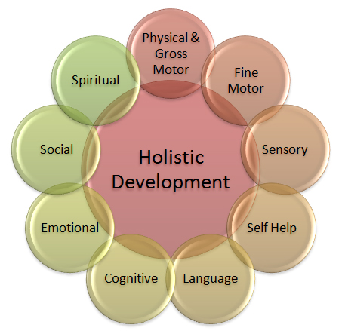
- Sensory
- Self-help/ Self-care
- Language
- Cognitive
- Emotional
- Social
- Spiritual

(Source: Million smiles, 2014)

Partnerships
All children have some form of Multi-agency professionals involved in their care. They could range from health visitors, nurses, social services, flying start support etc.
As a practitioner a child’s safeguarding is one of your main priorities. Some children may already have some multi-agencies involved in their care. Sometimes you may feel it is necessary to contact multi-agencies to support a child and their families if you have any concerns regarding safeguarding.
Safeguarding policies are in place to protect children. And must always be followed (Kelly, 2015).
Before sharing information between these multi-agency professional’s consent will be needed from parents and everyone involved as to not share any information unlawfully.
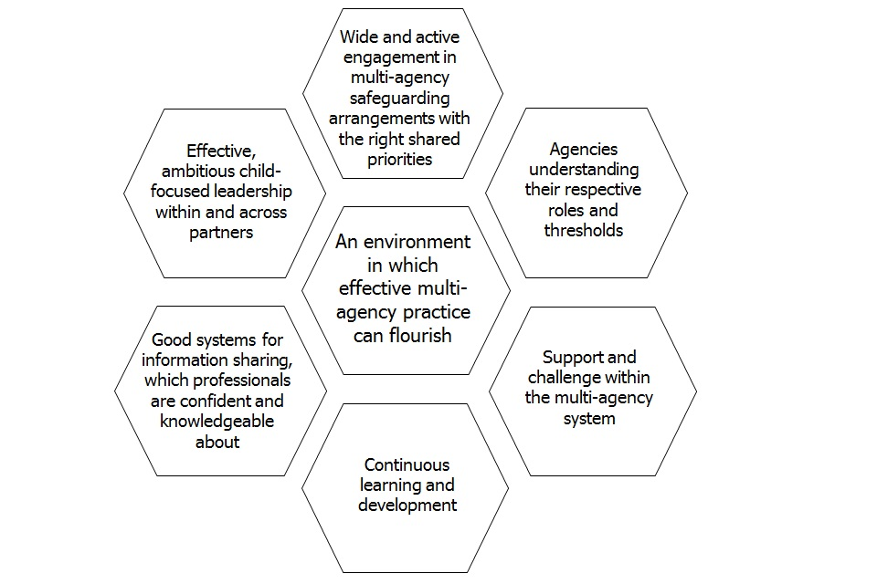

(Source: Welsh Government, 2018)

Interventions
To ensure children are happy and comfortable in the transition process and to give the parents plenty of reassurance that their child is well cared for in a fun and nurturing environment some interventions are necessary. Here are some of the more common interventions used today and why they are important.
‘One-page profile’s’ or ‘All about me’ information pages are a very useful way for the practitioner to find out important details about a child. Some of these details may include what is important to them, likes/dislikes, trauma/upsetting times that may have occurred in a child’s life, the best ways to support the child, important information about the child’s learning and development so far in their life, their daily routines and their abilities with self-care. Producing these pages also involves the parents/primary care giver and gives them reassurance that the school setting knows all the important information about the child and has it to hand when needed (Welsh Government, 2017).
Settling in days are a good way to help a child feel at ease when they start daily in the setting. By takin part in these sessions they will become familiar with their surroundings, practitioners and other children in their group.
Role play areas are a good way to help the child feel valued and included in the settings as you can set up these areas to children’s interest and they can be easily altered when children’s interests change. They also give practitioners the chance to observe a child’s learning, development, language and social skills while they are doing something they like.
Home school links are a vital part of good communication between parents and practitioners. They give a practitioner the opportunity to share a child’s progress with the parents. They also give the parents reassurance and the opportunity to check and comment on their child’s developments and progress.

Outcomes
The EPPE(Effective preschool education project), EPPSE(effective primary school and secondary school) and the REPEY(Researching effective pedagogy in the early years) were 3 studies that took place. They assessed more than 3000 children from pre-school up to their adult lives and it proved that children that attended a high quality setting ended up carrying on into higher education.
The best possible outcome you want to achieve is that you are teaching children to the highest excellence in a high quality environment that has a holistic approach to teaching, is nurturing, enjoyable and a happy place to be.
You also want everyone involved to be happy and relaxed.
Below are a few statements on reviews and reports made on Early years education. They have been included as they state positive and negative points about Early years education today and changes that will make education systems work to the best possible outcome. There are also links to follow if you wish to read them in full.

Cathy Nutbrown (2012) believed that the current early years qualifications system was not providing practitioners with the knowledge, skills and understanding they needed to give children and babies high quality experiences.
Nutbrown Review: https://assets.publishing.service.gov.uk/government/uploads/system/uploads/attachment_data/file/175463/Nutbrown-Review.pdf
In 2018 research was carried out in a Canadian school. Interviewing practitioners on their role of building a professional relationship with the children and their parents during the transition period.
Early European Childhood Education Research Journal:
https://moodle.uwtsd.ac.uk/pluginfile.php/192908/mod_resource/content/0/How%20educators%20define%20their%20role%20building%20professional%20relationships%20with%20children%20and%20parents%20during%20transition%20to%20childcare%20a%20case%20study.pdf

Reference list

Bruce, T. (2012). Early childhood practice Froebel Today. London: Sage Publications.
Cormac404 (2017) Some thoughts on an ecological perspective of social media research [image] Available at:https://cormac404.wordpress.com/2017/05/18/some-thoughts-on-an-ecological-perspective-of-social-media-research/ Accessed: 25th November 2020.
Drake, J. (2020). Transition between settings Available at: https://www.nurseryworld.co.uk/news/article/transition-between-settings Accessed: 7th November 2020.
Education Scotland What are Transitions (2020). Available at:
https://education.gov.scot/parentzone/my-child/transitions/what-aretransitions/#:~:text=%E2%80%8BTransitions%20are%20the%20moves,to%20further%20education%20and%20beyond. Accessed: 7th November 2020.
Guy-Evans, O. (2020). Bronfenbrenner’s Ecological Theory. Available at:https://www.simplypsychology.org/Bronfenbrenner.html#:~:text=Bronfenbrenner's%20ecological%20systems%20theory%20views,values%2C%20laws%2C%20and%20customs Accessed: 6th November 2020.
Gopnik, A. (2016). The Gardener and the Carpenter London: The Bodley Head.
Gunning, C. (2020). Transitions Available at: https://www.early-education.org.uk/transitions Accessed: 7th November 2020.
Richard, H. (No date). [image] Available at: https://www.pinterest.co.uk/hanlierich/ Accessed: 7th November 2020.
Harvard University. (2019). 5 steps for brain-building serve and return. [video] Available at: https://youtu.be/KNrnZag17Ek Accessed: 5th November 2020.
The Frobel Trust (no date). Inspiring early learning Available at: https://www.froebel.org.uk/ Accessed: 18th November 2020.

Whinnet, J. (2020). Froebel’s Gift’s and Block Play Today Available at: https://www.froebel.org.uk/uploads/documents/Froebels-gifts-and-block-play-today.pdf Accessed: 18th November 2020.
Smiles, M. (2014). The Natural Environment And Holistic Development [image] Available at:https://forestexplorers.weebly.com/holistic-development/holistic-development-and-the-outdoors# Accessed: 25th November 2020.
Nutbrown, C. (2016). FOUNDATIONS FOR QUALITY The independent review of early education and childcare qualifications Final Report. Available at:https://assets.publishing.service.gov.uk/government/uploads/system/uploads/attachment_data/file/175463/Nutbrown-Review.pdf Accessed: 24th November 2020.
Hostettler- Scharer, J. (2018). How educators define their role: building ‘professional’ relationships with children and parents during transition to childcare: a case study, European Early Childhood Education Research Journal. Available at: https://doi.org/10.1080/1350293X.2018.1442041 Accessed: 24th November 2020.
Welsh Government. (No Date). Theme 3: Welcoming families to engage with the school Available at:https://gov.wales/sites/default/files/publications/2018-12/theme-3-welcoming-families-to-engage-with-the-school-resources-1-9.pdf Accessed: 22nd November 2020.

Learning-theories. (2020). Attachment Theory (Bowlby) Available at: https://www.learning-theories.com/attachment-theory-bowlby.html Accessed: 22nd November 2020.
Unicef. (No Date). A summary of the UN Convention on the Rights of the Child. Available at: https://www.unicef.org.uk/wp-content/uploads/2019/10/UNCRC_summary-1_1.pdf Accessed: 20th November 2020.
Kelly. (2015). Accessing multi-agency support in the early years. Available at: https://www.earlyyearscareers.com/eyc/latest-news/accessing-multi-agency-support-in-the-early-years/ Accessed: 25th November 2020.
Welsh Government. (2018). Social care commentary: multi-agency safeguarding arrangements. [Image]. Available at:https://www.gov.uk/government/speeches/social-care-commentary-multi-agency-safeguarding-arrangements Accessed: 25th November 2020.
University of Reading. (No Date) Maslow’s Hierarchy of needs. Available at: https://www.futurelearn.com/info/courses/supporting-learning-primary/0/steps/58666 Accessed: 26th November 2020.
Mendix.com. (2018). Early childhood and Maslow’s Hierarchy of needs. [image]. Available at: http://www.discovery-dayschildcare.com/blog/earlychildhood-and-maslows-hierarchy-of-needs# Accessed: 26th November 2020.
Welsh Government. (2017). Flying Start-Annex Transition Guidance. Available at: https://gov.wales/sites/default/files/publications/2019-07/flying-start-transition-guidance-for-professionals.pdf Accessed: 7th November 2020.
Welsh Government. (2015). Foundation Phase Framework. Available at:https://www.earlyyears.wales/sites/www.earlyyears.wales/files/foundation-phase-framework.pdf Accessed: 22nd November 2020.
Hartley, D. (2018). Wisdom Begins with wonder. Available at: https://donnahartley.com/wisdom-begins-with-wonder-socrates/ Accessed: 26th November 2020.

