

Student name: Hamad Al-Jorani
Student ID number: 2310312
Programme:
BA (Hons) Leadership and Management Skills for the Workplace
Module: Research Methods for Business
Module code: LCLM6004
Lecturer: Dr Olu Adegbite
Assignment Title: Component 1 – Business Research Proposal

Investigating Employee Well-being and Its Impact on Organisational Performance
in the Fast-Food Industry: A Case Study of McDonald's Birmingham.

Employee well-being within the fast-food industry is crucial in matters that deal with high turnover rates, stress at work, and burnout, which greatly affect business. McDonald's is a restaurant chain of fast-food restaurants worldwide and has problems concerning staff satisfaction and performance, particularly in its Birmingham branch. It is linked to the stress levels, dissatisfaction, intentions to leave, and the service quality is low. The paper analyses the relationship among the welfare of the workers, organisational performance in terms of job stress, burnout, and pay in McDonald's of Birmingham. The study aims at understanding how the welfare of the employees relates to the operational efficiency, customer service, and performance of the business entity, and offers information on how to improve the level of satisfaction and turnover, as well as achieve the competitive advantage of the restaurant business environment.

Aim, Objectives, and Questions of the Research.
Research Aim
This research study is meant to investigate the connection between the well-being of employees and organisational performance within the McDonald's of Birmingham. The research will seek to determine the effect of employee well-being on the efficiency of operations, customer services, and the overall workplace performance by studying the effect of job stress, burnout, and compensation.

Research Objectives
- Determine the existing patterns of employee well-being in McDonald's Birmingham with reference to job stress, burnout, and personal happiness.
- Determine the most critical tasks that cause job stress and burnout, including work environment, remuneration, and managerial support.
- Assess the effect of employee welfare on the organisational performance of its employees, customer care, and the quality of service.
- Based on the findings of the research, suggest measures to enhance employee welfare in McDonald's in Birmingham.

Research Questions
- What are the major determinants that influence the well-being of employees in McDonald's Birmingham?
- In what ways does employee well-being affect the performance of McDonald's operations in terms of turnover and customer satisfaction?
- What are the relationship strategies that McDonald's can use to improve employee welfare and minimise stress and burnout?

Literature Review
Workplace Happiness in Fast-Food Restaurants.
The issue of employee welfare in the fast-food sector is highly alarming, and the contributors to poor performance in this sector are the fact that employees are exposed to high stress by working marathon shifts, poor wages, and strained customer relationships. According to Cinar and Bilodeau (2022), job stress was one of the causative factors of burnout, especially in fast-service restaurants. Job insecurity and low remuneration were also suggested as some of the stressors that lead to employee burnout. The results are especially applicable in the comprehension of the rates of workforce stress at McDonald's.

The Organisational Performance Impact.
Employee well-being has a great contribution to the performance of an organisation, particularly in fast-food restaurants where employees directly deal with customers. Dumitriu et al. (2025) established that job dissatisfaction correlates with burnout, which strengthens the turnover rates and quality of services. In the case of McDonald's, employees under stress might move to other firms, which will raise the cost of recruitment and training. Furthermore, dissatisfaction among employees may lead to loss of frontline behaviour, lessening customer satisfaction, and the consideration of the bad image of the company, hence damaging the revenue performance.

Theoretical Frameworks

Job Demand-Resource Model (JD-R)
The Job Demand-Resource Model (JD-R) is applicable in interpreting the health of the workers. It describes how high job demands, like the ones at fast-food restaurants, are stressful and lead to burnout when employees do not get the necessary resources, including support from management or job control (Elshaer et al., 2025). Employees are under pressure, their schedules may be extremely strict and flexible at McDonald's, which is sometimes minimal and thus, causes stress. This model is useful in understanding how a shortage of resources may be used to magnify the impact of work pressure.

Planned Behaviour (TPB) Theory
The Theory of Planned Behaviour (TPB) describes the way in which employee behaviour, including turnover, is determined by attitudes, social norms, and perceived control over work circumstances. This theory suggests that the employees at McDonald's can make a personal choice on whether to quit depending on their attitude towards the job, the expectations of society, and whether they can manage the working environment. This framework will provide better insight into the levels at which employees' perceptions and attitudes affect the decision-making process.

Gaps in Literature
Although there has been an increasing focus on the well-being of employees, there has been a gap, particularly in fast-food restaurants. Most of the research, such as Gelencsér et al. (2023) and Dangaiso and Mukucha (2024), pay attention to bigger service industries or hospitality, overlooking fast-food chains such as McDonald's. Secondly, some of the studies were concerned with short-term well-being outcomes, but few studies were concerned with the long-term intervention, such as enhancing pay, providing flexible schedules, or altering management practices in a fast-food chain.

Research Methodology and Design.
Research Approach
The research proposal will be based on mixed methods, which will be a combination of quantitative and qualitative methods. The surveys that will be part of the quantitative approach will amass data about employee well-being, stress, burnout, and turnover intentions. Such data will give an opportunity to analyse the data statistically in order to determine patterns and correlations. In addition to the surveys, in-depth interviews will also add insight into the personal experience and perception of the employees. All these will combine to provide a wholesome insight into the problem at McDonald's in Birmingham.

Data Collection Methods
A structured survey with Likert scale questions will be the main data collection tool used to determine the well-being, stress, burnout, and turnover intentions of employees. The questionnaire will provide some measurable data to be statistically analysed as trend data. Besides this, a smaller number of employees will also be interviewed qualitatively. The underlying causes of stress and burnout will be addressed during these interviews, and the data provided will be invaluable in furnishing the qualitative information on how the factors affect the work of McDonald's employees in Birmingham (Sibanyoni et al., 2024).

Sampling Strategy
Convenience sampling will be used to select a sample of 30 employees in McDonald's in Birmingham. The subjects will be selected randomly by considering their availability and willingness to take part in the research. Depending on their positions, the sample will also consist of employees such as crew members, kitchen staff, and managers (Žnidaršič & Bernik, 2026). Demographic factors such as age and tenure will be taken into consideration to ensure diversity and representativeness. Such a sample size will be effective enough to get meaningful information without violating the time limitations of the study.

Ethical Considerations
Ethical considerations will be highly adhered to in this study. The research participants will be fully informed of the study in terms of its purpose and will have the right to exit the research without any penalty. The personal and identifying information will be treated as confidential data, and only anonymised data will be utilised (Cinar & Bilodeau, 2022). This study will be conducted to follow both the internal policies and the ethical practices of McDonald's. To ensure trust and ethical integrity, transparency in the use of data and voluntary ethical participation will be stressed.

Distribution of Data Reliability and Validity.
The reliability and the validity of the data shall also be decided through a pilot study using a small sample of the employees. To determine consistency, the results of the survey will be compared with the results achieved with qualitative interviews. The triangulation strategy of the study will be accurate and credible. Through quantitative and qualitative research, the study will allow the researcher to have confidence in the conclusions reached on employee well-being and its effect on performance in the McDonald's restaurant located in Birmingham (Dangaiso & Mukucha, 2024).
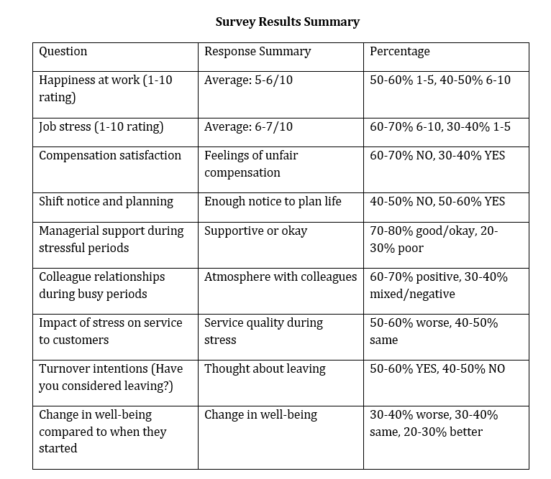
Analysis of Primary Data
Data Presentation
The survey and interview findings of McDonald's, Birmingham, overall show that there are multiple concerns regarding employee welfare. Just a percentage of 60-70 stated that the employees experienced high levels of stress with a score range of between 6 and 10 out of 10, which was mainly because of long shifts and heavy workloads (Dumitriu et al., 2025). Moreover, a fifth to half told of being unhappy with their compensation, based on some unfairness. Additionally, 55-60% had rated their job satisfaction as less than 6/ 10 and had shown that they were thinking of quitting because of these problems.

Discussion of Findings
The results are comparable to the past studies on job stress and turnover intentions. According to Elshaer et al. (2025), fast-food employees are likely to experience burnout and turnover due to high stress and low pay. The same trend is observed in the McDonald's data, whereby the employees who were under stress and dissatisfied were more likely to think about quitting. In addition, 50-60 per cent of respondents claimed that stress adversely affected their customer service, which confirms the relationship between employee well-being, service quality, and performance in the organisation.

Themes Identified
The data revealed several important themes that influence the well-being of the employees. The question of pay and compensation also became one of the points that 60-70% of workers complained about, and is consistent with the literature that has been associating low pay with stress and low morale (Lupu et al., 2025). The alteration of schedules was also stressful for 40-50% of workers with work-life balance problems. Although 70-80% ended up having sufficient management support, 20-30% added that they were not getting the management support in periods when they were busy, which implied that there was a necessity for better management practices.

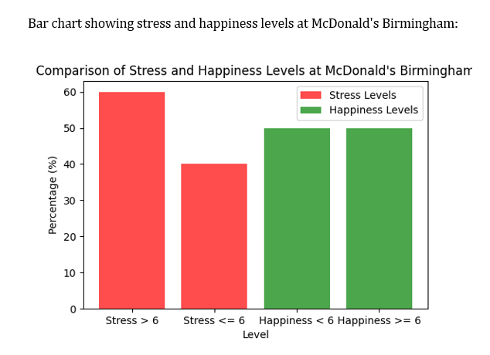

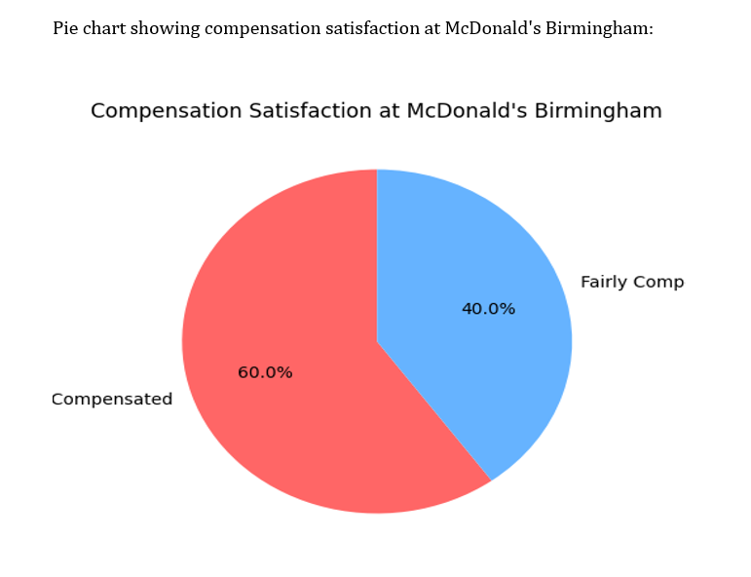
Implications and Recommendations in Practice.

Effect on Business Processes.
Employee welfare greatly determines the business performance of McDonald's, specifically in terms of turnover, service delivery, and efficiency of operations. High stress and burnout also cause high rates of turnover, which causes extra costs in terms of recruitment and training. Poor work conditions and pay dissatisfaction influence the dynamics of a team and the quality of the services in a negative way (Sibanyoni et al., 2024). When employees are stressed, their ability to provide good service is reduced, and this will lead to poor customer satisfaction and a tarnished reputation of the company.

Recommendations
McDonald's needs to revise and expand the employee compensation and benefit plan in an effort to enhance the welfare of its employees. It would alleviate stress and dissatisfaction among employees by providing increased pay and benefits such as medical and vacation (Dangaiso & Mukucha, 2024). Employees would be relieved of financial pressure, employee standards would be boosted, and turnover would be reduced due to improved wages and other benefits. This strategy would conserve talent, develop a more fixed workforce and eventually improve long-term performance of the company because of improved employee satisfaction and reduced recruitment expenses.

Stress Management and Work Life Programs.
The solution of addressing staff stress is among the key issues to McDonald's success. Mindfulness and other mental health resources could be implemented as stress reduction programs that would enhance the well-being of employees (Dangaiso & Mukucha, 2024). Also, there should be flexible work schedules and sufficient use of shifts to support a healthy work-life balance. These would assist the employees in sustaining their personal and work life, enhancing employee satisfaction, and decreasing stress levels. McDonald's can enhance the performance and satisfaction of employees by giving them the required breaks and accommodating their needs.
Managerial Personnel and Supply Award.
Employee well-being needs managerial support, particularly in stressful working environments such as McDonald's. Training to help the employees come out of stressful situations should be provided to the managers so that they can feel appreciated and listened to (Cinar & Bilodeau, 2022). Rewarding the employees by rewarding their success, like in programmes like Employee of the Month or normal praise, motivates a good working environment and enhances morale.
Strategic Implications
Increasing employee welfare gives McDonalds competitive advantage, resulting in improved performance and greater productivity. The engaged employees are healthier and enhance the customer interactions and satisfaction, which enhances the brand and fosters loyalty (Sibanyoni et al., 2024). Also, minimising turnover and absenteeism reduces recruitment and training costs. In the long run, the interest in employee welfare enhances the efficiency of operations, customer satisfaction, and overall success.
Conclusion
This study brings out the key interconnection between the welfare and the performance of the employees in McDonald's, Birmingham. The stress rates, burnout, and turnover have an enormous influence on the quality of services, efficiency, and business in general. McDonald's can make the workforce more satisfied and engaged by means of improved compensation, stress reduction programs, better work-life balance, and improved managerial support. Such developments would help not only to decrease turnover and absenteeism costs, but also improve customer service and operating efficiency. Finally, the investment in employee well-being will give McDonald's a competitive edge in the short and long term, resulting in the ultimate success and improvement in business operations.
References
Cinar, A.B. & Bilodeau, S. (2022). Sustainable Workplace Mental Well-Being for Sustainable SMEs: How? Sustainability, 14(9), p.5290. doi: https://doi.org/10.3390/su14095290.
Dangaiso, P. & Mukucha, P. (2024). Evaluating the impact of service encounter incivility on employee job stress, turnover intentions, and labour attrition: a study on frontline employees in the fast-food service industry. Cogent business & management, 11(1). doi: https://doi.org/10.1080/23311975.2024.2355671.
Dumitriu, S., George, B.C., Vărzaru, Anca Antoaneta, Al-Floarei, Andreea Teodora, Maria, S.N., Popescu, F.L. and Băloi, I.-C. (2025). The Role of the Workplace Environment in Shaping Employees' Well-being. Sustainability, [online] 17(6), p.2613. Available at: https://www.mdpi.com/2071-1050/17/6/2613.
Elshaer, I.A., Azazz, A.M.S., Fayyad, S., Kooli, C., Fouad, A.M., Hamdy, A., & Fathy, E.A. (2025). Consumer Boycotts and Fast-Food Chains: Economic Consequences and Reputational Damage. Societies, [online] 15(5), p.114. doi: https://doi.org/10.3390/soc15050114.
Gelencsér, M., Szabó-Szentgróti, G., Kőmüves, Z.S. and Hollósy-Vadász, G. (2023). The Holistic Model of Labour Retention: The Impact of Workplace Well-being Factors on Employee Retention. Administrative Sciences, [online] 13(5), p.121. doi: https://doi.org/10.3390/admsci13050121.
Lupu, C.E., Scafa-Udriște, A., Matei, R.S., Licu, M., Stanciu, T.I., Stanciu, G., Hashemi, F., Mihai, A., Lupu, S., Ene, R., Cristache, R.E., Boroghină, S.C., Coliță, A., Buda, O. and Mititelu, M. (2025). Adolescent Nutritional Patterns and Health Behaviours in Romania: A Cross-Sectional Analysis. Nutrients, [online] 17(9), p.1448. doi: https://doi.org/10.3390/nu17091448.
Sibanyoni, T.M., Tshipala, N.N., & Venter, D.H. (2024). Key factors of job satisfaction among the tourism and hospitality employees within national parks. SA Journal of Human Resource Management, [online] 22(0), p.10. Available at: https://sajhrm.co.za/index.php/sajhrm/article/view/2474/3759?
Žnidaršič, J. & Bernik, M. (2026). Drivers of Work Engagement in the Private Sector: The Mediating Role of Work–Life Balance and Behavioural Work-Life Conflict. Sustainability, 18(3), p.1382. doi: https://doi.org/10.3390/su18031382.

