Peter Kristof
Student 2113479

Module: Effective Team Work and Communication
Module code: BMSW4002

Assignment Title: Effective Team Work and Communication Assessment 1

University of Wales Trinity St David
Lecturer: Saqib Shamim



Table of Contents
Introduction 2
Verbal and non-verbal communication 3
Models of communication 3
Shannon and Weaver (1949) 3
Schramm (1954) 4
Berlo (1961) 4
Source 4
Message 5
Channel 5
Receiver 6
Communication skills 6
Example of poor communication at the workplace 8
Advantages of technology in communication 8
Disadvantages of technology in communication 9
Conclusion 9
References 9

Introduction

What is communication? Most people would say communication is talking but is that true? We talk every day to family members, friends, colleagues, and even strangers but is that communication? Talking is speaking words or sentences to others and sometimes the others understand what message we are trying to pass but sometimes they do not. We can even talk to ourselves with understanding the message but is that communication? Communication is exchanging information, thoughts, or opinions from one person or group to another. We can also say that communication is a process where two or more people reach understanding. So, it is a two-way process where the speaker or sender is sending a message and the listener or receiver is trying to understand the message. Speakers should speak, and listeners should pay attention to the speaker’s message. The problem is that most people focus more on what they want to say rather than listening to others. People ignore the importance of listening, but they need to realize it is not communication when no one receives the message. Distraction or lack of interest also plays a big role in misunderstanding or failure to receive the message.

Verbal and non-verbal communication
We usually use verbal and non-verbal communication at the same moment effectively, sometimes without realizing it. Verbal communication is the use of words to pass the message. This includes oral and written communication. Some examples of oral communication are speech, interviews, face-to-face conversation, and television or radio broadcasting. Examples of written communications are emails, books, text messages, notes, or letters. In non-verbal communication, we use our body to pass the message for example smiling, head nods, handshakes, hugs, gestures, voice tone, eye contact, and much more. Both forms of communication can be learned and mastered. (Bajracharya, 2018)
According to Professor Albert Mehrabian, 7% of the message we receive is from the words that are spoken, 38% of the message we receive is from the way the words are said and a huge 55% of the message we receive is from facial expression. (Mehrabian and Chapman, 2022). So according to this, non-verbal communication is even more powerful than verbal communication as people tend to transmit most of the message from the way words are said and facial expressions. We need to be careful when using non-verbal communication as some gestures may have various meanings for people from different cultures.

Models of communication

Shannon and Weaver (1949)

Shannon- Weaver’s model of communication is the first and most basic model of communication. This model was originally developed in 1949 to improve technical communication, but it was later generally applied in the field of Communication. According to this model, the sender is the originator of the message, the encoder is the transmitter that encodes a message into a signal. For face-to-face communication, we can compare it to our thoughts being converted into a common language. Then the signal goes through the channel, for example, voice, text message, emails, and reach decoder. The decoder converts the signal back into the message and passes it to the receiver. The receiver is the destination of the message. The advantage of this model is the consideration of noise, which can cause distraction and maybe why the message is misunderstood or not received. The main problem of this model is a lack of nonverbal communication which is an enormous part of communication. This model also does not take into consideration the feedback, so the sender is not sure if the message was received correctly.
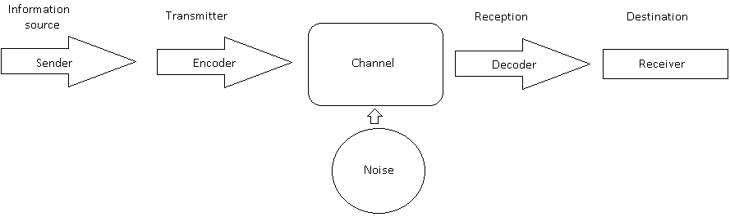

Schramm (1954)

This model was built on top of Shannon- Weaver’s model of communication by Wilber Schramm in 1954. Encoding and decoding is the most important factor for effective communication. According to Schramm receiver needs to understand the message otherwise is the message useless. He also believed communication is a two-way process between sender and receiver and communication is not complete if the sender does not receive feedback. The receiver is responsible to give feedback and let the sender know if the message was received correctly otherwise communication is not effective. Schramm also believed that senders’ and receivers’ knowledge, experience, and background are important in communication, affecting how we interpret the message. The advantage of this model is that it takes into consideration feedback and senders’ and receivers’ field of knowledge. (Juneja, 2022)

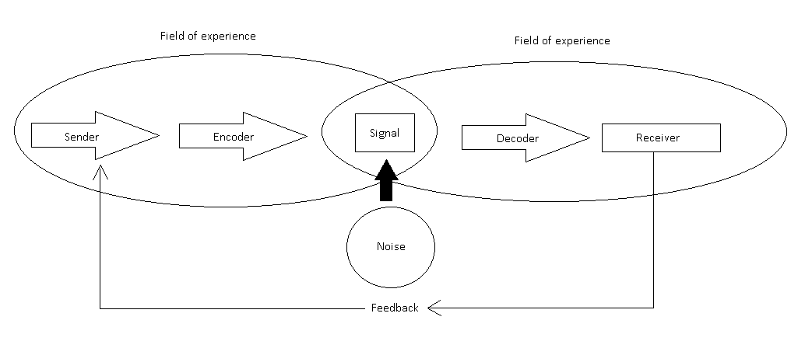

Berlo (1961)

Berlos’ model of communication takes into consideration the emotional aspect of the message and describes components that form communication. It operates on the SMCR model.
S- source
M- message
C- channel
R- receiver

Source

Also called the sender, it is the person that transfers the message to the receiver.
The factors that affect source and receiver are:
Communication skills- The source needs to have good communication skills, he needs to know where to pause, repeat the sentence, pronounce words, and so on.
Attitude- sender needs to have a good attitude toward the audience to impress.
Knowledge- knowledge affects the clarity of information the sender tries to transfer. The sender needs to be familiar with the topic or subject and be ready to answer clarifying questions.
Social system- beliefs and religious feelings influence speech.
Culture- different backgrounds influence the understanding of the message

Message

The message is information or meaning that is sent from sender to receiver. It is created when converting thoughts or opinions into words and it is also called encoding.
The message is influenced by:
Content- thoughts need to be transferred into words and they need to be prepared
Element- the audience will lose interest if the speech is not supported with nonverbal communication such as gestures, facial expression, voice tone, posture, and more.
Treatment- it is the way the sender treats a message. The sender needs to understand the importance of the message so he can pass it appropriately.
Structure- message needs to be structured correctly to send it in the desired form.
Code- the correct nonverbal communication needs to be used otherwise the receiver will not be able to decode the message correctly.

Channel

Channel is a medium used to pass the message. The sender is using his senses to send a message and the receiver must be able to receive the message using his senses. Humans have five senses:
Hearing
Seeing
Touching
Smelling
Tasting
We use all those senses to send or receive the message.

Receiver

The receiver decodes the message. He should have good communication skills to understand what information is sender trying to pass. He should also have a good attitude, knowledge of the subject, and come from the same social and cultural background as a sender to correctly understand the message. The factors that affect the receiver are the same as the factors that affect the sender.
According to this model sender and receiver must be on the common ground for a smooth conversation however most of the time it is not practical in the real world. Other disadvantages are lack of feedback, no room for noise, and it does not consider any barriers to communication. This model is also very complex. (Juneja, 2022)
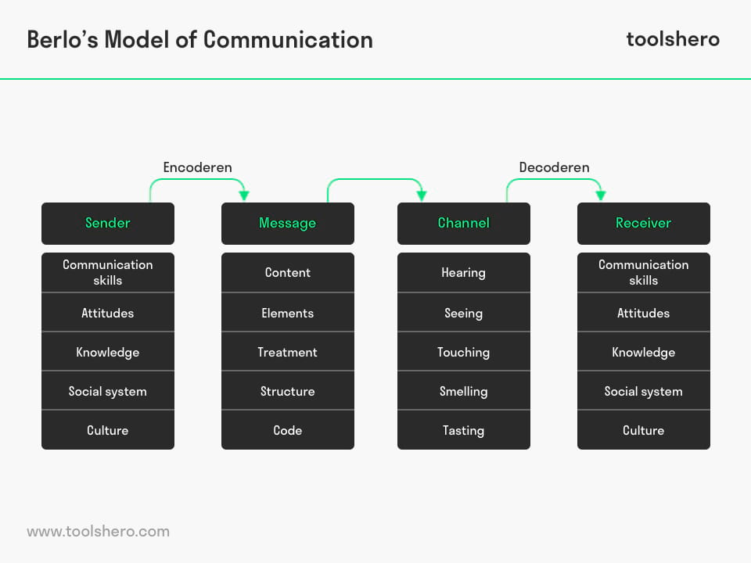
(Janse, 2022)

Communication skills

Communication skills are essential for our workplace and personal life. We need to know how to send and receive messages in person as well as via digital channels. We can use different skills to help us communicate effectively with others.
The most important communication skill is active listening. Being a good listener nearly equals being a good communicator. No one likes to communicate with people that only talk and never listen to others. Active listening involves paying attention to the message others try to pass, asking the question that will clarify the topic, and rephrasing it to ensure understanding. Thanks to active listening we can respond appropriately to the message.
Nonverbal communication such as body language, eye contact, and gestures also play a big part in communication skills. By looking into the sender’s eyes, we demonstrate our focus on the conversation. We also need to pay attention to the nonverbal communication of others. Thanks to that we will acquire more information like their feelings, or if the other person is avoiding eye contact it may signal, he is not comfortable or hiding the truth.
Good verbal communication includes staying on the topic, saying not too much or too little. The best practice is to stay direct and think about what we want to say before we say it, this will give our message clarity and we will not confuse our audience.
Friendliness and politeness are also important, if we use a friendly tone and smile, we will encourage another party to have open and honest communication with us. Many times, in the past I approached the angry person with a friendly tone, and I could see a change in his reactions. Suddenly he calmed down, replied in a calmer tone, and within a few sentences, we had a nice conversation. It is like a boomerang, whatever you throw on people will come back to you.
That brings us to confidence. If we are confident in our replies, we will earn the trust of others. Of course, we need to make sure we do not sound arrogant, and as I mentioned before we also need to keep eye contact as that will show others, we are being honest.
Once we get into the conversation it is good to show empathy, this will demonstrate that we were listening, and we are trying to understand others’ points of view. Sometimes even a short “Sorry to hear that” can make a difference. Many times, people do not talk to you because they are trying to find a solution to their problem, they just want to talk it out and they feel much better when someone is showing them empathy.
Many times, I entered the conversation disagreeing with the ideas others tried to present but by the end of the conversation, they convinced me their ideas is good. I was able to change my mind because I respected the opinions of others and tried to be open-minded. That is why it is so important to bring an open mind and respect to the conversation, even if we are in a conversation with someone we disagree with. We should try to understand their point of view and respect their opinions. We can show respect by performing skills I mentioned before such as active listening, eye contact, and friendly voice tone. All those will show others in the dialog that we are respecting them even if we disagree.
When starting the conversation, we always need to choose the right channel depending on the topic and audience. Some channels are more formal as email, some are more informal such as text messages or phone calls. Some channel depends on conversation and audience for example it is a different face-to-face conversation with your family or friends to a conversation with your boss or colleagues. Your boss can use email to pass you some messages but when it comes to important staff it will be better to use face-to-face conversation to ensure the message is understood. If the message has an emotional impact on the receiver, it is also better to use face-to-face conversation as you can reassure the receiver and be the emotional support he may need.

Finally, I want to talk about feedback. Many people underestimate the importance of feedback. Feedback in conversation can make a huge difference. Simply asking a clarifying question to ensure we fully understand the message is crucial in communication. We can get feedback from others’ nonverbal communication as well, we can see if the receiver understood the message and if he is annoyed, angry, happy, or sad with the message we are sending. When we see the receiver is changing his attitude, for example, he is getting angry, we can also change our voice tone to calm him down. If we see he is getting confused, we can explain the message we are passing or use different words to make it simpler to understand. Many times, we do not realize we may sound angry when communicating with others but thanks to their nonverbal and verbal feedback we can change our voice tone, facial expression, or body language at any time. By doing that we can de-escalate the situation and prevent unneeded arguments. (DOYLE, 2022)

Example of poor communication at the workplace

I see poor communication between my colleagues every day. Sometimes they don’t use the right channel other times they are not aware of their nonverbal communication when trying to pass the message. But the biggest problem in my workplace is a lack of active listening. All colleagues try to say something but not many actively listen. Just because of a lack of listening skills we had many misunderstandings and conflicts in the past and most of them could be easily avoided. Once we had two of my colleagues arguing about the way to do the task so much that I had to interfere. After joining the discussion, I could see a change in their approach thanks to my calm voice. I asked each party about their point of view and ensure they are not interfering with each other. I kept eye contact with the speaker and listen carefully while sending nonverbal feedback to the speaker. I also asked clarifying questions to ensure I fully understand each point of view. After listening to both I was able to find a solution that both parties were happy about. The conflict has been resolved quickly and they both thanked me for resolving the conflict for them.
Communication in our workplace could be improved by learning communication skills like active listening, using the right nonverbal communication, choosing the right channel, showing respect and friendliness, and giving feedback to the speaker including clarifying questions. Also, sometimes people get into conflict only because they do not enter a conversation with an open mind, and they find it difficult to embrace others people’s opinions.

Advantages of technology in communication

Technology in communication has many advantages. We can communicate with people all over the world thanks to information technologies. We can send a message and the message can reach person miles away from us in a few seconds. So, we can say the communication speed has improved dramatically in the past decade. Technologies also allow us to track the conversation and check the history of the conversation in case we forget or just want to go back to a message we received in the past.

Disadvantages of technology in communication

There are some disadvantages of technologies in communication such as lack of feedback, empathy, or nonverbal communication when an incorrect channel is used. Another disadvantage is privacy as our conversation may be accessed by a third party in hackers’ attacks.

Conclusion

Effective communication has an essential role in the workplace and personal life. By communicating effectively, we build trust between co-workers and family members. The ability to listen and embrace different points of view or opinions helps others trust that you make non-favorable decisions for everyone in the group. That also creates a better relationship with others as they are not afraid to present their ideas and suggestions or openly talk about concerns. We can also prevent problems and resolve any issues that may arise thanks to effective communication. With good communication skills, we can provide clarity and improve productivity when passing the message. When team members understand their roles and the roles of others, they can focus more on their objectives without being distracted.
Communication also has some disadvantages for example when someone is passing the information that should be confidential or when the incorrect channel for communication is chosen leaving people confused. Some messages may be also wrongly worded, sentenced, or decoded by the receiver. Sometimes sender keeps sending too much information not needed by the receiver and after a while receiver will stop listening and miss some important messages. There are also environmental factors like noise that may be affecting communication.

References

Bajracharya, S., 2018. Verbal versus Non-verbal Communication - Businesstopia. [online] Businesstopia. Available at: <https://www.businesstopia.net/communication/verbal-vs-non-verbal-communication> [Accessed 25 April 2022].
Mehrabian, A. and Chapman, A., 2022. Mehrabian's Communication Theory: Verbal, Non-Verbal, Body Language. [online] Businessballs.com. Available at: <https://www.businessballs.com/communication-skills/mehrabians-communication-theory-verbal-non-verbal-body-language/> [Accessed 25 April 2022].
DOYLE, A., 2022. These Are the Communication Skills Employers Look for in Employees. [online] The Balance Careers. Available at: <https://www.thebalancecareers.com/communication-skills-list-2063779> [Accessed 26 April 2022].
Juneja, P., 2022. Schramm's Model of Communication. [online] Managementstudyguide.com. Available at: <https://www.managementstudyguide.com/schramm-model-of-communication.htm> [Accessed 28 April 2022].
Juneja, P., 2022. Berlo's Model of Communication. [online] Managementstudyguide.com. Available at: <https://www.managementstudyguide.com/berlo-model-of-communication.htm> [Accessed 1 May 2022].
Janse, B., 2022. Berlo's SMCR Model of Communication. [online] toolshero. Available at: <https://www.toolshero.com/communication-skills/berlos-smcr-model-of-communication/> [Accessed 1May 2022].

