Table of Contents
a. Calculate the resistance of E and H for the circuit’s configuration. [3] 2
b. B and C are identical and the current passing through A is 0.5A, calculate the current passing through B and C. [2] 2
c. 2
c (i) The Resistance of A. [2] 2
c (ii) The Resistance of B and C. [3] 2
c (iii) The potential difference across A, B and C. [1] 2
c (iv) Since the total potential different across L to M is 6V, calculate the potential different across D and find its Resistance. [2] 2
d. The lost volts across one of the cells in the parallel arrangement is 2V. Calculate r and hence the total resistance of the parallel combination of cells. [3] 2
e. Given that the resistance F is 6Ω, calculate the voltage drop across it. [2] 2
f. Calculate the total resistance of the circuit, this includes total internal and the resistance cause by the reverse polarity battery and the open diodes in given scenario (ignore any “non-open diodes”). [2] 2
g. Calculate the emf of each of the cells in the parallel combination. [3] 3

Calculate the resistance of E and H for the circuit’s configuration. [3]

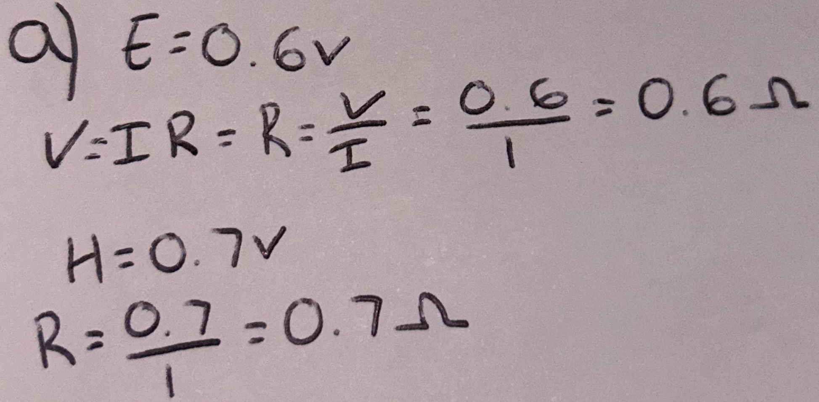
Answer = 0.6Ω and 0.7Ω

B and C are identical and the current passing through A is 0.5A, calculate the current passing through B and C. [2]

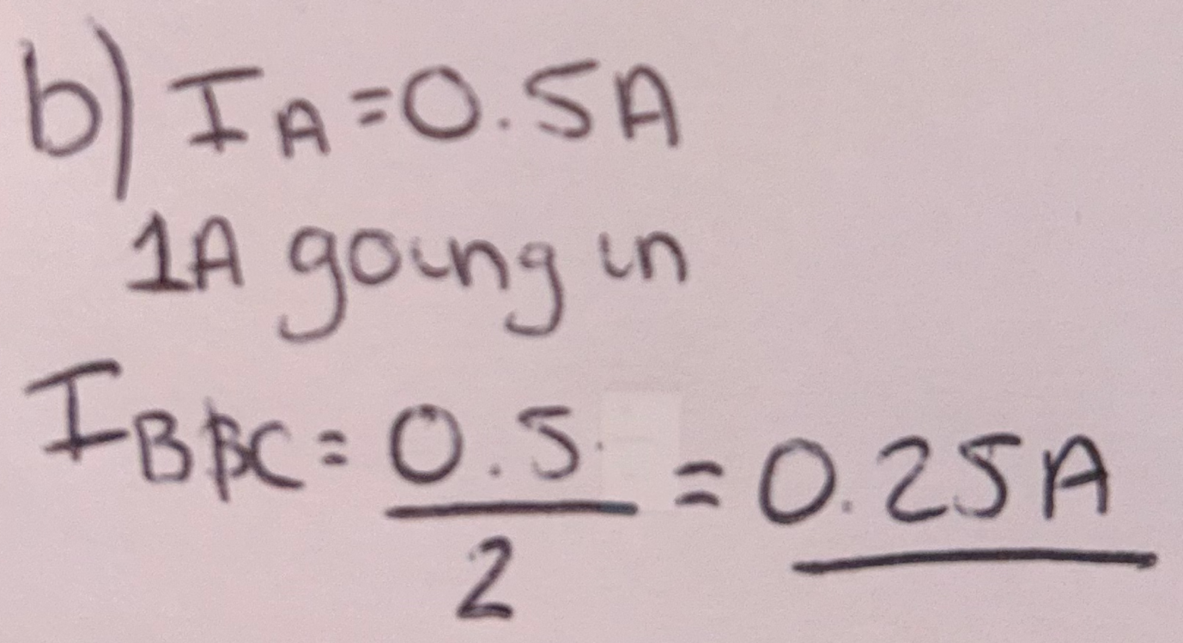
Answer = 0.25A

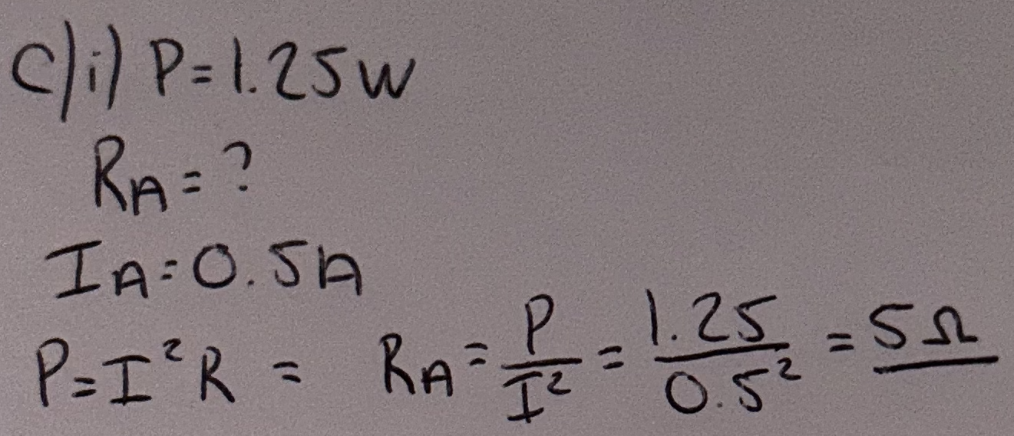
c (i) The Resistance of A. [2]
Answer = 5Ω

c (ii) The Resistance of B and C. [3]

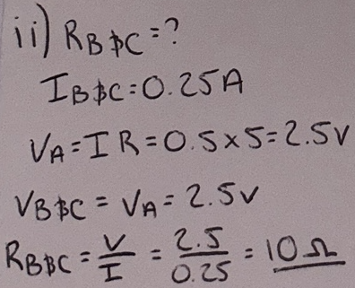
Answer = 10Ω

c (iii) The potential difference across A, B and C. [1]

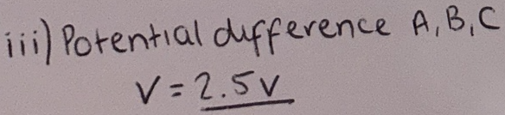
Answer = 2.5V

c (iv) Since the total potential different across L to M is 6V, calculate the potential different across D and find its Resistance. [2]

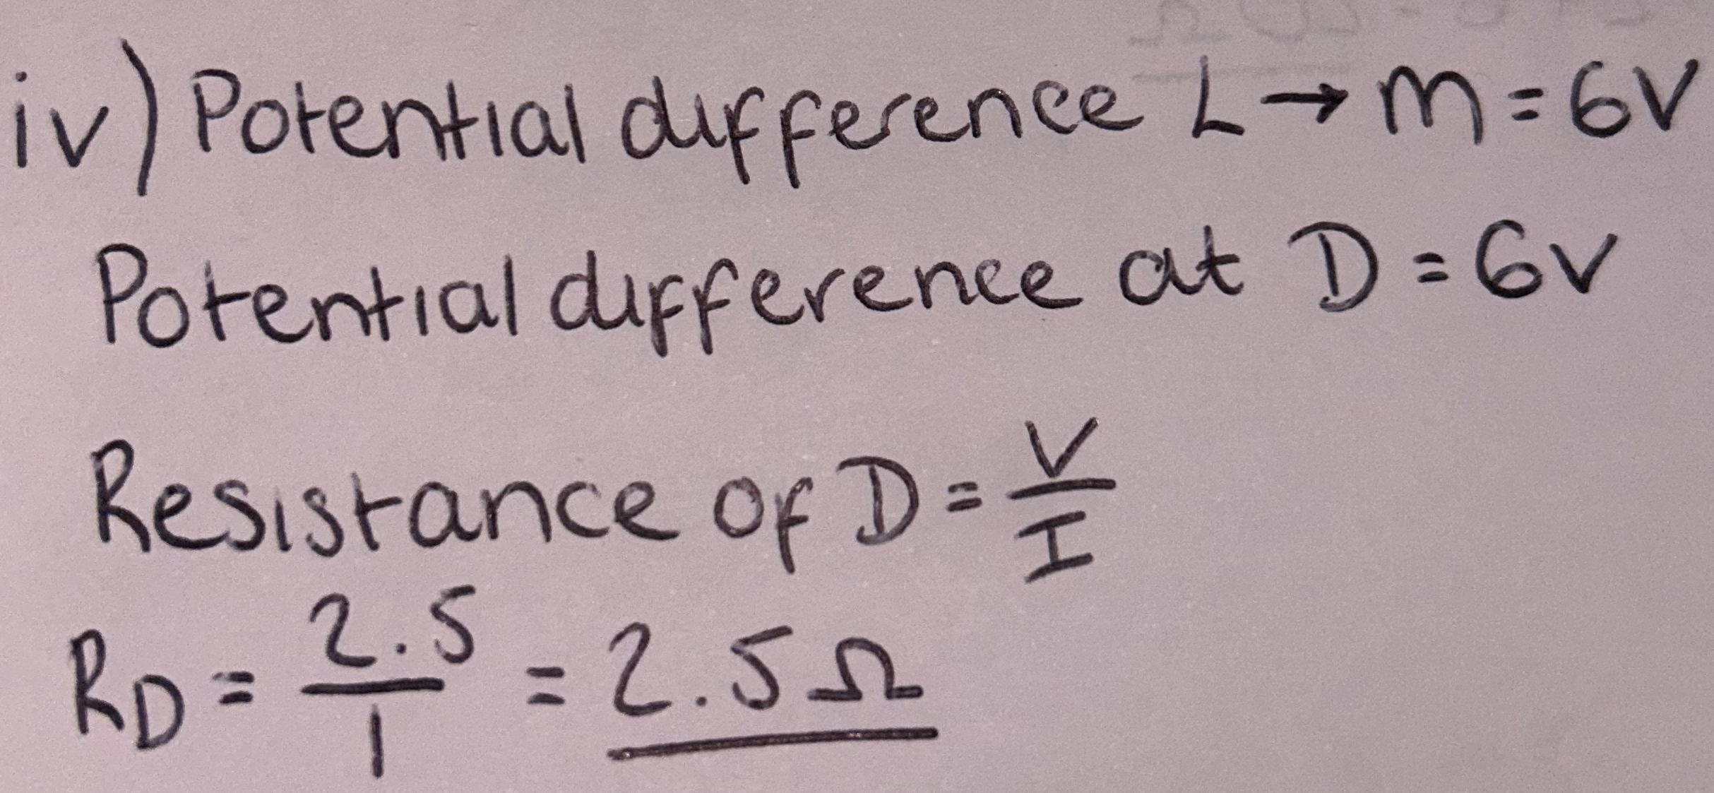
Answer = P.d = 6V and Resistance D = 2.5Ω

The lost volts across one of the cells in the parallel arrangement is 2V. Calculate r and hence the total resistance of the parallel combination of cells. [3]

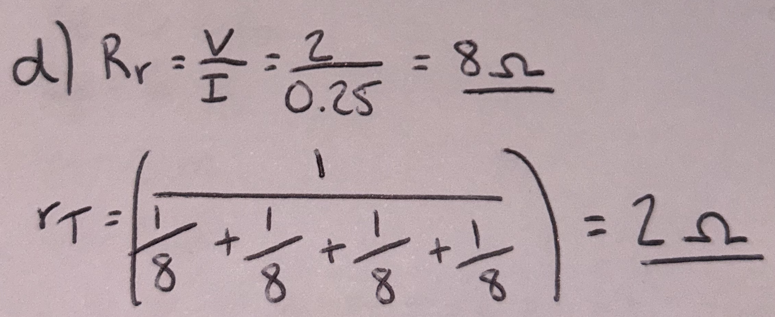
Answer = 8Ω and 2Ω

Given that the resistance F is 6Ω, calculate the voltage drop across it. [2]

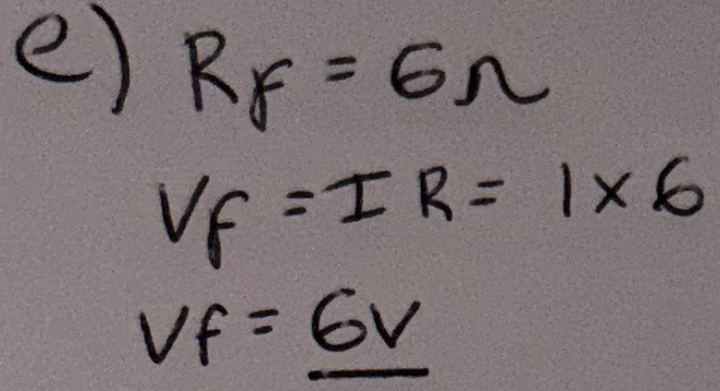
Answer = 6V

Calculate the total resistance of the circuit, this includes total internal and the resistance cause by the reverse polarity battery and the open diodes in given scenario (ignore any “non-open diodes”). [2]

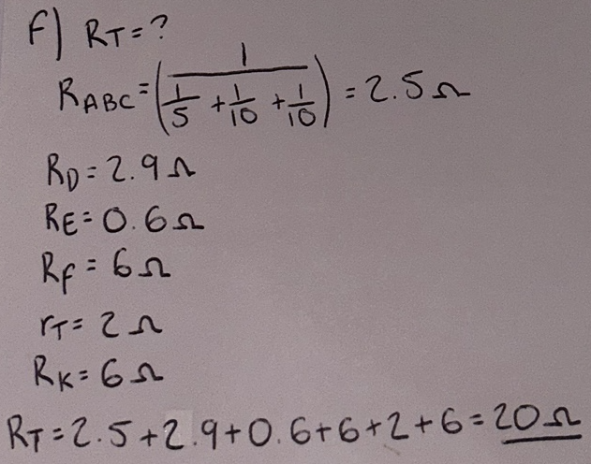
Answer = 20Ω

Calculate the emf of each of the cells in the parallel combination. [3]
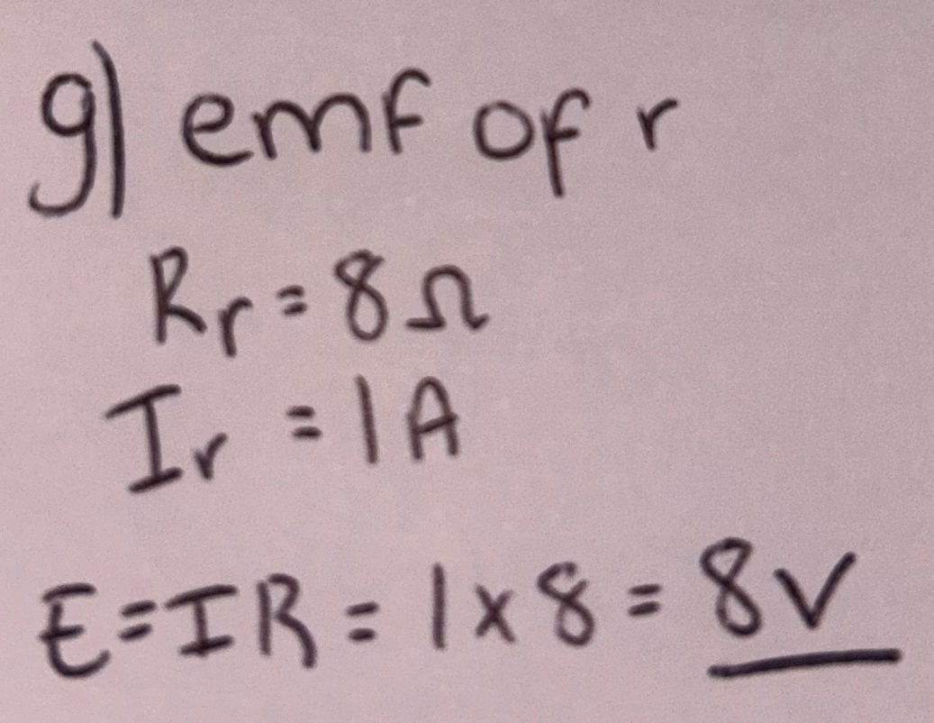

Answer = 8V

