program of study: BA (Hons) Business Management
module name and code: Entrepreneurship (LCBB5001)
title: Component 1: Written Report
lecturer: Dr Said Usman
name: Catalin Tabaras
word count: 2236

Vinalia: Romanian Wine Tasting Bar
Table of Contents
Overview of the Business Idea 2
Products and Services 2
Legal Format of the Startup Company 3
Management and Operations of the Company 3
SWOT Analysis 4
4Ps of Marketing 6
Cash Flow Forecast for the First 12 Months 9
References 11

Overview of the Business Idea

Vinalia aims to carve out a special place in London’s culinary scene by bringing attention to the rich yet often underappreciated world of Romanian wines. A carefully curated selection features everything from the crisp whites of Transylvania to the robust reds of Dealu’ Mare. The wine tasting bar caters not only to the nostalgic tastes of the local Romanian community but also to adventurous wine lovers eager to discover new flavors.
To enhance the wine experience, the settlement offers a genuine dining journey with traditional cold platters that highlight Romanian cheeses, cured meats, and fish dishes, immersing guests in the Romanian culture. By beautifully blending exceptional wines with authentic cuisine in a sophisticated yet welcoming atmosphere, Vinalia strives to be a cultural ambassador for Romania, inviting everyone to explore and enjoy their heritage amidst London’s vibrant dining landscape. Vinalia’s mission is to enrich this culinary world by showcasing the diverse and often overlooked treasures of Romanian wines.

Products and Services
Vinalia seeks to establish a distinct presence in London's culinary landscape by introducing patrons to the often-disregarded Romanian wines, showcasing diverse selections from regions like Transylvania and Dealu Mare. Catering to both the local Romanian community and adventurous wine enthusiasts, Vinalia pairs its wines with traditional Romanian cold platters, featuring cheeses, cured meats, and fish dishes. This combination aims to enhance the wine tasting experience while immersing guests in Romanian culture, positioning Vinalia as a cultural ambassador within London's vibrant dining scene. The business model the company adopts is a traditional retailer one, as it will sell products or services created by others directly to consumers at a higher price than the original (Barringer and Duane, 2018).

Legal Format of the Startup Company

Vinalia's choice to operate as a Limited Company in the UK brings multiple strategic benefits. This structure helps protect the personal assets of owners from the company's debts and legal problems, enabling founders to take risks without putting their personal finances on the line. It also offers benefits like lower corporate tax rates and the ability to deduct a wider range of expenses. Additionally, the Limited Company format permits flexible profit distribution through dividends, benefiting both the business and its shareholders (Barringer & Ireland, 2018). Moreover, this structure enhances Vinalia's market credibility, aiding in securing funding and partnerships, and establishes a solid foundation for its growth and sustainability in a competitive startup environment.

Management and Operations of the Company

The Company's management structure is tailored to promote efficient operations and deliver a high-quality customer experience. The owner, Catalin Tabaras, also in the position of General Manager, leads the team, bringing significant hospitality experience and a passion for Romanian culture and wines, which are central to the business's vision and strategy, especially in providing an authentic wine experience. To assist with daily operations, two part-time staff members will focus on service and support, helping uphold excellent customer service and a welcoming environment. The Wine Director is a Romanian wine expert who curates the wine list, organizes tastings, and trains staff on wine selection and pairing, playing a key role in enriching the Company's offerings and organizing engaging wine activities. The Marketing Manager promotes the wine bar through social media and events to attract both locals and tourists interested in Romanian culture. The Operations Manager takes care of logistics, inventory, supplier relationships, and makes sure the bar follows health and safety rules, while the Customer Experience Manager focuses on improving guest experiences by gathering feedback and making needed changes. Finally, the Events Coordinator organizes special events, wine tastings, and cultural nights to engage the community and promote the bar.
Additionally, the business will use professional services, including an accountant for financial oversight and a legal advisor for compliance with licensing and regulations. This integrated management strategy combines internal expertise with external support, setting the company up for success in the competitive wine bar market.

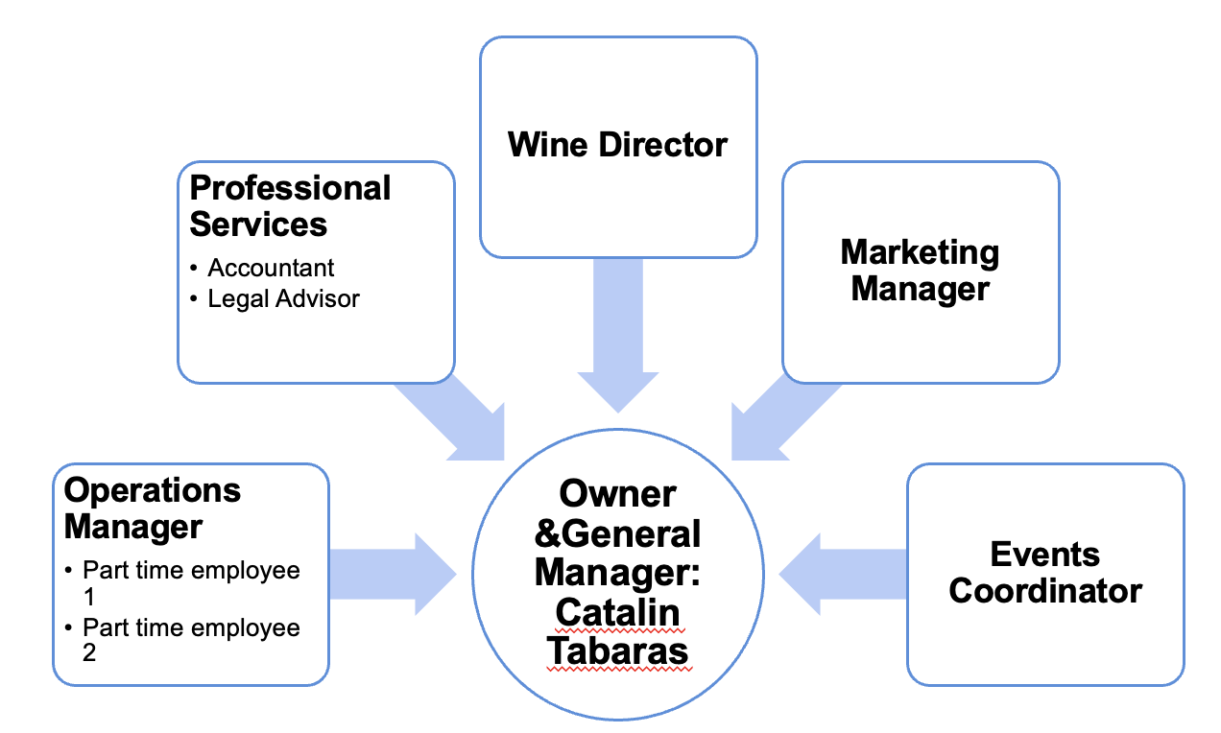

SWOT Analysis

A SWOT analysis of a company’s strengths, weaknesses, opportunities, and threats provides valuable insights for strategic planning, marketing campaigns, and competitor profiling (Hague, 2023).

Strengths

Vinalia's market position is anchored in its focus on Romanian wines, targeting enthusiasts of authentic, lesser-known varietals. This niche sets it apart from competitors and meets the rising demand for diverse wine experiences. Strong connections with Romanian winemakers ensure a steady supply of quality products (Jandik & Salikhova, 2023), enhancing brand credibility and attracting consumers seeking genuine cultural experiences. The skilled management team, experienced in importation, distribution, and marketing, is crucial in navigating the international wine trade, fostering supplier relationships, and promoting Romanian wines. Their expertise enables Vinalia to make strategic decisions on product selection, pricing, and market expansion, establishing it as a leading source for Romanian wines.

Weaknesses

Limited market awareness presents a major challenge for Vinalia’s customer acquisition efforts (Chen, 2024). As a relatively unknown player in the industry, attracting potential customers who may not be familiar with the products or services is difficult. This lack of visibility hinders the company’s competitiveness against well-established brands, potentially resulting in slower growth and diminished market share (Kene & Kene, 2024). Additionally, the focus on a niche market allows Vinalia to specialize and meet specific customer needs, however it may also limit the overall growth potential. Relying on a narrow customer base increases the risk if market conditions or consumer preferences shift (Pavlovic, Reyneke, & Boyd, 2021); a decline in demand within this niche could make it challenging to pivot or expand into new areas without significant investment in research, development, and marketing. This restricted focus may also prevent the firm from taking advantage of broader market trends or opportunities outside the current scope, leaving it vulnerable to more adaptable and diversified competitors (Biloshapka & Osiyevskyy, 2019).

Opportunities

People around the world are becoming more interested in the different wine cultures, creating a big opportunity for producers and sellers to grow their market and brand presence. Nowadays, wine lovers want to explore and enjoy the unique traditions and flavors from various wine regions (Scheid, 2024). Businesses can tap into this growing trend by creating educational and interactive marketing experiences that let customers immerse themselves in the rich cultural heritage of their wines. Hosting events like themed dinners, virtual vineyard tours, and interactive workshops can provide memorable experiences that deepen consumer connections and foster loyalty. Collaborating with cultural groups and local artisans can add authenticity and extra appeal to these occasions, boosting word-of-mouth promotion.

Threats
Entering the market as a new wine bar is tough due to established competitors who already enjoy loyal customers, strong supplier ties, and fine-tuned operations. These existing bars often have great locations and brand recognition, making it challenging for newcomers to win over patrons and gain market share. To stand out, a new wine bar needs to offer something unique, deliver exceptional service, or bring fresh, innovative ideas to the table. Vinalia does this, by bringing to the table also a story of culture.
Economic downturns also pose a significant risk, as people tend to reduce spending on non-essential items like luxury goods and dining out during challenging times (Koh, Choi & Lee, 2013). This can seriously impact a wine bar’s earnings and threaten its survival. To mitigate this, new wine bars should think about ways to appeal to budget-conscious customers, such as running special promotions, creating value-focused menus, or diversifying by selling wines for home consumption and offering virtual tasting events. These strategies can help generate additional revenue streams, even when the economy is struggling.

4Ps of Marketing

According to Hague (2023), the 4P model is valuable for developing marketing plans or business cases, especially for new product launches and market entries.

Product

Vinalia’s handpicked selection of exclusive Romanian wines is at the heart of the wine tasting bar’s unique offering, showcasing the country's rich viticultural heritage. These wines, sourced from top vineyards across Romania's diverse regions, feature both traditional varieties and modern blends, catering to wine connoisseurs and casual enthusiasts alike. The collection features indigenous grape varieties like Fetească Neagră, Băbească Neagră, and Tămâioasă Românească, as well as other types that showcase the unique Romanian terroir. To enhance the wine experience, the hosts will also provide a menu of authentic Romanian version of antipasti prepared with traditional recipes and locally sourced ingredients. This pairing will create a comprehensive gastronomic experience that immerses guests in Romanian culture. From hearty cold meat dishes like air-dried ham and sausages to vegetarian offerings like Zacuscă (vegetable spread) and Salata de Vinete (eggplant salad), along with traditional fish options like smoked trout, the food options are designed to complement the wines while requiring no proper kitchen since all items are premade and served cold. This exceptional combination of Romanian wines and authentic cuisine will distinguish the establishment, offering patrons a unique and memorable experience that is not available elsewhere in the local market.

Price

A competitive pricing strategy will be introduced to attract both Romanian customers and non-Romanian wine enthusiasts. This strategy will involve a thorough analysis of current market prices for similar wines in Romania and abroad, taking into account production costs, quality, and brand positioning. The pricing will aim to present the wines as high-quality yet accessible, maintaining a balance between affordability for local consumers and premium appeal for international buyers. To enhance this strategy, a tiered pricing approach may be employed, providing different price levels for various wine collections, including an entry-level range for everyday use, a mid-range selection for special occasions, and a premium line aimed at connoisseurs and collectors. Additionally, promotional pricing and volume discounts could be offered during certain seasons or events to boost sales and improve market penetration. By adopting a flexible and competitive pricing strategy, the winery can address a broad range of customer segments, optimize revenue potential, and establish a robust presence in both domestic and international markets (Gonen, Tavor, & Spiegel, 2024).

Place

A semi-central bar in London presents several advantages for attracting and retaining the target demographics (Williams, 2022). Located in the heart of the Romanian community in Stratford, the venue benefits from excellent public transport connections, including nearby tube stations and bus routes, making it easily accessible for both locals and tourists. Additionally, the location leverages high foot traffic from surrounding businesses, shopping areas, and cultural attractions, which can lead to increased spontaneous visits and walk-in customers. Furthermore, being strategically placed enhances the bar's prestige and appeal, meeting the expectations of the target audience. It provides opportunities for after-work gatherings for nearby professionals and serves as a social hub for friends and colleagues from across the city. Its closeness to other entertainment venues, restaurants, and nightlife spots can create a synergistic effect, encouraging customers to include the bar in their evening plans. This prime location not only boosts visibility but also integrates the bar into London's dynamic social scene, potentially resulting in increased word-of-mouth promotion and repeat patronage.

Promotion

To enhance Vinalia’s promotional efforts, the marketing manager will execute a comprehensive social media marketing strategy across platforms like Facebook, Instagram, and TikTok. This will include producing engaging content that highlights Romanian culture, traditions, and cuisine, as well as providing behind-the-scenes insights into the restaurant operations. The business will employ targeted advertising to connect with Romanian expatriates and food enthusiasts in the area. Additionally, collaborating with Romanian influencers and food bloggers will help extend the venue’s reach and establish credibility within the community. Forming partnerships with Romanian cultural organizations, language schools, and community centers will be vital for increasing brand awareness and fostering authenticity. Vinalia’s management team plan to sponsor and partake in local events such as Romanian festivals, cultural celebrations, and food fairs to boost visibility and showcase business’ dedication to preserving and promoting Romanian heritage. Moreover, Vinalia will host themed nights at the restaurant featuring traditional music, dance performances, and special menu items to create immersive experiences that attract both Romanian and non-Romanian patrons.

Cash Flow Forecast for the First 12 Months

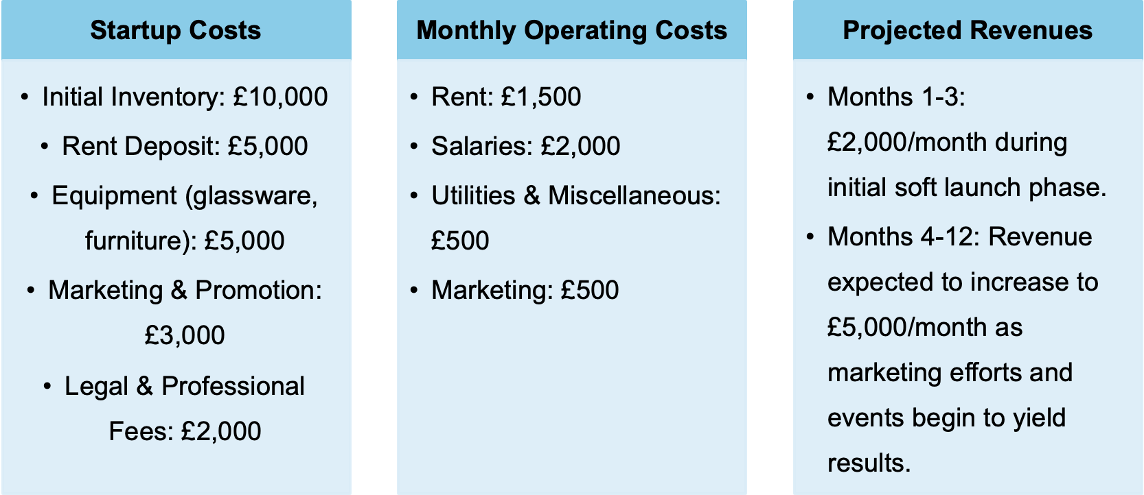

Total conservative estimate for Year 1

Month | Income (£) | Operating Costs (£) |  | Net Cash Flow (£)
1 | 2,000 |  | 4,500 | (2,500)
2 | 2,000 |  | 4,500 | (2,500)
3 | 2,000 |  | 4,500 | (2,500)
4 | 5,000 |  | 4,500 | 500
5 | 5,000 |  | 4,500 | 500
6 | 5,000 |  | 4,500 | 500
7 | 5,000 |  | 4,500 | 500
8 | 5,000 |  | 4,500 | 500
9 | 5,000 |  | 4,500 | 500
10 | 5,000 |  | 4,500 | 500
11 | 5,000 |  | 4,500 | 500
12 | 5,000 |  | 4,500 | 500
Total | 60,000 |  | 54,000 | 6,000

The cash flow forecast for the first 12 months of this business venture provides a detailed breakdown of startup costs, monthly operating expenses, and projected revenues. The initial investment includes £25,000 for startup costs, covering essential elements such as inventory, rent deposit, equipment, marketing, and legal fees. This upfront expenditure is crucial for establishing the business and ensuring it has the necessary resources to begin operations.

The monthly operating costs are estimated at £4,500, encompassing rent, salaries, utilities, and ongoing marketing efforts. The revenue projections show a conservative approach, with a soft launch phase during the first three months generating £2,000 per month. From the fourth month onwards, as marketing efforts and events gain traction, the revenue is expected to increase to £5,000 per month. This gradual increase in income reflects a realistic expectation of business growth and customer acquisition. The cash flow table illustrates that while the business may experience negative cash flow during the initial three months, it is projected to become cash positive from the fourth month onwards, indicating a potential for sustainability and growth as the business establishes itself in the market.

References

- Barringer, B. & Ireland, D. (2018) Entrepreneurship. Harlow: Pearson Education, Limited.

- Biloshapka, V., & Osiyevskyy, O. (2019) “Opportunity-based growth management: enabling a company-wide effort to proactively take advantage of new business prospects”. Strategy & Leadership, 47(3), 11–18. https://doi.org/10.1108/sl-02-2019-0029.

- Chen, S. (2024) “The Impact of Brand Awareness on Purchase Intention”. Highlights in Business, Economics and Management, 30, 239–246. https://doi.org/10.54097/88gfk880.

- Gonen, L. D., Tavor, T., & Spiegel, U. (2024) “Unlocking Market Potential: Strategic Consumer Segmentation and Dynamic Pricing for Balancing Loyalty and Deal Seeking”. Mathematics, 12(21), 3364. https://doi.org/10.3390/math12213364.

- GOV UK (2024) Limited companies. Available at: https://www.gov.uk/limited-company-formation. (Accessed: 20 November 2024).

- Hague, P. (2023) The Business Models Handbook. 2nd edn. Kogan Page. Available at: https://www.perlego.com/book/4191690. (Accessed: 20 November 2024).

- Jandik, T., & Salikhova, T. (2023) “The effect of social connections on capital structure in supplier-customer relationships”. Journal of Corporate Finance, 79, 102352. https://doi.org/10.1016/j.jcorpfin.2023.102352.

- Kene, S., & Kene, S. (2024) “The Impact of Influencer Collaborations on Brand Awareness for Start-ups”. International Journal of Advanced Research in Science, Communication and Technology, 133–140. https://doi.org/10.48175/ijarsct-17821.

- Koh, Y, Choi, C., & Lee, S. (2013) “The Income Elasticity of Demand and Firm Performance of US Restaurant Companies by Restaurant Type during Recessions”. Tourism Economics, 19(4), 855–881. https://doi.org/10.5367/te.2013.0250.

- Pavlovic, P., Reyneke, M., & Boyd, S. (2021) “Origin artisan coffee: growth challenges faced by a niche brand in South Africa”. Emerald Emerging Markets Case Studies, 11(3), 1–38. https://doi.org/10.1108/eemcs-04-2021-0110.

- Scheid, A. (2024) Wine Trends: Industry, Consumer, Marketing And Pricing Trends. Available at: https://thebrandsmen.com/wine-trends-industry-consumer-marketing-and-pricing-trends/. (Accessed: 20 November 2024).

- Williams, S. (2022) The Financial Times guide to business start up 2021/23 : the most comprehensive guide for entrepreneurs . 32nd edition. Harlow: Pearson.

