ENTREPRENEURSHIP

ASSESSMENT 1

Student name: DENISA-ROXANA STOICA
Student ID: 2211503
Module name: ENTREPRENEURSHIP
Module code: LCBB5001
Lecturer name: NISHI RAMSURRUM

Table of contents

Aysha’s Coffee LTD……………………………………………………………………………………………3
- Vision …………………………………………………………………………….…………………….3
- Missions……………………………………………………………………………………..…………3
- Objectives……………………………………………………………………………………………..3
STP Marketing Model…………………………………………………………………………………………4
- Segmentation…………………………………………………………………………………………4
- Targeting………………………………………………………………………………………………..4
- Positioning……………………………………………………………………………………………..4
- Legal Ownership Limited………………………………………………………………………….4
Industry analysis……………………………………………………………………………………………...5
- Porter's Five Forces Analysis…………………………………………………………………….5
- VIRO……………………………………………………………………………………………………..6
Operations and Management Team Plan………………………………..…………………………….7
- Operations…………………………………………………………………………………………….7
- Revenue and loss prevention……………………………………………………………………7
- Management Team…………………………………………………………………………………8
Marketing plan and strategies…………………………………………………………………………….8
Financial plan………………………………………………………………………………………………….9
- Source and Uses of Funds……………………………………………………………………….9
- Monthly Revenue and Costs……………………………………………………………………10
Conclusion…………………………………………………………………………………..………………..10
Reference…………………………………………………………………………………………….………..11

Aysh's Coffee Ltd

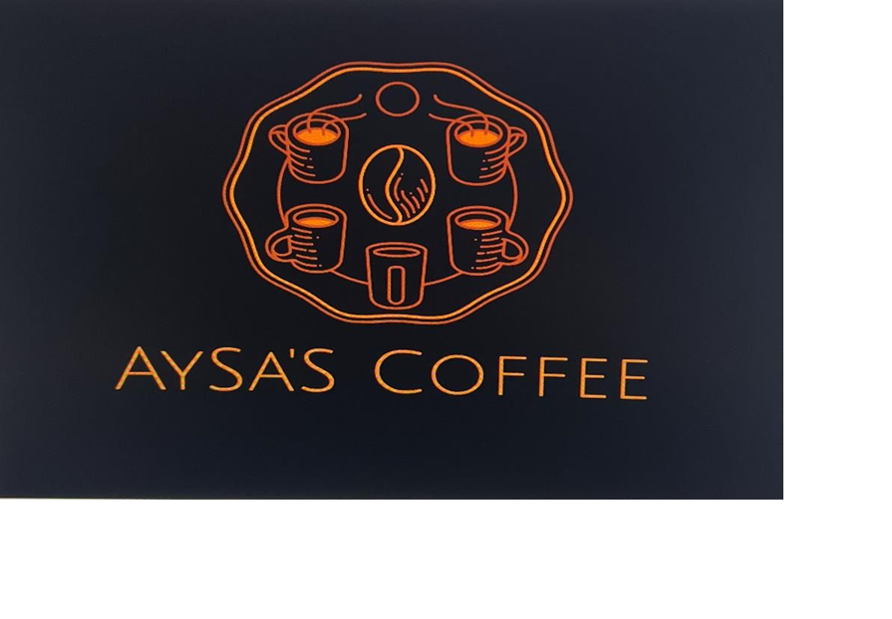

Vision: We aim to establish ourselves as the go-to destination for coffee lovers seeking exceptional drinks made with expertise and care. We strive for excellence in both our products and experiences and are committed to providing exceptional customer service. Our goal is to become synonymous with premium coffee and service through innovation, creativity, and passion.
Mission: We aim to create a space where you can slowly enjoy the rich flavor of our carefully selected blended coffee. Whether you prefer strong, bold drinks or a smooth, indulgent latte, our menu has something to suit every palate. Pair drinks with fresh baked goods and sweets for the perfect treat. Experience exceptional service and quality in a warm and welcoming atmosphere.

Objectives: Develop and execute a targeted marketing strategy to attract new customers and boost traffic to both our website and physical store. Offer promotions to attract first-time customers while encouraging repeat business and retaining loyalty with a customer loyalty program. Collaborate with local businesses and organizations to host events and cross-promote products. Continually enhance products and services based on data analysis and customer feedback. Build brand credibility and engage with customers regularly through informative social media content.. Monitor and track metrics to measure campaign success and optimize results. Seek out new opportunities for growth and expansion while considering market trends and customer preferences.
STP Marketing Model

Segmentation: Whether you need a quick caffeine jolt or looking to savor every sip, our coffee shop is the perfect destination. Sit back, take a deep breath, and let the rich aroma of freshly brewed coffee envelop you in a sense of calm and contentment. Our carefully curated selection of beans will please even the most discerning coffee connoisseur. Join us in our cozy and welcoming cafe, where you can indulge in the simple pleasure of a good cup of coffee in a peaceful setting.
Targeting: Our café is the perfect place to start your day with a delicious cup of coffee and a comforting atmosphere. Whether you're looking for a jumpstart on your workday or seeking a peaceful place to study, our café has everything you need. With a variety of coffee options and cozy seating areas, we cater to both professionals in need of a morning pick-me-up and students looking for a spot to hit the books. Visit us and let us help you kickstart your day as best as possible.
Positioning: Through our dedication to crafting the perfect cup of coffee and providing exceptional customer service, Aysh's Coffee is focused on positioning itself as the premier destination for those seeking a premium coffee experience. Our inviting atmosphere, coupled with our passion for quality, sets us apart from other coffee shops in the area. Stop by Aysh's Coffee for a memorable coffee experience that will leave you wanting more.

Legal Ownership Limited: Liability is a key benefit for shareholders of Aysh's Coffee Ltd as it ensures their assets are protected if the company fails. They are only liable for the amount they have invested in the business. This sense of security attracts more investors and external funding opportunities from banks and lending institutions. However, being a limited company also brings additional regulations and requirements. Aysh's Coffee Ltd must comply with legal and financial reporting standards set by the government, resulting in increased paperwork, annual accounts, and disclosure obligations. Shareholders may also have a say in major company decisions, limiting control over decision-making. Despite these downsides, the advantages of limited company status provide stability and growth opportunities for Aysh's Coffee Ltd.

Industry Analysis

Porter's Five Forces Analysis:

1. The coffee shop industry faces a high threat of new entrants due to low barriers to entry, which can result in increased competition as new competitors easily enter the market.

2. Suppliers of coffee beans, pastries, and other supplies hold a medium bargaining power, but Aysha's Coffee can potentially secure favorable terms by building strong relationships or diversifying its supplier base.

3. Customers wield a high bargaining power in the coffee shop industry, as they have numerous options to choose from based on factors like price, quality, and convenience. To attract and retain customers, Aysha's Coffee must differentiate itself effectively.

4. The threat of substitutes in the coffee shop industry is at a medium level, with alternatives like tea, energy drinks, and homemade beverages available. To distinguish itself from substitutes, Aysha's Coffee must offer unique products or experiences.

5. Competitive rivalry is high in the saturated coffee shop industry, with numerous competitors offering similar products. To succeed, Aysha's Coffee must focus on building a strong brand, delivering quality products, providing excellent customer service, and potentially introducing unique offerings to stand out from the competition.

VRIO Analysis
One of the strategies commonly utilized to discover the competitive advantage is by conducting an inside examination utilizing the VRIO system. The shortcomings of said system are that they cannot be utilized to decide how solid the competitive advantage of the company can be overseen by them. (Ariyani, et all, 2018)
1. Value:
- Aysha's Coffee offers a unique blend of high-quality coffee sourced from exotic locations, providing customers with a premium coffee experience.
- The cozy ambiance and personalized customer service create a welcoming atmosphere that sets Aysha's Coffee apart from competitors.

2. Imitability:
- The coffee shop's specific blend and sources of coffee beans could be imitated, but the personalized customer service and ambiance are harder for competitors to replicate.
- Building a loyal customer base through exceptional service and unique offerings may be challenging for competitors to mimic.

3. Rarity:
- The specific blend of coffee and the ambiance of Aysha's Coffee are relatively rare in the market, giving the shop a competitive edge.
- Aysha's personal touch in customer interactions and the curated experience make it a unique player in the coffee shop industry.

4. Organization:
- Aysha's Coffee benefits from well-trained and motivated staff who embody the brand's values and provide excellent customer service.
- The management's focus on quality control and maintaining the brand's image ensures consistent delivery of the unique coffee experience.

Operations and Management Team Plan

1. Operations:

- Business Process: Order taking involves receiving customer requests and processing them efficiently, ensuring accuracy and timeliness. Coffee preparation requires skilled baristas to craft each drink with precision and care, creating a delightful experience for customers. Customer service involves addressing inquiries, concerns, and feedback promptly and courteously, fostering positive relationships with patrons. Inventory management entails monitoring stock levels, restocking supplies, and optimizing storage to meet demand effectively.

- Supply Chain Management: Sourcing high-quality coffee beans involves researching reputable suppliers, evaluating product quality, and negotiating favorable pricing terms. Maintaining relationships with suppliers requires open communication, timely payments, and mutual respect to ensure a reliable and sustainable partnership. By collaborating closely with suppliers, businesses can secure a consistent supply of premium coffee beans, uphold quality standards, and adapt to market fluctuations efficiently.

2. Revenue and Loss Prevention:

- Sales Target: 500 cups of coffee per day in the first 6 months. This goal will require a strong focus on customer service and quality to attract and retain customers. By consistently providing a positive experience, we can increase customer loyalty and word-of-mouth referrals, ultimately driving sales.
- Revenue Generation: Upselling pastries and merchandise will be a key strategy to maximize revenue. Offering loyalty programs can also incentivize repeat business and increase customer lifetime value. By diversifying our product offerings and implementing effective marketing techniques, we can create multiple streams of income to boost overall revenue.
- Loss Prevention: Implementing lean management strategies, such as optimizing workflows and reducing waste, will help minimize costs and maximize profitability. Monitoring inventory levels closely is essential to prevent overstocking or stockouts, ensuring that we can meet customer demand while avoiding unnecessary expenses. By proactively managing our resources and expenses, we can protect our bottom line and maintain financial health.

3. Management Team:

- CEO: Leyla Khan - MBA with 10 years of experience in the hospitality industry. Aysha has successfully led various teams and projects, demonstrating her strong leadership skills and strategic thinking. Her vast experience in the industry has equipped her with the knowledge and expertise to steer the company towards success.

- Head Barista: John Doe - Certified barista with 5 years of experience. John is a dedicated and passionate barista who takes pride in crafting the perfect cup of coffee for every customer. His extensive experience has honed his skills, allowing him to consistently deliver high-quality beverages that keep customers coming back for more.

- Marketing Manager: Sarah Smith - Marketing degree with expertise in social media marketing. Sarah is a creative and innovative marketing professional who excels in leveraging social media platforms to promote brands and engage with customers. Her strategic marketing approach has proven to be effective in driving brand awareness and increasing customer engagement.

Marketing Plan and Strategy
In today´s turbulent times, companies have to grasp modern commerce models and ideal models of B2B marketers, learn from the botches of others, and get propelled by better approaches and inventive thoughts, as developments speak to a source of long-term benefit, commerce victory, and competitive advantage. ( Vaníčková, Szczepańska-Woszczyna, 2020)
- Product: Our coffee shop offers a wide range of premium coffee blends, specialty drinks, delicious pastries, and unique merchandise that cater to every taste and preference. From rich and bold espresso to creamy and indulgent lattes, we have something for everyone to enjoy. Our products are carefully curated to ensure the highest quality and satisfaction for our valued customers.

- Place: With strategically located stores in high foot traffic areas, we aim to make our products easily accessible to our customers. In addition to our physical locations, we also offer the convenience of online ordering for those who prefer to enjoy our products from the comfort of their own homes. Our goal is to provide a seamless and convenient shopping experience for all our customers, whether they choose to visit us in person or order online.

- Price: Our pricing strategy is designed to cover the cost of goods sold while also allowing for a mark-up that covers our expenses and generates a reasonable profit margin. We believe in offering our customers value for money, without compromising on the quality of our products. By carefully balancing our pricing structure, we ensure that our customers receive the best possible products at a fair and competitive price point.

- Promotion: At our coffee shop, we believe in the power of effective promotion to reach and engage with our target audience. Through engaging social media campaigns, exciting loyalty programs, and special events, we strive to create a strong and loyal customer base. By consistently promoting our products and services through various channels, we aim to build brand awareness and loyalty, while also attracting new customers to experience all that our coffee shop has to offer.

Financial Plan
Source and Uses of Funds:
Fund is irreplaceable to each kind of commerce and thus it is properly said to be the lifeblood of a trade. Commerce back is the movement concerned with the estimation, raising, and administration of the stores to be utilized in commerce undertakings. (Shilpa R, Rakesh H M, 2013)
We are currently in the process of securing financial support from potential investors to cover the initial expenses required to establish our start-up. The funds we aim to acquire will be allocated towards various essential aspects of our business, including enhancing the leased premises, acquiring the necessary equipment, stocking up on inventory, and covering the costs associated with marketing strategies. Our goal is to attract funding from investors to finance crucial start-up needs like improving our leasing space, purchasing essential equipment, stocking up on inventory, and executing effective marketing campaigns.

Monthly Revenue and Costs:
The monthly revenue for our establishment consists of £10,000 from sales of coffee drinks and an additional £3,000 from pastries, resulting in a total monthly revenue of £13,000. This impressive figure is attributed to the high demand for our delicious offerings.

However, it is important to note that running a successful business also incurs various costs. Our monthly costs include £2,000 for rent, £4,000 for employee salaries, £3,000 for coffee beans and supplies, £500 for utilities, and an additional £1,000 for miscellaneous expenses. This adds up to a total of £10,500 in costs.

Despite these expenditures, we are pleased to announce a healthy monthly profit of £2,500 (£13,000 - £10,500). This is a testament to our efficient operations and dedicated team who strive to deliver the best experience to our valued customers. We will continue to monitor our finances closely and make necessary adjustments to ensure continued success. Thank you for your support in contributing towards our sustained growth.

Conclusion

Aysh's Coffee Ltd boasts a robust and meticulously crafted business plan that intricately delineates the company's overarching objectives, comprehensive strategies for growth, and meticulously calculated financial forecasts. Pioneering a distinct reputation for unwavering commitment to excellence, unparalleled customer service, and sustainable profitability, Aysh's Coffee stands poised for triumph within the fiercely contested coffee market landscape. Potential investors are urged to conscientiously contemplate Aysh's Coffee as an auspicious and lucrative investment prospect with immense potential for substantial returns.

REFERENCE

Radka Vaníčková, . Katarzyna Szczepańska-Woszczyna, 2020, INNOVATION OF BUSINESS AND MARKETING PLAN OF GROWTH STRATEGY AND COMPETITIVE ADVANTAGE IN EXHIBITION INDUSTRY, Polish journal of management studies, Vol.21 No.2. https://pjms.zim.pcz.pl/resources/html/article/details?id=206323&language=en
Shilpa R, Rakesh H M, 2013, Analysis of Effective Utilization of Funds, International Journal of Business and Management Invention, Volume 2 Issue 11, November. 2013, PP.42-46, https://d1wqtxts1xzle7.cloudfront.net/57468961/F021101042046-libre.pdf?1538219305=&response-content-disposition=inline%3B+filename%3DAnalysis_of_Effective_Utilization_of_Fun.pdf&Expires=1713996600&Signature=BO505QFqYB0wfe-kbJQ05HvAKTnIxQVxNrLlptQe0J2VvqX0uUyi4bNxpjCHNHcxXcYVdoF7k-Zs5oPlLFtgSAgvJS9IzBtHffVvVNEj0oouoCWj7r4rwzw6jqWBT66HmXEw-nLUZd8kYws6RAYSbBYgRmAlfFUqQcHg9dSN6T-RsPCk4sce3bk98xqb-nzl-DX7zKOhOpUbL9IptyR7n0ku8YXr3T34o4f4u7tHYrt72R9pvyLhZArM5BI-HI4orS4aBJeMKu-LXTwA2InUe8iB06NSPpoPX~KbgiTD7R1kS7DlekmSUrVj8uHWNnqorp6lYCfjLDEFQCuw5EuxYQ__&Key-Pair-Id=APKAJLOHF5GGSLRBV4ZA

Widya Ariyani, Arief Daryanto, Sahara, 2018, Operationalization of Internal Analysis Using the VRIO Framework: Development of Scale for Resource and Capabilities Organization, Case Study: XYZ Company Animal Feed Business Unit, Vol.3, https://ecsenet.com/index.php/2576-6759/article/view/6

