

Student: Antoaneta Vazova

ID number: 2123847

Module: Management Economics

Module code: LCBB5008

Assignment 1

Lecturer: Dr. Taye Osadiya

TABLE OF CONTENT

- INTRODUCTION……………………………………………………………………….3

- MAIN BODY……………………………………………………………………………..3

- Covid pandemic……………………………………………………………………….3
- Brexit……………………………………………………………………………………….4
- Relevance of Demand and Supply………………………………..6
- Elasticity and inelasticity…………………………………………………………..8

- CONCLUSION…………………………………………………………………………….10

- REFERENCES……………………………………………………………………………..11

- INTRODUCTION

This essay analyses the differential impact of COVID-19 on trade in the UK through a detailed analysis of transmission mechanisms. In a dynamic crisis situation such as the current one, forecasts of the impact of COVID-19 on the economy and development of individual cities are constantly changing. International and local business are increasingly experiencing difficulties, and a sense of uncertainty is increasingly prevalent in global economic life. The fast one an informed and coordinated response and the development of innovation and digitisation at the international and local level is increasingly key to dealing with the pandemic. The COVID-19 pandemic has left a particular impression on the economy in the United Kingdom, resulting in some fundamental economic challenges that endure as the country navigates its recovery. The COVID-19 pandemic has three effects on global value chains (GVCs). First, it drastically interrupts transportation systems and, in some circumstances, supply chain logistics. The disruption of manufacturing supply is the second way in which the pandemic affects GVC. In addition to the supply chain disruption, other measures such as employment closures and public transport closures were implemented, imposing considerable constraints on labour input into production. The third channel by which COVID-19 affects GVC is the significant decline in demand. In January and February, the fall in demand was minimal, with China serving as the epicentre. (Lyon J., Dhingra S. ,2021) UK GDP plummeted by roughly 20% in the early months of the pandemic before recovering partially over the summer (Office for National Statistics (ONS), 2021a). However, the economy was harmed in early 2021 by the continued high levels of Covid-19 cases and the need for a nationwide lockdown. Despite a recovery compared to the previous month, the economy was 7.8% lower in February 2021 than before the effects of Covid-19 (February 2020), and 3.1% lower than the initial recovery peak (October 2020) (ONS, 2021a).

- MAIN BODY

The COVID-19 pandemic has left a particular impression on the economy in the United Kingdom, resulting in some fundamental economic challenges that endure as the country navigates its recovery. Following the epidemic, the UK faced several major issues, including:
- Unemployment: The pandemic resulted in severe job losses in a variety of industries. While the economy appears to be improving, particular areas, such as hospitality, tourism, and retail, continue to confront labour shortages and rehiring hurdles, adding to prolonged unemployment. Data from the United States Bureau of Labour Statistics (BLS) and comparable organisations around the world suggest severe job losses in industries primarily reliant on in-person activities, such as hospitality, tourism, and retail, during the pandemic's height in 2020. For example, the BLS recorded significant job losses in leisure and hospitality. Government studies and industry-specific surveys frequently disclose information about persistent labour shortages, rehiring challenges, and the need for specialised policies or incentives to boost worker engagement in certain industries.
- Inflation: During the pandemic, inflation rates in the UK surged due to supply chain delays, increasing demand following lockdowns, and rising energy prices. Individuals' living costs have risen as a result, putting pressure on the Bank of England to regulate inflation while promoting economic recovery. (Elliot Major, L., Eyles, A., & Machin, S. 2020)
- Brexit Repercussions: Overall, Brexit added significant difficulties and hurdles for businesses functioning in the UK-EU trade relationship. It triggered a rethinking of supply networks, increased administrative demands, and introduced uncertainties that harmed UK-EU commerce, logistics, and supply chain activities. Businesses have been attempting to adjust their operations in order to navigate the changing trade landscape and reduce the effects of these disruptions. This interrupted traditional trade routes and caused border delays, interfering with the steady flow of products. Customs processes and heightened border checks have an impact on transportation routes and logistics operations. Transportation delays and longer lead periods were prevalent, affecting just-in-time manufacturing and delivery schedules. Following Brexit, many businesses revaluated their supply chain plans. To keep access to the single market, some companies chose to rearrange supply networks by creating subsidiaries or warehouses in the EU. Companies attempted to diversify their sourcing and markets in order to lessen their reliance on the United Kingdom or the European Union. This included looking for alternative suppliers or marketplaces to offset the risks associated with Brexit. New regulatory frameworks, quality standards, and certification criteria required businesses to adjust. This called for changes to product labelling, conformity assessments, and compliance procedures. ( Springford, J. 2021).
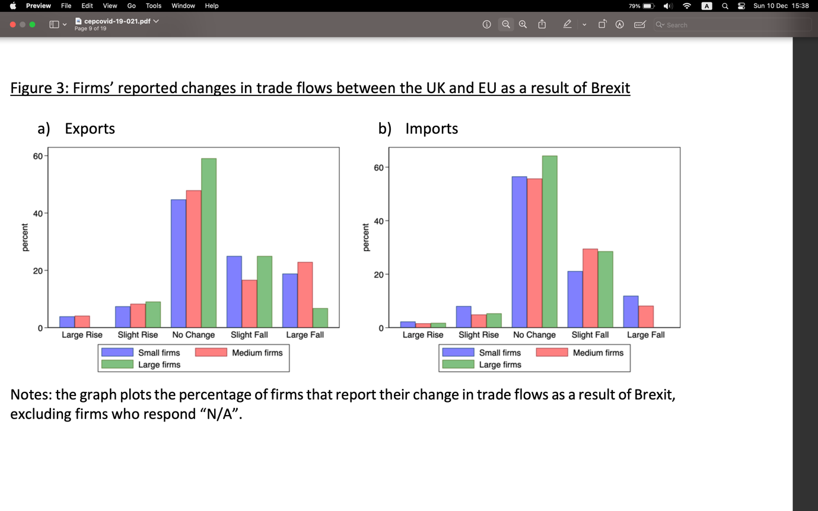
- Due to new customs requirements, supply chains that formerly operated effortlessly across EU borders experienced greater complexity and paperwork. Businesses had to manage new import and export laws, which resulted in administrative difficulties and potential disruptions. Tariffs and other administrative processes raised the cost of conducting business between the United Kingdom and the European Union. Companies faced increased costs as a result of customs taxes and costs associated with complying with new laws.
- To prevent anticipated interruptions, some businesses adapted by storing supplies.
- Mismatch in Skills: The epidemic has expedited digital transformation, emphasising the importance of specific skills. However, there is a mismatch between the skills required by the labour market and those possessed by the workforce, which causes difficulties in filling specific job jobs.
- Housing Affordability and Market Instability: During the pandemic, the housing market saw changes due to shifting demand patterns, government assistance programmes, and price swings. Affordability remains an issue, particularly for first-time buyers. (Koecklin, T. 2021)
To boost the economy during the epidemic, the UK government launched significant fiscal stimulus measures, resulting in rising public debt levels. Balancing the need for ongoing assistance with fiscal sustainability is a major concern. Healthcare and Social Care Strains: The epidemic has put a strain on the healthcare and social care systems. The necessity to solve these concerns while staying within financial restrictions is still a major concern.
To address these issues, the UK government has prioritised economic recovery measures that include infrastructure investment, skill training, and green initiatives aimed at creating jobs and supporting businesses. Furthermore, policies addressing housing affordability, fiscal sustainability, and the healthcare system are critical for ensuring a robust and inclusive economic recovery from the pandemic's economic repercussions.
Addressing economic issues within the framework of COVID-19 regulations and constraints entails adapting company strategies to ongoing pandemic challenges.
To enable remote working, online sales, and virtual contacts with clients, digital transformation must come full circle. It is critical to invest in technological infrastructure and technologies that allow for effective operations while conforming to health regulations.
Flexible and adaptable company structures that can adjust swiftly to changing market conditions are also required. To suit evolving consumer needs, consider product/service diversification or centre business strategies.
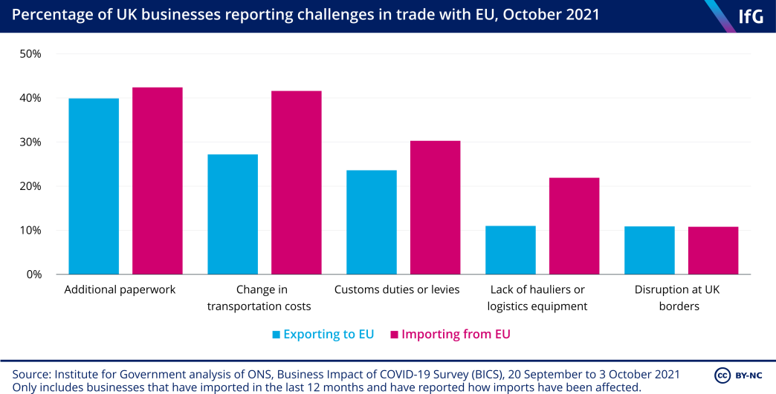

- Relevance of Demand and Supply

Supply chains should be reengineered to decrease dependence and risks. Create resilient supply networks, do local sourcing research, and put in place contingency plans to deal with disruptions caused by bottlenecks or limitations. Employee well-being and operation maintenance are maintained by applying strong health and safety procedures in the workplace. Compliance with health rules not only protects employees but also fosters customer trust. Assessing financial risks and implementing contingency plans creates comfort and peace of mind in a particular firm. To sustain liquidity, prioritise cash flow management, investigate financial aid programmes, and negotiate payment conditions with suppliers/customers. Creating collaborations with other companies or suppliers and sharing resources to reduce costs and address difficulties jointly. Collaboration can boost resilience in the face of economic shocks. Focusing on open and compassionate contact with customers. During the pandemic, adapt marketing techniques to accommodate shifting consumer behaviour and needs.(Institute for Government,2021)
Dynamic pricing employs a pricing mechanism that is adaptable to variations in demand and supply. To analyse market movements and adjust prices, real-time data analysis is used. This can assist optimise revenue during peak demand while avoiding redundancy during low demand periods.
Bundle pricing combines various products or services into a single bundle. This method can assist sell extra inventory by combining complimentary items at a low price, allowing excess supply to be managed. ( Osadiya T. 2023, p.45)

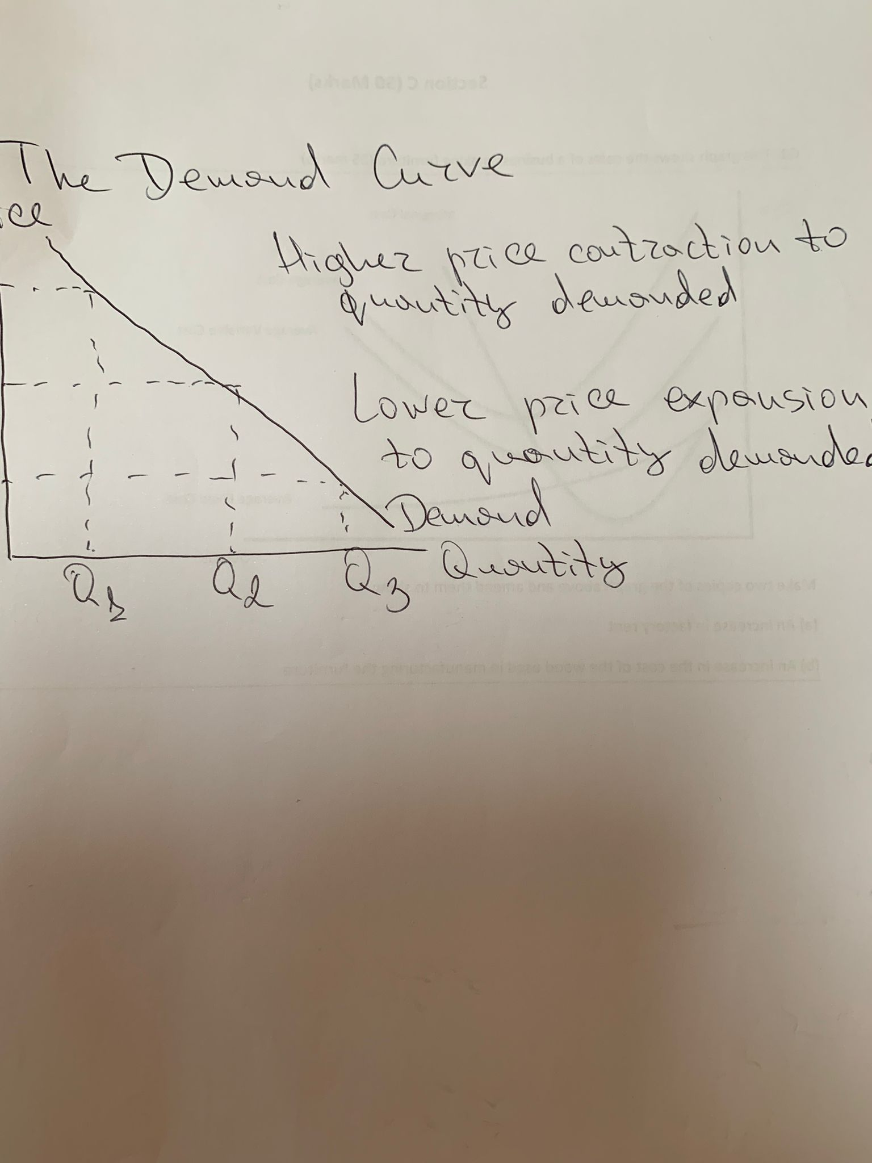
Using targeted promotions, discounts, or limited-time offers, you can increase demand for slow-moving goods or services. In uncertain times, this method can assist clear surplus inventory and encourage customers to make purchases. To cater to diverse customer segments, offer different levels of products or services at different price points. This method allows clients to select alternatives that fit their budgets while also increasing income for your company.
Offering discounts or additional incentives to customers to encourage them to sign longer-term contracts or subscriptions. This method can help to stabilise demand while also providing a more dependable revenue source.
Working closely with suppliers, distributors, or other enterprises in an industry allows for collective pricing adjustments. Collaboration can aid in addressing supply chain disruptions and ensuring a more balanced market.
As a result, in order to adapt to market changes, pricing strategies must be examined and altered on a frequent basis depending on changing demand, supply, and economic situations.
Customer Relationship Management (CRM) Strategies: Offer personalised pricing or discounts by leveraging customer data and insights. Building great client relationships can lead to higher loyalty and more predictable demand patterns. (Ellickson Paul B., Misra Sanjog 2008)

- Elasticity and inelasticity

Elasticity is a measure of the responsiveness or sensitivity of one variable (such as amount required or supplied) to a change in another variable (such as price, income, or the price of related commodities) in economics. It measures the degree of change in one variable as a result of a change in another. Elasticity values assist economists and businesses in understanding how changes in variables such as price and income affect consumer behaviour and market dynamics. A high price elasticity of demand, for example, shows that consumers are extremely responsive to price changes, whereas a low elasticity indicates less responsiveness. Understanding supply elasticity, on the other hand, aids in forecasting how producers will react to price fluctuations.
Inelasticity is a scenario in which the quantity desired or provided of a good or service is relatively insensitive to changes in price, income, or other factors. Changes in price or other variables result in proportionately smaller changes in quantity when demand or supply is inelastic. Understanding inelasticity is important for businesses and governments because it allows them to predict how changes in pricing or other factors will affect consumer behaviour or production levels. Inelastic items may allow firms to raise prices without seeing a large decline in demand, or they may allow enterprises to sustain output levels despite price swings.
Elasticity and inelasticity of demand are economic concepts that describe how price changes affect the quantity desired of a product or service. The key distinction is the degree to which the amount demanded responds to price fluctuations.
Elastic demand describes a situation in which price changes cause a proportionately bigger change in the amount desired.
Mathematically, demand is elastic (Elasticity > 1) if the percentage change in quantity demanded is greater than the percentage change in price.
Luxury products are an example where consumers are more sensitive to price changes. If the price of a luxury car rises, purchasers may cut their demand dramatically.
Inelastic demand denotes a situation in which price changes result in a correspondingly less change in quantity required.
Mathematically, demand is inelastic (Elasticity 1) if the percentage change in quantity desired is smaller than the percentage change in price.
Essential commodities such as medicines and certain food items are examples. Even if prices rise, customers may continue to buy in equal numbers out of necessity.
Consumers can quickly find substitutes for commodities with elastic demand. Substitutes for items with inelastic demand are limited or unavailable.
Luxury vs. Necessity: Consumers are less susceptible to price changes when it comes to essentials, hence they frequently demonstrate inelastic demand. Elasticity is also affected by the proportion of income spent on a product. Goods that account for a lower share of income are less susceptible to price fluctuations (inelastic), whereas those that account for a higher share are more responsive (elastic).
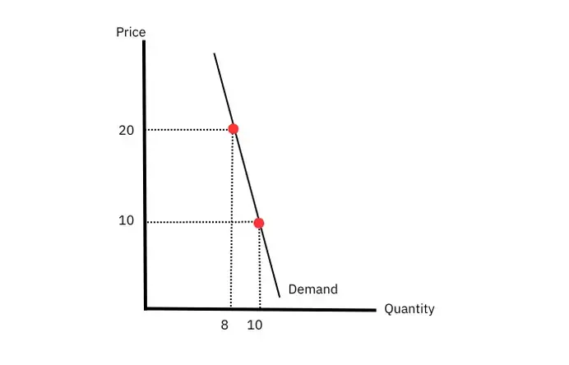
Understanding demand elasticity and inelasticity assists firms in determining prices, forecasting revenue changes, and deciding on production levels. Inelastic items, for example, may withstand price hikes without losing too much demand, whereas elastic goods may require price modifications to maintain sales volumes. The responsiveness of quantity required or supplied to variations in price, income, or other factors is referred to as elasticity or inelasticity. In terms of responsiveness, they are at different ends of the spectrum. Elastic demand or supply suggests a high level of sensitivity to price or other circumstances. It is deemed elastic when the absolute value of the elasticity coefficient is more than one (|Elasticity| > 1). Elastic goods or services have many substitutes on the market, making buyers more sensitive to price changes.
Airline tickets, for example, frequently display elastic demand. If the price of flights rises, consumers may pick alternate forms of transportation or postpone their travel, resulting in a considerable drop in demand.
Inelastic demand or supply suggests a lack of sensitivity to price or other forces.
It is called inelastic when the absolute value of the elasticity coefficient is less than one (|Elasticity| 1). Because there are few replacements for inelastic goods or services, consumers are less sensitive to price changes.
For instance, petrol (or fuel) often has inelastic demand. Even if petrol prices rise, consumers may still need it for important uses such as commuting to work, resulting in a relatively slight decrease in the quantity demanded. (Osadiya T. 2023)
To summarise, elasticity and inelasticity indicate the responsiveness of quantity required or supplied to variations in a variety of parameters. Elasticity denotes strong responsiveness, where relatively minor price changes result in considerable changes in quantity, whereas inelasticity denotes low responsiveness, where quantity changes proportionately less in reaction to price or other factors. (Smith, J., Johnson, A., & Brown, K. 2020, pp.215-240)
The rules of supply and demand are the foundation of economic theory, exhibiting the complex link between the quantity of goods or services available in a market and the quantity desired by consumers. The law of demand describes how customers react to price changes by changing their demand in the opposite direction. The rule of supply, on the other hand, explains how producers respond to price fluctuations by modifying the quantity they're willing to offer. The interaction of these rules determines market equilibrium, which occurs when supply and demand intersect, resulting in a steady price and quantity. Understanding these principles is critical for understanding market dynamics, price setting, and resource allocation within an economy.

- CONCLUSION

Analysing these rules helps firms determine prices and output levels, and policymakers use them to shape economic policies and regulations. These concepts also provide insights into consumer behaviour, production decisions, and the effects of external influences on markets. Finally, supply and demand rules serve as the foundation of economic analysis, assisting in the interpretation of market behaviours, trends, and responses to changes, supporting educated decision-making in economic systems around the world.
The global impact of the COVID-19 pandemic has been significant, altering the landscape of commercial operations in key industrialised economies such as the United Kingdom. The epidemic compelled businesses to respond quickly to extraordinary obstacles, fundamentally altering how they handle demand and supply chains.
Furthermore, the COVID-19 epidemic accelerated a paradigm shift in how firms handle demand and supply chains. It emphasised the necessity of adaptation, agility, and resilience in the face of unexpected obstacles. Businesses will likely focus on establishing more flexible, tech-driven, and diverse supply chains in the future to better deal with future uncertainties. The pandemic has inspired a rethinking of existing business strategies, stimulated innovation and putting a greater emphasis on risk reduction and preparedness.

REFERENCES:

- Ellickson Paul B., and Misra Sanjog (2008), “Supermarket Pricing Strategies,” Marketing Science, 27 (5), 811–28
- Elliot Major, L., Eyles, A., & Machin, S. (2020). Generation Covid: Emerging work and education inequalities. CEP Covid-19 Analysis, 11.
- Koecklin, T. (2021). How are Covid-19 and Brexit affecting the products that UK firms trade? Economics Observatory.
- Lyon, J., Dhingra, S. (2021) “The impact of Covid – 19 and Brexit on the UK economy: early evidence in 2021” , Centre for Economic Performance
- Osadiya T. (2023), Introduction to Economics, chapter 7, p. 53- 73
- Office for National Statistics. (2020). Average weekly earnings in Great Britain: February 2020. Office for National Statistics.
- Office for National Statistics. (2021a). GDP monthly estimate, UK: February 2021.
- Smith, J., Johnson, A., & Brown, K. (2020) "Understanding Elasticity: A Comprehensive Review of Concepts and Applications", Journal of Economic Analysis, 35(2), pp. 215-240
- Springford, J. (2021). The cost of Brexit, January 2021: The end of transition edition by. Centre for European Reform Insight, March.
- https://www.instituteforgovernment.org.uk/explainer/supply-chain-problems (Accessed at: 11.12.2023)

