Title: Future Developments in Marketing Strategy: A Critical Evaluation of Marketing Activities at British Airways
Student ID:- 2422722

Executive Summary
British Airways is also one of the major full service airlines that have been operating in the global aviation sector. The airline has a good brand name and a wide network of routes including international which makes it a premium carrier serving to emphasise on service quality, reliability and global connectivity. Nonetheless, the airline sector has grown more competitive and dynamic that poses a major marketing challenge to the traditional full-service airlines. The accelerated digital change and increased customer demands, coupled with the growing competition by low-cost airlines is transforming the marketing and customer engagement patterns within the airlines.
This report is a critical analysis of the existing marketing operations of British Airways and an evaluation of the external and internal issues affecting its marketing strategy. The marketing frameworks used to analyse the competitive environment of the airline, marketing environment, and the existing marketing strategy are based on the established marketing frameworks. These results suggest that British Airways has an advantage in the form of good global brand and route network that helps in reinforcing its premium positioning. However, the analysis also displays a number of opportunities such as the high intensity of competition in the industry, growing role of digital customer interaction and the necessity to meet sustainability demands in the aviation market.
The report draws a conclusion that the airline needs to ensure that its marketing strategy is adapted to these varying industry conditions so that it can react well to them. A number of strategic suggestions are given in order to facilitate future competitiveness. They are the introduction of AI-driven personalised marketing approaches, enhancing digital customer experience in the process of booking and travelling, strengthening brand communication that is sustainability-oriented, and the increase in the loyalty programme engagement. Collectively, these initiatives would facilitate British Airways to consolidate relationships with customers, enhance marketing performance and sustain competitive edge in the rapidly changing aviation market around the world.

Contents

Executive Summary 1

1. Introduction 3

2. Organisation and Industry Overview 4
2.1 Overview of British Airways 4
2.2 Industry Context 5

3. Marketing Environment Analysis 5
3.1 Macro Environment Analysis 5
3.2 Micro Environment 6

4. Evaluation of Current Marketing Strategy 7
4.1 Segmentation, Targeting and Positioning 7
4.2 Marketing Mix Strategy (7Ps) 9
4.3 Marketing Communication Strategy 10

5. Measuring Marketing Performance 11

6. Drivers of Marketing Change 13

7. Conclusion 15

8. Recommendations 16

References 18

Figure 1: British Airways official website 3
Figure 2: Porter's Five Forces Analysis. Source: planiumpro.com. 7
Figure 3: STP Model Applied to British Airways source: Oxford College of Marketing Blog 8
Figure 4: Marketing Mix: The Marketing Mix of British Airways 10

Table 1: Major Competitors of British Airways……………………………………………………5
Table 2: PESTLE Analysis of British Airways 6
Table 3: Evaluation of British Airways Marketing Mix (7Ps) 10
Table 4: Key Marketing Performance Metrics 12

1. Introduction
British Airways is a large international airline company that has many long-haul destinations and is a part of the International Airlines Group that handle a number of aviation brands (International Consolidated Airlines Group, 2024). The airline is a full-service premium carrier that focuses on the quality of service and international connectivity. The airline industry relies heavily on marketing since the experience that customers receive, the reliability of the services provided as well as online interactions determine which airline they will choose and remain loyal to (Jahmani, 2024). Service quality and relationship marketing strategies have a close association with customer satisfaction and customer loyalty (Hameed et al., 2024; Ali, 2024). The pressure on traditional carriers has been increased by increasing competition of the low-cost airlines and technological change (Dewi, Masruroh and Wibowo, 2025; Heiets, 2022). As a result, airlines turn to the usage of data-driven digital marketing and ethical and data protection concerns (Amadi, 2022; Mwalukaka, 2024; Khalid, 2025).
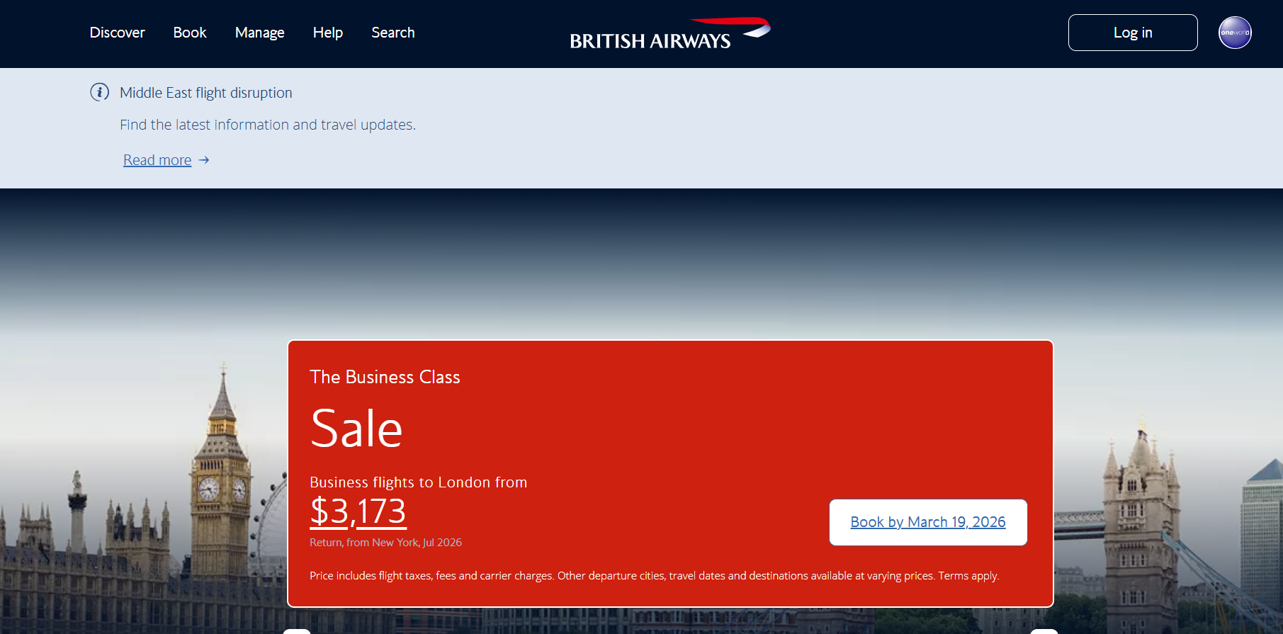
Figure 1: British Airways official website

2. Organisation and Industry Overview

2.1 Overview of British Airways
British Airways is another of the most popular full-service airlines headquartered in the United Kingdom and has widespread international flights through its main station at London Heathrow Airport. It has both short- and long-haul products and cabin differentiation such as economy, premium economy, business class and first class (International Consolidated Airlines Group, 2024). The organisation focuses on itself as a high-quality airline that pays attention to the high service quality, global connectivity and good brand reputation. This positioning is to appeal to the business traveller and high end leisure traveller who are concerned about reliability and comfort. Nonetheless, to maintain the high-end positioning, the brand should continue to deliver high-quality services and communicate the brand promise through marketing messages (Jahmani, 2024). Being the member of the International Airlines Group, British Airways enjoys the advantages of shared operating resources and increased route networks with the partner airlines such as Iberia or Aer Lingus (International Consolidated Airlines Group, 2024). The Executive Club is another example of loyalty programmes that enhance the long-term customer relationships by rewarding the frequent fliers and promoting the repeat purchases (Ali, 2024; Hameed et al., 2024).

2.2 Industry Context
Technological innovation and shifting consumer demands have brought significant change in the airline industry. Ryanair and EasyEt are low-cost airlines that have grown at a high pace thanks to their simplified service and cheaper tickets (Dewi, Masruroh and Wibowo, 2025). The differentiation of the service is thus a contest between premium airlines based on brand reputation and improved customer experience (Jahmani, 2024). The price transparency has also been enhanced by the digital travel platforms, which force airlines to enhance the digital marketing potential and customer interaction strategies (Heiets, 2022; Mwalukisa, 2024).
Table 1: Major Competitors of British Airways
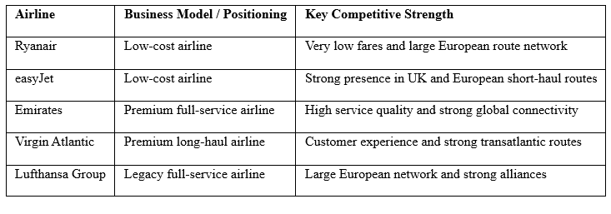

3. Marketing Environment Analysis

3.1 Macro Environment Analysis
The macro-environmental factors affecting the airline industry include influencing the marketing strategies and performance. It has a direct impact on the airline operations and marketing processes as political regulations and aviation policies influence them (Dewi, Masruroh and Wibowo, 2025). The travelling demand is affected by economic conditions, whereas the airline pricing strategies are influenced by the increasing gas prices (Jahmani, 2024). The social trends indicate that passengers are more demanding of convenient, personalised and digitally facilitated travelling experiences (Hameed et al., 2024). Artificial intelligence and data analytics are technological advances that can allow airlines to tailor marketing messages and optimise booking platforms (Heiets, 2022; MoghadasNian and PourMoradian, 2025). The branding and marketing of the airline are affected by environment pressures and sustainability efforts, as well (British Airways, 2023). Airline communication and service practises are also influenced by legal provisions about the rights of passengers and the protection of their data (Khalid, 2025).
Table 2: PESTLE Analysis of British Airways
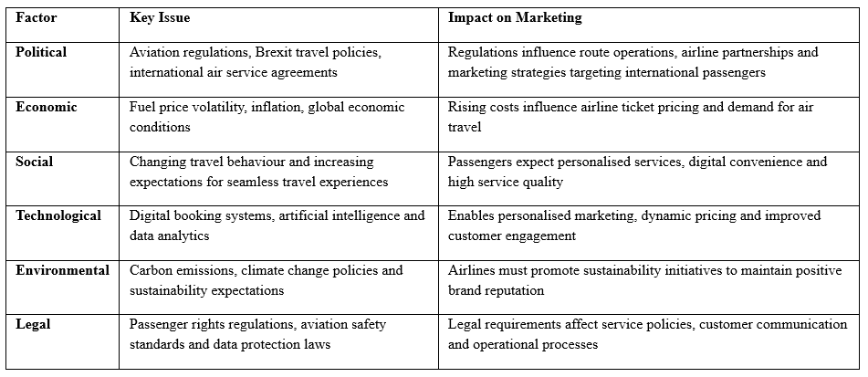

3.2 Micro Environment
Customers, competition, distribution partners and suppliers are some of the micro-environments that affect the marketing strategy of British Airways. The segments of customers are business, leisure and premium travellers, whose expectations towards the quality of services and prices vary (Jahmani, 2024). Business travellers are concerned with reliability and quality services whereas leisure travellers are concerned with cheaper prices and flexibility. The intensity of competition is high since airlines work on the same routes and provide the similar services. Service quality is what separates full-service airlines, whereas low-cost carriers compete in terms of price advantages (Dewi, Masruroh and Wibowo, 2025). Online reservation systems have also become one of the most important distribution channels, providing the freedom to conduct individual marketing communication (Amadi, 2022; Mwalukisa, 2024). The relationship with suppliers also affects the airline pricing and operational effectiveness.
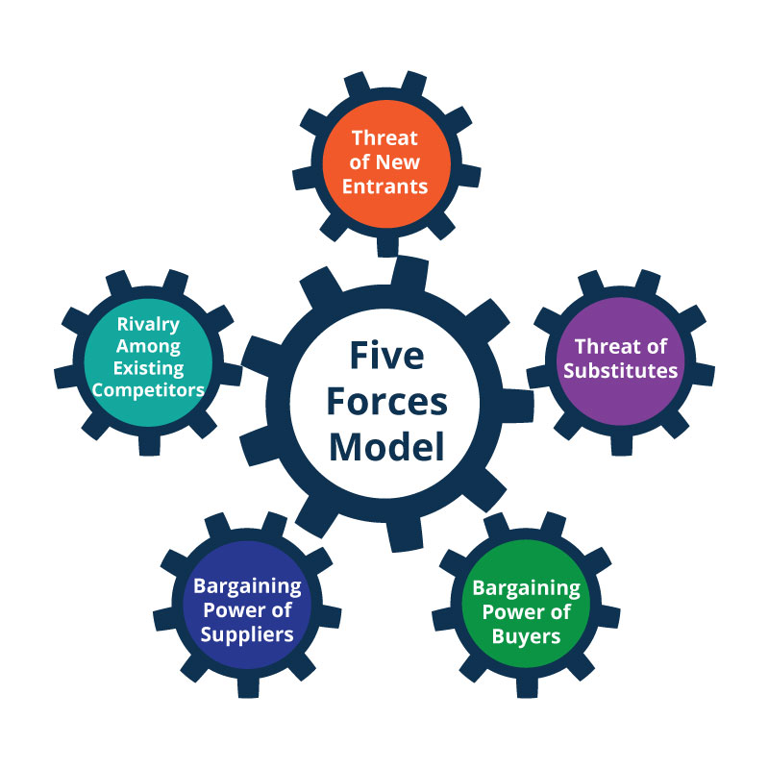
Figure 2: Porter's Five Forces Analysis. Source: planiumpro.com.

4. Evaluation of Current Marketing Strategy

4.1 Segmentation, Targeting and Positioning
In the airline marketing strategy, market segmentation is an essential element since the needs of passengers differ greatly in different travel segments. The main market segmentation of British Airways is in the purpose of travels, the level of income and the frequency of travels. Business travellers are one of the major target groups due to their greater revenue generation on premium cabin bookings and high rates of travel (Jahmani, 2024).
Leisure travellers are also a target market especially to the long distance tourism routes. Nevertheless, these travellers tend to be more price-elastic and can make comparisons of the airlines available to them through online travel sites. Sound segmentation strategies can thus help airlines formulate differentiated marketing strategies, which address the needs of certain customers (Ali, 2024).
British Airways is also aiming at the premium business traveller segment by offering business class and first-class services. Such services will offer superior comfort, lounge, and personalised in-flight services. This type of service differentiation also helps the airline position itself as a premium international airline. Nonetheless, to sustain this positioning it is necessary to also ensure consistent quality of service and to communicate the value of the brand (Hameed et al., 2024).
The premium positioning of the airline can be undermined by service failures and operational hitches despite its good brand image. Providing services that are not in proportion to brand promises can cause a decrease in customer trust and the loss of passengers to other airlines that provide similar services (Jahmani, 2024). This dilemma emphasises the need to ensure that marketing communication is in line with real service performance.
The change in technology and digital innovation also affect strategic positioning. Airlines are made to maximise their choice of AI and data analytics to comprehend what passengers desire and tailor marketing promotions. The technologies will help the airlines create a specific marketing campaign that will enhance customer engagement and loyalty to the brand (MoghadesNian, Shahriari and Shahriari, 2026).
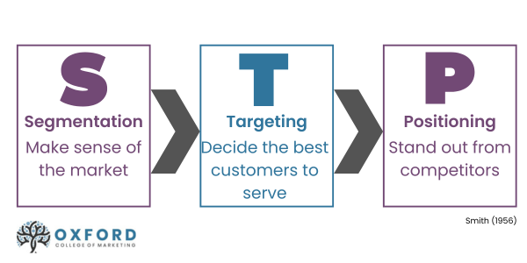
Figure 3: STP Model Applied to British Airways source: Oxford College of Marketing Blog

4.2 Marketing Mix Strategy (7Ps)
The marketing mix framework offers a viable framework in studying the airline marketing strategies. The product strategy of British Airways aims at offering quality travel experience via differentiating the cabin classes, quality in-flight service and global routes. These attributes are meant to help the premium brand positioning of the airline and capture the high value customer.
The airline industry is quite dynamic in terms of pricing, and its pricing strategies are dependent on the advanced revenue management systems. Airlines set ticket charges according to the trends in demand, the time of booking and the popularity of the routes. This will enable airlines to maximise the revenue with sustainable competitive pricing (Dewi, Masruroh and Wibowo, 2025).
The digital transformation has changed a lot in the place or distribution strategies. British Airways is adopting more and more digital methods of communicating with its customers through the use of mobile applications and web based online booking systems. Online distribution channels enable airlines to offer personalised sales promotions and increase the customer experience (Amadi, 2022; Mwalukasa, 2024).
The advertisement techniques are key in conveying the brand name and value of service of the airline. British Airways applies integrated marketing communication campaigns such as online advertisement, social media, and marketing promotions in their loyalty programmes. Promotional strategies are also effective in strengthening brand identity and attracting new customers as well as repeat customers (Bolocan and Savciuc, 2025).
Customers also perceive airline services influenced by people, process and physical evidence. Cabin crew and customer service staff are examples of employees whose roles are viewed as significant touch points in the customer journey. The quality of services and the professionalism of the staff have a strong impact on customer satisfaction and brand reputation (Hameed et al., 2024).
Other processes like booking, cheque-in and customer support are shaping the general experience of the passengers as well. The airlines are increasingly applying digital technologies to make these processes smooth and to enhance operational efficiency. Brand positioning is further enforced with the help of physical evidence such as aircraft cabins and airport lounges, as they can give physical evidence of the quality of the service.
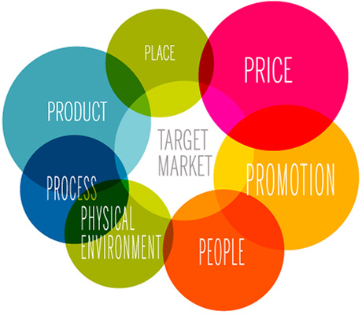
Figure 4: Marketing Mix: The Marketing Mix of British Airways
Table 3: Evaluation of British Airways Marketing Mix (7Ps)
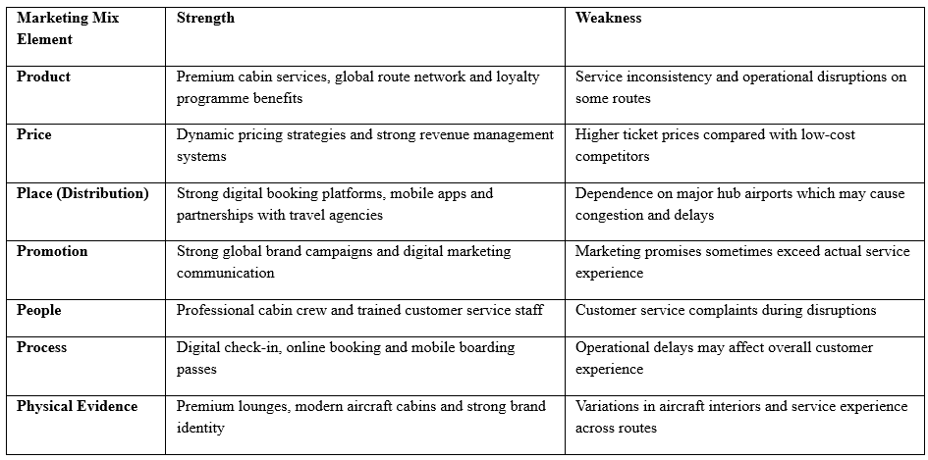

4.3 Marketing Communication Strategy
The marketing communication strategies are very crucial in defining airline brands perception and customer relationships. The British Airways engages various communication methods such as digital advertisement, social media and social media communications through the loyalty programme. The channels would enable the airline to have constant communication with the customers during the travel process (Ali, Hacioglu and Zehir, 2025).
Social media sites are one such tool of communication that has been of significant concern in the airline industry. The airlines apply these platforms to carry brand campaigns, exchange travel experience and receive customer feedback. Customers perceptions and brand loyalty may be greatly impacted when social media is managed (Loo and Leung, 2020).
The technology of artificial intelligence and data analytics are becoming the supporting force behind integrated marketing communication strategies. These technologies enable airlines to study the behaviour of customers and provide them with individual marketing messages via digital platforms (Bolocan and Savciuc, 2025). Nevertheless, the application of the latest marketing technologies also brings up ethical aspects about privacy of data and ethical practises in marketing (Khalid, 2025).
In brief, marketing communication should be effective with promises to the brand matched with the real service delivery. Airlines may build brand trust and long-term relationships with customers when the communication strategies mirror customer experience. On the other hand, lack of correspondence between promotional messages and service delivery may undermine brand integrity and consumer loyalty.

5. Measuring Marketing Performance
Marketing performance measurement is critical to airlines since customer acquisition, customer loyalty and long-term profitability are direct results of marketing efforts. Airlines perform in the sphere of a high competition when a service differentiation, a brand and relations with customers are the strong determinants of the market success. Therefore, airlines are forced to implement performance measures that enable them to assess the effectiveness of marketing and enhance the effectiveness of strategy (PwC, 2023).
The customer satisfaction is among the most crucial measurements of marketing performance in the airline industry. Airline companies place a lot of emphasis on customer experience and quality of service to stand out among the rivals. Passenger satisfaction is measured as the satisfaction of the customers regarding the services offered by the airline during the whole process of travelling. A high level of satisfaction is linked with a better brand loyalty and favourable word of mouth communication among passengers (Shen, 2022). Lack of satisfaction can create the prospect that the customers will use other airlines offering similar services and routes.
Another evaluation metric commonly used to measure airline marketing success is Net Promoter Score since it is the willingness of customers to recommend a brand to others. The airlines that have good Net Promoter Scores are often known to have steady customer loyalty and favourable brand image in the competitive markets. These were some cues that can give you a good understanding of how customers rate the quality of service and brand trust (Wendel, 2025).
Another important performance indicator in the marketing of airlines is the loyalty programme engagement. Frequent flyer programmes bring about repeat purchase since they give rewards like loyalty points, travel upgrades and priority services. These programmes have high rates of engagement which means that they have good customer relationships and effective relationship marketing strategies. The long-term customer retention and lifetime value of passengers are thus supported by these loyalty programmes (O’Connell, 2025).
The online booking channels have also triggered the growth of digital conversion rates to become significant markers of performance. The current use of digital platforms like mobile applications and online travel agencies has become an important tool to attract and convert potential customers by airlines. The assessment of the digital conversion rates enables airlines to determine the success of their online marketing campaigns and digital customer-engagement strategies (Keke, 2023).
The data on the industry also emphasises the role of performance measurement in the aviation markets. The international travel that has been disrupted in the recent past is yet to recover, and international passenger demand is up on the growth. Airlines are thus finding increased opportunities and competition in the expanding markets (Richter, 2024). An efficient performance measurement process helps airlines to understand the effectiveness of their marketing and react to the shift in the market.
All in all, marketing performance indicators are useful in customer behaviour, brand loyalty and marketing efficiency. These indicators enable airlines to assess strategic marketing initiatives and keep the customer engagement and competitive positioning in a sustained manner.
Table 4: Key Marketing Performance Metrics
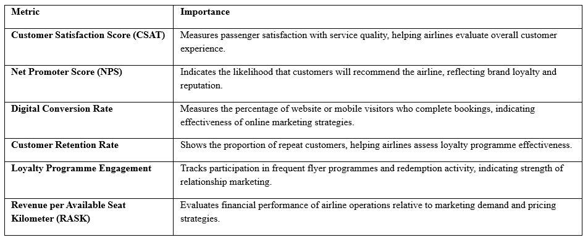

6. Drivers of Marketing Change
The technological innovation, environmental issues and changing passenger expectations are causing massive changes in the airline industry. The above change drivers have necessitated the need by the airlines to keep on changing their marketing strategies so as to enable them to be competitive and relevant within the world aviation markets. It is important to understand these drivers hence in assessing the future marketing development of British Airways.
In the aviation sector, digital transformation is one of the most powerful marketing change agents. The airlines are increasingly turning to digital technology to improve customer interaction and efficiency through data analytics, artificial intelligence and mobile platforms. Airlines can analyse passenger data in real time using digital technologies and tailor marketing messages and optimise prices depending on this data (Keke, 2023). Such features help in making marketing decisions more efficiently and also allow the airline companies to provide personalised customer experiences.
Another way artificial intelligence is changing the airline marketing strategies is through the capability to make decisions and conduct predictive analytics. The AI systems enable the airlines to predict the patterns of demand, determine customer preferences and offer individualised marketing opportunities. Nevertheless, organisations need to strike the right balance between technological innovation and strategic positioning to prevent inefficiency of operations and customer doubt (Yadav, 2026).
Another significant marketing change driver in the aviation industry is the sustainability pressures. Governments, regulators and consumers are putting more and more pressure on the airlines to minimise environmental effects and practise sustainable operations. The response to aviation emissions and environmental issues has emerged as the key topic in the industry discourse and legislation (OECD, n.d.). Consequently, airlines should deliver environmental initiatives through their marketing strategies to ensure their brands have credentials and to fulfil the expectations of their stakeholders.
The economic and structural changes in the industry also affect marketing strategy development. The demand of the aviation sector is still on the rise as the world tourist and international travel resume normalcy after the recent disruptions. The development of the tourism industry and the revival of the aviation sector have offered airlines new business areas to increase their services and focus on new customer groups (UNWTO, 2023). Simultaneously, fluctuating economy and the cost of operation is also posing continuous pressure on airline companies to ensure profitability.
There is also technological innovation on the wider aviation ecosystem that is also transforming industry dynamics. Digitalised travel systems, electrification and alternative energy technologies are some of the new developments anticipated to revolutionise the operations of the airline companies over the next few decades (Chomel and Verrecchia, 2025). Such developments can have a future impact on the airline marketing plan by changing the expectations and capabilities of customers and operations.
Another aspect of industry statistics, which has changed the aviation market size and complexity, is the scope of global markets. The world is experiencing a high speed increase in passenger demand, which is facilitated by the growth in tourism and the connectivity of the world. The statistics given by the industry show that airlines need to be able to handle the growing number of passengers and to remain efficient in their operations and the quality of services they provide (International Air Transport Association, 2025). Such shifts force the airlines to formulate versatile marketing plans that have the capability of adjusting to the changing market environments.
On balance, these drivers prove that airline marketing approaches have to be constantly updated depending on the technological, environmental and economic shifts. Those organisations that manage to accommodate these changes will be in a better position to stay at the top of the competitive aviation markets in the global markets.

7. Conclusion
This report was a critical analysis of the marketing practises of British Airways and an analysis of the industry environment at large that can affect its marketing strategy. The discussion has shown that marketing is a key factor in the retention of competitive advantage in the world airline industry. Airlines should also differentiate their services by using the right branding, customer engagement and digital strategy of communication to attract and retain passengers.
The high quality of British Airways brand image and positioning in the premium market is one of the greatest assets of the marketing strategy. Historically, the airline has been establishing itself as a full-service carrier with high degrees of service quality and international connexions. Being an airline of the International Airlines Group also enhances the operational capacities and strategic resources of the airline (Shen, 2022). These are the reasons why the airline is able to compete in the global aviation markets.
Nevertheless, the analysis also revealed a number of threats which can undermine the success of the marketing strategy of the airline. Rising competition posed by low cost airlines and international premium airlines has heightened the pressure on the old traditional full service airlines. Rival companies are still launching new service models, electronic customer experience and competitive price initiatives to overturn new market positions (O’Connell, 2025).
The marketing environment analysis has also indicated the increasing impact of technological change, sustainability expectations and digital transformation in the aviation industry. Artificial intelligence and improved data analytics, together with digital media, are transforming the approaches of the airline marketing by allowing more personalised communication and more effective customer-related engagement strategies (Keke, 2023). Simultaneously, the pressure of sustainability and environmental issues is becoming a more significant element of airline brand reputation and airline marketing communication.
The aviation industry reports also show that it has continued to record a high rate of growth and transformation. The growing passenger traffic and the changing demands of consumers necessitate sustained changes in the marketing strategies of airlines in order to keep up with the competitive environment (Deloitte, 2024). Another major factor that guarantees stronger competitive positioning is a successful integration of digital innovation, customer experience management and sustainability initiatives by airlines.
In general, the results of this report indicate that British Airways should persist with the development of its marketing strategy to respond to the new challenges in the industry and technology. The strategic adaptation will help the airline to build the relationship with the customers, build the brand credibility and build on the long term competitive advantage in the dynamically evolving aviation industry.

8. Recommendations
According to the analysis carried out in the current report, a row of strategic recommendations can be offered to improve the marketing strategy of the British Airways and contribute to its long-term competitiveness. The recommendations are centred on enhancing the digital marketing potential, customer engagement strategy and sustainability communication.
The application of sophisticated AI-powered personalised marketing strategies can be suggested as the first recommendation. The analysis of customer behaviour and the provision of targeted marketing offers are developed by the airlines using artificial intelligence and data analytics more often. Individual marketing can enhance the involvement of customers with the provision of relevant promotions and travel suggestions depending on the preferences and booking history of the passengers. Deploying AI-based marketing systems would allow British Airways to boost customer experience and increase the rates of digital booking (Keke, 2023). Research conducted in the industry has shown that airlines utilising modern digital marketing technology are capable of enhancing their marketing competence and customer satisfaction (PwC, 2023).
The second suggestion is to enhance the online customer experience of the airline in the course of every stage of travel. Online platforms have become the main point of contact between airlines and their customers. The convenience and access to services by customers can be promoted through the improvement of mobile applications, online booking systems, and the digital communication channels. The digital transformation plans enable the airlines to simplify the customer experience and minimise the operations inefficiency as well (Oxford Business Group, 2022). The improved level of digital interactions would enable British Airways to consolidate its competitive stance in digitalized travel markets that are becoming more prevalent.
The third recommendation is creation of an enhanced sustainability-based marketing plan. The environmental issues are taking on greater significance to the consumers as well as the regulators. Airlines should thus report the sustainability initiatives in an open and transparent manner in their marketing strategies. According to industry analysis, sustainability communication can have a strong impact on brand perception and trust of stakeholders (OECD, n.d.). British Airways may reinforce its brand image by popularising such activities as carbon emission reduction, sustainable aviation fuel and environmental innovation.
The last suggestion is on the enhancement of the loyalty programme participation in order to enhance a customer relationship in the long run. Frequent flyer programmes are also good marketing concepts since it motivates customers to travel frequently and make more customers stick to the airline. Increasing a loyalty programme benefits, personalised rewards and digital engagement options may boost the participation in the programmes and customer satisfaction (O’Connell, 2025). The increased loyalty plans would enable the British Airways company to reinforce its relationship marketing strategy and create greater lifetime value of the passengers.
The aviation markets also have strategic innovation that is of importance as indicated in industry forecasts. The aviation demand is growing worldwide, and it opens new prospects to the airlines that manage to adjust to changing market conditions (International Air Transport Association, 2021). By including the digital transformation, sustainability initiatives and customer-oriented marketing strategies, airlines will have more chances to succeed in competitive aviation markets.
To conclude, the above strategic recommendations would help British Airways to improve its marketing performance and cope with the new challenges in the industry. Increasing the digital capabilities, sustainability communication and customer loyalty strategies can enable the airline to ensure the premium brand positioning and attain sustainable competitive advantage in the global aviation industry.

References
Ali, F., Hacioglu, U. and Zehir, M., 2025. Building brand loyalty through digital marketing: insights from young airline travelers. Bussecon Review of Social Sciences, 7(1), pp.22–31. Available at: https://doi.org/10.36096/brss.v7i1.799 (Accessed: 9 March 2026).
Ali, N. (2024) ‘The impact of electronic customer relationship management on customer loyalty in the airline industry’, Cogent Business & Management, 11(1). Available at:https://www.tandfonline.com/doi/full/10.1080/23311975.2024.2364838 (Accessed: 9 March 2026).
Amadi, C. (2022) ‘Digital marketing strategy and customer satisfaction in the aviation industry’, International Journal of Business and Management, 8(5). Available at: https://iiardjournals.org/get/IJEBM/VOL.%208%20NO.%205%202022/Digital%20Marketing%20Strategy.pdf (Accessed: 9 March 2026).
Bolocan, E. and Savciuc, O., 2025. Evolution of integrated marketing communication from telecommunications models to AI frenzy. In: International Scientific Conference “Development Through Research and Innovation (IDSC-2025)”, 6th ed., 16 May 2025, Chisinau, Republic of Moldova, pp.240–248. Available at: https://doi.org/10.53486/dri2025.30 (Accessed: 9 March 2026).
British Airways (2023) Sustainability Report. Available at: https://www.britishairways.com/en-gb/information/about-ba/sustainability (Accessed: 9 March 2026).
Chomel, V. and Verrecchia, J.-A., 2025. Reinventing aviation through electrification and digitalization. World Economic Forum. Available at: https://www.weforum.org/stories/2025/08/reinventing-aviation-electrification-digitalization-hydrogen/ (Accessed: 9 March 2026).
Deloitte (2024) Global Airline Industry Outlook. Available at: https://www2.deloitte.com (Accessed: 9 March 2026).
Dewi, O.A.C., Masruroh, N.A. and Wibowo, B.S., 2025. Trends and challenges of forecasting in the airline industry research. Engineering Management in Production and Services, 17(2), pp.23–36. Available at: https://doi.org/10.2478/emj-2025-0010(Accessed: 9 March 2026).
Hameed, I., et al. (2024) ‘Navigating loyalty and trust in the airline industry’, Journal of Air Transport Management, 116. Available at: https://www.sciencedirect.com/science/article/pii/S2666188824001485 (Accessed: 9 March 2026).
Heiets, I. (2022) ‘Digital transformation of the airline industry’, Research in Transportation Economics, 92. Available at: https://www.sciencedirect.com/science/article/abs/pii/S0739885922000099 (Accessed: 9 March 2026).
International Air Transport Association (IATA), 2021. Airline Industry Economic Performance – October 2021 Report. Geneva: International Air Transport Association. Available at: https://www.iata.org/en/iata-repository/publications/economic-reports/airline-industry-economic-performance---october-2021---report/ (Accessed: 9 March 2026).
International Air Transport Association (IATA), 2025. World Air Transport Statistics (WATS). Available at: https://www.iata.org/en/services/data/market-data/world-air-transport-statistics/ (Accessed: 9 March 2026).
International Consolidated Airlines Group (IAG), 2024. Annual Report and Accounts 2024. London: International Consolidated Airlines Group S.A. Available at: https://www.iairgroup.com/media/4qxgaavc/iag-annual-report-and-accounts-2024.pdf (Accessed: 9 March 2026).
Jahmani, A. (2024) ‘The influence of airline marketing strategies on passenger satisfaction’, International Journal of Service and Hospitality Management. Available at: https://digitalcommons.aaru.edu.jo/cgi/viewcontent.cgi (Accessed: 9 March 2026).
Keke, M.E. (2023) ‘Impact of digital marketing on the aviation industry’, E3S Web of Conferences, 412. Available at: https://www.e3s-conferences.org/articles/e3sconf/pdf/2023/39/e3sconf_transsiberia2023_02009.pdf(Accessed: 9 March 2026).
Khalid, M.I., 2025. Rethinking digital marketing ethics in the metaverse: a framework for responsible engagement. In: Conference on e-Business, e-Services and e-Society. Cham: Springer Nature Switzerland, pp.362–377. Available at: https://doi.org/10.1007/978-3-032-06164-5_26 (Accessed: 9 March 2026).
Loo, P.T. and Leung, R. (2020) ‘Airline social media engagement and customer responses’, Journal of Air Transport Management, 86. Available at: https://www.sciencedirect.com/science/article/abs/pii/S2211973620300246 (Accessed: 9 March 2026).
MoghadasNian, S.A.H. and PourMoradian, F. (2025) ‘Digital transformation strategies in the airline industry’, Journal of Aviation Management. Available at: https://www.researchgate.net/publication/377930760_Navigating_the_Digital_Skies_A_Comprehensive_Study_of_Digital_Transformation_Strategies_in_the_Airline_Industry (Accessed: 9 March 2026).
MoghadasNian, S.A.H., Shahriari, S. and Shahriari, S. (2026) ‘Optimising airline digital marketing strategies using KPI-driven decision making’. Available at: https://www.researchgate.net/publication/378316351_Optimizing_Airline_Digital_Marketing_Strategies_An_Analytical_Approach_to_KPI-Driven_Decision_Making (Accessed: 9 March 2026).
Mwalukasa, B.E. (2024) ‘Digital marketing strategies and tourism sector performance’, International Journal of Business and Economic Development. Available at: https://journal.rescollacomm.com/index.php/ijbesd/article/view/610 (Accessed: 9 March 2026).
Nagyová, S., 2020. Digital marketing plan for a book using service-oriented marketing mix. Master’s thesis. Brno: Masaryk University, Faculty of Informatics. Available at: https://is.muni.cz/th/ciuqx/Nagyova_445504_DP.pdf (Accessed: 9 March 2026).
O’Connell, J.F., 2025. The Airline Industry – A Comprehensive Overview: Dynamic Trends and Transformations. 1st ed. London: Routledge. Available at: https://www.taylorfrancis.com/books/mono/10.4324/9781032714561/airline-industry-comprehensive-overview-john-frankie-connell (Accessed: 9 March 2026).
OECD, n.d. OECD Regulatory Policy Working Papers. Paris: OECD Publishing. Available at: https://www.oecd.org/en/publications/oecd-regulatory-policy-working-papers_24140996.html (Accessed: 9 March 2026).
Oxford Business Group (2022) Aviation sector analysis. Available at: https://oxfordbusinessgroup.com (Accessed: 9 March 2026).
PwC, 2023. 2023 Aviation Industry Review and Outlook. Dublin: PricewaterhouseCoopers Ireland. Available at: https://www.pwc.ie/reports/aviation-industry-outlook-2023.html (Accessed: 9 March 2026).
Richter, F., 2024. Airline industry aims for new passenger record in 2024. Statista. Available at: https://www.statista.com/chart/24107/global-air-passenger-traffic/ (Accessed: 9 March 2026).
Shen, Z. (2022) ‘Analysis of British Airways strategic financial management’, Proceedings of the International Conference on Economic Development and Business Culture. Available at: https://www.researchgate.net/publication/368484640_Analysis_of_British_Airway%27s_Hedging_Strategies (Accessed: 9 March 2026).
UNWTO (2023) Tourism and aviation recovery report. Available at: https://www.unwto.org (Accessed: 9 March 2026).
Wendel, L.M. (2025) ‘Airline vertical strategy and performance’, Journal of Air Transport Management. Available at: https://www.sciencedirect.com/science/article/pii/S0969699725000730 (Accessed: 9 March 2026).
Yadav, P.S., 2026. Strategic positioning versus operational excellence in AI adoption: how AI-driven cost-cutting strategies backfire. In: P.S. Yadav (ed.) The AI Competency Paradox: Why AI Doesn’t Replace Jobs, but Reshapes Organizational Competence. Cham: Springer Nature Switzerland, pp.139–167. Available at: https://doi.org/10.1007/978-3-032-11748-9_7 (Accessed: 9 March 2026).

