Literature Review
Over the years UK police forces have moved away from the conventional training methods they historically used and steered more towards higher education programmes (Shohel et al, 2020)
When Sir Robert Peel was appointed Home Secretary in 1822, he was the first to introduce the idea of professionalising law enforcement. The Peels Metropolitan Police Act 1829 established the Metropolitan Police as a full-time, professional, and centrally managed police force for the greater London area (National Archives, 2022). However, Cordner (2011) recognises that the intricacy of police work today and the evolving nature of policing have become central themes in the discussions surrounding police studies.
The necessity of higher education inside the Police Service has been questioned in several studies. The distinctive responsibilities of a police officer including making decisions independently and exerting their authority whilst employing their discretionary powers, may be directly impacted by an officers education and training (MacVean & Cox, 2012). However, one author suggests that there has been little comparative research into the introduction and impact of police educational practices and questions whether police officers are shaped by their police education when entering their profession, however it may be dependent on the sort of person who is recruited into the service (Bjorgo & Damen, 2020)
UK police education has developed into an accredited academic programme to bring about a positive impact on UK police service (Del Barrio, 2009). Paterson (2011) suggests that higher education is thought to be essential for the professional growth of all professions since it promotes critical thinking and reflective practice. Similarly, Clapton et al (2008) also suggests the prerequisites for every profession to function in a professional capacity and include specialised knowledge, adherence to associated ethical norms, opportunity for continual professional development (CPD) and specific educational qualifications.
It is recognised that police departments in other European nations, including Denmark, Norway, and Sweden, have similarly looked for a link between education and professional training, and supports this point of view (Kyvik, 2009). Moreover, these nations have the longest initial police training programmes compared to other nations and view police education as higher education (Kyvik, 2009).
Many police professionals recognise the need for theoretical reflection during police training and this is due to the ever-changing police role (Bjorgo & Damen, 2020). However, Wood (2018) raises questions about whether higher education creates competent, reflective police officers given the absence of evidence to support this claim. However, it can be argued that having a higher education degree has a more significant impact on police officers' understanding of, and respect for, individuals from various cultures, particularly members of underrepresented groups (Brown, 2018). As a result, it has been suggested that the professional academic education programme is an essential tool for the development of the British police forces.
In 2009, Wood & Tong (2009) argued that there was serious concern surrounding professionalising police initial training which has raised tensions amongst police officers. Furthermore, Telep (2010) suggests that the timing of a policing degree during the officers probationary period has brought about a negative attitude of newly appointed officers. Others specialising in this field explores that police recruits may be impacted by the delivery of higher educational training, when the lecturers themselves were not professionally placed to deliver the curriculum (White & Heslop, 2012)
Many continue to question whether a degree aids the performance and behaviour of a police officer. According to research, officers with a higher education demonstrate greater oral and written communication skills, are more intelligent, and have a professional mindset (Carlan and Byxbe, 2000). This view is also expressed by American research, who identify that college-educated police officers experience less disciplinary problems than their non-educated counterparts (Aamodt, 2004)
Kleinig (1996) suggests that effective policing is based on sound decision-making whilst working under pressure and it is the ability of officers to think critically and make wise decisions. The College of Policing (2021) supports this view, and acknowledges the significance of developing a professional workforce by supplying the skills, knowledge, and behaviours to effectively police a constantly changing society.
Through incorporated learning and assessment, the Police Education Qualification Framework (PEQF) offers an opportunity to enhance policing through reflective practice (College of Policing, 2021). One author reveals that a reflective practitioner is someone engaged in professional practice (Simmons,1979), however, this brings into question whether the police service can be identified as a profession.
Ashenhurst (1959) states that persons who work in a profession must be educated, trained, and able to use their knowledge in a professional capacity. However, police work has not been traditionally recognised as a profession, despite the views of those such as Huber in 1977, who acknowledged that a modern profession must have formal training of knowledge, codes of ethics, and a professional culture, with a strong service orientation.
This point of view would imply that the police service is a profession, yet it has recently been questioned as to whether the UK police service has a professional culture. Police Foundation (2017) state ‘Policing cultures are almost universally condemned as being sites of, among other things, masculine hegemony, prejudice, discrimination and exclusion’ (Police Foundation, 2017 pg??) However, Kleinig, (2003) argues that police officers are members of a governing body and are subject to self-regulation and professionalism. Yet, according to Lumsden (2017), police professionalisation is linked to government changes, education, recruitment, and policing principles.
Neyroud (2011) advocated for the need for a professional police force to be overseen by a professional authority. These suggestions were accepted, and the Police Education Qualification Framework was developed with the help of the College of Policing (PEQF). The PEQF is ‘a professional training framework for police officers and staff and is based on a modern curriculum of dynamic operational training, underpinned by sound theoretical education’ (College of Policing, 2020).
The close collaboration between police and academia mirrors other professions within the UK for example nursing, manufacturing, and banking (Home Office, 2015). It has been identified that many students in the health care profession who are undertaking academia as part of their job role question the advantages that it brings as suggested by Sanchez & Brutus (2022). It is well known that new police recruits typically disagree with academic lessons and see life skills acquired on the job as being far more valuable than those obtained in university (Constable, 2017). This view is also debated by the Police Federation who raises concerns that police students are falling behind in their studies, even though they are a competent police officers (Police Federation, 2021)
In previous years, becoming a police officer required a certain level of education (Neyroud, 2011) However, all police recruits must now possess or obtain a degree-based certification to become police officers. The College of Policing (2020) has designed and regulated three entry points into policing. An advanced apprenticeship programme, where upon the recruit will graduate with a bachelor’s degree (PCDA), a degree holder entry programme (DHEP), and a pre-join undergraduate degree in Professional Policing. The level of theory, operational, and practical skills will be the same for all pathways.
The Policing Vision 2025 and 2030 has set the objectives of the PEQF, which hopes to provide an improved service to the public. The vision emphasised the necessity of consistency, certification in clearly defined jobs, and that roles call for specialised expertise supported by credentials (College of Policing, 2020). By enabling policing to become a graduate profession, which some have said would be a dramatic reform of the police service, the PEQF has been created to promote the policing vision (Watkinson-Miley, 2022)
The PCDA programme is crucial since it is predicted to become the most preferred way to join the police force, as many applicants do not hold a degree level qualification (Wood, 2018). However, it is important to note that four in ten police recruits entering the police service already have a undergraduate qualification (Dodd, 2016) and many officers believe that a higher education will benefit their career (Rydberg et al, 2012).
Historically, the curriculum for police training had been dictatorial and provided limited learning for a probationer officer and did not develop the skills and knowledge needed for policing (Wood & Tong, 2009). However, the new curriculum is modern, dynamic and more fitting for operational policing today (College of Policing, 2020).
According to Rogers and Smith (2018), the College of Policing has become a crucial player in the growth of ties between the police and academic institutions. As Lumsden and Goode (2017) expresses, the police force has evolved into a learning organisation that is more receptive to outside study. As a result of the PEQF's implementation, it is now possible for the police to evaluate their professional practise and knowledge, which has helped the police officer integrate themselves into the core of the curriculum.
A substantial advancement in police education and training is provided through the PEQF, and it prioritises postsecondary education over all other forms of education within the police organisation (Wood, 2020). The police service must embrace, support, and empower their officers as reflective practitioners for the PEQF to achieve its full potential.
The development of the policing education programme has advanced significantly, but there has been, and continues to be, numerous implementation obstacles and challenges. Morgan et al (2004 p360) contends that foundation degrees ‘…are another in a long list of government schemes aimed at combining or bridging the academic vocational divide or at least providing an HE-based curriculum with a vocational content’.
It is not a simple task to redefine the 100-year-old traditional police-training to university education programmes and police forces are having difficulty addressing various practical and academic concerns while implementing the new programmes (Mahruf et al, 2020) Furthermore, the creation of police education programmes has advanced significantly, yet there are still major obstacles to overcome (Shohel et al, 2020) Many opponents of the police service's professionalisation are concerned that new recruits may become weary of the erratic hours, investigational pressures, and low pay (Varricchio, 1988). One author acknowledges that the implementation of higher education inside the police service may result in a higher rate of resignations and a larger turnover of recruits (Whetstone, 2000)

The UK Government (Home Office 2022b) has made it a key priority to minimise crime as part of the country's levelling up effort. However, they acknowledge the need for a trained and driven police force to develop aptitude and capacity to deal with contemporary crime.
Research by the Home Office suggests that there are several factors that obstruct the government’s goals, even though police funding has increased to £16.9 billion in 2022/23. This includes funding for national priorities, such as recruitment and retention of police officers (Home Office, 2022b)
There has been a steady increase in the number of officers recruited to meet the UK Government's target of hiring an additional 20,000 police officers by March 2023. However, the number of officers hired varies from month to month, which may reflect the distinct hiring cycles of the forces.
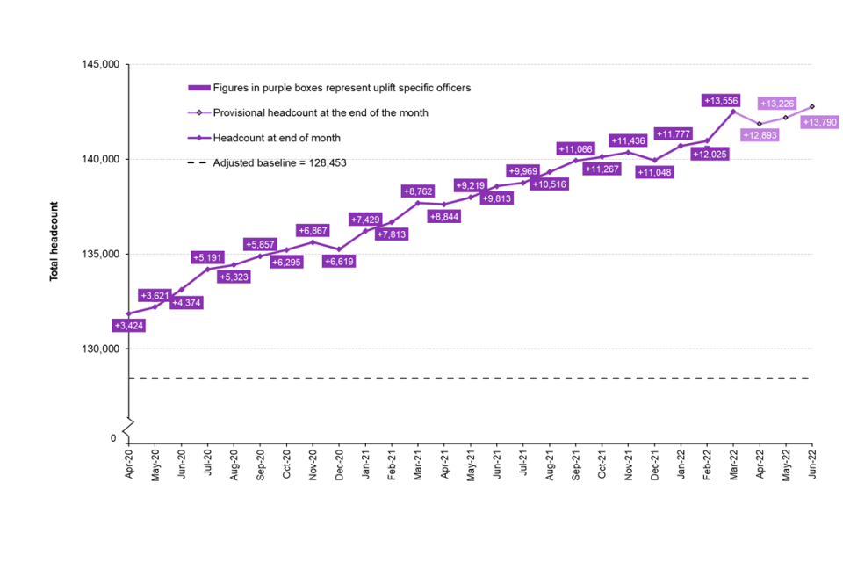
As shown in the above graph (Home Office, 2022c) there has been a steady rise of police officers employed across England and Wales. However, there was a significant decline in the number of officers leaving the service between November 2021 and December 2021, and between March 2022 and April 2022. This decline falls within the period that the Police Education Qualification Framework was introduced in March 2019, which may be significant or coincidental (Home Office, 2022a).
In January 2021, the Office of National Statistics (2022) confirmed that there were 97,300 full-time officers in 43 territorial police forces in England and Wales, but according to the Home Office (2022c) by March 2022 that number had risen to 140,228. There appears to be inconsistences between the data, as the Home Office (2022c) identified that only 12,789 new police officers joined the 43 territorial police forces in England and Wales in the year ending March 2022. This is an increase of 662 (or 5.5%) on the previous year (Home Office, 2022c). Compared to previous years, this year has seen the second-highest number of new police recruits.
The increase in recruitment is reflected in the UK Governments’ pledge to employ 20,000 more police officers in England and Wales by the end of March 2023, and 12,000 extra police officers could be employed by the end of March 2022 under the first two phases of this pledge.
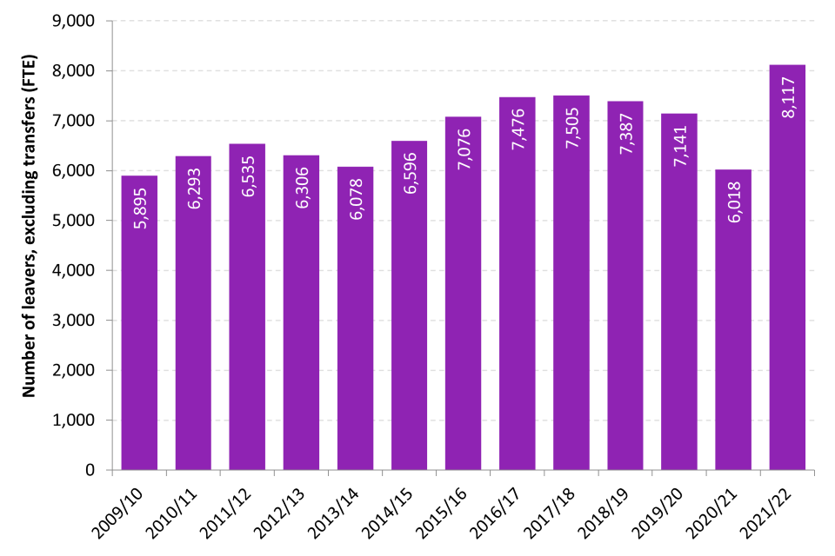
The above table obtained from the Home Office (2022c), shows that the same year 8,117 police officers leaving the 43 territorial police forces in England and Wales. This is the most annual leavers since comparable data first started in March 2003. This data excluded transferees. It is interesting that the same author acknowledges that the rate of police officers leaving was 6.0%, which was comparable to levels between the fiscal years ending in 2016 and 2019 (Home Office, 2022c).
There may be many reasons for the significant 35% decrease in national police force establishment figures. An expanding workforce may cause a rise in departures, however, according to the Home Office (2022c), the reasons for resignations vary.

Year ending 31 March: | 2017 | 2018 | 2019 | 2020 | 2021 | 2022
Normal retirement | 4,507 | 4,747 | 4,492 | 4,169 | 3,429 | 4,134
Voluntary resignation | 2,035 | 1,995 | 2,175 | 2,363 | 1,996 | 3,433
Transfer | 1,093 | 1,068 | 1,339 | 1,405 | 1,024 | 1,186
Medical retirement | 587 | 500 | 514 | 377 | 357 | 303
Contract termination and dismissal | 289 | 269 | 161 | 163 | 169 | 180
Death | 57 | 51 | 46 | 69 | 67 | 67

In the years prior to March 2022, many officers leaving the service (excluding transferees) did so via normal retirement, which has historically accounted for 60% to 70% of departing officers. Interestingly, the number of voluntary resignations has risen compared to previous years and although there is no national data surrounding the reasons for the resignations, the Home Office (2022c) has identified that the makeup of police officers in the year ending March 2022 showed that 33% of the police force have less than 5 years’ service, with 9% of them having less than 1 year service. This not only reflects a young in-service workforce, but it could be suggested that the significant size of the young workforce would play a prominent place in the figures relating to voluntary resignations.
According to the Police Federation (2022), many police officers have resigned from their jobs before their probationary periods ends. Research suggests there were 2,567 resignations from 28,173 probationary officers within this financial year. This resulted in an average attrition rate of 9.1% (Police Federation, 2022). This data is echoed by Northamptonshire Police who reported that 19.3% of their new recruits left the police service within their probationary period since the launch of the new national uplift of police officers (National Police Chiefs' Council, 2022)
There are smaller forces that have seen a lower rate of resignations, including Cumbria and North Wales, who both had rates of 3.9%. In addition to Merseyside and the West Midlands, who both had rates of 5.4%. Furthermore, data shows notable variations in attrition rates across forces however, within some forces, attrition rates have reached double digits.
Police Federation (2022) recognises that to retain new officers, fairer compensation and working conditions are essential. They highlighted that many officers begin with a salary of £19,164 in the first year of a police constable degree apprenticeship, which is just slightly more than the nation's national living wage, which was implemented in April of this year. Additionally, Police Federation (2022) identified that more than one in ten police officers are unable to afford their monthly bills, and they recognise that the low income has made student officers more likely to leave the force. They also contend that the quantity of academic work that officers are required to complete in their own time lowers their hourly pay, which puts further strain on families.
It could therefore be argued that for policing to continue to offer the finest service to the public, police leaders must make sure they do not just focus on getting people through the door, but also take the necessary steps to keep them (Smith & Smith, 2022).
Police Federation (2022) has emphasised how national attrition rates are impacted by low pay, poor management, the lack of promotion opportunities, and heavy workloads.
Jeff Harris, Surrey Police's Deputy Police & Crime Commissioner, shares this opinion and claims that recruitment practices are becoming problematic, and that a poisonous combination of lack of confidence, incident trauma, and academic pressures exists. (Policing Insight, 2022)
The government has pledged to support the police by providing them with the tools they need to safeguard the public and has promised to employ 20,000 more police officers, despite the fact that it acknowledges the resolve and dedication displayed by police officers all around the nation (Home Office, 2022b). In order to carry out this pledge, the government has promised to provide a professional and motivated police force, however it is recognised that the UK Government has fallen short of its desired uplift figures, with only 13,790 recruited up until July 2022 (Home Office, 2022b).

Despite the remarkable success of developing the police education programme, there remains several challenges faced by the police forces, higher educational providers, and the police students when putting the certification framework into practice.
Organisational Challenge
A new organisational framework is required to give the UK police service the skills it needs to deal with the growing issues it is currently facing. These issues feature a shift in social divisions causing rising demands to deal with violence, abuse, and exploitation. As expressed by The Police Foundation, (2022), who contends that difficult hurdles are causing troubling signals and a decline in police performance. These are due to the technical advancements inherent in modern society, where a new criminal realm has emerged. The police have also seen an increase in public order and violence during national protests, an increase in organised crime that preys on the young and vulnerable, and a growing threat of terrorism to public safety.
The new educational platform aims to supply police officers with the cognitive and problem-solving abilities to manage these growing issues, whilst applying their own judgement in a more challenging working environment (The Police Foundation, 2022). Chappell and Lanza-Kaduce, (2010) recognise that historically, recruit learning was hindered by the militaristic characteristics of police training, which included hierarchy, submission to authority, isolation, and discipline. This implies that for police training reform to take root, a necessary precondition is a suitable shift in police culture. Moreover, Hellenberg and Cockcroft, (2021) contends that a vital aspect of changing the culture of policing, is a change in how police officers learn and think. According to Christopher (2015), adopting a new learning paradigm into police training would necessitate a considerable organisational transformation because modern policing, like many other professions, should embrace the idea of becoming a critically reflective practice. However, according to Lumb & Breazeale (2002) inadequate implementation or a lack of organisational support may lead to a lack of relevant resources for recruits. To ensure that police services have the infrastructure necessary to accommodate postsecondary levels of learning and assessment, both investment and a significant adjustment to the curriculum are required, which will be an advocate for a change in the culture of policing (Wood, 2018)

Student morale and wellbeing
There have been some debates and complaints over the PEQF's implementation. Lincolnshire Constabulary Chief Constable Bill Skelly asserts that the implementation of the PEQF would lead to a reduction in the number of police officers engaged in front-line work. His views are that they are working many hours to achieve their degree-related courses and this would have an adverse effect on his current staff, causing increased pressures (Kadry & Lambert, 2021). Furthermore, according to Reiner & Newburn, (2007), it is evident that when developing learning materials for police studies, consideration must be made to operational commitments. However, in practice, police students may find it difficult to spend a significant portion of their working hours and free time to purse an academic degree, compared to traditional students on university programmes who are required to study and learn throughout the week (Mahruf et al, 2020). Duran et al, (2019) suggests that due to exposure to some extremely stressful incidents, policing is perceived as a very demanding profession, and as a result, physical and mental ill health is more prevalent among police officers. A paralleled opinion can be drawn from Buda & Lenaghan (2005) who reveals that working and studying can produce substantial stress and have a negative effect on a student’s wellbeing.
Ellison, (2004) recognises that inadequate staffing levels, heavy workloads, extended hours of work under pressure, refusal of holiday leave, and deadlines for academic submissions, are experienced by student police officers and are all linked to poor mental wellbeing. Furthermore, Baskinska et al (2014) suggests long study sessions, shift work, and the demands of the employer may lead to fatigue, which can be a psychological risk in an already hard profession. The author also recognises that the negative perception of police study heightens emotions and could further add to increased stress within their family life.
According to Syed et al, (2020), police officers experience twice as much stress as the average population and are more likely to experience mental health issues like PTSD, depression, and anxiety. This view is supported by Elliot-Davies (2018) who suggests that a police officer’s job role is the main cause of stress, depression, anxiety, or mental health issues.
The UK Government continues to support the wellbeing of officers despite acknowledging the challenging and demanding work that student officers do. The government has committed £7.5 million to creating a national police wellbeing programme that would offer officers guidance, resources, and tools. These include tools for officers who are struggling with their mental health (Home Office, 2022d). The onerous workloads and worries concerning health and wellbeing were highlighted by police personnel all around the UK. In 2019, the Home Secretary listened to the officers and outlined a proposal for a new police covenant. The covenant would recognise the courage and commitment of the police while emphasising the officers' physical safety, their well-being, and aid for their families (Home Office, 2022d).
Personal wellbeing is influenced by both the individual and the organisation, with a focus on the organisation and management's ability to assist its employees. While there are several national programmes and campaigns in place, it is unclear how the individual and organisational perspectives of wellbeing can be aligned (Phythian et al, 2021)

Collaboration
Making sure that higher education institutions (HEI) and police forces collaborate consistently and deliver the degree programme to students is a challenge. Jones & Newburn (1994) suggest that the HEI and the force will experience many obstacles, with the partnership facing difficulties of bringing the workplace into the classroom and the classroom into the workplace (Payne et al, 2003). It has been recognised across several universities that there is a reduction of teaching staff with policing skills and experience, which is needed to deliver the police education programme and this has brought about tensions within the partnership (Stanislas, 2014). However, this view is refuted as it has been recognised that many police departments enjoy a productive working relationship with the higher education institution that collaborates on other programmes, such as promotional qualifications (Stanislas, 2014)
Although some programmes are force-led, in which the force designs and delivers the course materials while the HEI approves and evaluates the learning, many forces and HEIs pursue a co-delivery model. This raises the question of who should oversee the running of the programme. One author questions that within the collaborative arrangement who ‘owns’ the student officers? (Wood & Tong, 2009)
The collaboration between the police and the HEI has produced successes, and many forces have fruitful conversations with their HEIs about the curriculum and assessment (Tong & Wood, 2009) However, Wood (2020) contends that whilst initial police training includes a very specific curriculum that outlines what must be studied, it focuses too much on what must be taught from the perspective of liability issues, and not enough on what must be learned to improve the officer's skill and comprehension. Kadry et al, (2022) reveals that in contrast to their operational responsibilities, some student police officers have withdrawn from their studies, which has led to a strained relationship between them and their higher education institution.
Perception of Higher Education in Policing
Cockcroft & Hallenberg, (2021) suggests that education has the power to influence how police officers engage with the public and their co-workers. However, there is currently limited knowledge surrounding the ways that higher education can alter the dynamics of the collaboration between police officers and police institutions. Furthermore, Paoline III et al, (2014) notes that education has a substantial impact on police officer behaviour and that educated police officers are more effective in combating crime. However, Lee and Punch (2004) contend that additional study is necessary to strengthen the case for why education is the most effective way to produce accomplished police officers.
In terms of the advantages of higher education, Punch (2007) suggests that officers benefit from a rise in personal and intellectual self-confidence, which in turn encourages effective working both internally and externally. However, the author also noted that officers share a more negative perception of higher education and highlight that the organisation value higher education credentials more when they were held by senior-ranking officers. The link between policing and higher education institutions is further complicated by the fact that Rowe (2006) suggests that many officers view practical experience as the gold standard of police knowledge and competency.
Additionally, Ramshaw & Soppitt (2018) noted that one criticism of the programme was that students frequently found it difficult to recognise the link of the academic content that was presented to them to their role. According to Cockcroft & Hallenberg (2021), the police forces show little appreciation for either student achievement or its potential value to the police, which highlights the cultural resistance faced in integrating education into policing.
Learning Experience
The delivery of police education is predominantly via a virtual learning environment, and the learning materials require interaction by the student officer. Some students may not interact with online lectures and thus lose critical instruction on the laws that are relevant to their professional duties, despite online learning being as effective as traditional classroom delivery models. One author notes that many students would still prefer a more conventional classroom setting as online delivery does not cater for all learning needs of students (Smart & Cappel, 2006). However, research suggests students learn by doing in real-life contexts, and retain ‘10% of what they read and 90% of what they say and do’ (Reif, 1993). Furthermore, it could be argued that officers need to be trusted and urged to put their knowledge to use in a manner that fosters their individual sense of professionalism (Williams, 2019)
Recruitment
During the recession of 2007, a problematic period for policing was indicated by a decline in the number of police offices, a more complicated pattern of developing crime, and the ripple impact of budgetary cuts to public services. Both the police forces and universities were unprepared when Prime Minister Boris Johnson declared in 2019 that he would recruit 20,000 new officers for the country's police forces to alleviate the lack of personnel.(…….)
In order to ensure that policing maintains resilience in areas that are crucial to the success of the service, the boost of 20,000 officers has brought extra recruitment and retention issues. To address these issues, the UK Government is closely collaborating with the National Police Chief Council (NPCC) whose objective is to improve learning and development, especially for those who supervise student officers (Home Office, 2022d)
According to Pollard et al, (2014), organisations must steer clear of the quantity over quality policy, which limits staff student ratios and strains already-limited resources by over-recruiting students. This view is echoed by Sir Mark Rowley who is the commissioner of the Metropolitan Police, who raises concerns whether it is prudent to swiftly hire thousands of officers. He also emphasises that the sheer magnitude of recruitment entailed considerable risks of hiring the incorrect people (BBC News, 2022)
Retention
In England and Wales, there has been a substantial increase in the number of police officers who have voluntarily left the force in recent years (Charman & Bennett, 2021). Concerns over the nation's police forces' increased rates of voluntary resignations, coupled with the challenging and expensive aim of hiring 20,000 additional officers over a three-year period, appear to have prompted a fresh focus on retention (Home Office, 2019). Furthermore, the Chief Constable of Northamptonshire, Nick Adderley, voiced his criticism of the police educational framework, claiming it was affecting force retention rates (Kadry and Lambert, 2022).
The number of police officers resigning prematurely from their employment has been rising quickly, despite statements from the Home Office that retention rates are consistent (Home Office, 2020). In contrast, UK police forces are receiving fewer applications than there are vacancies (NPCC, 2018). The stability of employment and the superior final wage pensions meant that retirement was always the primary cause of police resignations (IFS, 2017). However, following dramatic changes to police pensions and wages, one author suggests that these negative long-term impacts may hinder an organisation's ability to function, thus increasing absenteeism and increasing the propensity of individuals to quit their jobs (Noblet et al, 2009).
According to Matz et al, (2014), workplace attitudes and work environments are more closely correlated with intentions to leave the police force than individual characteristics. Several elements, such as the working environment, autonomy, management's support, and opportunities for growth, have an impact on officers' perceptions of their professions. However, according to Boag-Munroe et al, (2017), police officers are more likely to leave the organisation on their own, or publicly declare their wish to do so if they demonstrate weak organisational commitment, low levels of job satisfaction, high levels of stress, and low morale. This view is supported by Allen and Meyer (1990) who suggests that officers displaying a lack of organisational commitment is directly linked to staff attrition.
Contrary to what many organisations believe, research suggests that employees have a strong organisational loyalty which declines as length of service grows, and this presents a dilemma for policing organisations (Beck and Wilson, 2000). The decision to voluntarily leave the police service is complex, and it is more likely that a run of negative events will influence an officer decision making rather than a single, defining one.
Police Funding
High levels of voluntary turnover can negatively impact an organization's efficacy and expertise as well as its performance (Hom and Griffeth 1995). Additionally, the hiring and training of new workers can be expensive, with the cost of training a police constable to be £80,000 over two years (Boyd et al, 2011).
The demands imposed on the police are changing and becoming more complicated, but the UK government is devoted to supporting the police and giving them the additional funds they need to safeguard the public. The UK government vows to increase the number of police officers by 20,000 over the following three years which has raised concerns about the retention of existing experienced police officers.
The previous Police Pension Scheme from 1987 encouraged officers to serve for 30 years and then retire to maximise their pension benefits. However, the reforms to police pensions in 2006 is no longer an incentivise to retire at 30 years’ service and much experience is lost following its introduction (Home Office, 2022d). Retirement rates have remained constant over the past number of years, and many officers continue to leave the organisation soon after 30 years’ service. However, the police uplift initiative makes it difficult to preserve the workforce's important expertise and abilities. De Mesquita-Ferreira and de Acquino-Almeida (2015) suggests that employee turnover poses a serious threat to organisations. The authors contend that when individuals leave an organisation, new employees are brought in who don't possess the same level of competence and as a result, while the new employee is adjusting to the organisational culture, productivity within the organisation declines.
The government has acknowledged the need to strike a compromise between measures to increase recruitment and retention through an affordable pay award, as they recognise that retention is crucial to delivering on the police uplift commitment of additional officers. The now starting salary for police officers is approximately £20,880, although Chief constables have the flexibility to appoint those joining on the Police Constable Degree Apprenticeship scheme on a starting salary of £18,000. Police Federation (2022) argue that the recent pay award for all police officers was not enough, and is not aligned to the increase in cost of living. They have disclosed how the epidemic, growing inflation, and the terrible financial impacts of the wage freeze have made it impossible for officers to pay their bills (Police Federation, 2022a). Dissatisfaction within the service has grown with many voicing that they intend to resign within the next year.
Words 5474

