Management Assignment 1 2019 – LIDL – GERMAN DISCOUNTER GAINING MARKETSHARE



OCTOBER 2019

MODULE NAME: STRATEGIC MANAGEMENT AND SUSTAINABILITY
Name: MUHAMMAD HAZEEQ HAZWAN BIN GHANI
Student Number: 1903961

TABLE OF CONTENT

TABLE OF CONTENT 2
INTRODUCTION 3
COMPANY BACKGROUND 5
DEFINITION 8
MAIN BODY 11
IMPLEMENTATION OF STRATEGY 11
ADVANTAGES AND DISADVANTAGES OF THE STRATEGY 13
CONCLUSION 15
RECCOMMENDATION 16
REFERENCES 17

INTRODUCTION

Through concept, there are several approaches that can be implemented in a brand's positioning strategy to achieve optimal placement on different markets, be they regional, ethnic, social or economic.
This starts with the first phase in implementing a strategic planning template, defining a basic framework from which steps will be taken. Many strategic planning strategies emerge from a "global strategy" or a complex and long-term strategy, as compared to "incremental objectives," a strategy which evolves together with the company's growth. Researchers have developed indicators in this regard that analyse how close the company has use the strategy and the companies in general is to the literature strategy plan. Boyd (1998) shared the common planning model in four steps: “specifying goals, strategy generation, strategy evaluation, and results monitoring.” (Boyd & Reuning-Elliott, 1998).
In the article of Cespedes (1996) mention the value of pursuing a shorter-term strategy and its strong influence of a shorter "opportunity period" as a consequence of global competition, rapid development and delivery of technology and information systems are now able to copy any successful strategy more easily and quickly. We can therefore conclude that the competitive advantage is increasingly dependent on the capacity of businesses to successfully accomplish and control a range of strategic strategies that are also important to the business in the short and very limited term (Cespedes & Piercy, 1996). Stalk and Hout (1990) He noted that this strategy creates an improvement in the company's opportunity cost as strategies based on a short and limited term place the company in a competitive advantage role, but the execution of such strategies that increase costs compared to the normal strategies implemented and not linked to a limited term. (Stalk & Hout, 1990).

Therefore, the development and execution of the concept became more restrictive than before and the management team was required to obtain permission to execute the plan and to set deadlines for this. The executive team, whether it is the marketing department or the sales or management department, varies in many cases from the policy development committee, which usually consists of the management team and, in this case, the marketing department.
Cespedes examined the relation between formulating and executing strategies in terms of product existence, and their life cycles are lowered. The disparity between the design and execution of the policy will lead to the loss of the value of being the first or the advantage of being the industry's leader. It is therefore necessary to make the institutional and administrative distinction between the development and the implementation of the marketing strategy. So each group will have a clear set of step-by-step procedures and timelines to be met. The "formulation-implementation dichotomy" must always be pursued and attempts must be taken to reduce or eliminate it, thus producing effective results in the promotion of the product being applied. (Cespedes & Piercy, 1996).

COMPANY BACKGROUND

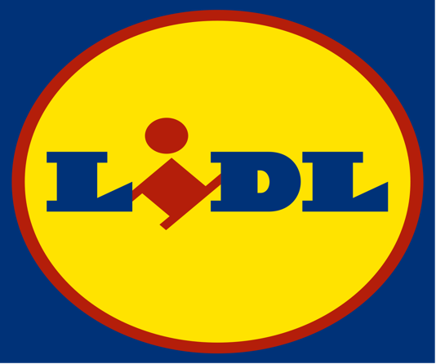
Figure 1.1 Lidl

Lidl Stiftung Co. KG ‐ popularly known as Lidl, is a Germany‐based, international retail giant. Back to the 1930s, the company can follow its roots. The business began to take its current shape and form as a discount, or low price, food chain, from the mid-1970s. The company has grown at a tremendous pace since that time, to the point that it ranks as a key player in Europe's supermarket retail market today. It shows that Lidl is ranked by revenue as Europe's largest discount company. The business strategy concept has spread to many other European countries. The organisation is known as a "Stiftung," or Trust, which is why it is not transparent in its policy and reports. Based on the observed behaviour of the business, it is fair to assume that the business is pursuing a massive growth strategy and intends to become a key player in any sector it wants to join. (Meland 2004).
As Lidl grew big during the 1980s in Germany, it became the foundation for the achievement of the Schwartz Groups. Lidl launched its first outlets outside of Germany in the 1990s. Today, Lidl has over 8,000 stores in 25 various countries, and the percentage continues to increase. This makes Lidl Europe's largest low-cost food retailer measured by turnover (Ness, 2001). “They have recently started to go beyond Europe, to places like Cyprus and Dubai” (Bloomberg Businessweek, 2009). Lidl believes that their uniqueness is the fundamental basis for their success and the reason for all their activities and procedures. They show this by having the same interior structure in all outlets and the same exterior design. (Ivoikoey, 2005).

Mission and Vision Statement
Statement of mission and vision for all types of organisations is an essential part of the strategic management process. Such claims have a huge impact on the overall and operational dimensions of the business (Darbi, 2012). According to the findings of (Bart Baetz & Kenneth, 1998) a positive relationship occurs between the organization's quality and mission statement (Rarick, & Vitton, 1995) It has been found that organisations with an official mission and vision statement have twice the returns on shareholders ' equity compared to organisations with no mission statement.
Mission statement
- “To deliver outstanding customer satisfaction”
- “To ensure market leading quality and value by constantly innovating and optimising our efficient processes, driven by technology and people.”
- “To work with business partners in sustainable relationships, contributing positively to local communities.”
- “To achieve long term success by investing in the recruitment, training and development of our people.”

According to (Drucker, 2008) The statement of mission states what the company's business is. A clear mission statement is required to set goals and objectives. There are several elements that need to be included on the statement while writing a mission statement. These components are the company's customers, products or services, market in which the organisation is involved, growth, employee concern, belief, community and social concern, technology and the organization's ultimate competitive advantage (David, 2011).

Vision statement
“To enhance the lives of our customers, by providing quality products at market leading value, whilst ensuring that customer satisfaction is at the heart of everything we do.”
The goal of the statement of vision is to give an explanation of where the organisation wants to be and what it wants to become in the future. It focuses on the company's long-term plan (David, 2011). Vision declaration plays a key role in the company's management, policy execution and transition (Avery, 2010).

DEFINITION
Bowman's Strategies Clock is a very useful approach to help you understand how the market's companies are competing. Through looking at the different price point and perceived benefit ratios, you will start to pick a competitive advantage situation that makes sense for you and the expertise of your company. This is a compelling way of looking at how a strong position in a market driven environment can be developed and sustained. Through knowing these eight key strategic roles, you will assess and review your current strategy to decide if your overall competitive position could be strengthened through improvements.
Bowman develops his own "Bowman's Strategy Clock" marketing strategy based on the concept of gaining competitive advantage by supplying consumers to what they want or need, more or even more effectively than rivals.
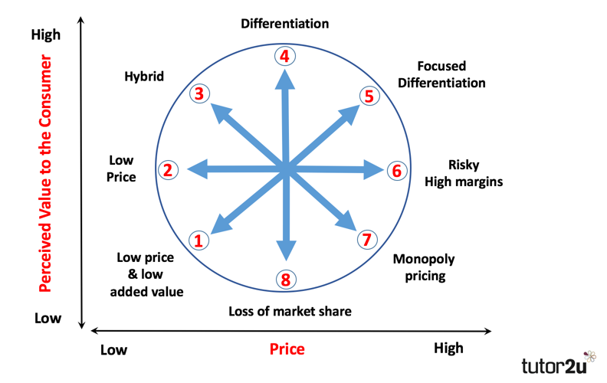
Figure 1.2 Bowman and Faulkner Strategy Clock

"Strategy clock" positions show different market positions where consumers have different (perceived) value and (monetary) cost factors requirements. By using the following places, the competitive advantage is done:

- Low price and low added value. It is a class in which firms tend not to put themselves, primarily occupied by goods that vary very little from each other. The cost is also small here, and the only way to achieve profitability is by growing the quantities and the number of new consumers. Unable to achieve differentiation in this category, the objective is to reach the customer by any method other than the product features or price (eg.: higher numbers can be reached by a bigger distribution and a strong sales team)

- Low price. It is a class where the business depends on the most critical being the consumer's cost tolerance. For the business, this role is challenging because it consists of small margins, large chances of not collecting expenses and misleading customers. Revenues can also only be reached here with large quantities and economies of scale.

- Hybrid. Price is low, added value is strong. Companies in this category provide high perceived value in comparison with the competition at a low price. An instance of such pricing can be seen when the goods are of medium and high value in the discount-type stores, but at lower prices. The consumer considers the relationship between both the perceived value and the price to be correct. Many existing customers are gained in this kind of positioning.

- Differentiation. This positioning provides high quality products and differentiates them in such a way that a high added value of the product is perceived by the customer. It can be of two kinds in terms of price policy. A high price is performed in the first case, and consumers may find the value to be compatible with the performance delivered. The second situation is a normal average value. The company is benefiting from the increased market share in this case.

- Focused differentiation. For a different category, it gives a very strong perceived value. Of example, despite high margins, high prices are exercised in the meantime. In the case of ultra-premium products, this technique is typically followed. Some examples of brands using this positioning are: Rolex, Armani, Rolls Royce.

- High price and standard added value. Organizations can only do this strategy if rivalry does not take action in the short term and if the rivals support it. It is a very profitable business segment, but it is also dangerous and can lead to the loss of a big market share. Usually this strategy is adopted over a relatively short period of time, on a normal and competitive market, no to lose the product's consumers.

- High price and low added value. In the case of monopoly, this strategy only works. In a free and competitive market, it is difficult to follow this approach.

- Low value and standard price. This method leads to the loss of market share directly. Goods with low perceived value added, and without being distinguished, cannot compete only by price on the market. If neither the price is correct, the proposed product will not be bought by the consumer.

MAIN BODY

IMPLEMENTATION OF STRATEGY

Bowman's Strategy Clock (Bowman & Faulkner, 1996) is a strategy which can be used to analyse the company’s competitive position in comparison to offerings of competitors, the current stance of Lidl is plot no. 2.
Lidl claims that they buy and sell products in order to offer their customers "top-quality products every day at the lowest possible price." To this end, the headquarters of the company and all the stores are following a well thought-out and standardised strategy (Iyikoey, 2005).
In Germany as much as 85% of the items in Lidl's shelves are private label items (Haug, 2003). Nonetheless, the 15 million branded products give Lidl the reputation of having more brand products in their stores than their rivals. A German researcher commented: “Lidl uses the brand products as a frequency generator. And they need these products to strengthen their image as a discounter. This is because customers can only through brand name products compare with prices at Real and Edeka” (Iyikoey, 2005).
Lidl is a big player in Europe, and they use this power to push suppliers ' prices to an absolute minimum. They also use an aggressive price strategy to create the impression of particularly low prices with spectacular special offers. Typically, such rates were implemented for only a short time, but long enough to create the impression of low prices. The company has been criticised by both competitors and customer representatives for this method, which they consider to be misleading and unreasonable (Iyikoey, 2005).
To even more lower prices, Lidl focuses on plain retail, providing its products directly from boxes or pallets. (Iyikoey, 2005). Lidl is known at very low prices for selling beer. Lidl made a loss for every bottle of beer they sold when they entered Sweden. Beer was used as a frequency generator (Molberg, 2004).
According to Kotabe (2008), Global pricing has one of the most critical and complex challenges facing global companies. Price is the key element that generates money, and in efforts to expand overseas, a business's pricing policy can make or break it.
Prices vary around continents, even within the same geographical regions, such as the Eu market. Kotabe (2008) argues that this resulted from the following: “Business (costs, company objectives), Consumers (price sensitivity, divisions, consumer preferences), Market (market structure, intensity) Channels and government policies (price controls, tariffs, import duties).”
Lidl is known for its top cheap prices in the market. Lidl will mix its low prices with high-quality products as it has found numerous suppliers in Central Europe, signed favourable deals, and developed a simple purchase system. Lidl rarely needs to sell products below their actual cost because of its cost-effective and strict operations. In fact, due to the low number of staff, Lidl is likely to drop its prices even further, as its margins are still acceptable. While Lidl never really had to give up its products ' quality. Eventually, Lidl has packaged items almost ready and they have no counters for fresh fish or food delivery. (LIDL WEBSITE, 2015)
According to data of US retail markets and findings DHAR (2001), Best-performing retailers typically offer a greater selection of products, use private labels, charge significantly lower prices, and use advertising to drive store traffic and display to boost in-store purchases.
By following the needs of customers for every country, Lidl maintains with change. They have managed to succeed in adapting to Finnish culture and buying habits, for example, and nowadays they offer good-looking products and also have more targeted customer services. (LIDL WEBSITE, 2015)

ADVANTAGES AND DISADVANTAGES OF THE STRATEGY

Price wars can produce economically terrifying and psychologically weakening situations that take an incredible toll on profit margins for an individual, a business, and market. Whoever wins, all the company seem to end up worse off than they did before they joined the fight. And yet, price wars are becoming ever more common and seldom serious.The price wars between the supermarket company will give benefit to the consumer but it will give the company to get lesser profit because of competing with the competitor for the lowest price. The main competitor for Lidl would be Saintsbury, Tesco and Aidl. These big for will compete with each other especially during the festive season.
If a corporation wants to sell a high amount of a low-margin commodity, this will be the market area where they would like to operate. Low cost pioneers are often one of the top names in a given market, as it takes enormous size to make a profit by pricing the products at a very cheap price. Most small and medium-sized enterprises are unable to take this approach because, without a high sale price, the volumes they gain will simply not sustain the industry in the long term.
"Price leadership" is therefore one way of reducing competition across the market. Price leaders usually develop reputations for avoiding price reductions as a way of gaining market share and reacting to price cuts by renegade companies quickly and decisively. The market leaders are viewed as reliable enforcers of value regimes based on their cost ratios, strategic positions, or their officers ' personal characteristics.
Once Lidl penetrated Norway in late 2004, they mainly marketed their own products that were new to customers in Norway. It was the outcome of a standardised strategy from Lidls, and an important way of keeping their prices competitive. The large number of private labels tends to be a conflict to actions purchasing from Norwegians.
We can now see plainly why Norwegian consumers are used to spending in a different way from other Countries in europe. Norwegian are used in discount stores to shop their grocery stores. Both Kiwi and Rema 1000 are strong players in the discount sector, which has a market share of over 50 percent in Norway.

Because Lidl did not succeed in becoming the market pioneer as they were in other European countries, they seemed to be trapped in a position of rates at the same rate as Rema 1000, but in the hands of a less desirable Norwegian brand. Lidl gradually added 400 new and branded items to cope with the Norwegian buying behaviour.

CONCLUSION

Overall, competition is increasing as foreign players enter mature markets already. Such increasing competition in Europe's retail market has also grown bigger. Overseas companies have turned to Europe, and similarly European corporations have gradually begun looking outside their own country's borders for market opportunities to grow and profits from economies of scale. This pattern has also reached the local markets for the last three decades, including fresh food. (Howard, 2004)
The development of large corporations depend on their competitiveness in the market. If the organization on the market establishes more competitiveness in terms of prices, costs and profits, in so far as it will itself have a higher market share. The goal of every big company is to acquire most of the market in order to maximize profit. However, the process that leads to the achievement of a competitive position is very long and it is necessary to implement the appropriate company strategy. People are a very important factor in the functioning of each organization, because it is exactly they that influence the development of business. The company has managed to capture a huge market share in Europe and is the largest competitor in the field of trade.
The future of positioning strategies will continue to be focused on the theories presented above, but it will be increasingly based on customer segments and will have a shorter time efficiency. Adaptability will be a decisive factor in the development of globalisation and communication positioning strategy.

RECCOMMENDATION

The retail technology, particularly over the last two decades, has experienced a transformation with the fast growth of electronic economic activity. E-business is becoming a popular platform for customer-seller transactions throughout the world as a means to match and complement a physical store's experiences.
According to Orel and Kara (2014), Rapid technological developments also driven distributors to offer high-quality customer services. The use of online shopping services based on technology has expanded rapidly in past years. A change from the traditional physical store style to the more sophisticated non-store formats has taken place, with online shopping sales just crossing the $100 billion in 2007. The use of electronically and modern technology has led to a change in today's online businesses. Playing online is a playing necessity as a medium that complements and enhances a traditional store's interactions.
Now, via worldwide technological networks, access to goods and services is facilitated. It is possible to access and evaluate a broad range of goods and services in terms of characteristics, functionality and cost, thereby favourably impacting purchasing decisions. So it would be suggested to have an online store for Lidl. By providing this online service, this will help businesses generate more revenue.

REFERENCES

Avery, G. C., 2010. The power of vision: Statements that resonate. Journal of Business Strategy, 31(1), pp. 37-45.
Bart Baetz, M. C. & Kenneth, C., 1998. The Relationship Between Mission Statements and Firm Performance: An Exploratory Study. Journal of Management Studies, 35(6), p. 823–853.
Baack, D. W., & Boggs, D. J. (2008). The difficulties in using a cost leadership strategy in emerging markets. International Journal of Emerging Markets , 3 (2), 125-139.
Blankson, C., & Kalafatis, S. P. (2001). The Development of a Consumer/Customer- Derived Generic Typology of Positioning. Journal of Marketing Theory and Practice , 9 (2), 35-53.
Bowman, C., & Faulkner, D. (1997). Competitive and corporate strategy. London: Irwin.
Boyd, B. K., & Reuning-Elliott, E. (1998). A Measurement Model of Strategic Planning. Strategic Management Journal , 19 (2), 181-192.
Boyd, H. W., Walker, O., & Larroche, J.-C. (1998). Marketing Management: A (Vol. 3rd edition). Irwin, Chicago.
Cespedes, F. V., & Piercy, N. F. (1996). Implementing Marketing Strategy. Journal of Marketing Management , 135-160.
Darbi, W. P. K., 2012. Of Vision and Mission Statements and Their Potential Impact on Employee Behaviour and Attitudes. International Journal of Business and Social Science, 3(14).
Dhar, S. K. Hoch, S.J. Kumar, N. (2001). Effective category management depends on the role of the category. Journal of Retailing 77: 165-184
Drucker, P. F., 2008. The Five Most Important Questions You Will Ever Ask About Your Organization. 1st ed. San Francisco: Jossey-Bass.
David, F. R., 2011. Strategic Management Concepts and Cases. 13th ed. New Jersy: Pearson Education.
Haug, K., Rønning, F(2003) Klassekampen.no, Versting til Norge
Iyikoey, G., Csurgó, K.(2005) LIDL’s Success Entry to the European Market
Meland, A. (2004) Slik stoppet de Lidl,
Ries, A., & Trout, J. (1976). Pozitionarea Lupta pentru un loc in mintea ta. The McGraw Hill companies, Inc.
Rarick,, C. A. & Vitton, J., 1995. Corporate Strategy: Mission Statements Make Cents. Journal of Business Strategy, 16(1), pp. 11-12.
Stalk, G., & Hout, T. M. (1990). Competing against time: How time-based competition is reshaping global markets. New York: Free press.

