Securing the Enterprise Network with Check Point GAIA: Part 2 Implementation Report

Programme: MSc Cybersecurity and Digital Forensics
Module:Enterprise Network Security
Module code: ACCA7032
Student name: patel jay rajendrakumar
Student ID number: 2433122
Table of Contents
1. Introduction 4
1.1 Purpose and Scope 4
1.2 Report Structure 4
2. Enterprise Context and Objectives 4
2.1 Enterprise Network Overview 4
2.2 Threat and risk drivers 4
2.3 Security objectives and boundaries 5
3. Methodology and Evidence 5
3.1 Evidence Capture Approach 5
3.2 Guidance Sources Used 6
3.3 Validation Approach 6
4. Management Architecture Integration 7
4.1 Topology Modification Rationale 7
4.2 SMS deployment (Gaia OS) 7
4.3 SmartConsole Installation and Connection 10
4.4 Gateway Object Creation and SIC 12
4.5 Licensing application and documentation 14
4.6 Management verification 15
5. Firewall policy design and enforcement 16
5.1 Translating Enterprise Policy to Rules 16
5.2 Rulebase design approach 17
5.3 Inbound Traffic Controls 17
5.4 Outbound Traffic Controls 19
5.5 Service-Specific Rules 19
5.6 Testing and Justification 20
6. Additional security enhancements 21
6.1 Selection Criteria 21
6.2 Proposed Enhancements 21
6.3 Implementation Evidence 22
6.4 Residual Risk and Further Hardening 23
7. Verification and Report Quality 23
7.1 Connectivity Validation 23
7.2 Functional Security Validation 24
7.3 Documentation Checklist 24
8. Conclusion 24
8.1 Outcomes versus Objectives 24
8.2 Limitations and Next Steps 25
9. References 26

1. Introduction

1.1 Purpose and Scope
This report discusses Portfolio Part 2 that is concerned with the securing of the enterprise network with the help of the GAIA appliances, that is, the buildings on the deployment that had been achieved during Part 1. A written report that captures the accomplished security settings with screenshots of the settings put in place as a witness will be the deliverable.

1.2 Report Structure
The report is structured in accordance to the three major requirements. First, it records the integration of a Check point Security Management Server, where SmartConsole is used to manage central policies, monitor and update, which includes license verification and expiry information. Second, it identifies and justifies a firewall policy and rulebase with the limitation of unauthorised inbound and outbound traffic based on an enterprise security policy. Third, it suggests and introduces other security features that match the accepted industry standards with the Check Point guidance.

2. Enterprise Context and Objectives

2.1 Enterprise Network Overview
The enterprise network setting is an extension of Part 1 and grounded on a two site arrangement of SWANSEA.ACCA and LONDON.SWANSEA.ACCA. Part 2 is about the protection of this environment through the use of GAIA appliances without re-documenting the activities of the Part 1 build. Security-relevant elements in scope to protect are management plane where the central administration is to be performed, on the security gateway is the point where policies are to be implemented, inter-site traffic flows between the two locations, and any business services made within the enterprise topology where they appear in the lab implementation such as directory, name resolution, addressing, and web services [1].

2.2 Threat and risk drivers
Part 2 discusses the two major security issues that are unauthorized inbound and outbound traffic, and the operational risk of the lack of uniform controls when there is no centralised policy control and monitoring. The lack of restraint or only loosely controlled ingress results in more vulnerability to exploitation and service denial, and lax egress results in high chances of leaking data and command-and-control messaging [2]. These threats are explicit to confidentiality, integrity, and availability and they form the basis on which firewall rules would be created in the future and further security.

2.3 Security objectives and boundaries
The quantifiable goals are to unify management of security policies through a Security Management Server, implement firewall policies that control unwarranted incoming and outgoing traffic, and record the status and expiry of license of the management and the gateway software [3]. Every statement in the report is limited to that which could be demonstrated in the laboratory setting by screenshots, logs, and test results recorded and anything that cannot be proven by such means should not be included.
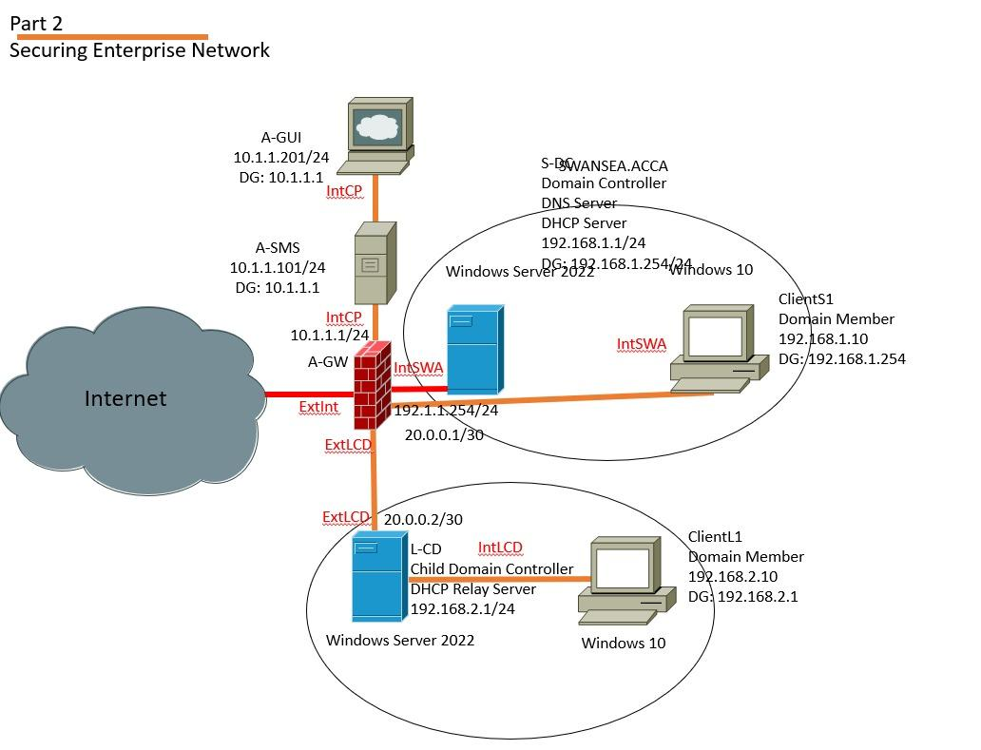
Figure 1: Securing enterprise network with multiple configurations

3. Methodology and Evidence

3.1 Evidence Capture Approach
Every practical work is supported with screen-shots, preferably with timestamps visible, and it is all summarised in the final report. The screenshot should also be audit ready with the title of the application or screen, the name of the area of configuration, critical fields and values, names of the relevant objects, the portion of the rule base where part of it exists, and validation evidence like logs or test results [4].
Table 1: Minimum screenshot evidence checklist
Evidence item | Must show | Why it matters
Configuration proof | Screen title, key fields, object names. | Shows control is configured correctly.
Policy enforcement | Rulebase excerpt, installed policy confirmation. | Links policy intent to enforcement.
Validation result | Test output and relevant logs. | Demonstrates expected outcomes.
Timing | Visible timestamp where possible. | Supports traceability of work.

3.2 Guidance Sources Used
Guidelines on official Check Point are referred to in order to recognize, pick, and appropriately put to use progressed security properties, which are consistent with accepted business practice, especially in the event that Part 2 advises supplementary security properties to those suggested by standard firewalling. In order to rationalise the decisions related to the security policy, the findings of the credible and reputable sources on technical grounds are applied to the justification of the rationale of the risk and the choice of the control measure, with references being made to the least privilege, the defence in depth, and CIA impact, without referring to the sources that are not going to be reviewed and implemented in the work.

3.3 Validation Approach
Validating is done through confirming that the management shows connectivity between the Smartconsole and the Security Management server, policy level is correctly installed to the gateway, there is a successful SIC communication state, a valid license and expiry information, and controlled traffic tests, which are used to show controlled services in addition to blocked services. Every validation step is supported by screen shot and, in case needed, logs and test results obtained in the environment. The test results are written in a tabulated file with the format source host, destination, protocol/ service, expected result, actual result and a pointer to the evidence provided.

4. Management Architecture Integration

4.1 Topology Modification Rationale
By introducing a Security Management Server, SMS, security policy management is centralised, event monitoring is centralised and updates in a face so that the enforcement of the gateway is now controlled through a single, authoritative, platform as opposed to being done locally on each system. In this implementation, they changed the topology that was in place by adding an A-SMS server which was running the Gaia OS, and they configured the management workstation A-GUI with SmartConsole by connecting to an A-SMS to do the central administration [5]. The integrated management part employs lab addressing where A-SMS is 10.1.1.101/24, A-UI is 10.1.1.201/24 and the gateway is A-GW is 10.1.1.1/24.

4.2 SMS deployment (Gaia OS)
The SMS, the Security Management Server, is installed as the central control entity that consists of policy administration, policy monitoring and policy updating of the enterprise security infrastructure. It offers a special management plane by hosting the management services to which SmartConsole is being administered, with the security gateway as the interpretation point. The administrative access is done by the sms management ip which is the Gaia Portal, and also by SmartConsole where the management workstation connects.
The SMS hostname, which is going to be installed under A-SMS, here the main management interface is eth0 and the hostname is set to 10.1.1.101/24 with default gateway 10.1.1.1. When we are using First Time Wizard; Security Management is empowered and Security Gateway is off and the SMS is defined as the Primary Security Management. The actual management hardening settings that can be observed in the build are the longer inactivity and web session timesetting to 720 and configuring the setting. The account of the dedicated SmartConsole administrator is defined as cpadmin, and only the 10.1.1.0/24 network is allowed to access the GUI client. The operational readiness of the SMS is checked on the status of the API until the status of the readiness test is notified to be successful.
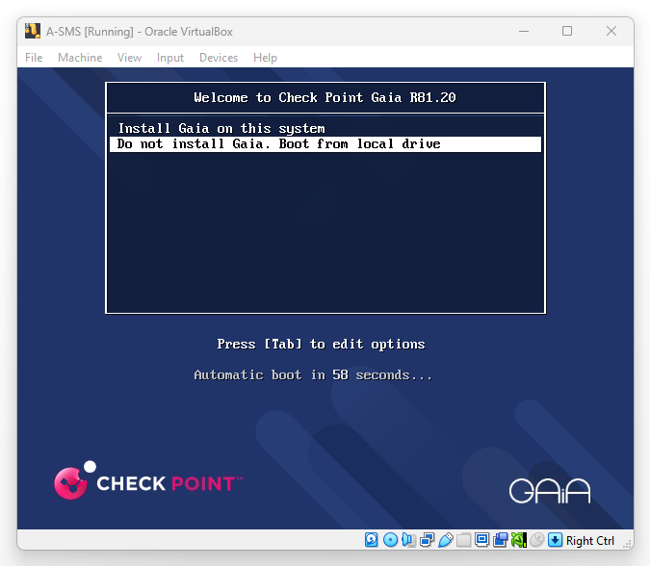
Figure 2: A‑SMS Gaia R81.20 boot menu showing the option to install Gaia on the system
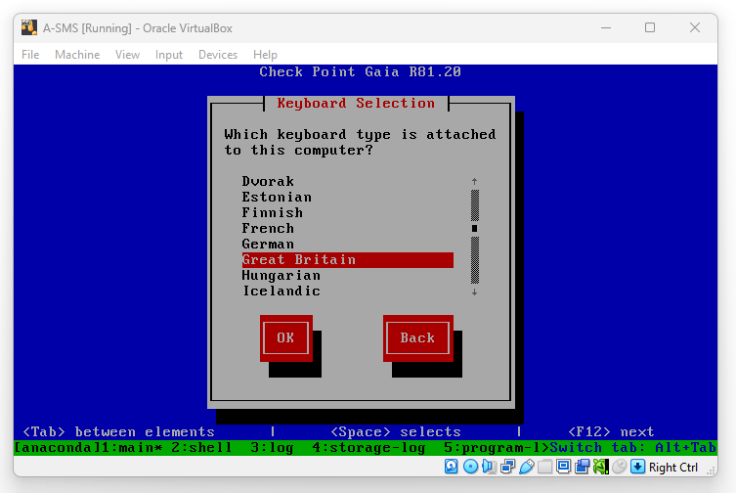
Figure 3: Gaia installer keyboard selection, Great Britain selected for A-SMS
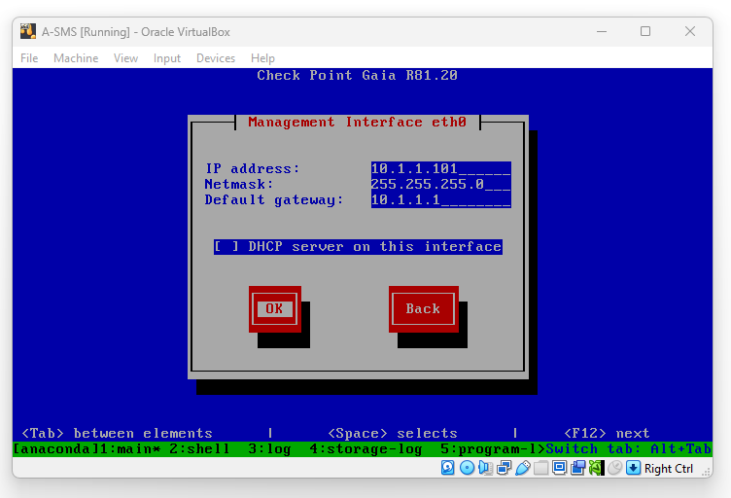
Figure 4: A-SMS management interface configuration showing IP addressing and default gateway settings on eth0
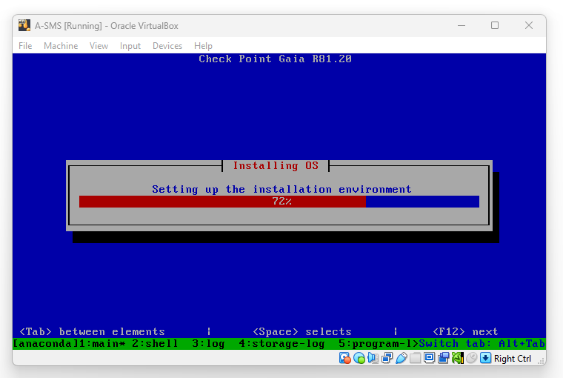
Figure 5: Gaia OS installation progress screen for A‑SMS, confirming OS installation is in progress
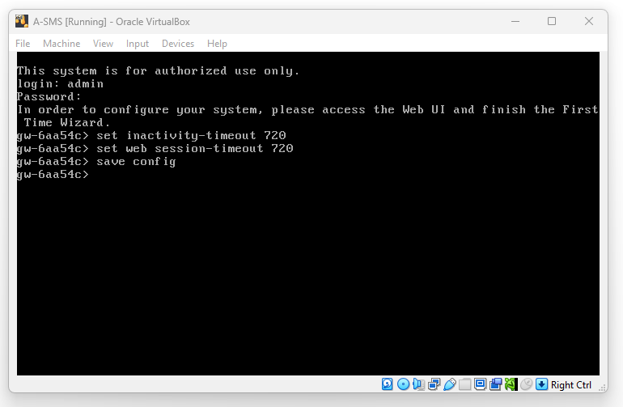
Figure 6: Post-install CLI hardening on A‑SMS showing inactivity and web session timeouts configured and saved.

4.3 SmartConsole Installation and Connection
SmartConsole is deployed on the management workstation, A-GUI to offer centralised management of the Security Management Server and the entire security infrastructure. In this implementation, SmartConsole is started at A-GUI and then applied to connect to the SMS located at 10.1.1.101; it contains the operations of the management onto the management plane though not on the gateway but instead on the SMS located above. The dedicated SmartConsole administrator account, cpadmin, is used to perform administrative access, and this is created during the SMS settings in order to secure a delegated management. The further limit of access is achieved by the setting of GUI client permissions to SMS 10.1.1.0/24 network, restricting access to the SMS by whom it is defined. The success of the connection can be demonstrated by an authenticated session in SmartConsole to the SMS and access to the objects and policies of the gateway using the central console.
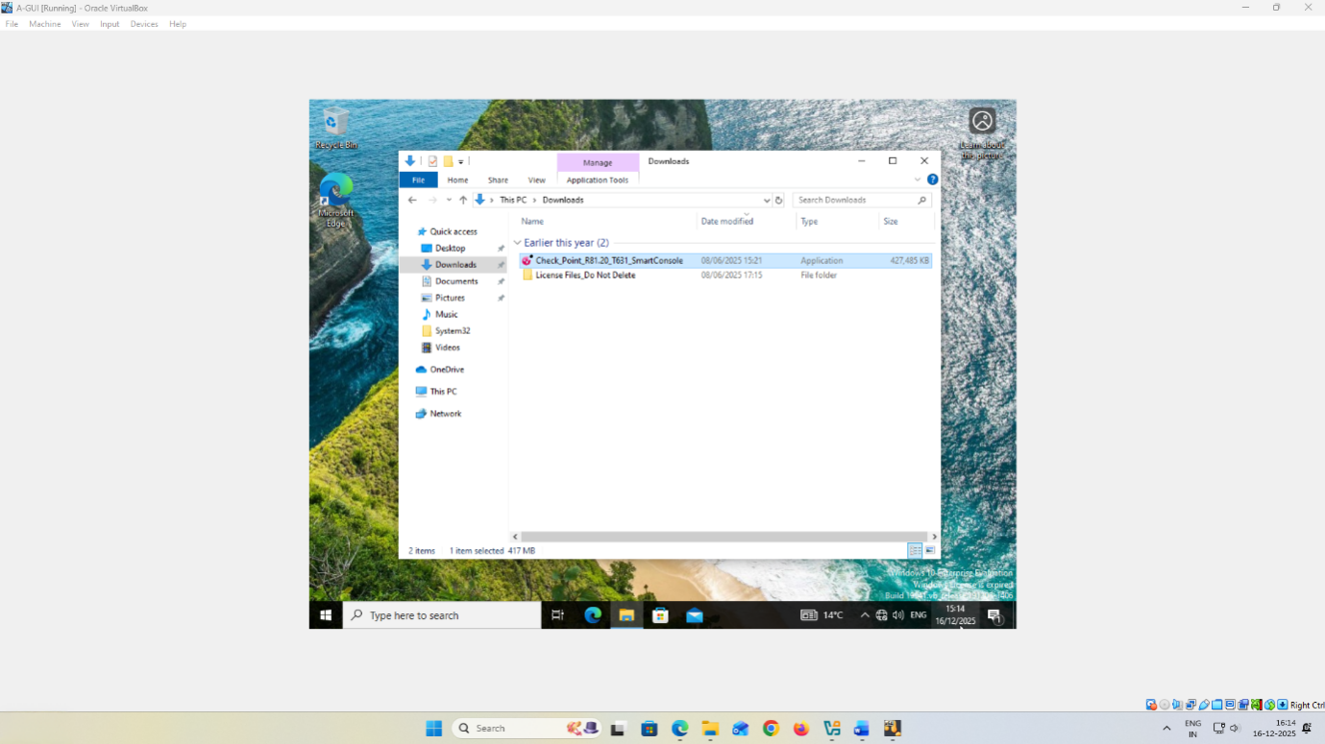
Figure 7: A‑GUI Downloads directory showing the SmartConsole installer (Check_Point_R81.20_T631_SmartConsole.exe) ready for installation
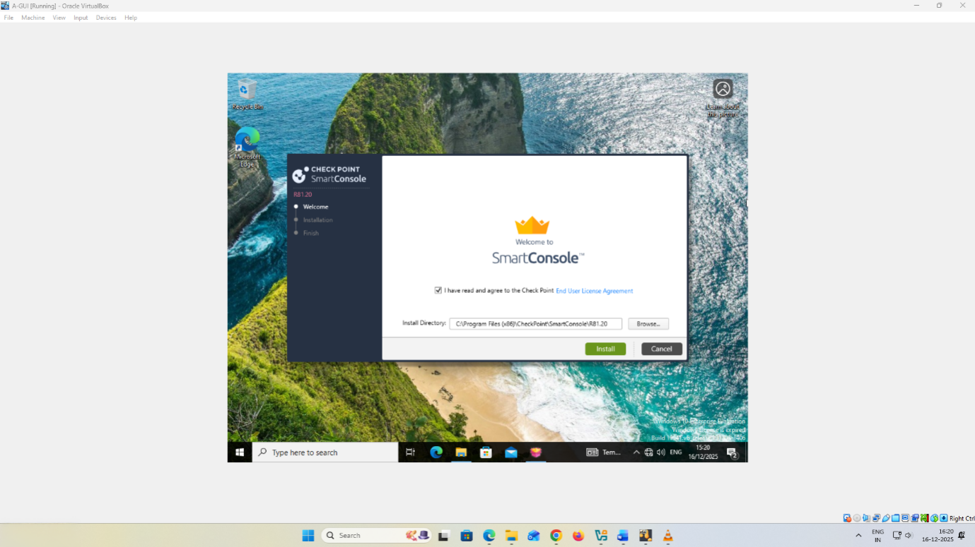
Figure 8: SmartConsole setup display indicating acceptance of the End User License Agreement and the installation destination folder chosen
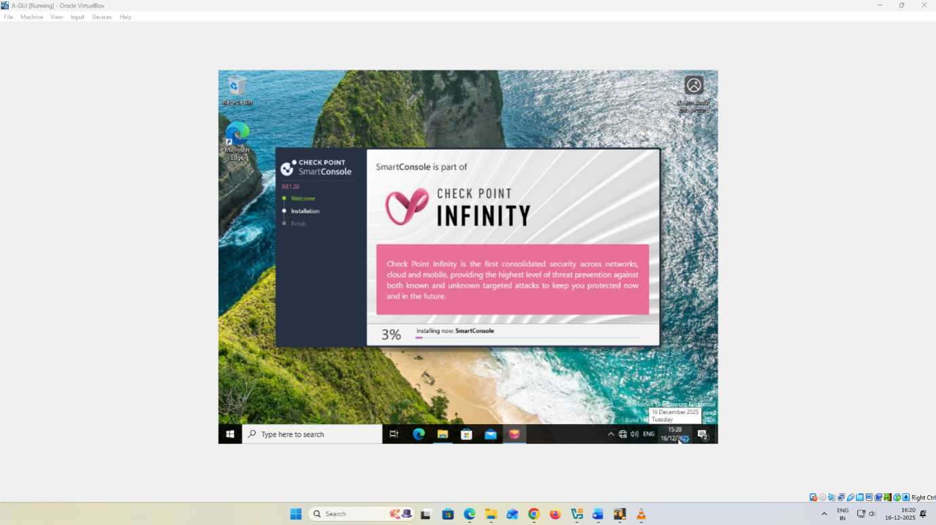
Figure 9: SmartConsole progress screen on installation, indicates that it is still being installed on A-GUI
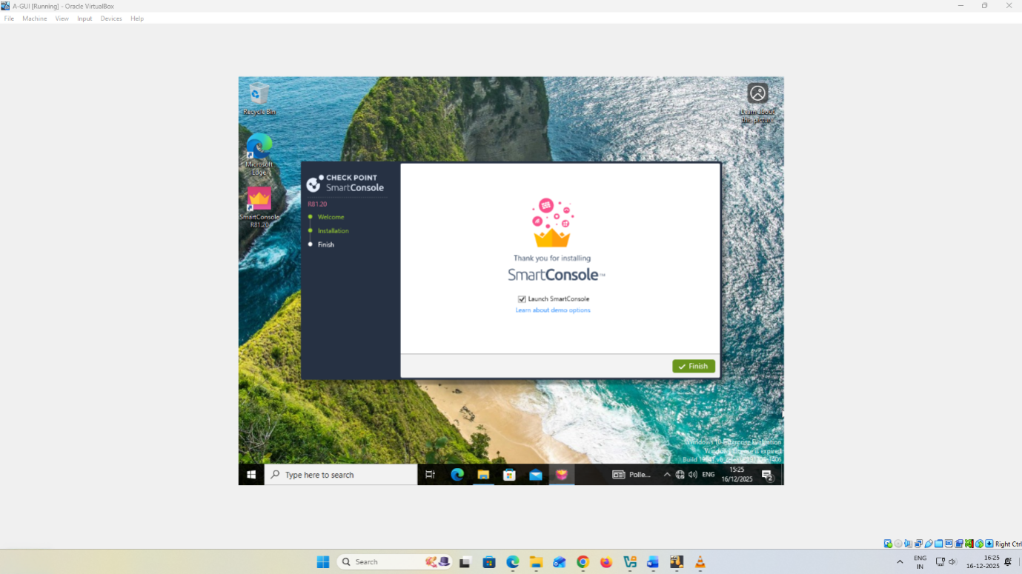
Figure 10: SmartConsole setup display indicating acceptance of the End User License Agreement and the installation destination folder chosen

4.4 Gateway Object Creation and SIC
In SmartConsole, the onboarding of the Security Gateway can be done by the creation of a gateway object which is utilized by the management database as an object that depicts the physical or virtual gateway device. In this implementation, the creation of the gateway object is done via Gateway creation wizard where the name of the gateway is A-GW and linked to the management IP of the gateway in the 10.1.1.0/24 network. This association enables the SMS to drive policy, log and centrally control the gateway using the SmartConsole.
Secure Internal Communication, SIC, defines a trusted, authenticated administration channel in between the SMS and the Security Gateway to ensure that the policy instalment and administration functions are safeguarded against unauthorised administration. SIC is done by generating a one-time activation key on the gateway on the occasion of its First Time Wizard, and the same one-time password as the key in SmartConsole when making gateway objects or configuring trusted communication. Once the gateway object has been created, SIC can be checked with the help of the gateway object properties; in general, the choice of the communications settings and SIC status test should be performed. The status of the SIC is determined as Communicating which is registered as evidence in the report to confirm successful setup.
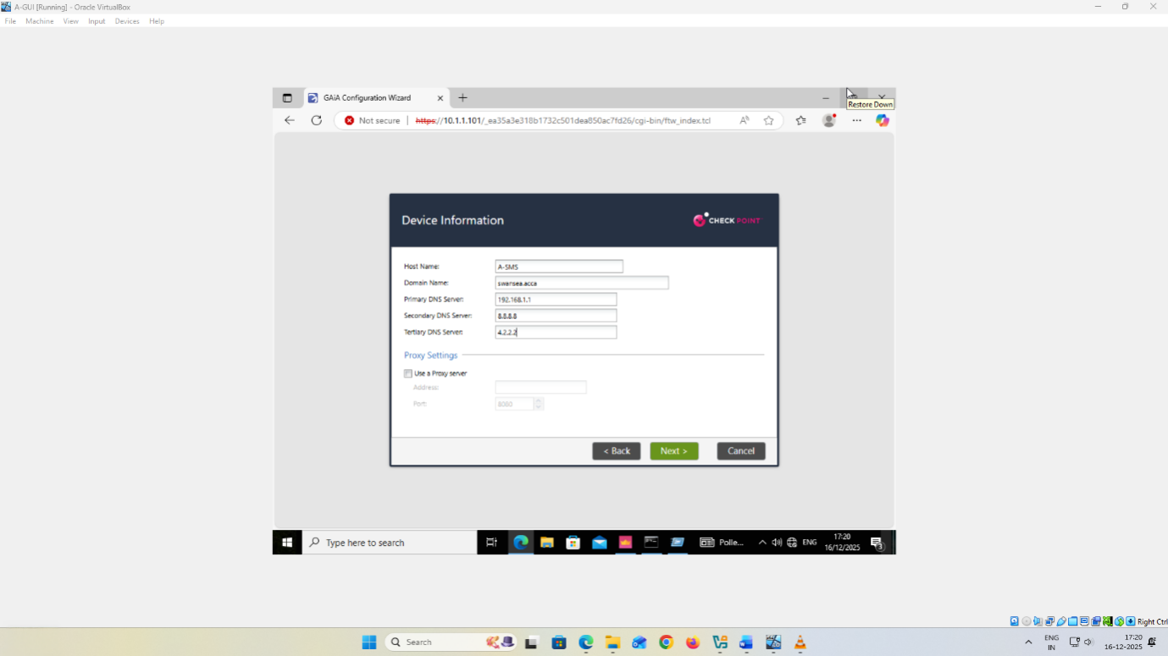
Figure 11: First Time module A-SMS configuration, page - device informationhost name A-SMS, domain swansea.acca, nameservers set to be used.
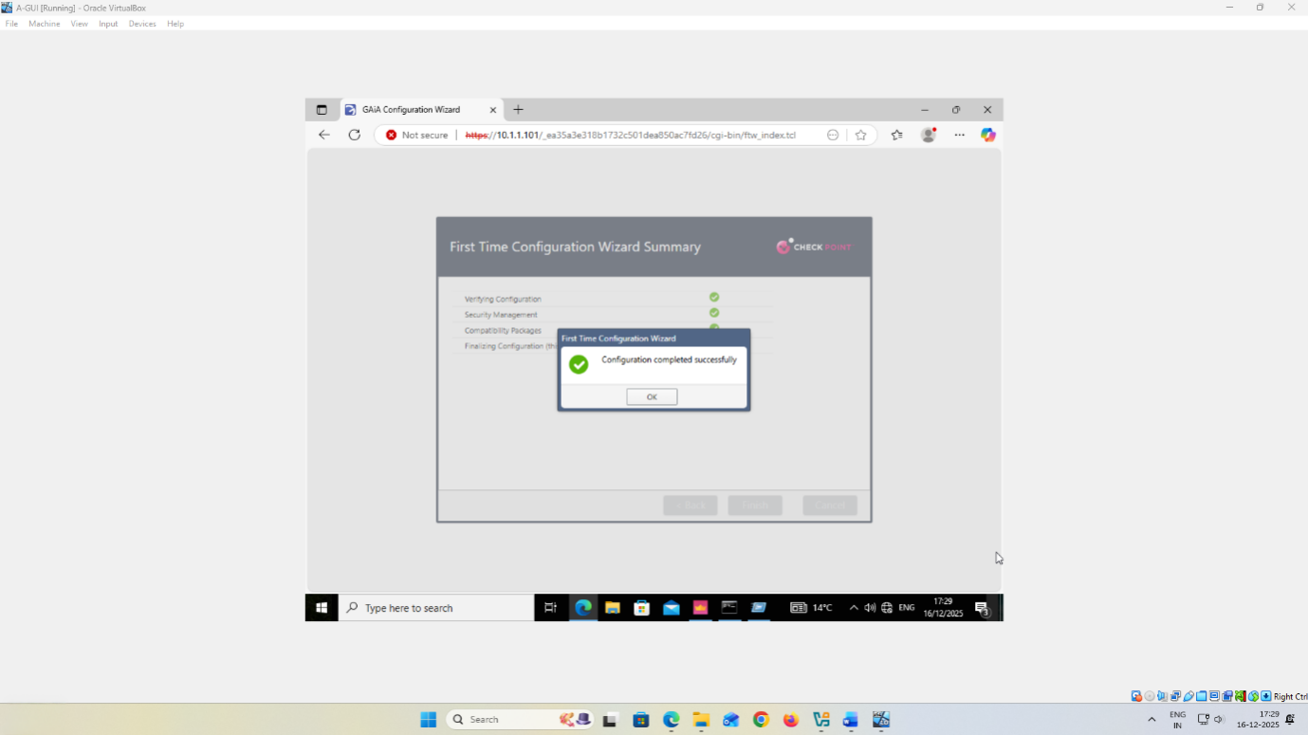
Figure 12: First Time Configuration Wizard summary Inquiries into the success of the configuration of the Security Management Server

4.5 Licensing application and documentation
Part 2 involves license application to both the Security Management Server and the Check Point appliances, and implies checking that the licensing complies with the module and keeps track of the license status and expiration date. The licensing is considered to be a governance control on the reason that it ensures that the necessary software blades and managerial capabilities are authorized and legally empowered to work in terms of the policy management and enforcement.
The workflow used in this implementation is the SmartConsole that opens Manage licenses and packages to launch SmartUpdate to handle licenses centrally [6]. The first step involves the importation of the license into the License and Contracts Repository where Add License is selected under file and the appropriate license files of SMS and gateway are selected. Once the import has been done, the gateway license is bound to the appropriate device by clicking the unattached license and attaching it by attaching the license to the object of the A-GW and also ensuring the A-SMS license is also attached to the A-SMS [7]. The evidence is recorded in the form of screenshots of the repository state and the allocated status of each device, and device-level views of the license status and expiration date. A report called Consolidated License Inventory report is created out of the SmartConsole and is exported to PDF in order to maintain a time-stamped and auditable report on license status and expiry.
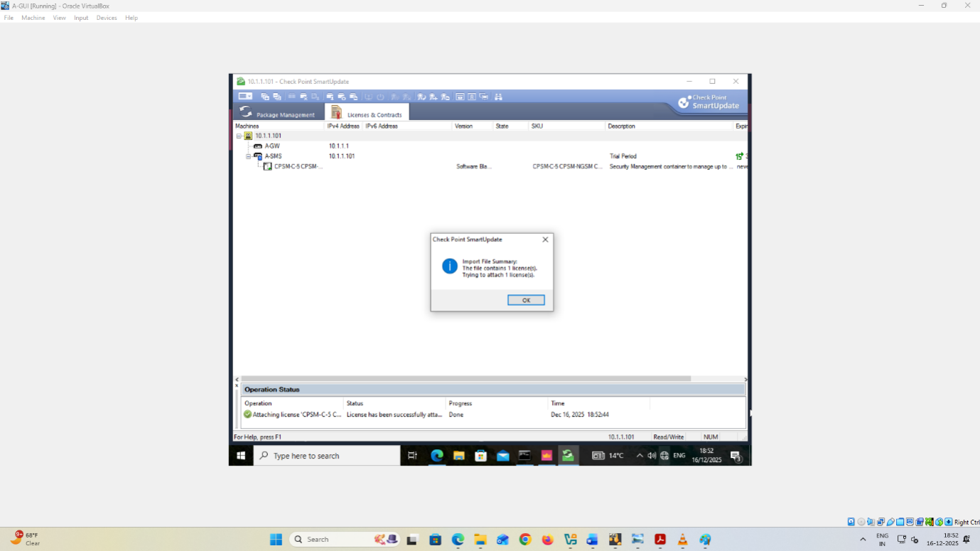
Figure 13: SmartUpdate license import confirmation dialog
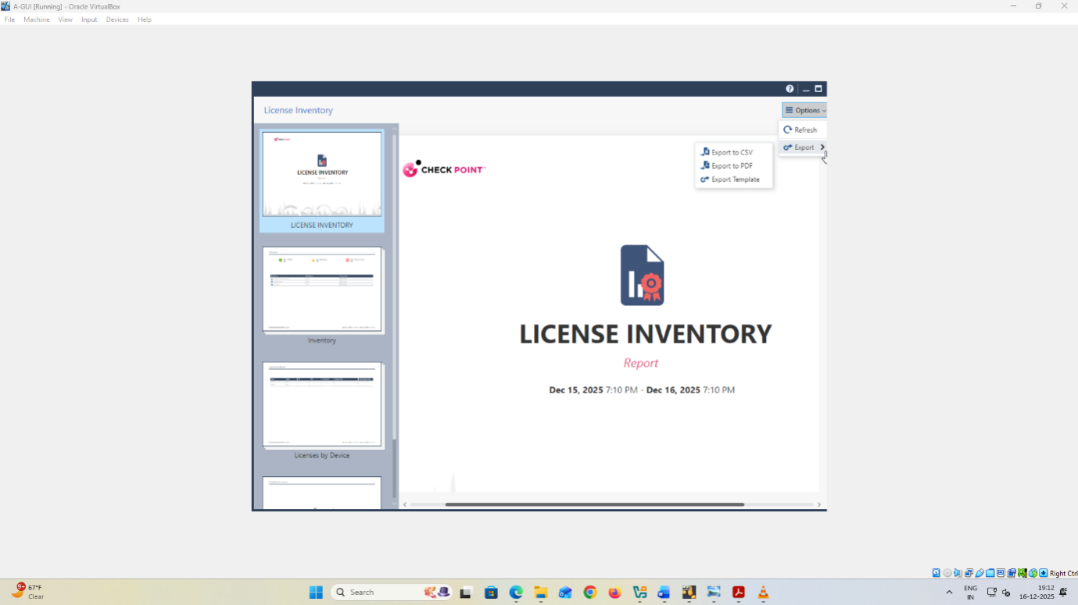
Figure 14: License Inventory report export options

4.6 Management verification
The central management is checked by setting a SmartConsole session to the SMS and creating and saving A-GW gateway object of the management database and verified trusted communication by the SIC status of the SmartConsole to the A-GW that displays a status of Communicating. Evidence is captured in the form of screenshot of object properties of gateway, SIC test output, and published session that makes configuration modification to the SMS database. These findings information of how the management plane is operationally prepared to administer under controlled and central administration of gateways since the SMS is capable of secure identification, trust, and control of the object of the gateway using a single console.
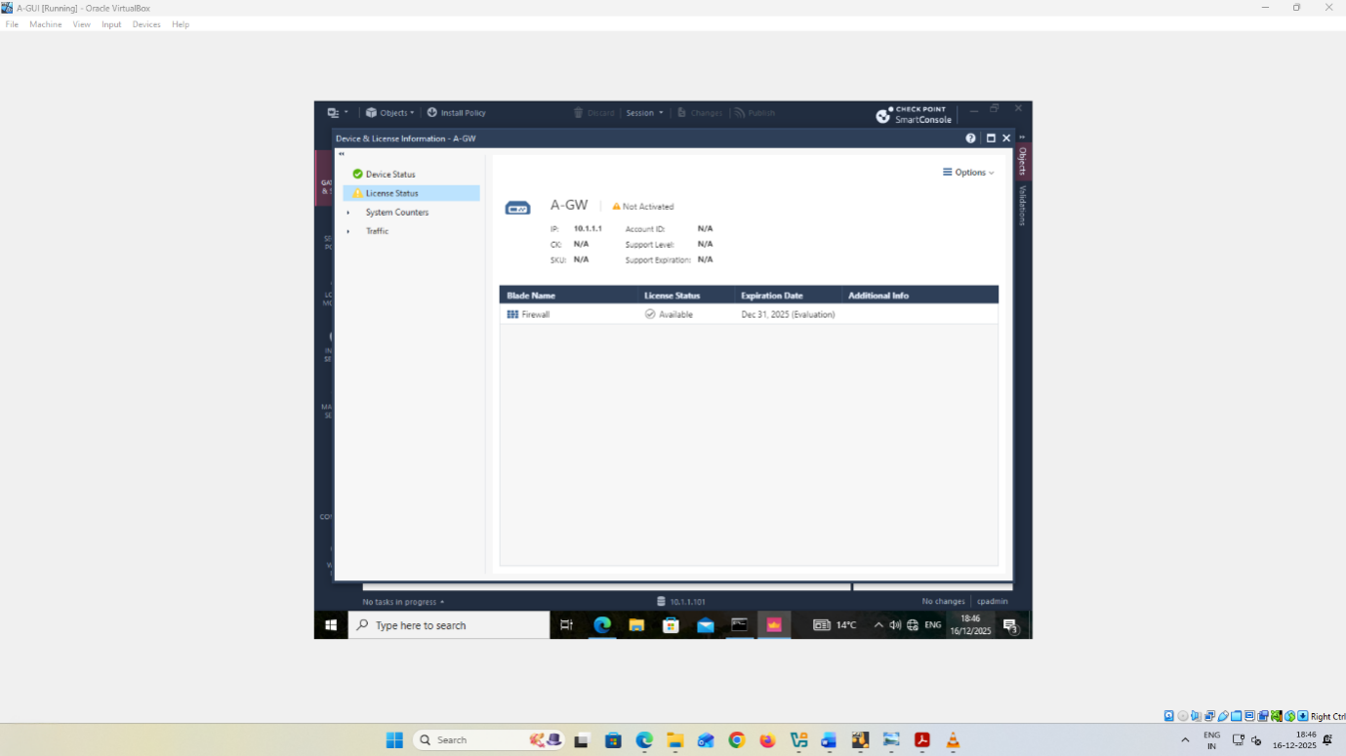
Figure 15: SmartConsole “Device & License Information” for gateway A‑GW showing license status and blade entitlement with the recorded expiration date.

5. Firewall policy design and enforcement

5.1 Translating Enterprise Policy to Rules
An example of enterprise security policy stance in real life would be a default deny model with least-privilege exception since Part 2 explicitly imposes a firewall rules that restricts unauthorised inbound and outbound traffic and that these must be justified as an enterprise policy decision. In this position, all services and management flows justified by a business are permitted, and all other are blocked and logged to ensure that the rulebase offers protection and auditability.
The decision of policymaking can be implemented in the form of firm control by transforming organisational requirements into tangible rulebase items. This begins by assigning traffic management domains or interface based segments to events, internal site worlds, cross site connections and any externally directed interfaces, and attaching rules to those segments instead of generic "any to any" relationships. Protected assets are represented as network objects and groups e.g. management servers, gateways, any service hosts that exist in the lab implementation and, therefore, access decisions are explicit and repeatable [8]. The representation of the user populations in terms of identity based construct is only done with the implementation of identity source otherwise access is limited by network location and definition of the service. Admitted as service objects are business services, which are explicitly admitted only when they enable the necessary operations, with high-risk or unnecessary services being rejected to enforce the policy described above of achieving the aforementioned policy objective of blocking unauthorised inbound and outbound traffic.

5.2 Rulebase design approach
The rulebase is designed in such a way that it has reusable objects to ensure that enforcement is maintained and changes are low risk. Network objects and groups define important segments and systems such as management networks, subnets of internal sites, and any server roles that need to be secured whereas service objects define the specific protocols that the business is allowed to use. In this object-first design, redundant IPs are eliminated, as well as the use of a hoc definition of the services, which increases the ease of maintenance and simplifies the auditing process due to intent being expressed by names, rather than arbitrary numbers [9].
The order of the rules is based on a least-privileged order in which the most specific and high-confidence ones are first then site-to-site and business application flows then broader but also restrictive allows. This is applicable to the need to block inbound and outbound questioned traffic that is unauthorised upon an enterprise security policy that is supposed to have a justification. A clear cleanup rule is inserted at the bottom to prevent and record any traffic that is not caught previously as a clear boundary of control and also aiding fault-finding. The logging is used selectively where the visibility on reimburseable denies, critical allows, and any service exposed externally is high, such that monitoring becomes practical instead of becoming discordant, which helps to collect evidence later and document the results.

5.3 Inbound Traffic Controls
Inbound controls follow exposure minimisation and explicit allow rules, meaning only published and business-justified inbound services are permitted and all other unsolicited inbound traffic is treated as unauthorised [10]. This approach directly supports the Part 2 requirement to restrict unauthorised inbound traffic and to justify the rulebase as an enterprise security policy.​
In this lab implementation, the only inbound flows claimed as allowed are those evidenced for central administration of the security infrastructure, specifically management access from the management workstation network 10.1.1.0/24 to the Security Management Server at 10.1.1.101, plus controlled administrative access paths via SmartConsole and the Gaia Portal. This limitation is supported by the configured SMS management IP and the explicit GUI client allowance for the 10.1.1.0/24 network, which constrains who can initiate administrative sessions to the SMS. Secure Internal Communication, SIC, is then used to maintain a trusted management relationship between the SMS and the gateway, with status verified as “Communicating”, ensuring that management actions originate from the authorised management system.​
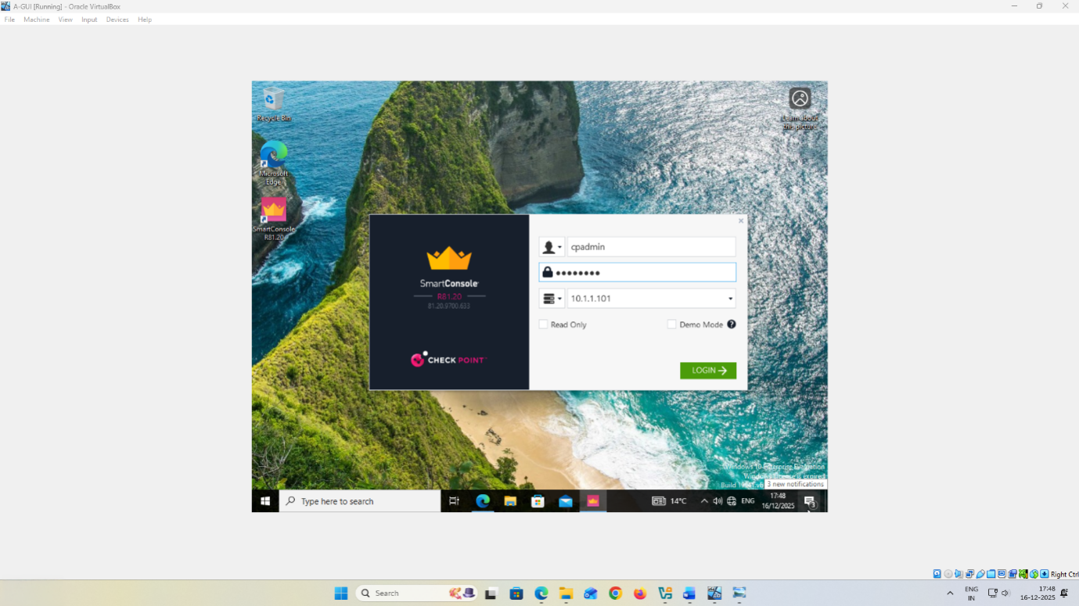
Figure 16: SmartConsole R81.20 connection with Security Management Server at 10.1.1.101 with the cpadmin account writeup log in screen
All other inbound flows are classified as unauthorised by default in line with the Part 2 security objective, and should therefore be blocked and logged, but no additional service-specific inbound allowances are stated here unless they are validated and evidenced by screenshots, logs, and recorded test outcomes in the report.​

5.4 Outbound Traffic Controls
Outbound controls build upon egress filtering and least privilege and therefore, only business-justified connections are allowed and all other outbound traffic is rejected and logged to minimize the data exfiltration and malware command-and-control risk [11]. This method directly meets Part 2 of only limiting unauthorised outbound traffic and justifying rules as an enterprise policy of security.
Outbound flows explicitly evidenced in this implementation of the lab are: DNS resolution to the configured DNS servers and NTP time synchronisation to the configured NTP servers: time1.google.com and time2.google.com because both the SMS build and the gateway build give out DNS settings and NTP servers. The justification of these flows is that the operations of stable management, consistent logging and secure security administration require name resolution and a precise time. Outbound services which fall under higher risk or non-essential to the business when adopting rulebase stance are automatically blocked and not authorised until a documented business requirement is proved and confirmed through recorded tests and logs. To allow auditability, all accepted outbound rule should have a small scope with explicit destination objects and service definitions and be backed with screen shots and reported final result in the final report.

5.5 Service-Specific Rules
This should be clearly indicated by the firewall policy since the allow and block decisions in relation to the ICMP, FTP, HTTP, Telnet, and SSH are cited as some of the proper inbound/outbound controls as indicated in part 2 (Stanger and Lane, 2020). The regulations below are report capable structures that can only be applied to your lab where necessary after which your tests, logs, and screenshots must be documented to confirm the evidence requirement.
Rule goal | Direction | Service | Default action | Business justification if allowed | Expected test evidence
Diagnostic reachability | Inbound and outbound | ICMP | Restrict, allow only for approved diagnostics | Limited troubleshooting, avoid broad host discovery | Ping succeeds only for approved sources, denied attempts logged.
Legacy file transfer | Inbound and outbound | FTP | Block | High risk, cleartext credentials, rarely justified | FTP connection fails, log shows drop, rule hit count increments.
Web access | Inbound and outbound | HTTP | Allow only to published web service or approved destinations | Required business web service or controlled browsing | HTTP succeeds for approved flow, denied elsewhere, logs captured.
Legacy remote admin | Inbound and outbound | Telnet | Block | Cleartext admin protocol, unacceptable enterprise risk | Telnet connection fails, drop logged with source and destination.
Secure administration | Inbound and outbound | SSH | Allow only for defined admin hosts to defined targets | Controlled device administration under least privilege | SSH succeeds only from approved admin host, denied elsewhere, logs and screenshots show result.

5.6 Testing and Justification
Testing is documented as a small matrix such that every decision taken by a firewall can be tracked through the intentions of the rule and the resultant situation that is evident as a result of the rule, backed up by screenshots and recorded findings. Each of the tests is to include evidence in the form of the appropriate rulebase fragment, the result of the traffic, and the associated logs or tool output, which are subsequently gathered into the final report. This will prove that controls will prevent unauthorised inbound and outbound traffic as desired, by only allowing legitimate enterprise flows.
Service | Source | Destination | Expected | Observed | Evidence reference
ICMP | Host A | Host B | Allow or block per rule. | Pass or fail. | Screenshot ID, log entry ID.
SSH | Admin host | Gateway or server | Allow only if justified. | Pass only for allowed source. | Rule hit, log, test output.
Telnet | Any | Internal targets | Block. | Fail. | Drop log plus screenshot.
HTTP | Approved host | Approved web | Allow only for defined service. | Pass only for approved flow. | Browser output plus logs.
FTP | Any | Any | Block unless explicitly justified. | Fail. | Connection attempt output plus logs.

An effective rule is one that shows the results which are expected, and that are observed in many sources and destinations, and one that has logs corresponding to the rule which satisfy that the desired decision is being enforced by the rule. Any inconsistency causes refinement of rule, violation is re-tested and new evidence is captured until consistency and auditing of results is achieved.

6. Additional security enhancements

6.1 Selection Criteria
Security improvements are determined based on the recognised industry standards and in addition to strengthening protection over and above minimum firewalling as Part 2 [12], [13]. The official Check Point guidance is used to derive the choices of features so that the configurations are appropriate, maintainable, and suitable with the GAIA based security infrastructure.
The selection criteria applied are:
- Risk minimisation: Give priority to controls that have the potential of lowering the probability/effectiveness of unauthorised access, malware response, lateral movements, and data leakage.
- Lab feasibility: Choose features supported by the topology being used that can be deployed to the lab end to end, with the current management and gateway components that are already deployed.
- Evidenceability: It is better to have controls that will give evidence such as screenshots of active settings and policy snippets, and observable results in logs and controlled traffic tests since the report will need to be accompanied by documented results.
- Operation maintainability: Select configurations that are maintainable by central policy, amenable to administrators and those that are not subject to proliferation of rules and tuning overhead over time.

6.2 Proposed Enhancements
Part 2 regards this as an incremental benefit to have some more security options, including enabling IPS and anti-malware software, as well as user authentication and identity awareness to role-based access control. The improvements below have been picked since they directly bolster prevention, detection and accountability of the same inbound and outbound risks the firewall policy is supposed to subdue.
Intrusion Prevention System (IPS)
- Risk avoided: Exploitation of known vulnerabilities via authorized services and hostile scanning and protocol abuse that may be able to evade crude port based filtering [14].
- Success indicators: Screenshots of the IPS being set in the policy, IPS profile being configured on the relevant gateway or policy layer and proof of logs being taken where the Squid captures IPS events being produced by controlled test traffic.
Anti-malware protections
- Reduced threat: Malware deployment and execution via authorized Web and file transfer channels, malicious content, which might result in malicious exploitation and date loss.
- Evidence of success: Screenshots of anti-malware protections being enabled and attached to the policy, which is enforced, and logs of event made when trying to escape security measures.
- Identity-based (user authentication, identity awareness) controls.
- Risk alleviated: Over access where any internal host can access sensitive services and insufficient accountability where any rule is founded on IP addresses.
- Evidence of success: Screenshots featuring identity sources and user groups configured, Access Control rules with reference to user or group identities to access limited information, and test results with authorised users successfully accessing the system with the corresponding logs and denied access before the unauthorised users.

6.3 Implementation Evidence
The report will provide artefacts of configuration (in terms of screenshots) recorded and recommended to have visible timestamps and eventually being put in the final submission where necessary. Under each applied improvement, there will be a screen shot displaying the protection or feature turned on in the management layer, the profile or policy settings that have been implemented or the enforcement point where the control is implemented, such as the applicable gateway or policy layer. In identity-based control, identity sources and identity user or group objects that are being used in the access policy will be also represented by a screenshot to ensure the association between user role and authorized access is clear.
To prove the fact that both features are active, evidence will involve:
- Policy deployment evidence, indicating successful policy instalment to the gateway with where enforcement is being conducted.
- Evidence of operational visibility which displays logs or events or alert produced by the protections used or disclosed by the enabled protections in the context of controlled testing [15].
- Evidence of effectiveness The traffic results of the test are typical, reflecting expected behaviour, both with permitted business flows and unsuccessful unauthorised ones.
- Traceability evidence, indicating evidence of rule hits or profile hits where can be seen, and providing screenshots of the pertinent rulebase snippets relating to the entries which were actually observed in the log.

6.4 Residual Risk and Further Hardening
The risk that is left includes any place where controls have not been enforced or cannot be proven in a laboratory through screenshots, logs, and controlled test results, since the scope of the report is only as far as results can be proved. Subsequent phases of hardening must be committed to broadening what can be validated (e.g., tightening of least-privilege, denying additional logging to enable investigation, and activating more Check point features suggested in Part 2, including anti-malware, identity-based access controls, and IPS), and testing each one, documented evidence.

7. Verification and Report Quality

7.1 Connectivity Validation
Swansea network to A-SMS connectivity is tested to be connected to qualify the Part 2 criteria of successful connectivity between Swansea and A-SMS. This is shown in evidence in the form of screenshots of the placement of the gateway interface connecting Swansea to the management network, e.g. A-GW on 192.168.1.254/24 to the Swansea internal segment and 10.1.1.1/24 to the management segment, and A-SMS on 10.1.1.101/24. It has been verified by use of reachability tests between a host at Swansea and 10.1.1.101 and confirmation of allowed management access paths by testing in 2011 of the A-SMS web portal, and the allowance of paths to SmartConsole connectivity, screenshots of routes displayed, interfaces displayed, and test output.

7.2 Functional Security Validation
The performing validation is supported by documented traffic test and logs that indicate that the services are authorized and unauthorised inbound and outbound services are blocked according to the Part 2 requirement to enforce and justify restrictive firewall rules. This is recorded to ensure or deny access to then discussed specified services namely, ICMP, FTP, HTTP, Telnet, and SSH, by association with corresponding rulebase record and the attached log record that validates the enforcement action [16]. Where more security mechanisms are used, validation is provided by configuration screenshots indicating that the feature is turned on, and security events indicating that it has been used such as IPS notifications, anti-malware detection, or identity based access audit trails indicating role or group enforcement. Every outcome obtained in the reported results is confined to evidences in screenshots, logs and controlled test results obtained in the environment.

7.3 Documentation Checklist
All the accomplished configurations with timestamps preferably exposed must be screen-shot and the report must include the set of those screenshots as the necessary evidence at Part 2. Proofs of licensing have been provided of the Security Management Server and the Check Point appliances in both cases indicating the licensing status and expiration details as read through the management interfaces as well as inventory output [17]. Each significant technical claim should be supported by evidence and a concise explanation we are stating what was configured, why it was selected in accordance with the Part 2 requirements, and how it was proven with the help of logs and controlled test results.

8. Conclusion

8.1 Outcomes versus Objectives
Part 2 is divided into three objectives that include integration of a Check Point Security Management Server, SMS, to achieve a centralised management, create and enforce a justified firewall policy to limit unauthorised inbound and outbound traffic, and to deploy other GAIA security features as recommended by industry standards. The former can be fulfilled by installing A-SMS, installed using A-GUI to SmartConsole administration, validation of management readiness with API readiness status and defined management control over the gateway with SIC with a status of "Communicating" indicated. The requirements in terms of licensing would also be achieved by applying the SMS and the gateway licenses through the repository import and attach workflow and record license status and expiration information accordingly.
The second goal is reached through the adoption of centrally controlled rulebase on the gateway to enforce enterprise policy position and exclusion of unauthorised traffic with reasons being given as supplementary to rule design [18]. The good indicators of this goal are the policy install result on the gateway, and logged and documented results of traffic tests relating to the given services, and their expected outcomes are supported by logs and the documented findings.
The third goal is accomplished by suggesting and where incorporated facilitating further safeguards alongside IPS, anti-malware and identity-based safeguards, the efficiency shown by arrangement artefacts and ensuing security incidents or test results.

8.2 Limitations and Next Steps
The report is restricted to configuration and results that can be proven in the lab setting using screen shots, logging and controlled test outcomes since Part 2 includes a report with screenshots of successfully completed configuration. All security capabilities that are not implemented end to end or cannot be verified based on captured evidence are deliberately not claimed or regarded as being out of scope when being assessed. Evidence is also confined to what was implemented in the given GAIA based management and gateway topology and the management that is applied in A-SMS and A-GUI connectivity.
Additional hardening according to the Part 2 should be attempted to refer to the official Check Point documentation in order to find out and utilize advanced security features in order to enhance the network to standard firewalling. The next working steps are to proceed with feature coverage only where it can be established with evidence e.g. enabling and tuning IPS and anti malware protection, and checking functioning with logs, alerts and repeatable traffic tests. In cases where identity-based access control is possible set up user authentication and identity awareness to make policy decisions based on roles and document results at the same standard of evidence.

9. References
[1] Cyber.Gov.AU, “Gateway security guidance package: Gateway security principles | Cyber.gov.au,” Cyber.Gov.AU. [Online]. Available: https://www.cyber.gov.au/business-government/asds-cyber-security-frameworks/gateway-security-guidance-package/gateway-security-guidance-package-gateway-security-principles
[2] OSCE, “TECHNICAL GUIDE PHYSICAL SECURITY CONSIDERATIONS FOR PROTECTING CRITICAL INFRASTRUCTURE FROM TERRORIST ATTACKS,” 2025. [Online]. Available: https://www.osce.org/sites/default/files/f/documents/e/6/597756_0.pdf
[3] Nazmul Rajib, CCNP Security Cisco Secure Firewall and Intrusion Prevention System Official Cert Guide. Cisco Press, 2022.
[4] SAP Business, “User Guide | PUBLIC SAP Business Integrity Screening THE BEST RUN Content,” 2023. [Online]. Available: https://help.sap.com/doc/08e2cf10e2764bb48ab56b51dacdc3db/1.6.0.0/en-US/loio63e706ff12f5438b85adf61c3baf580a.pdf
[5] “GAIA R81.20 Administration Guide,” 2023. [Online]. Available: https://sc1.checkpoint.com/documents/R81.20/WebAdminGuides/EN/CP_R81.20_Gaia_AdminGuide/CP_R81.20_Gaia_AdminGuide.pdf
[6] “Accessing SmartUpdate,” CheckPoint. [Online]. Available: https://sc1.checkpoint.com/documents/R81/WebAdminGuides/EN/CP_R81_Installation_and_Upgrade_Guide/Topics-IUG/Accessing-SmartUpdate.htm
[7] A. A. Amin, N. Alvi, M. Irfan, M. Abdullah, and H. U. Manzoor, “Design of a Low‐Cost Efficient IoT Based SCADA System for Automating Different Textile Machines and Controllers for Central Monitoring,” J. Eng., vol. 2025, no. 1, p. e70089, Jan. 2025, doi: 10.1049/tje2.70089.
[8] U. Tariq, I. Ahmed, A. K. Bashir, and K. Shaukat, “A critical cybersecurity analysis and future research directions for the internet of things: A comprehensive review,” Sensors, vol. 23, no. 8, 2023, doi: 10.3390/s23084117.
[9] Center for Internet Security, “CIS Controls Version 8,” CIS. [Online]. Available: https://www.cisecurity.org/controls/v8
[10] T. Virtue and J. Rainey, “Preventative Control - an overview | ScienceDirect Topics,” www.sciencedirect.com. [Online]. Available: https://www.sciencedirect.com/topics/computer-science/preventative-control
[11] “Microsoft cloud security benchmark v2 - Network Security,” Microsoft. [Online]. Available: https://learn.microsoft.com/en-us/security/benchmark/azure/mcsb-v2-network-security
[12] Fortinet, “What is Firewall Configuration and Why is it Important?,” Fortinet. [Online]. Available: https://www.fortinet.com/resources/cyberglossary/firewall-configuration
[13] Hanan, “A Comprehensive NIST Firewall Audit Checklist | Tufin,” Tufin. [Online]. Available: https://www.tufin.com/blog/a-comprehensive-nist-firewall-audit-checklist
[14] T. B. Azad, “Auditing and Security Incidents,” Secur. Citrix Present. Serv. Enterp., pp. 667–728, 2008, doi: 10.1016/b978-1-59749-281-2.00010-x.
[15] “What Is EDR? Endpoint Detection and Response | Microsoft Security,” Microsoft. [Online]. Available: https://www.microsoft.com/en-in/security/business/security-101/what-is-edr-endpoint-detection-response
[16] Aircon, “Net Sec Challenge | TryHackMe (THM),” Medium. [Online]. Available: https://medium.com/@Aircon/net-sec-challenge-tryhackme-thm-7c9a849153a7
[17] “sk11054 - Check Point License Guide,” CheckPoint. [Online]. Available: https://support.checkpoint.com/results/sk/sk11054
[18] N. Díaz-Rodríguez, J. Del Ser, M. Coeckelbergh, M. López de Prado, E. Herrera-Viedma, and F. Herrera, “Connecting the Dots in Trustworthy Artificial Intelligence: from AI principles, ethics, and Key Requirements to Responsible AI Systems and Regulation,” Inf. Fusion, vol. 99, no. 101896, p. 101896, 2023, doi: 10.1016/j.inffus.2023.101896.

