

BMIH6007
Module Title: International Meetings Management for the Hotel Industry
Assignment Title: Strategic Planning and Execution of the Inclusive Hospitality Forum: Advancing Equity, Diversity, and Inclusion in the Hospitality Industry
Name of student: Silviu-Nicolae Comanescu
Student Number: 2226638

AI Declaration
Grammarly was used on 25th February 2025 to check for spelling and grammatical errors and structural problems. The tool offered a couple of minor suggestions regarding readability, which I looked over manually before deciding to accept or reject them. The research, analysis, and completion of this assignment did not involve any artificial intelligence tools generating content.
Besides, I have not used any AI-generated content in my work at any point during this assignment. All research, writing, and revision have been done independently to ensure authenticity and academic integrity. Furthermore, original drafts, notes, and supporting materials used to create this assignment will be given upon request as evidence of independent work. This declaration proves that the submission follows the academic honesty policies and ethical research standards.

Table of Contents
1 Introduction 4
2 The Event Cycle 4
2.1 Announce and Presale 5
2.2 Onsale 5
2.3 Maintenance 5
2.4 Close 6
3 Event Concept 6
3.1 Registration and Welcome Breakfast (8:00 AM - 9:00 AM) 6
3.2 Opening Keynote Session (9:00 AM - 10:00 AM) 6
3.3 Breakout Workshops (10:00 AM - 11:30 AM) 6
3.4 Networking Break (11:30 AM - 12:00 PM) 6
3.5 Expert Panel Discussion (12:00 PM - 1:00 PM) 6
3.6 Closing Keynote and Reflections (1:00 PM - 4:00 PM) 7
3.7 Key Stages of the EMBOK Model 7
3.7.1 Initiation 7
3.7.2 Planning 7
3.7.3 Implementation 8
3.7.4 Event 8
3.7.5 Closure 8
4 Aim and Objectives 8
4.1 SMART Objectives 8
5 Event Management 9
5.1 Operational Management 9
6 Event Budget - Inclusive Hospitality Forum: A New Era in Guest Experiences 10
7 Industry Trends, Issues, and Impacts 11
7.1 Equity, Diversity, and Inclusion (EDI) in Events 11
7.2 Technology and Hybrid Event Models 12
7.3 Sustainability and Green Event Practices 12
8 Situational and Cultural Considerations 13
8.1 Political Factors 14
8.2 Economic Factors 14
8.3 Social Factors 14
8.4 Technological Factors 15
8.5 Legal Factors 15
8.6 Environmental Factors 15
9 Conclusion 15
References 16

Introduction
The Inclusive Hospitality Forum: A New Era in Guest Experience is a first-of-its-kind event within the hospitality industry to achieve equity, diversity and inclusion (EDI) (Spanaki et al. 2024). At the same time, workforce diversity, gender pay parity, and accessibility are growing concerns for us all as industry leaders, policymakers, and hospitality professionals, and this event serves as a strategic platform for action for all these groups. It is a forum that brings together all the global experts, corporate leaders, and advocacy groups to discuss policies, share ideas, and make long-term commitments towards inclusive practices. The reason for picking this event was due to the rise in the need for diversity inclination projects in the hospitality industry.
In addition to this, the gender pay gap is already at 28%, and the workforce shortages reinforce the idea that the industry needs to be transformed on a larger scale (Skakun, 2024). The forum ensures businesses can practically address and make meaningful, measurable business changes by holding keynote discussions, panel sessions, and workshops. Manchester Central Convention Complex is a well-equipped venue which is easy to get to, has state-of-the-art technology, and can easily accommodate a variety of attendees (Labadie and Legner, 2023). With its strategic location, the site provides an easy connection for international and local participants to discuss EDI best practices.

The Event Cycle
It is imperative that the planning and execution of the Inclusive Hospitality Forum: A New Era in Guest Experiences (Bowdin et al., 2023) are structured by following the event life cycle. Detailed analysis of these Stages of a listing's lifecycle is crucial in ensuring the highest level of stakeholder engagement, logistics optimisation, and the industry’s long-term impact assessment.
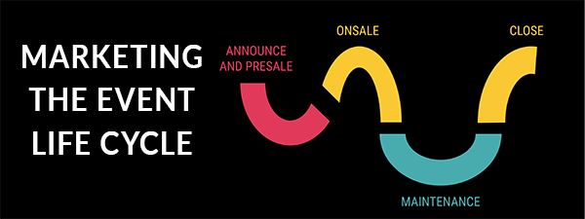
Figure 1 Event Life Cycle
(Source: Etix, 2024)

Announce and Presale
It is essential to plan and market the event in the first place. Spanaki (2024) has contended that it includes defining the event’s purpose, securing the key stakeholders and launching initial promotional activities. The outreach phase here involves going out to hospitality brands and policymakers with the purpose of the Inclusive Hospitality Forum.

Onsale
Active driving of registrations and maximising attendance are involved in the sales period. A key ingredient to this kind of marketing strategy is a targeted marketing strategy in digital campaigns and industry partnerships. According to research, online event registrations have increased by 27% following the pandemic, suggesting that digital platforms should be leveraged to sell tickets and engage the participants (Skakun, 2024).

Maintenance
Logistical aspects like venue setup before the event, speaker confirmations and session finalisation are worked on before the event. As shown in Giousmpasoglou (2024), who has researched the issue, it is vital to ensure staff in the UK hospitality industry is accessible, as 22% of their workforce see barriers to workplace inclusivity.

Close
Event execution and post-event evaluation fall into the final part. The Inclusive Hospitality Forum is intended to secure 70% of organisations adopting EDI policies (Gay, 2024). The long-term impact of the forum will be measured post-event by metrics, attendee feedback, and stakeholder follow-ups.

Event Concept

Registration and Welcome Breakfast (8:00 AM - 9:00 AM)
Networking breakfast is the first event, and it lets attendees connect with their peers, industry leaders, and keynote speakers (Giousmpasoglou, 2024). It is an early engagement session to talk about industry challenges and pass on the shared insights before the formal sessions start.

Opening Keynote Session (9:00 AM - 10:00 AM)
The research from Bowdin et al. (2023) tells us that a first hospitality leader will open the keynotes with emphasis on the importance of equity, diversity and inclusion (EDI) within the hospitality industry. Some of the things that the session will cover include key challenges and strategic solutions for meaningful change and industry trends.

Breakout Workshops (10:00 AM - 11:30 AM)
Delegates will be given the opportunity to deal with core industry challenges in interactive workshops. Included are topics on inclusive hiring practises, access in hospitality and closing the gender pay gap (Gursoy and Maier, 2023). These sessions will help to facilitate collaboration and action on the idea behind them.

Networking Break (11:30 AM - 12:00 PM)
If allowed a short break, attendees can talk about what was learned in the workshop, chat with peers in the industry, or spin through the event’s resources.

Expert Panel Discussion (12:00 PM - 1:00 PM)
Manoharan et al. (2024) state that the panel of industry experts, policymakers, and EDI professionals will provide critical thoughts on diversity and accessibility in hospitality. The panellists will share case studies and real-world strategies on how the policy could be implemented.

Closing Keynote and Reflections (1:00 PM - 4:00 PM)
As a closing keynote, the reflections from the event will be summarised by industry leaders and testimonies (Rogers and Wynn-Moylan, 2022). The session will translate discussion about events into actions for the industry.

Key Stages of the EMBOK Model
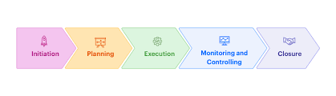
Figure 2 EMBOK Model
(Source: International EMBOK, 2023)

Initiation
If the need for diversity and inclusion in hospitality was growing, the event concept was developed to address the problem. Key stakeholders, including industry leaders, policymakers, and advocacy groups, defined the event’s purpose and scope.

Planning
Venue selection, programme structure, and speaker engagement were also formalised through a strategic approach to the event’s goals. For example, other studies, like Gay's (2024), argued that to attract as many participants as possible, it was necessary to target hospitality professionals, HR leaders, and industry policymakers.

Implementation
Deluxe logistical tailoring took care of all aspects of accessibility, catering considerations and digital engagement for virtual attendees or those not having the ability to be physically present at the event. The event staff training prioritised participant experience (Maloney and Minh, 2024).

Event
According to Maloney and Minh (2024), the event execution phase was about an engaging, insightful, and action-driven experience. The sessions were participatory and collaborative and meant to discuss and take away something of value at the end of each session.

Closure
According to Maloney and Minh (2024), the event execution phase was about an engaging, insightful, and action-driven experience. Sessions engaged, collaborated, and were participatory, resulting in verbalised and brought-back conversations that made sense to both the speaker and the listener.

Aim and Objectives
The goal of this event is to provide hospitality professionals with practical steps to implement the initiative of Equity, Diversity, and Inclusion (EDI) practises as well as industry-wide collaboration to effect meaningful change.

SMART Objectives
Specific: Increase 80% attendance awareness about EDI principles through interactive workshops and expert discussions.
Measurable: Invite 10 or more large hospitality brands to talk in a structured way about using inclusive service strategies.
Achievable: At the event closure, 70% of participants are committed to implementing new EDI policies with their organisations (Calver et al., 2023).
Relevant: In order to offer data based solutions and best practises to essential worldwide industry issues like the 28% gender pay gap for hospitality (Cascavilla et al., 2023) I need to use quantitative and qualitative research data.
Time Bound: Post-event follow-ups within six months to assess the impact of the policy commitment made during the forum.

Event Management
It is evident that to orchestrate a successful event for the Inclusive Hospitality Forum: A New Era in Guest Experiences, a strategic potpourri of skill, resources, and structure must be used to execute the event seamlessly. Gursoy and Maier's (2023) study recommends that the event's success depends on a well-coordinated operational framework, strong marketing strategies, and meticulous logistical arrangements that are in sync with global best practices in event management. Using the 4Ps of the Marketing Mix, the Inclusive Hospitality Forum guarantees a strategic method because it enhances the product value, pricing accessibility, venue selection and promotional outreach to maximise industry engagement and impact.
Table 1 Marketing Mix (4Ps) for the Inclusive Hospitality Forum
Factor | Strategy
Product | The forum provides a knowledge-sharing platform featuring expert discussions, interactive workshops, and networking opportunities.
Price | Ticket pricing follows a tiered model, offering early bird discounts, corporate packages, and student rates to maximise accessibility.
Place | The event is hosted at the Manchester Central Convention Complex, a premier venue with state-of-the-art facilities and accessibility features.
Promotion | A multi-channel marketing strategy maximises outreach by leveraging social media, industry partnerships, digital ads, and press releases.

Operational Management
This forum also requires highly skilled professionals with expertise in event logistics, venue coordination and risk management to provide operational aspects of this forum. In light of 40 per cent of hospitality professionals believing workplace inclusivity is inadequately addressed, the event has a key operational priority of adherence to EDI principles (Whyte-Phillips et al., 2024). Inclusive seating arrangements, ramps and sign language interpreters, and dietary accommodations for attendees of varied dietary needs are all needed. This statement has also been backed up by Cascavilla et al. (2023) that selecting Manchester Central Convention Complex as the venue ensures state-of-the-art infrastructure, high-speed internet, and a location accessible to an international audience.

Event Budget - Inclusive Hospitality Forum: A New Era in Guest Experiences
The budget for the Inclusive Hospitality Forum ensures financial sustainability while maximising inclusivity and engagement. The main revenue sources are ticket sales (35%), sponsorships (42%), and government grants (17%), reflecting the industry's commitment to EDI initiatives (Vander Schee and DeLong, 2022). Merchandise sales account for 6% of revenue, providing an additional income stream. Expenditure allocation prioritises venue quality, speaker expertise, accessibility, and engagement, with venue hire and speaker fees forming 38% of total costs. Vander Schee and DeLong (2022) have asserted in this research that investments in marketing (10%) and technology (8%) ensure broad participation, including hybrid attendees. Surplus funds (£7,000) will be used for follow-up reports, post-event networking, and impact assessments, ensuring that discussions lead to measurable industry change.
Table 2 Event Budget
Income and Expenses | Details | Amount (£)
Income
Ticket Sales | 250 attendees x £120 per ticket | 30,000
Sponsorship | 12 sponsors x £3,000 each | 36,000
Government Grants | EDI-focused hospitality initiatives | 15,000
Merchandise Sales | Branded event merchandise | 5,000
Total Income |  | 86,000
Expenditures
Venue Hire | Full-day rental of Manchester Central Convention Complex | 15,000
Speaker Fees | 6 EDI experts x £2,500 each | 15,000
Catering | Inclusive meals and refreshments | 10,000
Marketing | Digital ads, press releases, and social media campaigns | 8,000
Staffing and Logistics | Event coordinators, security, and volunteers | 9,000
Technology and AV | Live streaming, translation services, and accessibility features | 6,000
Workshop Materials | Printed guides, interactive resources, and accessibility aids | 3,500
Event Merchandise | Branded items for delegates | 3,000
Health and Safety Compliance | Security, medical staff, and accessibility modifications | 5,000
Miscellaneous Costs | Unexpected expenses and contingencies | 4,500
Total Expenditure |  | 79,000
Net Income | Surplus allocated to post-event EDI initiatives and industry impact reports | 7,000

Industry Trends, Issues, and Impacts
The meetings and events industry is transforming rapidly, driven by emerging trends, socio-economic challenges, and technological advancements. However, it has been argued by Calver et al. (2023) that the Inclusive Hospitality Forum: A New Era in Guest Experiences aligns with these industry changes, addressing critical issues such as equity, diversity, and inclusion (EDI), technological innovation, sustainability, workforce challenges, and economic uncertainties.

Equity, Diversity, and Inclusion (EDI) in Events
A significant shift in the industry is the heightened focus on EDI initiatives, as diversity gaps remain a pressing concern in the hospitality sector. Many organisations now adopt inclusive hiring practices and policies, yet senior-level representation remains limited (Tavale et al., 2022). Reports indicate that a substantial portion of hospitality workers still experience barriers related to gender, ethnicity, or disability.
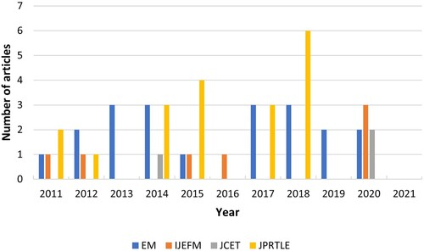
Figure 3 The (in)visibility of equality, diversity, and inclusion in events management
(Source: Calver et al., 2023)

Technology and Hybrid Event Models
The increasing reliance on technology-driven solutions is reshaping the event landscape, with hybrid models becoming the standard. Ruusunoksa (2024) found that digital engagement has expanded global participation as virtual and hybrid events connect attendees from different regions seamlessly. With live streaming, AI-powered accessibility tools, and interactive networking platforms, the forum embraces this shift, making industry discussions more inclusive.

Sustainability and Green Event Practices
Sustainability is now a non-negotiable factor for event organisers, with a strong push toward reducing environmental impact. Many large-scale events adopt paperless registrations, digital documentation, and carbon offset programs to enhance sustainability efforts (Dwivedi et al., 2022). The Inclusive Hospitality Forum incorporates eco-friendly practices, such as sustainable catering, recyclable event materials, and responsible waste management.
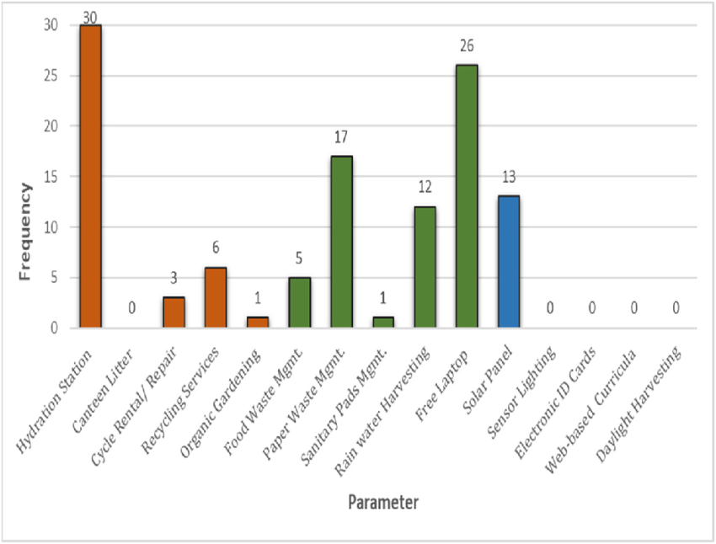
Figure 4 Go-Brown, Go-Green and Smart initiatives
(Source: Agarwal, 2023)

Situational and Cultural Considerations
A PESTLE analysis is used to give a structured approach to situational and cultural factors affecting the hospitality and events industry (Ramely et al., 2023). Event success is dependent on how well the event aligns with political, social, economic, technological, legal, and environmental internal and external forces so that industry-wide issues and opportunities are addressed.
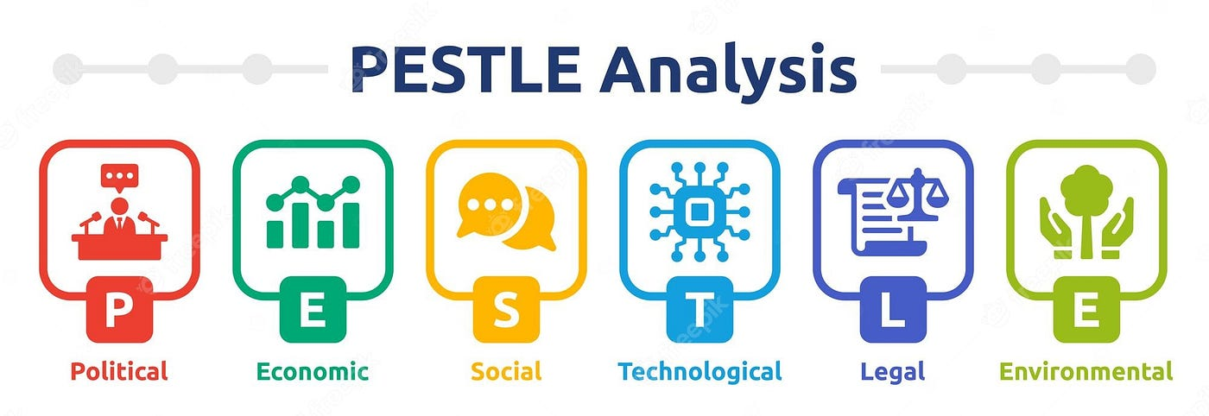
Figure 5 PESTLE Analysis
(Source: Mukherjee, 2023)

Political Factors
Government regulations and labour laws control the industry's hiring practices and workplace culture regarding equity, diversity, and inclusion (EDI).
Ilevbare and McPherson (2022) highlight the research showing that geopolitical instability and travel restrictions can limit international event participation and that blended event models are needed to prevent dropped participation levels.

Economic Factors
- The increase in event costs due to inflation means a 15% increase in venue prices, catering and logistics, and higher ticket pricing strategies such as average ticket price caps (Ilevbare and McPherson, 2022).
- Economic downturns impact corporate sponsorship budgets, influencing event funding and industry participation rates.
- The hospitality industry contributes significantly to GDP, making workforce development and skills training events crucial for long-term economic stability.

Social Factors
- According to Tavale (2022), workforce diversity remains an issue, with reports showing that only 15% of hospitality leadership roles are held by women, requiring targeted EDI initiatives.
- Consumer demand for inclusive experiences is rising, influencing hospitality businesses to adopt policies that align with evolving cultural expectations.
- Workforce hospitality shortages affect event staffing and service quality, requiring strong recruitment and retention strategies.

Technological Factors
- Integrating AI-powered translation services and virtual networking platforms makes events more accessible to global audiences.
- Hybrid event models have increased attendance by 30%, emphasising the need for digital engagement strategies (Agrikolianskaia, 2023).

Legal Factors
- Strict labour laws on equal pay and anti-discrimination policies influence event content and speaker selections.
- Labadie and Legner (2023) evaluated that GDPR and data privacy regulations require organisations to implement secure attendee data management systems for online event participation.

Environmental Factors
- Moreover, 80% of attendees prefer sustainable events, increasing the demand for eco-friendly venues, waste-reduction strategies, and paperless registration systems (Labadie and Legner, 2023).
- Many events have started to launch carbon offset programmes to encourage businesses to commit to sustainable practises due to carbon footprint concerns.

Conclusion
The inclusive hospitality forum is a strategically designed event that corresponds to the industry trends and solves the key challenges that the industry is facing on the topics of equity, diversity and inclusion (EDI), sustainability and technological innovation, and concluded that it is a new era in guest experiences. By using the Event Cycle and the EMBOK model, you can plan effectively and also execute and evaluate the plan in a structured manner. By adding hybrid event models, AI powered accessibility and data powered marketing strategies, engagement is increased, EDI commitments with the hospitality industry are pushed further. Sponsorships, ticket sales and, where necessary, government grant, allow a detailed financial strategy that guarantees sustainability. The PESTLE analysis also offers you a chance to adapt to the prevailing conditions in the economic and regulatory landscape. This event is unique because addressing workforce shortages, sustainability expectations and shifting consumer requirements is the new competitive benchmark for all inclusive industry conferences.

References
Agarwal, S. M. (2023) 'Bar Graph representation of Go, Brown, Go Green, and Smart initiatives between parameters'. ResearchGate, February.
Agrikolianskaia, K. (2023). Investigating effective ways to engage the younger generation through events.
Bowdin, G. A., Allen, J., Harris, R., Jago, L., O'Toole, W., and McDonnell, I. (2023). Events management. Routledge.
Calver, J., Dashper, K., Finkel, R., Fletcher, T., Lamond, I. R., May, E., ... and Sharp, B. (2023). The (in) visibility of equality, diversity, and inclusion research in events management journals. Journal of Policy Research in Tourism, Leisure and Events, 1-25.
Calver, J., Dashper, K., Finkel, R., Fletcher, T., Lamond, I. R., May, E., Ormerod, N., Platt, L., and Sharpe, B. (2023) 'The (in)visibility of equality, diversity, and inclusion research in event management journals', Journal of Policy Research in Tourism, Leisure and Events.
Cascavilla, G., Tamburri, D. A., Leotta, F., Mecella, M., and Van Den Heuvel, W. (2023). Counter-terrorism in cyber-physical spaces: Best practices and technologies from state of the art. Information and Software Technology, 161, 107260.
Dwivedi, Y. K., Hughes, L., Kar, A. K., Baabdullah, A. M., Grover, P., Abbas, R., ... and Wade, M. (2022). Climate change and COP26: Are digital technologies and information management part of the problem or the solution? An editorial reflection and call to action—International Journal of Information Management, 63, 102456.
Gay, B. R. (2024). Exploring the Use of Inclusive Teaching Strategies to Increase the Effectiveness of Adult Learning Programs Related to Equity, Diversity, and Inclusion (EDI) Within Canadian Public Sector Organisations (Master's thesis, Royal Roads University (Canada)).
Giousmpasoglou, C. (2024). Working Conditions in the Hospitality Industry: The Case for a Fair and Decent Work Agenda. Sustainability, 16(19), 8428.
Gursoy, D., and Maier, T. (2023). Diversity, equity and inclusion in hospitality: Value centred leadership as a conduit for change. Journal of Hospitality Marketing & Management, 32(4), 445-453.. .
Ilevbare, S. I., and McPherson, G. (2022). Understanding COVID-19: A hybrid threat and its impact on sport mega-events. A focus on Japan and the Tokyo 2020 Olympic Games. Frontiers in sports and active living, 4, 720591.
International EMBOK Executive (2023) 'Domains'. Event Management Body of Knowledge.
Labadie, C., and Legner, C. (2023). Building data management capabilities to address data protection regulations: Learnings from EU-GDPR. Journal of Information Technology, 38(1), 16-44.
Maloney, C., and Minh, P. (2024). Revitalizing GastroBar Saimaa: expanding its online presence using digital content.
Manoharan, A., Madera, J. M., and Singal, M. (Eds.). (2024). The Routledge handbook of diversity, equity, and inclusion management in the hospitality industry. Routledge.
Mukherjee, A. (2023) 'Understanding PESTLE analysis: A comprehensive guide to business environment assessment'. Medium, 15 October.
Ramely, A., Ab Talib, M. F., Ahmad, R., and Yusof, N. A. M. (2023). Examining PESTEL Analysis of Event Businesses in Malaysia. Journal of Event, Tourism and Hospitality Studies, 3, 57-79.
Rogers, T., and Wynn-Moylan, P. (2022). Conferences and conventions: A global industry. Routledge..
Ruusunoksa, M. (2024). How to ensure good customer experience in hybrid events.
Skakun, A. (2024). Leveraging digital transformation to address women's challenges in the technology industry.
Spanaki, M. Z. (2024). Management of new procedures' implementation risks in the hotel industry: A case study from Crete, Greece.
Tavale, N. A. (2022). Strategies to Recruit Underrepresented Groups' to Middle and Senior Management Positions in Financial Services. Walden University.
Vander Schee, B. A., and DeLong, D. (2022). What motivates marketing educators to attend in-person and virtual academic conferences in a time of pandemic pedagogy? Journal of Marketing Education, 44(2), 250-264.
Whyte-Phillips, K. S. (2024). Effective Strategies Human Resource Business Leaders Use to Implement Diversity, Equity, and Inclusion Initiatives that Reduce Worker Turnover (Doctoral dissertation, Walden University).
Etix (2024) Marketing the event life cycle. Available at: https://hello.etix.com/marketing-the-event-life-cycle/.

