

LOCATION: Swansea | LLEOLIAD: abertawe
LEVEL 7 | LEFEL 7
EXAMINATION PERIOD | CYFNOD ARHOLIADAU
July 2017 | Gorffennaf 2017

MODULE CODE: M7X01695
IMPLEMENTING IP ROUTING
TIME: 3 HOURS

Name :
Student ID :
Date & Time :

This is an individual practical lab-test, held under examination conditions. You will be assigned four Routers, you should configure these Routers based on the following specifications.

The routers that you will configure are: R1, R2, R3, and R4.

This paper is marked out of 100.

You will have 3 hours to complete this task.

Network Topology

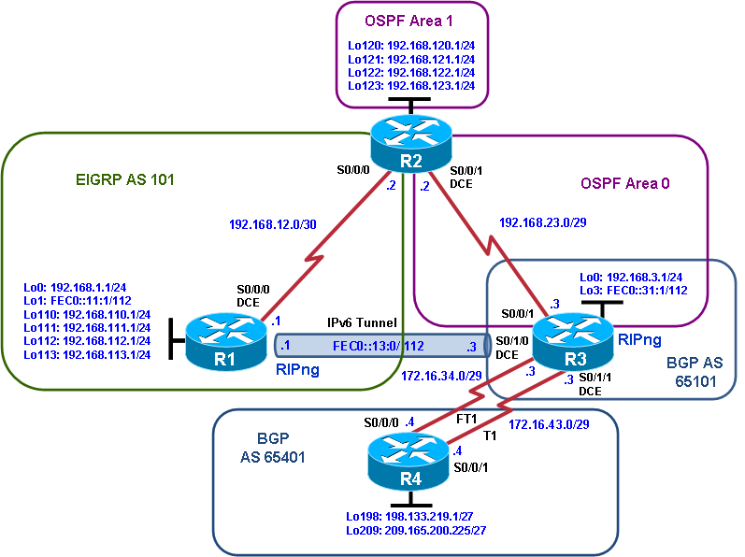

Addressing Scheme Table

Device | Interface | IP Address | Subnet Mask
R1 | Serial 0/0/0
 | Loopback0
 | Loopback1
 | Loopback110
 | Loopback111
 | Loopback112
 | Loopback113
R2 | Serial 0/0/0
 | Serial 0/0/1
 | Loopback120
 | Loopback121
 | Loopback122
 | Loopback123
R3 | Serial 0/0/1
 | Serial 0/1/0
 | Serial 0/1/1
 | Loopback0
 | Loopback3
R4 | Serial 0/0/0
 | Serial 0/0/1
 | Loopback 198
 | Loopback 209

Requirements:

Task 1 – Network Connections (10 marks)

Physically cable the network as shown in the topology diagram.

Configure the router with hostname.

Configure interfaces with the IP addresses shown in the diagram. Set the bandwidth to 128 kbps on the links between R1, R2, and R3 and set the clock rate on the DCE connections as appropriate. Add a description for each WAN interface.

Note: Configure and test the IPv4 components of the network before configuring the IPv6 components

Task 2 – Configure Routing (70 marks)

- Configure the OSPF router identifier 2.2.2.2 on R2 and 3.3.3.3 on R3.
- Ensure that all loopback interfaces are advertised in OSPF with the correct masks. Place the loopback interface Lo0 on R3 and the connection between R2 and R3 in OSPF area 0.
- On R2, place the loopback interfaces Lo120 through Lo123 on R2 in OSPF area 1 and the connection between R2 and R3 in OSPF area 0.
- Summarize area 1 to the backbone with the most efficient mask.
- Propagate a default route from R3 into the OSPF domain.
- Configure R1 to be in EIGRP AS 101, add the entire class C network, and disable automatic summarization.
- Configure R2 to be in EIGRP AS 101, add only the link between R1 and R2 and disable automatic summarization.
- Configure passive and non-passive interfaces for EIGRP and OSPF as appropriate.
- Configure a static default route from R1 to R2 and avoid a recursive lookup.
- Redistribute EIGRP into OSPF with a metric of 1000.
- On R2, filter R1 network 192.168.113.0 from being advertised to R3.
- Enable BGP on both WAN links between R3 and R4. R3 is in BGP AS 65101 and R4 is in BGP AS 65401.
- Advertise R4’s loopback interfaces into BGP.
- Modify the local preference on R3 so that AS 65101 prefers the T1 link to AS 65401 networks.
- Traffic exiting from R3 and returning to R3 should prefer the T1 link. Add a static route on R4 to 192.168.0.0/16 pointing to the T1 link to R3 and add a floating static route as a backup using the FT1 link.
- Configure the IPv6 loopback and tunnel interfaces on R1 and R3.
- Enable RIPng on R1 and R3 and configure the advertisement of the loopback and tunnel networks.

Task3: Test network connectivity and path control (20 marks)
- Create a Tcl script and test connectivity from each router to the addresses shown in the diagram.
tclsh

foreach address {
192.168.1.1
192.168.3.1
192.168.110.1
192.168.111.1
192.168.112.1
192.168.113.1
192.168.120.1
192.168.121.1
192.168.122.1
192.168.123.1
192.168.12.1
192.168.12.2
192.168.23.2
192.168.23.3
172.16.34.3
172.16.34.4
172.16.43.3
172.16.43.4
198.133.219.1
209.165.200.225
FEC0::13:1
FEC0::13:3
FEC0::11:1
FEC0::31:1
} {
ping $address }

Note: One or more addresses will not be reachable from all routers after final configuration due to the use of distribute lists to filter routes and the use of IPv4 and IPv6 addressing in the same network.

- Verify that filtered routes are not present in routing tables of the correct routers.
- Verify that traffic from AS 65101 to AS 65401 uses the preferred T1 route.
- Verify that R4 has a backup route to the AS 65101 networks if the T1 link fails.
- Verify that R1 and R3 have learned of their respective IPv6 networks via RIPng.
- Verify that R1 can ping the R3 Lo3 interface via the IPv6 tunnel. R1 and R3 should also be able to ping the tunnel endpoints.

Submission Requirements:

On each Router the following outputs should be copied on to a text file. The file name should be studentname_Pno_routername.txt
Show running-configuration
Show ip interface brief
Show ip route
Show ip protocols
Show ip bgp neighbors
Show ip bgp summary

All documentation for your solution should be submitted electronically on Moodle.
It is your responsibility that you copy all the files correctly.

