Problem solving and decision making

Name: Nisa Azad
Student number: 2025737
Module code: BMSW 4004
Lectures name: Sujeewa Herath

Contents
Introduction 3
The nature of the complex problem 3
The impact of the problem 4
Cause and effects of work relating stress 5
A Pestile analysis of the macro-environmental factors contributing to the complex problem 7
Proposed solution 8
Comparing solution- Grid analysis 9
Conclusion 11
References 12
References 13

Introduction
This report purposes to aid the complex problem challenged by work relating stress. Beside this, they will be discussion on the nature and the impact of the complex problems, causes-and-effects analysis of the complex problem established on data delivered in the case study and Pestile analysis, I will also propose three alternatives and compare the alternatives with a grid analysis and suggest a solution.

The nature of the complex problem
There are several complex problems which are caused by work- related stressed. Heubeck (2007) infers work relating stress is causing serious health condition. They are many ways that can cause work- relating stress such as verbal abuse, disparaging, and overworked and many more. This can produce worsening health conditions. As well as this underpaying at work can lead to financial stress. Kloppers(2021), Major et.al (1984) states being underpaid or getting paid less that you deserve or worked for, is unreasonable but also unhealthy. Further to this, staff may feel pressured at work due to their individual performance, trying to compete with others to get promotions and pay rise, this can also lead to distress and stress at work. Due to fact to that, it has been acknowledged in the case study workers who work in customer services have the up most informed level in stress due to great experience to customer who may be angry and frustrated.

The impact of the problem
By assessing and examining the nature of the complex problem it was certain to know the impacts of work relating stress. Staff feeling demotivated, undervalued, and discouraged due to being underpaid can impact organisations as workers will not work to the standards, they are required this will lead to further complaints and unsatisfied customers and impact organisation by delivering them terrible status and reputation. Roper (2020), Merelman et, al (1977) In current years, several researchers have overseen studies on the mental health problems of staff. Mental health is directly associated to the working world. In addition to this, work pressure has a substantial effect on mental health. Analyses have indicated that there is a relationship among mental health and work stress. University of Cambridge (2021) suggest over pressured workers can impact workers it can affect them mentally; the work may be inefficient which impact organisation as they will be unsatisfied customer. Staff feeling tired due to being overworked, having unrealistic workload can lead to poor quality work and not delivering the high standard of work they require, this can impact organisation as they will be high turnover and likewise this will make staff feel exhausted and overworked as they are altering a lot of responsibilities and duties. Being overworked, lack of stability and value of work will cause additional accidents and incidents can impact workers psychologically as they will be over thinking, taking the problem at home which can drain the workers mentally and physically and this will also impact organisation image and reputation.

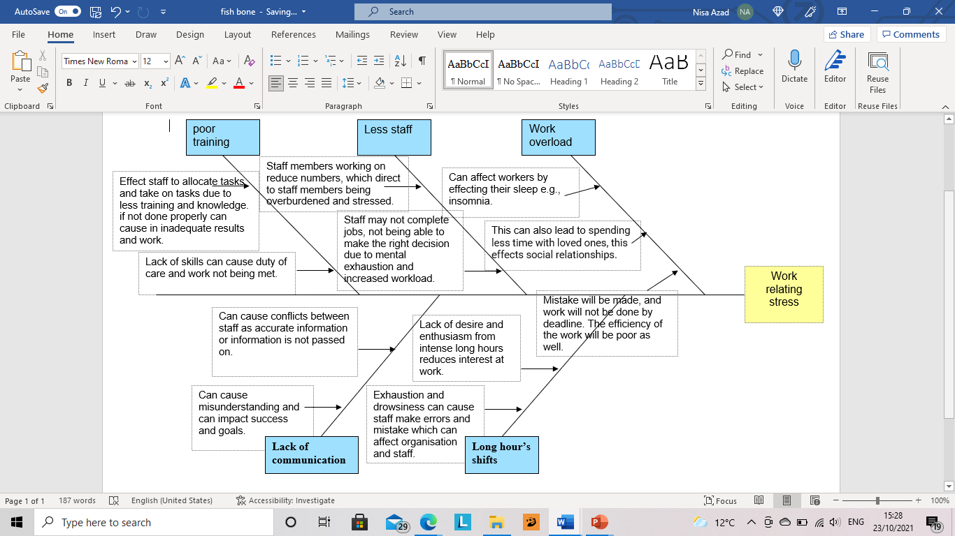
Cause and effects of work relating stress

The effects are work overload, less staff, poor training, long hours shifts and lack of communication which on the whole indicates from work relating stress Fry (2021), Michie’s (2002) infers Insomnia is a sleep disorder resulting from difficulties, work overload and unhappiness at work. Work overload effects workers by effecting their sleep which can lead to insomnia. Due to work overload workers are not getting enough time to spend time with their loved ones, this effects their social relationship. Work overload also can affect workers and organisation as mistake will be made due to workers being under pressure and strained by the workload and this will lead to work is not done by deadline. The also will cause the efficiency of the work being poor as well. Less staff can cause work relating stress as staff members working on reduce numbers, which direct to staff members being overburdened and stressed. Weldon (2018), Terry et,al suggests NHS sector is on its last leg, in the sense having intense workloads and unavailability of staff. this causing work-related stress and due to this, Staff may not complete jobs, not being able to make the right decision due to mental exhaustion and increased workload. Workers are not feeling appreciated in their career. Lack of training can cause work related stress as it harder to allocate tasks and take on tasks due to less training and knowledge. However, if not done properly it can cause in inadequate results and work. Lack of skills can cause duty of care and work not being met. Wong et.al indicates long shifts can create agitation to body clock, reduced sleep. Long hours can cause exhaustion and drowsiness which can cause staff make errors and mistake which can affect organisation and staff. Moreover, excessive long hours can make staff have a lack of desire and enthusiasm and decreases interest at work. Finally, Vicky (2020) states lack of communication can cause conflicts between staff as accurate information or information is not passed on, this can cause work related stress as it is a pattern of unruly mental and physical operative that happens when an environmental occasion is assessed as a threat to significant objectives and one’s capability to manage. It can also cause misunderstanding and can impact success and goals.

A Pestile analysis of the macro-environmental factors contributing to the complex problem
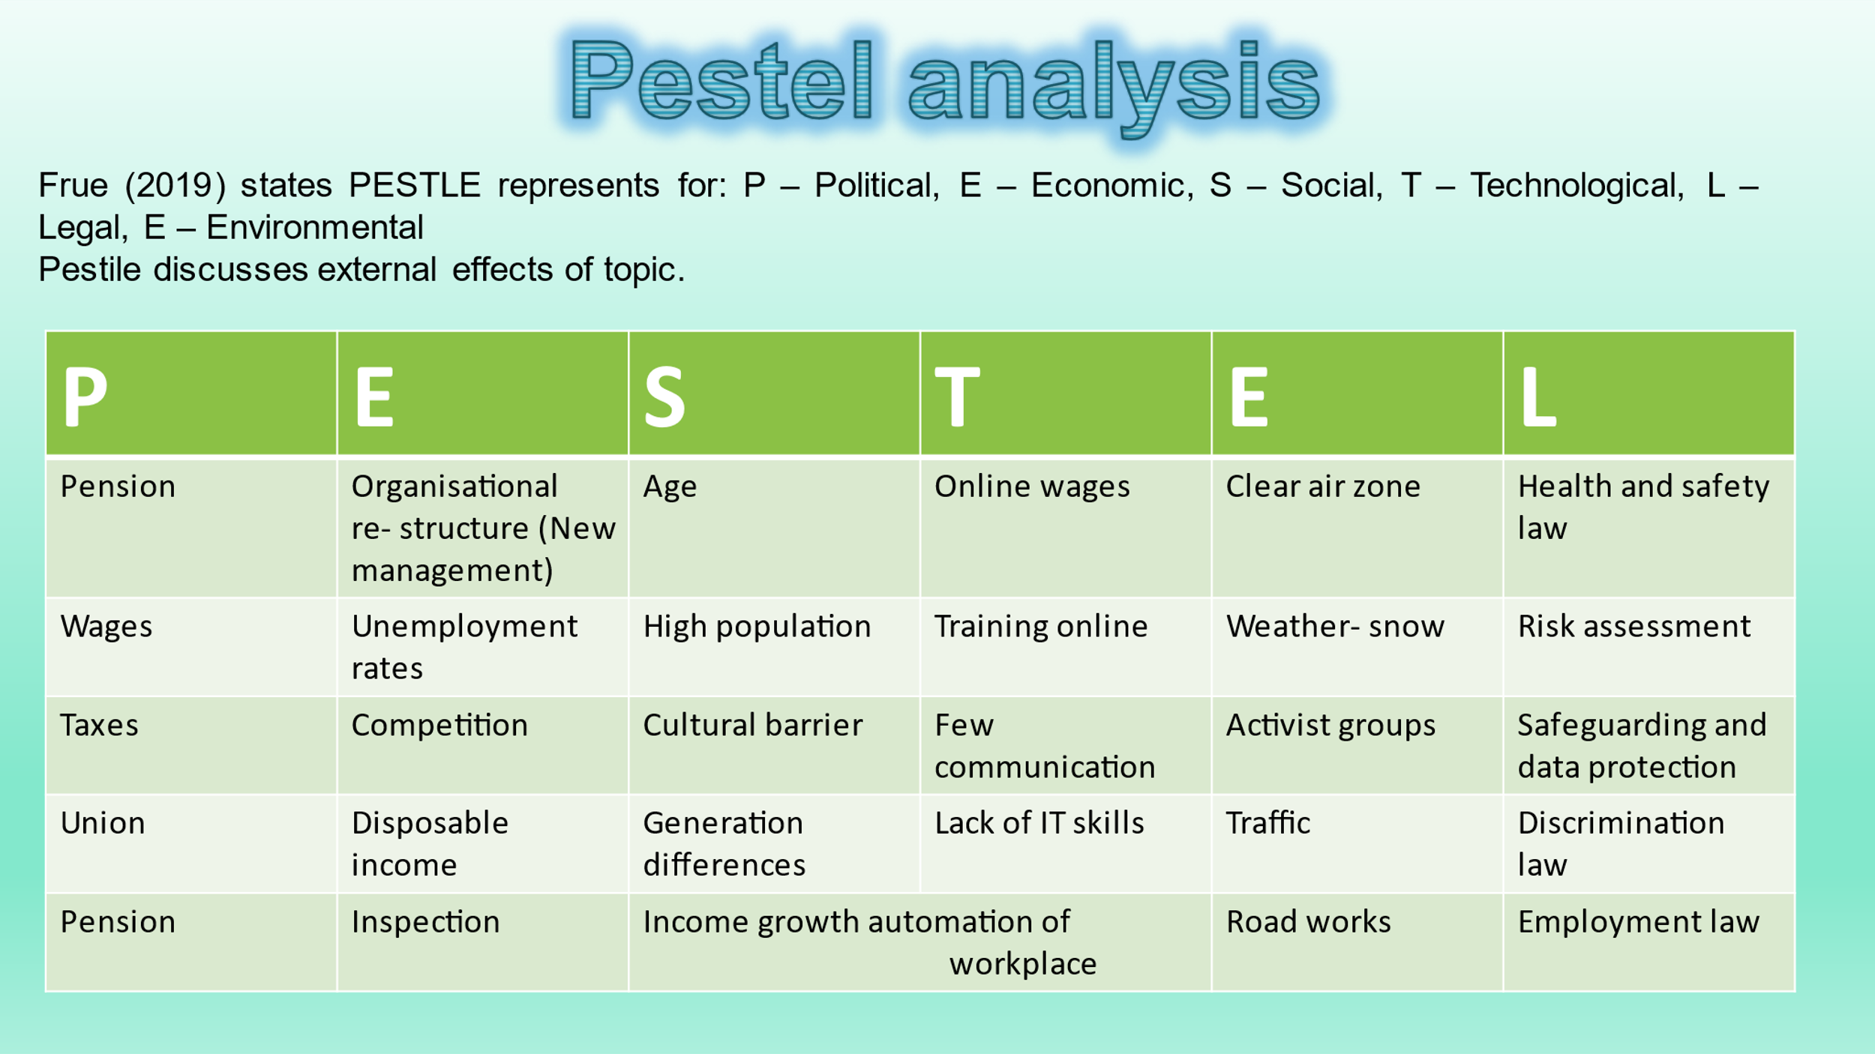

The Pestile analysis stands for political, economic, social, technological, legal, and environmental. This pestile above is representing the external factors of work- relating stress.
A few factors I have mentioned in political section can cause work- relating stress e.g., wages and taxes. The reason why wages and taxes can cause work relating stress is individuals are working long hours, getting pitiful pay and then on top of that there are being taxed outrageously from their wages which may lead them to struggle to live on what they are left over with, this can cause work relating stress. Inspections and competition are economic factors as these factors can certainly cause both employees and employers work related stress as they are concerned that they are not achieving what they should be so the workload increases, the stress level and tension expands, and everyone will feel under pressure as they don’t want to let the team down. With competition everywhere all organisations aim to go above and beyond, this can also lead to work relating stress as it can have high expectations from workers. Social factors are high population and age, this can cause work related stress as population of society has increased therefore it’s difficult to find a careers and jobs individuals enjoy, age is another factor that can cause work related stress as an individual who are older and less experience may not be able to do all tasks and individual who are younger will have to do their share of work load which can cause additional stress for them. Lack of communication and training online is a factor of technological, these factors can cause work relating stress as key information is not passed due to lack of communication, it can lead to misunderstanding and barriers between staff members and training online can be very difficult for individuals who are not technical, and this can cause them distress at workplace and lead to work relating stress. Clear air zone and traffic is an environmental factor that is causing a lot of stress to individuals as society are running late to work due work roads and are finding it difficult with the new restrictions as it harder to travel to their workplace every day this is causing them additional stress that can affect their work ability. Health and safety law and safeguarding policy is legal factors that can also work relating stress to workers as it’s a lot of information and regulations to follow and can be consequences if not followed or followed appropriately.

Proposed solution
I decided there is three solutions that can solve the problem in setting regarding work-related stress.
These solutions are
- Leave their job
- Speak to manager
- Change departments
Leaving their job, this will expand many opportunities as they ca go for job that is less stressful, this will benefit their mental health. The second alternative is to voice their issues regarding work-relating stress to manager, this will give them a boost of confidence to speak up and try and resolve the situation with their manger as it is the mangers duty of care and role to resolve issues that is brought to their attention. The final preference is change department, this has many benefits one of which is to better yourself and develop your career path and further you career as well as thinking of your welfare and health by reducing work relating stress

Comparing solution- Grid analysis
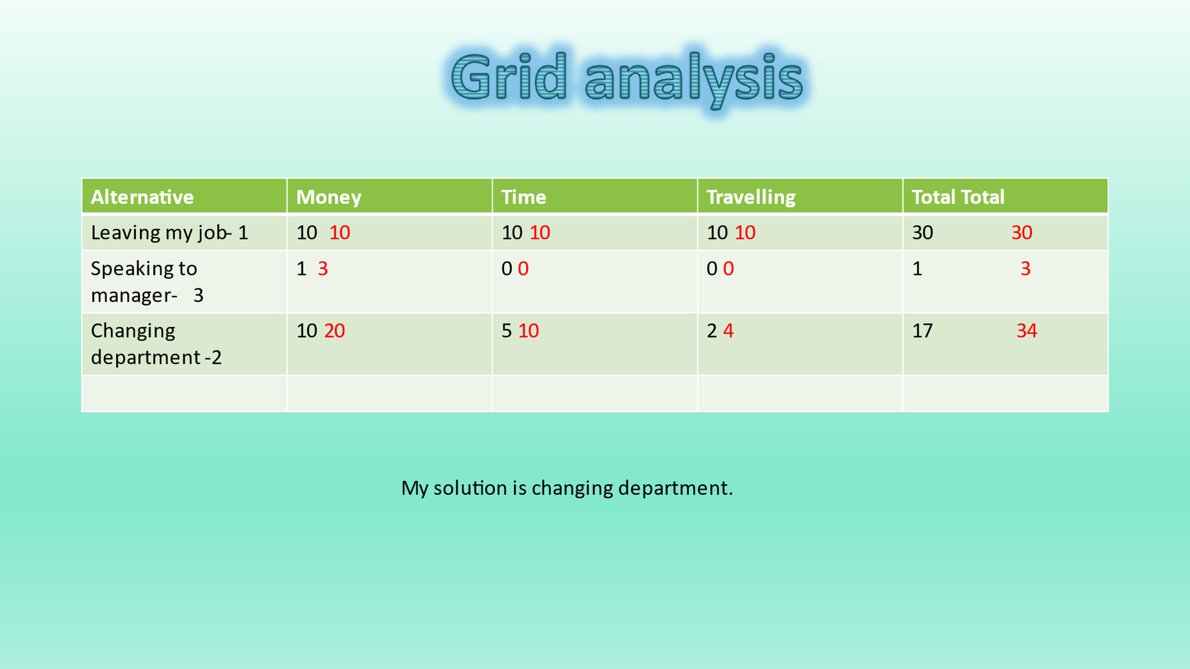

After the three suggested findings, a grid analysis was created to monitor which alternative is best for workers to solve the issues of work-relating stress.
The score rate is 1 being the lowest to 3 being the highest
It was decided:
3.Speaking to manger was the first option to do
2.Changing departments is the second option to do.
1.Leaving job is the last result.
These alternatives were then rated by how these alternatives may be affected by money, time and travelling. This was ranked from 10 being the most beneficial and 0 being the least beneficial to these proposals. After being ranked from 10 to 0, the alternatives were times (x) by the number it was ranked by.
For example, leaving job was 1 however it was ranked 10 regarding money as the worker will look for better job with more efficient money.
1 x 10= 10
This was done for all of them and then a total was worked out for all of them together and the grid analysis states changing department is the solution.
Monitoring and evaluation
By undertaking this grid analysis, it was competent to assess the statistics and facts of the three various alternatives that was projected to resolve work-relating stress. This analysis discovered that speaking to manager has the lowest rating in time, money and travel however, we worked out this solution is the slightest practical alternative as speaking to manager regarding matters may get reviewed, investigated and monitored and this can be helpful according to Clarke (2021) it is suggested manager can assist their team members by discovering in what way they can do to decrease stress in organisation but it is hard for manager to completely get rid of work relating stress as it impossible, it all depends on what type of environment and organisation you work in. This can also cause further problems at work as you can be stress about various of thing regarding your job for example not getting along with certain members staff, if your manager gets involved in this it may not be resolved in the way you wanted it to be resolved and cause additional problems this then can lead to more work- relating stress.
Leaving job can have many positives such as you can look for a job that your ambitious about, change career paths and work the hours you always wanted to work and be flexible. This will able you to have extra time for yourself instead of working long shift and taking workload home to complete your task, you can make sure your new job has less responsibility and this may reduce stress however, there is no guarantee that will be the case as due to high population there is less jobs. Gallup (2021) state while the population expands more rapidly than the humanity has the capability to grasp the extra requirements for food, clothing, shelter, and employment, you may well understand over population has decrease the number of jobs accessible. On top of that worry, you may need additional training as every day in work environment things are changing and developing. These things out right the positives of getting a new job as this may well cause your even more stress and can result you being jobless.

So therefore, from the grid analysis. It was able to verify that changing department is the most applicable and advantageous solution for individuals who are suffering from work-relating stress. The reason being for this is you will be exploring new opportunities and branching out but without leaving a place and going somewhere totally new which you do not know how it’s going to be like. This will defiantly benefit your mental health in a positive way as a change now and then and new experience is essential, and it gives you an opportunity to have a fresh start. This will aid you have an improved lifestyle, enjoy family and social time as you can ensure you do things different to your pervious job and make sure whatever was affecting you previously that cause work related stress you will avoid that in this new department. To find out if this is the right outcome by changing departments you can do customer response or feedback form and gather this data by applying the technique online to assess, monitor it weekly and the supervisor can be accountable to accumulate this feedback or response.

Conclusion
Overall, by doing this report it was recognised the problem of work-relating stress has and impact both workers and organisations. All through this report we establish over-worked staff is the main cause of work relating stress which impacts individuals’ ability of work, social and family and impact the organisation in many ways for example bad reputation. The Pestile analysis has identified many external effects. There was a discussion on three suggested solution that could solve work relating stress thus, a grid analysis was undertaken to compare the three alternatives to classify which alternative is suitable for individuals who are suffering from work relating stress. By monitoring and evaluating, it was decided changing department is the most effective and realistic decision.

References
Clarke, L (2021) How Great Managers Can Help Reduce Stress in the Workplace (WEB) Available at: Stress and Insomnia | Sleep Foundation (Accessed:20/11/21)

Fry, A (2021) Stress and Insomnia (WEB) Available at: Stress and Insomnia | Sleep Foundation (Accessed:10/10/21)

Frue, k (2019) Why You Should Use PESTLE and SWOT Analysis (WEB) Available at Why You Should Use PESTLE and SWOT Analysis (pestleanalysis.com) (Accessed:10/10/21)

Gullap, B (2021) Can Overpopulation Decrease Jobs? (WEB) Available at Why You Should Use PESTLE and SWOT Analysis (pestleanalysis.com) (Accessed:20/11/21)

Heubeck, E (2007) Workplace Stress and Your Health (webmd.com) (WEB) Available at Workplace Stress and Your Health (webmd.com) (Accessed:10/10/21)

Kapo Wong , Alan H. S. Chan , S. C. Ngan 2019 International Journal of Environmental Research and Public Health Volume: 16, Issue: 12, pp 2102

Kloppers, M (2021) Here’s How Being Underpaid at Work Can Cause Stress and Impact Your Mental Health (WEB) Available at What is the Impact of Work Pressure on Mental Health? - Fact Folk (Accessed:10/10/21)

Major, B., McFarlin, D. B., & Gagnon, D. (1984). Overworked and underpaid: On the nature of gender differences in personal entitlement. Journal of Personality and Social Psychology, 47(6), 1399–1412. https://doi.org/10.1037/0022-3514.47.6.1399

References

Merelman, R., Lindzey, G. and Aronson, E., 1977. On Social Psychological Handy Work: An Interpretive Review of The Handbook of Social Psychology, Second Edition. The American Political Science Review, 71(3), p.1109.

Michie S CAUSES AND MANAGEMENT OF STRESS AT WORK Occupational and Environmental Medicine 2002; 59:67-72.

Roper. K (2020) What is the Impact of Work Pressure on Mental Health? (WEB) Available at What is the Impact of Work Pressure on Mental Health? - Fact Folk (Accessed:10/10/21)

Terry, D., Nielsen, M. and Perchard, L., 1993. Effects of work stress on psychological well-being and job satisfaction: The stress-buffering role of social support. Australian Journal of Psychology, 45(3), pp.168-175.

Vicky (2020) Managing Stress and Conflicts at Workplace (WEB) Managing Stress and Conflicts at Workplace (yourarticlelibrary.com) Available at: (Accessed:13/11/21)

Welden, V (2018) NHS staff 'overworked and undervalued', according to Unite survey (web) Available at: https://www.heraldscotland.com/news/18659764.nhs-staff-overworked-undervalued-according-survey/ (Accessed: 14/11/21)

University of Cambridge (2021) Effects of Work-Related Stress (WEB) Available at Effects of Work-Related Stress | Human Resources (cam.ac.uk) (Accessed:10/10/21)

