

SECOND ASSIGNMENT COMPONENT 2

STUDENT’S NAME:CRISTIAN ANDREI PISTROESCU
Module Code: LCHS4003
STUDENT’S NUMBER: 2509012

LECTURER'S NAME:AZIDA ZAINOL
- MODULE TITLE:
Introduction to Health and Social Care

Executive Summary
In this report, the author examines the case of the care of Mr Ahmed, a stroke survivor of Bengali heritage that is under the domiciliary care of a multidisciplinary team. It examines the essential effect of proper communication, the application of both Communication Cycle and the Equality Act 2010 rules developed by Argyle to defy the barriers of language therefore facilitating inclusive practice. Data Protection Act 2018 and Care Act 2014 are reviewed on the effects of administrative skills and record-keeping to ensure safety and accountability. The cooperation of various agencies obtains emphasis to be considered crucial in integrated care. The report concludes that the overall use of legislation and joint efforts can provide person-centred safety deliveries that can reduce risks within disjointed health and social care simulations.

Table of Contents
1. Introduction 4
2. Importance of Effective Communication 4
2.1 Importance in Mr Ahmed’s Care 4
2.2 How to Communicate with Service Users and Family Members 5
2.3 Application of One Communication Model 6
3. Importance of Good Administrative Skills and Record-Keeping 7
3.1 Importance in Mr Ahmed’s Care 7
3.2 Record-Keeping Principles and the Data Protection Act 2018 7
3.3 Relevant Legislation and Policy Frameworks 7
4. Working Collaboratively with Other Professionals 8
4.1 Importance in Mr Ahmed’s Care 8
4.2 Approaches to Foster Effective Collaboration 8
4.3 Strategies for Overcoming Common Challenges 8
5. Conclusion 8
References 10

1. Introduction
Mr Ahmed is a 68-year-old Bengali speaking man and has just left the hospital following a stroke treatment. Mr Ahmed stays with his wife on the ground floor and gets domiciliary care three times a day to assist him in personal care, medication and preparing food. The patient is supported by a multidisciplinary team, consisting of his GP, a district nurse, speech and language therapist, and care agency workers. The admissions of strokes have been increasing in 2023/24 in the UK, reaching 111,137 which is a 28% increase at the time of 2004 (Peart, 2024). Delays in medication are an indication of the risks of coordination associated with a recent missed home visit by the care agency.
In the present report, scopes of appropriate communication and record-keeping, and collaboration between multiple agencies in the care of Mr Ahmed are covered. It is associated with the learning outcomes of the UK health and social care system, partnership working, and relevant legislation such as Equality Act 2010 and Data Protection Act 2018. Improved practice in these domains would mean person-centred, safe care and less preventable injury to service users with complex and culturally varied needs.

2. Importance of Effective Communication

2.1 Importance in Mr Ahmed’s Care
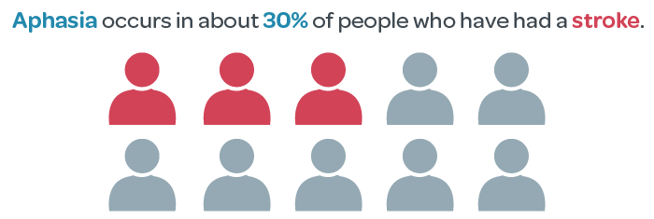
Figure 1: Aphasia among stroke patients
(Source: Speech-Language & Audiology Canada, 2023)
Safety, consent and person-centred care in health and social care are about effective communication. In the case of Mr Ahmed, since he is a post-stroke patient with low English, incompetent communication has been a root cause of the incorrect medication incident. Communication difficulties occur in approximately 30% of individuals directly after a stroke, and aphasia occurs in approximately one in three stroke survivors (Speech-Language & Audiology Canada, 2023). As per the recent data, more than 350,000 individuals in the UK have aphasia following a stroke (Stroke Association, 2025). An initial language of Bengali and swallowing/communication impairments due to the stroke are considered a contributing factor to the increased risk, as Mr Ahmed was unable to use his fluent English to act as the complete mitigation to face-to-face interaction. Unless there is excellent dialogue of information, medication hiccups, medication non-adherence, and diminished therapy prospects are experienced, which compromise healing and integrity. NHS records indicate that 1 million individuals in the UK communicate in very small or no English (NHS England, 2025). Hence, the patient becomes more vulnerable when receiving domiciliary care due to language barriers in which severe instances of harm occur.

2.2 How to Communicate with Service Users and Family Members
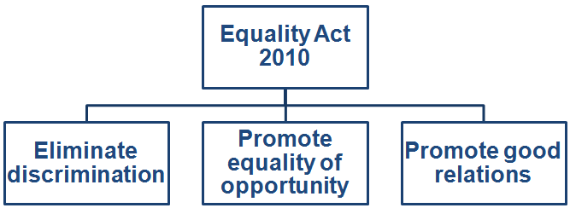
Figure 2: Three principles of the Equality Act 2010
(Source: Self-developed)
There requires to be culturally sensitive, accessible, and inclusive communication with service users and their families. In the case of Mr Ahmed, simple English, use of graphics (pictures, translated Bengali material) and body language, and professional interpretation are the tools that care workers ought to make possible because the oncologist cannot just rely on his wife alone. Avoiding exclusion by checking the understanding by means of the teach-back method, and simply by engaging the patient, Mr Ahmed. Families offer good context, but they should not replace the voice of service users in order to not interfere. The three principles of the Equality Act 2010 on which this practice is based are to eliminate discrimination, promote equality of opportunity, and promote good relations (HSE, 2024). The guarded nature of characteristics of Mr Ahmed (race/ethnicity and a stroke-disabled nature) demands adequate modifications, including translated facilities or bilingual personnel, among others, to do away with obstacles. The inability to do so is illegal discrimination because agencies should offer equal access to those similar to English-speaking users. In domiciliary services, this would be by arranging visits accompanied by language support to address the "advance equality" obligation, making anticipated visits and delays in accessing medications less frequent.

2.3 Application of One Communication Model
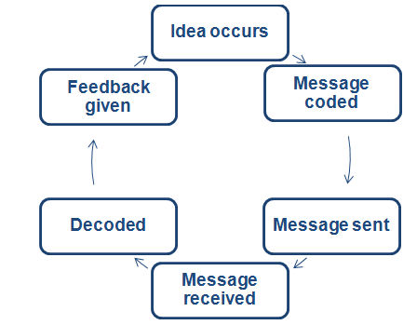
Figure 2: Argyle’s Communication Cycle (1967)
(Source: Self-developed)
Among the models studied during teaching lessons is the Argyle’s Communication Cycle (1967). The Argyle’s Communication Cycle comprises six steps such as idea occurs, message coded, message sent, message received, decoded, and feedback given (Barbieri, 2023). In stage 2, a medication instruction will be coded in English and in stage 5, a limited proficiency in English renders decoding impossible. In the absence of active feedback (say, confirmation through gestures or interpreter), or efficiency, the cycle collapses, which was observed in the missed visit of Mr Ahmed. Doedens and Meteyard (2022) denoted that decoding the model requires the use of simplified codes, non-verbal codes, and repeated feedback loop and is mainly applied in SALT sessions when dealing with swallowing. This helps to ensure the cycle is completed effectively, avoiding mistakes and in line with duties of the Equality Act. Altogether, the safety and rights of Mr Ahmed are preserved through the combination of proper communication and data on the presence of strokes and difficulties with languages. It turns possible dangers to consistent care of mutual trust.

3. Importance of Good Administrative Skills and Record-Keeping

3.1 Importance in Mr Ahmed’s Care
Administrative skills particularly record keeping can be used in continuity, accountability and safety of domiciliary care of Mr Ahmed. The missed visit to the home and the failure to take medication in good time was a direct consequence of the inadequate recording of the schedule and administration of the visits. Ayre et al. (2023) denoted that in England, there are 237 million medication errors per year of which 54 million are on the administration stage and 40 million are avoidable harm associated with care-home and community care. Out of the 51,994 high-risk medication incidents examined at the National Reporting and Learning System, community nursing has an explanation rate of 15.97% (Alrowily et al., 2024). Proper documentation would have raised a red flag indicating the gap that the GP or the district nurse would have acted timely.

3.2 Record-Keeping Principles and the Data Protection Act 2018
Records should be accurate, legible, factual, timely and signed and secure. In the case of Mr Ahmed, this would be recording all the visits, medicines administered, blood-pressure measurements and swallowing instructions. The Data Protection Act 2018 (within the scope of UK GDPR) requires seven principles namely lawfulness, fairness and transparency, limitation of purpose, data minimisation, accuracy, storage limitation, data integrity and confidentiality, and accountability (ICO, 2023). The highest data breach of personal data is reported by health and social care with 3,820 self-reported cases of data breach between 2023 and Q1 2025 (Williams, 2025). Considering it was reported that 12,412 personal data breach reports were received in the country alone in the year 2024/25, health topped the list. Electronic systems that have audit trails prevent unauthorised access to the needs or stroke history of Mr Ahmed in Bengali language.

3.3 Relevant Legislation and Policy Frameworks
Care Act 2014 creates the need to have integrated records to facilitate wellbeing and multi-agency assessment. Failure to document controlled-drug use in domestic homes (as part of domiciliary care gives rise to the risk of diversion and inadequate care) must be reported in the appropriate place, in a controlled manner (CQC, 2024). Medication safety framework in England by NHS, updated March 2025, connects strong records with the minimised harm. In the case of Mr Ahmed, it would have been supported by compliant records that would have assisted the investigation, ensured the protection of the care agency, and the visits made by the district nurse to Mr Ahmed were consistent with SALT recommendation; twice a week. Good administrative practice will thus avoid the avoidable damage observed in the missed visit and maintain professional standards throughout the fractured system.

4. Working Collaboratively with Other Professionals

4.1 Importance in Mr Ahmed’s Care
The collaboration of the GP, the district nurse, the speech and language therapist and the domiciliary care workers would enable them to provide person-centred care to Mr Ahmed in a holistic manner. The missed visit and drug delay was due to poor coordination. The UK health and social care system is still at a disjointed stage and lacks information sharing those leaves stroke survivors and language needy with a vacuum (CQC, 2024). Proper multi agency working will minimise redundancy, eliminate errors and enhance the results as part of the Care Act 2014 integration responsibilities.

4.2 Approaches to Foster Effective Collaboration
Such strategies are frequent multidisciplinary team meetings, shared digital care plans and a dedicated key worker. The 2023/24 assessments by the Integrated Care Board of NHS England demonstrated the improvements of population-health management and the decrease of inequalities due to the joint working (NHS England, 2023). Real-time medication, wound care, and swallowing therapy updates are made possible by secure platforms that are in line with the Data protection act 2018. Other connections between health and social care are enhanced by joint training and the home first model of intermediate care.

4.3 Strategies for Overcoming Common Challenges
Among the challenges are the difference in priorities, lack of available resources and barriers to information sharing. The strategies include transparent procedures in the Care Act 2014, roles of the agency and cross-feedback loops. Examples of good multi-agencies result in fewer hospital admissions and poor coordination results in vulnerable adults as unsupported (CQC, 2024). In the case of Mr Ahmed, these strategies will guarantee that his cultural and linguistic needs are fulfilled on a regular basis and prevent loopholes that the recent incident has revealed.

5. Conclusion
The model of effective communication and the principles of the Equality Act 2010, the strong maintenance of records according to the Data Protection Act 2018, and the cooperation of multiple agencies as a part of the Care Act 2014 are all necessary conditions to ensure safe care. These factors would have averted the missed medication visit in the case of Mr Ahmed on top annual medication errors in the UK. In the UK health and social care system, the integrated practice supports rights, facilitates recovery and delivers person-centred outcomes.

References
Alrowily, A., Alfaraidy, K., Almutairi, S., Alamri, A., Alrowily, W., Abutaleb, M., Zaitoun, M., Sarawi, W. and Aljead, M. (2024) ‘High-risk Medication errors: Insight from the UK National Reporting and Learning System’, Exploratory Research in Clinical and Social Pharmacy, 17(100531), p. 100531. DOI: https://doi.org/10.1016/j.rcsop.2024.100531.
Ayre, M.J., Lewis, P.R., Phipps, D.L. and Keers, R.N. (2023) ‘unDerstandIng the cauSes of mediCation errOrs and adVerse drug evEnts for patients with mental illness in community caRe (DISCOVER): a qualitative study’, Frontiers in Psychiatry, 14, p. 1241445. DOI: https://doi.org/10.3389/fpsyt.2023.1241445.
Barbieri, K. (2023) ‘The Effect of ISBAR Tool on Patient Safety’, John Heinrichs Scholarly & Creative Activities Day, p. 1. DOI: https://doi.org/10.58809/nqpd5215.
CQC (2024) Key issues in 2024 - Care Quality Commission, Cqc.org.uk. Available at: https://www.cqc.org.uk/publications/controlled-drugs/2024/issues (Accessed: 24 March 2026).
Doedens, W.J. and Meteyard, L. (2022) ‘What is Functional Communication? A Theoretical Framework for Real-World Communication Applied to Aphasia Rehabilitation’, Neuropsychology Review, 32(4), pp. 937–973. DOI: https://doi.org/10.1007/s11065-021-09531-2.
HSE (2024) Equality - HSE, Hse.gov.uk. Available at: https://www.hse.gov.uk/aboutus/equality.htm (Accessed: 22 March 2026).
ICO (2023) A Guide to the Data Protection Principles, Information Commissioner’s Office. Available at: https://ico.org.uk/for-organisations/uk-gdpr-guidance-and-resources/data-protection-principles/a-guide-to-the-data-protection-principles/ (Accessed: 23 March 2026).
NHS England (2023) NHS England» Annual assessment of integrated care boards 2023/24, England.nhs.uk. Available at: https://www.england.nhs.uk/long-read/annual-assessment-of-integrated-care-boards-2023-24/ (Accessed: 23 March 2026).
NHS England (2025) NHS England» Improvement framework: community language translation and interpreting services, England.nhs.uk. Available at: https://www.england.nhs.uk/long-read/improvement-framework-community-language-translation-and-interpreting-services/ (Accessed: 20 March 2026).
Peart, L. (2024) Hospital stroke admissions up by 28% since 2004, Healthcare-management.uk. Available at: https://www.healthcare-management.uk/hospital-stroke-admissions-2004 (Accessed: 23 March 2026).
Speech-Language & Audiology Canada (2023) Stroke Awareness, SAC. Available at: https://www.sac-oac.ca/practice-resources/toolkits/stroke-awareness/ (Accessed: 21 March 2026).
Stroke Association (2025) Aphasia awareness and the communications access symbol | Stroke Association, www.stroke.org.uk. Available at: https://www.stroke.org.uk/stroke/effects/aphasia/aphasia-awareness (Accessed: 19 March 2026).
Williams, S. (2025) Health sector tops UK self-reported data breaches in 2023-2025, IT Brief UK. Available at: https://itbrief.co.uk/story/health-sector-tops-uk-self-reported-data-breaches-in-2023-2025 (Accessed: 25 March 2026).

